Table 1. SiRNA Sequences

FN1-1 | Forward | GGUGGACUGUACUUGUCUATT
FN1-1 | Reverse | UAGACAAGUACAGUCCACCTT
FN1-2 | Forward | GCAGUAGCACAGAGCUCAATT
FN1-2 | Reverse | UUGAGCUCUGUGCUACUGCTT
FN1-3 | Forward | GCUAUUACAGAAUCACCUATT
FN1-3 | Reverse | UAGGUGAUUCUGUAAUAGCTT
FOXC1-1 | Forward | CGUCUAUGACUGUAGCAAATT
FOXC1-1 | Reverse | UUUGCUACAGUCAUAGACGTT
FOXC1-2 | Forward | GGCACAACCUCUCGCUCAATT
FOXC1-2 | Reverse | UUGAGCGAGAGGUUGUGCCTT

Table 2. RT-qPCR primers
FN1 | Forward | GAGAATAAGCTGTACCATCGCAA
FN1 | Reverse | CGACCACATAGGAAGTCCCAG
TNF-a | Forward | CCCACGTCGTAGCAAACCAC
TNF-a | Reverse | GCAGCCTTGTCCCTTGAA
Nos2 | Forward | GTTCTCAGCCCAACAATACAAGA
Nos2 | Reverse | GTGGACGGGTCGATGTCAC
IL-1β | Forward | TCATCTCGGAGCCTGTAGTG
IL-1β | Reverse | AGAGCATCCAGCTTCAAATC
IL-6 | Forward | ACTCTGGCTTTGTCTTTCTTGTTATCT
IL-6 | Reverse | TGTATGAACAACGATGATGCACTT
IL-12 | Forward | ACAGGTGAGGTTCACTGTTTCT
IL-12 | Reverse | TGGTTTGCCATCGTTTTGCTG
Mrc1 | Forward | CTCTGTTCAGCTATTGGACGC
Mrc1 | Reverse | CGGAATTTCTGGGATTCAGCTTC
Chil3 | Forward | AAGAACACTGAGCTAAAAACTCTCCT
Chil3 | Reverse | GAGACCATGGCACTGAACG
Fizz1 | Forward | CCCTCCACTGTAACGAAGACTC
Fizz1 | Reverse | CACACCCAGTAGCAGTCATCC
Actin | Forward | GTGACGTTGACATCCGTAAAGA
Actin | Reverse | GCCGGACTCATCGTACTCC

Table 3. Antibodies
Target | Dilution | Application | Vendor
FN1 | 1:1000 | WB | Abcam
PI3K | 1:1000 | WB | Affinity Biosciences
Phospho-PI3K | 1:1000 | WB | Affinity Biosciences
AKT1 | 1:1000 | WB | Selleck
Phospho-AKT1 | 1:1000 | WB | Selleck
AKT2 | 1:1000 | WB | Selleck
Phospho-AKT2 | 1:1000 | WB | Selleck
STAT1 | 1:1000 | WB | Beyotime
Phospho-STAT1 | 1:1000 | WB | Selleck
STAT6 | 1:1000 | WB | ZEN-BIO
Phospho-STAT6 | 1:1000 | WB | Selleck
β-actin | 1:2000 | WB | Proteintech
HRP-conjugated goat | 1:10000 | WB | Jihua Biotechnology Services
F4/80 | 1:1000 | IF | Immumoway
FN1 | 1:1000 | IF | Abcam
GZMB | 5 μL/test | FC | Biolegend
IFN-γ | 5 μL/test | FC | Biolegend

WB*:Western blot; IF**: Immunofluorescence; FC*** : Flow Cytometry

Figure S1
Supplementary Figure1. Differential gene expression and correlation analysis
（A）IL-1β、Plxna4、CD36、Ephx2、Ybey、Ald1a7、TNN-1、Vegfc and Ifitm1 mRNA levels in distal tumors from irradiated and control mice. （B）Analysis of the correlation between FN1 expression and M1 macrophage markers, including the immunosuppressive receptors CD163 and CD209, using the TIMER2 database. Data in (A) are shown as mean ± SD (n = 9). ns, not significant (P > 0.05) by two-sided Student’s t test.

Figure S2
Supplementary Figure 2. Efficiency of FN1 genetic manipulation in macrophages and related analyses
(A) Knockdown efficiency of FN1 in BMDMs assessed by RT-qPCR and Western blot.(B) Overexpression efficiency of FN1 in BMDMs assessed by RT-qPCR and Western blot.(C) Overexpression efficiency of FN1 and expression levels of immunostimulatory genes in J774A.1 cells, as determined by RT-qPCR.(D) Correlation analysis between FN1 expression and CD8⁺ T cells along with their immunosuppressive receptors, based on the TIMER2 database. Data in (A) are shown as mean± SD (n = 3). ***P < 0.001 by One-Way ANOVA. Data in (B) and (C) are shown as mean ± SD (n = 3). ***P < 0.001, **P < 0.01 by two-sided Student’s t test.

Figure S3
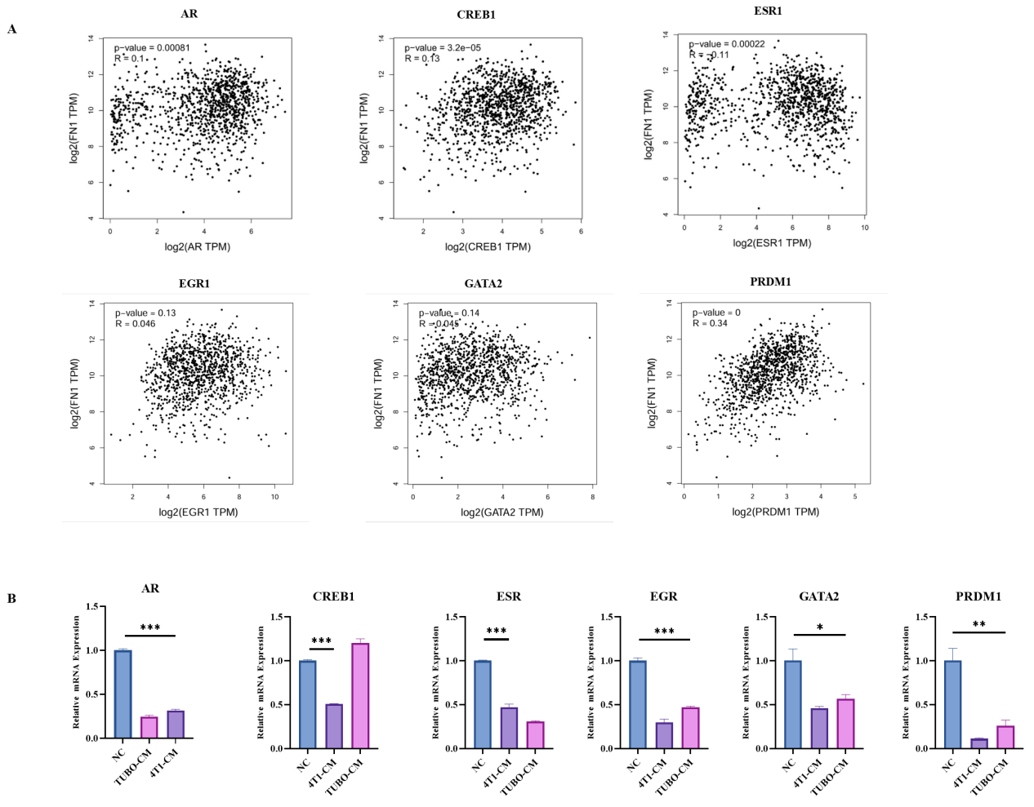

Supplementary Figure 3. Analysis of Gene Correlation with FN1 and Expression in the RIAE Model
（A）Analyze the correlation between FN1 and AR, CREB1, ESR1, EGR1, GATA2, and PRDM1 by GEPIA2.（B）AR、CREB1、ESR1、EGR1、GATA2 and PRDM1 mRNA expression levels in the in vitro RIAE model. Data in (B) are shown as mean± SD (n = 3). *P < 0.05 by Repeated Measures ANOVA.

