Supramolecular Semi-Convertible Hydrogel Enabled Self-healing Responsive Lubrication under Dynamic Shearing
Xuewei Zhang,¹ Kaiyao Shi,⁴ Jian Wang,^{2, 3} Wenlong Song*¹ and Shutao Wang*^{2, 3}
[1] Dr. Xuewei Zhang, Prof. Dr. Wenlong Song
The State Key Laboratory of Supramolecular Structure and Materials, College of Chemistry, Jilin University
Changchun 130023 P. R. China
Email: songwenlong@jlu.edu.cn

[2] Dr. Jian Wang, Prof. Dr. Shutao Wang
CAS Key Laboratory of Bio-inspired Materials and Interfacial Science, CAS Center for Excellence in Nanoscience, Technical Institute of Physics and Chemistry, Chinese Academy of Sciences
Beijing 100190 P. R. China
Email: stwang@mail.ipc.ac.cn

[3] Dr. Jian Wang, Prof. Dr. Shutao Wang
University of Chinese Academy of Sciences
Beijing 100190 P. R. China

[4] Prof. Dr.Kaiyao Shi
Department of Cardiology, Jilin Provincial Key Laboratory for Genetic Diagnosis of Cardiovascular Disease
Changchun 130023 P. R. China
Dr. Xuewei Zhang and Dr. Kaiyao Shi are contribution equally.

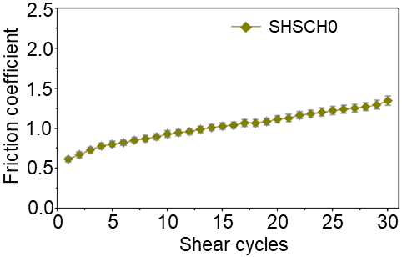
Figure S1. Friction coefficient on SHSCH0 during 30 shear cycles. Experiment condition: Load: 10 mN, shear velocity: 0.1 mm/s, Humidity: 80%.

Figure S2. The relationship between friction coefficient of fresh SHSCH2 and controlled humidity (20, 40, 60 and 80%) following shear cycles. Experiment condition: Load: 10 mN, shear velocity: 0.1 mm/s.

Figure S3. The shear-responsive lubrication on SHSCH in controlled shear velocity and load. a) When keeping the load constant at 10 mN and changing the shear velocity of the contact ball from 0.1 to 0.5 mm/s. b) By keeping the shear velocity constant at 0.1 mm/s, the load force was controlled from 6 to 14 mN. The humidity in the experiment was 80%.

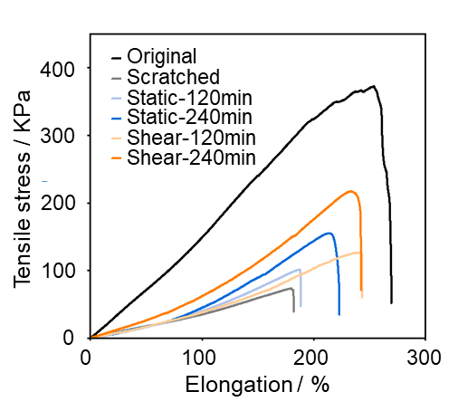
Figure S4. The self-healing on the tensile strength of scratched SHSCH2 during static and dynamic shearing process at SA of 0º.

Table S1. Comparison of lubrication recovery under shearing for different materials.

Substrate species | Substrate materials | Elasticity modulus (KPa) | Coefficient after self-healing | Method on lubrication recovery | Ref.
Alloy | Nickel aluminum bronze | 3.31×10⁸-3.56×10⁸ | 0.4-0.7 | Lubricants infusion | 38
Alloy | Steel | 2.06×10⁸ | 0.15-0.25 | Lubricants infusion | 39
Alloy | Steel | 2.06×10⁸ | 0.03-0.05 | Lubricants infusion | 40
Alloy | Steel | 2.03×10⁸ | 0.1-0.6 | Lubricants infusion | 41
Alloy | Steel | 2.03×10⁸ | 0.1-0.4 | Lubricants infusion | 42
Ceramics | ZrO₂ | 1.90×10⁸ | 0.04-0.06 | Lubricants infusion | 43
Metal | Grey cast iron | 6.20×10⁷-1.62×10⁸ | 0.06-0.14 | Lubricants infusion | 44
Silicon | Silicon wafer | 1.60×10⁸ | 0.2-0.45 | Lubricants infusion | 45
Silicon | Silicon wafer | 1.60×10⁸ | 0.1-0.3 | Lubricants infusion | 46
Silicon | Silicon wafer | 1.12×10⁸ | 0.6-1.1 | Lubricants infusion | 47
Silicon | Silicon wafer | 1.12×10⁸ | 0.01-0.03 | Lubricants infusion | 48
Silicon | Silicon wafer | 1.12×10⁸ | 0.027-0.057 | Lubricants infusion | 49
Silicon | Glass | 6.00×10⁷-6.40×10⁷ | 0.1-0.6 | Microcapsules lubricants encapsulation with abrasion | 50
Polymer | Epoxy composites | 1.40×10⁷ | 0.05-0.10 | Microcapsules lubricants encapsulation with abrasion | 51
Polymer | Epoxy composites | 1.00×10⁶-5.00×10⁶ | 0.2-0.4 | Microcapsules lubricants encapsulation with abrasion | 52
Polymer | Epoxy composites | 2.00×10⁶-3.80×10⁶ | 0.15-0.7 | Microcapsules lubricants encapsulation with abrasion | 53
Polymer | Epoxy composites | 2.00×10⁶-3.80×10⁶ | 0.12-0.17 | Microcapsules lubricants encapsulation with abrasion | 54
Polymer | Epoxy composites | 2.04×10⁶ | 0.38-0.49 | Microcapsules lubricants encapsulation with abrasion | 55
Polymer | Nylon | 1.50×10⁶ | 0.05-0.5 | Microcapsules lubricants encapsulation with abrasion | 56
Hydrogel | Lipid-incorporating PHEMA hydrogel | 100-800 | 0.005-0.05 | Microcapsules lubricants encapsulation with abrasion | 57
Hydrogel | SHSCH2 (This work) | 26.30 | 0.34 | Molecular assembly and disassembly

