Supplementary Information for
Exceptional Interfacial Thermal Transport Across Individual Polytype Boundaries
Zifeng Huang¹, Yicheng Wei², Ying Song,³ Hui Li^{3,}*, Zhe Cheng^{1,4,}*

¹ School of Integrated Circuits and Beijing Advanced Innovation Center for Integrated Circuits, Peking University, Beijing 100871, China
² School of Software & Microelectronics, Peking University, Beijing 100871, China
³ Beijing National Center for Condensed Matter Physics and Institute of Physics, Chinese Academy of Sciences, 100190 Beijing, China
⁴ Frontiers Science Center for Nano-optoelectronics, Peking University, Beijing 100871, China

^{a)}Authors to whom correspondence should be addressed: zhe.cheng@pku.edu.cn; lihui2021@iphy.ac.cn

- Structural characterization
Structure characterization of the polytypic SiC was performed using Raman spectroscopy. Regions with different polytypes can be readily distinguished by their distinct optical colors, as shown in Fig. S1, which enables rapid localization for subsequent Raman mapping. The observed cracks formed after thermal characterization and have no impact on the reported results. The complete Raman spectra of the three SiC polytypes are presented in Fig. S2. The existence of polytype boundary is independently reviewed by micro-Raman mapping, which facilitated by the scanning of laser spot position. Each pixel in the origin Raman file represents a full Raman spectrum, similar to Fig. S2. The Raman data was analyzed by a commercial software NanoSpectrum. To accurately extract the characteristic Raman peaks of SiC, background subtraction was performed, as illustrated in Fig. S3. Specifically, the peak position and width were first defined to determine the integration range. Subsequently, a background region was selected to obtain the average background signal, which was then subtracted from the measured spectra. Three peak channels centered at ~150 cm⁻¹, 174 cm⁻¹, and 205 cm⁻¹ were defined, with a peak width of 5 cm⁻¹ and a background width of 10 cm⁻¹. The integrated intensities of these three channels were denoted as I₁, I₂, and I₃, respectively. The total intensity at each pixel was calculated as I = I₁ + I₂ + I₃. The relative portion of a polytype i was represented as p_{i} = I_{i}/I, the color of each pixel in Fig. 2 was determined by the maximum p_{i}, the gray scale of each pixel was determined by the absolute of the maximum p_{i} (0.33 – 1.0), representing the purity of this local position, and the brightness of the pixel was determined the total signal intensity I.
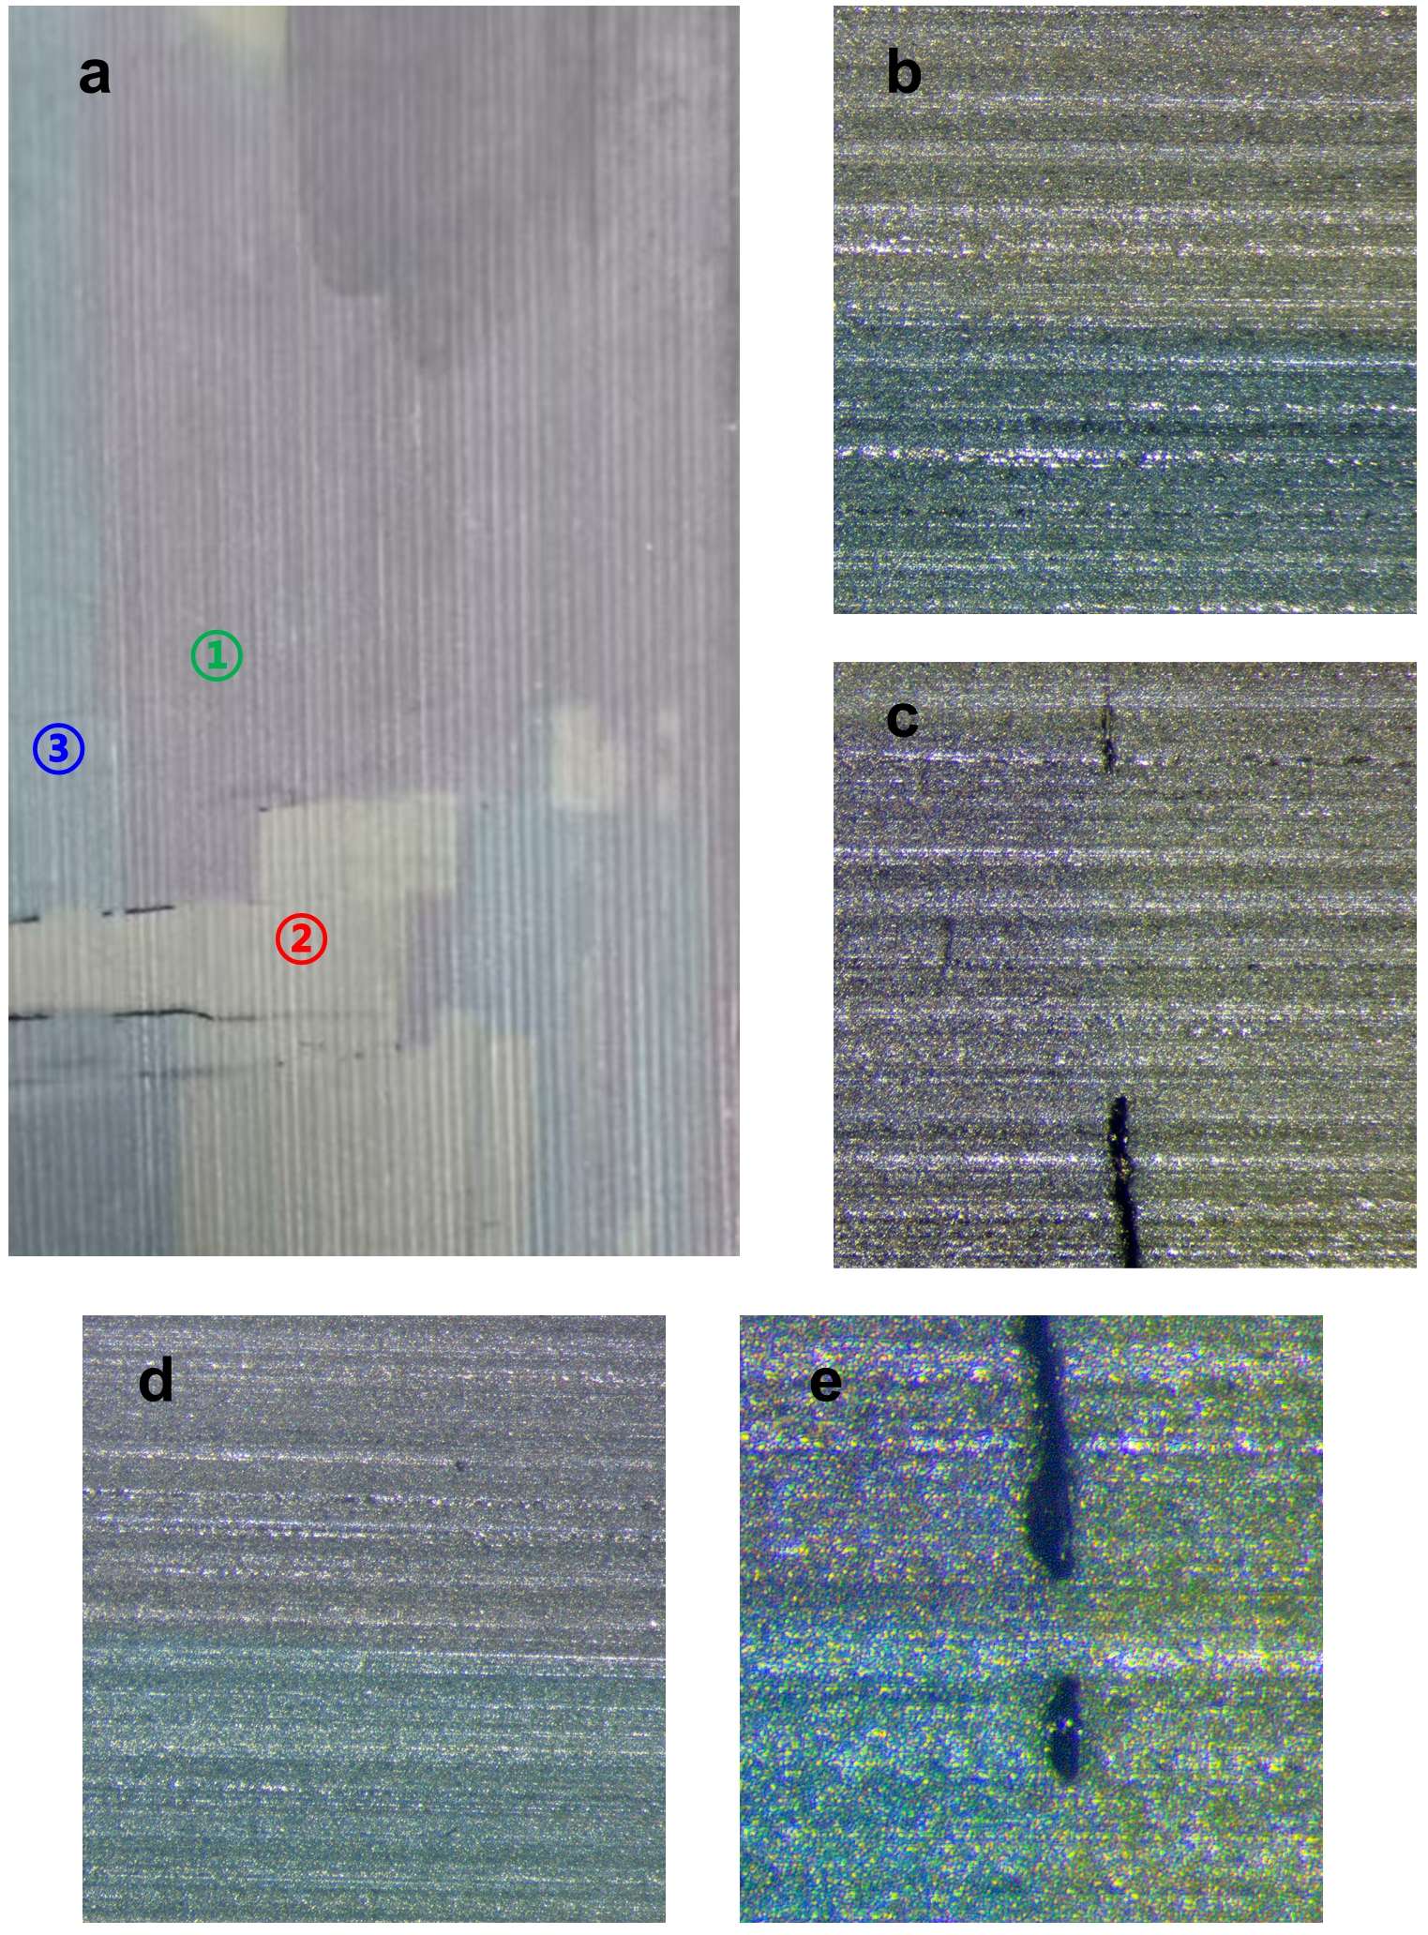
Fig. S1 Optical photograph of the polytypic SiC sample. a, Regions with different polytypes exhibit distinct colors. The backside of the crystals is not polished. The areas labeled 1, 2, and 3 correspond to 4H-, 15R-, and 6H-SiC, respectively. b, Magnified view of the 15R/6H-SiC interface. c, Magnified view of the 4H/15R-SiC interface. d, Mixed region comprising 1R-, 6H-, and 4H-SiC.
Fig. S2. Linear-scale Raman spectra of 4H-, 6H-, and 15R-SiC polytypes. a, 4H-SiC; b, 6H-SiC; c, 15R-SiC. The positions of the folded modes are highlighted, where FTA, FLA, and FTO denote the folded transverse acoustic, folded longitudinal acoustic, and folded transverse optic modes, respectively. The parameter x = q/q_{B} represents the reduced wave vector within the basic Brillouin zone of 3C-SiC. Detailed discussion on Brillouin zone folding in long-period SiC polytypes can be found in Ref.¹. Note that the splitting of the FTO mode in a is consistent with previous observations².
Fig. S3. Background subtraction procedure for the Raman spectrum. The blue dashed region indicates the subtracted background, and the orange dashed region indicates the integrated peak.

- Thermal characterizations
Thermal characterization in this study was performed using time-domain thermoreflectance (TDTR). The thermal properties were extracted by fitting the measured ratio signal R to an analytical heat transfer model^{3–5}. In this study, the Al/SiC thermal boundary conductance (TBC) and the thermal conductivity (κ) of SiC were treated as fitting parameters, while other required parameters, such as the heat capacity, were fixed. Representative experimental data and fitting results for the three SiC polytypes are shown in Fig. S4.

Fig. S4. The representative fitting results of three polytypes of SiC: 15R (a), 6H (b), and 4H (c).
The sensitivity S_{α} represents the degree of dependence of R on a given parameter α, which is defined as⁶:
(S1)
Parameters with near-zero sensitivity have negligible influence on the resulting R signal; therefore, their effects can be excluded from the analysis. During the mapping procedure, the delay stage was fixed at a specific delay time where the sensitivity to the Al/SiC TBC is nearly zero. Under this condition, the measured R depends primarily on a single fitting parameter, the SiC thermal conductivity κ. This enables rapid mapping, as the measured R map can be directly converted into a κ map. The thermal transport model, along with the key parameters employed in this study, is illustrated in Fig. S5a; a representative sensitivity plot is provided in Fig. S5b. The impact of the Al transducer κ was neglected due to its negligible sensitivity. A standard TDTR measurement is performed before every mapping to identify the delay time, therefore the delay time of each κ map is experimentally determined.
Fig. S5. Sensitivity analysis. a, Schematic of the thermal transport model and the primary parameters utilized for fitting. b, Representative sensitivity plot for the Al/SiC system.
Due to non-Fourier thermal transport arising from the comparable size of the laser spot and the phonon mean free path (MFP) in SiC, the κ is lower than the corresponding bulk values^{7,8}. However, as shown in Fig. S6, our results are in good agreement with previously reported values that account for the phonon MFP distribution. Specifically, our measured κ was compared with the geometric mean of the in-plane κ_{in} and cross-plane κ_{out} reported in the literature⁹. This agreement validates the reliability of our TDTR measurements.

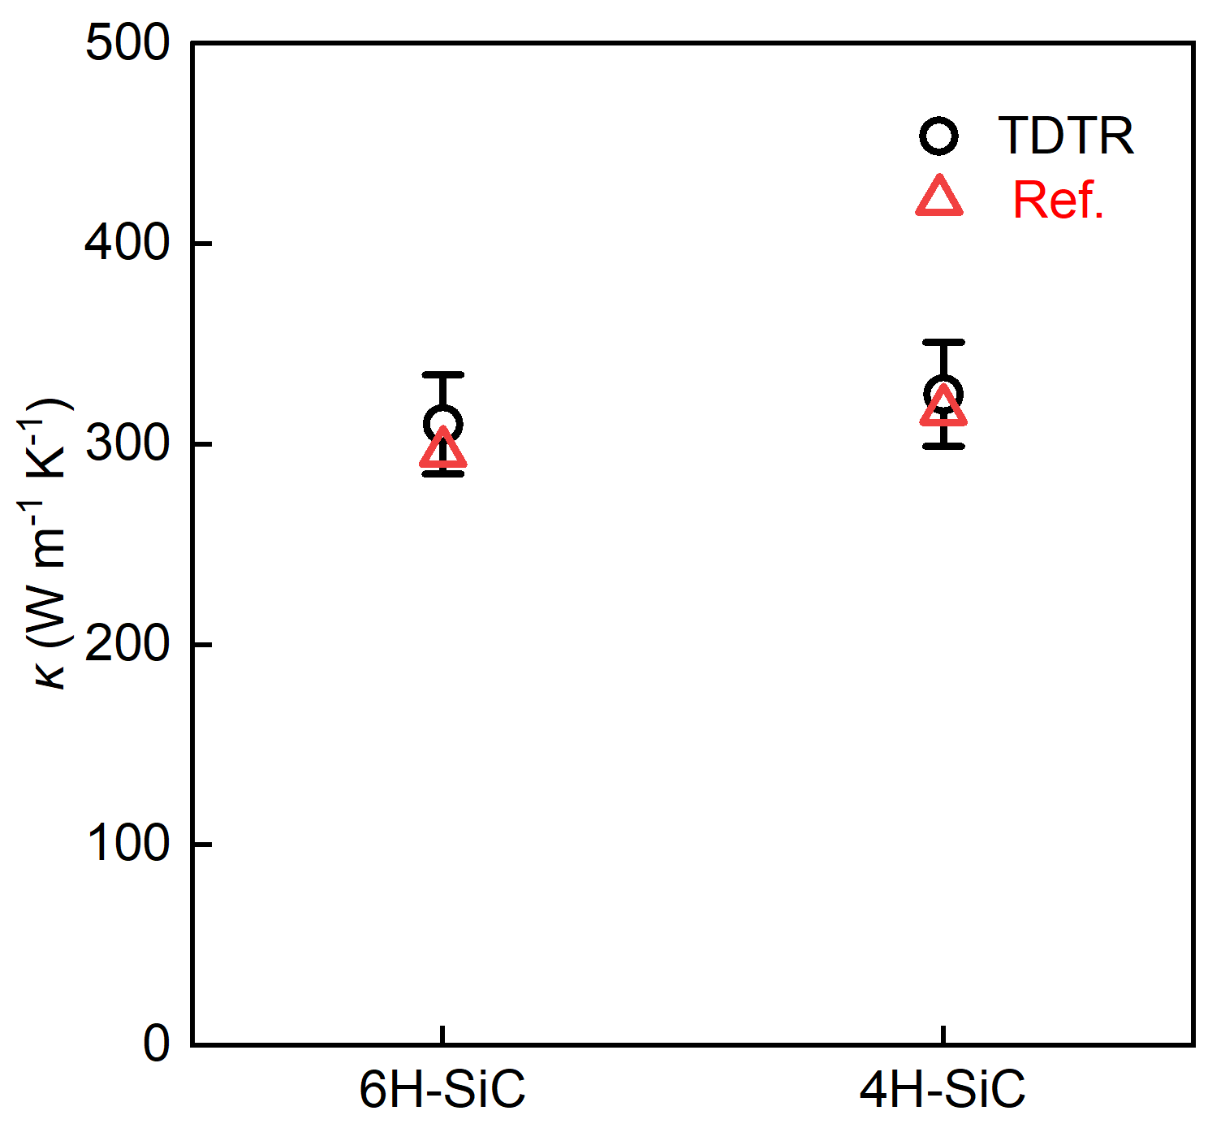
Fig. S6. Comparison of the experimental and theoretical κ. The experimental data were obtained via TDTR in this work. The theoretical values represent the phonon MFP-limited κ as reported in the literature, corresponding to the effective thermal conductivity defined as the geometric mean ${\text{κ}}_{\text{eff}}\text{ = }\sqrt{{\text{κ}}_{\text{in}}{\text{κ}}_{\text{out}}}$, where κ_{in} and κ_{out} denote the in-plane and cross-plane thermal conductivities, respectively. These suppressed thermal conductivities, κ_{in} and κ_{out}, are estimated to be 88% and 80% of their respective bulk counterparts.
- TDTR mapping data analysis
The TDTR κ mapping areas were strategically selected to encompass the polytype interfaces of 4H/6H-SiC, 6H/15R-SiC, and 4H/15R-SiC. Data collection was performed on an integrated polytypic SiC crystal, which was subsequently sectioned into several pieces to facilitate the experimental procedure. This partitioning step is expected to have no impact on the measurement integrity or the resulting thermal conductivity values. In standard TDTR measurements, the Al/SiC G and the SiC κ are typically the primary fitting variables. By selecting a specific delay time where R becomes insensitive to G, a polynomial relationship was established by fitting discrete model values. This allowed for the direct conversion of raw R maps into κ maps based on the thermal model, as illustrated in Figs. S7a–c.

To generate a representative one-dimensional κ profile, the original κ values from the two-dimensional map were grouped according to the same distance d from the polytype interface and averaged along the interface contour, where d represents the local normal distance. This approach accounts for any spatial curvature or misalignment of the interface within the mapping area, as shown in Fig. S8. Figure S8a shows the extraction process for a horizontal interface, where calculating the average κ at a specific distance d from the interface is straightforward. For curved interfaces, as shown in Fig. S8b, the procedure is more involved. To achieve a sufficiently high signal-to-noise ratio (SNR), a region encompassing enough pixels on both sides of the interface was first selected. This area was also chosen to minimize the overall inclination between the interface and the scanning direction. Next, a sub-region with the same perpendicular range from the interface was defined as the sampling area, and pixels at the same distance d from the interface were grouped to calculate their average κ and standard deviation, following the standard procedure. The right panels of Figs. S8a and S8b show the frequency distributions and fitted Gaussian curves of κ for the corresponding pixel groups, highlighted with dashed boxes. Note that, although the scanning directions of the κ profiles in this study are not strictly perpendicular to the interfaces, previous work has shown that this only leads to an overestimation of the TBR due to the increase in κ suppression distance alone the profile and does not affect the conclusions of this study. Figs. S8c - e shows the κ profile with standard deviation error bar across three kinds of polytype interfaces.

Fig. S7. Procedure for TDTR κ mapping conversion. a, Representative polynomial fitting of the κ – R relationship. A discrete sequence of R was first generated to calculate the corresponding κ values (open circles). A polynomial function was then employed to fit the κ – R relationship (red solid line), providing the basis for signal-to-property conversion. b, The raw R map obtained directly from TDTR mapping. c, The corresponding κ map converted from the raw R data using the established polynomial relationship.

Fig. S8. Procedure for cross-interface κ profile extraction. a, Extraction of the κ profile for a horizontal 6H/15R-SiC interface. The white dash-dotted line indicates the interface position, and the dashed box encloses pixels at the same distance d, which are then grouped to calculate the average κ and standard deviation. By scanning the box across the interface, the one-dimensional κ profile is obtained. The right panel shows the corresponding frequency distribution of pixels within the dashed box, fitted with a Gaussian curve. b, Extraction of the κ profile for a curved 4H/15R-SiC interface. The light blue region indicates the selected portion, while the cyan line outlines the sampling area that follows the curvature of the interface. Dashed boxes highlight pixels at the same d; the frequency distribution of these pixels and the corresponding Gaussian fit are shown in the right panel. c – e, The extracted κ profile of three polytype interfaces: 6H/15R-SiC (c), 4H/6H-SiC (d), and 4H/15R-SiC (e).

- Phonon transmittance extraction
The phonon transmittance (τ) obtained here represents a frequency- and mode-averaged gray value, τ_{gray}. The estimation of the phonon suppression–induced decrease in κ due to polytype interfaces follows the analysis procedure in Ref.¹⁰, which corresponds to Eq. (1) in the main text. The calculated suppression function F(x) for different τ_{gray} values at various positions x is shown in Fig. S9, with the phonon MFP set to 500 nm. As the measurement location approaches the interface, an increasing fraction of phonons is suppressed, as illustrated in the inset of Fig. S9a (x₃→x₂→x₁), reaching nearly 50% suppression near the interface. The phonon accumulation function was adopted from a previous study⁸ and fitted with a polynormal function, as shown in Fig. S9b on both logarithmic and linear scales. Its derivative yields the κ spectrum, which also serves as the integrand ($\frac{\text{1}}{\text{3}}{\text{C}}_{\text{V}}\text{(}\text{l}\text{)}{\text{v}}_{\text{g}}\text{(}\text{l}\text{)}\text{l}$) in Eq. (2) of the main text. A cutoff function was applied to set the spectrum below 16 nm to zero. By multiplying the suppression function F(x) with this term, specifically as a suppression on the phonon MFP l, we obtained the suppressed κ spectrum, illustrated in Fig. S9c, calculated at 50 nm from the interface with decreasing τ_{gray}. Re-integrating the suppressed κ spectrum produces the κ accumulation function, with the final κ(x) under different τ_{gray} shown in Fig. S9d. These results indicate that the interface-induced suppression of κ is highly localized, predominantly within 10 μm of the interface.

The raw κ profile calculated using the aforementioned phonon suppression model is shown in Fig. S10a for different values of τ_{gray}. A pronounced and abrupt jump or decrease in κ across the interface is observed for all τ_{gray} values, as highlighted in the inset of Fig. S10a. However, such a sharp transition is not representative of practical measurements. This discrepancy arises because the κ values measured by TDTR correspond to a spatially averaged response over the finite area defined by the laser spot. To account for this spatial averaging effect, a Gaussian kernel was employed to smooth the raw κ profile prior to fitting. The Gaussian kernel is expressed as:
(S2)
The final κ profile used for fitting is obtained by convolving the raw profile with Eq. (S2) in a discrete form. For each spatial position x, the convolution is evaluated over the range (x - 3w₀, x + 3w₀), where w₀ denotes the effective laser spot size. In this study, w₀ is set to 3.3 μm. The resulting smoothed κ profile is presented in Fig. S10b, together with the corresponding raw profile for comparison. It is evident that the Gaussian smoothing significantly reduces the sharp variation in κ near the interface, yielding a more physically realistic profile that is better suited for fitting with TDTR measurements.

During the fitting process, both the boundary position b and the τ_{gray} for each interface are simultaneously determined. Figure S11 presents the κ profiles calculated with different assumed τ_{gray} values, while using the same best-fit b for each corresponding interface. The shaded area represents the experimental standard deviation. The κ values within a narrow region (3w₀) near each boundary of the profile are fixed, taken as the averaged values on each side. It can be observed that as τ_{gray} decreases, κ exhibits a more pronounced dip in the interfacial region. However, such a feature is not clearly observed in our experimental mapping results, and the model predictions show good agreement with the measurements.

The phonon density of states (DOS) of 4H, 6H, and 15R-SiC shown in Fig. 4e of the main text was obtained from a publicly accessible online database of phonon properties:
http://github.com/atztogo/phonondb/blob/main/mdr/phonondb/README.md

Fig. S9. Calculation of the interfacial suppression on κ. a, Suppression function F(x) for different τ_{gray}; the inset illustrates the principle of interfacial phonon transport suppression. b, Polynomial fitting of the normalized MFP accumulation function, shown on both logarithmic and linear scales. c, Normalized κ spectral density obtained from the derivative of the accumulation function with different τ_{gray}. The calculation is performed 50 nm from the interface to clearly illustrate the suppression effect. d, Final κ(x) suppressed for different τ_{gray}. The corresponding positions where κ(x) reaches 99% of κ_{bulk} are also indicated, showing that the suppression effect is localized within approximately 10 μm from the interface.
Fig. S10. κ profile calculation and smoothing. a, Representative raw κ profiles across the interface calculated with different τ_{gray} values. The inset shows a zoomed-in view near the interface, where sharp jumps in κ are observed when τ_{gray} approaches unity, while a pronounced reduction in κ occurs when τ_{gray} approaches zero. b, The κ profile after Gaussian smoothing, shown together with the corresponding raw profile for comparison.

Fig. S11. κ profile comparison under different τ_{gray}. a, 4H/6H-SiC interface. b, 4H/15R-SiC interface. c, 6H/15R-SiC interface. The shaded area represents the standard deviation at each position, as obtained from Fig. 4b–d in the main text.

- TBC comparison
The TBC data shown in Fig. 5c of the main text are compiled from a wide range of previous studies and are listed in Table S1 below. Entries in the table are arranged such that their order from top to bottom matches the left-to-right order of the corresponding data points in the figure.

Interface | TBC (MW/m²K) | Reference
Ga₂O₃/SiC | 17.5 | ¹¹
Au/Qz | 36 | ¹²
Ga₂O₃/Diamond | 17 | ¹³
Au/SiO₂ | 40 | ¹⁴
GaN/Diamond | 4.55 | ¹⁵
Au/Al₂O₃ | 45 | ¹⁶
Au/Diamond | 40 | ¹⁶
MoS₂/h-BN | 17 | ¹⁷
Graphene/h-BN | 52.2 | ¹⁷
MoS₂/SiO₂ | 19.5 | ¹⁸
MoS₂/GaAs | 8.4 | ¹⁸
MoS₂/Si | 16.1 | ¹⁸
MoS₂/GaN | 17.2 | ¹⁸
MoS₂/SiC | 12.2 | ¹⁸
Al/Al₂O₃ | 175 | ¹⁹
Al/SiC | 200 | ²⁰
Al/GaN | 400 | ²¹
Cr/GaN | 230 | ²²
Cr/Si | 200 | ²²
Cr/Sapphire | 190 | ²²
Cr/AlN | 200 | ²²
Al/Si | 120 | ²²
Al/Sapphire | 200 | ²²
Ni/Ga₂O₃ | 83 | ²³
Al/Ga₂O₃ | 82 | ²³
Ti/Ga₂O₃ | 17 | ²³
TiN/SiC | 281 | ²⁴
HfN/SiC | 189 | ²⁴
SiC/AlN | 800 | ²⁵
SiC/Si | 620 | ²⁶
SiC/Ga₂O₃ | 244 | ²⁷
SiC/GaN | 350 | ²⁸
SiC/Diamond | 150 | ²⁹
GaN/AlN | 620 | ³⁰
GaN/BAs | 250 | ³¹
Si/Diamond | 64 | ³²
GaN/Diamond | 120 | ³³
Ga₂O₃/Diamond | 179 | ³⁴
AlN/Si | 105 | ³⁵
GaN/ZnO | 490 | ³⁶
AlN/SiO₂ | 225 | ³⁷
AlN/Diamond | 63 | ³⁸
Diamond/GaAs | 40 | ³⁹
SiC/SiC MD | 2222 | ⁴⁰
SiC/SiC | 2050 - 2250 | This work

Reference
1. Nakashima, S. & Harima, H. Raman Investigation of SiC Polytypes. phys. stat. sol. (a) 162, 39–64 (1997).
2. Bauer, M., Gigler, A. M., Huber, A. J., Hillenbrand, R. & Stark, R. W. Temperature‐depending Raman line‐shift of silicon carbide. J. Raman Spectroscopy 40, 1867–1874 (2009).
3. Mohan, R., Khan, S., Wilson, R. B. & Hopkins, P. E. Time-domain thermoreflectance. Nat. Rev. Method. Prime. 5, 55 (2025).
4. Jiang, P., Qian, X. & Yang, R. Tutorial: Time-domain thermoreflectance (TDTR) for thermal property characterization of bulk and thin film materials. Journal of Applied Physics 124, 161103 (2018).
5. Cahill, D. G. Analysis of heat flow in layered structures for time-domain thermoreflectance. Review of Scientific Instruments 75, 5119–5122 (2004).
6. Costescu, R. M., Wall, M. A. & Cahill, D. G. Thermal conductance of epitaxial interfaces. Phys. Rev. B 67, 054302 (2003).
7. Wilson, R. B. & Cahill, D. G. Anisotropic failure of Fourier theory in time-domain thermoreflectance experiments. Nat. Commun. 5, 5075 (2014).
8. Wilson, R. B. & Cahill, D. G. Limits to Fourier theory in high thermal conductivity single crystals. Applied Physics Letters 107, 203112 (2015).
9. Zhou, H. et al. Effective Phonon Mean Free Paths for Thermal Modeling of Modern Semiconductors. IEEE Trans. Electron Devices 1–10 (2026)
10. Isotta, E. et al. A thermal boundary resistance model via mean free path suppression functions and a Gibbs excess approach. International Journal of Heat and Mass Transfer 242, 127417 (2025).
11. Shen, Y. et al. Improving interfacial thermal conductivity by constructing covalent bond between Ga₂O₃ and SiC. Nat. Commun. 16, 10723 (2025).
12. Losego, M. D., Grady, M. E., Sottos, N. R., Cahill, D. G. & Braun, P. V. Effects of chemical bonding on heat transport across interfaces. Nat. Mater. 11, 502–506 (2012).
13. Cheng, Z. et al. Thermal conductance across β-Ga₂O₃-diamond van der Waals heterogeneous interfaces. APL Materials 7, 031118 (2019).
14. Oh, D., Kim, S., Rogers, J. A., Cahill, D. G. & Sinha, S. Interfacial Thermal Conductance of Transfer‐Printed Metal Films. Adv. Mater. 23, 5028–5033 (2011).
15. Waller, W. M. et al. Thermal boundary resistance of direct van der Waals bonded GaN-on-diamond. Semicond. Sci. Technol. 35, 095021 (2020).
16. Stoner, R. J. & Maris, H. J. Kapitza conductance and heat flow between solids at temperatures from 50 to 300 K. Phys. Rev. B 48, 16373–16387 (1993).
17. Liu, Y. et al. Thermal Conductance of the 2D MoS₂/h-BN and graphene/h-BN Interfaces. Sci. Rep. 7, 43886 (2017).
18. Lu, J. et al. Characterization of thermal boundary conductance of 2D–3D van der Waals interface using wideband transducerless frequency-domain thermoreflectance. Journal of Applied Physics 138, 105102 (2025).
19. Cahill, D. G. et al. Nanoscale thermal transport. Journal of Applied Physics 93, 793–818 (2003).
20. Hsieh, W.-P., Lyons, A. S., Pop, E., Keblinski, P. & Cahill, D. G. Pressure tuning of the thermal conductance of weak interfaces. Phys. Rev. B 84, 184107 (2011).
21. Koh, Y. R. et al. High thermal conductivity and thermal boundary conductance of homoepitaxially grown gallium nitride (GaN) thin films. Phys. Rev. Mater. 5, 104604 (2021).
22. Stevens, R. J., Smith, A. N. & Norris, P. M. Measurement of Thermal Boundary Conductance of a Series of Metal-Dielectric Interfaces by the Transient Thermoreflectance Technique. Journal of Heat Transfer 127, 315–322 (2005).
23. Shi, J. et al. Thermal Transport across Metal/β-Ga₂O₃ Interfaces. ACS Appl. Mater. Interfaces 13, 29083–29091 (2021).
24. Khan, S. et al. Properties for Thermally Conductive Interfaces with Wide Band Gap Materials. ACS Appl. Mater. Interfaces 14, 36178–36188 (2022).
25. Liu, J. et al. Ion Implantation Enhanced Nucleation Facilitates Heat Transport across Atomically-Sharp Semiconductor Interfaces. arXiv:2602.13827.
26. Cheng, Z. et al. High thermal conductivity in wafer-scale cubic silicon carbide crystals. Nat. Commun. 13, 7201 (2022).
27. Liang, J. et al. Selective Direct Bonding of High Thermal Conductivity 3C-SiC Film to β-Ga₂O₃ for Top-Side Heat Extraction. arXiv:2209.05669.
28. Walwil, H. et al. High thermal boundary conductance across a GaN/SiC interface characterized via signal-ratio-based dual-frequency time-domain thermoreflectance. Journal of Applied Physics 139, 075103 (2026).
29. Ji, X. et al. Interfacial Reaction Boosts Thermal Conductance of Room‐Temperature Integrated Semiconductor Interfaces Stable up to 1100 °C. Adv. Electron. Mater. 11, 2400387 (2025).
30. Koh, Y. K., Cao, Y., Cahill, D. G. & Jena, D. Heat‐Transport Mechanisms in Superlattices. Adv. Funct. Mater. 19, 610–615 (2009).
31. Kang, J. S. et al. Integration of boron arsenide cooling substrates into gallium nitride devices. Nat. Electron. 4, 416–423 (2021).
32. Cheng, Z. et al. Tunable Thermal Energy Transport across Diamond Membranes and Diamond–Si Interfaces by Nanoscale Graphoepitaxy. ACS Appl. Mater. Interfaces 11, 18517–18527 (2019).
33. Xu, B. et al. Record-Low thermal boundary resistance at bonded GaN/diamond interface by controlling ultrathin heterogeneous amorphous layer. Acta Materialia 282, 120458 (2025).
34. Cheng, Z. et al. Integration of polycrystalline Ga₂O₃ on diamond for thermal management. Applied Physics Letters 116, 062105 (2020).
35. Nieminen, T., Koskinen, T., Kornienko, V., Ross, G. & Paulasto-Kröckel, M. Thermal Boundary Conductance of Direct Bonded Aluminum Nitride to Silicon Interfaces. ACS Appl. Electron. Mater. 6, 2413–2419 (2024).
36. Gaskins, J. T. et al. Thermal Boundary Conductance Across Heteroepitaxial ZnO/GaN Interfaces: Assessment of the Phonon Gas Model. Nano Lett. 18, 7469–7477 (2018).
37. Vaziri, S. et al. AlN: An Engineered Thermal Material for 3D Integrated Circuits. Adv. Funct. Mater. 35, 2402662 (2025).
38. Mandal, S. et al. Thick, Adherent Diamond Films on AlN with Low Thermal Barrier Resistance. ACS Appl. Mater. Interfaces 11, 40826–40834 (2019).
39. Clark, S. P. R. et al. Growth and thermal conductivity analysis of polycrystalline GaAs on chemical vapor deposition diamond for use in thermal management of high-power semiconductor lasers. Journal of Vacuum Science & Technology B, Nanotechnology and Microelectronics: Materials, Processing, Measurement, and Phenomena 29, 03C130 (2011).
40. Xing, X. et al. Single-Crystal 4H/3C-SiC Engineered Substrate: A Novel Platform Enabling High-Performance Low-Voltage SiC Devices. in 2025 IEEE International Electron Devices Meeting (IEDM) 1–4 (IEEE, San Francisco, CA, USA, 2025).

