Supporting Information

Valorization of phosphate–potassium ore tailings via microwave-assisted calcination: a novel multifunctional soil conditioner for fertility enhancement and contamination remediation

Shiwei Leiª, Shida Liª, Chuan Guan^{b}, Xiaojun Yang^{b}, Baoxin Li^{c}, Hexi Tang^{b}, Changjun Chen^{c}, Wei Zhang^{b}, Cheng Li^{b}, Yuting Guo^{b}, Ping Jiang^{b}, Yang Tang^{b,*}, Zhenhua Feng^{b,*}, Hongguan Xie^{a,*}

ª College of Ecology and Environment, Chengdu University of Technology, Chengdu, Sichuan 610059, China.

^{b} Sichuan Experimental Testing and Research Center of Natural Resources (Sichuan Nuclear Emergency Technical Support Center), Chengdu, Sichuan 610081, China.

^{c} Sichuan Institute of Nuclear Geological Survey, Chengdu, Sichuan 610061, China.

* Corresponding authors: E-mail: Tyoung94_SCETRCNR@163.com (Y.T.); fengshanzhong86@163.com (Z.F.); Xiehongguan@hotmail.com (H.X).

Table of Contents

Section S1. Preparation of soil conditioner by conventional calcination 3
Section S2. Determination of available potassium and activation Rate 4
Section S3. Determination of total cadmium in Soil 5
Section S4. Determination of bioavailable cadmium in soil 6
Section S5. Determination of soil nutrient indicators 7
Section S6. Tables and Figures 8

Section S1. Preparation of soil conditioner by conventional calcination
Firstly, phosphorus-potassium ore tailings, limestone, and dolomite were mixed at a mass ratio of 1:1:1, which were then added into an agate mortar to be ground for 15 min until fully mixed and ground to −200 mesh. Subsequently, 15 g of the mixed mineral sample (phosphorus-potassium ore tailings, dolomite, and limestone) was loaded into a corundum crucible. Afterwards, the mixed mineral sample was calcined at 900ºC for different holding time in a conventional box-type resistance muffle furnace, which was heated to the target temperature at a steady heating rate and maintained at a constant temperature throughout the whole calcination process. Finally, the calcined solids were naturally cooled to room temperature, followed by regrinding to −200 mesh to obtain conventional calcinated conditioner.

Section S2. Determination of available potassium and activation rate
The available potassium content of the calcined products was extracted with neutral 1 mol·L⁻¹ ammonium acetate solution, in accordance with the Chinese agricultural industry standard NY/T 889-2004.
Briefly, 2.000 g of the sample was weighed into a 250 mL conical flask, and 100 mL of 1 mol·L⁻¹ NH₄OAc solution was added. The mixture was oscillated at 25 ± 1ºC and 180 r·min⁻¹ for 30 min, then filtered through dry quantitative filter paper. The filtrate was diluted appropriately with ultra-pure water, and the available potassium concentration was determined by ICP-OES.

Section S3. Determination of total cadmium in soil
0.2000 g of air-dried soil sample (sieved through a 100-mesh nylon sieve) was weighed into a PTFE digestion tube, with 6 mL HNO₃, 3 mL HF, and 1 mL HClO₄ added sequentially. The digestion procedure was consistent with Section S2. After digestion, the solution was evaporated to near dryness, acidified, fixed to a 25 mL volumetric flask, filtered through a 0.45 μm filter membrane, and the total Cd concentration was determined by ICP-OES.

Section S4. Determination of bioavailable cadmium in soil
The bioavailable (DTPA-extractable) Cd in soil was extracted using diethylenetriaminepentaacetic acid (DTPA) solution, in accordance with GB/T 23739-2009.
Briefly, 10.00 g of air-dried soil sample (sieved through a 2 mm nylon sieve) was weighed into a 50 mL centrifuge tube, and 20 mL of DTPA extractant (pH 7.30 ± 0.05, containing 0.005 mol·L⁻¹ DTPA, 0.01 mol·L⁻¹ CaCl₂, and 0.1 mol·L⁻¹ triethanolamine) was added. The mixture was oscillated at 25 ± 1ºC and 180 r·min⁻¹ for 2 h, then centrifuged at 4000 r·min⁻¹ for 10 min. The supernatant was filtered through a 0.45 μm filter membrane, and the DTPA-extractable Cd concentration was determined by ICP-OES.

Section S5. Determination of soil nutrient indicators
Available phosphorus: Extracted with 0.5 mol·L⁻¹ NaHCO₃ solution (pH 8.5), in accordance with NY/T 1121.7-2014; the P concentration in the extract was determined by ICP-OES.
Readily available potassium: Extracted with 1 mol·L⁻¹ neutral NH₄OAc solution, consistent with Section S1.2.2; K concentration determined by ICP-OES.
Slowly available potassium: Extracted with 1 mol·L⁻¹ boiling HNO₃ solution, in accordance with NY/T 889-2004; K concentration determined by ICP-OES.
Available silicon: Extracted with 0.025 mol·L⁻¹ citric acid solution, in accordance with NY/T 1121.15-2006; Si concentration determined by ICP-OES.
Exchangeable calcium and magnesium: Extracted with 1 mol·L⁻¹ neutral NH₄OAc solution, in accordance with NY/T 1121.13-2006; Ca and Mg concentrations determined by ICP-OES.
Soil organic matter: Determined by potassium dichromate oxidation-external heating method, in accordance with NY/T 1121.6-2006; the organic carbon content was quantified by titration with ferrous sulfate standard solution, and converted to soil organic matter content with the conversion factor of 1.724.
Cation exchange capacity (CEC): Extracted with 1 mol·L⁻¹ neutral NH₄OAc solution, in accordance with NY/T 1121.5-2021; the total concentration of exchangeable base cations (K⁺, Na⁺, Ca²⁺, Mg²⁺) in the extract was determined by ICP-OES, and the soil cation exchange capacity was calculated by combining with exchangeable acidity data.

Section S6. Tables and Figures
Table S1. XRF detection data of main components in Phosphorus-Potassium Mine Tailings (wt. %).
MgO | P₂O₅ | K₂O | SiO₂ | CaO | Cu | PbO | As₂O₃ | Hg | CdO
2.01% | 7.16% | 8.71% | 45.13% | 32.98% | < | < | < | < | <

Table S2. XRF detection data of main components in dolomite (wt. %).
MgO | P₂O₅ | K₂O | SiO₂ | CaO | CuO | PbO | As₂O₃ | HgO | CdO
15.19% | 0.0124% | 0.0549% | 1.28% | 26.79% | < | < | < | < | <

Table S3. XRF detection data of main components in limeston (wt. %).
MgO | P₂O₅ | K₂O | SiO₂ | CaO | CuO | PbO | As₂O₃ | HgO | CdO
0.758% | 0.0034% | 0.0054% | 0.0527% | 44.22% | < | < | < | < | <

Table S4. Basic physicochemical properties of the tested soil.
Indicator | Value | Unit
pH | 6.55 | —
Readily Available potassium (K) | 136 | mg kg⁻¹
Exchangeable calcium (Ca) | 13.7 | cmol(+) kg⁻¹
Exchangeable magnesium (Mg) | 2.95 | cmol(+) kg⁻¹
Available phosphorus (P) | 47.1 | mg kg⁻¹
Total cadmium (Cd) | 1.76 | mg kg⁻¹
Available cadmium (Cd) | 0.677 | mg kg⁻¹
Organic matter | 26.4 | g kg⁻¹
Cation exchange capacity(CEC) | 13.71 | cmol(+) kg⁻¹
Table S5. Phase powder diffraction file (PDF) code.
Phase | Code
Ca₅(PO₄)₃F | 00-015-0876
CaCO₃ | 00-005-0586
CaMg(CO₃)₂ | 00-011-0078
KAlSi₃O₈ | 00-010-0353
MgO | 00-004-0829
Ca₂MgSi₂O₇ | 00-011-0129
Ca₂SiO₄ | 00-001-1029
CaAl₂Si₂O₈ | 00-001-0572
K₂CO₃ | 00-016-0820

Fig. S1. Content of the available elements (P, K, Si, Ca, and Mg) in the soil conditioners prepared by microwave-assisted calcination at different temperatures (700, 800, 900, 1000, and 1100ºC) for 1 h.

Fig. S2. Activation rate of the available elements (P, K, Si, Ca, and Mg) in the soil conditioners prepared by microwave-assisted calcination at different temperatures (700, 800, 900, 1000, and 1100ºC) for 1 h.

Fig. S3. Content of the available elements (P, K, Si, Ca, and Mg) in the soil conditioners prepared by microwave-assisted calcination at 900ºC for different holding times (0.5, 1, 1.5, 2, and 2.5 h).

Fig. S4. Activation rate of the available elements (P, K, Si, Ca, and Mg) in the soil conditioners prepared by microwave-assisted calcination at 900ºC for different holding times (0.5, 1, 1.5, 2, and 2.5 h).
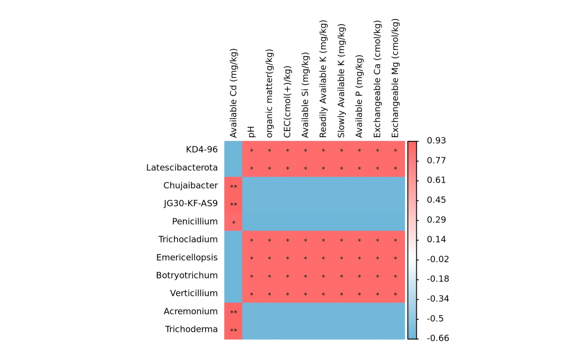
Fig. S5. Spearman correlation heatmap between soil physicochemical properties and dominant microbial genera in Cd-contaminated soil, * indicates significant difference at p < 0.05. ** indicates extremely significant difference at p < 0.01.

Fig. S6. Effects of PPMC application on the α-diversity indices of soil bacterial and fungal communities in Cd-contaminated farmland soil. (a) Chao1 index of soil bacterial community; (b) Shannon index of soil bacterial community; (c) Chao1 index of soil fungal community; (d) Shannon index of soil fungal community. * indicates significant difference at p < 0.05, ** indicates extremely significant difference at p < 0.01 (independent-samples t-test).

