Supplementary Information

Normal Mode Analysis of the Thermal conductivity in Amorphous Polymers:
The Importance of Localized Modes

Buxuan Li¹, Freddy DeAngelis², Gang Chen¹, Asegun Henry^{1,2}

¹Department of Mechanical Engineering, Massachusetts Institute of Technology, Cambridge MA, 02139, USA

²Woodruff School of Mechanical Engineering, Georgia Institute of Technology,
Atlanta, GA 30332, USA

Molecular dynamics and structure relaxation

All MD simulations were carried out using the open-source Large-scale Atomic/Molecular Massively Parallel Simulator (LAMMPS) MD software¹, modified to implement the GKMA protocol (described below). For all amorphous polymers simulations, the DREIDING force field was used². The DREIDING potential has been tested against real-world systems in numerous cases for organic molecules, including predictions of crystal structure², rotational energy barriers², conformational energies^{2–5}, and binding energies^{6,7}, with agreement ranging from satisfactory to excellent. Accurately creating amorphous polymer structures is challenging: not only are polymers polyatomic, but they are also comprised of varying individual units that consist of different atom types, functional groups, etc., all of which increases the heterogeneity of the structure substantially. All polymer simulations in this work were carried out on structures initially created using the Polymer Modeler^{8–10} and allowed to relax using LAMMPS.

Before any lattice dynamics calculations, the generated amorphous polymer structures were fully relaxed in MD. For example, in the a-PMMA case, the simulation domain was a cube 30.4 Å on each side with periodic boundary conditions. The a-PMMA consisted of 4 isotactic linear chains of 50 monomers each; given that a single monomer is comprised of 15 atoms, and accounting for the 2 H atoms at the end of each polymer chain, the total number of atoms in the supercell is 3008. The initial relaxation process involved several successive minimizations via the LAMMPS minimize command. This minimization process involves LAMMPS iteratively computing the local energy gradient (i.e., forces) for every atom and moving the atom some distance down the gradient. After this series of minimizations, the atoms were simulated at a finite temperature using MD with a 1 fs timestep. It should be noted that a timestep of 0.1 fs is necessary to adequately resolve the dynamics of H atoms in the polymer when calculating its TC. However a timestep 1 fs is sufficiently small for the purposes of structural relaxation, as an accurate atomic trajectory is unimportant¹¹. The atoms were simulated using a constant atom number, volume, and temperature (NVT) ensemble. The temperature was controlled by a Langevin thermostat.
The atoms were first heated and held at 300 K for 1 ns, subsequently cooled from 300 K to 0 K linearly over 1 ns, and then held at 0 K for an additional 1 ns. To ensure that the structure was fully relaxed, the structure was simulated for an additional 100 ps under a constant atom number, volume, and energy (NVE) ensemble. If the atoms were in an unstable configuration, they would develop non-zero velocities, through the conversion of potential energy (PE) into kinetic energy, and their position would change after some small (~10 fs) amount of time. However, after the additional 100 ps NVE simulation, the atoms of our relaxed structure did not change position appreciably (≪ 10⁻³ Å), and the temperature remained ~10⁻⁴ K (i.e., effectively 0 K). These observations confirmed to us that the structures were indeed relaxed to equilibrium.

All TC calculations were obtained by using the GKMA protocol on MD trajectories generated at 300 K with an NVE ensemble.

Lattice dynamics

Lattice dynamics was used to extract normal modes of atomic vibration. Normal modes are harmonic oscillators consisting of atoms under harmonic approximation. Normal modes form an orthonormal basis of atomic displacement. For a system with $N$ atoms, there are $3N$ degrees of freedom and thus $3N$ normal modes, which are the eigen states of the coupled Newtonian equation of motion with harmonic interactions. For crystalline materials with translational symmetry, Bloch theorem enables us to define phonons out of the normal modes from a simple primitive cell of crystalline materials, by modulating the normal modes with a periodic profiling ${\overset{⃑}{U}e}^{-i\left(ωt-\overset{⃑}{k}⋅\overset{⃑}{R}\right)}$. Here $\overset{⃑}{U}$ indicates the polarity of atom vibrations in the primitive cell, and $\overset{⃑}{R}$ is the position of the unit cell in concern. Therefore, we could get the vibrational modes of a larger supercell ($\overset{⃑}{R}≠0$) by a calculation only involve $\overset{⃑}{U}$, which is an eigen problem in the dimension of the primitive cell.

For an amorphous material, however, the lattice vibration can no longer be modulated by a wavevector due to the lack of translational symmetry. Phonons are not well defined in such systems. However, normal modes are still well-defined as the basic components in the frequency domain and as the energy carriers of heat conduction. The Newton’s equation of motion of each atom is described as:

$$\begin{aligned}m_{i}\ddot{u_{i}}=\sum_{j}{ϕ_{ij}u_{j}}\#\left(1\right)\end{aligned}$$

where $ϕ_{ij}$ are the interatomic force constants, defined as the second order derivative of total energy to the interatomic distance: $ϕ_{ij}=-\frac{∂^{2}E}{{\left(∂r_{ij}\right)}^{2}}$. This equation can be made symmetric in matrix form as follows:

$$\begin{aligned}e_{n}D=-ω_{n}^{2}e_{n}\#\left(2\right)\end{aligned}$$

where $e_{n}=\left(\frac{u_{i}^{α}}{\sqrt{m_{i}}}\right)$ is the eigenvector representing the vibrational normal mode, $i$ runs over all atoms, and $α$ runs over the three cartesian directions, $x,y,z$. $D=\left(D_{nm}\right)=\left(\frac{ϕ_{nm}}{\sqrt{m_{n}m_{m}}}\right)$ is the dynamical matrix, obtained from the interatomic force constants reweighted by the atomic masses of the associated atom pair. $-ω_{n}^{2}$ is the eigenvalue of normal mode $e_{n}$ in units of inverse time squared.

For a crystal supercell repeating (l,m,n) times in each direction, a Gamma point ($k=0$) lattice dynamics calculation is equivalent to a primitive cell lattice dynamics calculation with a (l,m,n) mesh in its first Brillouin zone (FBZ). For crystalline materials, calculations using a normal mode basis obtained from a Gamma point calculation of a large simulation domain is equivalent to using a normal mode basis obtained from a primitive cell with a dense k-mesh in the FBZ. However, for an amorphous material without translational symmetry, the convenience of a plane-wave phonon calculation is no longer available, and therefore only Gamma point LD can be performed. Ideally, to have converged results, the supercell used in the Gamma point LD calculation should be larger than the longest mean free path of the associated normal modes. Unfortunately, for an amorphous polymer, the mean free path of many normal modes is unknown to us. As such, the lattice dynamics calculation in this work were performed with supercell domains whose size was primarily limited by the available computational resources.

To construct the dynamical matrix used in LD calculations, we performed 3N finite displacement calculations, in which each atom was perturbed in each direction in real space by 0.01 Å, with one displacement from equilibrium per calculation. For each calculation, the resulting forces were obtained from all atoms of the system in every direction. The forces divided by the 0.01 Å displacement are the harmonic force constants, which is weighted by inverse square rooted mass to obtain the dynamical matrix.

Measure of localization: PR, MSE, and PCPR

Using the participation ratio (PR) as a means of distinguishing localized modes – namely locons – from delocalized modes (i.e., propagons and diffusons) was introduced by Bell & Dean¹². The PR for a mode $n$ is defined as:

$$\begin{aligned}PR_{n}=\frac{{\left(\sum_{i}^{N}{e_{i,n}^{2}}\right)}^{2}}{N\sum_{i}^{N}{e_{i,n}^{4}}}\#\left(3\right)\end{aligned}$$

where $e_{i,n}$ is the eigenvector of the $i^{th}$ atom for the $n^{th}$vibrational mode, and $N$ is the number of atoms in the supercell. If only a few atoms have large eigenvectors, the PR is small, and the mode is a locon. On the other hand, if the majority of the atoms have large eigenvectors, the PR is large, and the mode is delocalized, either as a propagon or diffuson. One way to view the PR is that it represents the fraction of atoms participating in a vibration. Thus, for a mode with PR = 1, 100% of the atoms participate in the vibration, whereas when the PR is ~$1/N$, only a single atom would be participating. The lowest threshold for delineating locons in the literature is PR < 0.1. Using this threshold, we have observed abnormally high degree of localization in all three polymers studied here, as discussed in the main text. Here, we emphasize that this observation is general and independent of simulation size. We performed similar lattice dynamics in a series of simulations involving different domain sizes of three polymers in study. The PR spectrum of the three polymers with different simulation domain sizes are shown in Fig. S1.
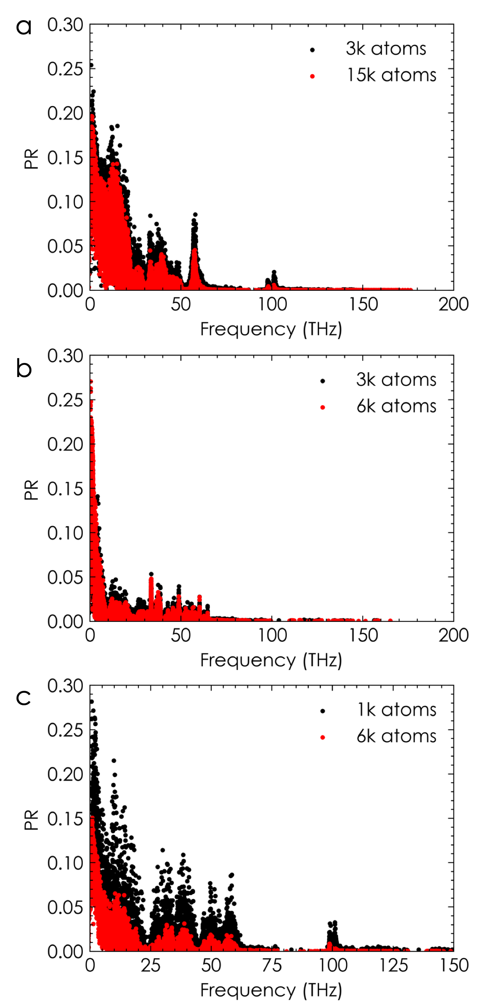
Figure S1| Comparison of PR spectrum over different simulation domain sizes of a-PMMA (panel a), a-PS (panel b), and a-PVC (panel c). (Colors online)
This figure shows that the degree of localization of normal modes in a-PS and a-PVC are consistent with observations seen in a-PMMA: most modes have a PR < 0.2. Fig. S1 also demonstrates that the proportion of locon populations is persistent in the three amorphous polymers regardless of domain size. Likewise, overall PR spectrums remains largely unchanged with domain size. The only observable difference in the PR spectrum, if any, is that modes are actually slightly more localized (smaller PR) in larger domain systems. This is the opposite of what would be expected from conventional amorphous semiconductors, were there any discrepancy in the PR spectrums for such systems across different domain sizes.¹³ The phenomenon observed here may be attributed to the fact that locons dominates the normal modes in amorphous polymers, including many that are localized onto individual chains. The number of excited atoms of a locon mode only involving one chain would not scale up with an increasing number of polymer chains in a simulation, hence resulting in a smaller PR for larger domain sizes. Presumably, propagons will also be observed in these materials, but only if one studies much larger supercells (e.g. 1-10 μm, rather than ~30 nm in this work). However, relaxing such a large supercell and performing LD/GKMA calculations are beyond the scope of this work, due to their computational cost.

Mode spatial extent (MSE) measures how a mode is spatially distributed, or the spatial spreading of its vibrational energy. To measure how the energy is distributed spatially, one can divide a supercell into thin rectangular “slices” of atoms and sum the square of the eigenvectors the atoms of in a given slice to give a single value. This value for each slice is fitted as a function of location in the direction perpendicular to the slices, which resembles that of Gaussians. While a single Gaussian can describe the general shape of these curves, we found that fitting a two-term Gaussian ($f\left(x\right)=a_{1}e^{-{\left(\frac{x-b_{1}}{c_{1}}\right)}^{2}}+a_{2}e^{-{\left(\frac{x-b_{2}}{c_{2}}\right)}^{2}}$) allows the function to more accurately capture the behavior of the eigenvector-sums, since many modes either have two peaks or have a long tail offset far away from a major peak. One set of outputs of this fitting procedure is the variances of the Gaussian peaks (i.e., their widths). A wide peak indicates a long “tail” of eigenvectors, which would indicate a mode is delocalized, while a narrow peak would correspond to only a few atoms whose eigenvectors are much larger than their neighbors, indicating a localized mode. The resultant variances of the Gaussian peaks in each of the three spatial directions are then averaged. It is this resulting average of variances that is defined as the MSE. The MSE has units of distance and is typically expressed in Å; it can be thought of as the effective “size” of a vibrational mode. To be specific, the calculations in this study use 40 slices in each direction, resulting in 0.75 Å layers with ~ 70 atoms in each layer. It is justified that the number of slices is insensitive to the MSE results so long as the slices are thin enough (< 2 Å) and contain substantial atoms (> 30 atoms). The procedure is repeated three times in each direction and the average is taken as the MSE for each mode.

To show how the MSE provides additional information about the spatial distribution of modes, we present several typical modes with low PR (<0.05) yet large MSE (>100 Å) in Fig. S2. Again, these two measures are not in conflict, as several atoms with extremely large eigenvectors can have a small PR, but still exhibit a large spatial distribution of excited atoms.
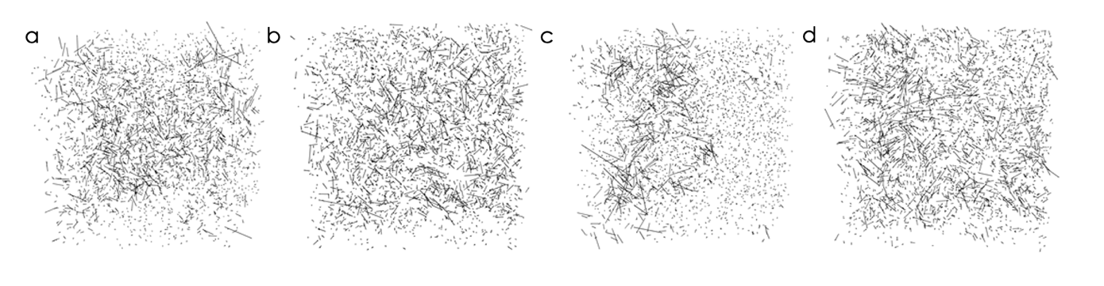
Figure S2| Typical normal mode eigenvectors in a-PMMA with low-PR and high-MSE. There are 3000 atoms in simulation. The arrows show the vibrational direction and amplitude of each atom. Atoms are removed in figures for clarity. a. PR=0.036, MSE=331 Å. b. PR=0.05, MSE=392 Å. c. PR=0.027, MSE=422 Å. d. PR=0.036, MSE=116 Å.

Another localization metric, the polymer chain participation ratio (PCPR), modifies the numerator of PR to only include atoms in a single polymer chain. For a polymer with 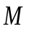 atoms in a polymer chain, the PCPR sum would be

$$\begin{aligned}PCPR_{n}=\frac{{\left(\sum_{i}^{M}{e_{i,n}^{2}}\right)}^{2}}{N\sum_{i}^{N}{e_{i,n}^{4}}}\#\left(4\right)\end{aligned}$$

There will be a total of$M$ PCPR values for each mode (corresponding to $M$individual polymer chains). This method has been derived and applied for systems where there are an equal number of atoms on each chain. If one wished to normalize PCPR for systems with a different number of atoms on each chain, one could presumably normalize the PCPR differently, namely by

$$\begin{aligned}PCPR_{n}^{*}=\frac{{\left(\sum_{i}^{N^{*}}{e_{i,n}^{2}}\right)}^{2}}{N^{*}\sum_{i}^{N}{e_{i,n}^{4}}}\#\left(5\right)\end{aligned}$$
Where $N^{*}$ is the number of atoms in each polymer chain. If, however, the number of atoms on each polymer chain are the same, which is the case in this work, these two PCPR’s will just differ by a factor of $M$, and there is no particular reason to use one value over the other. Thus, this work will use the PCPR defined in Equation (4).

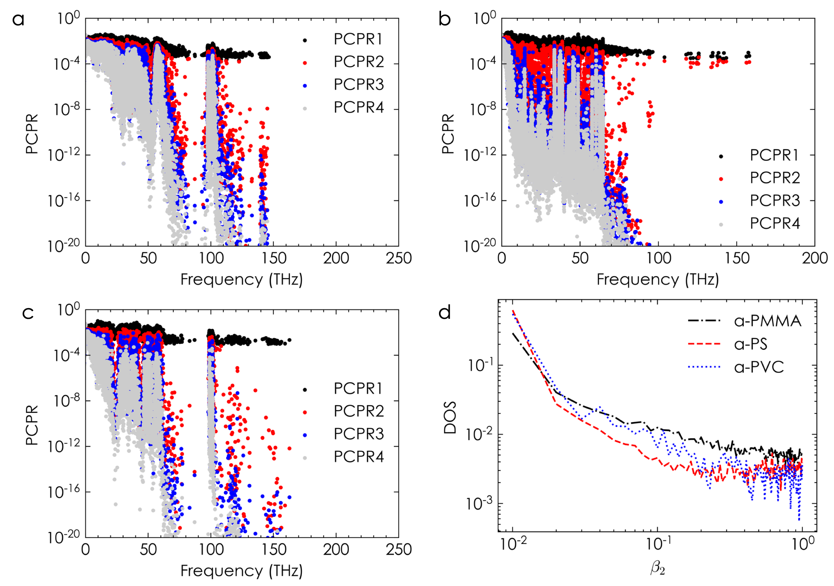
Figure S3| PCPR spectrums of a-PMMA (panel a), a-PS (panel b), and a-PVC (panel c). Panel d shows the DOS with respect to $β_{2}$ for three polymers. (Colors online)
The width of PCPR values at given frequency in the PCPR spectrum indicates how the modes are localized. For example, the low frequency modes in a-PMMA below 10THz all have $β_{4}<0.01$. Thus, the low-frequency modes are more likely to involve all four polymer chains. However, a large separation of PCPR values in the a-PMMA spectrums is observed for frequencies higher than 50 THz, indicating orders of magnitude greater energy concentrating on one primary chain. As a result, we can conclude that these modes are confined onto a single chain. The value $β_{2}$ gives a more quantitative measure of this observation. The spectrum of $β_{2}$suggests that more than half of the localized modes are confined onto a single chain.

Polymer chain partition of normal mode energy

Energy $E$ of an excited normal mode consists of potential $E_{p}$ and kinetic $E_{k}$ contributions. Under harmonic approximation, the total energy of an excited mode is a constant which therefore could be calculated as the potential energy at the maximum displacement ($E=E_{p}$). The maximum displacement $u_{i}^{α}$of one mode is related to the corresponding eigenvector $e_{i}^{α}$ of the dynamical matrix by $u_{i}^{α}∝\sqrt{m_{i}}e_{i}^{α}$, for atom $i$ and direction $α$, as discussed in the LD section. Furthermore, under modal coordinate, the harmonic energy of mode $n$ could also be expressed in terms of mode eigenvector $e_{n}$ and dynamical matrix $D$ as:
$$\begin{aligned}E=E_{p}^{n}=\frac{A^{2}}{2}e_{n}^{T}⋅D{⋅e}_{n}=\frac{{A^{2}ω}_{n}^{2}}{2}e_{n}^{T}⋅e_{n}=\frac{A^{2}ω_{n}^{2}}{2}\sum_{i,α}{e_{i,α}^{2}} \#\left(6\right)\end{aligned}$$

$A$ is the amplitude of one mode decided by the absolute value of modal energy, and $ω_{n}$ is the modal frequency. Since modal eigenvectors are normalized, i.e. $\sum_{i,α}{e_{i,α}^{2}=1}$, the percentage of energy contribution from a subgroup of atoms, e.g. a polymer chain, to one mode will be the partial summation of the modal eigenvector norm as $\sum_{i∈Chain}{e_{i,α}^{2}}$.

The energy concentration onto the primary chain (EC) of one mode is therefore the partial summation of the modal eigenvector norm, which is related to the proposed PCPR in Equation (4) as:

$$\begin{aligned}\text{EC}=\frac{\sqrt{PCPR_{1}}}{\sum_{i}{\sqrt{{PCPR}_{i}}}} \#\left(7\right)\end{aligned}$$

EC is bounded by the $β_{2}$ by definition: $\frac{1}{3+\sqrt{β_{2}}}<\text{EC}<\frac{1}{1+\sqrt{β_{2}}}$ for our studies involving four identical chains. These two limits are observed in all polymers studied as shown in Fig. S4a, b, and c. To be specific with our criterion of identification of modes localized onto a single chain, $β_{2}<0.1$, we showed the normalized cumulative DOS for this subgroup of modes in Fig. S4d. It is shown that for modes with $β_{2}<0.1$, at least 53% total energy is confined onto a single chain and most of the modes will have over 90% energy localized onto their primary chains. We also presented the normalized cumulative DOS and TC with respect to EC for all modes in three polymers studied in Fig. S4e and f. There are jumps at EC=1 for both plots, indicating there are non-negligible amount of modes with exactly one chain been excited.

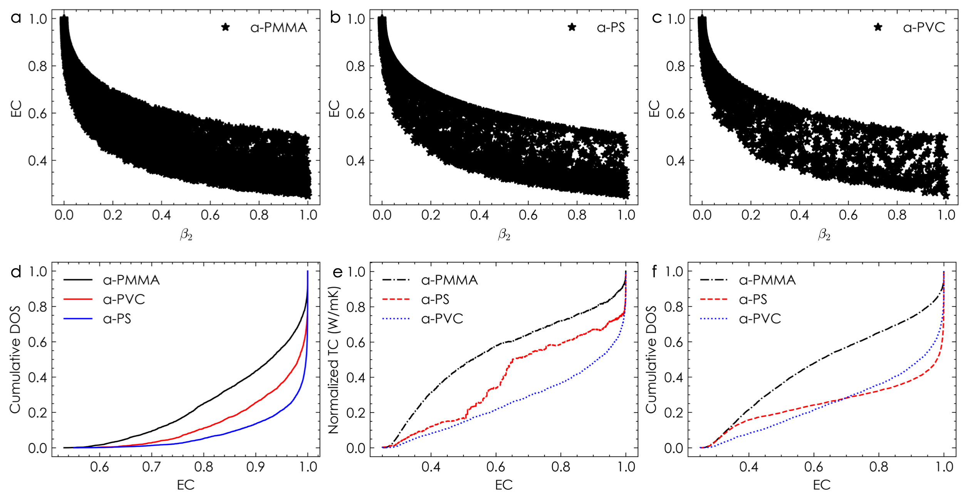
Figure S4| Energy concentration onto primary chain. a,b,c. EC versus $β_{2}$ for a-PMMA, a-PS, and a-PVC. d. Cumulative DOS with respect to EC for modes with $β_{2}<0.1.$ e. Cumulative TC with respect to EC of all modes. f. Cumulative DOS with respect to EC of all modes. (Colors online)

Green Kubo formula and Modal Analysis

The GK method is a perturbation method based on the linearized Liouville equation.^{14,15} For a system comprised of N particles with known positions and momenta, one can determine the TC of a system via

$$\begin{aligned}k_{αβ}\left(T,ω\right)=\frac{V}{k_{B}T^{2}}\int_{0}^{∞}{<J_{α}\left(0\right)⋅J_{β}\left(t\right)>⋅e^{-iωt}dt}\#\left(8\right)\end{aligned}$$
where${ k}_{αβ}\left(T,ω\right)$ is a tensor that gives TC in the $αβ$ direction for a given temperature $T$ at a specific thermal perturbation frequency $ω$. $V$ is the volume of the system, $k_{B}$ is Boltzmann’s constant, $J$ is the heat flux, and $t$ is time. The $<>$ operator denotes the ensemble average. A detailed derivation of this equation can be found elsewhere.^{15–18}
When considering the timescales over which atoms oscillate (i.e., the THz regime), the frequency is several orders of magnitude larger than the frequency at which temperature perturbations typically occur (anywhere from MHz down to <1 Hz). As such we can consider only the zero-frequency limit for steady state heat conduction, allowing the TC to be rewritten as

$$\begin{aligned}k_{αβ}\left(T\right)=\frac{V}{k_{B}T^{2}}\int_{0}^{∞}{<J_{α}\left(0\right)⋅J_{β}\left(t\right)>⋅dt} \#\left(9\right)\end{aligned}$$

It is worth pointing out the GK method is general for both crystalline and amorphous materials. Contributions from different normal modes are implicitly included in the calculation. The ability of GK analysis to describe disordered materials without any modifications to the theory is arguably its strongest advantage over the use of PGM-based methods. Moreover, since it can be applied to modes without a well-defined wave vector, the GK method can also be used to calculate the TC liquids and gases, in addition to solid materials (which are the focus of PGM-based methods). The GK method also allows one to include all degrees of anharmonicity – i.e. 3-phonon, 4-phonon, up to 3N-phonon interactions – implicitly inherited from the EIP in MD.

There is however one drawback to GK analysis that limits its usefulness for studying heat transfer mechanisms via MD: whereas PGM-based methods can attribute TC to a specific mode or collection of modes, GK analysis will provide only bulk values of TC. Using a combination of GK analysis and LD, however, can allow one to determine the contribution of any given subset of modes to the total TC of the system. This method, GKMA, is a powerful tool for determining mode-level contributions without any of the approximations required by the PGM. Thus, GKMA is uniquely situated to provide an unprecedented degree of information when analyzing the vibrational modes’ effect on TC in disordered materials.

GKMA relies on projecting real-space atomic trajectories onto the normal mode coordinates. The eigenvectors of a dynamical matrix form an orthonormal basis for the vector $\sqrt{m_{i}}u_{i}^{α}$, i.e., a square root mass-weighted displacement of each atom $i$ in each direction $α$. Using normal mode coordinates, the displacement vector and velocity vector at each molecular dynamics step can be expressed in a basis of these eigenvectors:

$$\begin{aligned}U_{n}=\sqrt{m}u⋅e_{n}, {\dot{U}}_{n}=\sqrt{m}\dot{u}⋅e_{n}\#\left(10\right)\end{aligned}$$

where $u, \dot{u}$ are the vectors of displacement and velocity indexed by atom $i$ and direction $α$, e.g. $u=\left(u_{i}^{α}\right)$, and $e_{n}$ is the eigenvector, $e_{n}=(e_{n}^{i,α})$. $U_{n}, {\dot{U}}_{n}$ are scalar. In normal modes coordinates, the harmonic potential energy and kinetic energy of this system is therefore:

$$\begin{aligned}E_{h}=\frac{1}{2}\sum_{i}{ω_{n}^{2}U_{n}^{2}, E_{k}=\frac{1}{2}\sum_{i}{\dot{U_{n}^{2}}}} \#\left(11\right)\end{aligned}$$

In MD, the heat flux is calculated following the method proposed by Hardy¹⁹:

$$\begin{aligned}J_{α}=\frac{1}{V}\sum_{i}{{(E}_{i}{\dot{u}}_{i}+}\sum_{i<j}{(F_{ij}\dot{{⋅u}_{j}}})r_{ij} ) \#\left(12\right)\end{aligned}$$
where the normalization factor $V$ is simulation volume, $E_{i}=\frac{1}{2}m_{i}\sum_{α}{{{\dot{u}}_{i}^{α}}^{2}}+ \sum_{k}{\frac{1}{k}p_{k}}$ is the total energy associated with atom $i$, and where the potential energy of $k$ atoms interaction is assumed to be uniformly distributed. ${F_{ij}, r}_{ij}$ are the force and distance between atom $i$ and atom $j$. The two terms in brackets in Hardy’s expression correspond to the convective and conductive terms, respectively. The convective term dominates in liquids and gases,²⁰ while the conductive term is dominant in solids.²¹

Within the GKMA formalism, velocity can be decomposed into a normal mode basis, using the inverse of Equation (10). From this, the heat flux contributed by each mode can be written as:

$$\begin{aligned}J_{α}=\sum_{n}{J_{α}^{n}} \#\left(13\right)\end{aligned}$$

$$\begin{aligned}J_{α}^{n}=\frac{1}{V}\sum_{i}{\left(\frac{E_{i}}{\sqrt{m_{i}}}e_{n}^{i,α}U_{n}+\sum_{j}{\frac{F_{ij}}{\sqrt{m_{j}}}e_{n}^{j,α}{\dot{U}}_{n}} r_{ij}\right)} \#\left(14\right)\end{aligned}$$

Using these mode-specific contributions to heat flux, the original GK formula for TC can therefore be expanded into modal contributions coming from all pairs of modes:

$$k_{αβ}=\frac{V}{k_{B}T^{2}}\int{<J_{α}\left(t+t^{'}\right)J_{β}\left(t\right)>dt^{'}} \\ \begin{aligned} =\frac{V}{k_{B}T^{2}}\sum_{n,m}{\int{<J_{α}^{n}\left(t+t^{'}\right)J_{β}^{m}\left(t\right)>dt^{'}} } \#\left(15\right)\end{aligned}$$

where $<>$ means ensemble average and $t'$ runs from zero to infinity. We can then rewrite the GK formula as a sum of contributions from normal mode$n$:

$$\begin{aligned}k_{αβ}^{n}=\frac{V}{k_{B}T^{2}}\sum_{m}{\int{<J_{α}^{n}\left(t+t^{'}\right)J_{β}^{m}\left(t\right)>}dt^{'}} \#\left(16\right)\end{aligned}$$

Compared to the phonon gas model, this expression not only includes the diagonal contributions to TC from each mode, $k_{αβ,0}^{n}=\frac{V}{k_{B}T^{2}}\int{<J_{α}^{n}{\left(t+t^{'}\right)J}_{β}^{n}(t)>}dt'$, but also takes the off-diagonal terms representing the coupling between any pair of modes.

In Fig. S5, the modal TC obtained from GKMA of the three polymers of interest are shown. We present the modal TC as a function of modal frequency (a) and as a function of localization metrics PR (b) and MSE (c). The spreading of modal TC is wider at lower PR/MSE, indicating that the active modes with larger modal TC values are more likely to more localized. Note that the modal TC from GKMA can be negative without violating the second law of thermodynamics. The total thermal conductivity is always positive and agrees with values reported in experiments as shown in Fig. 5.
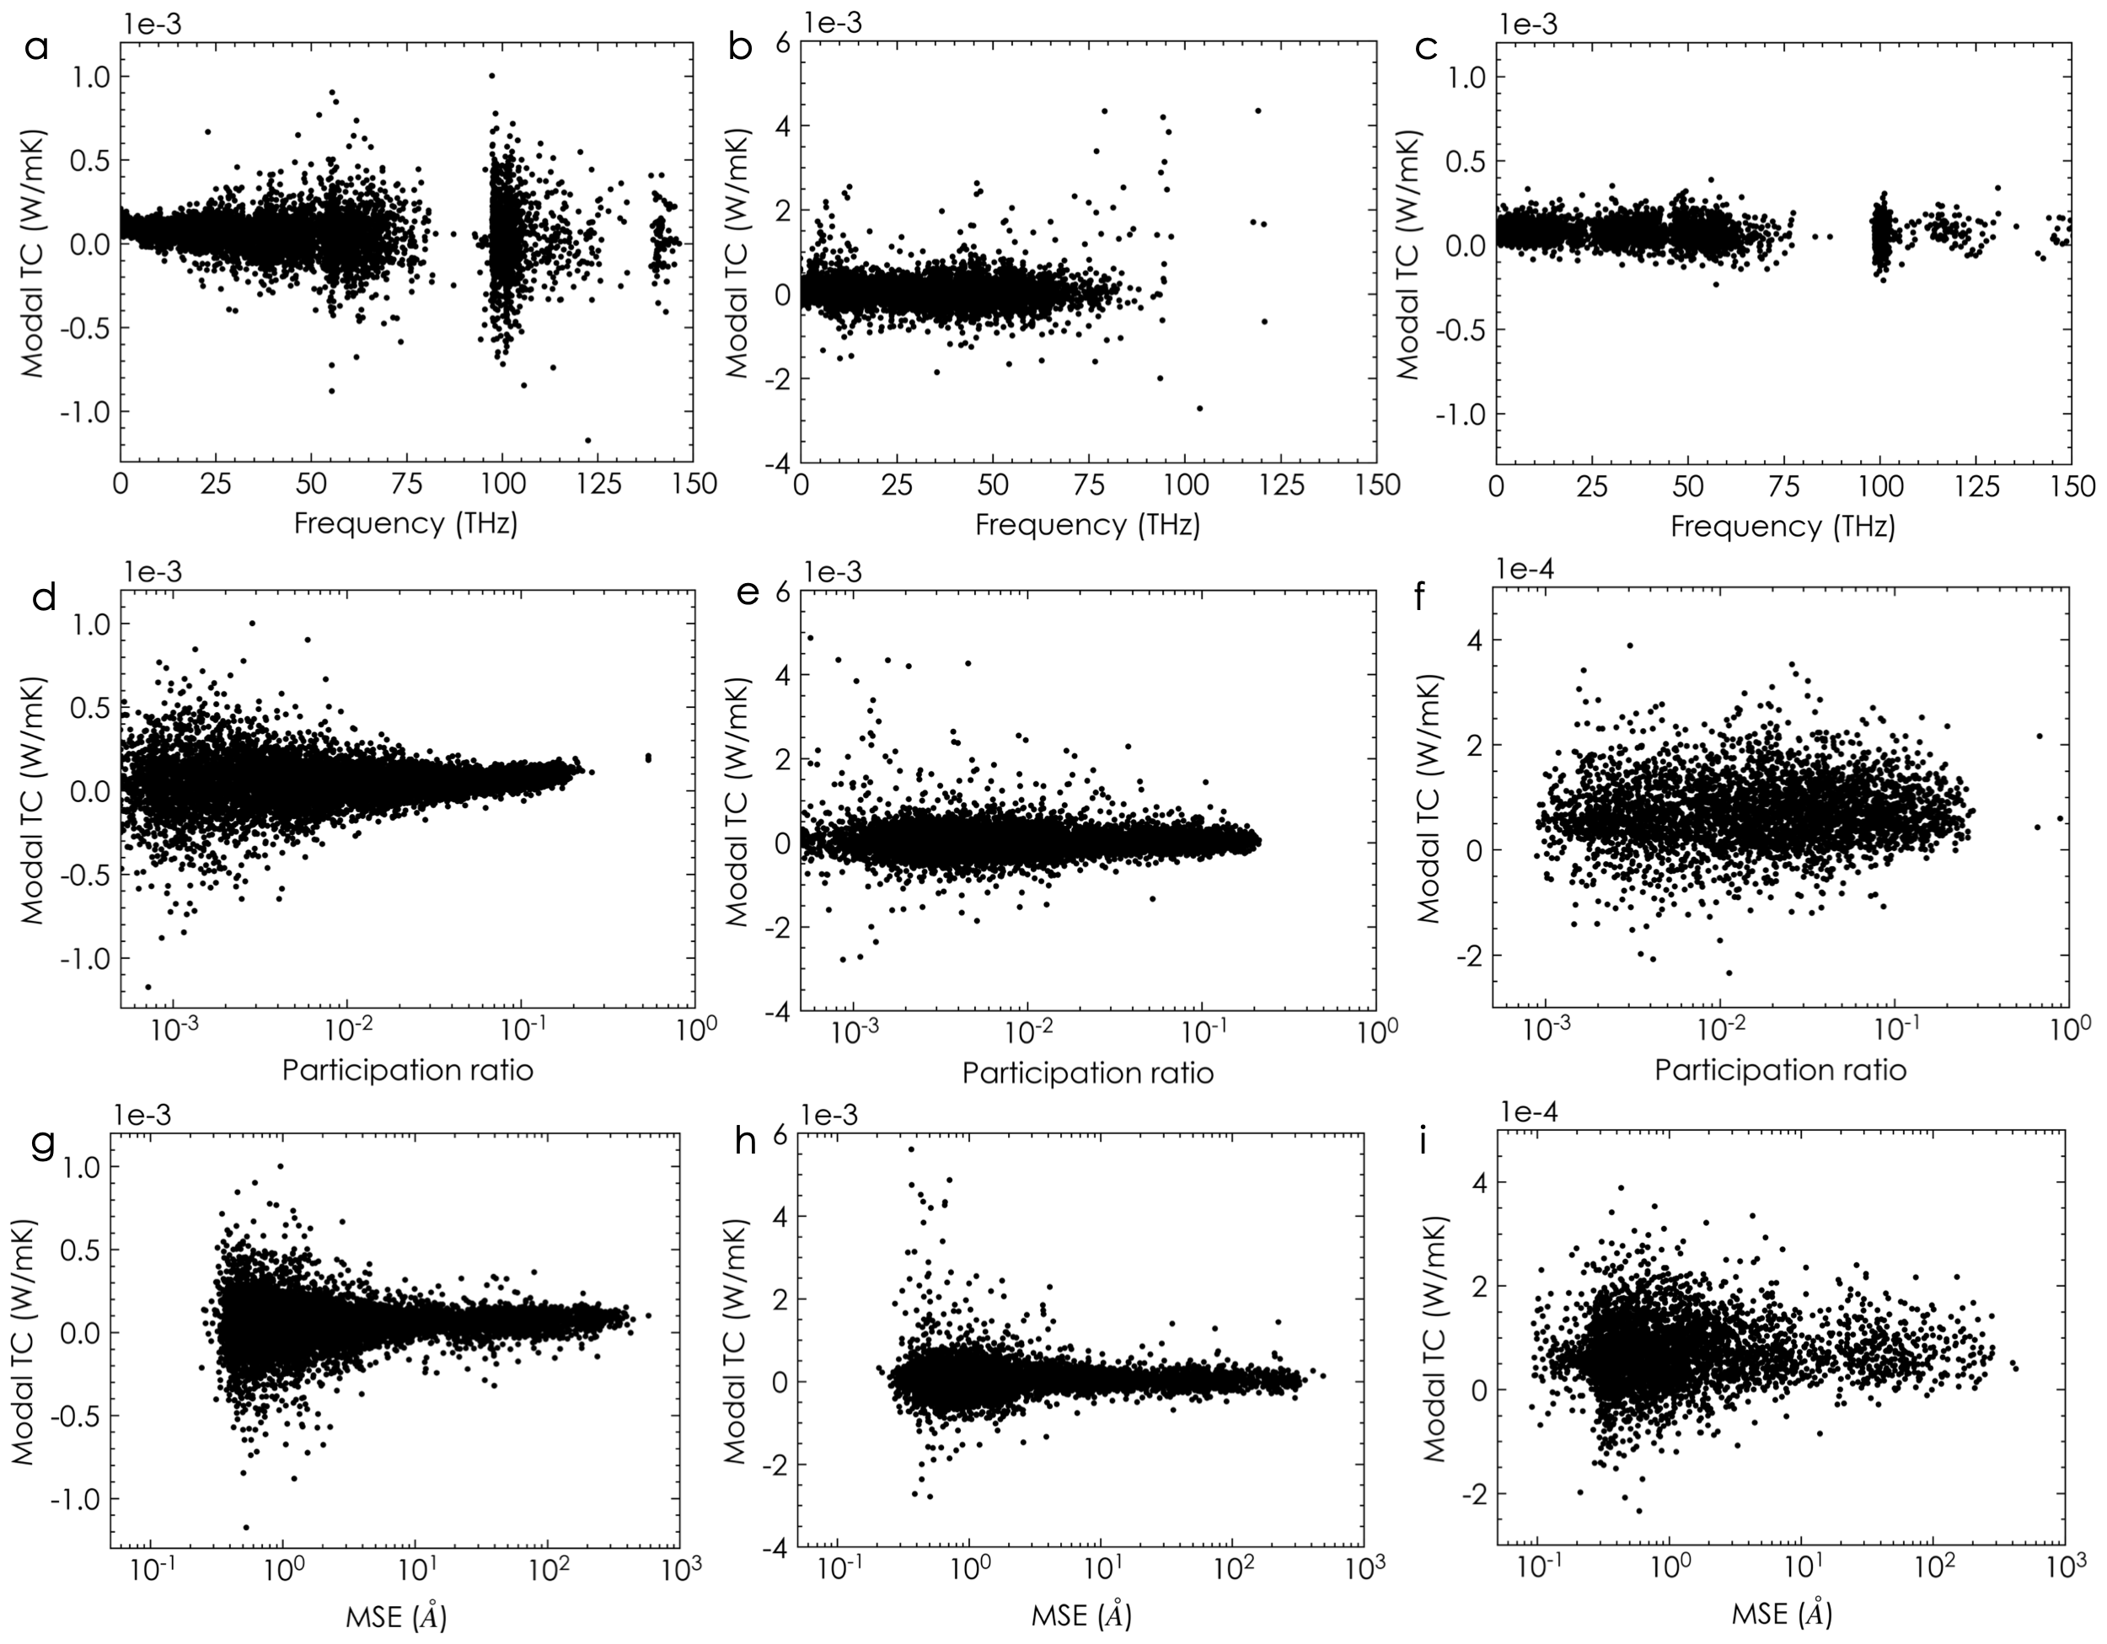
Figure S5| Modal TC of a-PMMA with 3000 atoms. a. Contour maps of modal heat flux correlation represented in 2D and 3D. b. Modal TC versus mode frequency. c. Modal TC versus mode PR. d. Modal TC versus mode MSE.

Because GKMA allows one to ascribe a TC to each mode, and because one can determine the mode’s frequency, a quantum correction can be applied to the TC contribution from the mode. The quantum correction reweights modal contribution to thermal conductivity under given temperatures. Direct GK calculation in equilibrium MD is insufficient to capture the temperature dependent thermal conductivity. Because the classical dynamics that used to update atomic positions and velocities implies equipartition of modal occupation numbers. The normal modes, however, follow a Bose-Einstein distribution and at low temperature may not be fully excited. Therefore, with the modal TC one could apply the quantum correction using the corresponding mode frequency by reweighting their occupation number according to a Bose-Einstein distribution:

$$\begin{aligned}C_{q}\left(ω,T\right)=\frac{k_{B}x^{2}}{V}\frac{e^{x}}{{\left(e^{x}-1\right)}^{2}};x=\frac{hω}{k_{B}T} \#\left(17\right)\end{aligned}$$

where $C_{q}\left(ω,T\right)$ is the quantum corrected heat capacity.

References

1. Plimpton, S. Fast parallel algorithms for short-range molecular dynamics. J. Comput. Phys. 117, 1–19 (1995).
2. Mayo, S. L., Olafson, B. D. & Goddard, W. A. DREIDING: A generic force field for molecular simulations. J. Phys. Chem. 94, 8897–8909 (1990).
3. Floriano, W. B., Vaidehi, N., Zamanakos, G. & Goddard, W. A. HierVLS Hierarchical Docking Protocol for Virtual Ligand Screening of Large-Molecule Databases. J. Med. Chem. 47, 56–71 (2004).
4. Kekenes-Huskey, P. M., Vaidehi, N., Floriano, W. B. & Goddard, W. A. Fidelity of phenylalanyl-tRNA synthetase in binding the natural amino acids. J. Phys. Chem. B 107, 11549–11557 (2003).
5. Brameld, K. A. & Goddard, W. A. Ab initio quantum mechanical study of the structures and energies for the pseudorotation of 5’-dehydroxy analogues of 2’-deoxyribose and ribose sugars. J. Am. Chem. Soc. 121, 985–993 (1999).
6. Datta, D. et al. Interaction of E. coli outer-membrane protein A with sugars on the receptors of the brain microvascular endothelial cells. Proteins Struct. Funct. Genet. 50, 213–221 (2003).
7. Datta, D., Vaidehi, N., Xu, X. & Goddard, W. A. Mechanism for antibody catalysis of the oxidation of water by singlet dioxygen. Proc. Natl. Acad. Sci. U. S. A. 99, 2636–2641 (2002).
8. Anstine, D. M., Strachan, A. & Colina, C. M. Effects of an atomistic modeling approach on predicted mechanical properties of glassy polymers via molecular dynamics. Model. Simul. Mater. Sci. Eng. 28, 025006 (2020).
9. Li, C. & Strachan, A. Cohesive energy density and solubility parameter evolution during the curing of thermoset. Polymer (Guildf). 135, 162–170 (2018).
10. Islam, M. M. & Strachan, A. Decomposition and Reaction of Polyvinyl Nitrate under Shock and Thermal Loading: A ReaxFF Reactive Molecular Dynamics Study. J. Phys. Chem. C 121, 22452–22464 (2017).
11. Bitzek, E., Koskinen, P., Gähler, F., Moseler, M. & Gumbsch, P. Structural relaxation made simple. Phys. Rev. Lett. 97, 170201 (2006).
12. Bell, R. J. & Dean, P. Atomic vibrations in vitreous silica. Discuss. Faraday Soc. 50, 55–61 (1970).
13. Crupi, C., D’angelo, G., Tripodo, G., Carini, G. & Bartolotta, A. Low-temperature specific heat in caesium borate glasses. Philos. Mag. 87, 741–747 (2007).
14. Kubo, R. Statistical’Mechanical Theory of Irreversible Processes. I. General Theory and Simple Applications to Magnetic and Conduction Problems. J. Phys. Soc. Japan 12, 570–586 (1957).
15. Kubo, R., Yokota, M. & Nakajima, S. Statistical-Mechanical Theory of Irreversible Processes. Response to Thermal Disturbance. J. Phys. Soc. Japan 12, 1203–1211 (1957).
16. Chen, G. P. Nanoscale energy transport and conversion : a parallel treatment of electrons, molecules, phonons, and photons. (Oxford University Press, 2005).
17. Zhang, Z. M. Nano/Microscale Heat Transfer. (Springer International Publishing, 2020). doi:10.1007/978-3-030-45039-7.
18. Kubo, R. Statistical’Mechanical Theory of Irreversible Processes. I. General Theory and Simple Applications to Magnetic and Conduction Problems. J. Phys. Soc. Japan 12, 570–586 (1957).
19. Hardy, R. J. Energy-flux operator for a lattice. Phys. Rev. 132, 168–177 (1963).
20. Enhanced thermal conductivity of nanofluids diagnosis by molecular dynamics simulations - PubMed. https://pubmed.ncbi.nlm.nih.gov/19051928/.
21. McGaughey, A. J. H. & Kaviany, M. Phonon transport in molecular dynamics simulations: Formulation and thermal conductivity prediction. Adv. Heat Transf. 39, 169–255 (2006).

