Contents

Supplementary Table 6: SF-36 domains heterogeneity Page 2
Supplementary Figures 11-25: Meta-Analysis of ThyPRO Domains Across Treatment Modalities with
Forest Plots Page 4
Supplementary Table 7: ThyPRO domains heterogeneity Page 10
Supplementary Table 8: SF-36 and ThyPRO Sensitivity Analysis Page 13
References Page 14

Supplementary Table 6. SF-36 domains heterogeneity
Domain | Pooled mean | 95% Confidence interval | Q | I2
SF-36 Antithyroid Drugs
Physical functioning | 66.24 | (43.97, 88.50) | 2140.99 (p < .001) | 99.64%
Physical role limitation | 60.66 | (44.80, 76,52) | 1248.27 (p < .001) | 99.07%
Bodily pain | 56.76 | (37.25, 76.27) | 2140.99 (p < .001) | 99.64%
General health perception | 63.3 | (52.71, 73.88) | 523.16 (p < .001) | 98.68%
Vitality | 55.9 | (44.63, 67.16) | 1037.99 (p < .001) | 99.24%
Social functioning | 65.78 | (48.81, 82.76) | 2523.11 (p < .001) | 99.52%
Emotional role limitation | 62.92 | (48.19, 77.65) | 1177.09 (p < .001) | 98.97%
Mental health | 62.19 | (53.63, 70.75) | 444.7 (p < .001) | 98.62%
Physical component scale | 51.68 | (49.15, 54.20) | 15.33 (p = .001) | 85.13%
Mental component scale | 47.69 | (42.74, 52.63) | 20.29 (p < .001) | 89.28%
SF-36 Surgery
Physical functioning | 67.22 | (40.32, 94.12) | 1697.24 (p < .001) | 99.74%
Physical role limitation | 70.75 | (48.91, 92.58) | 1086.95 (p < .001) | 99.21%
Bodily pain | 51.11 | (22.70, 79.51) | 829.02 (p < .001) | 99.48%
General health perception | 63.05 | (53.88, 72.21) | 206.92 (p < .001) | 96.58%
Vitality | 55.41 | (47.1, 63.71) | 92.71 (p < .001) | 97.70%
Social functioning | 72.32 | (55.62, 89.01) | 804.7 (p < .001) | 98.97%
Emotional role limitation | 70.79 | (58.79, 82.79) | 205.36 (p < .001) | 97%
Mental health | 66.55 | (62.77, 70.32) | 36.7 (p < .001) | 84.50%
Physical component scale | 51.29 | (48.37, 54.22) | 3.53 (p= 0.0602) | 71.70%
Mental component scale | 47.37 | (45.66, 49.08) | 1.10 (P=0.2952) | 8.75%
SF-36 Radioiodine
Physical functioning | 84.02 | (78.53, 89.52) | 27.75 (p < .001) | 84.92%
Physical role limitation | 76.3 | (68.49, 84.11) | 11.28 (p=0.01) | 73.16%
Bodily pain | 68.57 | (65.94, 71.20) | 2.27 (p=0.518) | 0%
General health perception | 65.61 | (59.74, 71.48) | 16.22 (p=0.001) | 79.33%
Vitality | 59.35 | (50.35, 68.34) | 37.74 (p < .001) | 92.25%
Social functioning | 80.95 | (73.10, 88.79) | 28.69 (p < .001) | 85.41%
Emotional role limitation | 78.23 | (69.61, 86.85) | 21.17 (p < .001) | 81.66%
Mental health | 67.07 | (60.09, 74.05) | 35.65 (p < .001) | 90.84%
Physical component scale | 48.28 | (46.68, 49.89) | 7.86 (p=0.049) | 65.26%
Mental component scale | 45.14 | (40.49, 49.80) | 30.3 (p < .001) | 92.67%

All data are presented as mean (95% confidence interval).

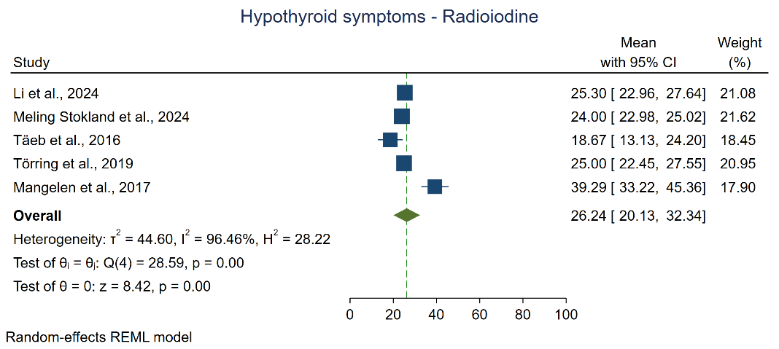
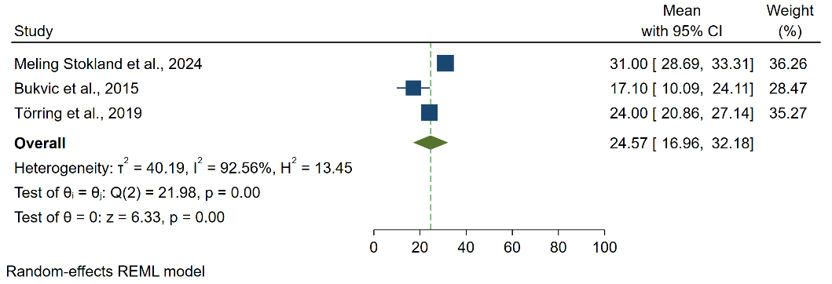
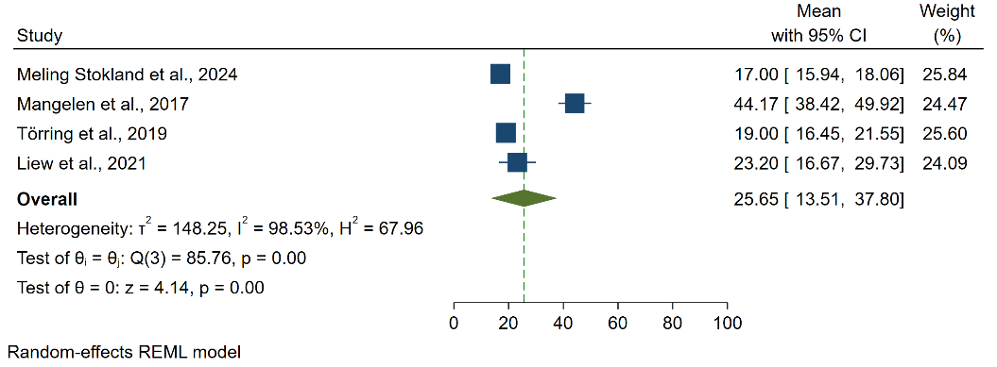
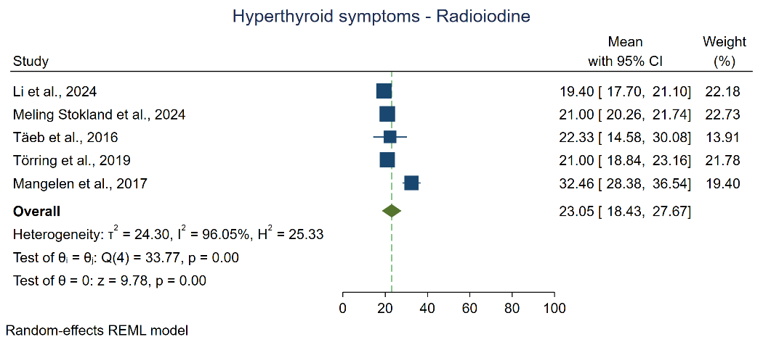
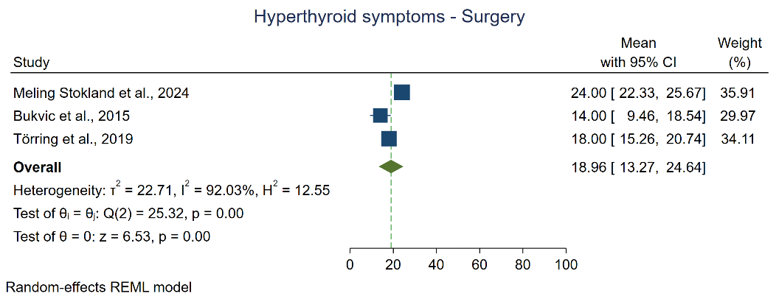
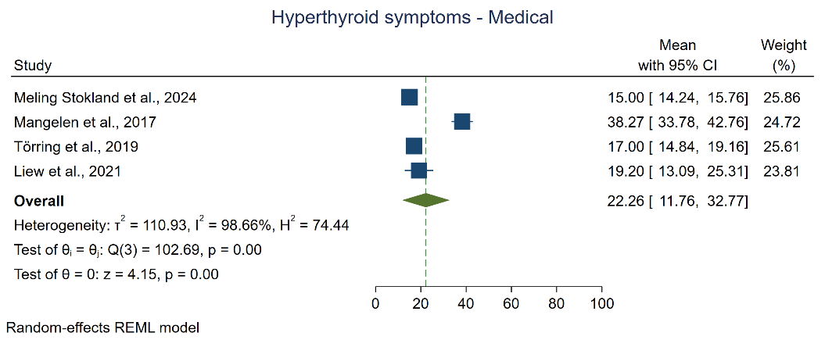
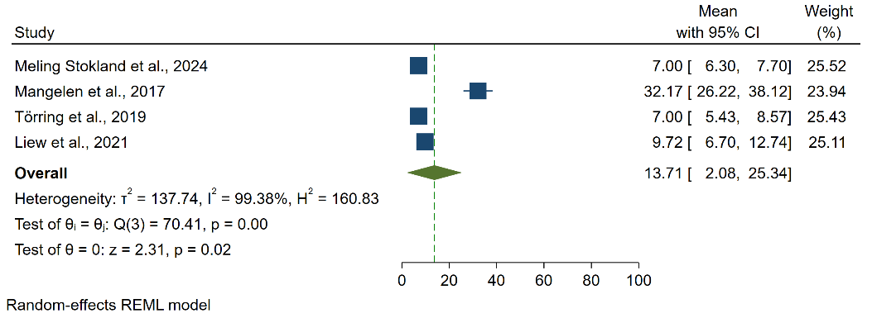
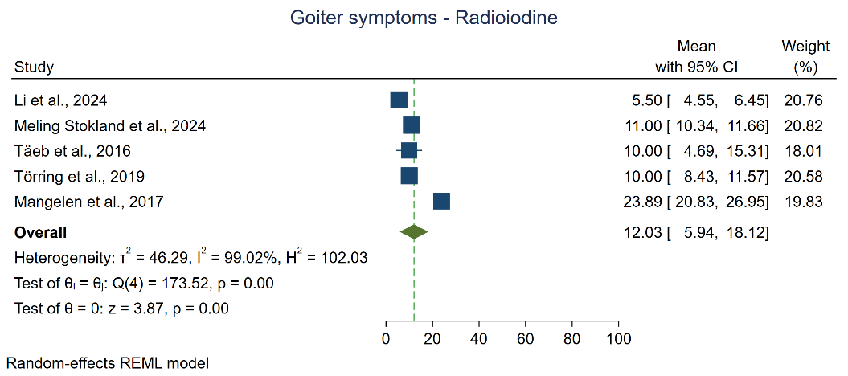
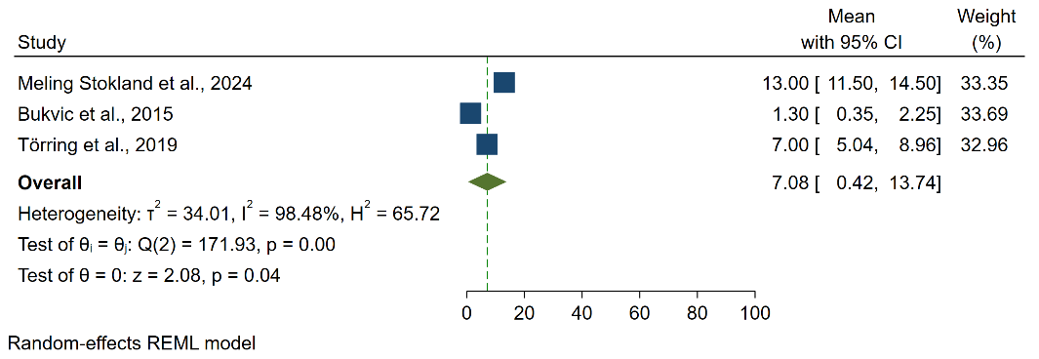
Supplementary Fig 13. Hypothyroid symptoms domain scores for different treatment modalities

Supplementary Fig 12. Hyperthyroid symptoms domain scores for different treatment modalities

Supplementary Fig 11. Goiter symptoms domain scores for different treatment modalities

C. Radioiodine– Hypothyroid symptoms domain
B. Surgery– Hypothyroid symptoms domain
A. Antithyroid drug– Hypothyroid symptoms domain
C. Radioiodine– Hyperthyroid symptoms domain
B. Surgery– Hyperthyroid symptoms domain
A. Antithyroid drug– Hyperthyroid symptoms domain
Meta-Analysis of ThyPRO Domains Across Treatment Modalities with Forest Plots
C. Radioiodine– Goiter symptom domain
B. Surgery– Goiter symptom domain
A. Antithyroid drug– Goiter symptom domain
Supplementary Fig 10C. Radioiodine – Mental component scale domain
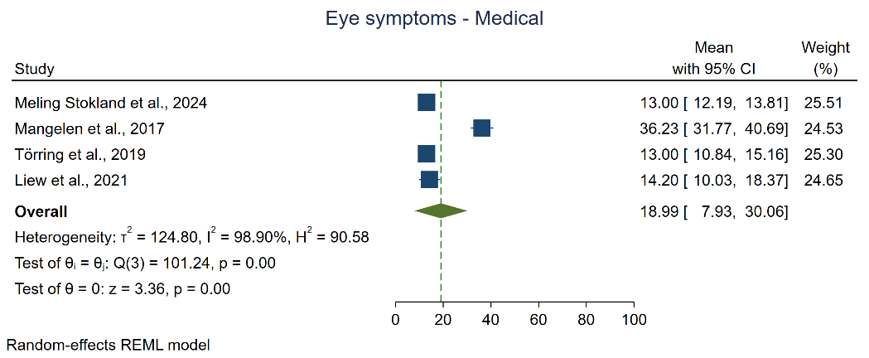
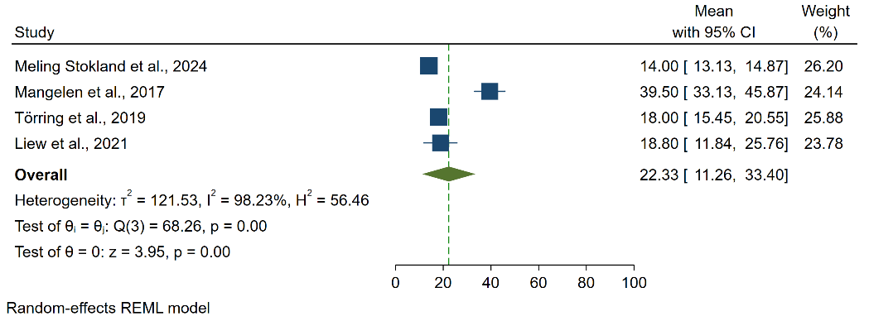
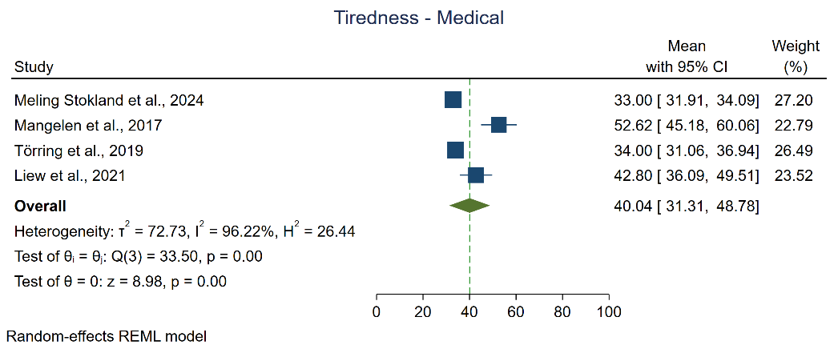
Meta-Analysis of ThyPRO Domains Across Treatment Modalities with Forest Plots
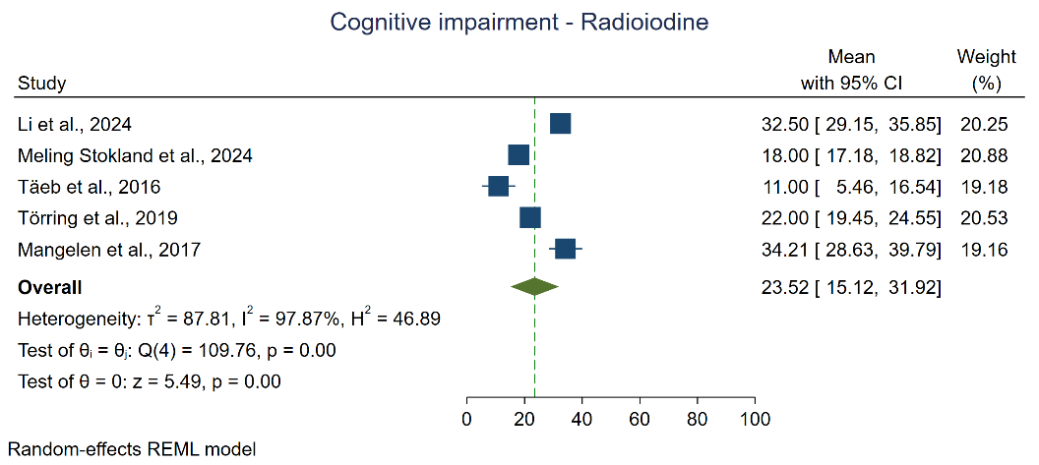
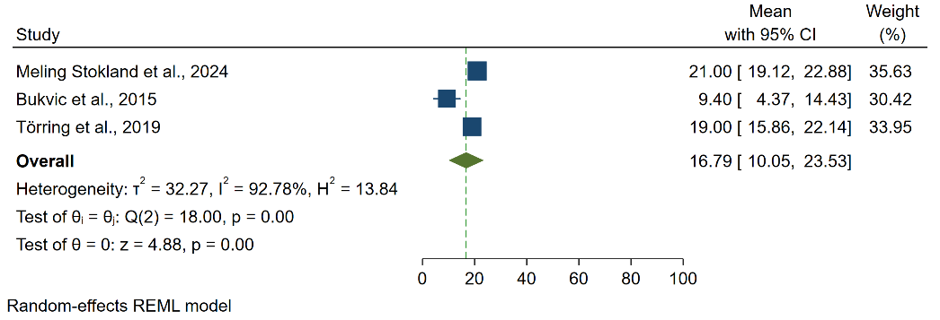
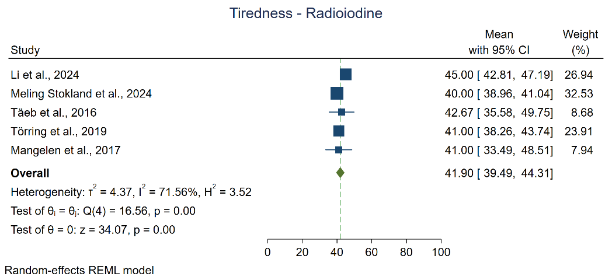
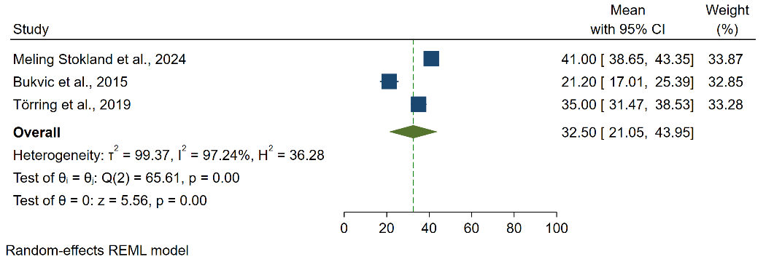
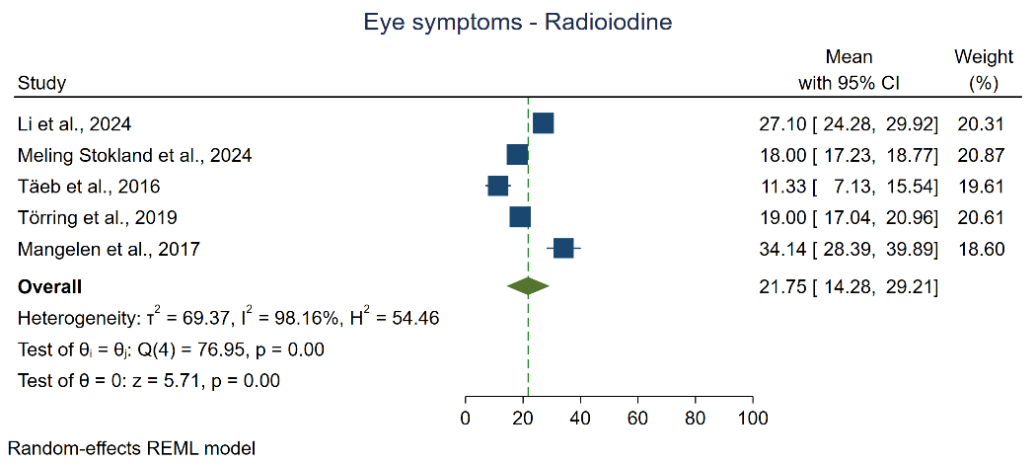
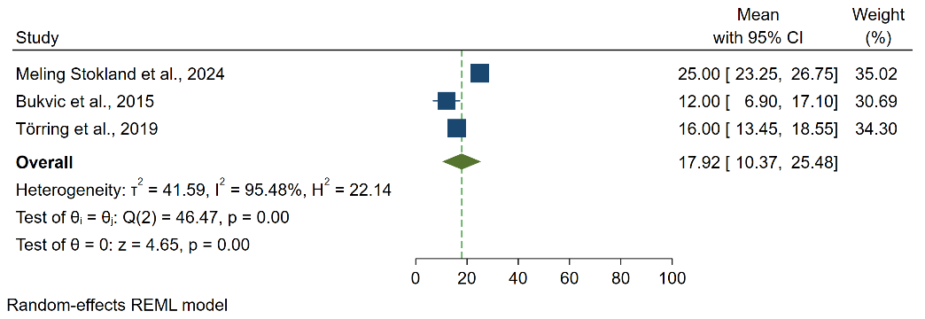
C. Radioiodine– Cognitive impairment domain
B. Surgery– Cognitive impairment domain
A. Antithyroid drug– Cognitive impairment domain
A. Antithyroid drug– Eye symptoms domain
A. Antithyroid drug– Tiredness domain
C. Radioiodine– Tiredness domain
B. Surgery– Tiredness domain
C. Radioiodine– Eye symptoms domain
B. Surgery– Eye symptoms domain

Supplementary Fig 15. Cognitive impairment domain scores for different treatment modalities

Supplementary Fig 14. Eye symptoms domain scores for different treatment modalities

Supplementary Fig 15. Tiredness domain scores for different treatment modalities

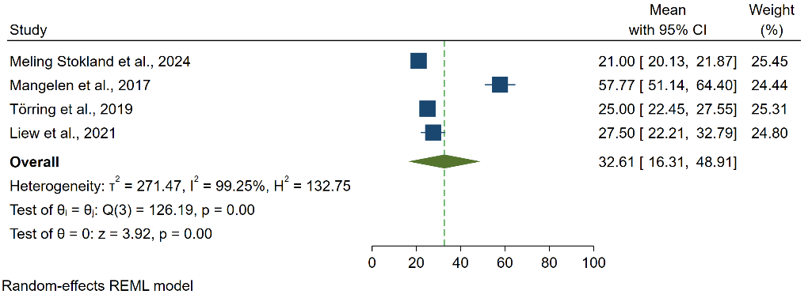
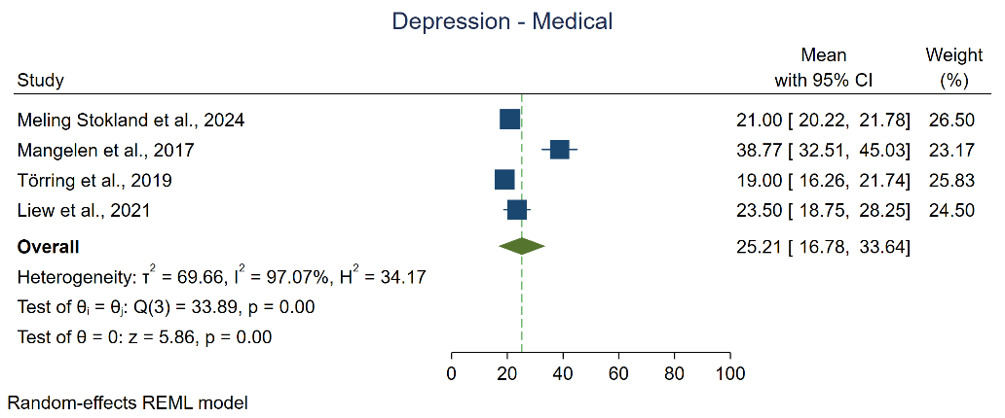
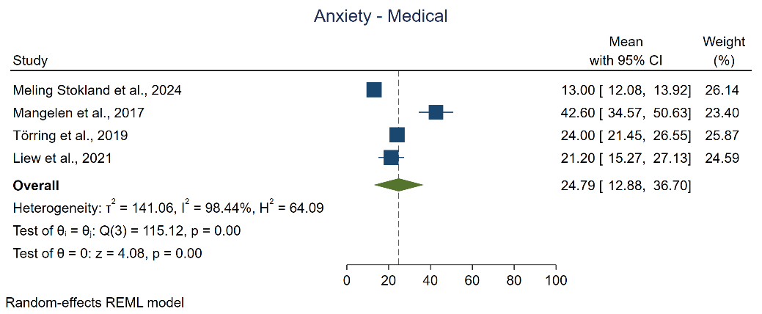
Meta-Analysis of ThyPRO Domains Across Treatment Modalities with Forest Plots
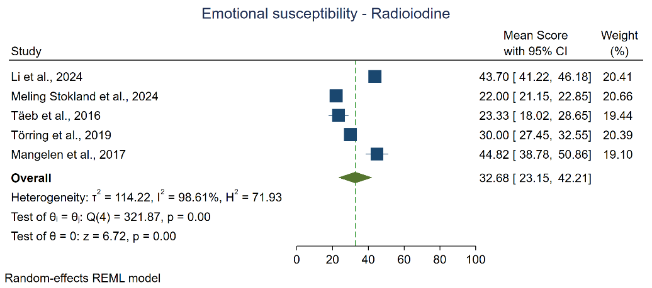
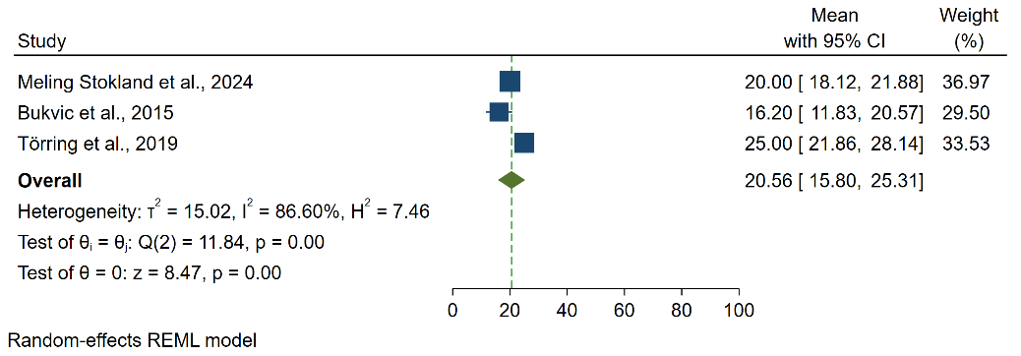
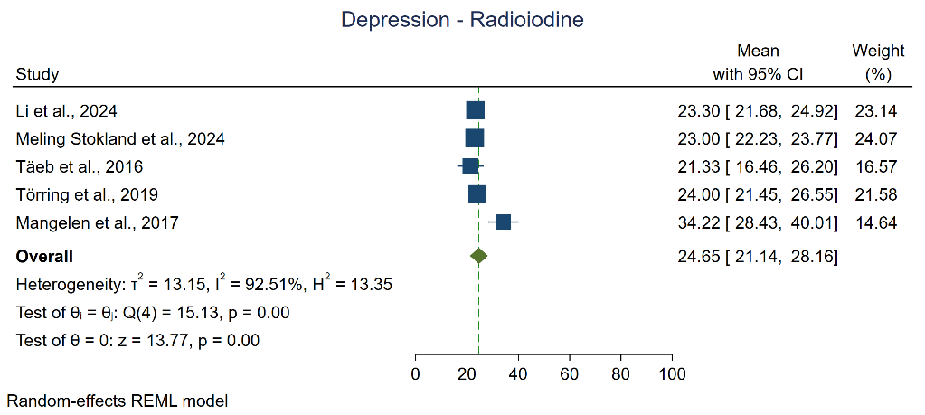
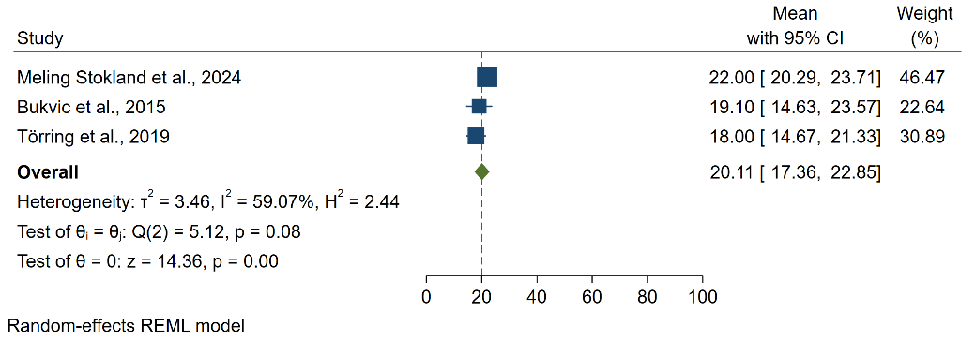
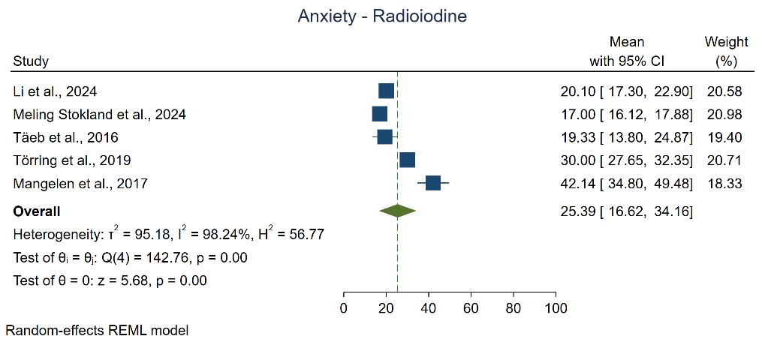
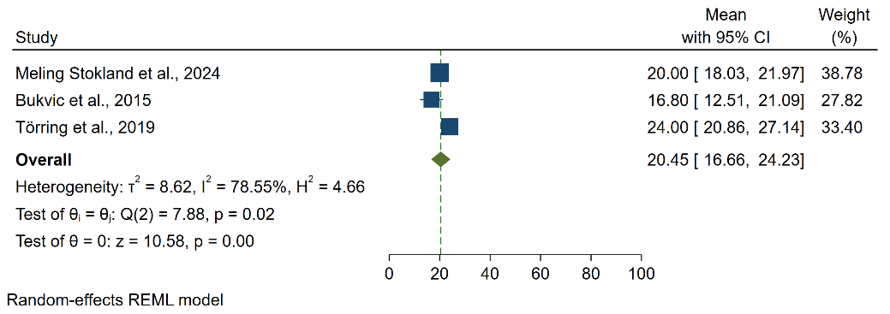
Supplementary Fig 19. Emotional susceptibility domain scores for different treatment modalities

C. Radioiodine– Emotional susceptibility domain
B. Surgery– Emotional susceptibility domain
A. Antithyroid drug– Emotional susceptibility domain
C. Radioiodine – Depression domain
Supplementary Fig 18. Depression domain scores for different treatment modalities

B. Surgery – Depression domain
A. Antithyroid drug– Depression domain
C. Radioiodine – Anxiety domain
Supplementary Fig 17. Anxiety domain scores for different treatment modalities

B. Surgery – Anxiety domain
A. Antithyroid drug – Anxiety domain

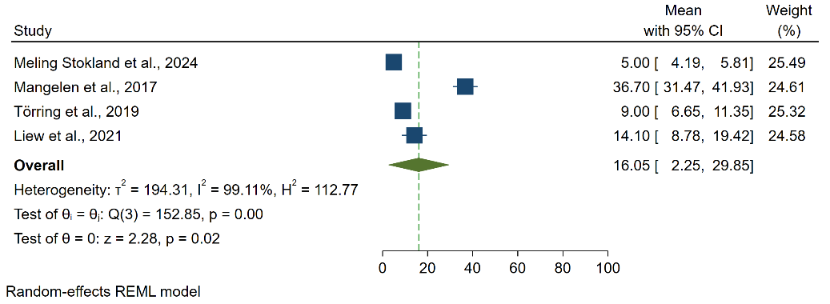
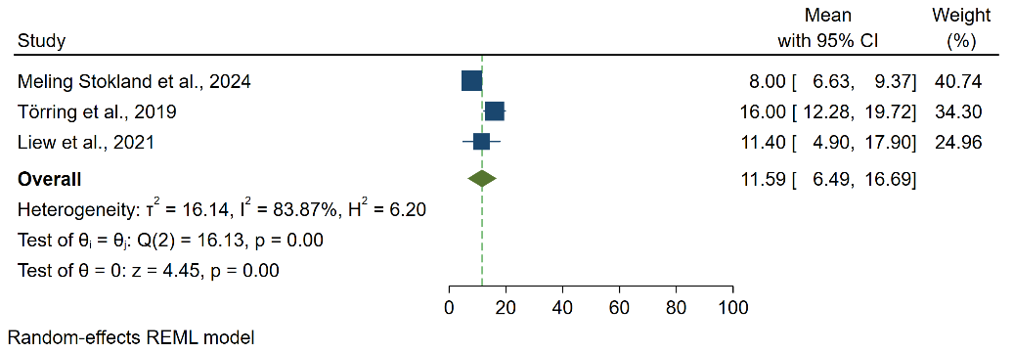
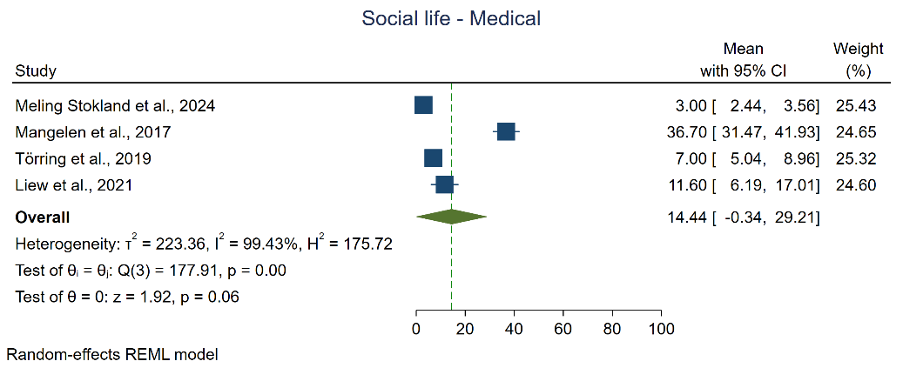
Meta-Analysis of ThyPRO Domains Across Treatment Modalities with Forest Plots
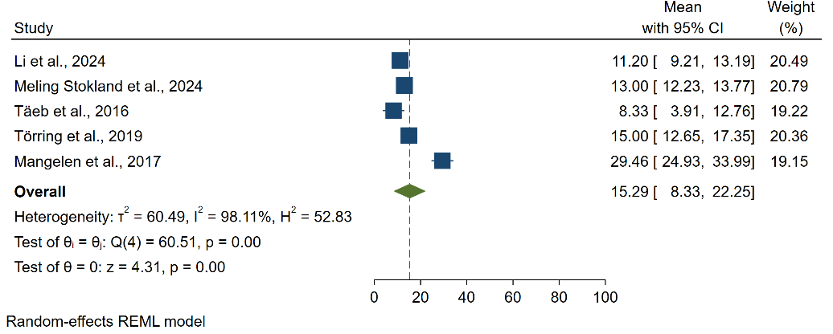
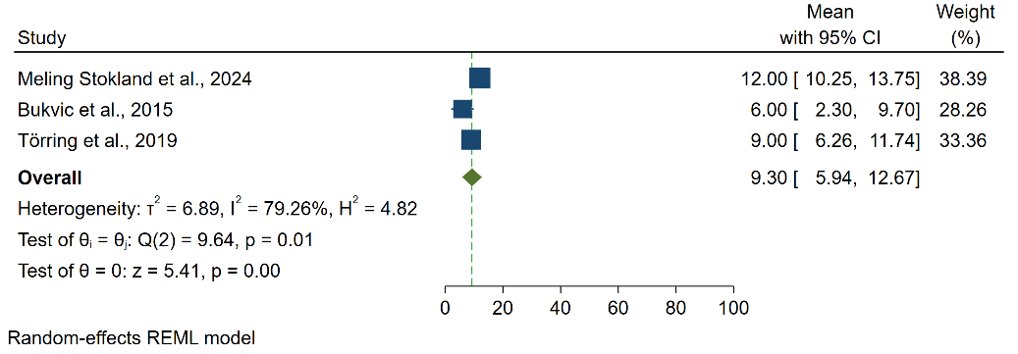
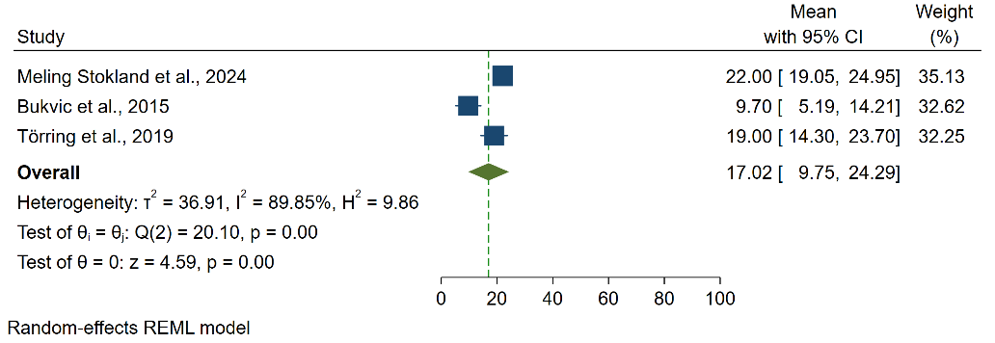
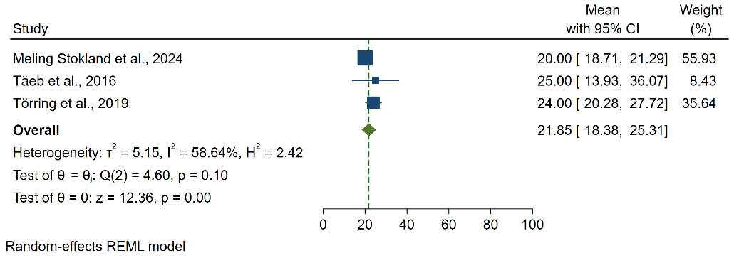
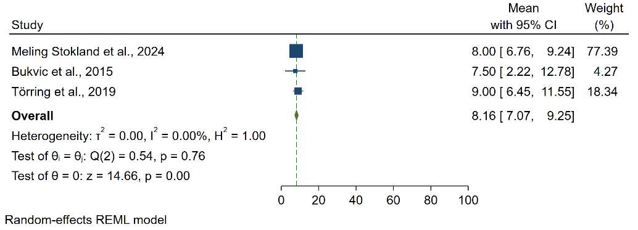
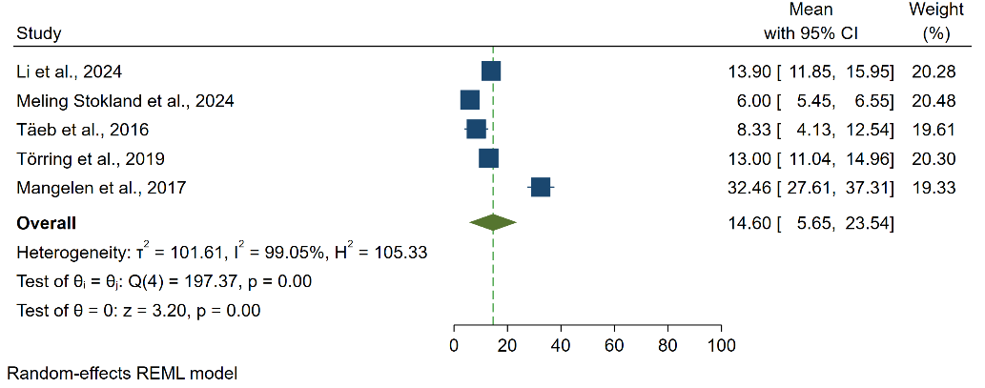
Supplementary Fig 22. Sex life scores for different treatment modalities

Supplementary Fig 20. Daily life scores for different treatment modalities

C. Radioiodine – Daily life domain
B. Surgery – Daily life domain
A. Antithyroid drug – Daily life domain
A. Antithyroid drug – Sex life domain
B. Surgery – Sex life domain
C. Radioiodine – Sex life domain
B. Radioiodine – Social life domain
B. Surgery – Social life domain
Supplementary Fig 20. Social life scores for different treatment modalities

A. Antithyroid drug – Social life domain

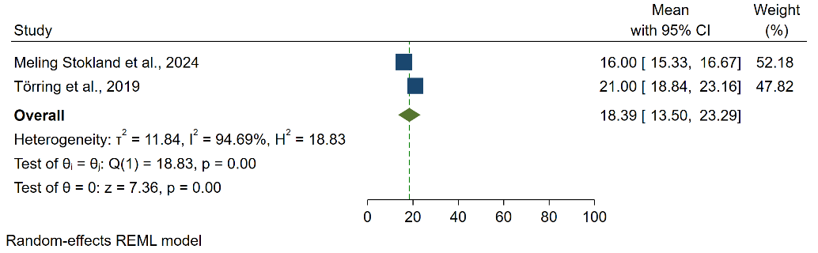
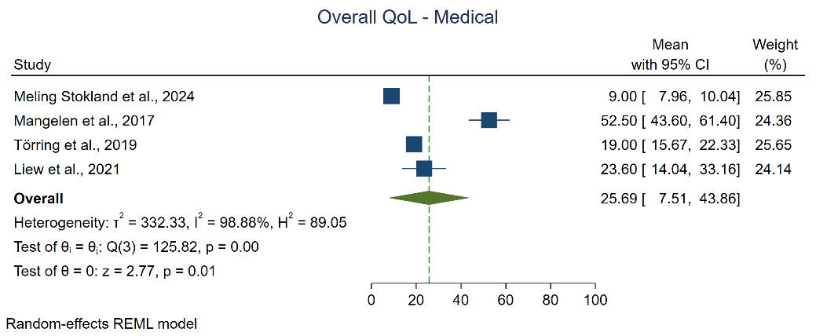
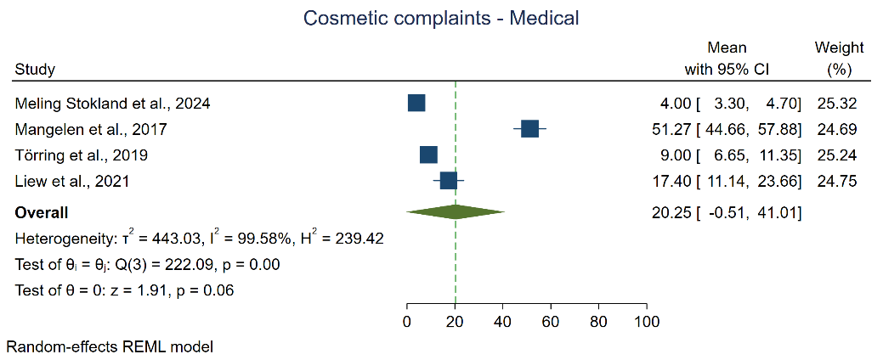
Meta-Analysis of ThyPRO Domains Across Treatment Modalities with Forest Plots
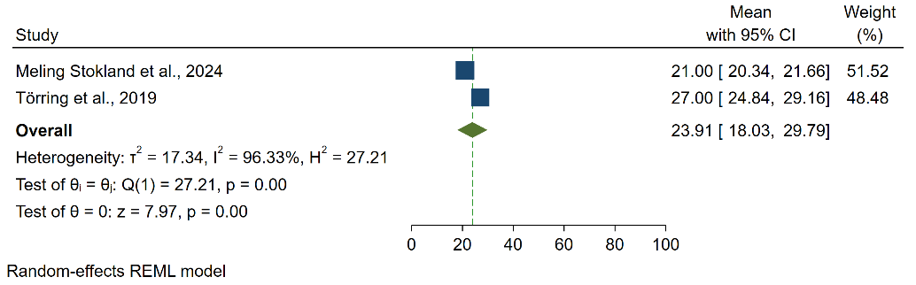
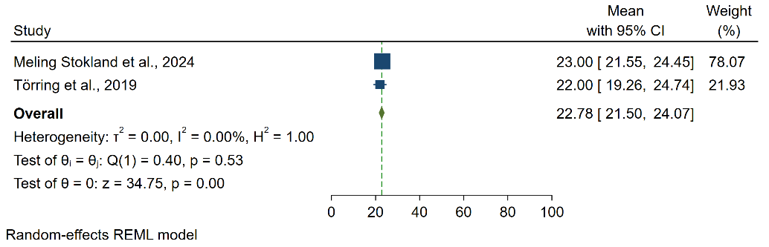
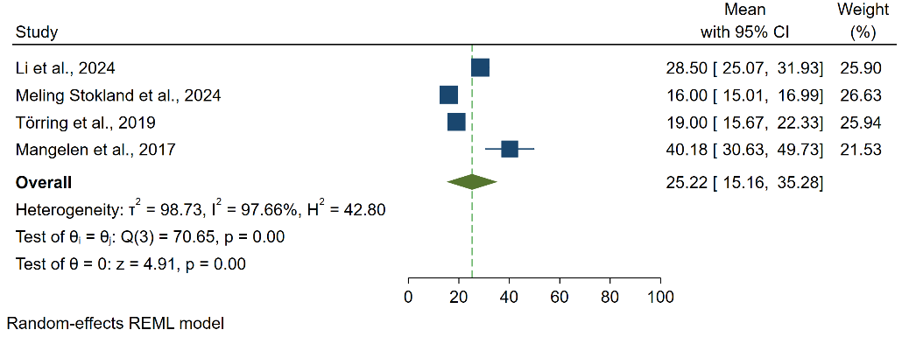
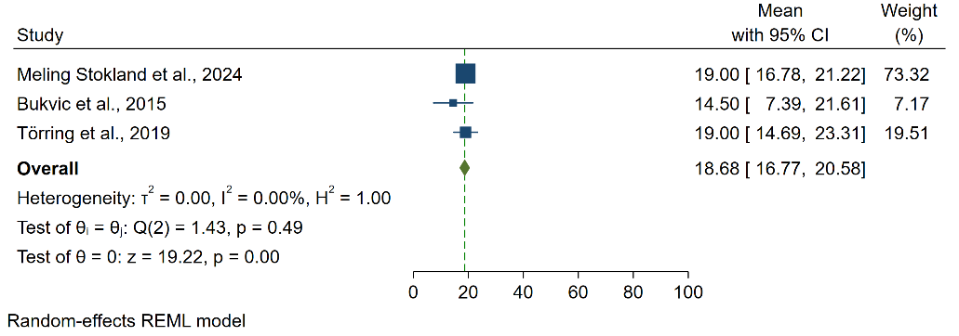
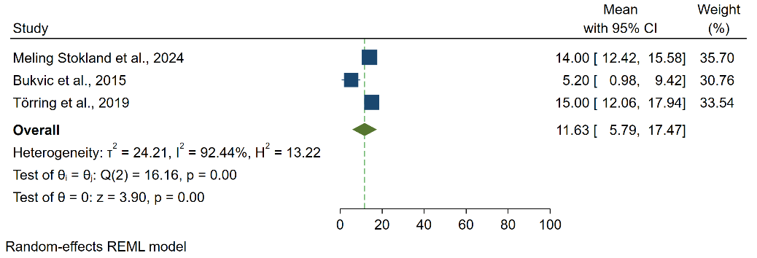
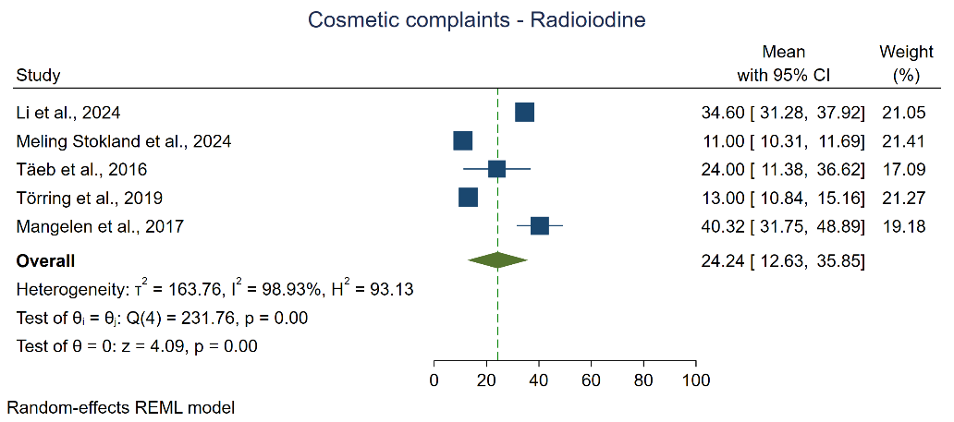
Supplementary Fig 25. Composite scale scores for different treatment modalities

Supplementary Fig 24. Overall QoL scores for different treatment modalities

C. Radioiodine – Composite scale domain
B. Surgery – Composite scale domain
A. Antithyroid drug – Composite scale domain
C. Radioiodine – Overall QoL domain
B. Surgery – Overall QoL domain
A. Antithyroid drug – Overall QoL domain
B. Surgery – Cosmetic complains domain
Supplementary Fig 23. Cosmetic complain scores for different treatment modalities

C. Radioiodine – Cosmetic complains domain
A. Antithyroid drug – Cosmetic complains domain
Domain  Supplementary Table 7. ThyPRO domains heterogeneity | Pooled mean | 95% Confidence interval | Q | I2
ThyPRO-Antithyroid Drugs
Goiter symptoms | 13.71 | (2.08, 25.34) | 70.41 (p < .001) | 99.38%
Hyperthyroid symptoms | 22.26 | (11.76, 32.77) | 102.69 (p < .001) | 98.66%
Hypothyroid symptoms | 25.65 | (13.51, 37.8) | 85.76 (p < .001) | 98.53%
Eye symptoms | 18.99 | (7.93, 30.06) | 101.24 (p < .001) | 98.90%
Tiredness | 40.04 | (31.31, 48.78) | 33.5 (p < .001) | 96.22%
Cognitive impairment | 22.33 | (11.26, 33.4) | 68.26 (p < .001) | 98.23%
Anxiety | 24.79 | (12.88, 36.7) | 115.12 (p < .001) | 98.44%
Depression | 25.21 | (16.78, 33.64) | 33.89 (p < .001) | 97.07%
Emotional susceptibility | 32.61 | (16.31, 48.91) | 126.19 (p < .001) | 99.25%
Social life | 14.44 | (-0.34, 29.21) | 177.91 (p < .001) | 99.43%
Daily life | 16.05 | (2.25, 29.85) | 152.85 (p < .001) | 99.11%
Sex life | 11.59 | (6.49, 16.69) | 16.13 (p < .001) | 83.87%
Cosmetic complaints | 20.25 | (-0.51, 41.01) | 222.09 (p < .001) | 99.58%
Overall QoL | 25.69 | (7.51, 43.86) | 125.82 (p < .001) | 98.88%
Composite scale | 18.39 | (13.5, 23.29) | 18.83 (p < .001) | 94.69%
ThyPRO-Surgery
Goiter symptoms | 7.08 | (0.42, 13.74) | 171.93 (p < .001) | 98.48%
Hyperthyroid symptoms | 18.96 | (13.27, 24.64) | 25.32 (p < .001) | 92.03%
Hypothyroid symptoms | 24.57 | (16.96, 32.18) | 21.98 (p < .001) | 92.56%
Eye symptoms | 17.92 | (10.37, 25.48) | 46.47 (p < .001) | 95.48%
Tiredness | 32.5 | (21.05, 43.95) | 65.61 (p < .001) | 97.24%
Cognitive impairment | 16.79 | (10.05, 23.53) | 18 (p < .001) | 92.78%
Anxiety | 20.45 | (16.66, 24.23) | 7.88 (p=0.02) | 78.55%
Depression | 20.11 | (17.36, 22.85) | 5.12 (p=0.08) | 59.07%
Emotional susceptibility | 20.65 | (15.8, 25.31) | 11.84 (p < .001) | 86.60%
Social life | 8.16 | (7.07, 9.25) | 0.54 (p=0.76) | 0%
Daily life | 9.3 | (5.94, 12.67) | 9.64 (p=0.01) | 79.26%
Sex life | 17.02 | (9.75, 24.29) | 20.1 (p < .001) | 89.85%
Cosmetic complaints | 11.63 | (5.79, 17.47) | 16.16 (p < .001) | 92.44%
Overall QoL | 18.68 | (16.77, 20.58) | 1.43 (p=0.49) | 0%
Composite scale | 22.78 | (21.5, 24.07) | 0.4 (p=0.53) | 0%
ThyPRO-Radioiodine
Goiter symptoms | 12.03 | (5.94, 18.12) | 173.52 (p < .001) | 99.02%
Hyperthyroid symptoms | 23.05 | (18.43, 27.67) | 33.77 (p < .001) | 96.05%
Hypothyroid symptoms | 26.24 | (20.13, 32.34) | 28.59 (p < .001) | 96.46%
Eye symptoms | 21.75 | (14.28, 29.21) | 76.95 (p < .001) | 98.16%
Tiredness | 41.9 | (39.49, 44.31) | 16.56 (p < .001) | 71.56%
Cognitive impairment | 23.52 | (15.12, 31.92) | 109.76 (p < .001) | 97.87%
Anxiety | 25.39 | (16.62, 34.16) | 142.76 (p < .001) | 98.24%
Depression | 24.65 | (21.14, 28.16) | 15.13 (p < .001) | 92.51%
Emotional susceptibility | 32.68 | (23.15, 42.21) | 321.87 (p < .001) | 98.61%
Social life | 14.6 | (5.65, 23.54) | 197.37 (p < .001) | 99.05%
Daily life | 15.29 | (8.33, 22.25) | 60.51 (p < .001) | 98.11%
Sex life | 21.85 | (18.38, 25.31) | 4.6 (p=0.1) | 58.64%
Cosmetic complaints | 24.24 | (12.63, 35.85) | 231.76 (p < .001) | 98.93%
Overall QoL | 25.22 | (15.16, 35.28) | 70.65 (p < .001) | 97.66%
Composite scale | 23.91 | (18.03, 29.79) | 27.21 (p < .001) | 96.33%

All data are presented as mean (95% confidence interval).

Sensitivity Analysis
SF-36
 | Antithyroid Drug | Surgery | Radioiodine
Physical functioning | 80.54 (63.58, 97.51) | 88.26 (84.31, 92.22) | 84.02 (78.53, 89.52)
Physical role limitation | 68.49 (54.14, 82.84) | 84.19 (77.29, 91.09) | 76.30 (68.49, 84.11)
Bodily pain | 71.31 (61.84, 80.78) | 74.10 (70.85, 77.35) | 68.57 (65.94, 71.20)
General health perception | 68.54 (56.96, 80.12) | 67.88 (62.42, 73.35) | 65.61 (59.74, 71.48)
Vitality | 62.00 (52.18, 71.81) | 59.16 (46.50, 71.82) | 59.35 (50.35, 68.34)
Social functioning | 72.96 (56.72, 89.20) | 82.69 (79.60, 85.78) | 80.95 (73.10, 88.79)
Emotional role limitation | 69.90 (56.23, 83.57) | 78.17 (73.68, 82.66) | 78.23 (69.61, 86.85)
Mental health | 66.82 (57.64, 75.99) | 67.28 (65.01, 69.55) | 67.07 (60.09, 74.05)
Physical component scale | 51.68 (49.15, 54.20) | 51.29 (48.37, 54.22) | 48.28 (46.68, 49.89)
Mental component scale | 47.69 (42.74, 52.63) | 47.37 (45.66, 49.08) | 45.14 (40.49, 49.80)
ThyPRO
 | Antithyroid Drug | Surgery | Radioiodine
Goiter symptoms | 7.12 (6.49, 7.74) | 7.08 (0.42, 13.74) | 8.99 (6.22, 11.76)
Hyperthyroid symptoms | 16.06 (14.13, 18.00) | 18.96 (13.27, 24.64) | 20.65 (19.70, 21.59)
Hypothyroid symptoms | 18.41 (15.98, 20.85) | 24.57 (16.96, 32.18) | 24.16 (23.30, 25.03)
Eye symptoms | 13.04 (12.29, 13.79) | 17.92 (10.37, 25.48) | 18.96 (12.83, 25.10)
Tiredness | 35.71 (30.59, 40.82) | 32.5 (21.05, 43.95) | 41.99 (39.34, 44.65)
Cognitive impairment | 16.24 (12.97, 19.50) | 16.79 (10.05, 23.53) | 21.01 (12.39, 29.63)
Anxiety | 19.20 (12.30, 26.09) | 20.45 (16.66, 24.23) | 21.67 (15.82, 27.51)
Depression | 20.84 (19.70, 21.97) | 20.11 (17.36, 22.85) | 23.09 (22.42, 23.75)
Emotional susceptibility | 23.90 (20.21, 27.58) | 20.56 (15.8, 25.31) | 29.82 (20.03, 39.61)
Social life | 6.61 (2.06, 11.15) | 8.16 (7.07, 9.25) | 10.33 (6.46, 14.20)
Daily life | 8.82 (3.95, 13.70) | 9.3 (5.94, 12.67) | 12.34 (10.14, 14.54)
Sex life | 11.59 (6.49, 16.69) | 17.02 (9.75, 24.29) | 21.85 (18.38, 25.31)
Cosmetic complaints | 9.60 (2.31, 16.88) | 11.63 (5.79, 17.47) | 20.36 (9.08, 31.65)
Overall QoL | 16.37 (7.92, 24.83) | 18.68 (16.77, 20.58) | 21.05 (13.68, 28.41)
Composite scale | 18.39 (13.5, 23.29) | 22.78 (21.5, 24.07) | 23.91 (18.03, 29.79)
Supplementary Table 8. SF-36 and ThyPRO Sensitivity Analysis

1.
Refrences:
1. Ljunggren JG, Törring O, Wallin G, Taube A, Tallstedt L, Hamberger B, et al. Quality of life aspects and costs in treatment of Graves' hyperthyroidism with antithyroid drugs, surgery, or radioiodine: results from a prospective, randomized study. Thyroid. 1998;8(8):653–9.
2. Palestini N, Grivon M, Durando R, Freddi M, Odasso C, Robecchi A. Thyroidectomy for Graves' hyperthyroidism. Retrospective study of patients' appreciation. Annali italiani di chirurgia. 2007;78(5):405–12.
3. Cashman EC, Bresnihan M, Timon C. Patients' quality of life post thyroidectomy. B-ent. 2011;7(4):261–5.
4. Scerrino G, Morfino G, Paladino NC, Di Paola V, Amodio E, Gulotta G, et al. Does thyroid surgery for Graves' disease improve health-related quality of life? Surg Today. 2013;43(12):1398–405.
5. Bukvic BR, Zivaljevic VR, Sipetic SB, Diklic AD, Tausanovic KM, Paunovic IR. Improvement of quality of life in patients with benign goiter after surgical treatment. LANGENBECKS ARCHIVES OF SURGERY. 2014;399(6):755–64.
6. Watt T, Cramon P, Hegedüs L, Bjorner JB, Bonnema SJ, Rasmussen Å K, et al. The thyroid-related quality of life measure ThyPRO has good responsiveness and ability to detect relevant treatment effects. J Clin Endocrinol Metab. 2014;99(10):3708–17.
7. Cramon P, Winther KH, Watt T, Bonnema SJ, Bjorner JB, Ekholm O, et al. Quality-of-Life Impairments Persist Six Months after Treatment of Graves' Hyperthyroidism and Toxic Nodular Goiter: A Prospective Cohort Study. Thyroid. 2016;26(8):1010–8.
8. Donovan PJ, McLeod DSA, Little R, Gordon L. Cost-utility analysis comparing radioactive iodine, anti-Thyroid drugs and total thyroidectomy for primary treatment of Graves' disease. European Journal of Endocrinology. 2016;175(6):595–603.
9. Kus LH, Hopman WM, Witterick IJ, Freeman JL. Quality-of-life outcomes in Graves disease patients after total thyroidectomy. Ear, Nose and Throat Journal. 2017;96(4-5):E8.
10. Yang D, Liu F, Ma T. Evaluation of cardiovascular complexities and quality of life related to health in Chinese patients with thyrotoxic heart disease secondary to toxic diffuse goiter. Biomedical Research. 2018;29(1):1–8.
11. Conaglen HM, Tamatea JAU, Conaglen JV, Elston MS. Treatment choice, satisfaction and quality of life in patients with Graves’ disease. Clinical Endocrinology. 2018;88(6):977–84.
12. Sawicka-Gutaj N, Ruchala M, Feldt-Rasmussen U, Rasmussen AK, Hegedüs L, Bonnema SJ, et al. Patients with Benign Thyroid Diseases Experience and Impaired Sex Life. Thyroid. 2018;28(10):1261–9.
13. Sjölin G, Holmberg M, Törring O, Byström K, Khamisi S, De Laval D, et al. The Long-Term Outcome of Treatment for Graves' Hyperthyroidism. Thyroid. 2019;29(11):1545–57.
14. Törring O, Watt T, Sjölin G, Byström K, Abraham-Nordling M, Calissendorff J, et al. Impaired Quality of Life after Radioiodine Therapy Compared to Antithyroid Drugs or Surgical Treatment for Graves' Hyperthyroidism: A Long-Term Follow-Up with the Thyroid-Related Patient-Reported Outcome Questionnaire and 36-Item Short Form Health Status Survey. Thyroid. 2019;29(3):322–31.
15. Hamilton LOW, Lim AE, Clark LJ. Total thyroidectomy for Graves' disease-what do our patients think? A qualitative cohort study to evaluate the surgical management of Graves' disease. The surgeon : journal of the Royal Colleges of Surgeons of Edinburgh and Ireland. 2020;18(4):193–6.
16. Mirallié E, Borel F, Tresallet C, Hamy A, Mathonnet M, Lifante JC, et al. Impact of total thyroidectomy on quality of life at 6 months: The prospective ThyrQoL multicentre trial. European Journal of Endocrinology. 2020;182(2):195–205.
17. Rowe CW, Blefari ND, Rutherford N, Bendinelli C, O’Neill C. SAT-427 Quality of Life Following Treatment for Graves’ Disease: A Comparison of Radioactive Iodine Ablation and Surgery. Journal of the Endocrine Society. 2020;4(Supplement_1):SAT–427.
18. Shukurullaevich AD, Erdanovich RК, Sulaymonovich DS, Erkinovich НZ. Quality of life of patients before and after surgical treatment of diffuse toxic goiter. Вестник науки и образования. 2021(3-2 (106)):80–7.
19. Halada S, Baran J, Patel T, Isaza A, Magee L, Bauer A. Impact of Definitive Surgery for Graves' Disease on Adolescent Health-Related Quality of Life and Psychosocial Functioning. Journal of the Endocrine Society. 2022;6:A642–A3.
20. Calissendorff J, Cramon PK, Hallengren B, Khamisi S, Lantz M, Planck T, et al. Long-Term Outcome of Graves' Disease: A Gender Perspective. Womens Health Rep (New Rochelle). 2023;4(1):487–96.
21. Afsin H, Çaliskan B. Quality of Life Outcomes Following Radioactive lodine 131 Therapy in Hyperthyroid Patients: Insights from the Thyroid Patient-Reported Outcome Questionnaire. MOLECULAR IMAGING AND RADIONUCLIDE THERAPY. 2025;34(1):38–47.

