Contents
Supplementary Table 1: PRISMA Reporting Checklist Page 2
Supplementary Table 2: Literature search terms of the systematic review Page 5
Supplementary Table 3: Studies and reasons for exclusion at the stage of full-text screening Page 8
Supplementary Table 4: Risk of bias assessment of non-randomized Studies – of Interventions using (ROBINS-I V2) assessment tool Page 9
Supplementary Table 5: Risk of bias assessment of trail studies using RoB2 assessment tool Page 9
Supplementary Figures 1-10: Meta-Analysis of SF-36 Domains Across Treatment Modalities with Forest Plots Page 10
References Page 14

Supplementary Table 1: PRISMA Reporting Checklist.
Section and Topic | Item # | Checklist item | Location where item is reported
TITLE
Title | 1 | Identify the report as a systematic review. | 1
ABSTRACT
Abstract | 2 | See the PRISMA 2020 for Abstracts checklist. | 4
INTRODUCTION
Rationale | 3 | Describe the rationale for the review in the context of existing knowledge. | 6
Objectives | 4 | Provide an explicit statement of the objective(s) or question(s) the review addresses. | 6-7
METHODS
Eligibility criteria | 5 | Specify the inclusion and exclusion criteria for the review and how studies were grouped for the syntheses. | 7-8
Information sources | 6 | Specify all databases, registers, websites, organisations, reference lists and other sources searched or consulted to identify studies. Specify the date when each source was last searched or consulted. | 7
Search strategy | 7 | Present the full search strategies for all databases, registers and websites, including any filters and limits used. | Supplementary Table 1
Selection process | 8 | Specify the methods used to decide whether a study met the inclusion criteria of the review, including how many reviewers screened each record and each report retrieved, whether they worked independently, and if applicable, details of automation tools used in the process. | 7
Data collection process | 9 | Specify the methods used to collect data from reports, including how many reviewers collected data from each report, whether they worked independently, any processes for obtaining or confirming data from study investigators, and if applicable, details of automation tools used in the process. | 8
Data items | 10a | List and define all outcomes for which data were sought. Specify whether all results that were compatible with each outcome domain in each study were sought (e.g. for all measures, time points, analyses), and if not, the methods used to decide which results to collect. | 8
Data items | 10b | List and define all other variables for which data were sought (e.g. participant and intervention characteristics, funding sources). Describe any assumptions made about any missing or unclear information. | 8
Study risk of bias assessment | 11 | Specify the methods used to assess risk of bias in the included studies, including details of the tool(s) used, how many reviewers assessed each study and whether they worked independently, and if applicable, details of automation tools used in the process. | 8 and Supplementary Table 4 and 5
Effect measures | 12 | Specify for each outcome the effect measure(s) (e.g. risk ratio, mean difference) used in the synthesis or presentation of results. | 8-9
Synthesis methods | 13a | Describe the processes used to decide which studies were eligible for each synthesis (e.g. tabulating the study intervention characteristics and comparing against the planned groups for each synthesis (item #5)). | 9
Synthesis methods | 13b | Describe any methods required to prepare the data for presentation or synthesis, such as handling of missing summary statistics, or data conversions. | 9
Synthesis methods | 13c | Describe any methods used to tabulate or visually display results of individual studies and syntheses. | 9
Synthesis methods | 13d | Describe any methods used to synthesize results and provide a rationale for the choice(s). If meta-analysis was performed, describe the model(s), method(s) to identify the presence and extent of statistical heterogeneity, and software package(s) used. | 9
Synthesis methods | 13e | Describe any methods used to explore possible causes of heterogeneity among study results (e.g. subgroup analysis, meta-regression). | 9
Synthesis methods | 13f | Describe any sensitivity analyses conducted to assess robustness of the synthesized results. | 9
Reporting bias assessment | 14 | Describe any methods used to assess risk of bias due to missing results in a synthesis (arising from reporting biases). | NA
Certainty assessment | 15 | Describe any methods used to assess certainty (or confidence) in the body of evidence for an outcome. | 8 and Supplementary Table 4 and 5
RESULTS
Study selection | 16a | Describe the results of the search and selection process, from the number of records identified in the search to the number of studies included in the review, ideally using a flow diagram. | 10 and Figure 1
Study selection | 16b | Cite studies that might appear to meet the inclusion criteria, but which were excluded, and explain why they were excluded. | Supplementary Table 3
Study characteristics | 17 | Cite each included study and present its characteristics. | 10-11
Risk of bias in studies | 18 | Present assessments of risk of bias for each included study. | 10-11 and Figure 2
Results of individual studies | 19 | For all outcomes, present, for each study: (a) summary statistics for each group (where appropriate) and (b) an effect estimates and its precision (e.g. confidence/credible interval), ideally using structured tables or plots. | Tables 1
Results of syntheses | 20a | For each synthesis, briefly summarise the characteristics and risk of bias among contributing studies. | 11-12
Results of syntheses | 20b | Present results of all statistical syntheses conducted. If meta-analysis was done, present for each the summary estimate and its precision (e.g. confidence/credible interval) and measures of statistical heterogeneity. If comparing groups, describe the direction of the effect. | 12-13-14, Table 2
Results of syntheses | 20c | Present results of all investigations of possible causes of heterogeneity among study results. | 13-14
Results of syntheses | 20d | Present results of all sensitivity analyses conducted to assess the robustness of the synthesized results. | 13-14
Reporting biases | 21 | Present assessments of risk of bias due to missing results (arising from reporting biases) for each synthesis assessed. | NA
Certainty of evidence | 22 | Present assessments of certainty (or confidence) in the body of evidence for each outcome assessed. | 12-13-14, Table 2
DISCUSSION
Discussion | 23a | Provide a general interpretation of the results in the context of other evidence. | 14-16
Discussion | 23b | Discuss any limitations of the evidence included in the review. | 16-17
Discussion | 23c | Discuss any limitations of the review processes used. | 16-17
Discussion | 23d | Discuss implications of the results for practice, policy, and future research. | 17
OTHER INFORMATION
Registration and protocol | 24a | Provide registration information for the review, including register name and registration number, or state that the review was not registered. | 7
Registration and protocol | 24b | Indicate where the review protocol can be accessed, or state that a protocol was not prepared. | 7
Registration and protocol | 24c | Describe and explain any amendments to information provided at registration or in the protocol. | 7
Support | 25 | Describe sources of financial or non-financial support for the review, and the role of the funders or sponsors in the review. | 17-18
Competing interests | 26 | Declare any competing interests of review authors. | 17-18
Availability of data, code and other materials | 27 | Report which of the following are publicly available and where they can be found: template data collection forms; data extracted from included studies; data used for all analyses; analytic code; any other materials used in the review. | 7

From: Page MJ, McKenzie JE, Bossuyt PM, Boutron I, Hoffmann TC, Mulrow CD, et al. The PRISMA 2020 statement: an updated guideline for reporting systematic reviews. BMJ 2021;372:n71. doi: 10.1136/bmj.n71.
Supplementary Table 2: Literature search terms of the systematic review.
Queries |  | Results  (30/07/2025)
PubMed
#1 | (Therapeutics[MeSH Terms] OR therap*[tiab] OR treatment*[tiab]) | 11,630,577
#2 | ("radioactive iodine therap*"[tiab] OR "radioiodine therap*"[tiab] OR "RAI therap*"[tiab] OR "radioactive iodine treatment"[tiab] OR "radioiodine treatment"[tiab] OR "RAI treatment"[tiab] OR "I-131 therap*"[tiab] OR "I-131 treatment"[tiab] OR "radioactive iodine ablation"[tiab] OR "radioiodine ablation"[tiab]) | 6,851
#3 | (propylthiouracil[MeSH Terms] OR propylthiouracil[tiab] OR "6-propyl-2-thiouracil"[tiab]) | 6,046
#4 | (carbimazole[MeSH Terms] OR carbimazole[tiab] OR neomercazole[tiab] OR "neo-mercazole"[tiab] OR "neo tomizol"[tiab] OR "neo-thyreostat"[tiab]) | 1,623
#5 | (methimazole[MeSH Terms] OR methimazole[tiab] OR "1-methyl-2-mercaptoimidazole"[tiab] OR methylmercaptoimidazole[tiab] OR thiamazole[tiab] OR tapazole[tiab] OR tiamazol[tiab] OR mercazolil[tiab] OR mercazole[tiab]) | 5,505
#6 | (Antithyroid Agents[MeSH Terms] OR "antithyroid agent*"[tiab] OR "agent*, antithyroid"[tiab] OR "antithyroid drug*"[tiab] OR "drug*, antithyroid"[tiab] OR "thyroid antagonist*"[tiab] OR "antagonist*, thyroid"[tiab] OR goitrogen*[tiab] OR "antithyroid effect*"[tiab] OR "effect*, antithyroid"[tiab]) | 9,307
#7 | (Thyroidectomy[tiab] OR "Thyroid surgery"[tiab] OR "Thyroid removal"[tiab]) | 27,870
#8 | (quality of life[MeSH Terms] OR "quality of life"[tiab] OR "life quality"[tiab] OR "health related quality of life"[tiab] OR HRQOL[tiab]) | 522,805
#9 | (graves disease[MeSH Terms] OR "Graves* disease"[tiab] OR "Disease, Graves*"[tiab] OR "Basedow* disease"[tiab] OR "Disease, Basedow*"[tiab] OR "Exophthalmic goiter*"[tiab] OR "Goiter*, Exophthalmic"[tiab] OR "Hyperthyroidism autoimmune"[tiab] OR "Autoimmune hyperthyroidism"[tiab] OR "diffuse toxic goiter" [tiab]) | 25,321
#9 | (#1 OR #2 OR #3 OR #4 OR #5 OR #6 OR #7) AND #8 AND #9  1-7: 11,652,863 | 339
Embase
#1 | Title, Abstract or Author keywords: (therap* OR treatment*) | 12,324,045
#2 | Title, Abstract or Author keywords: ("radioactive iodine therap*" OR "radioiodine therap*" OR "RAI therap*" OR "radioactive iodine treatment" OR "radioiodine treatment" OR "RAI treatment" OR "I-131 therap*" OR "I-131 treatment" OR "radioactive iodine ablation" OR "radioiodine ablation") | 11,804
#3 | Title, Abstract or Author keywords: (propylthiouracil OR "6-propyl-2-thiouracil") | 6,570
#4 | Title, Abstract or Author keywords: (carbimazole OR neomercazole OR "neo-mercazole" OR "neo tomizol" OR "neo-thyreostat") | 1,846
#5 | Title, Abstract or Author keywords: (methimazole OR "1-methyl-2-mercaptoimidazole" OR methylmercaptoimidazole OR thiamazole OR tapazole OR tiamazol OR mercazolil OR mercazole) | 7,112
#6 | Title, Abstract or Author keywords: ("antithyroid agent*" OR "agent*, antithyroid" OR "antithyroid drug*" OR "drug*, antithyroid" OR "thyroid antagonist*" OR "antagonist*, thyroid" OR goitrogen* OR "antithyroid effect*" OR "effect*, antithyroid") | 7,342
#7 | Title, Abstract or Author keywords: (Thyroidectomy) OR ("Thyroid surgery") OR ("Thyroid removal") | 42,057
#8 | Title, Abstract or Author keywords: ("quality of life") OR ("life quality") OR ("health related quality of life") OR (HRQOL) | 757,977
#9 | Title, Abstract or Author keywords: ("Graves* disease") OR ("Disease, Graves*") OR ("Basedow* disease") OR ("Disease, Basedow*") OR ("Exophthalmic goiter*") OR ("Goiter*, Exophthalmic") OR ("Hyperthyroidism autoimmune") OR ("Autoimmune hyperthyroidism") OR ("diffuse toxic goiter”) | 22,307
#9 | (#1 OR #2 OR #3 OR #4 OR #5 OR #6 OR #7) AND #8 AND #9  1-7: 12,355,019 | 319
Scopus
#1 | TITLE-ABS-KEY: (therap* OR treatment*) | 14,864,810
#2 | TITLE-ABS-KEY: ("radioactive iodine therap*" OR "radioiodine therap*" OR "RAI therap*" OR "radioactive iodine treatment" OR "radioiodine treatment" OR "RAI treatment" OR "I-131 therap*" OR "I-131 treatment" OR "radioactive iodine ablation" OR "radioiodine ablation") | 8,059
#3 | TITLE-ABS-KEY: (propylthiouracil OR "6-propyl-2-thiouracil") | 11,830
#4 | TITLE-ABS-KEY: (carbimazole OR neomercazole OR "neo-mercazole" OR "neo tomizol" OR "neo-thyreostat") | 4,682
#5 | TITLE-ABS-KEY: (methimazole OR "1-methyl-2-mercaptoimidazole" OR methylmercaptoimidazole OR thiamazole OR tapazole OR tiamazol OR mercazolil OR mercazole) | 11,899
#6 | TITLE-ABS-KEY: ("antithyroid agent*" OR "agent*, antithyroid" OR "antithyroid drug*" OR "drug*, antithyroid" OR "thyroid antagonist*" OR "antagonist*, thyroid" OR goitrogen* OR "antithyroid effect*" OR "effect*, antithyroid") | 13,097
#7 | TITLE-ABS-KEY: (Thyroidectomy) OR ("Thyroid surgery") OR ("Thyroid removal") | 57,788
#8 | TITLE-ABS-KEY: ("quality of life") OR ("life quality") OR ("health related quality of life") OR (HRQOL) | 848,353
#9 | TITLE-ABS-KEY: ("Graves* disease") OR ("Disease, Graves*") OR ("Basedow* disease") OR ("Disease, Basedow*") OR ("Exophthalmic goiter*") OR ("Goiter*, Exophthalmic") OR ("Hyperthyroidism autoimmune") OR ("Autoimmune hyperthyroidism") OR ("diffuse toxic goiter”) | 30,511
#9 | (#1 OR #2 OR #3 OR #4 OR #5 OR #6 OR #7) AND #8 AND #9  1-7: 14,906,756 | 507
Web of Science
 | TS: (therap* OR treatment*) | 10,235,413
 | TS: ("radioactive iodine therap*" OR "radioiodine therap*" OR "RAI therap*" OR "radioactive iodine treatment" OR "radioiodine treatment" OR "RAI treatment" OR "I-131 therap*" OR "I-131 treatment" OR "radioactive iodine ablation" OR "radioiodine ablation") | 9,578
 | TS: (propylthiouracil OR "6-propyl-2-thiouracil") | 5,463
 | TS: (carbimazole OR neomercazole OR "neo-mercazole" OR "neo tomizol" OR "neo-thyreostat") | 1,232
 | TS: (methimazole OR "1-methyl-2-mercaptoimidazole" OR methylmercaptoimidazole OR thiamazole OR tapazole OR tiamazol OR mercazolil OR mercazole) | 4,968
 | TS: ("antithyroid agent*" OR "agent*, antithyroid" OR "antithyroid drug*" OR "drug*, antithyroid" OR "thyroid antagonist*" OR "antagonist*, thyroid" OR goitrogen* OR "antithyroid effect*" OR "effect*, antithyroid") | 5,483
 | TS: (Thyroidectomy) OR ("Thyroid surgery") OR ("Thyroid removal") | 27,983
 | TS: ("quality of life") OR ("life quality") OR ("health related quality of life") OR (HRQOL) | 675,481
 | TS: ("Graves* disease") OR ("Disease, Graves*") OR ("Basedow* disease") OR ("Disease, Basedow*") OR ("Exophthalmic goiter*") OR ("Goiter*, Exophthalmic") OR ("Hyperthyroidism autoimmune") OR ("Autoimmune hyperthyroidism" OR "diffuse toxic goiter”) | 18,636
 | (#1 OR #2 OR #3 OR #4 OR #5 OR #6 OR #7) AND #8 AND #9  1-7: 10,259,054 | 294

Supplementary Table 3. Studies and reasons for exclusion at the stage of full-text screening
Study | Title | Reason for exclusion
Ljunggren et al., 1998⁽¹⁾ | Quality of life aspects and costs in treatment of Graves' hyperthyroidism with antithyroid drugs, surgery, or radioiodine: results from a prospective, randomized study | Use of study-specific (custom) or non-validated questionnaires: The study employed a quality-of-life instrument that is not internationally validated or recognized for assessing thyroid-related quality of life.
Palestini et al., 2007⁽²⁾ | Thyroidectomy for Graves' hyperthyroidism. Retrospective study of patients' appreciation | Use of study-specific (custom) or non-validated questionnaires: The study employed a quality-of-life instrument that is not internationally validated or recognized for assessing thyroid-related quality of life.
Cashman et al., 2011⁽³⁾ | Patients' quality of life post thyroidectomy | Not Graves-specific: The study reports quality of life outcomes for all types of hyperthyroidism without specifically reporting results for Graves’ disease.
Scerrino et al., 2013⁽⁴⁾ | Does thyroid surgery for Graves' disease improve health-related quality of life? | Use of study-specific (custom) or non-validated questionnaires: The study employed a quality-of-life instrument that is not internationally validated or recognized for assessing thyroid-related quality of life.
Bukvic et al., 2014⁽⁵⁾ | Improvement of quality of life in patients with benign goiter after surgical treatment | Excluding Graves’ disease patients: The study reports quality of life outcomes for patients with benign goiter with excluding Graves’ disease.
Watt et al., 2014⁽⁶⁾ | The thyroid-related quality of life measure ThyPRO has good responsiveness and ability to detect relevant treatment effects | Quality of life not stratified by treatment: The study did not report quality of life scores separately for each specific treatment modality for Graves’ disease.
Cramon et al., 2016⁽⁷⁾ | Quality-of-Life Impairments Persist Six Months after Treatment of Graves' Hyperthyroidism and Toxic Nodular Goiter: A Prospective Cohort Study | Quality of life not stratified by treatment: The study did not report quality of life scores separately for each specific treatment modality for Graves’ disease.
Donovan et al.,2016⁽⁸⁾ | Cost-utility analysis comparing radioactive iodine, anti-Thyroid drugs and total thyroidectomy for primary treatment of Graves' disease | No exact quality of life measurement: The study is a cost-utility analysis using modeled QALY estimates from literature and expert opinion, without directly measuring quality of life in patients treated for Graves’ disease.
Kus et al., 2017⁽⁹⁾ | Quality-of-life outcomes in Graves disease patients after total thyroidectomy | Use of study-specific (custom) or non-validated questionnaires: The study employed a quality-of-life instrument that is not internationally validated or recognized for assessing thyroid-related quality of life.
Yang et al., 2018⁽¹⁰⁾ | Evaluation of cardiovascular complexities and quality of life related to health in Chinese patients with thyrotoxic heart disease secondary to toxic diffuse goiter | Assessing patients with thyrotoxic heart disease: This study only included patients with thyrotoxic heart disease secondary to toxic diffuse goiter.
Conaglen et al., 2018⁽¹¹⁾ | Treatment choice, satisfaction and quality of life in patients with Graves’ disease | Quality of life not stratified by treatment: The study did not report quality of life scores separately for each specific treatment modality for Graves’ disease.
Sawicka-Gutaj et al., 2018⁽¹²⁾ | Patients with Benign Thyroid Diseases Experience and Impaired Sex Life | Quality of life not reported for treatment: The study includes Graves’ disease patients but does not report quality of life outcomes by treatment.
Sjölin et al., 2019⁽¹³⁾ | The Long-Term Outcome of Treatment for Graves' Hyperthyroidism | Quality of life not reported for treatment: The QoL results regarding ThyPRO and SF-36 of this study results have been reported elsewhere⁽¹⁴⁾.
Hamilton et al., 2020⁽¹⁵⁾ | Total thyroidectomy for Graves' disease-what do our patients think? A qualitative cohort study to evaluate the surgical management of Graves' disease | Use of study-specific (custom) or non-validated questionnaires: The study applied an instrument that is not widely recognized or standardized for assessing thyroid-related quality of life.
Mirallié et al., 2020⁽¹⁶⁾ | Impact of total thyroidectomy on quality of life at 6 months: The prospective ThyrQoL multicentre trial | Not Graves-specific: The study reports quality of life outcomes for benign or non-extensive malignant thyroid pathologies without specifically reporting results for Graves’ disease.
Rowe et al., 2020⁽¹⁷⁾ | Quality of Life Following Treatment for Graves’ Disease: A Comparison of Radioactive Iodine Ablation and Surgery. | Abstract: This study is an abstract.
Shukurullaevich et al., 2021⁽¹⁸⁾ | Quality of life of patients before and after surgical treatment of diffuse toxic goiter | Use of study-specific (custom) or non-validated questionnaires: The study employed a tool that lacks international validation and is not broadly accepted for measuring thyroid-related quality of life.
Halada et al., 2022⁽¹⁹⁾ | Impact of Definitive Surgery for Graves' Disease on Adolescent Health-Related Quality of Life and Psychosocial Functioning | Abstract: This study is an abstract.
Calissendorff et al., 2023⁽²⁰⁾ | Long-Term Outcome of Graves' Disease: A Gender Perspective | Quality of life not stratified by treatment: The study did not report quality of life scores separately for each specific treatment modality for Graves’ disease.
Afsin et al., 2025⁽²¹⁾ | Quality of Life Outcomes Following Radioactive lodine 131 Therapy in Hyperthyroid Patients: Insights from the Thyroid Patient-Reported Outcome Questionnaire | Not Graves-specific: The study reports quality of life outcomes for all types of hyperthyroidism without specifically reporting results for Graves’ disease.

Supplementary Table 4: Risk of bias assessment of non-randomized Studies – of Interventions using (ROBINS-I V2) assessment tool
 | The Risk of Bias In Non-randomized Studies – of Interventions, Version 2 (ROBINS-I V2) assessment tool
 | Domain 1 |  |  |  | Domain 2 |  |  |  |  | Domain 3 |  |  |  |  |  |  |  |  |  | Domain 4 |  |  |  |  | Domain 5 |  |  |  |  |  |  |  |  |  |  |  |  | Domain 6 |  |  | Domain 7
Study | 1.1 | 1.2 | 1.3 | 1.4 | 2.1 | 2.2 | 2.3 | 2.4 | 2.5 | 3.1 | 3.2 | 3.3 | 3.4 | 3.5 | 3.6 | 3.7 | 3.8 | 3.9 | 3.10 | 4.1 | 4.2 | 4.3 | 4.4 | 4.5 | 5.1 | 5.2 | 5.3 | 5.4 | 5.5 | 5.6 | 5.7 | 5.8 | 5.9 | 5.10 | 5.11 | 5.12 | 5.13 | 6.1 | 6.2 | 6.3 | 7.1 | 7.2 | 7.3 | 7.4
Elberling et al., 2004 | WN | PY | PN | PN | N | NA | PY | N | PY | N | NA | PY | NA | PN | NA | NA | NA | NA | NA | N | NA | NA | NA | PY | Y | Y | NI | Y | NI | WN | NA | NA | NA | NA | NA | NA | PY | N | NI | WY | NI | N | NI | NI
Abraham-Nordling et al., 2005 | PY | PY | N | PN | N | NA | PY | N | PY | N | NA | PY | NA | PY | NI | NA | NA | NA | NA | N | NA | NA | NA | PY | Y | N | PY | Y | NI | WN | NA | NA | NA | NA | NA | NA | PY | N | NI | WY | NI | N | NI | NI
Al-Adhami et al., 2012 | WN | PY | PN | PN | N | NA | PY | N | PY | N | NA | PY | NA | PY | PY | PY | N | N | PN | N | NA | NA | NA | PY | Y | PN | NI | Y | NI | WN | NA | NA | NA | NA | NA | NA | PY | N | NI | WY | NI | N | NI | NI
Bukvic et al., 2015 | WN | PY | PN | PN | N | NA | PY | N | PY | N | NA | PY | NA | N | NA | NA | NA | NA | NA | N | NA | NA | NA | PY | Y | Y | NI | Y | PN | NA | NA | NA | NA | NA | NA | NA | NA | N | NI | WY | NI | N | NI | NI
Villagelin et al., 2015 | PY | PY | PN | PN | N | NA | PY | N | PY | N | NA | PY | NA | PY | NI | NA | NA | NA | NA | N | NA | NA | NA | PY | Y | Y | NI | Y | PN | NA | NA | NA | NA | NA | NA | NA | NA | N | NI | WY | NI | N | NI | NI
Mangelen et al., 2017 | WN | PY | PN | PN | N | NA | PY | N | PY | N | NA | PN | PN | PY | PY | PY | N | N | PN | N | NA | NA | NA | PY | Y | Y | NI | Y | PN | NA | NA | NA | NA | NA | NA | NA | NA | N | NI | WY | NI | N | NI | NI
Riguetto et al., 2019 | PY | PY | N | PN | N | NA | PY | N | PY | N | NA | PN | PN | PY | PY | PY | N | N | PN | N | NA | NA | NA | PY | Y | Y | NI | Y | PN | NA | NA | NA | NA | NA | NA | NA | NA | N | NI | WY | NI | N | NI | NI
Törring et al., 2019 | PY | PY | N | PN | N | NA | PY | N | PY | N | NA | PN | PN | PY | PY | PY | PY | NA | NA | N | NA | NA | NA | PY | Y | PN | PY | Y | PN | NA | NA | NA | NA | NA | NA | NA | NA | N | NI | WY | NI | N | NI | NI
Ismailov et al., 2020 | WN | PY | PN | PN | N | NA | PY | N | PY | N | NA | PN | PN | PY | Y | N | N | N | PN | N | NA | NA | NA | WN | Y | Y | NI | Y | NI | NI | NA | NA | NA | NA | NA | NA | PY | N | NI | WY | NI | N | NI | NI
Liew et al., 2021 | PY | PY | N | PN | N | NA | PY | N | PY | N | NA | PY | NA | N | NA | NA | NA | NA | NA | N | NA | NA | NA | PY | Y | PY | NI | Y | NI | NI | NA | NA | NA | NA | NA | NA | PY | N | NI | WY | NI | N | NI | NI
Li et al., 2024 | WN | PY | PN | PN | N | NA | PY | N | PY | N | NA | PN | PN | PN | NA | NA | PN | N | N | N | NA | NA | NA | PY | Y | Y | NI | Y | NI | NI | NA | NA | NA | NA | NA | NA | PY | N | NI | WY | NI | N | NI | NI
Meling Stokland et al., 2024 | PY | PY | PN | PN | N | NA | PY | N | PY | N | NA | PN | PN | PY | PY | PY | PN | PY | N | N | NA | NA | NA | PY | Y | PN | PY | Y | PN | NA | NA | NA | NA | NA | NA | NA | NA | N | NI | WY | NI | N | NI | NI
Urunbayeva, et al., 2025 | WN | PY | PN | PN | NI | NA | NA | NI | NA | NI | NA | NI | NA | NI | NA | NA | NA | NA | NA | N | NA | NA | NA | WN | Y | Y | NI | Y | NI | NI | NA | NA | NA | NA | NA | NA | PY | N | NI | WY | NI | N | NI | NI

Supplementary Table 5: Risk of bias assessment of trail studies using RoB2 assessment tool
 | The Revised Cochrane risk-of-bias tool for randomized trials (RoB 2) assessment tool
 | Domain 1 |  |  | Domain 2 |  |  |  |  |  |  | Domain 3 |  |  |  | Domain 4 |  |  |  |  | Domain 5
Study | 1.1 | 1.2 | 1.3 | 2.1 | 2.2 | 2.3 | 2.4 | 2.5 | 2.6 | 2.7 | 3.1 | 3.2 | 3.3 | 3.4 | 4.1 | 4.2 | 4.3 | 4.4 | 4.5 | 5.1 | 5.2 | 5.3
Azizi et al., 2005 | Y | NI | PN | PY | PY | NI | NA | NA | PY | NA | N | PY | NA | NA | PN | PN | NI | PN | NA | NI | NI | NI
Tagami et al., 2012 | Y | NI | PN | N | N | NI | NA | NA | PY | NA | PY | NA | NA | NA | PN | PN | PN | NA | NA | NI | NI | NI
Täeb et al., 2016 | Y | NI | PN | PY | PY | NI | NA | NA | PY | NA | PY | NA | NA | NA | PN | PN | PN | NA | NA | PY | NI | NI

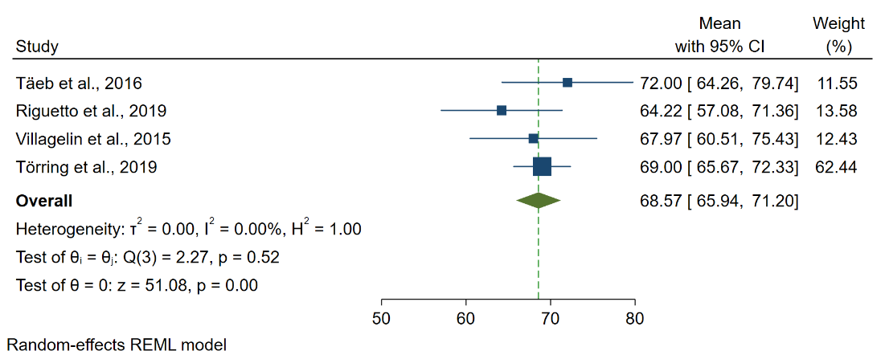
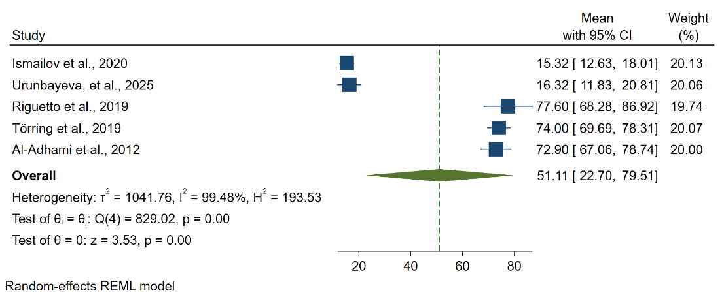
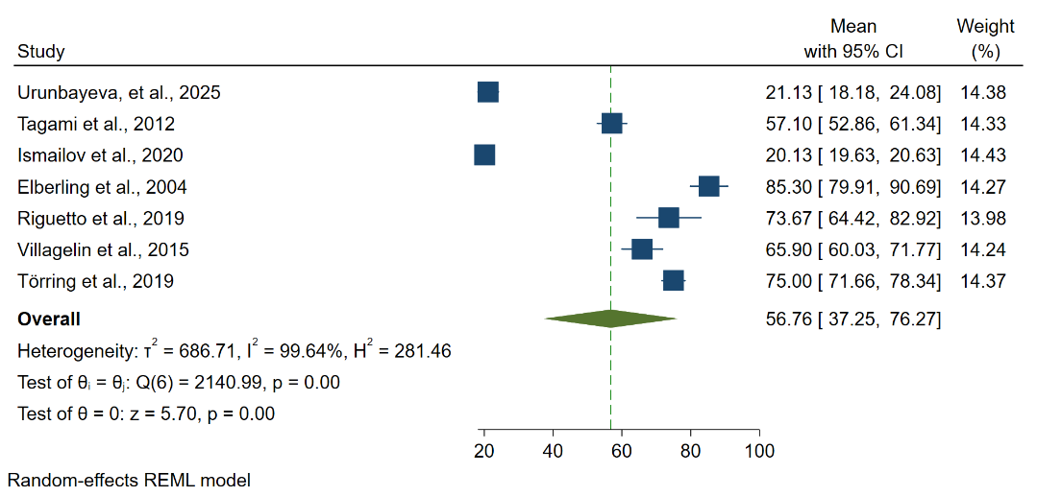
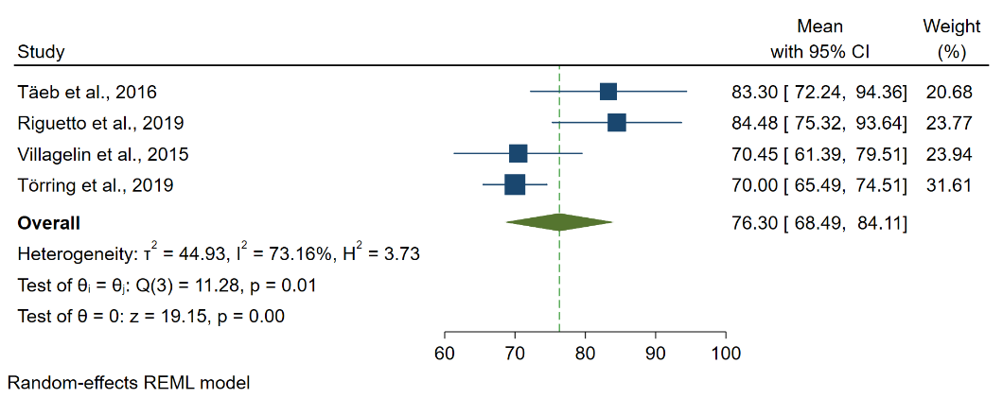
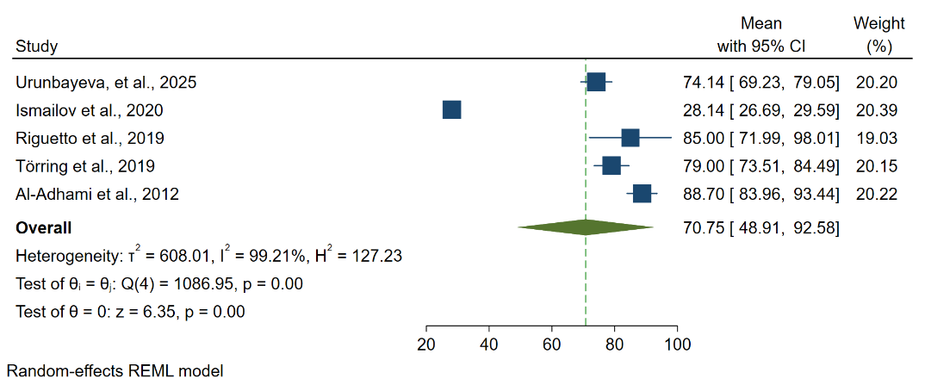
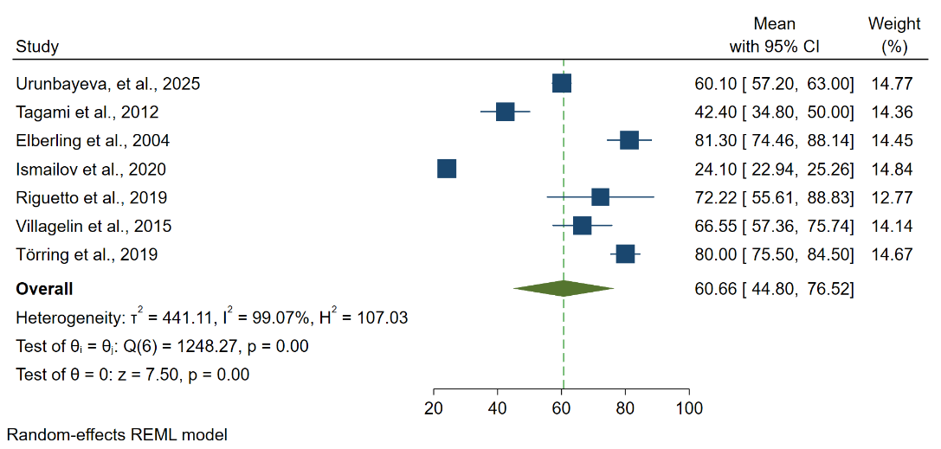
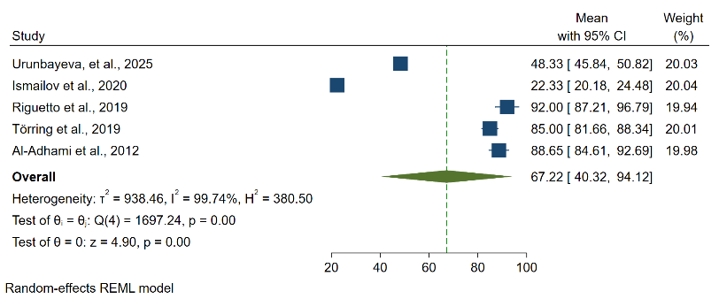
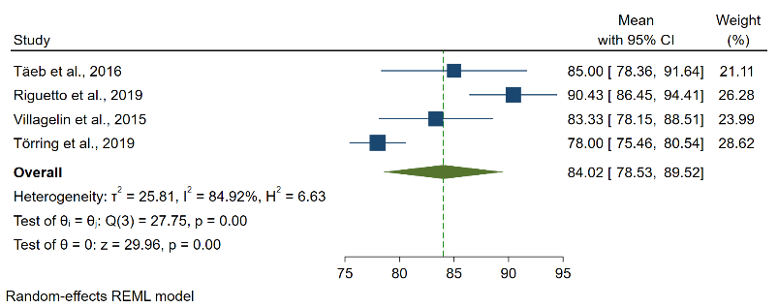
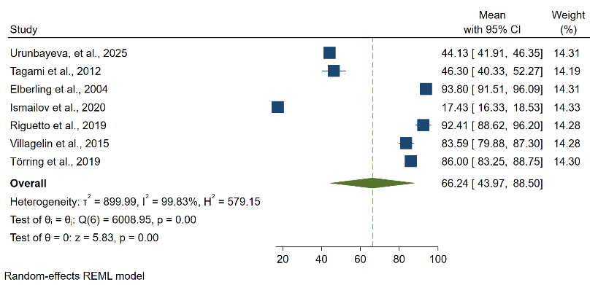
Meta-Analysis of SF-36 Domains Across Treatment Modalities with Forest Plots
Supplementary Fig 2. Physical role limitation domain scores for different treatment modalities
Supplementary Fig 3. Bodily pain domain scores for different treatment modalities
Supplementary Fig 1. Physical functioning domain scores for different treatment modalities
C. Radioiodine – Bodily pain domain
C. Radioiodine – Physical role limitation domain
B. Surgery – Bodily pain domain
A. Antithyroid drug – Bodily pain domain
B. Surgery – Physical role limitation domain
A. Antithyroid drug – Physical role limitation domain
C. Radioiodine – Physical functioning domain
B. Surgery – Physical functioning domain
A. Antithyroid drug – Physical functioning domain
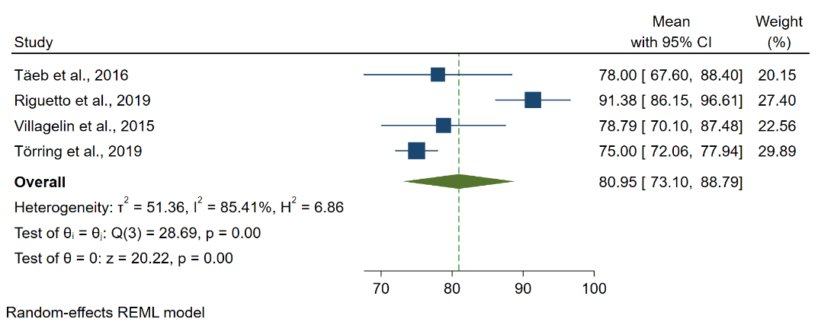
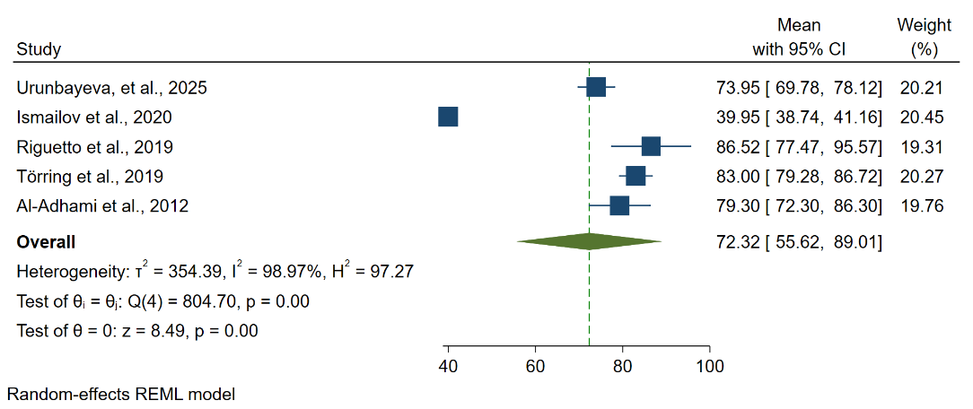
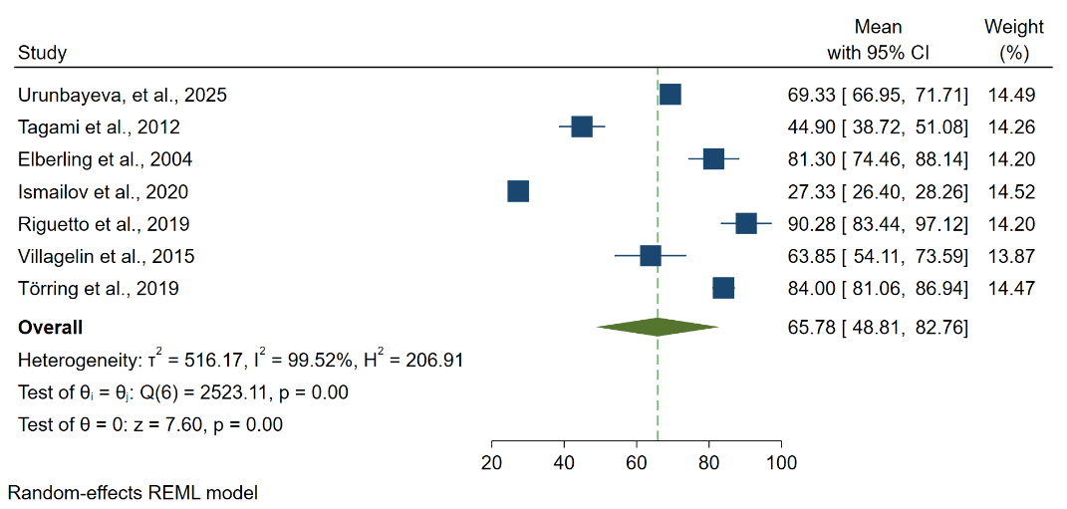
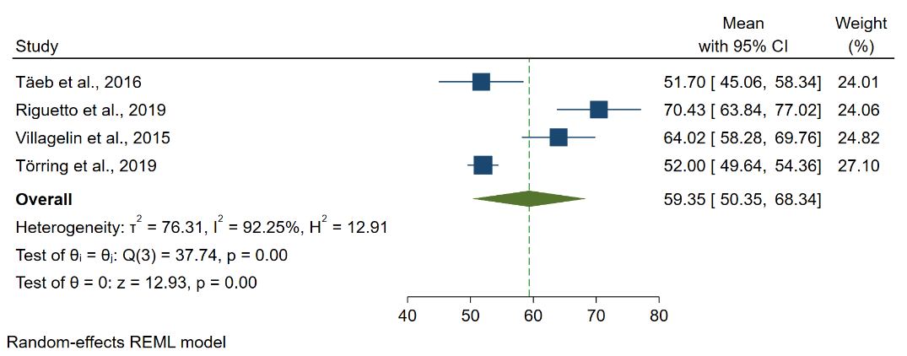
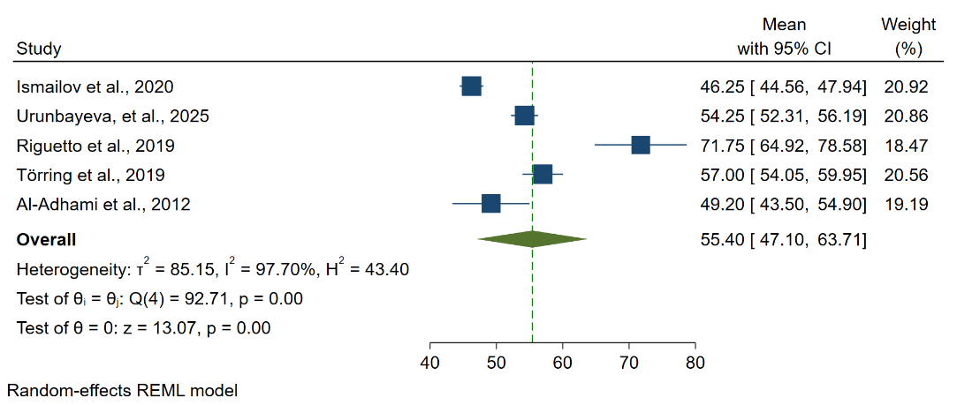
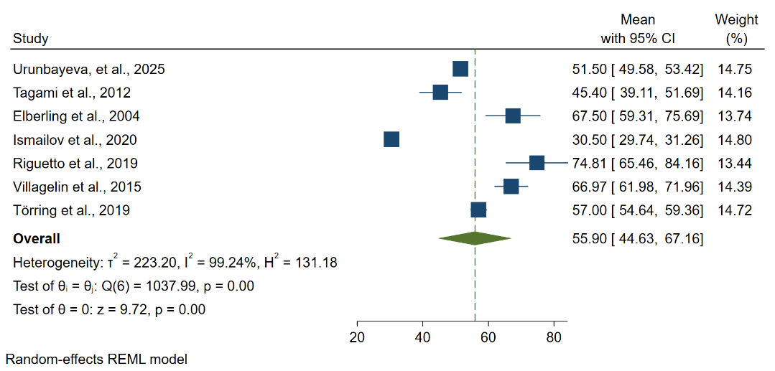
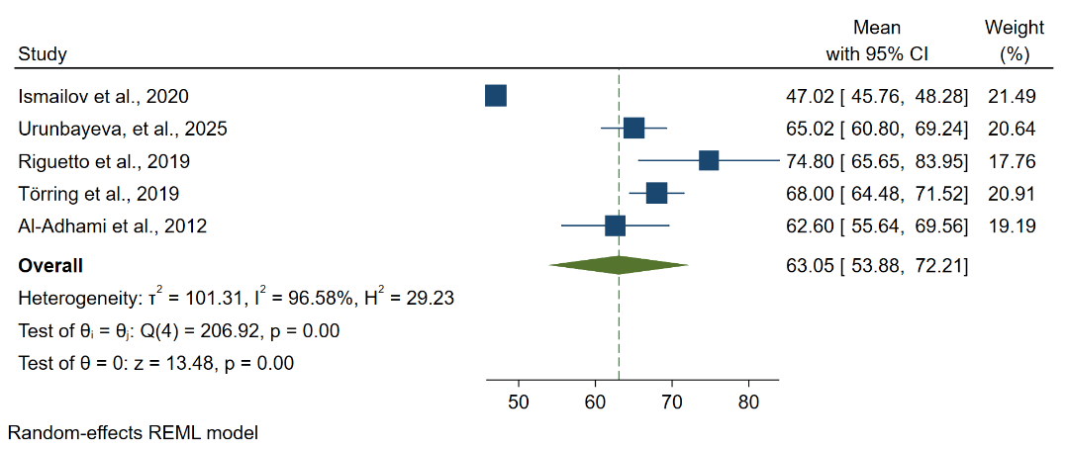
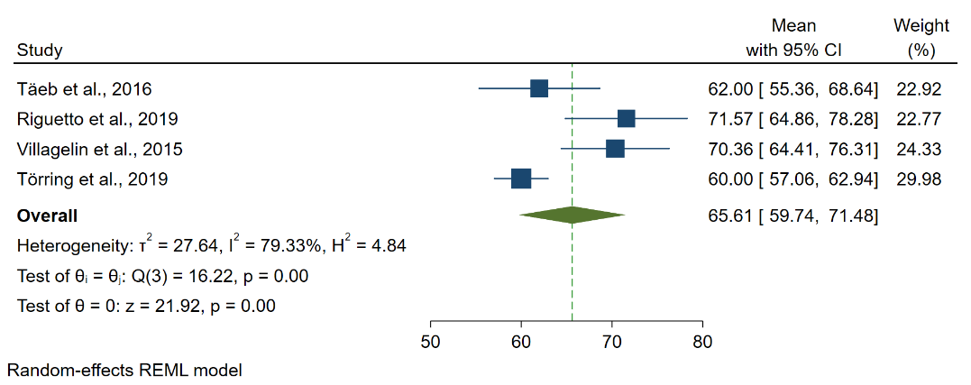
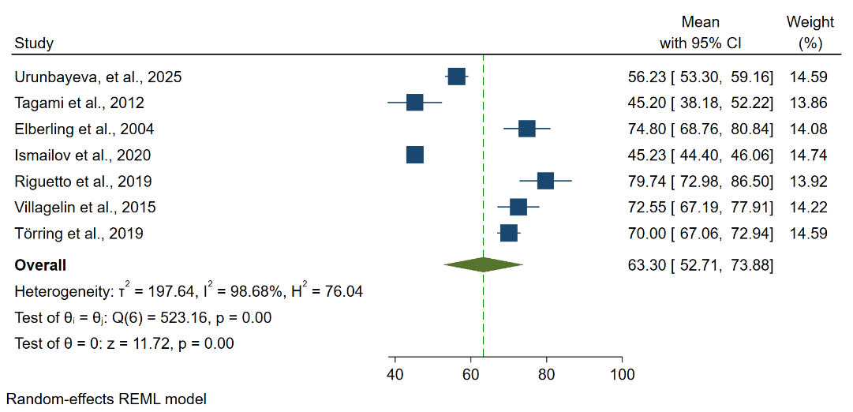
Meta-Analysis of SF-36 Domains Across Treatment Modalities with Forest Plots
Supplementary Fig 5. Vitality domain scores for different treatment modalities

Supplementary Fig 6. Social functioning domain scores for different treatment modalities

Supplementary Fig 4. General health perception domain scores for different treatment modalities

C. Radioiodine – Social functioning domain
B. Surgery – Social functioning domain
A. Antithyroid drug – Social functioning domain
C. Radioiodine – Vitality domain
B. Surgery – Vitality domain
A. Antithyroid drug – Vitality domain
C. Radioiodine – General health perception domain
B. Surgery – General health perception domain
A. Antithyroid drug – General health perception domain
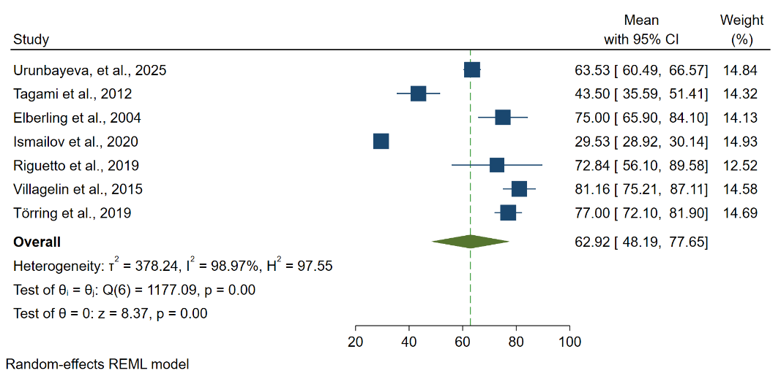
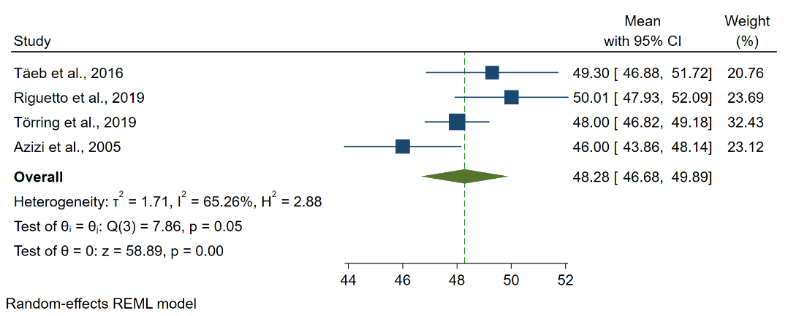
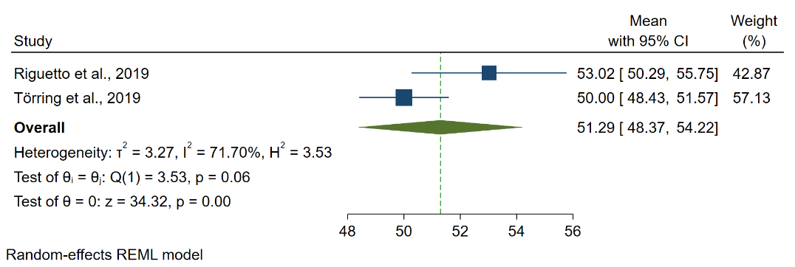
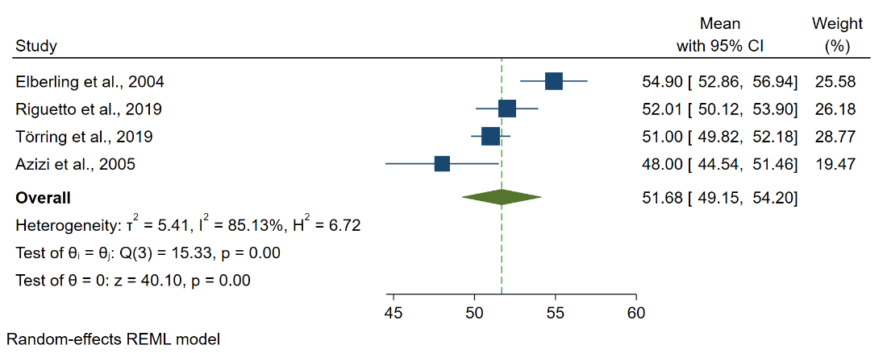
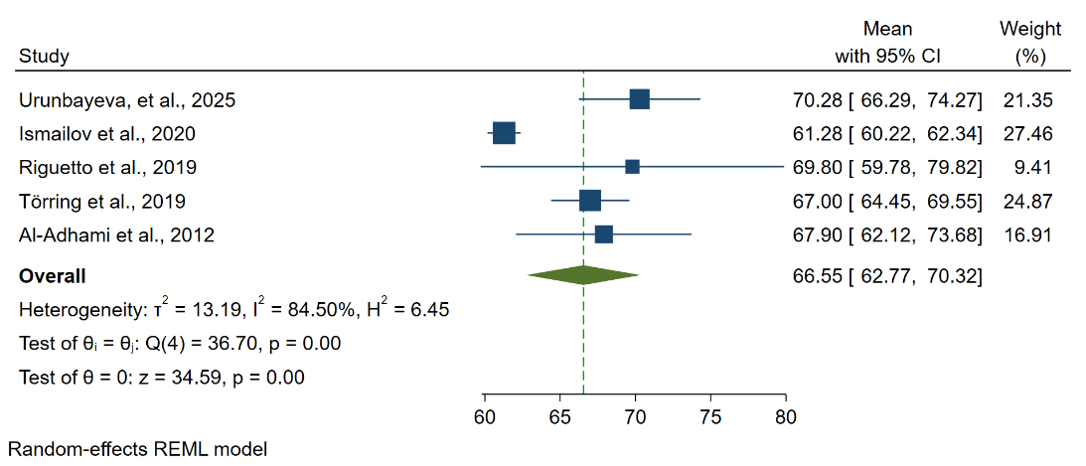
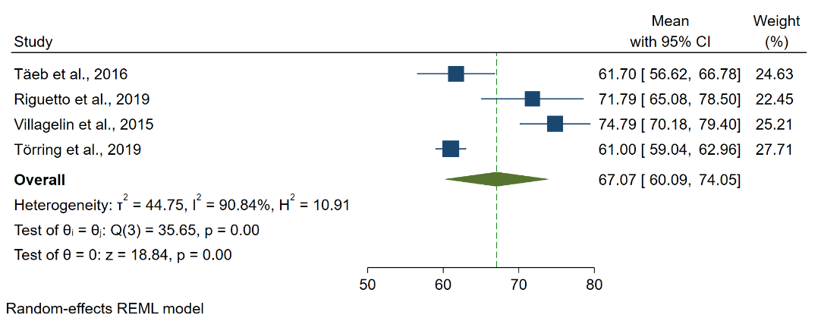
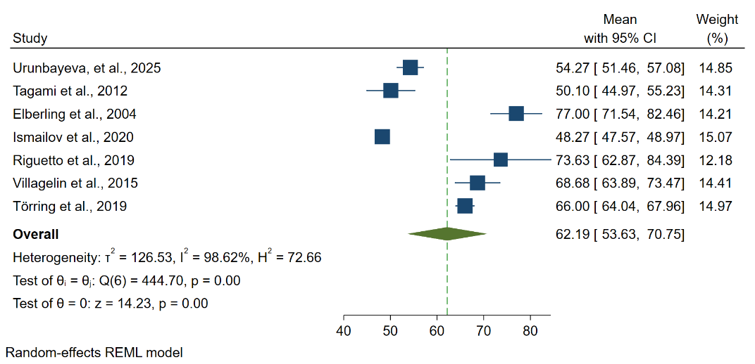
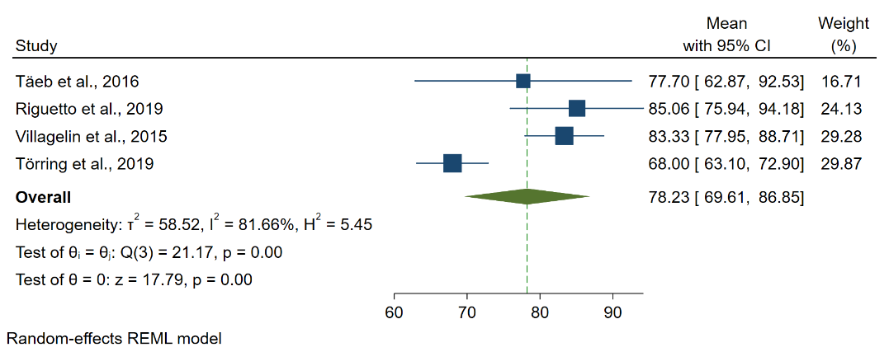
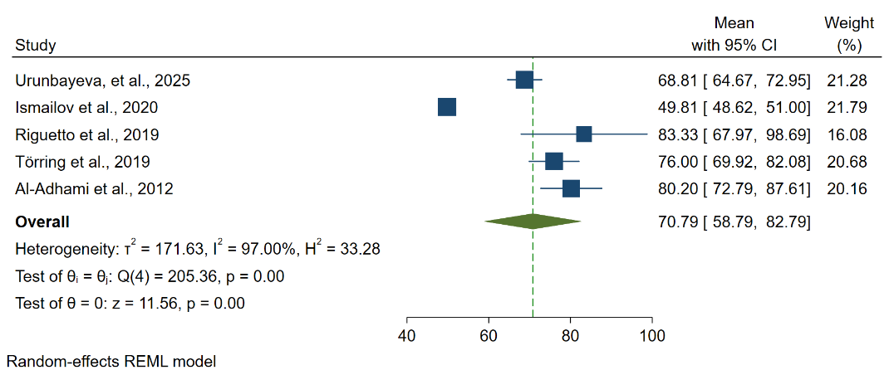
Meta-Analysis of SF-36 Domains Across Treatment Modalities with Forest Plots
Supplementary Fig 7. Emotional role limitation domain scores for different treatment modalities

Supplementary Fig 9. Physical component scale domain scores for different treatment modalities

C. Radioiodine – Physical component scale domain
B. Surgery – Physical component scale domain
A. Antithyroid drug – Physical component scale domain
Supplementary Fig 8. Mental health domain scores for different treatment modalities

C. Radioiodine – Mental health domain
B. Surgery – Mental health domain
A. Antithyroid drug – Mental health domain
A. Antithyroid drug – Emotional role limitation domain
C. Radioiodine – Emotional role limitation domain
B. Surgery – Emotional role limitation domain
Supplementary Fig 7A. Antithyroid drug – Emotional role limitation domain
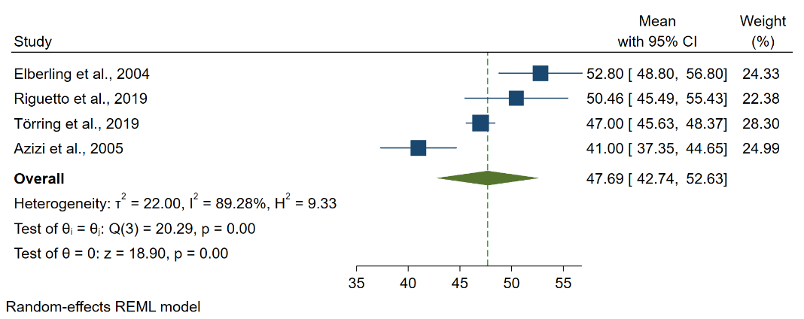
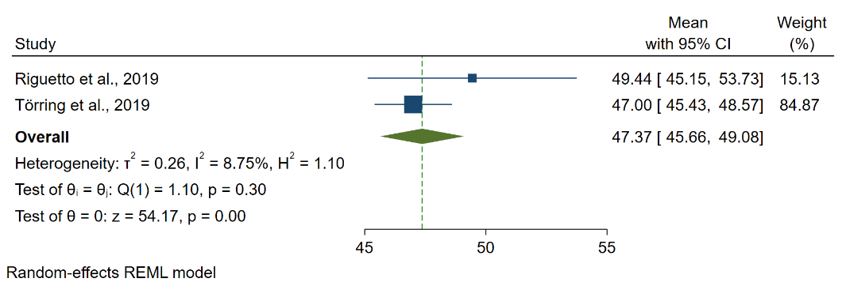
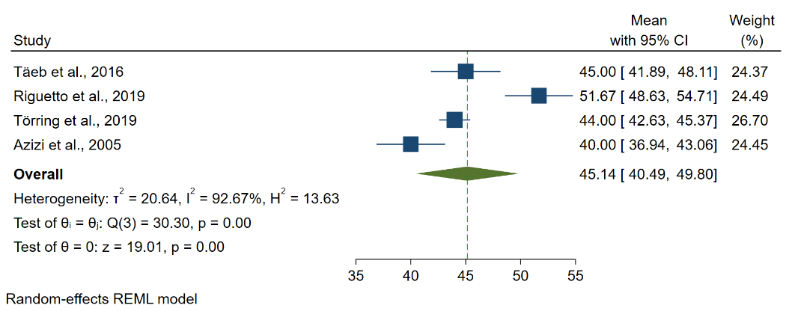
Meta-Analysis of SF-36 Domains Across Treatment Modalities with Forest Plots
A. Antithyroid drug – Mental component scale domain
C. Radioiodine – Mental component scale domain
B. Surgery – Mental component scale domain
Supplementary Fig 10. Mental component scale domain scores for different treatment modalities

1.
Refrences:
1. Ljunggren JG, Törring O, Wallin G, Taube A, Tallstedt L, Hamberger B, et al. Quality of life aspects and costs in treatment of Graves' hyperthyroidism with antithyroid drugs, surgery, or radioiodine: results from a prospective, randomized study. Thyroid. 1998;8(8):653–9.
2. Palestini N, Grivon M, Durando R, Freddi M, Odasso C, Robecchi A. Thyroidectomy for Graves' hyperthyroidism. Retrospective study of patients' appreciation. Annali italiani di chirurgia. 2007;78(5):405–12.
3. Cashman EC, Bresnihan M, Timon C. Patients' quality of life post thyroidectomy. B-ent. 2011;7(4):261–5.
4. Scerrino G, Morfino G, Paladino NC, Di Paola V, Amodio E, Gulotta G, et al. Does thyroid surgery for Graves' disease improve health-related quality of life? Surg Today. 2013;43(12):1398–405.
5. Bukvic BR, Zivaljevic VR, Sipetic SB, Diklic AD, Tausanovic KM, Paunovic IR. Improvement of quality of life in patients with benign goiter after surgical treatment. LANGENBECKS ARCHIVES OF SURGERY. 2014;399(6):755–64.
6. Watt T, Cramon P, Hegedüs L, Bjorner JB, Bonnema SJ, Rasmussen Å K, et al. The thyroid-related quality of life measure ThyPRO has good responsiveness and ability to detect relevant treatment effects. J Clin Endocrinol Metab. 2014;99(10):3708–17.
7. Cramon P, Winther KH, Watt T, Bonnema SJ, Bjorner JB, Ekholm O, et al. Quality-of-Life Impairments Persist Six Months after Treatment of Graves' Hyperthyroidism and Toxic Nodular Goiter: A Prospective Cohort Study. Thyroid. 2016;26(8):1010–8.
8. Donovan PJ, McLeod DSA, Little R, Gordon L. Cost-utility analysis comparing radioactive iodine, anti-Thyroid drugs and total thyroidectomy for primary treatment of Graves' disease. European Journal of Endocrinology. 2016;175(6):595–603.
9. Kus LH, Hopman WM, Witterick IJ, Freeman JL. Quality-of-life outcomes in Graves disease patients after total thyroidectomy. Ear, Nose and Throat Journal. 2017;96(4-5):E8.
10. Yang D, Liu F, Ma T. Evaluation of cardiovascular complexities and quality of life related to health in Chinese patients with thyrotoxic heart disease secondary to toxic diffuse goiter. Biomedical Research. 2018;29(1):1–8.
11. Conaglen HM, Tamatea JAU, Conaglen JV, Elston MS. Treatment choice, satisfaction and quality of life in patients with Graves’ disease. Clinical Endocrinology. 2018;88(6):977–84.
12. Sawicka-Gutaj N, Ruchala M, Feldt-Rasmussen U, Rasmussen AK, Hegedüs L, Bonnema SJ, et al. Patients with Benign Thyroid Diseases Experience and Impaired Sex Life. Thyroid. 2018;28(10):1261–9.
13. Sjölin G, Holmberg M, Törring O, Byström K, Khamisi S, De Laval D, et al. The Long-Term Outcome of Treatment for Graves' Hyperthyroidism. Thyroid. 2019;29(11):1545–57.
14. Törring O, Watt T, Sjölin G, Byström K, Abraham-Nordling M, Calissendorff J, et al. Impaired Quality of Life after Radioiodine Therapy Compared to Antithyroid Drugs or Surgical Treatment for Graves' Hyperthyroidism: A Long-Term Follow-Up with the Thyroid-Related Patient-Reported Outcome Questionnaire and 36-Item Short Form Health Status Survey. Thyroid. 2019;29(3):322–31.
15. Hamilton LOW, Lim AE, Clark LJ. Total thyroidectomy for Graves' disease-what do our patients think? A qualitative cohort study to evaluate the surgical management of Graves' disease. The surgeon : journal of the Royal Colleges of Surgeons of Edinburgh and Ireland. 2020;18(4):193–6.
16. Mirallié E, Borel F, Tresallet C, Hamy A, Mathonnet M, Lifante JC, et al. Impact of total thyroidectomy on quality of life at 6 months: The prospective ThyrQoL multicentre trial. European Journal of Endocrinology. 2020;182(2):195–205.
17. Rowe CW, Blefari ND, Rutherford N, Bendinelli C, O’Neill C. SAT-427 Quality of Life Following Treatment for Graves’ Disease: A Comparison of Radioactive Iodine Ablation and Surgery. Journal of the Endocrine Society. 2020;4(Supplement_1):SAT–427.
18. Shukurullaevich AD, Erdanovich RК, Sulaymonovich DS, Erkinovich НZ. Quality of life of patients before and after surgical treatment of diffuse toxic goiter. Вестник науки и образования. 2021(3-2 (106)):80–7.
19. Halada S, Baran J, Patel T, Isaza A, Magee L, Bauer A. Impact of Definitive Surgery for Graves' Disease on Adolescent Health-Related Quality of Life and Psychosocial Functioning. Journal of the Endocrine Society. 2022;6:A642–A3.
20. Calissendorff J, Cramon PK, Hallengren B, Khamisi S, Lantz M, Planck T, et al. Long-Term Outcome of Graves' Disease: A Gender Perspective. Womens Health Rep (New Rochelle). 2023;4(1):487–96.
21. Afsin H, Çaliskan B. Quality of Life Outcomes Following Radioactive lodine 131 Therapy in Hyperthyroid Patients: Insights from the Thyroid Patient-Reported Outcome Questionnaire. MOLECULAR IMAGING AND RADIONUCLIDE THERAPY. 2025;34(1):38–47.

