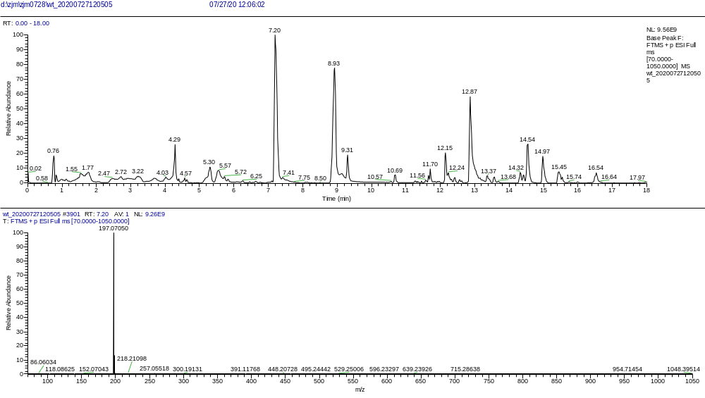
Figure 1 The total ion flow chromatogram of the PECE.
Figure 2 The mass spectra corresponding to chromatographic peaks with retention time of 7.20
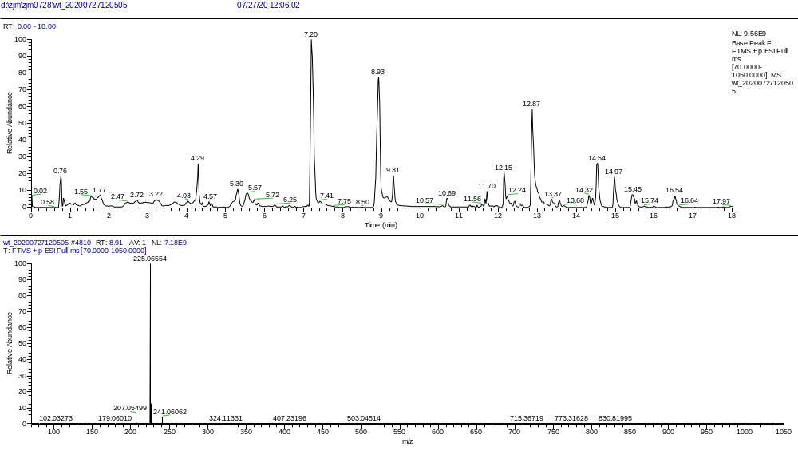
Figure 3 The mass spectra corresponding to chromatographic peaks with retention time of 8.91.
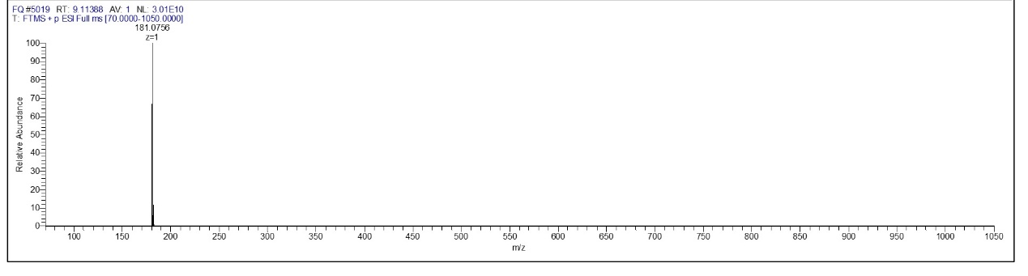
Figure 4 The mass spectra corresponding to chromatographic peaks with retention time of 9.11.

