Table S1 The primers used in this text.
Primer name | Sequence (5' to 3') | Base number
phzE-up-EcoRI-s | ACACGAATTCACCTGGAAACCACCCCTGACGA | 32
phzE-up-BamHI-a | ACACGGATCCGAGCCGGTTGCAGGATGCGCTC | 32
phzE-down-BamHI-s | ACACGGATCCCTGATCCACACACCTGTCGAGA | 32
phzE-down-HindIII-a | CACAAAGCTTCATAGAACGATGGTCCCCCGTC | 32
phzH-up-EcoRI-s | ACACGAATTCCCGATCCCATGAGCGTGCTGCA | 32
phzH-up-BamHI-a | CACAGGATCCCTGCACTTTTCAGATATTTACG | 32
phzH-down-BamHI-s | ACACGGATCCAAGCCTGATACGCCGCATGGTG | 32
phzH-down-HindIII-a | CACAAAGCTTGCGGTTTCGCGACCGTCATAAG | 32

Treatment group | Grade 1 | Grade 2 | Grade 3 | Grade 4
Negative Control | 0 | 6 | 16 | 28
 | 0 | 7 | 14 | 29
 | 0 | 4 | 19 | 27
Carbendazim | 14 | 5 | 3 | 4
 | 16 | 4 | 6 | 2
 | 15 | 3 | 4 | 5
P. chlororaphis ZM-1 | 12 | 2 | 5 | 3
 | 11 | 2 | 4 | 4
 | 14 | 3 | 4 | 2
ΔphzH | 10 | 7 | 11 | 9
 | 13 | 6 | 9 | 10
 | 12 | 5 | 10 | 9
ΔphzE | 2 | 8 | 17 | 23
 | 4 | 7 | 13 | 26
 | 3 | 6 | 16 | 25
Table S2 The number of diseased plants in each grade.

Table S3 The biocontrol efficacy of each group tested strains in greenhouse experiments.
Treatment group | Incidence rate (%) | Disease index（%） | Relative biocontrol efficacy (%)
Negative Control (NC) | 100 | 86.0 | /
 | 100 | 86.5
 | 100 | 86.0
Carbendazim | 52.0 | 24.5 | 71.57
 | 56.0 | 25.0 | 70.99
 | 54.0 | 26.5 | 69.25
P. chlororaphis ZM-1 | 44.0 | 21.5 | 75.05
 | 42.0 | 21.5 | 75.05
 | 46.0 | 20.0 | 76.79
ΔphzH | 74.0 | 46.5 | 46.04
 | 76.0 | 46.0 | 46.62
 | 72.0 | 44.0 | 48.94
ΔphzE | 100 | 80.5 | 6.58
 | 98.0 | 80.5 | 6.58
 | 98.0 | 81.5 | 5.42

Treatment group | Grade 1 | Grade 2 | Grade 3 | Grade 4
Negative Control | 21 | 34 | 45 | 36
 | 18 | 40 | 38 | 42
Carbendazim | 14 | 28 | 23 | 13
 | 16 | 20 | 28 | 11
P. chlororaphis ZM-1 | 12 | 23 | 16 | 15
 | 11 | 18 | 24 | 9
ΔphzH | 10 | 17 | 31 | 19
 | 13 | 16 | 24 | 21
ΔphzE | 22 | 31 | 47 | 34
 | 18 | 37 | 43 | 38
Table S4 The number of diseased plants in each grade.
Note: The total number of each group：160*2=320

Treatment group | Incidence rate (%) | Disease index（%） | Relative biocontrol efficacy (%)
Negative Control (NC) | 86.25 | 57.5 | /
 | 85.0 | 59.38
Carbendazim | 48.75 | 29.84 | 48.93
 | 46.88 | 28.75 | 50.80
P. chlororaphis ZM-1 | 41.25 | 25.94 | 55.62
 | 38.75 | 24.22 | 58.56
ΔphzH | 48.13 | 33.28 | 43.05
 | 46.25 | 31.41 | 46.26
ΔphzE | 83.75 | 56.41 | 3.48
 | 85.00 | 58.28 | 0.27
Table S5 The biocontrol efficacy of each group tested strains in plot experiments.

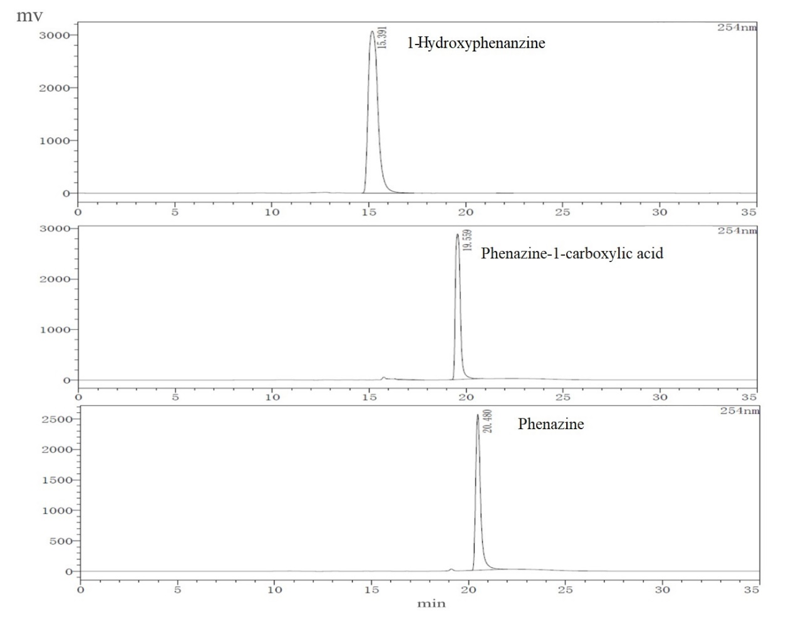
Figure S1 The liquid chromatograms of the three standard reagents.

