Table 3. Synthesis of 2-amino-4H-chromenes using nanosphere KCC-1@NH₂ª
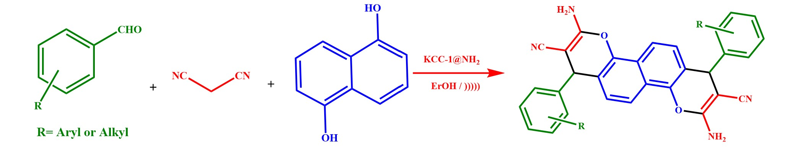
Entry | Name | Product^{b} | Time (min) | Yield^{c} (%) | M.P. (ºC)^{d}
1 | a | 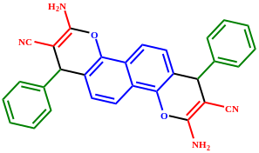 | 25 | 90 | 295-300⁵¹
2 | b | 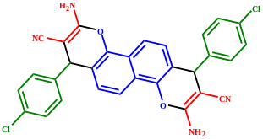 | 20 | 96 | 300-310^{49,50}
3 | c | 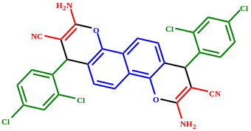 | 20 | 95 | 320-325⁵¹
4 | d | 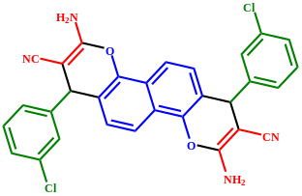 | 25 | 92 | 310-315
5 | e | 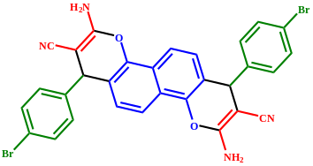 | 20 | 95 | 300-310 ⁵¹
6 | f | 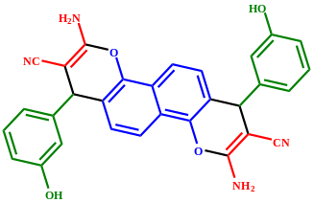 | 30 | 85 | >300
7 | g | 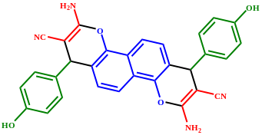 | 30 | 82 | >300
8 | h | 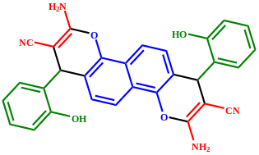 | 30 | 80 | >300
9 | i | 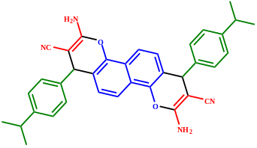 | 30 | 84 | 315-320
10 | j | 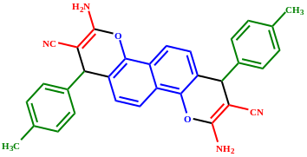 | 30 | 82 | 310-320
11 | k | 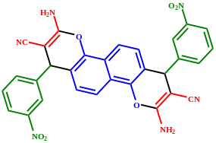 | 25 | 93 | >300⁵¹
12 | l | 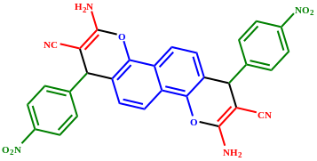 | 20 | 96 | >300
13 | m | 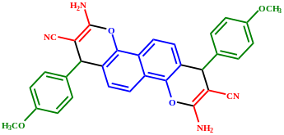 | 30 | 82 | 251-258⁵¹
14 | n | 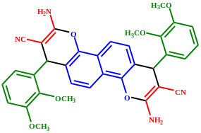 | 35 | 80 | 262-270
15 | o | 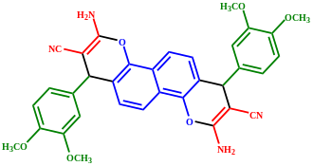 | 35 | 80 | 265-274 ⁵¹
ª Reactions conditions: benzaldehyde (1 mmol), malononitrile (1 mmol), 1,5- dinaphtol compound (0.5 mmol), nano KCC-1@NH₂ (5 %) under ultrasonic irradiation (80 W)
^{b} All products were characterized from their spectroscopic IR, ¹H NMR
^{c} Isolated yield
^{d} Literature references

