Supplementary information

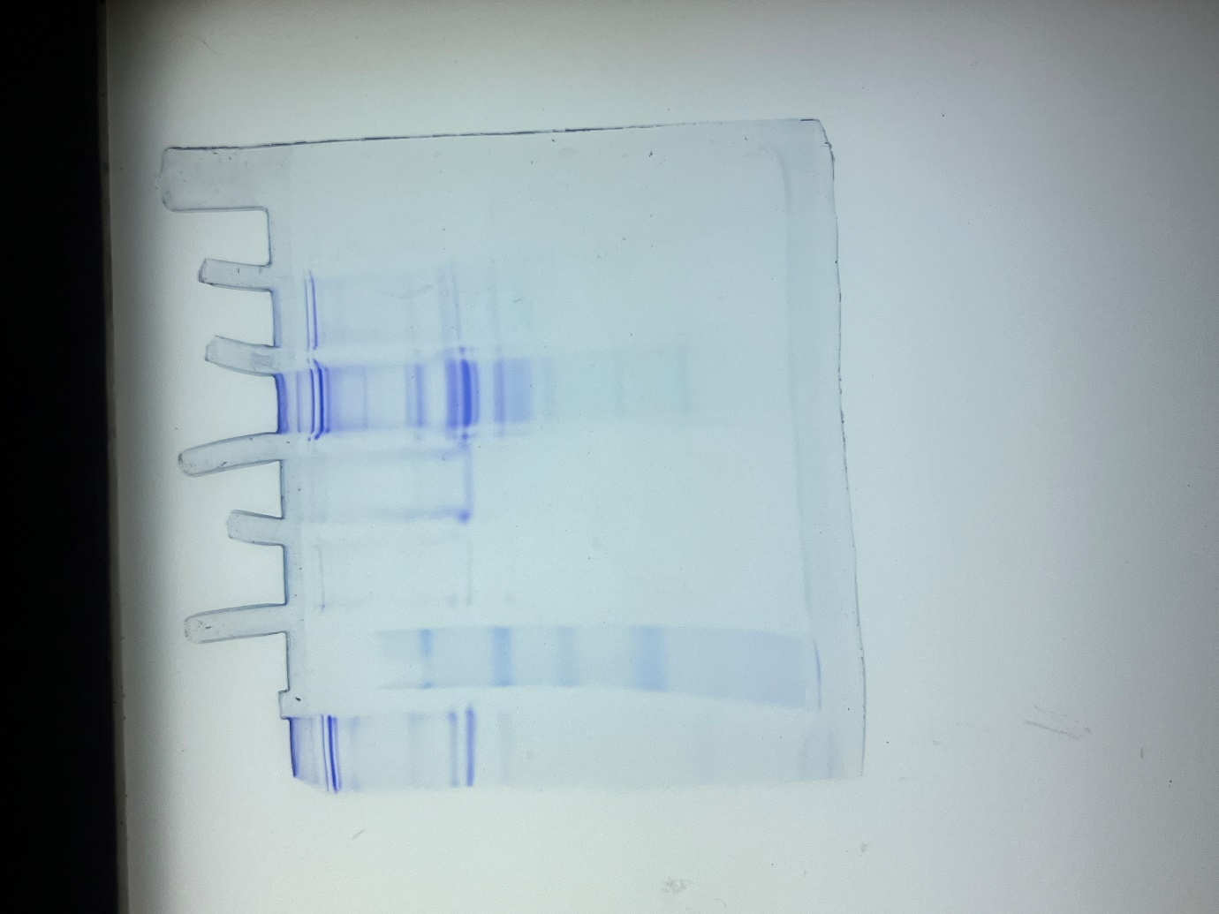
Supplementary Fig. 1 Supplementary Fig. 1. Uncropped PAGE gel image showing Lane 2 (molecular weight marker); Lane 3 (purified amylase, DEAE-cellulose fraction, 5 µg load); Lane 4 (purified amylase, DEAE-cellulose fraction, 20 µg load) displaying a distinct band at ~62 kDa; Lane 5 (size-exclusion fraction of the enzyme); Lanes 1 and 6 (other protein fractions); and Lane 7 (empty).
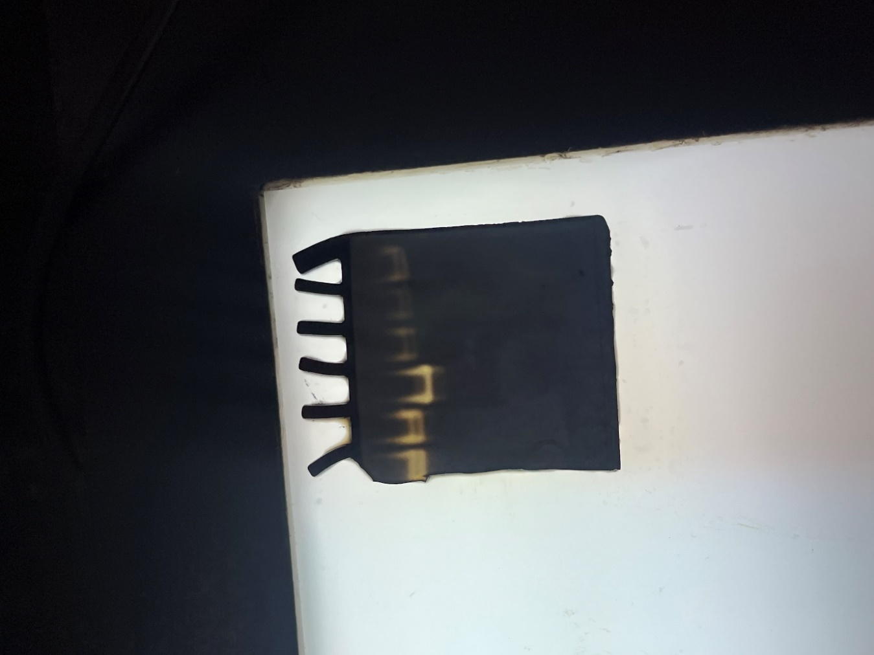
Supplementary Fig. 2. Uncropped zymogram gel image showing a clear activity band in Lane 3 (purified amylase from Laceyella sacchari); Lanes 1, 2, 4, 5, and 6 represent other bacterial amylase.

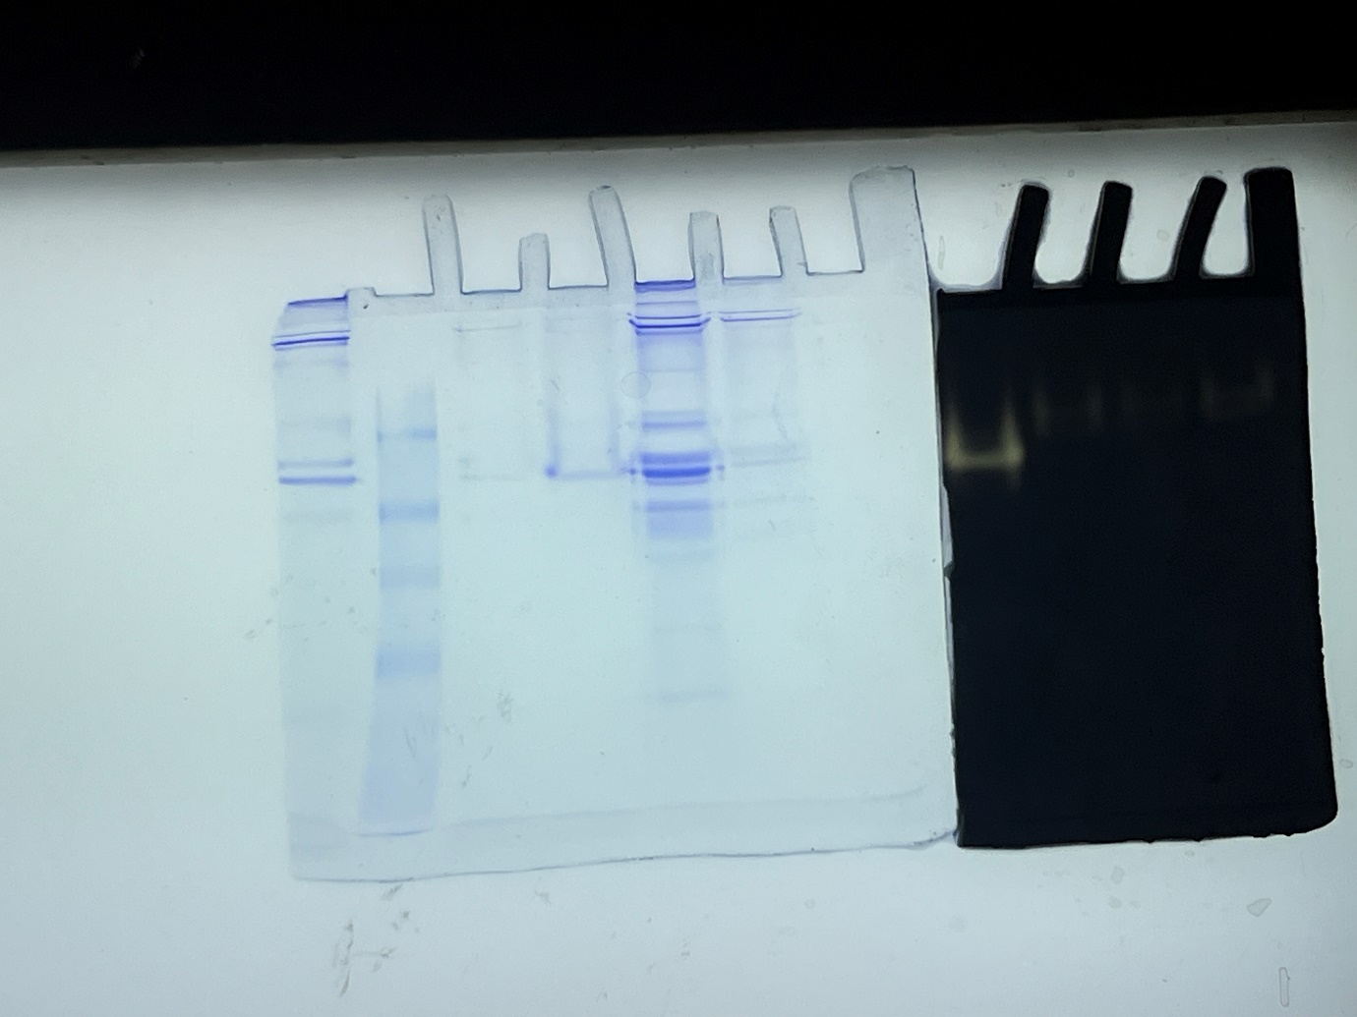
Supplementary Fig. 3 Uncropped gel image showing comparison of PAGE gel with zymography gel

Supplementary Table 1 Proximate analysis of wheat flour
Parameter | Obtained value (%)
Ash | 3.76
Fat | 2.19
Protein | 10.83
Crude fibre | 5.10
Carbohydrate | 78.12

