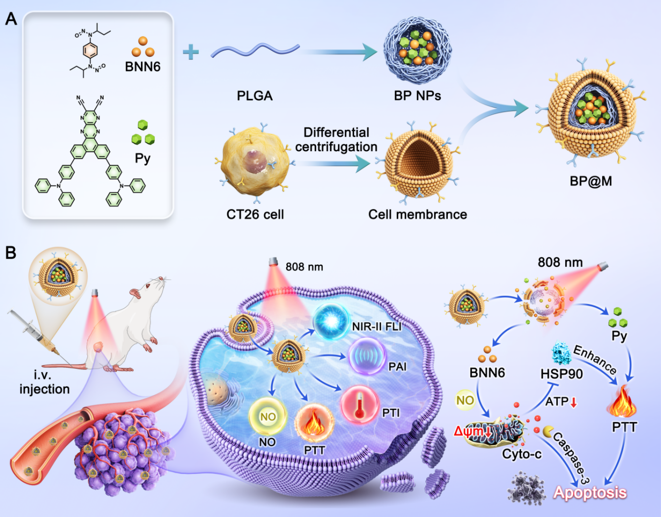
Scheme 1. Schematic illustration of multimodal imaging-guided AIE/NO biomimetic nano-controlled release for enhanced photothermal therapy. (A) Preparation of BP@M biomimetic nanosystem (B) The mechanism of BP@M in synergistic mPTT/NO antitumor theranostics.

