Table S1. Quality assessment of included studies using Newcastle-Ottawa Scale.
Cohort study | Representatives of the exposed cohort | Selection of the non-exposed cohort | Ascertainment of exposure | Was outcome of interest present at start of study | Comparability of cohorts on the basis of the design or analysis | Assessment of outcome | Was follow-up long enough for outcomes to occur | Adequate follow up | Total
Hashimoto, 2024 | 1 | 1 | 1 | 1 | 1 | 1 | 1 | 1 | 9
Fukushima, 2024 | 1 | 1 | 1 | 1 | 1 | 1 | 1 | 1 | 9
Aoyama, 2024 | 1 | 1 | 1 | 1 | 1 | 1 | 0 | 1 | 8
Nakashima, 2024 | 1 | 1 | 1 | 1 | 1 | 1 | 1 | 1 | 9
Okugawa, 2024 | 1 | 1 | 1 | 1 | 1 | 1 | 1 | 1 | 9
Sakurai, 2024 | 1 | 1 | 1 | 1 | 1 | 1 | 0 | 1 | 8
Toda, 2025 | 1 | 1 | 1 | 1 | 1 | 1 | 1 | 1 | 9
Liu, 2026 | 1 | 1 | 1 | 1 | 1 | 1 | 1 | 1 | 9

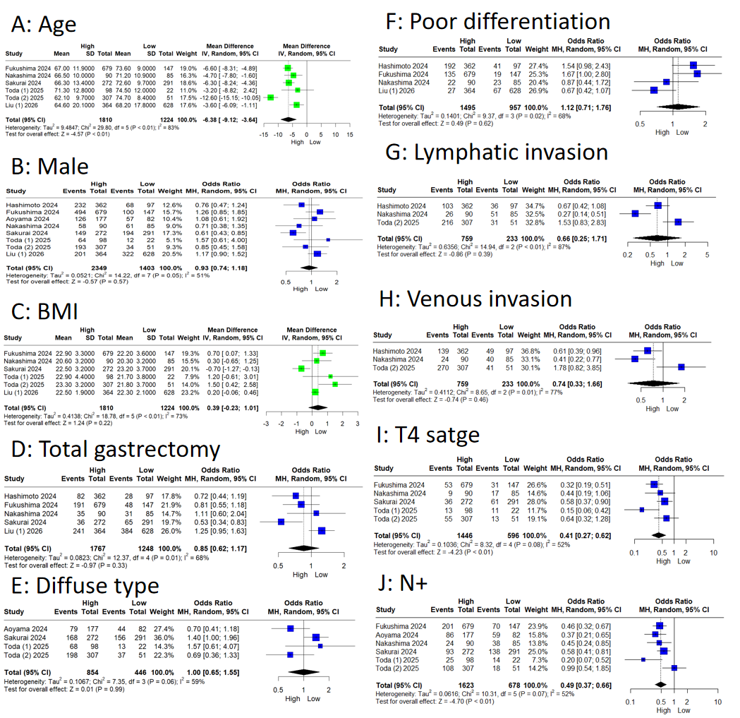
Figure S1. Clinicopathological characteristics of gastric cancer patients between the high and low CALLY index groups. A: Age; B: Male; C:BMI; D: Total gastrectomy; E: Diffuse type; F: Poor differentiation; G: Lymphatic invasion; H: Venous invasion; I:T4 stage; J: N+.

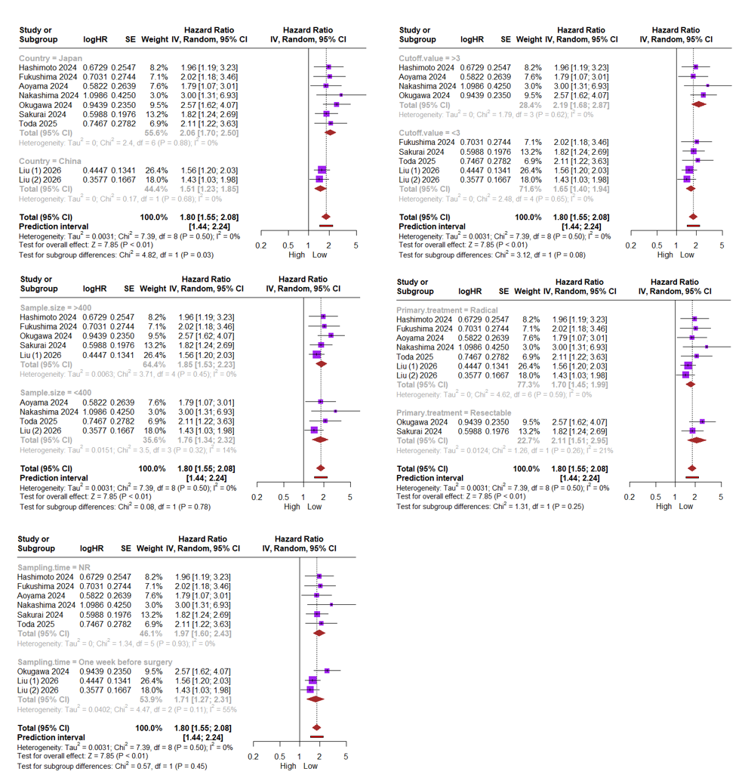
Figure S2. Forest plot of subgroup analyses assessing the relationship between CALLY index and OS. A: Country (China vs. Japan); B: Sample size (>400 vs. <400); C: Sampling time (Within one week vs. Others); D: Cut-off value (>3 vs. <3); E: Primary treatment (Radical vs. Resectable).
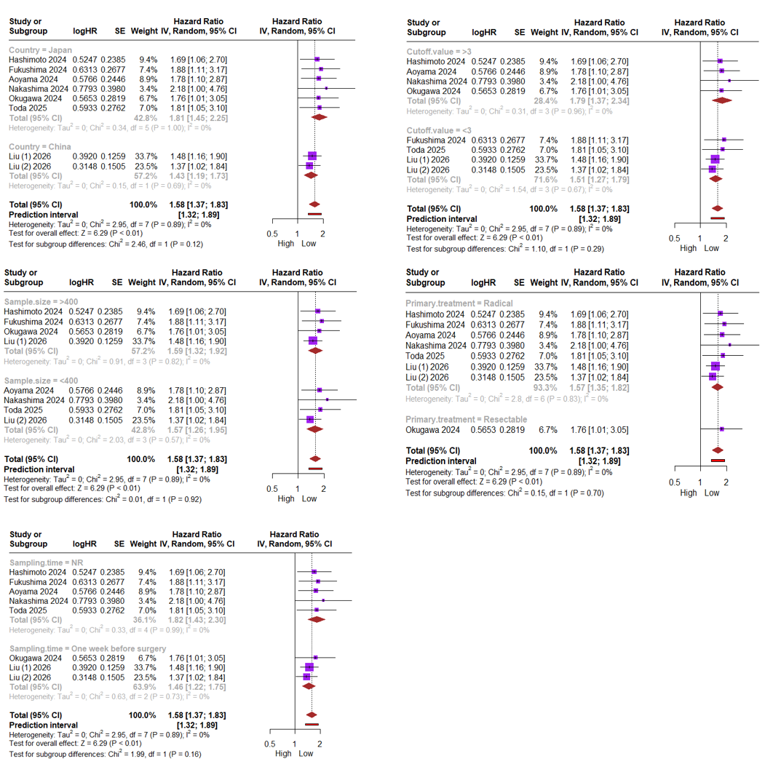
Figure S3. Forest plot of subgroup analyses assessing the relationship between CALLY index and DFS. A: Country (China vs. Japan); B: Sample size (>400 vs. <400); C: Sampling time (Within one week vs. Others); D: Cut-off value (>3 vs. <3); E: Primary treatment (Radical vs. Resectable).

