The relationship between compassion fatigue and professional identity among vocational undergraduate nursing interns: a cross-sectional network analysis

Additional file 2

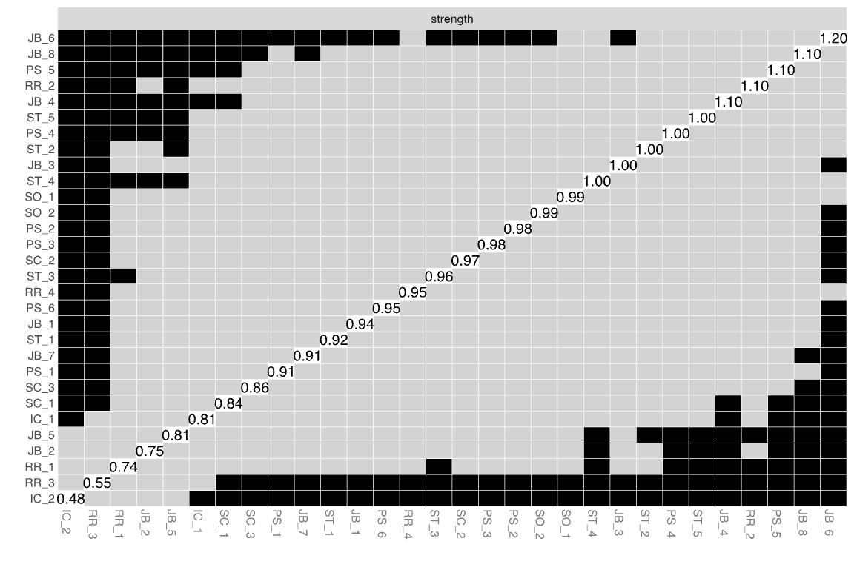
Additional file 2 Bootstrapped difference test for nodes

