Supplementary materials
AI-based spectral analysis of EVs for fetus status prediction

Seungmin Kim^{1#}, Da Eun Jeong^{2#}, Eunbit Park², Hyo Jin Lee², Young Mi Jung², Hyeon Ji Kim², Jihyun Hwang¹, Eun Byul Lee³, Hyunku Shin³, Jee Yoon Park^{2*} and Yeonho Choi^{1,3,4*}

¹ Department of Biomedical Engineering, Korea University, Seoul 02841, Republic of Korea
² Department of Obstetrics and Gynecology, Seoul National University, Bundang Hospital, Seoul National University College of Medicine, Gyeonggi-do 13620, Republic of Korea
³ Exopert Corporation, Seoul 02582, Republic of Korea
⁴ School of Biomedical Engineering, Korea University, Seoul 02841, Republic of Korea

Corresponding authors:
Jee Yoon Park (jyparkmd08@snu.ac.kr)
Yeonho Choi (yeonhochoi@korea.ac.kr)

# These authors contributed equally to this work
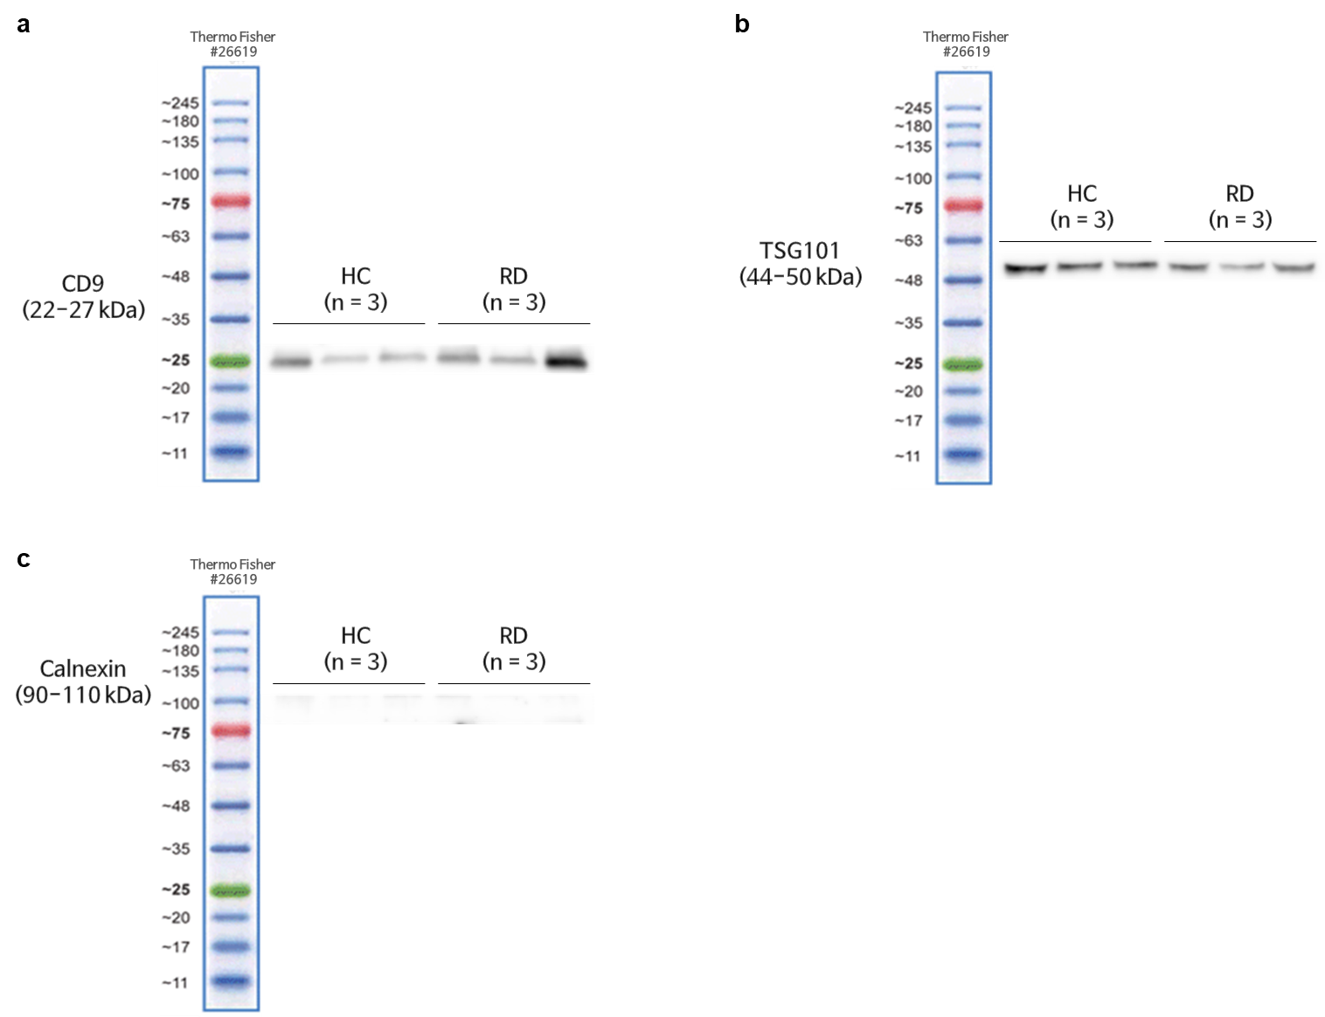 Supplementary Figure 1. Raw western blotting image of isolated EVs
(a-c) Raw western blot data. For western blot analysis, each nitrocellulose membrane was cut by referring to the protein ladder according to the protein size and identifying the protein expression. EV proteins were immunoblotted using antibodies against CD9, TSG101, and calnexin

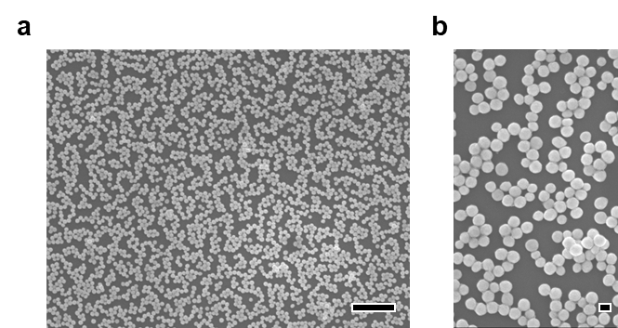
Supplementary Figure 2. SEM image of the SERS substrate
(a-b) SEM images of the SERS substrate prepared by coating 100 nm gold nanoparticles (GNPs) onto a glass surface. Low- and high-magnification images demonstrate the uniform distribution and dense packing of GNPs, enabling consistent Raman signal enhancement. Scale bar = 1μm (a) and 100 nm (b).

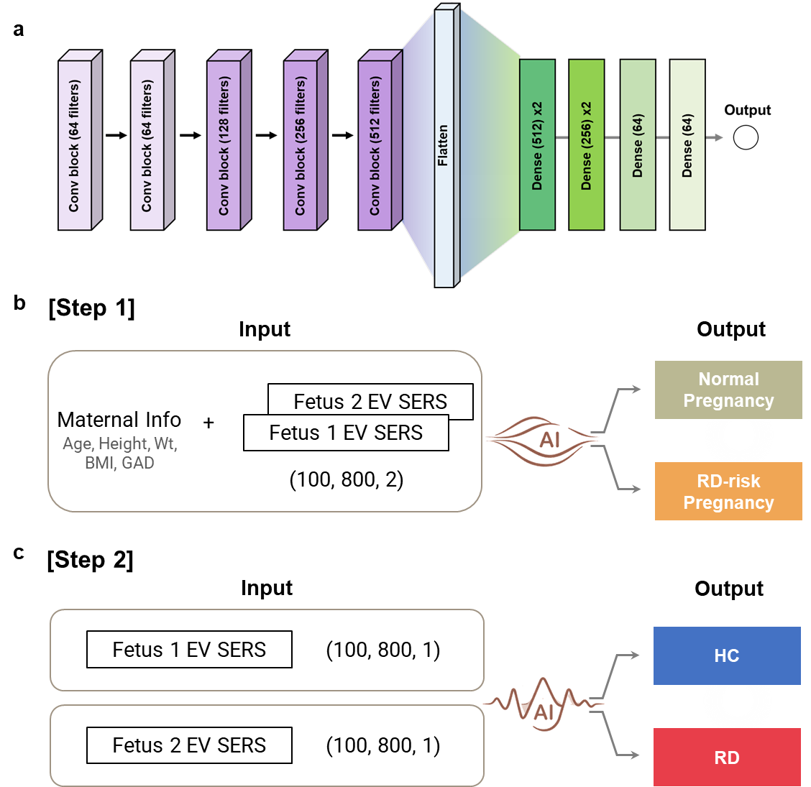
Supplementary Figure 3. CNN architecture and step-wise framework
(a) Schematic illustration of the CNN architecture. The model consists of sequential convolutional blocks with increasing filter sizes (64–512), followed by fully connected layers for feature extraction and classification. (b) Step 1: Pregnancy-level risk screening. Combined inputs including maternal clinical information (age, height, weight, BMI, and gestational age) and paired EV SERS spectra from fetus 1 and fetus 2 were used to classify pregnancies into normal and RD-risk groups. c) Step 2: Fetus-level prediction. Individual EV SERS spectra from each fetus were used as input to predict RD at the fetus-specific level, classifying each fetus as HC or RD.
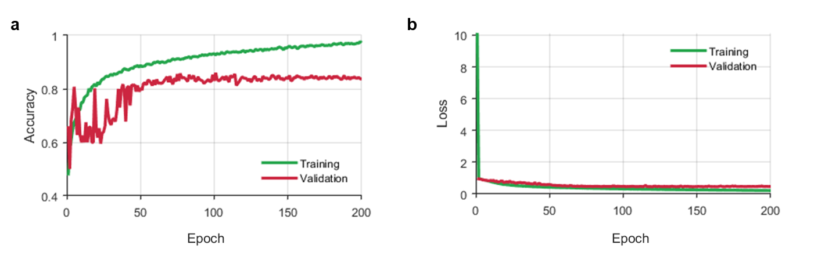
Supplementary Figure 4. Model diagnostic performance for the RD-risk pregnancy prediction (a-b) Results of training the deep learning model

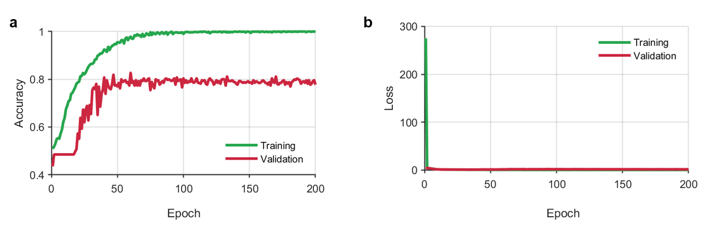
Supplementary Figure 5 . Model diagnostic performance for the RD fetus prediction (a-b) Results of training the deep learning model

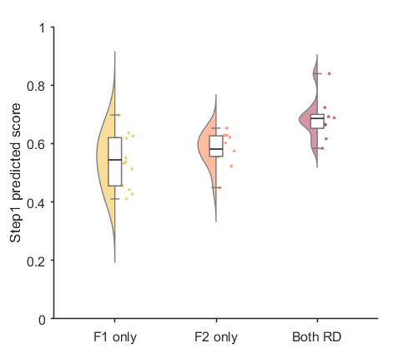

Supplementary Figure 6. Violin plots of Step 1 predicted scores across RD-risk pregnancy subtypes
RD-risk pregnancies were stratified into three groups based on fetal respiratory distress status: fetus 1 only (F1 only), fetus 2 only (F2 only), and both fetuses with RD (Both RD). The distributions of predicted scores demonstrate increasing risk levels across subgroups, indicating that the Step 1 model captures the severity and burden of fetal respiratory distress at the pregnancy level.

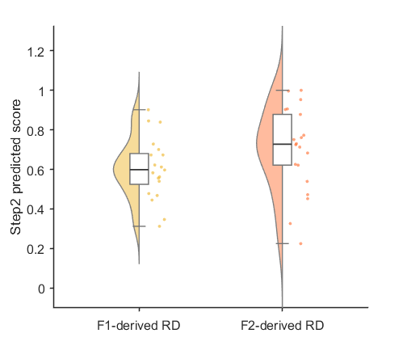
Supplementary Figure 7. Violin plots of Step 2 predicted scores across fetus with RD
Violin plots of Step 2 predicted scores stratified by fetus-specific respiratory distress origin. RD cases were grouped as fetus 1–derived RD (F1-derived RD) and fetus 2–derived RD (F2-derived RD). The distributions of predicted scores demonstrate that the Step 2 model consistently identifies fetus-specific RD, supporting its ability to distinguish individual fetal risk within twin pregnancies.

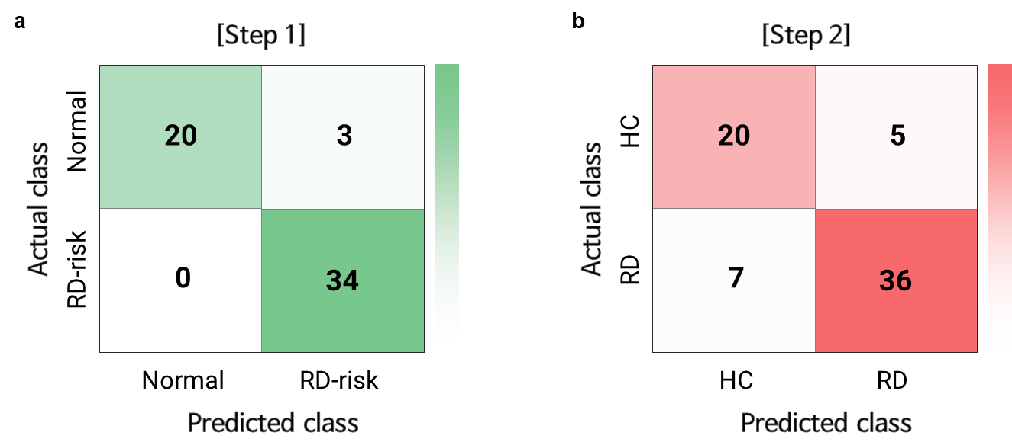

Supplementary Figure 8. Confusion matrix for the evaluation sample
(a-b) Evaluation samples were predicted using the entire algorithm including step 1(a) and 2 (b).

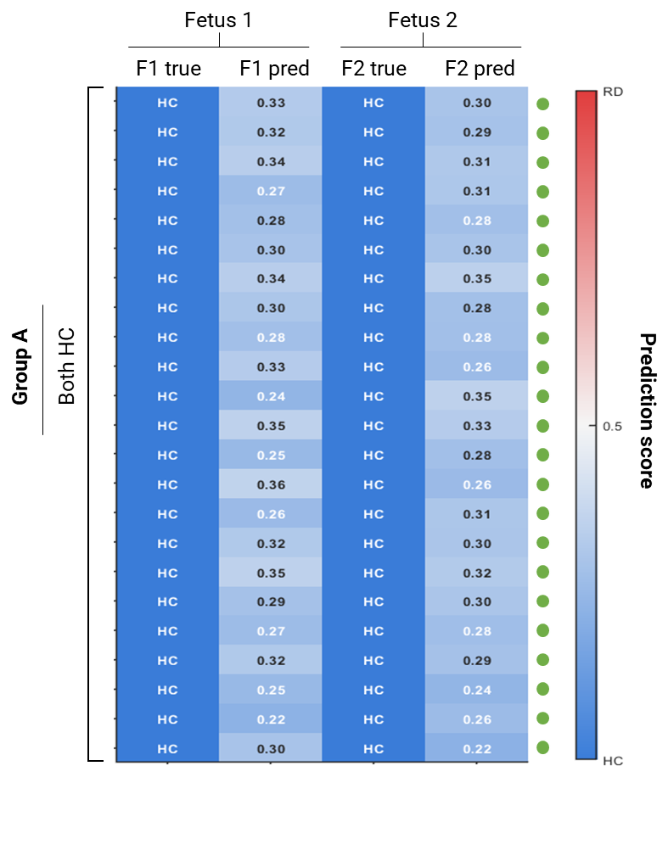
Supplementary Figure 9. Twin-level prediction patterns across pregnancies in Group A

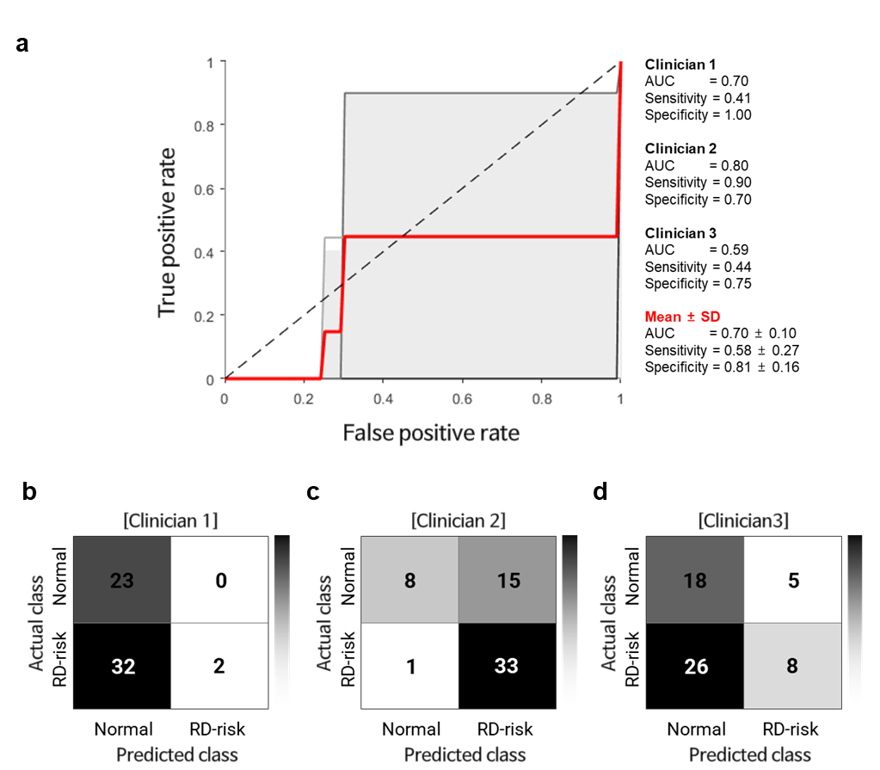

Supplementary Figure 10. Clinician-based prediction using conventional assessment in the blind test set
(a) Mean ROC curve with standard deviation (± SD) across three clinicians. (b–d) Confusion matrices for individual clinicians (Clinicians 1–3), where predictions were made using conventional clinical assessment.

Supplementary Table 1. Clinical characteristics of the pregnant woman.
Characteristics
Maternal Characteristics | n =100
Age (years) | 36.0 [33.0–38.0]
Height (cm) | 162.4 [158.4–165.9]
Prepregnancy weight (kg) | 56.5 [53.0–65.3]
Prepregnancy BMI (kg/m²) | 21.93 [20.00–25.26]
Nulliparous | 84.0% (84)
Conception by assisted reproduction
… Intrauterine insemination | 4.0% (4)
… In vitro fertilization & embryo transfer | 83.0% (83)
Monochorionicity | 8% (8)
Maternal comorbidities & pregnancy complications | n =100
Gestational hypertension | 12.0% (12)
Chronic hypertension | 1.0% (1)
Preeclampsia | 11.0% (11)
Gestational diabetes mellitus | 8.0% (8)
Pregestational diabetes mellitus | 3.0% (3)
Diabetes mellitus controlled by insulin | 5.0% (5)
Preterm labor with use of tocolytics | 15.0% (15)
Cerclage operation before 24 weeks of gestation | 4.0% (4)
Antenatal corticosteroids administration | 11.0% (11)
Placenta previa | 2.0% (2)
Neonatal outcomes | N=200
Gestational age at delivery (weeks) | 36.3 [36.0-36.9]
…Preterm birth before 36 weeks of gestation | 22% (44/200)
Birthweight (grams) | 2400 [2168-2603]
…Small for gestational age below 10 percentile | 10.5% (21)
…Large for gestational age over 10 percentile | 0.5% (1)
Male | 46.5% (93)
Cord pH | 7.325 [7.308-7.347]
Low Apgar score below 7 at 1 minute | 9.0% (18)
Low Apgar score below 7 at 5 minutes | 1.0% (2)
Intubation | 4.0% (8)
Non-invasive oxygen assistance* | 30.0% (60)
Respiratory distress syndrome | 3.0% (6)
Jaundice with phototherapy | 16.0% (32)
Intraventricular hemorrhage | 0.5% (1)
Early onset sepsis | 3.0% (6)
Retinopathy of prematurity | 0.5% (1)
Hypoglycemia | 4.0% (8)
Hospital stay(days) | 5 [5-6]
Survival at discharge | 100% (200)

Values are given as median [interquartile range, 25–75th percentile] or percentage (n).
*Non-invasive oxygen assistance includes Continuous Positive Airway Pressure (CPAP), Non-invasive Positive Pressure Ventilation (NIPPV), High Flow Nasal Cannula (HFNC)

Supplementary Table 2. Performance of step 1 model for RD-risk pregnancy screening in 5-fold CV.
 | Accuracy |  |  |  |  | Mean
 | CV1 | CV2 | CV3 | CV4 | CV5 | Mean
Training | 1 | 1 | 0.99 | 0.99 | 0.99 | 0.99 ± 0.005
Validation | 0.86 | 0.80 | 0.85 | 0.79 | 0.78 | 0.81 ± 0.036

 | Loss |  |  |  |  | Mean
 | CV1 | CV2 | CV3 | CV4 | CV5 | Mean
Training | 0.12 | 0.11 | 0.11 | 0.11 | 0.11 | 0.11 ± 0.005
Validation | 0.74 | 1.14 | 0.77 | 1.05 | 1.11 | 0.96 ± 0.2

Supplementary Table 3. Performance of step 2 model for RD fetus prediction in 5-fold CV.
 | Accuracy |  |  |  |  | Mean
 | CV1 | CV2 | CV3 | CV4 | CV5 | Mean
Training | 1 | 0.99 | 1 | 1 | 0.99 | 0.99 ± 0.0055
Validation | 0.78 | 0.77 | 0.78 | 0.79 | 0.79 | 0.78 ± 0.008

 | Loss |  |  |  |  | Mean
 | CV1 | CV2 | CV3 | CV4 | CV5 | Mean
Training | 0.07 | 0.06 | 0.06 | 0.08 | 0.07 | 0.068 ± 0.0084
Validation | 1.33 | 1.43 | 1.22 | 1.19 | 1.14 | 1.262 ± 0.118

Supplementary Table 4. Clinician-based predictions using conventional assessment in the blind test set
Information |  | Blind tests results
Pregnancy case | GAD | Clinician 1 | Clinician 2 | Clinician 3
HC1 | 37.1 | HC | HC | HC
HC2 | 37.1 | HC | HC | HC
HC3 | 35.7 | HC | RD-risk | RD-risk
HC4 | 36.6 | HC | RD-risk | HC
HC5 | 35.4 | HC | RD-risk | RD-risk
HC6 | 37.0 | HC | HC | HC
HC7 | 36.9 | HC | RD-risk | HC
HC8 | 36.6 | HC | RD-risk | HC
HC9 | 36.0 | HC | RD-risk | HC
HC10 | 36.9 | HC | RD-risk | HC
HC11 | 36.6 | HC | RD-risk | HC
HC12 | 37.1 | HC | HC | HC
HC13 | 35.6 | HC | RD-risk | RD-risk
HC14 | 36.4 | HC | RD-risk | HC
HC15 | 37.3 | HC | HC | HC
HC16 | 36.7 | HC | RD-risk | HC
HC17 | 36.3 | HC | RD-risk | HC
HC18 | 37.0 | HC | HC | HC
HC19 | 36.9 | HC | RD-risk | HC
HC20 | 37.9 | HC | HC | HC
HC21 | 37.1 | HC | HC | HC
HC22 | 36.4 | HC | RD-risk | HC
HC23 | 37.1 | HC | HC | HC
RD1 | 36.1 | HC | RD-risk | HC
RD2 | 32.6 | RD-risk | RD-risk | RD-risk
RD3 | 36.9 | HC | RD-risk | HC
RD4 | 35.4 | HC | RD-risk | RD-risk
RD5 | 36.7 | HC | RD-risk | HC
RD6 | 35.7 | HC | RD-risk | RD-risk
RD7 | 35.1 | HC | RD-risk | RD-risk
RD8 | 36.6 | HC | RD-risk | RD-risk
RD9 | 36.4 | HC | RD-risk | HC
RD10 | 36.0 | HC | RD-risk | HC
RD11 | 36.0 | HC | RD-risk | HC
RD12 | 36.1 | HC | RD-risk | HC
RD13 | 36.3 | HC | RD-risk | HC
RD14 | 37.3 | HC | HC | HC
RD15 | 36.7 | HC | RD-risk | HC
RD16 | 36.3 | HC | RD-risk | HC
RD17 | 36.4 | HC | RD-risk | HC
RD18 | 35.1 | HC | RD-risk | RD-risk
RD19 | 36.1 | HC | RD-risk | HC
RD20 | 36.3 | HC | RD-risk | HC
RD21 | 36.3 | HC | RD-risk | HC
RD22 | 31.1 | RD-risk | RD-risk | RD-risk
RD23 | 36.3 | HC | RD-risk | HC
RD24 | 35.4 | HC | RD-risk | RD-risk
RD25 | 36.0 | HC | RD-risk | HC
RD26 | 35.6 | HC | RD-risk | RD-risk
RD27 | 36.3 | HC | RD-risk | HC
RD28 | 36.1 | HC | RD-risk | HC
RD29 | 36.0 | HC | RD-risk | HC
RD30 | 36.3 | HC | RD-risk | HC
RD31 | 36.1 | HC | RD-risk | HC
RD32 | 36.9 | HC | RD-risk | HC
RD33 | 36.7 | HC | RD-risk | HC
RD34 | 35.4 | HC | RD-risk | RD-risk

