Method S1: CT acquisition protocols
Chest CT scans were performed using one of five multidetector CT scanners (Somatom Sensation 64, Siemens; Lightspeed16 or Discovery CT750 HD, GE Healthcare). For 64-detector scanners, the acquisition parameters were set at 120 kVp with automatic tube current modulation, and images were reconstructed at 1.5-mm slice thickness and interval. For other scanners, parameters included 120 kVp, 150-200 mA, and a reconstruction thickness/interval of 1.25 mm. Non-ionic iodinated contrast medium (Ultravist, 300 mgI/mL; Bayer) was administered intravenously via a power injector at a dose of 1.3-1.5 mL/kg of body weight and an injection rate of 2.5 mL/s. Contrast-enhanced image acquisition was initiated after a fixed delay of 70 seconds.

Method S2: radiomics features extraction
Radiomics features were extracted from these segmentations using PyRadiomics (v3.0). Key extraction parameters were set to ensure reproducibility: isotropic resampling to 1×1×1 mm³ (resampled Pixel Spacing), B-spline interpolation, and intensity discretization with a fixed bin width of 25 (binWidth). Other settings included intensity rescaling (rescale = True), 3D analysis (force2D = False), and no padding (padding = 0). This configuration yielded 1,316 features per case, categorized as follows: 108 first-order statistics, 14 shape-based, 144 from the gray-level co-occurrence matrix, 84 from the gray-level dependence matrix, 96 from the gray-level run-length matrix, 96 from the gray-level size zone matrix, 30 from the neighboring gray-tone difference matrix, and 744 wavelet-based features.

Method S3: deep learning features extraction
DL feature extraction was performed using a pre-trained ResNet50 convolutional neural network, implemented within an R/TensorFlow environment. For each patient, the three-dimensional lesion region was identified from the preprocessed CT images using its corresponding binary segmentation mask. All axial slices containing the lesion were extracted as two-dimensional regions of interest (ROI). Each 2D ROI was resized to 224×224 pixels, intensity-normalized, and formatted into a three-channel input compatible with the model. To obtain high-level, semantically rich feature representations, the ResNet50 model was truncated at its global average pooling layer, discarding the final task-specific classification head. This configuration yielded a compact 2048-dimensional feature vector for each input slice, encapsulating the abstract visual patterns learned by the network. Features extracted from all slices of the same lesion were then aggregated by averaging to produce a single, case-level 2048-dimensional feature vector.

Table S1
CT Semantic Features Scoring Scale for Lung Adenocarcinoma.
Characteristic | Definition | Scoring and Definition
Location | Lung nodule located in the outer third of the lung was defined as peripheral tumor, while others were located centrally | 1, central; 2, peripheral
Maximum diameter | The greatest dimension on the multi-planar reconstructed images with a lung window | cm
Maximum consolidation diameter | The greatest dimension on the multi-planar reconstructed images with a mediastinal window | cm
CTR | maximum diameter of the solid component/maximum diameter of the entire nodule
Consolidation level | Solid or GGO | 0, pure GGO; 1, mixed GGO with solid part < 50%;  2, mixed GGO with solid part > 50%; 3, solid
Contour | The overall shape of roundness | 1, round; 2, oval; 3, somewhat irregular; 4, irregular
Lobulation | A wavy or scalloped configuration of tumor’s surface | 0, absence; 1, presence
Spiculation | Lines radiating from the margins of the tumor | 0, absence; 1, presence
Calcification | Any patterns of calcification in the tumor | 0, absence; 1, presence
Air bronchogram | Tube-like or branched air structure within the tumor | 0, absence; 1, presence
Bubble-like lucency | Air space in the tumor with diameter ≤ 5mm at the time of diagnosis prior to biopsy or treatment | 0, absence; 1, presence
Cavity | Air space in the tumor with diameter > 5mm at the time of diagnosis prior to biopsy or treatment | 0, absence; 1, presence
Enhancement degree | Enhancement degree = A_{post} - A_{pre} , where A_{pre} and  A_{post} was unenhanced and contrast-enhanced CT attenuation of tumor, respectively | HU
Enhancement heterogeneity | Heterogeneity of tumor on contrast-enhanced images | 1, homogeneous; 2, slight or moderate heterogeneous; 3, marked heterogeneous
Relative enhancement | Relative enhancement E_{rel} = (A_{post} - A_{pre} )/E_{art} , where E_{art} was enhancement attenuation of the artery on the same section | %
Pleural attachment | Tumor attaches to the fissure/Pleura | 0, absence; 1, presence
Pleural retraction | Retraction of the pleura toward the tumor | 0, absence; 1, presence
Bronchovascular bundle thickening | Convergence of vessels to the tumor | 0, no significant thickening; 1, obvious thickening
Obstructive change | Consolidation shadow caused by obstructive pneumonia or atelectasis at the edge of tumor | 0, absence; 1, presence
CT, computed tomography; CTR, consolidation-to-tumor ratio; GGO, ground-glass opacity.

Table S2
Patient Characteristics in the Training and Test Cohorts for Each Predictive Model.
Variable | Mode A |  | Model B
Variable | Training Cohort | Test Cohort | Training Cohort | Test Cohort
Number  Age(years)  Sex  Male  Female  Smoking history  Yes  No  Family history  Yes  No  Histological subtype  Low-risk  Moderate-risk  High-risk  EGFR  Mutation  Wild  ALK  Mutation  Wild  KRAS  Mutation  Wild  Clinical stage  IA  IB  IIA  Pathological stage  I  II  III  OLNM  Positive  Negative  Invasive pathological features  VPI  LVI  STAS  Negative | 443  59.05 (±8.65)  164  279  163  280  106  337  64  186  193  138  83  10  152  18  172  360  59  24  436  7  0  0  443  35  16  18  389 | 114  60.42 (±8.48)  48  66  53  61  22  92  12  46  56  34  26  0  15  0  29  90  16  8  113  1  0  0  114  10  2  5  101 | 512  59.03 (±8.70)  198  314  196  316  112  390  64  192  256  169  95  14  181  19  200  399  79  34  436  27  49  69  443  46  23  27  438 | 127  60.62 (±8.46)  55  72  61  66  26  101  11  48  68  40  27  1  42  2  54  100  18  9  113  6  8  13  114  11  3  6  112
Data for continuous variables is mean ± standard deviation.
EGFR, epidermal growth factor receptor; ALK, anaplastic lymphoma kinase; KRAS, kirsten rat sarcoma viral oncogene homolog; OLNM, occult lymph node metastasis; VPI, visceral pleural invasion; LVI, lymphovascular invasion; STAS, spread through air spaces.

Table S3
Agreement of CT Semantic Features between the Two Readers.
Continuous  Variables | Kendall's W  (95% CI) | Categorical Variables | Cohen's ĸ (95% CI) | Ordered Variables | Kendall's W  (95% CI)
Maximum diameter | 0.86 (0.79, 0.90) | Location | 0.93 (0.89, 0.97) | Contour | 0.82 (0.78, 0.86)
Maximum consolidation diameter | 0.82 (0.77, 0.86) | Spiculation | 0.86 (0.82, 0.91) | Consolidation level | 0.84 (0.80, 0.88)
CTR | 0.83 (0.79, 0.88) | Lobulation | 0.91 (0.85, 0.94) | Enhancement heterogeneity | 0.90 (0.86, 0.95)
Enhancement degree | 0.90 (0.86, 0.94) | Calcification | 0.96 (0.90, 0.99)
Relative enhancement | 0.86 (0.79, 0.91) | Air bronchogram | 0.84 (0.79, 0.89)
 |  | Bubble-like lucency | 0.87 (0.83, 0.91)
 |  | Cavity | 0.91 (0.87, 0.96)
 |  | Pleural attachment | 0.88 (0.82, 0.93)
 |  | Pleural retraction | 0.86 (0.82, 0.91)
 |  | Bronchovascular bundle thickening | 0.89 (0.83, 0.93)
 |  | Obstructive change | 0.91 (0.88, 0.95)
CT, computed tomography; CI, confidence interval; CTR, consolidation-to-tumor ratio.

Table S4
Clinical and CT Semantic Features with No Significant Association in Univariate Analysis for Model A and Model B.
Variable | Model A |  |  | Model B
Variable | Positive | Negative | P Value | Positive | Negative | P Value
Age(years)  Sex  Male  Female  Smoking history  Yes  No  Family history  Yes  No  EGFR  Mutation  Wild  ALK  Mutation  Wild  KRAS  Mutation  Wild  Location  1  2  Contour  1  2  3  4  Spiculation  0  1  Calcification  0  1  Air bronchogram  0  1  Bubble-like lucency  0  1  Cavity  0  1  Enhancement heterogeneity  1  2  3  Enhancement degree (HU)  Relative enhancement  Pleural retraction  0  1  Obstructive change  0  1  Bronchovascular bundle  thickening  0  1 | 58.80 (±8.68)  22  32  23  31  11  43  13  11  1  22  2  21  8  46  1  2  26  25  38  16  53  1  31  23  47  7  47  7  5  23  26  45.2 (±13.6)  0.31 (±0.12)  14  40  51  3  45  9 | 59.25(±8.44)  142  247  140  249  95  294  125  72  9  130  16  151  63  326  10  47  168  164  310  79  373  16  241  148  367  22  368  21  22  165  202  42.8 (±17.3)  0.34 (±0.16)  146  243  372  17  332  57 | 0.097  0.546  0.346  0.513  0.375  1.000  1.000  0.796  0.259  0.118  0.665  0.520  0.082  0.065  0.477  0.358  0.644  0.096  0.965  0.697 | 58.90 (±9.03)  34  35  33  36  16  53  31  12  4  29  1  28  12  57  2  3  30  34  NA  65  4  44  25  62  7  64  5  8  29  32  46.3 (±14.2)  0.33 (±0.15)  NA  NA  NA | 59.05 (±8.65)  164  279  163  280  106  337  138  83  10  152  18  172  71  372  11  49  194  189  NA  426  17  272  171  414  29  415  28  27  188  228  43.9 (±16.9)  0.35 (±0.16)  NA  NA  NA | 0.872  0.052  0.080  0.893  0.228  0.403  0.472  0.775  0.182  0.662  0.707  0.404  0.978  0.263  0.452  0.627
Data for continuous variables is mean ± standard deviation.
CT, computed tomography; EGFR, epidermal growth factor receptor; ALK, anaplastic lymphoma kinase; KRAS, kirsten rat sarcoma viral oncogene homolog; NA, not applicable.

Table S5
Inter-observer Reproducibility of Radiomics and Deep Learning Features Assessed by ICC.
Feature Class | Total Features (n) | Features with ICC ≥ 0.75 (n) | Features with ICC ≥ 0.75 (%)
First-order | 108 | 98 | 90.7%
Shape | 14 | 14 | 100.0%
GLCM | 144 | 123 | 85.4%
GLDM | 84 | 69 | 82.1%
GLRLM | 96 | 87 | 90.6%
GLSZM | 96 | 90 | 93.8%
NGTDM | 30 | 28 | 93.3%
Wavelet-based Features | 744 | 658 | 88.4%
Deep Learning Features | 2048 | 1253 | 61.2%
ICC, intraclass correlation coefficient; GLCM, gray level co-occurrence matrix; GLDM, gray level dependence matrix; GLRLM, gray level run-length matrix; GLSZM, gray level size zone matrix; NGTDM, neighboring gray tone difference matrix.

Table S6
Comparison of Model Performance (AUC) for the Rad-score and DL-score Before and After ComBat Harmonization.
Model | Cohort | Predictors | Pre-ComBat AUC  (95% CI) | Post-ComBat AUC  (95% CI) | Change in AUC
Model A | Training | DL-score | 0.628 (0.550, 0.706) | 0.666 (0.592, 0.740) | +0.038
Model A | Training | Rad-score | 0.735 (0.672, 0.798) | 0.750 (0.692, 0.808) | +0.015
Model A | Test | DL-score | 0.541 (0.398, 0.684) | 0.587 (0.448, 0.726) | +0.046
Model A | Test | Rad-score | 0.635 (0.477, 0.793) | 0.660 (0.506, 0.813) | +0.025
Model B | Training | DL-score | 0.585 (0.507, 0.663) | 0.621 (0.546, 0.697) | +0.036
Model B | Training | Rad-score | 0.754 (0.702, 0.806) | 0.779 (0.732, 0.827) | +0.025
Model B | Test | DL-score | 0.692 (0.535, 0.849) | 0.741 (0.590, 0.892) | +0.049
Model B | Test | Rad-score | 0.758 (0.658, 0.858) | 0.783 (0.688, 0.879) | +0.025
Rad-score, radiomics score; DL-score, deep learning score; AUC, area under the curve; CI, confidence interval.

Table S7
Performance Metrics and Confusion Matrices of Model B at the Selected High-sensitivity Threshold and Other Key Comparative Thresholds in the Training Cohort.
Threshold | Sensitivity | Specificity | Youden Index | Positive Predictive Value | Negative Predictive Value | Accuracy
0.100 | 98.60% | 41.50% | 0.401 | 20.80% | 99.50% | 49.20%
0.200 | 97.10% | 49.90% | 0.470 | 23.20% | 99.10% | 56.20%
0.300 | 95.70% | 55.10% | 0.507 | 24.90% | 98.80% | 60.50%
0.400 | 95.70% | 59.10% | 0.548 | 26.70% | 98.90% | 64.10%
0.408 | 95.70% | 59.40% | 0.550 | 26.80% | 98.90% | 64.30%
0.500 | 91.30% | 63.40% | 0.547 | 28.00% | 97.90% | 67.20%
0.600 | 91.30% | 66.40% | 0.577 | 29.70% | 98.00% | 69.70%
0.700 | 89.90% | 72.20% | 0.621 | 33.50% | 97.90% | 74.60%

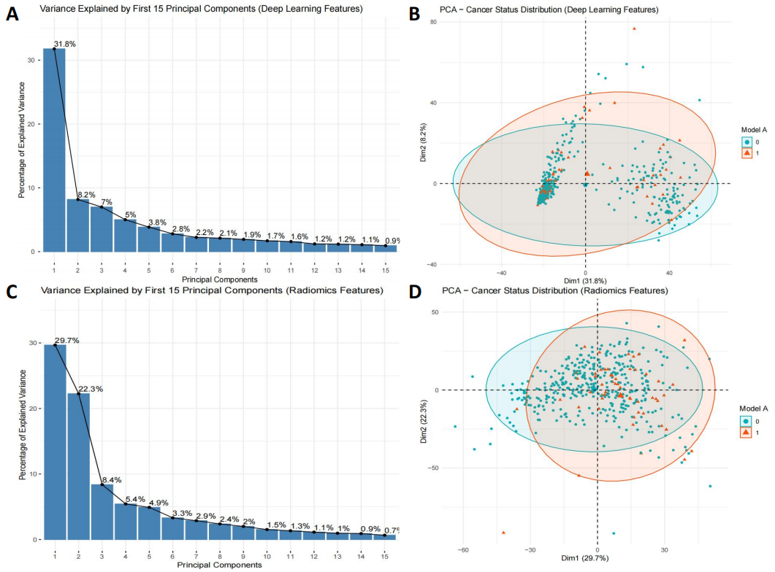

Figure S1: Principal component analysis of deep-learning and radiomics features in Model A. (A, C) Scree plots displaying the variance explained by the first 15 principal components for deep-learning (A) and radiomics (C) feature sets. (B, D) Biplots showing sample projections onto the first two principal components for deep-learning (B) and radiomics (D) features, with the percentage of explained variance indicated for each axis.
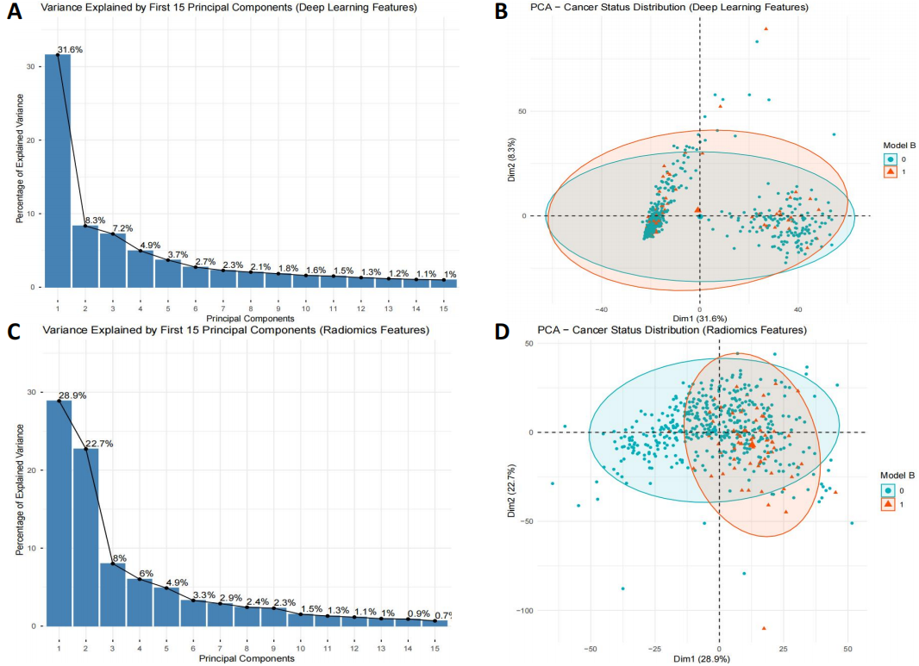
Figure S2: Principal component analysis of deep-learning and radiomics features in Model B. (A, C) Scree plots displaying the variance explained by the first 15 principal components for deep-learning (A) and radiomics (C) feature sets. (B, D) Biplots showing sample projections onto the first two principal components for deep-learning (B) and radiomics (D) features, with the percentage of explained variance indicated for each axis.

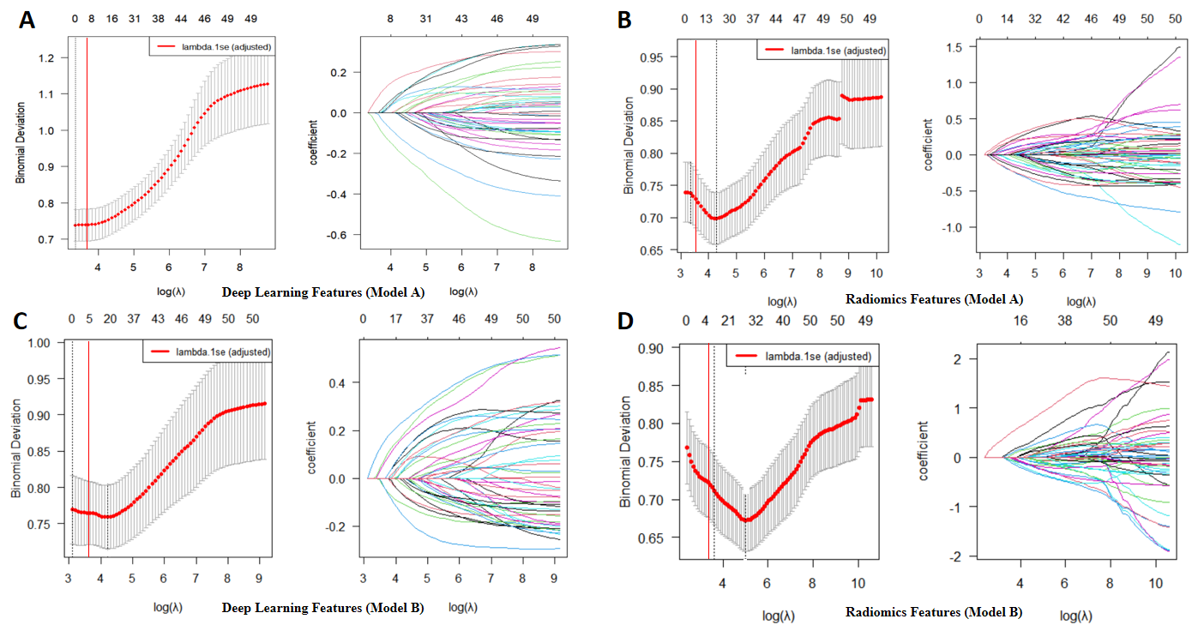
Figure S3: Feature selection via LASSO regression. (A) Deep-learning features in Model A: coefficient paths across λ values (left) and cross-validation mean squared error (right). Vertical lines indicate optimal λ. (B) Radiomics features in Model A: coefficient paths across λ values (left) and cross-validation mean squared error (right). (C) Deep-learning features in Model B: coefficient paths across λ values (left) and cross-validation mean squared error (right). (D) Radiomics features in Model B: coefficient paths across λ values (left) and cross-validation mean squared error (right). Vertical lines indicate optimal λ.

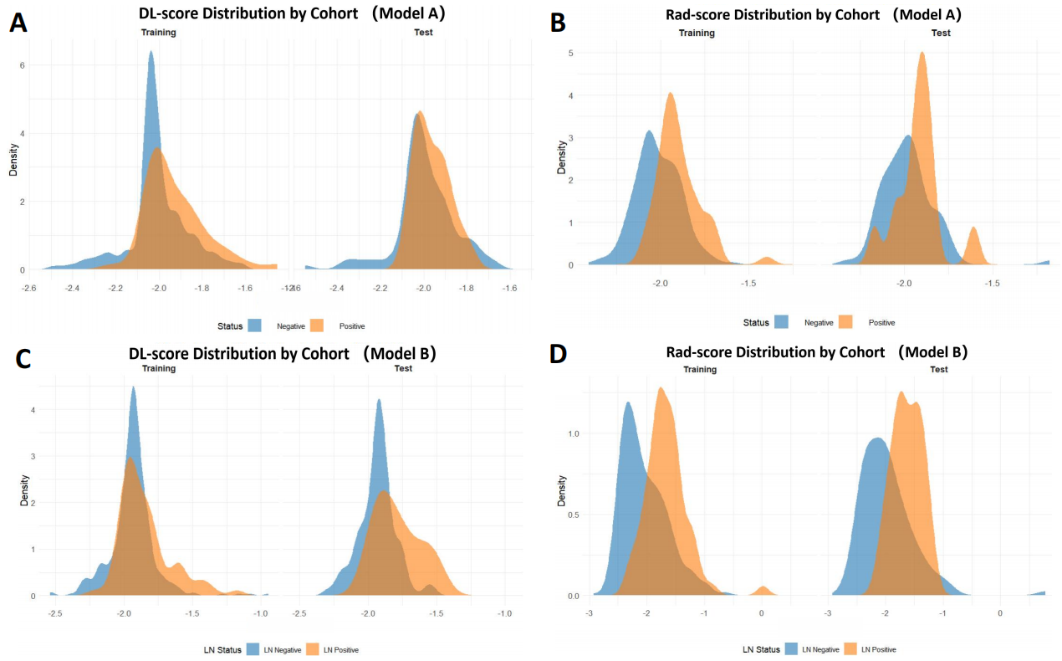
Figure S4: Deep-learning and radiomics score distributions stratified by outcome status for Model A and Model B. Density plots illustrate the separation between outcome-positive and outcome-negative patients. (A, C) Distributions of the DL-score (for Model A and Model B, respectively). (B, D) Distributions of the Rad-score (for Model A and Model B, respectively). The Rad-score consistently shows clearer separation across cohorts compared to the DL-score.

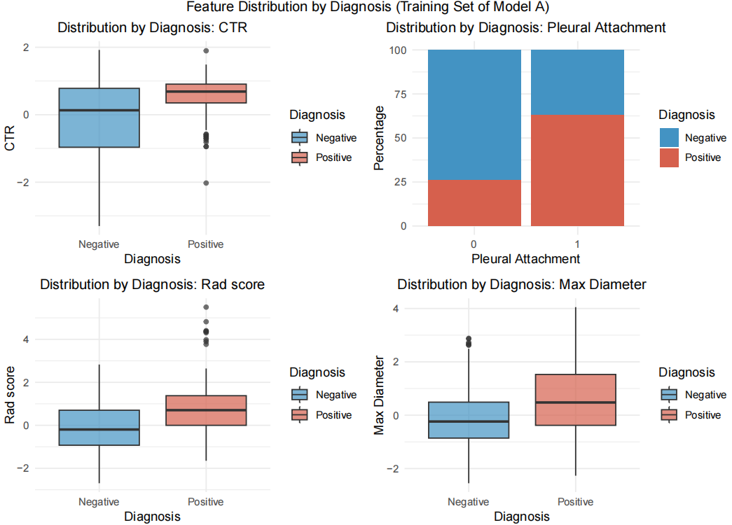
Figure S5: Distribution of the top four predictive features in Model A (training cohort). Comparison of feature values between outcome-positive and outcome-negative groups for the most influential predictors in Model A: CTR, pleural attachment, Rad-score, and maximum tumor diameter. Distributions are visualized using density plots (for continuous features) and box plots (for categorical features) to illustrate intergroup differences.

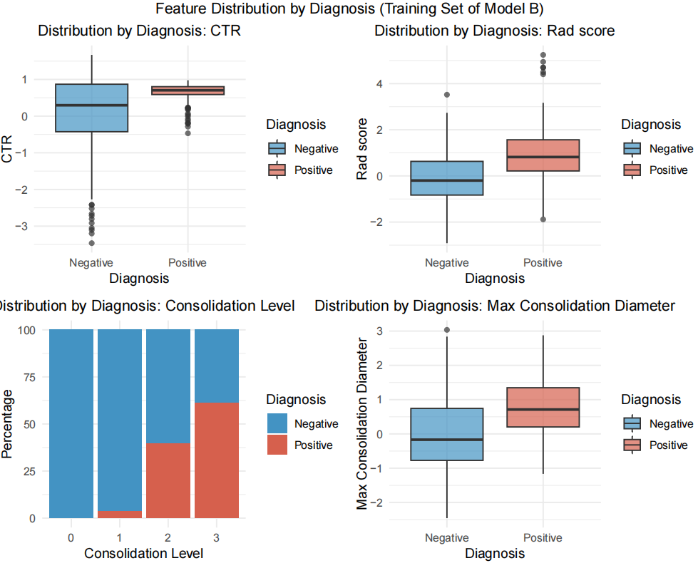

Figure S6: Distribution of the top four predictive features in Model B (training cohort).
Comparison of feature values between OLNM-positive and OLNM-negative groups for the most influential predictors in Model B: CTR, Rad-score, consolidation level, and maximum consolidation diameter. Distributions are shown using density plots for continuous features and box plots for categorical variables to illustrate intergroup separation.

