Supporting information
Table S1. Primer sequences for target genes used for qPCR
No. | Gene name | Forward | Reverse
1 | IL-6 | ACTCACCTCTTCAGAACGAATTG | CCATCTTTGGAAGGTTCAGGTTG
2 | TNF-α | CCTCTCTCTAATCAGCCCTCTG | GAGGACCTGGGAGTAGATGAG
3 | Wnt 7B | CACAGAAACTTTCGCAAGTGG | GTACTGGCACTCGTTGATGC
4 | CSNK1A1 | AGTGGCAGTGAAGCTAGAATCT | CGCCCAATACCCATTAGGAAGTT
5 | TLE3 | AACCACCATGAACTCGATCAC | TCACTGTCGTATCGGCTCAAG
6 | FZD | GTCTTTCAGTCAAGAGACGCTG | GTTGTGGTCGTTCTGTGGTG
7 | LRP6 | TGTCAGCGAAGAAGCCATTAAA | TCTAAGGCAATAGCTCTGGGT
8 | PP2A | CCGGGTGGATGACCAAATAGC | GAACTGCCCCAGATGAAGGG
9 | β-catenin | CATCTACACAGTTTGATGCTGCT | GCAGTTTTGTCAGTTCAGGGA

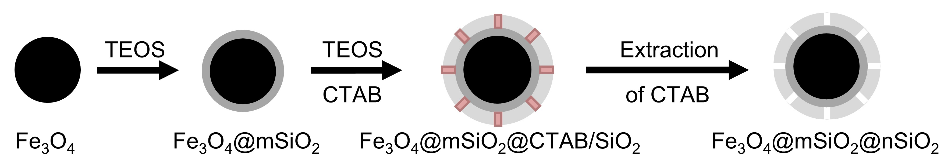
SI 1. The formation of mesoporous nanoparticles.

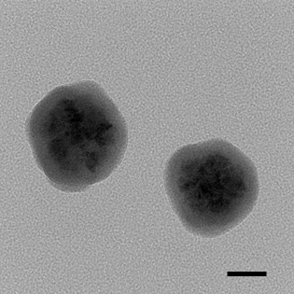
SI 2. The TEM image of Fe₃O₄@mSiO₂ (scale bar: 50 nm).

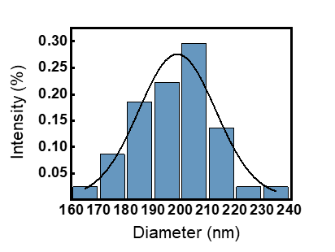
SI 3. Size distribution of rPMP.
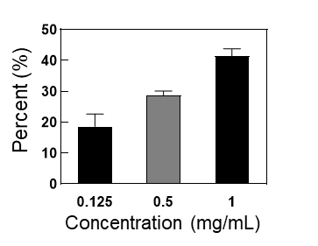
SI 4. Encapsulation efficiency of MMN.

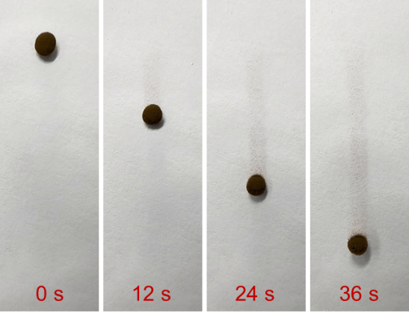
SI 5. Manipulation of nanomotors in 4 cP fluid.

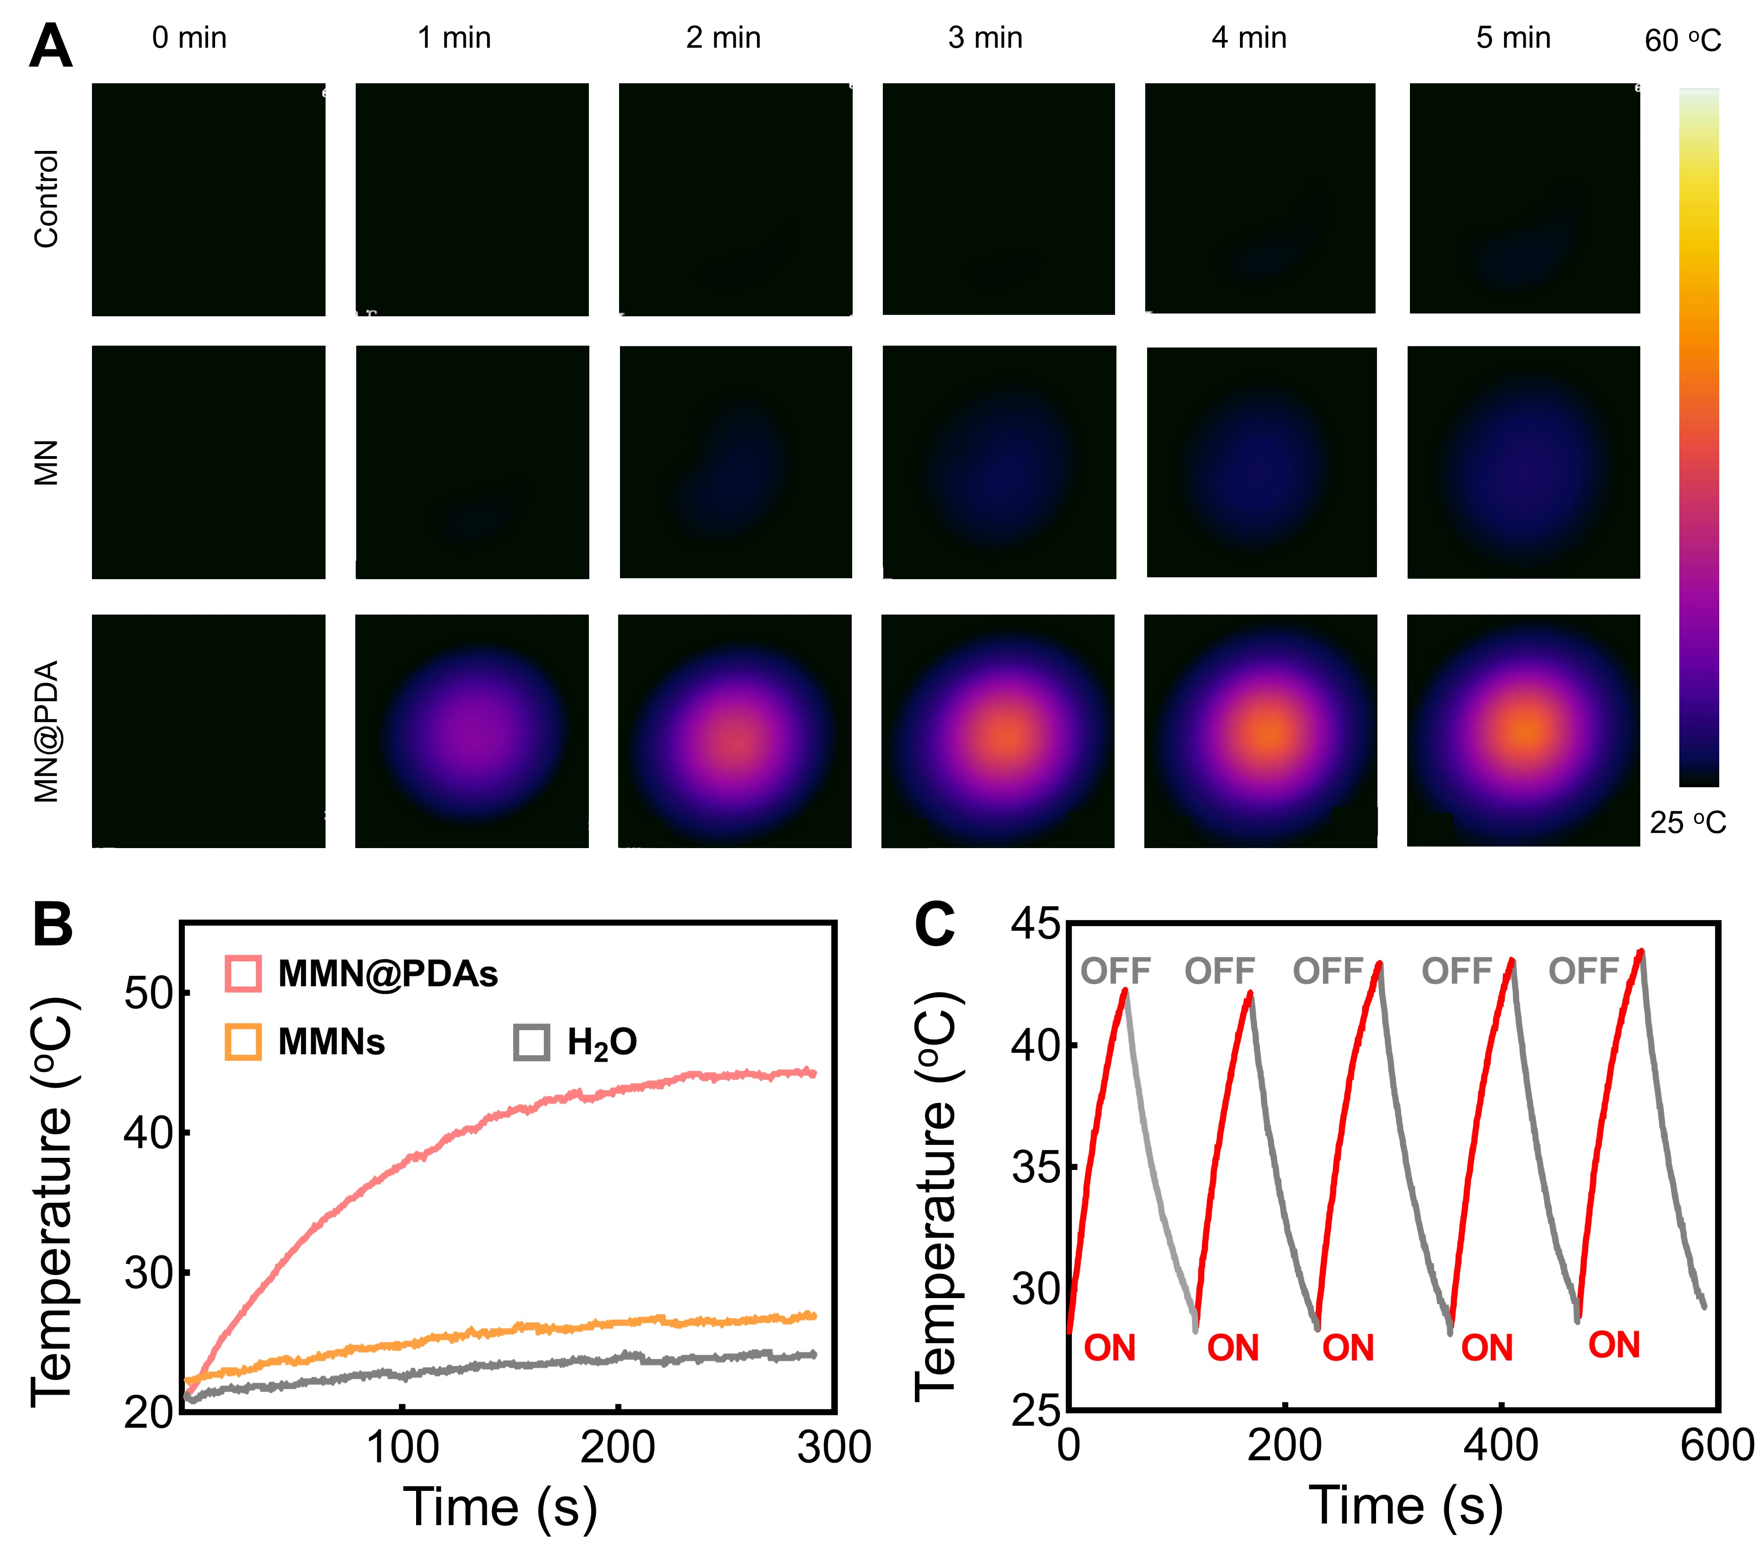
SI 6. In vitro photothermal capability of MMN@PDA. (A-B) Infrared thermal images (A) and temperature increase curves (B) of Control, MMN, and MMN@PDA (2.5 W/cm²). (C) Thermal stability of MMN@PDA during five heating-cooling cycles.

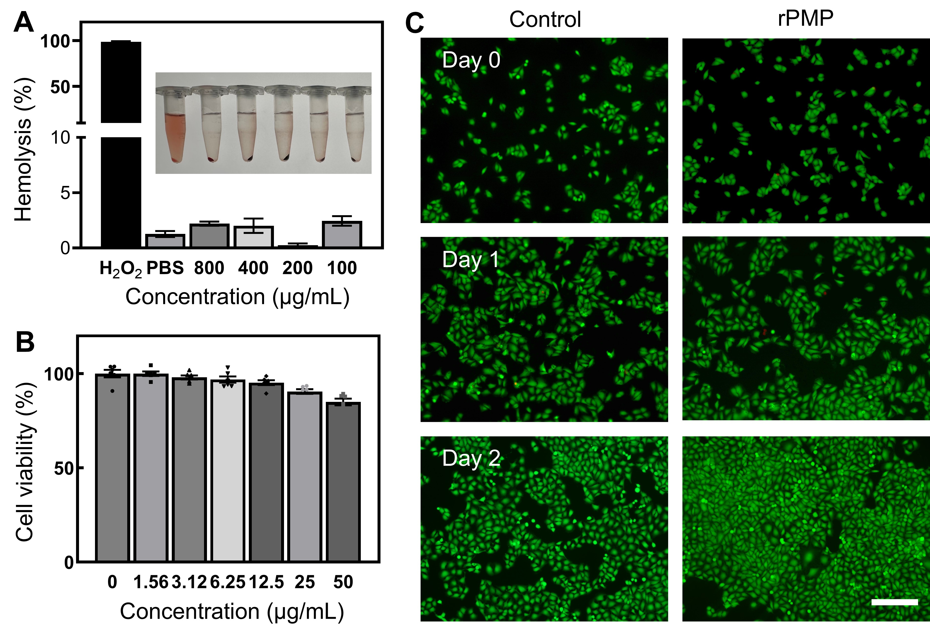
SI 7. The biocompatibility of rPMP. (A) Hemolysis test results of rPMP (n = 6). (B) The viability of HUVECs co-cultured with rPMP was measured by CCK-8 (n = 3). (C) The living/dead fluorescence images of HUVECs cocultured with rPMP (scale bar = 200 μm).

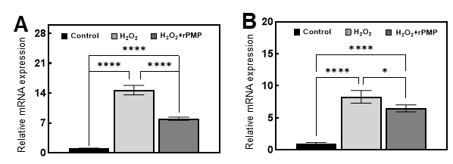
SI 8. qPCR results of IL-6 (A) and TNF-α (B).

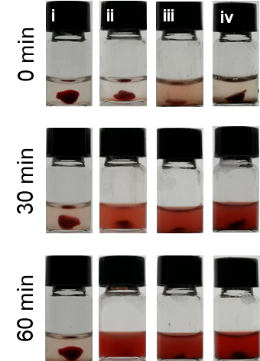
SI 9. Photographs of the residual thrombus (i: PBS + NIR, ii: rt-PA + NIR, iii: rt-PA/MMN + NIR, iv: rPMP + NIR).

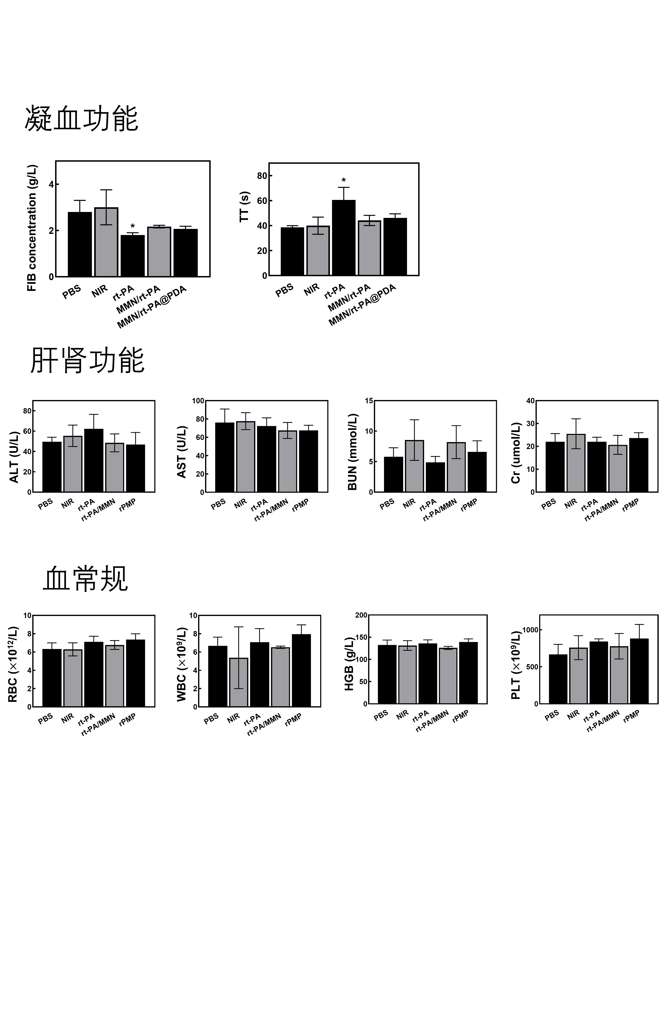
SI 10. Quantification of blood biochemistry test at 24 h after treatment with different.

SI 11. Quantification of typical hematological parameters at 24 h after treatment with different samples.
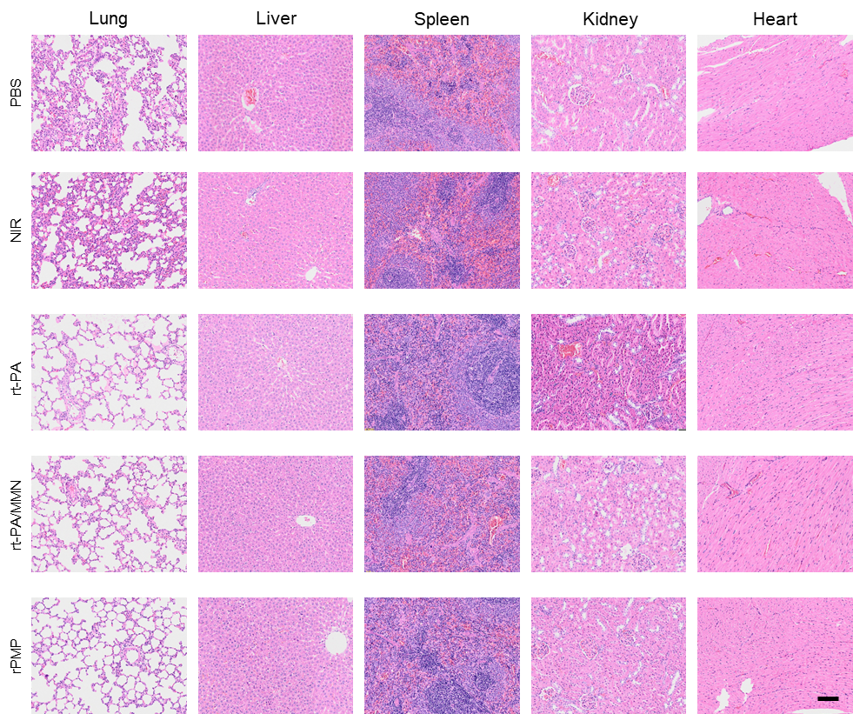
SI 12. H&E staining of major organs (scale bar: 100 μm).

