Supplementary information
Title: Industrial byproduct corn steep liquor enhanced drought tolerance by preserve membrane lipids and reestablishing redox homeostasis in tea plants (Camellia sinensis)
Running title: Corn steep liquor alleviated drought stress of tea plants
Authors:
Xin Liang^{1,a}, Yanhua Jiang^{1,b}, Peibin Dai^{c}, Yike Shao^{c}, Yang Liuª, Yu Duanª, Shanshan Wangª, Yufeng Lu^{d}, Haiqiang Feng ^{e*}, Li Ruan^{a*}
Institutions:
ª Institute of Sericulture and Tea, Zhejiang Academy of Agricultural Sciences, Hangzhou, 310021, China
^{b} Ninghai County Agricultural Industrialization Development Center, Ningbo, 315600, China
^{c} School of Food and Health, Zhejiang Institute of Economics and Trade, Hangzhou, 310018, China
^{d} Ruojun (Hangzhou) Ecological Agriculture Development Co., Ltd, Hangzhou, 311701, China
^{e} Zhejiang Agricultural Technology Extension Center, Hangzhou 310020, China
¹: Xin Liang, Yanhua Jiang contributed equally to this work.
* Corresponding author:
Haiqiang Feng*, 13588416332@163.com
Li Ruan*, ruanl@zaas.ac.cn
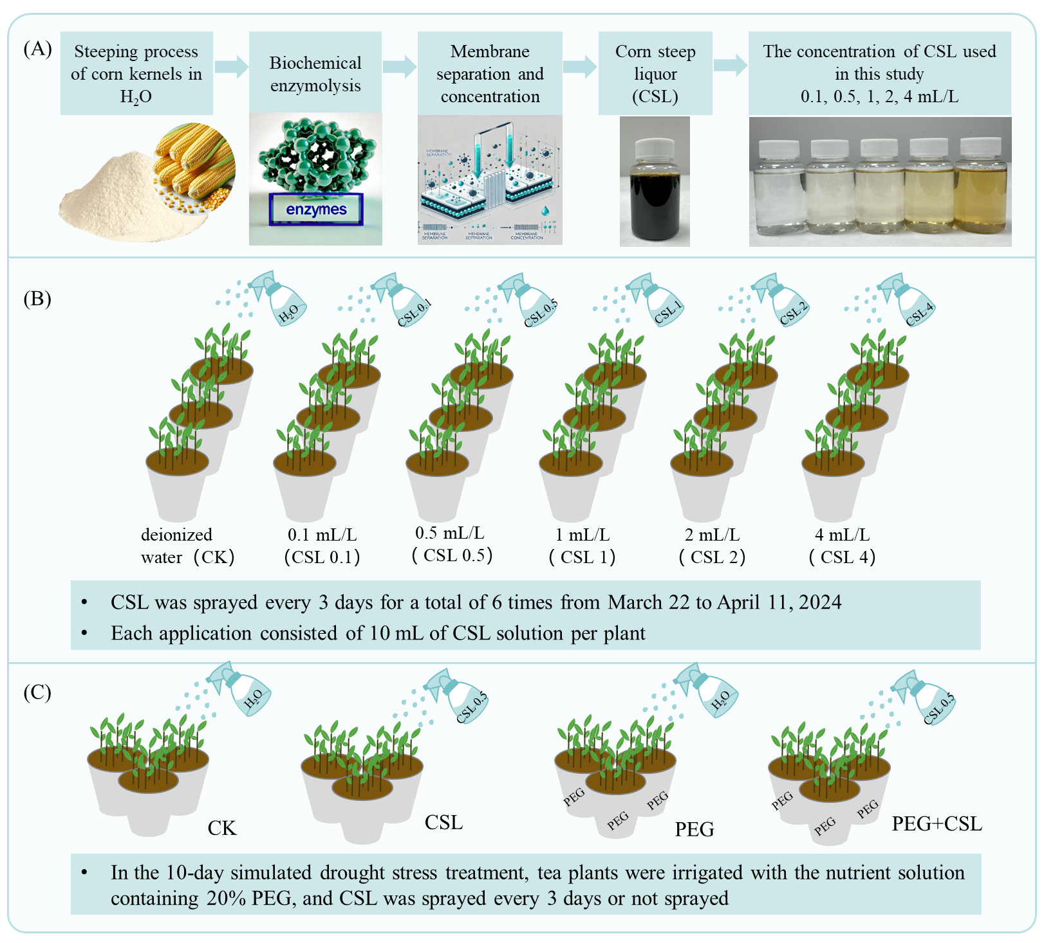
Figure S1 Schematic diagram of preparation process for CSL (A), treatments and concentrations of CSL in this study (B&C). CSL is a yellow-brown organic liquid residue obtained from the water used in the wet milling of corn kernels through enzymatic hydrolysis, membrane filtration, and concentration processes (A). Concentration gradient experiment of foliar spraying of CSL (B). Drought stress on tea plants was simulated using polyethylene glycol (PEG) and sprayed with or without CSL (C).
Figure S2. Effects of CSL on the morphological attributes (A), growth (B, C, D, E, F, G), photosynthetic related parameters (H, I, J, K, L, M). CK, CSL0.1, CSL0.5, CSL1, CSL2, and CSL4 represent the application concentration of CSL at 0 mL/L, 0.1 mL/L, 0.5 mL/L, 1 mL/L, 2 mL/L, and 4 mL/L, respectively. Fv/Fm: maximum photochemical quantum yield (maximum photosynthetic efficiency) of PSⅡ. ETR: photosynthetic electron transfer efficiency of PSⅡ reaction center. NPQ: non-photochemical quenching coefficient. Different lowercase letters indicate significant differences between treatments (p<0.05).
Table S1. Basic properties of corn steep liquor and content of major natural active components
pH | 4.0-5.0
Proportion | 1.18
Organic matter | 200 g/L
Total nutrients（N+P₂O₅+K₂O） | 80 g/L
Amino acid | 70 g/L
Small peptide | 18 g/L
Organic acid ( C<6) | 280 g/L  (Lactic acid 32.1%, Propionic acid 35.7%, Citric acid 17.9%)
Sugar | 30 g/L

Table S2. Information on fatty acids detected in tea leaves
Chemical formula abbreviation | Full name | Property
C24:0 | tetracosanoic acid (lignoceric acid) | saturated fatty acid, long-chain fatty acids
C23:0 | tricosanoic acid | saturated fatty acid, long-chain fatty acids
C22:0 | docosanoic acid (behenic acid) | saturated fatty acid, long-chain fatty acids
C22:1 n-9c | cis-13-docosenoic acid (erucic acid) | unsaturated fatty acid, long-chain fatty acids
C20:0 | eicosanoic acid (arachidic acid) | saturated fatty acid, long-chain fatty acids
C18:3 n-3c | cis-9,12,15-octadecatrienoic acid (alpha-linolenic acid) | unsaturated fatty acid, long-chain fatty acids
C18:2 n-6c | cis-9,12-octadecadienoic acid (linoleic acid) | unsaturated fatty acid, long-chain fatty acids
C18:2 n-6t | trans-9,12-octadecadienoic acid (linoelaidic acid) | unsaturated fatty acid, long-chain fatty acids
C18:0 | octadecanoic acid (stearic acid) | saturated fatty acid, long-chain fatty acids
C18:1 n-9c | cis-9-octadecenoic acid (oleic acid) | unsaturated fatty acid, long-chain fatty acids
C17:0 | heptadecanoic acid (margaric acid) | saturated fatty acid, long-chain fatty acids
C16:1n7c | cis-9-hexadecenoic acid (palmitoleic acid) | unsaturated fatty acid, long-chain fatty acids
C16:0 | hexadecanoic acid (palmitic acid) | saturated fatty acid, long-chain fatty acids
C15:0 | pentadecanoic acid | saturated fatty acid, long-chain fatty acids
C14:0 | tetradecanoic acid (myristic acid) | saturated fatty acid, long-chain fatty acids
C12:0 | dodecanoic acid (lauric acid) | saturated fatty acid, medium-chain fatty acids
C10:0 | decanoic acid | saturated fatty acid, medium-chain fatty acids
C9:0 | nonanoic acid | saturated fatty acid, medium-chain fatty acids
C8:0 | octanoic acid | saturated fatty acid, medium-chain fatty acids
C6:0 | hexanoic acid | saturated fatty acid, medium-chain fatty acids
i-C10:0 | isodecanoic acid | saturated fatty acid, medium-chain fatty acids
br-C9:0 | 3,5,5-trimethylhexanoic acid | saturated fatty acid, medium-chain fatty acids
i-C5:0 | isovaleric acid | saturated fatty acid, short-chain fatty acids
C3:0 | propionic acid | saturated fatty acid, short-chain fatty acids
a-C5:0 | 2-methylbutyric acid | saturated fatty acid, short-chain fatty acids
C5:0 | valeric acid | saturated fatty acid, short-chain fatty acids
C2:0 | acetic acid | saturated fatty acid, short-chain fatty acids
C4:0 | butyric acid | saturated fatty acid, short-chain fatty acids

