Supplementary Figure 1.
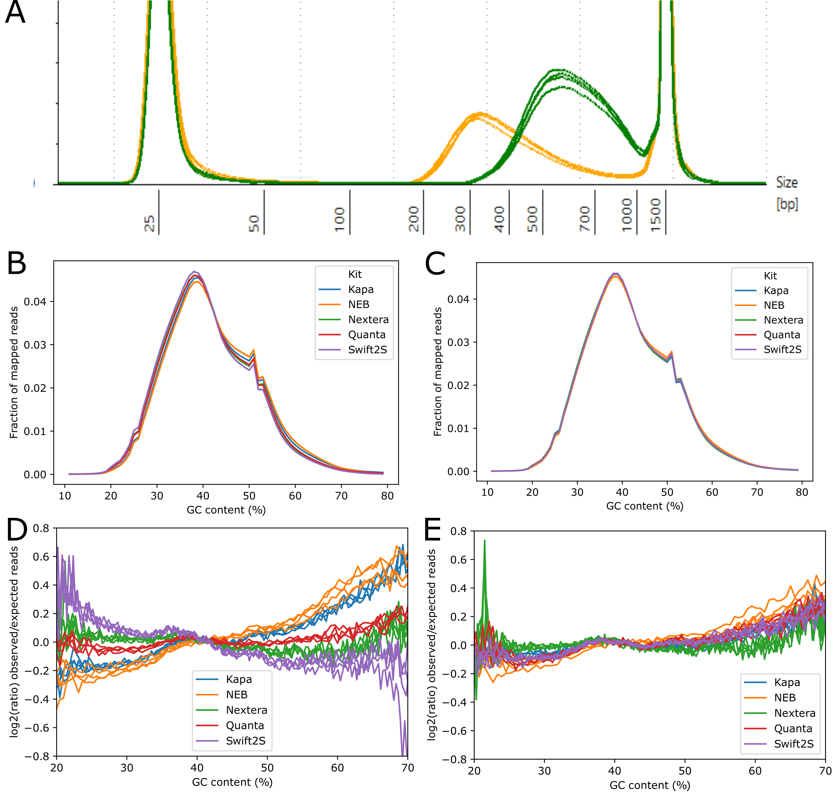

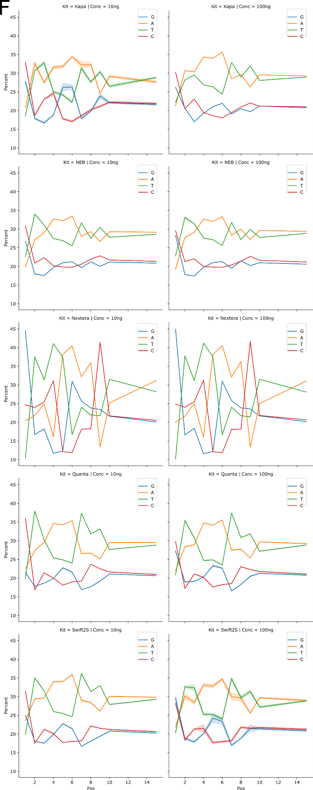
Supplementary Figure 1. Fragmentation profiles of libraries as assessed by Tapestation and GC content and bias of reads from different libraries
(A) Tapestation D1000 electorphoresis profiles for libraries prepared with 100 ng input DNA including PCR in four technical replicates each with Nextera DNA flex (Illumina) (green) and NEBNext Ultra II FS (NEB) (orange) PCR-free libraries (from Kapa, SparQ and Swift from 100 ng input) were not analysed, as they do not migrate properly due to their forked adapters. (B, C) Percentage GC content distribution of the sequencing reads as fraction of the mapped reads or as observed: expected ratio (D, E) of the sequencing reads from libraries produced from 10 ng (left panels) and 100 ng (right panels) input DNA. Abbreviations are Nextera DNA flex (Illumina), NEBNext Ultra II FS (NEB), Kapa Hyper Plus (Roche), SparQ DNA library (Quantabio) and Swift2S turbo flex (Swift) kits. (F) Base content percentage in the beginning (first 14 bases) of the reads for each library type and DNA input.

Supplementary Figure 2.
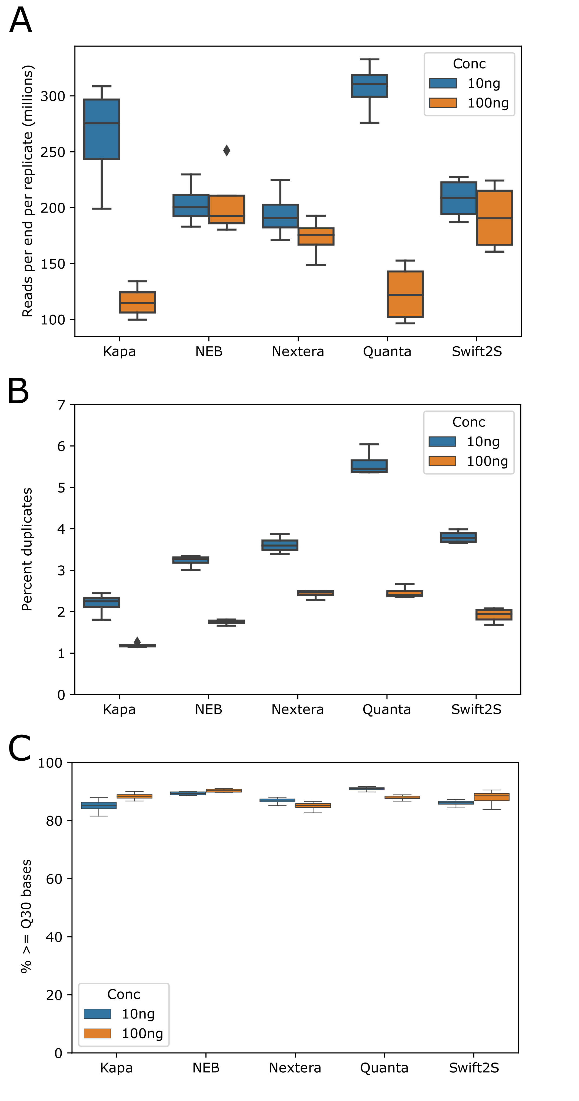
Supplementary Figure 2. Sequencing data yield and performance of libraries
Libraries were prepared from 10 ng and 100 ng DNA input using Nextera DNA flex (Illumina), NEBNext Ultra II FS (NEB), Kapa Hyper Plus (Roche), SparQ DNA library (Quantabio) kits and Swift2S turbo flex (Swift) kit. (A) Sequencing output as total million reads per replicate, (B) non-examp duplicates content (%), (C) Percentage of bases with Quality scores above Q30.

