SUPPLEMENTARY MATERIAL
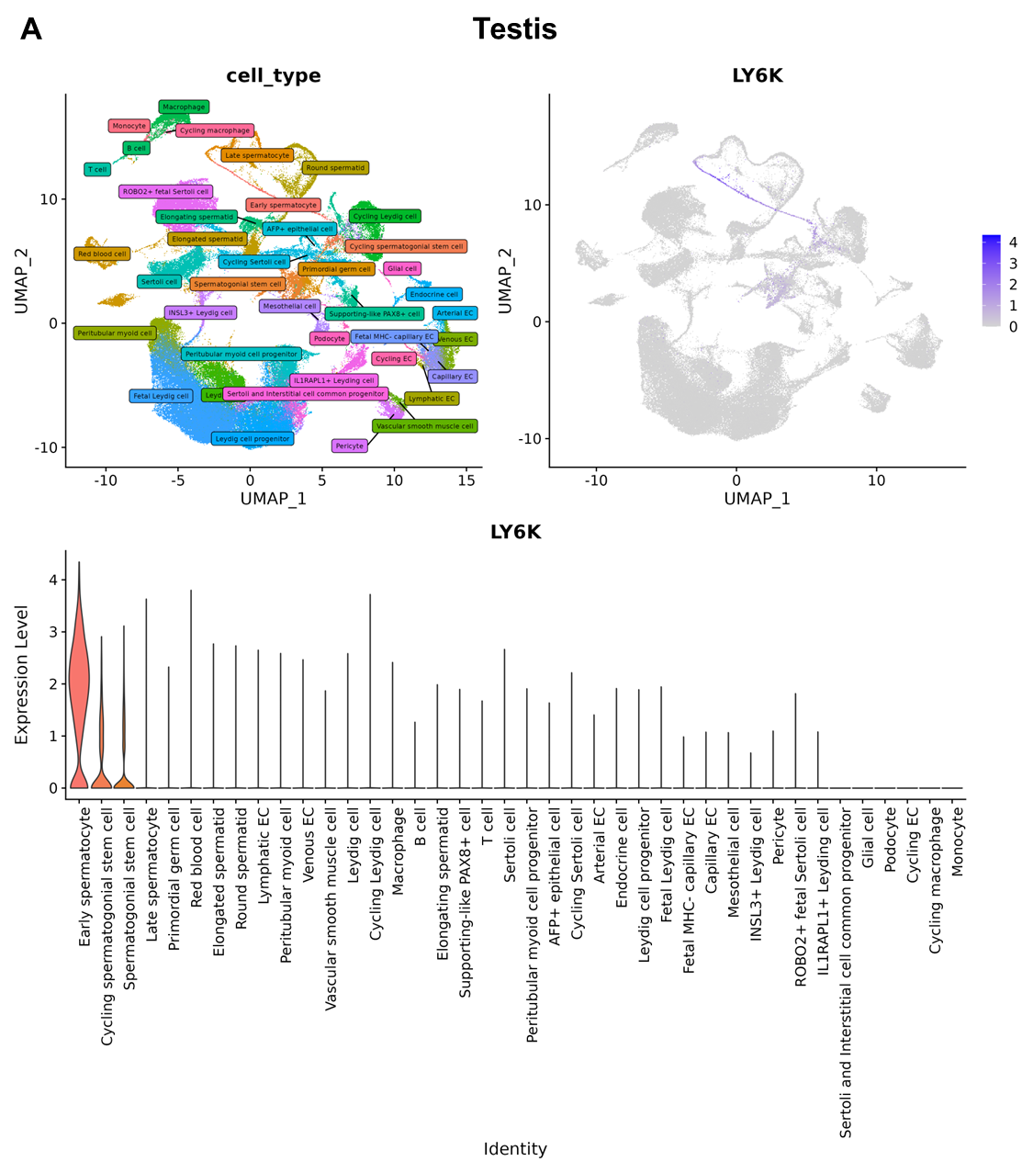
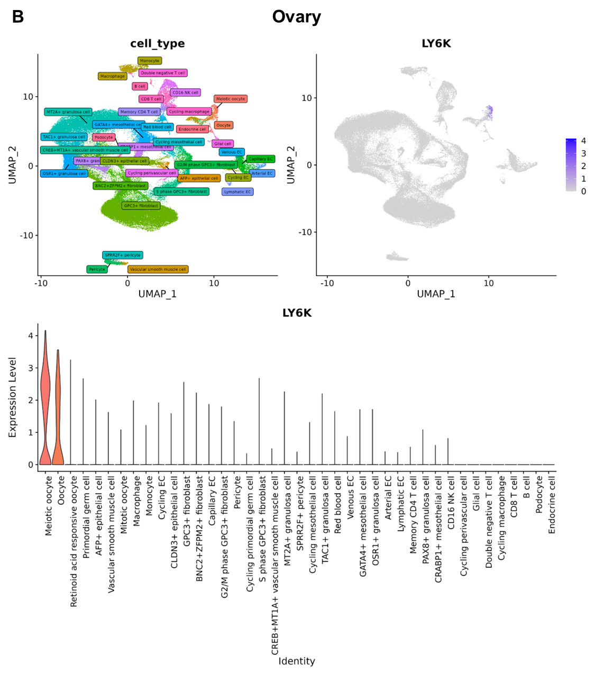
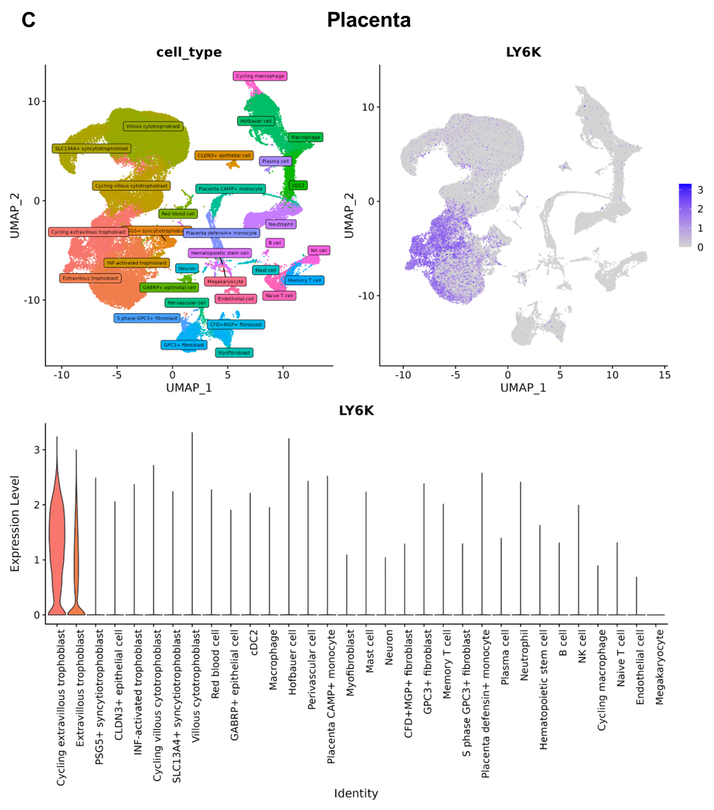

Fig. S1. Single-cell RNA-seq analysis of LY6K expression using the Deeply Integrated Single-Cell Omics (DISCO) database
UMAP visualizations show annotated cell types in (A) testis, (B) ovary and (C) placenta and LY6K expression levels across cell populations, with higher expression indicated by darker colour intensity. Violin plots depict LY6K expression across reference cell types, demonstrating predominant expression in reproductive and placental cell types such as cycling and extravillous trophoblasts.

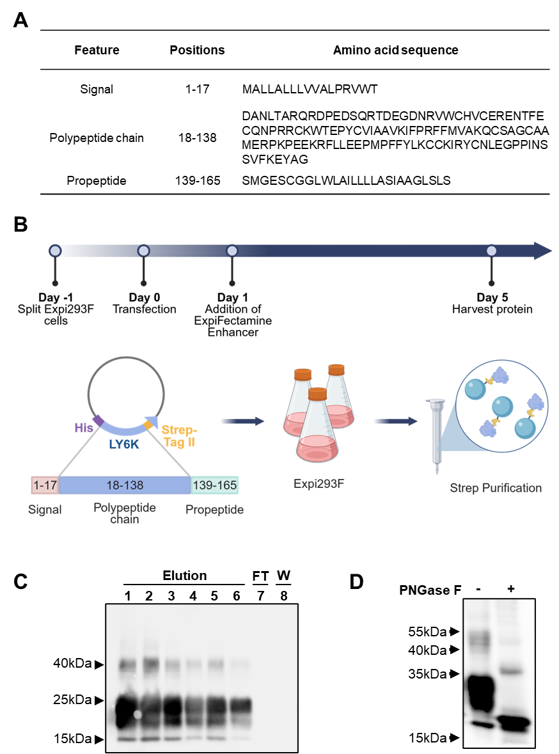

Fig. S2. Expression and purification of recombinant human LY6K protein
(A) Table showing features of human LY6K (UniProt Q17RY6), including predicted amino acid positions corresponding to the signal peptide, mature polypeptide chain and propeptide sequence
(B) Workflow illustrating the expression of LY6K polypeptide chain in the Expi293 expression system followed by Strep-tag purification. Five days post-transfection, proteins were harvested subjected to purification.
(C) Different fractions collected during the Strep purification (FT: flow-through; W: wash, E1-6: elution fractions) were analysed by Coomassie blue staining. Western blotting with murine 28C1 (1:5000) followed by goat anti-mouse HRP (1:10000) secondary antibody confirmed the presence of LY6K in elution fractions.
(D) Western Blot analysis of deglycosylated LY6K. Untreated and PNGase F- treated LY6K were separated on a 12% SDS-PAGE gel, transferred to nitrocellulose membrane and blocked with 4% milk in PBS-T. The blot was incubated with Hu22C-G8 (1 µg/mL) and goat anti-human HRP (1:5000) secondary antibody.

Table S1. Mass spectrometry analysis confirming LY6K identity using (A) Swiss-Prot and (B) UniProt-Human databases.
Proteins were separated by SDS-PAGE, digested in-gel, and deglycosylated with PNGase F at 37 °C for 8 h. Peptides were separated and analysed using a Vanquish Neo UHPLC system coupled to an Orbitrap Exploris 480. Data was searched with Mascot and filtered by Percolator at a strict false discovery rate of 1 % and relaxed false discovery rate of 5 %. (C) Identified peptides include sequences, modification status, and N-glycosylation sites following deglycosylation.
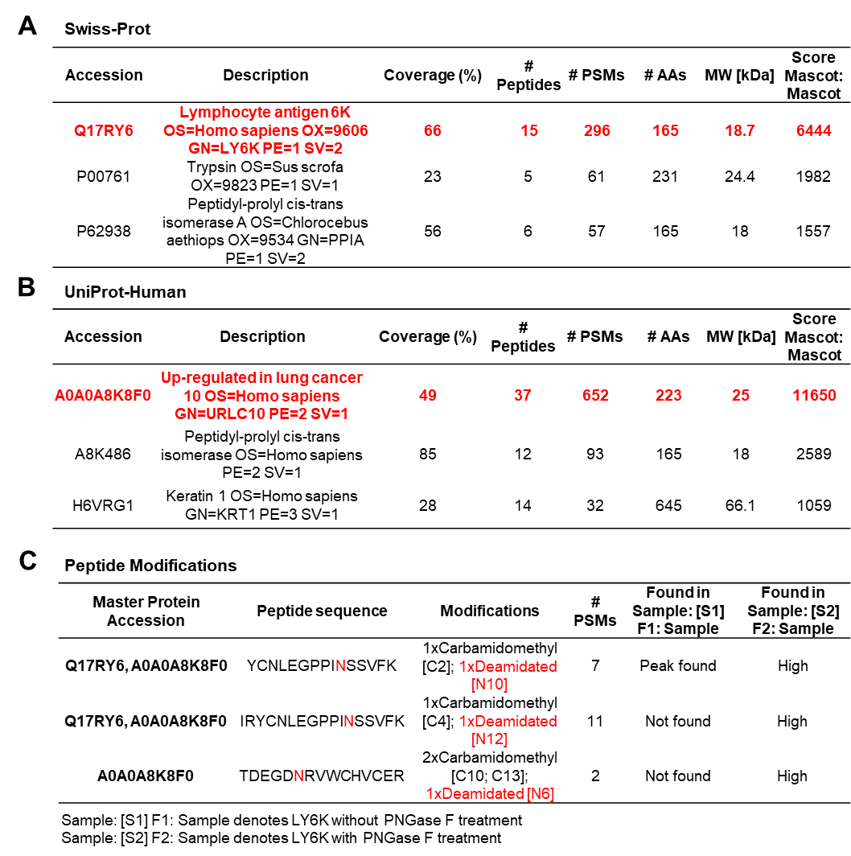
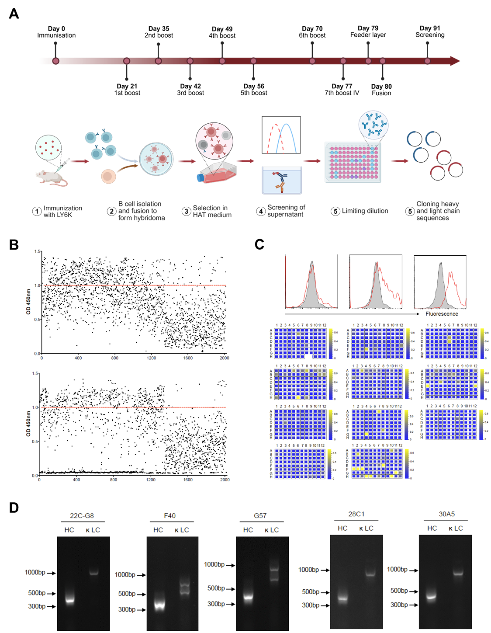

Fig. S3. Generation and screening of monoclonal antibodies binding to LY6K.
(A) Schematic overview of hybridoma workflow. BALB/c mice were immunized intraperitoneally with 25 μg LY6K, with a final intravenous (7th) boost to promote IgG class switching. B cells from spleen and lymph nodes were fused with NS-1 cells and selected in HAT medium. Hybridoma supernatants were screened by ELISA and flow cytometry, and positive clones were subjected to limiting dilution.
(B) ELISA screening of hybridoma supernatants. 96-well plates coated with LY6K were incubated with hybridoma supernatant and absorbance at OD450 nm was measured. Signals > 1.0 (red dotted line) were considered positive. (Top) First and (bottom) second-round screening identified ~1070 positive clones out of 2025 tested.
(C) Flow cytometry screening of ELISA-positive clones using Calu-1 cells. Representative histograms show low, medium and high binders (red lines); secondary antibody control is shown in as filled histograms. Colour-coded plate maps indicate binding intensity (blue to yellow).
(D) Cloning and expression of antibody candidates. Heavy and light chain sequences were amplified by PCR and cloned into expression vectors. DNA sequencing revealed that F40 and G57, as well as 28C1 and 30A5, share identical sequences; G57 was not successfully humanized.
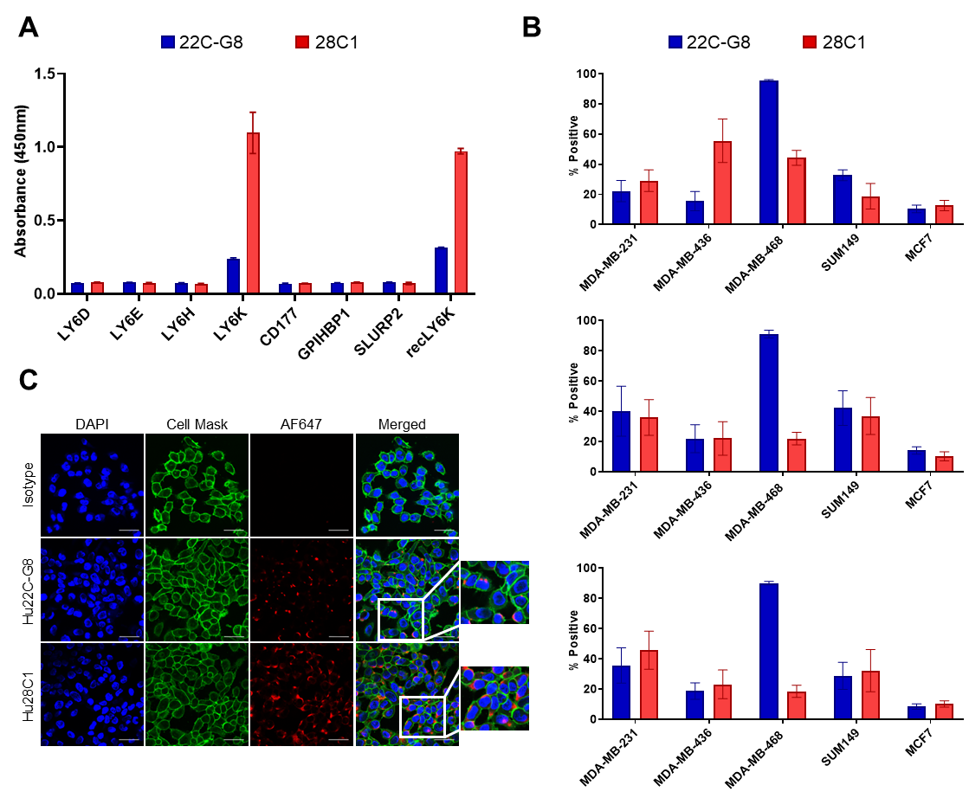

Fig. S4. Binding specificity of antibodies to LY6K
(A) ELISA showing no cross-reactivity of Hu22C-G8 (blue) and Hu28C1 (red) with other LY6/uPAR proteins (LY6D, LY6E, LY6H, LY6K, CD177, GPIHBP1, SLURP2). Recombinant proteins (0.3 µg/mL) were coated on plates and probed with antibodies (1 µg /mL), followed by HRP-conjugated secondary antibody and TMB detection (450 nm). Data represent mean ± SD of triplicates.
(B) Flow cytometry analysis of LY6K expression in breast cancer cell lines (MDA-MB-231, MDA-MB-468, SUM149 and MCF7) stained with murine, chimeric and humanized mAbs (10 µg/mL) and Alexa-Fluor 647- conjugated secondary antibody (1:100). Live single cells (PI⁻) were gated, and LY6K-positive percentages are shown relative to isotype controls (2% positive; mean ± SD, n=4).
(C) Immunofluorescence staining of LY6K in Ca Ski cells labelled with CellBrite Fix 488 membrane, fixed in 4% PFA and stained with isotype, Hu22C-G8 and Hu28C1 (10 µg/mL), followed by AF647-conjugated secondary antibody (10 µg/mL). Cells were mounted with Ibidi Mounting Medium with DAPI and imaged using an Olympus FV3000 confocal microscope. Scale bar, 40 µm.
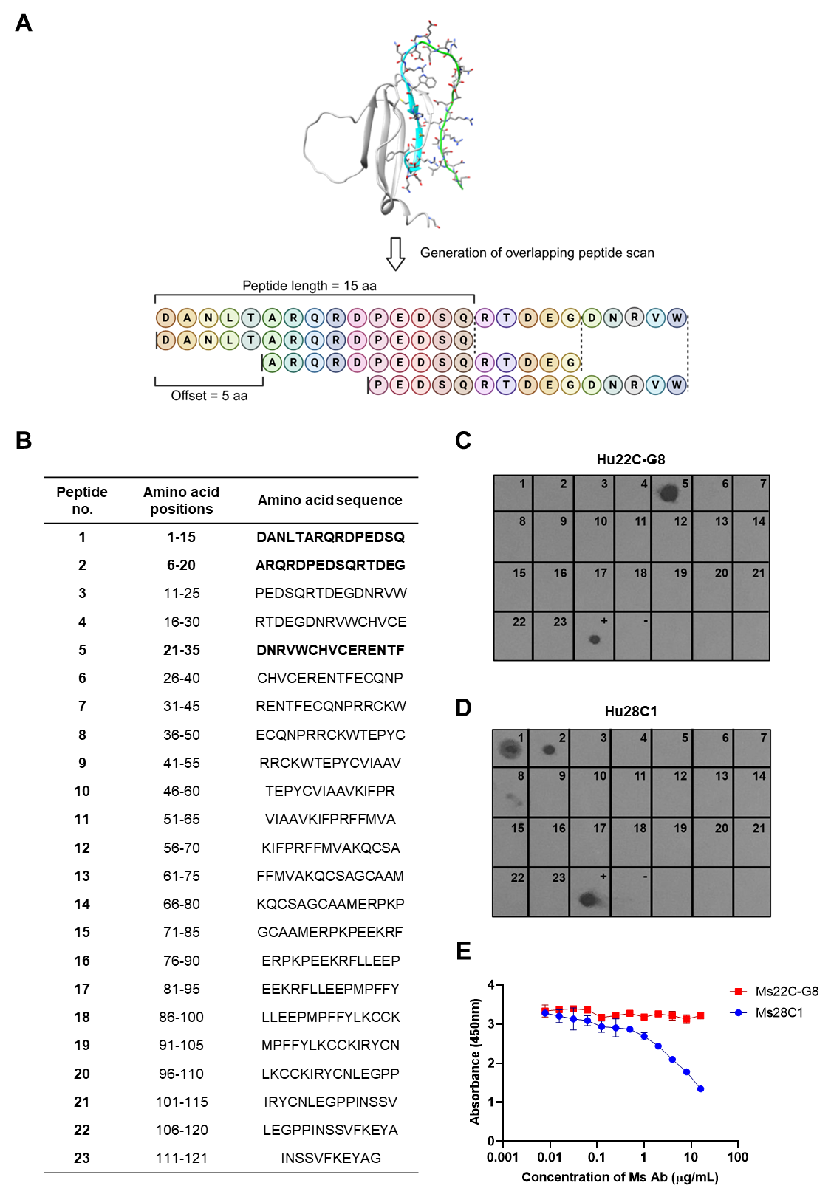

Fig. S5. Epitope mapping of LY6K
(A) Schematic diagram of 15-mer peptide library spanning the LY6K sequence, with 10-amino acid overlaps (offset of 5 aa).
(B) Table listing peptide number, amino acid positions and sequences. Epitope regions recognised by 22C-G8 and 28C1 are shown in bold.
(C, D) Dot-blot analysis using 15-mer synthetic peptides (2 µg/spot) dissolved in DMSO. DMSO alone and recombinant LY6K (0.01 µg) served as negative and positive controls, respectively. Membranes were probed with Hu22C-G8 or Hu28C1 (10 µg/mL), followed by goat anti-human HRP antibody (1:1000) and chemiluminescent detection.
(E) Competitive ELISA assessing simultaneous binding of 22C-G8 and 28C1 to LY6K. Recombinant LY6K (0.3 µg/mL) was coated on plates and incubated with Hu28C1 (0.1 µg/mL) mixed with serial 2-fold dilutions of Ms22C-G8 or Ms28C1 (starting at 16 µg/mL) HRP-conjugated goat anti-human secondary antibody (1:10,000) and TMB substrate were used for detection (450 nm). Data represent mean ± SD of triplicates.
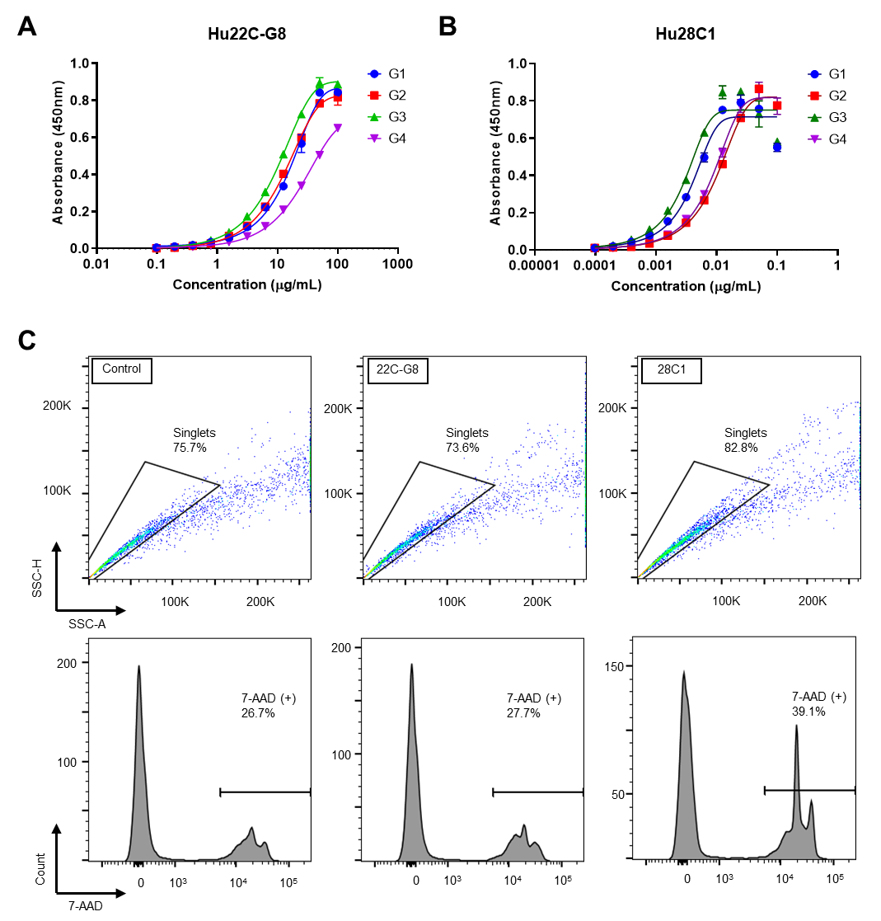

Fig. S6. Generation of antibody subclasses and CDC gating strategy
(A, B) Binding of IgG subclasses of Hu22C-G8 and Hu28C1 to recombinant LY6K (0.3 µg/mL) immobilised on ELISA plates. Antibodies were added in two-fold dilutions, followed by HRP-conjugated secondary antibody and TMB detection (OD₄₅₀).
(C) Gating strategy for CDC showing identification of 7-AAD+ cells. Cells (25,000 cells/well) were incubated with antibody (25 µg/mL) for 1 h at 37°C, followed by baby rabbit complement (4 h). After 7-AAD staining (20 min, dark), samples were analysed by flow cytometry; single cells (SSC-A/SSC-H) were gated prior to 7-AAD+ population quantification.
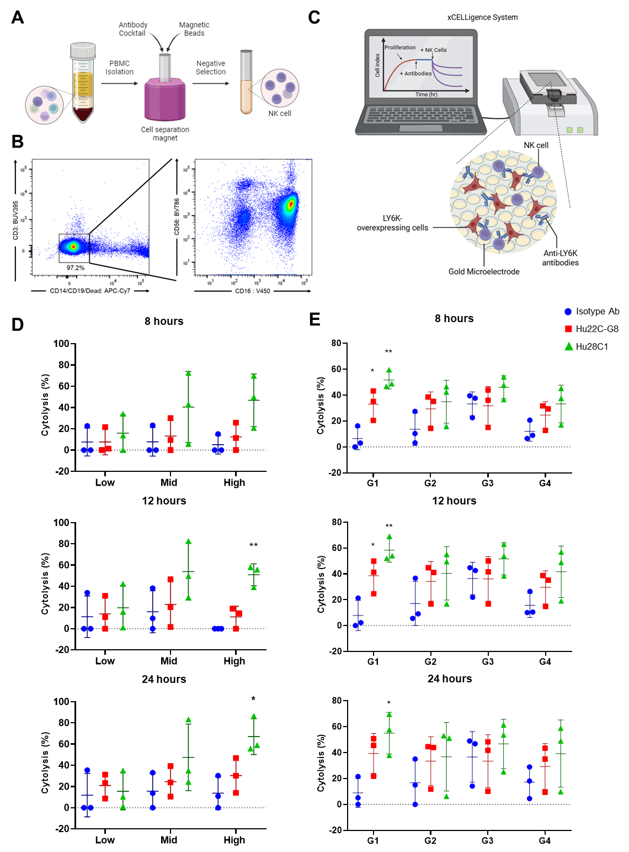

Fig. S7. NK cell isolation, gating, and ADCC analysis using xCELLigence RTCA.
(A) Schematic of NK cell isolation from PBMCs. PBMCs were isolated from whole blood by Ficoll-Paque PLUS density gradient centrifugation, followed by NK cell isolation using the EasySep Human NK Cell Isolation Kit. The NK-enriched supernatant was collected after magnetic separation. (Figure created with Biorender).
(B) Flow cytometry gating of isolated NK cells. Cells were stained with anti-CD3, anti-CD14, anti-CD16, anti-CD19, anti-CD56 antibodies and a live/dead stain. NK cells were identified as CD3⁻ CD14⁻ CD19⁻ live cells (left), followed by CD16 and CD56 gating (right). CD16 (FcγRIIIA), a potent activating receptor on NK cells, mediates ADCC via granzyme-perforin release and IFN-γ secretion. As many therapeutic mAbs depend on NK cell–mediated cytotoxicity, NK cells were used as effector cells in ADCC assays.
(C) Schematic of ADCC assay setup using the xCELLigence RTCA. LY6K-overexpressing cells were seeded on gold microelectrode E-plates overnight. After 1 h antibody incubation, NK cells were added, and impedance (cell index) was monitored in real time. (Figure created with Biorender).
(D, E) ADCC activity in (D) low, mid, and high LY6K-overexpressing cells treated with isotype control, Hu22C-G8, or Hu28C1 (25 µg/mL), and (E) high LY6K-overexpressing cells treated with IgG1-IgG4 subclass variants. NK effector cells were added at an E:T ratio of 4:1. Cytolysis was measured over time, and cytotoxicity at 8, 12 and 24 h post-NK cell addition is shown. Data represent mean ± SD from three independent experiments. Unpaired t-test: *, P < 0.05; **, P < 0.01; ***, P<0.001.
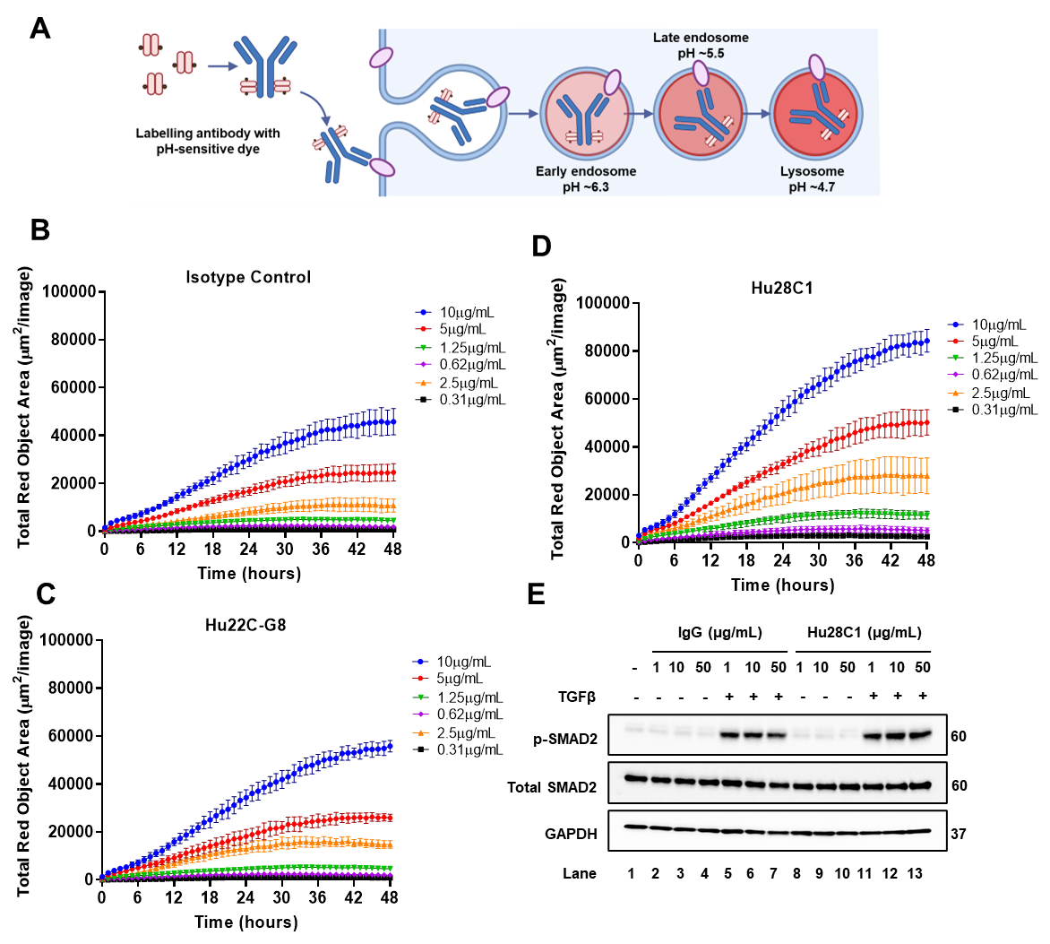

Fig. S8. Internalisation of anti-LY6K antibodies and effect on TGFβ signaling
(A) Schematic illustration of the internalisation assay. Anti-LY6K and isotype control antibodies were labelled with a pH-sensitive dye. Upon binding to LY6K, the antibody-LY6K complex undergoes endocytosis and trafficking into the endosomal and lysosomal compartments, where decreasing pH increases fluorescence intensity.
(B-D) Real-time monitoring of antibody internalisation. (B) Isotype control, (C) Hu22C-G8 and (D) Hu28C1 were labelled with Incucyte Human Fabfluor-pH Red (1:3 molar ratio) and incubated for 15 min at 37°C. Ca Ski cells (15,000 cells/well) were treated with increasing antibody concentrations and images were acquired every hour for 48 h at 20× magnification. Internalisation was quantified as total red object area per time point and plotted across time.
(E) Hu28C1 does not affect TGFβ-SMAD2 signalling. SiHa cells were treated for 1.5 h with varying concentrations of IgG or Hu28C1, followed by TGFβ (10ng/mL, 2 h). Cell lysates (40 µg total protein) were analysed by Western blot for phospho-SMAD2 (Ser465/467) (138D4) (1:1000), total SMAD2 (L16D3) (1:1000), and GAPDH (6C5) (1:3000). HRP-conjugated secondary antibodies (1:5000) were used for chemiluminescent detection.

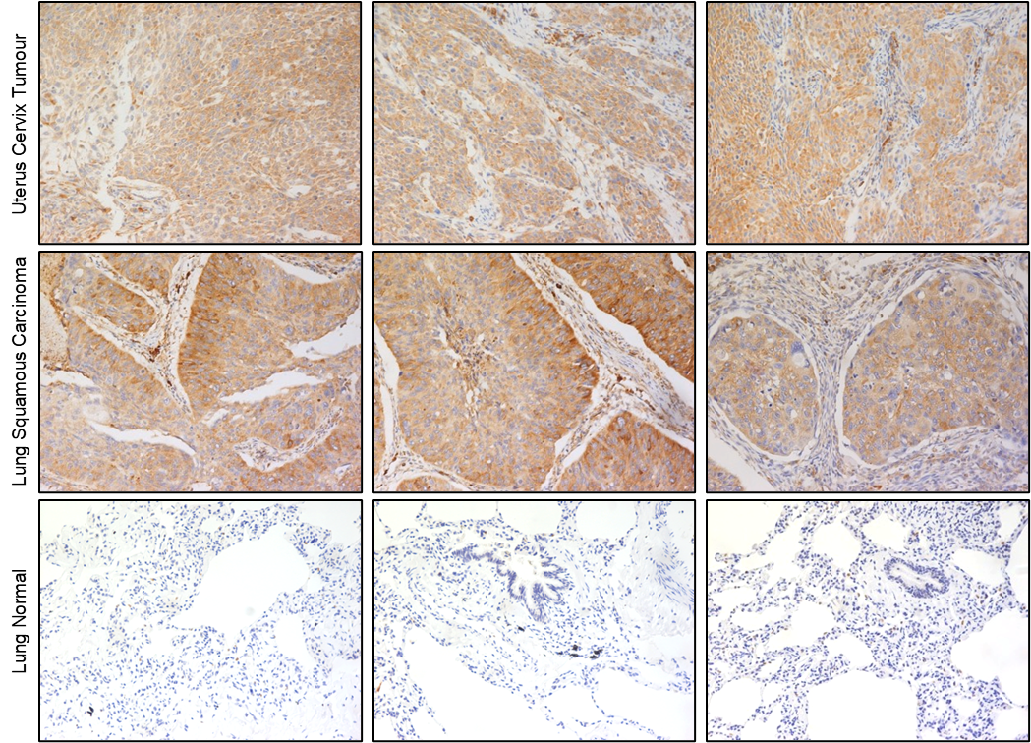

Fig. S9. Immunohistochemical staining of LY6K
The paraffin tissue sections of uterus cervix squamous cell carcinoma (top), lung squamous cell carcinoma (middle) and lung normal (bottom) were subjected to epitope retrieval solution

