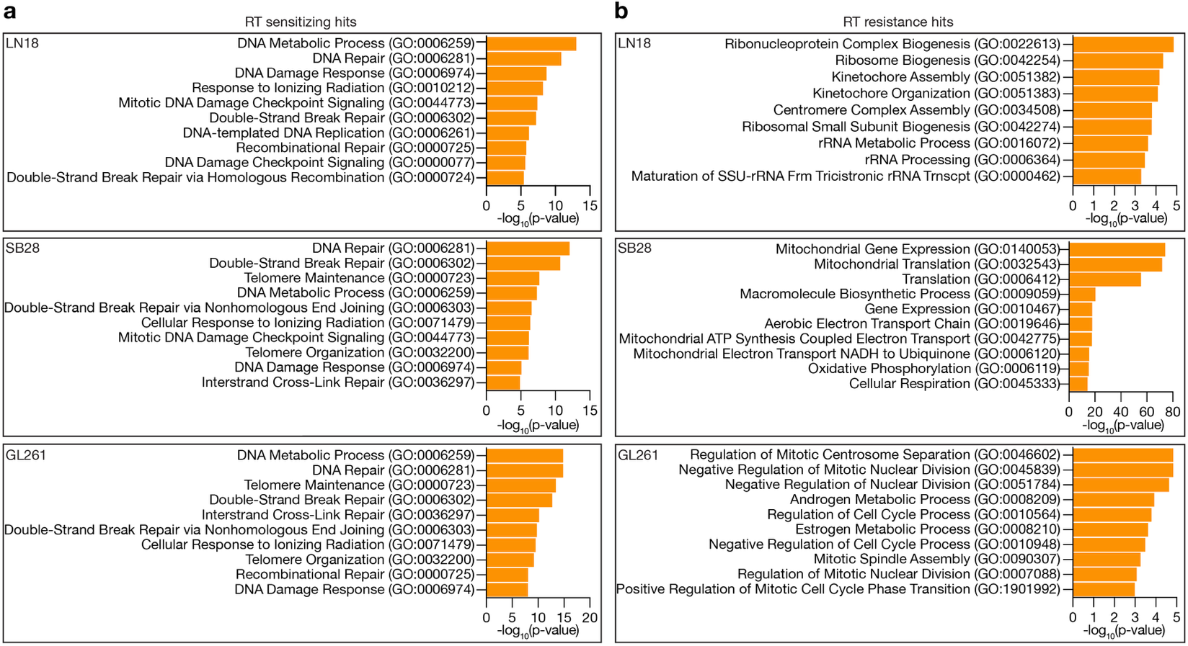
Extended Data Fig. 1. In vitro CRISPRi screens identify radiation response genes in cultured human and mouse glioblastoma cells. a, Gene ontology (GO) analyses of CRISPRi screen hits driving RT sensitization in human (LN18) and mouse (SB28, GL261) glioblastoma cells. Top GO Biological Process terms are shown. b, GO analyses as in a but for CRISPRi screen hits driving RT resistance in glioblastoma cells.
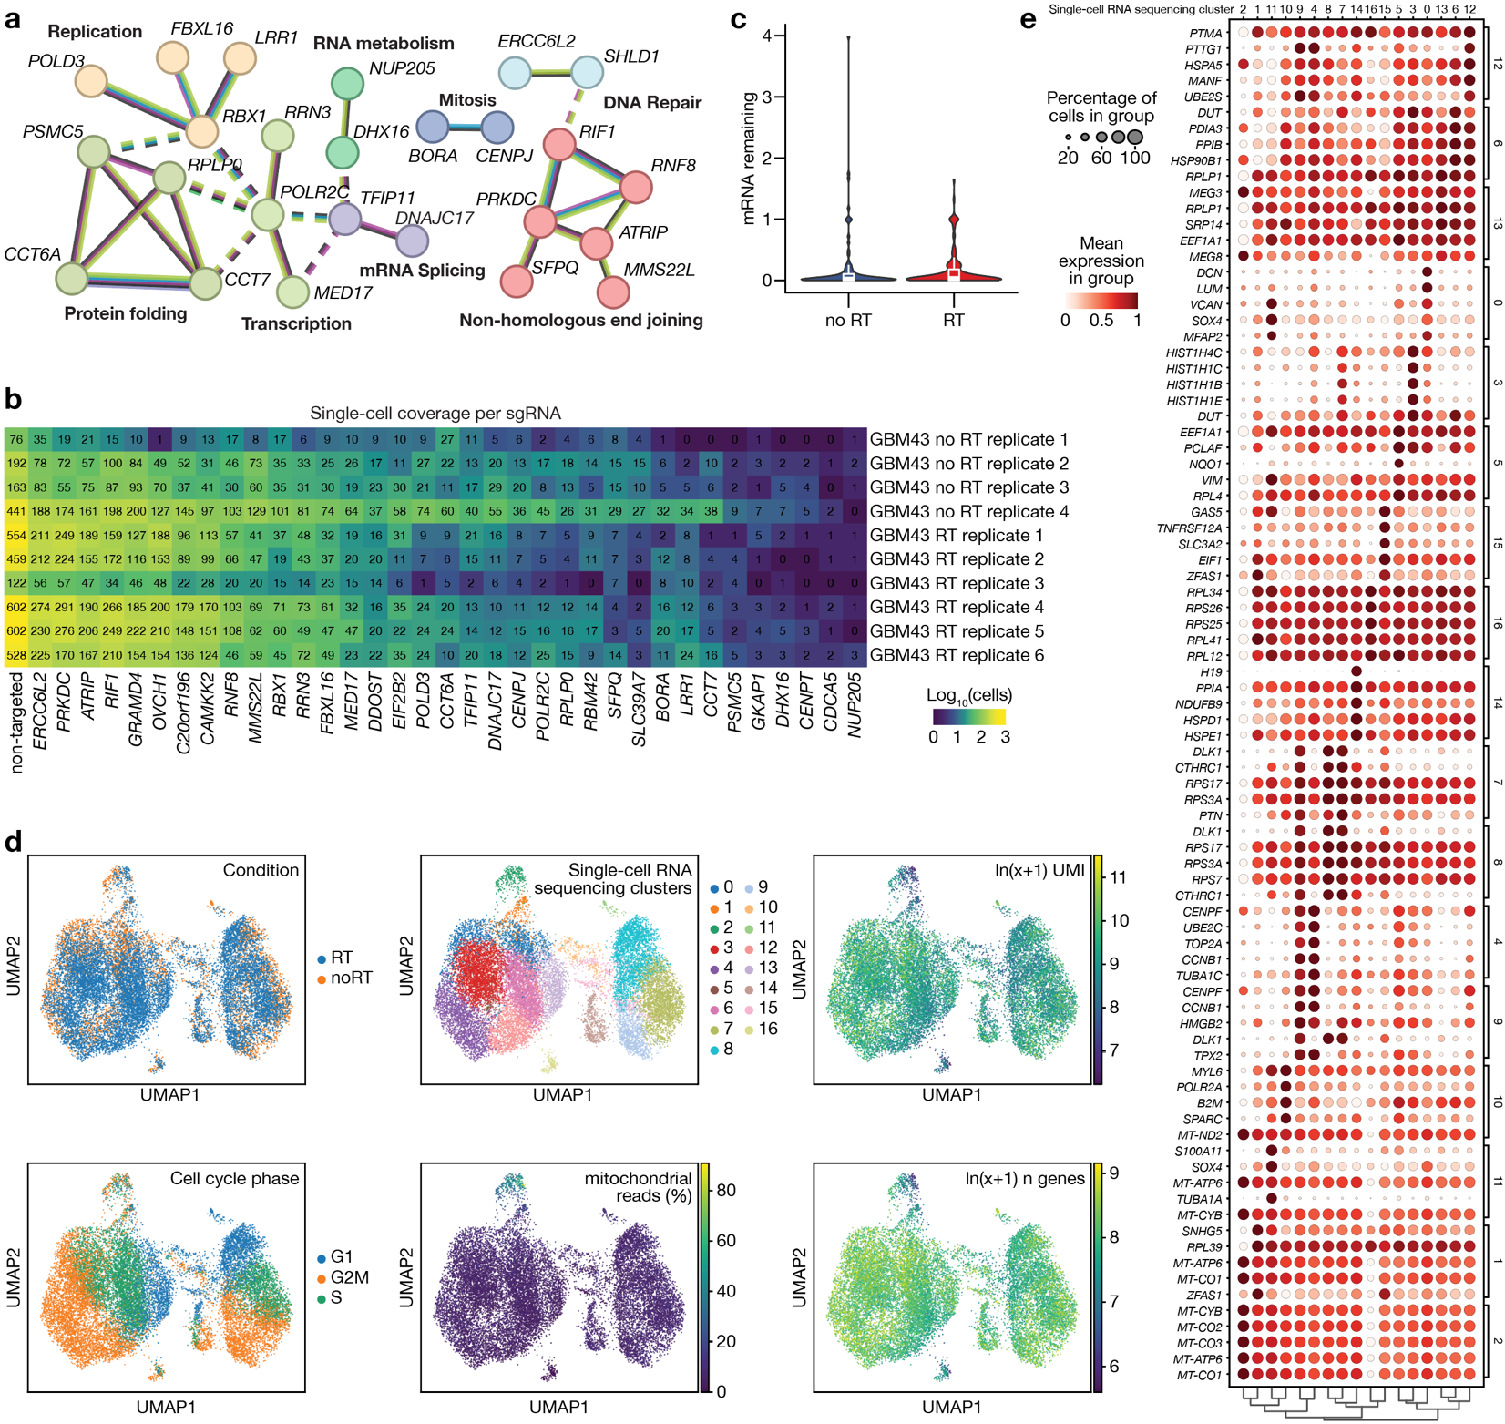Extended Data Fig. 2. In vivo perturb-seq of RT sensitizing genes in intracranial glioblastoma patient-derived xenografts. a, STRING-DB network analysis of 35 candidate RT sensitizing gene hits from in vitro CRISPRi screens that were used for glioblastoma in vivo perturb-seq analyses. Genes are grouped by Markov Cluster Algorithm with inflation parameter of 3 (Colored circles). Colored edges show neighborhood evidence (green), cooccurrence evidence (blue), experimental evidence (purple), text mining evidence (yellow), database evidence (light blue), and co-expression evidence (black). C20orf196, CAMKK2, CDCA5, CENPT, DDOST, EIF2B2, GKAP1, GRAMD4, OVCH1, and RBM42, which were included in the in vivo perturb-seq sgRNA library but did not segregate into any STRING-DB networks, are not shown. b, Heatmap of cellular coverage for sgRNA perturbations as well as merged non-targeted sgRNAs across replicate samples from glioblastoma in vivo perturb-seq experiments. c, Distribution of on-target gene knockdown from glioblastoma in vivo perturb-seq for pseudobulked single cells in either control or RT condition (2Gy x 2 daily fractions). Values were normalized to expression in cells with non-targeted sgRNAs (mRNA remaining = 1.0). Boxplots show 1st quartile, median, and 3rd quartile. Whiskers represent 1.5 inter-quartile range. d, UMAP plots of merged glioblastoma single-cell RNA sequencing data for tumor cells passing quality control and also expresses sgRNAs, colored by treatment condition, Leiden single-cell cluster, cell cycle phase, UMI, gene, or mitochondrial gene expression. e, Bubble plot of marker genes corresponding to Leiden clustering in d.
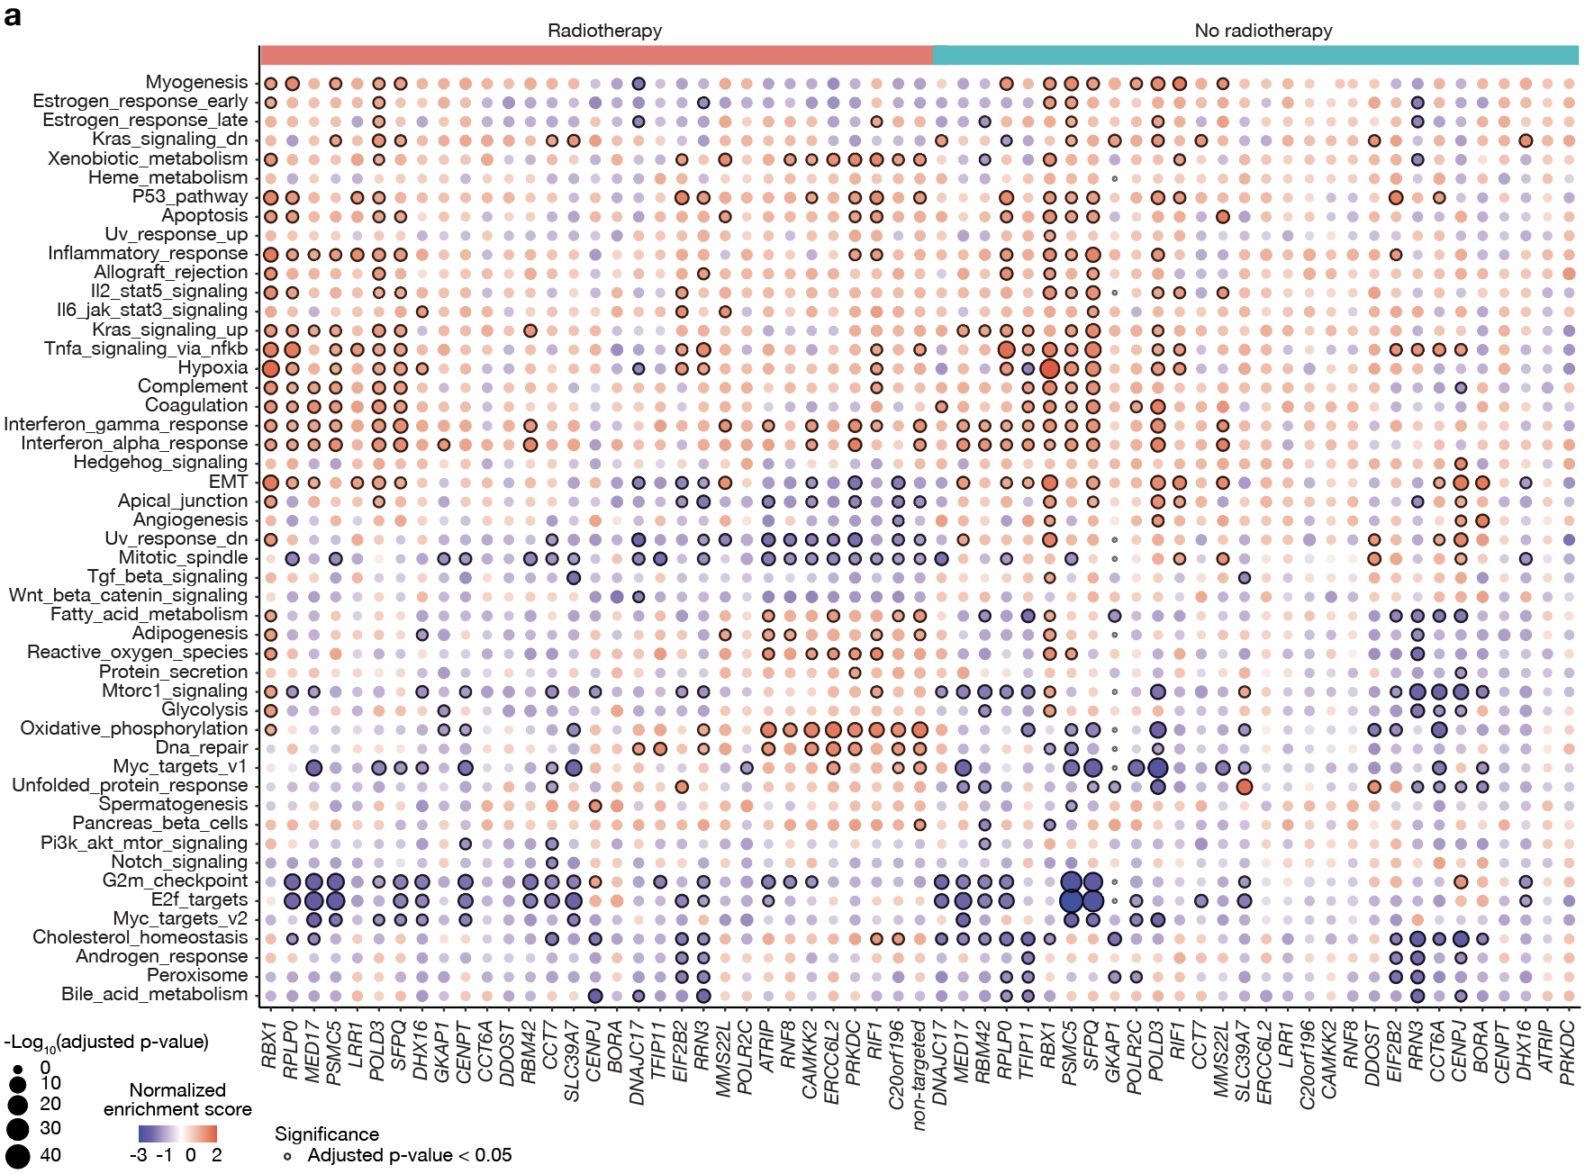Extended Data Fig. 3. In vivo perturb-seq analysis of RT sensitizing genes in intracranial glioblastoma patient-derived xenografts. a, Bubble plot of gene set enrichment analyses of gene expression modules (rows) following sgRNA perturbations (columns) with or without RT for in vivo perturb-seq in glioblastoma PDXs. Color represents normalized enrichment scores relative to non-targeted control sgRNAs in no RT (control) conditions.
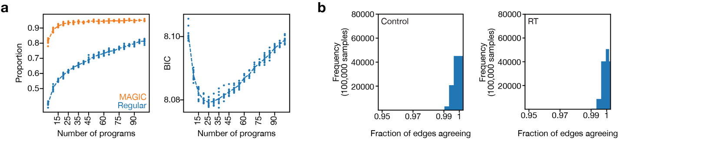
Extended Data Fig. 4. Gene regulatory network modeling of in vivo perturb-seq data using D-SPIN. a, Analysis of the proportion of variation explained in combined glioblastoma in vivo perturb-seq data using Markov affinity-based graph imputation of cells (MAGIC,left) or Bayesian Information Criterion (BIC, right) compared to orthogonal nonnegative matrix factorization (oNMF) rank specification (number of programs). b, Analysis of network edge uncertainty in control (left) or RT (right) glioblastoma in vivo perturb-seq conditions demonstrating robust D-SPIN gene regulatory network models.
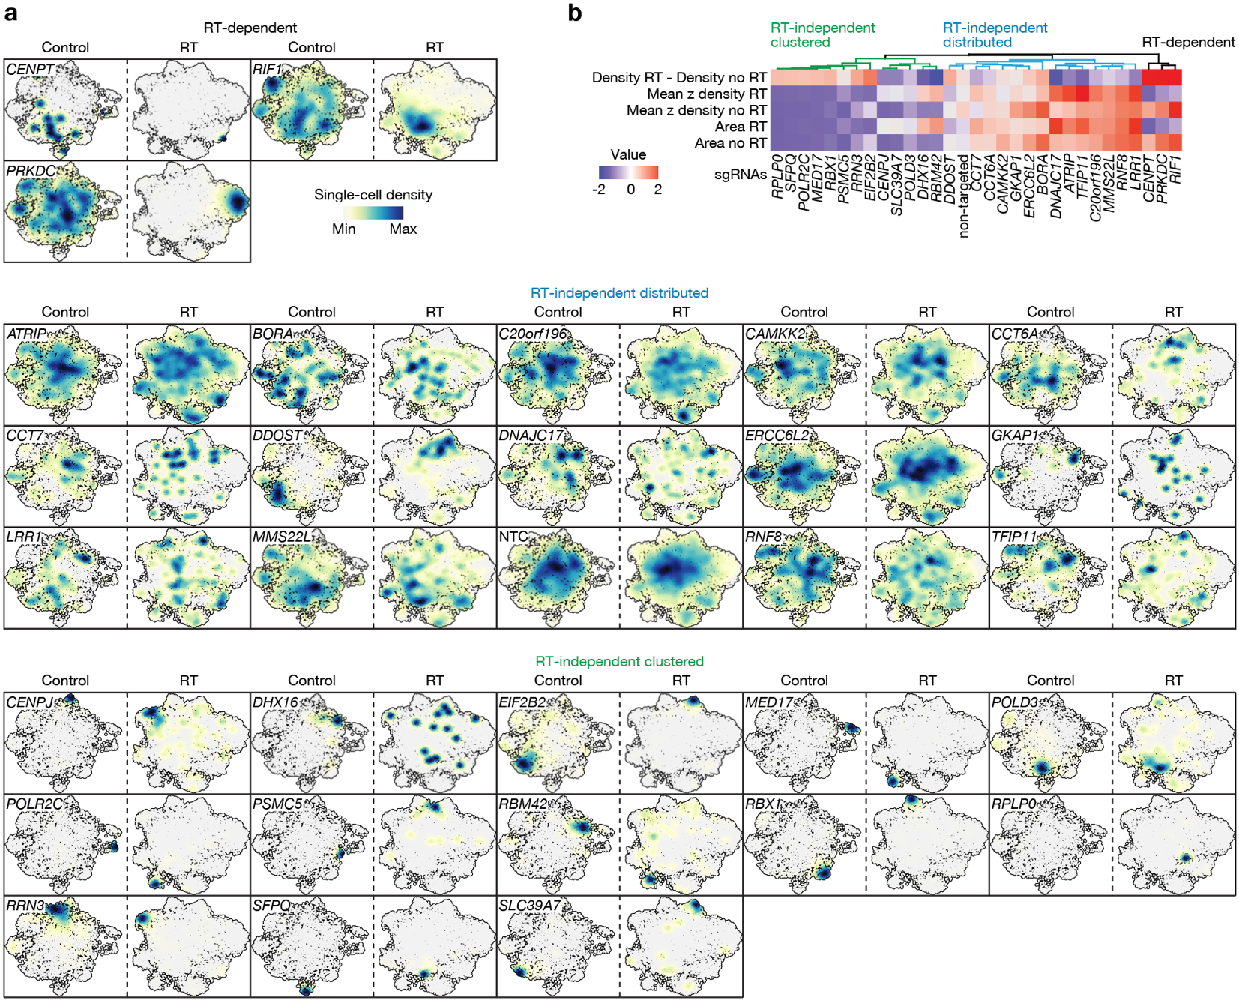Extended Data Fig. 5. Analysis of single cell heterogeneity and RT phenotypes from in vivo perturb-seq. a, LDA UMAP density plots showing distribution of single cells from glioblastoma PDX in vivo perturb-seq data expressing the indicated sgRNAs in either control (paired left) or RT (paired right) conditions. Cells expressing sgRNAs other than the one labeled (and highlighted in blue) represent the background UMAP outlined in white. NTC, non-targeted control sgRNA. b, Heatmap of UMAP density features (mean normalized density and area above 50th percentile) in either control or RT conditions from glioblastoma PDX in vivo perturb-seq data, grouped using hierarchical clustering, which shows 3 classes of in vivo perturb-seq distributions.
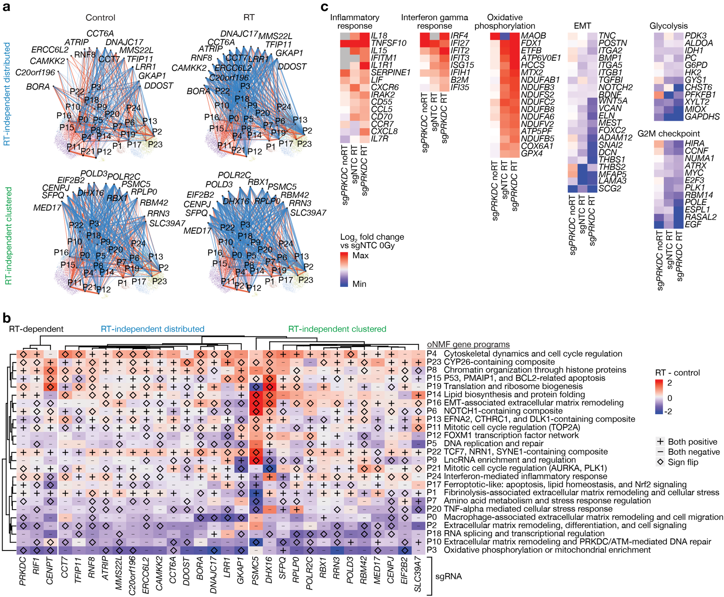Extended Data Fig. 6. Gene regulatory network analysis of in vivo perturb-seq data using D-SPIN. a, D-SPIN models of single-cell transcriptomes after sgRNA perturbations targeting RT-independent distributed (top) or RT-independent clustered genes (bottom) in control (left) or RT (right) conditions. Inferred activating (red) or inhibitory (blue) interaction edges between sgRNA perturbations (gene names) and gene expression programs (nodes) are shown. Edge thickness is proportional to the strength of network interaction. Gene expression programs (P#) are defined in b. b, Heatmap quantifying differences in interaction edges between sgRNA perturbations (columns) and gene expression programs (rows) in RT versus control conditions. Symbols show whether interaction directions were concordant (+/-) or sign flipped (diamond) in RT versus control conditions. c, Gene expression heatmaps grouped by Hallmark gene sets showing pseudobulked log₂ fold changes relative to single glioblastoma cells expressing non-targeted control sgRNAs in control conditions from glioblastoma in vivo perturb-seq data.
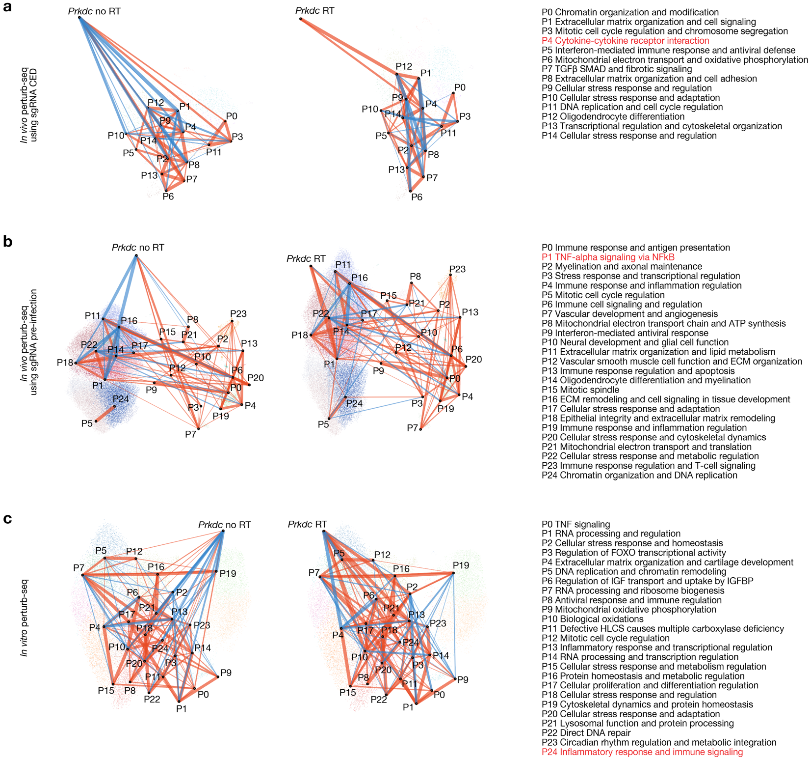Extended Data Fig. 7. Reanalysis of in vivo and in vitro perturb-seq data from GL261 syngeneic glioblastoma models. a, D-SPIN models of single-cell transcriptomes after sgRNA perturbations from CED in vivo perturb-seq in GL261 orthotopic allografts, isolating Prkdc perturbation in control (left network) or radiotherapy (2Gy x 5 fractions, right network) conditions. Inferred activating (red) or inhibitory (blue) interaction edges between Prkdc sgRNA perturbations and gene expression programs (nodes) are shown. Edge thickness is proportional to the strength of network interaction. Gene expression programs (P#) with inhibitory to activating interactions related to inflammatory gene programs following RT are shown in red. b, as in a but for in vivo perturb-seq using GL261 cells that were transduced with sgRNA perturbations prior to tumor implantation (pre-infected). c, as in a but for in vitro perturb-seq performed in GL261 cell cultures.
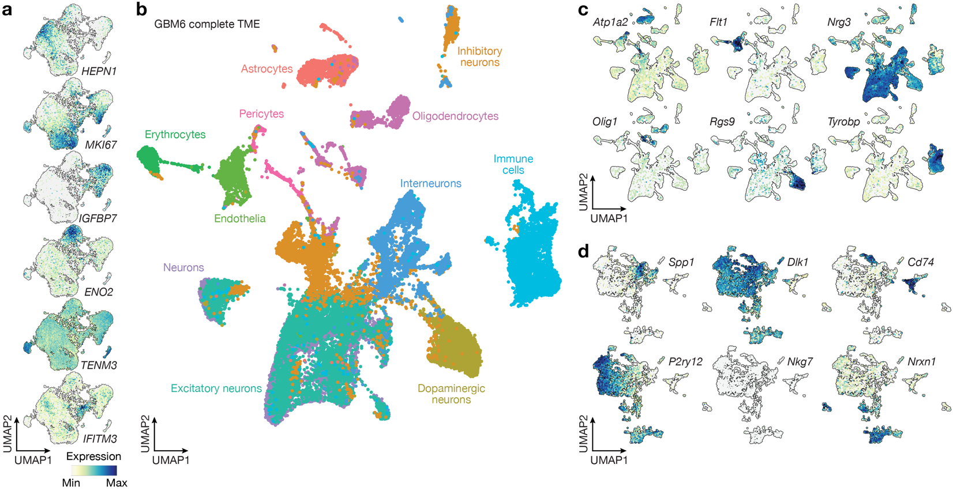Extended Data Fig. 8. Single-cell RNA sequencing of in vivo GBM6 PDX cells following DNA-PKcs inhibition and/or radiotherapy. a, Gene expression feature plots showing marker genes for malignant cell states from Fig. 2d. b, UMAP of single-cell transcriptomes from GBM6 PDXs treated with vehicle, peposertib (100mg/kg x 5 daily treatments), RT (2Gy x 5 daily fractions), or RT and peposertib (n=8) showing all mouse TME cell types (n=33,623 cells). c, Gene expression feature plots showing marker genes for complete TME cell types from b. d, Gene expression feature plots showing marker genes for iterative subclusters of immune TME cell types from Fig. 2d.

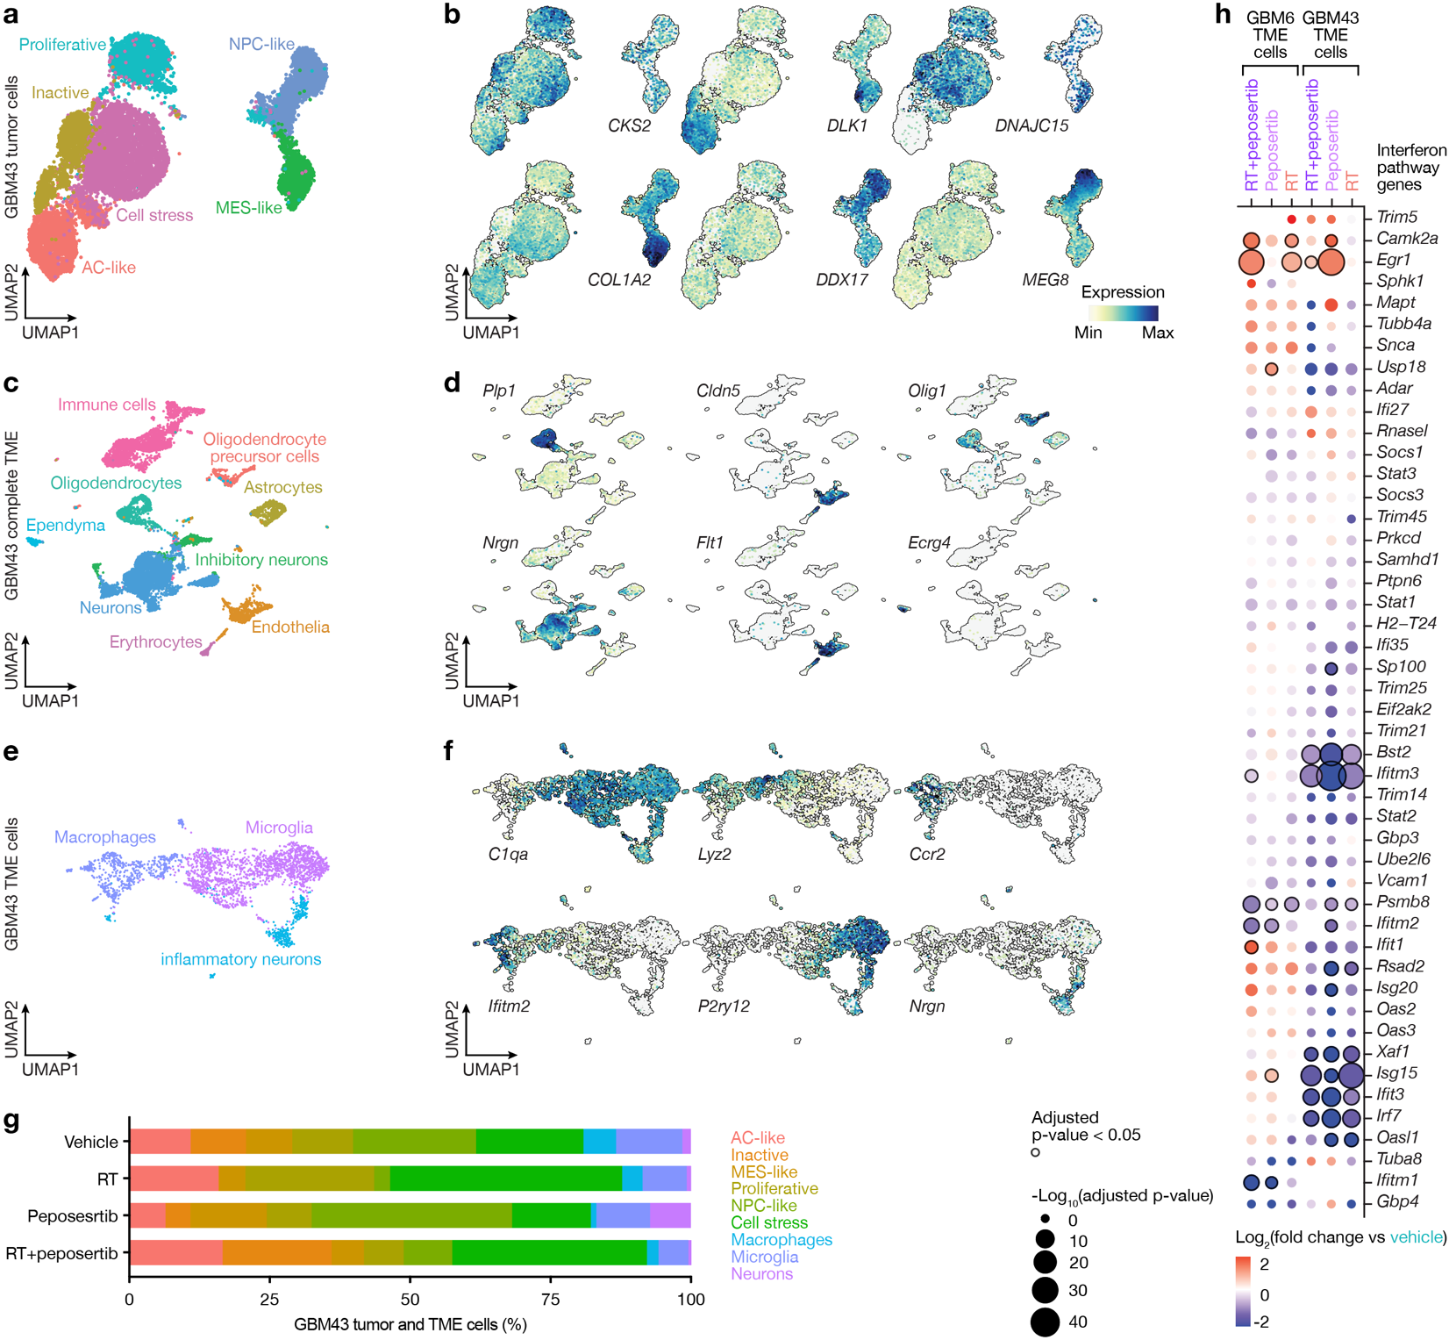Extended Data Fig. 9. Single-cell RNA sequencing of in vivo GBM43 PDX cells following DNA-PKcs inhibition and/or radiotherapy. a, UMAP of single-cell transcriptomes from GBM43 PDXs treated with vehicle, peposertib (100mg/kg x 5 daily treatments), RT (2Gy x 5 daily fractions), or RT and peposertib (n=8) showing human malignant cell states (n=16,009 cells). b, Gene expression feature plots showing marker genes for malignant cell states from a. c, UMAP of single-cell transcriptomes from GBM43 PDXs treated with vehicle, peposertib, RT, or RT and peposertib (n=8) showing all mouse TME cell types (n=10,192 cells). d, Gene expression feature plots showing marker genes for complete TME cell types from c. e, UMAP of iterative subclusters of immune TME cell types (n=8,441 cells) from GBM43 single-cell transcriptomes after treatment with vehicle, peposertib, RT, or RT and peposertib (n=8). f, Gene expression feature plots showing marker genes for immune TME cell types from e. g, Stacked bar plot showing the proportion of malignant glioblastoma cell states and immune TME cell types across GBM43 PDX treatment conditions. h, Bubble plot of interferon pathway gene expression from single-cell RNA sequencing of intracranial GBM6 or GBM43 mouse TME cells (microglia, macrophages, and NK cells) after treatment with RT (2 Gy x 5 daily fractions), peposertib (100 mg/kg x 5), or RT and peposertib.
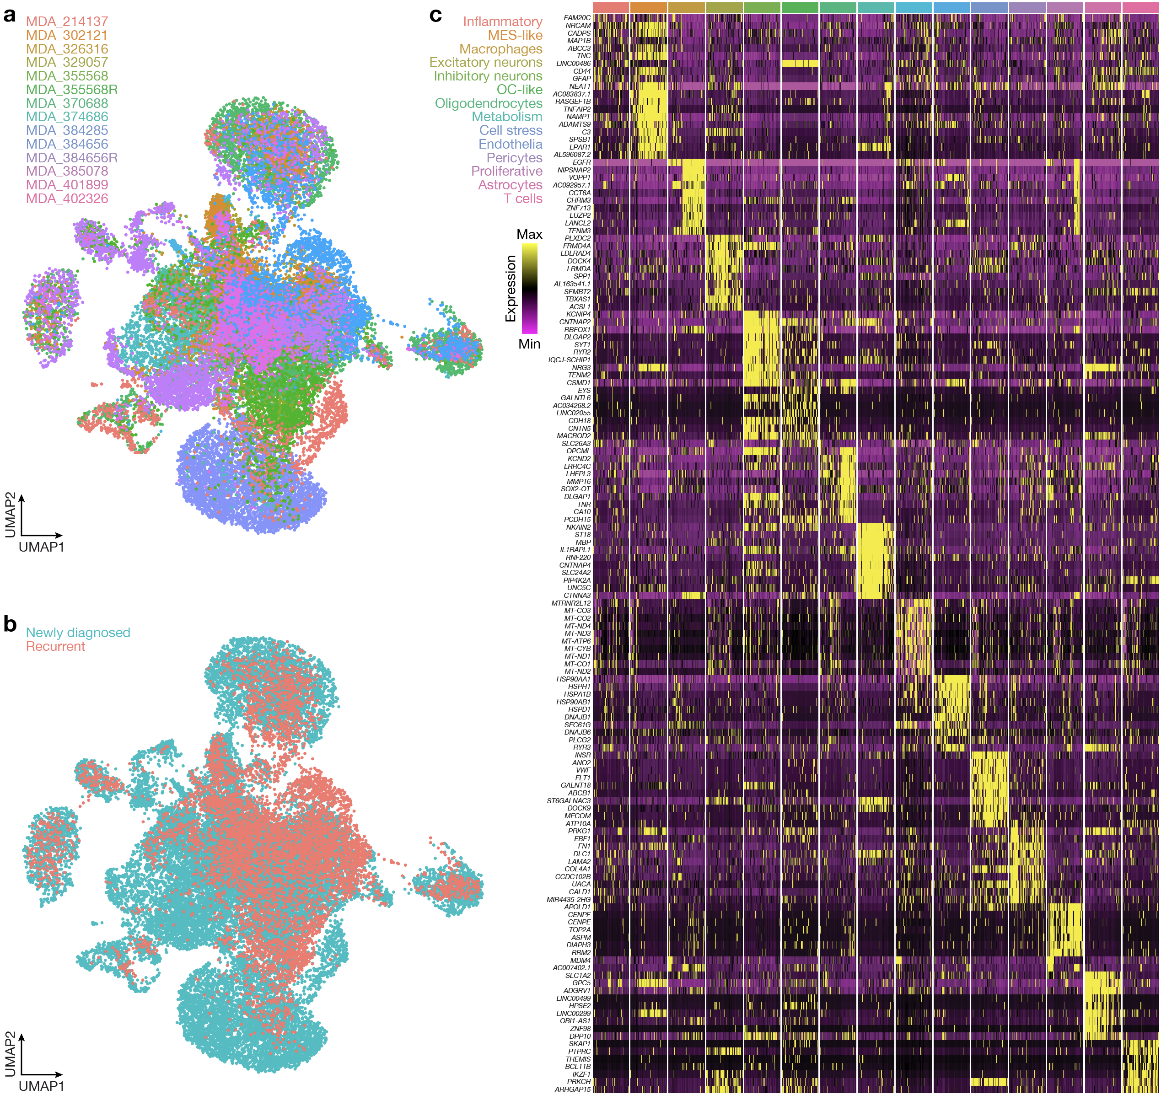Extended Data Fig. 10. Single-nucleus RNA sequencing of human glioblastomas from NCT04555577. a, UMAP of 102,709 single-nucleus transcriptomes from 14 human glioblastoma samples that were treated with RT and peposertib on NCT04555577 (n=12 newly diagnosed, n=2 recurrent), 4 of which correspond to patient-matched pairs of newly diagnosed and recurrent glioblastoma samples from 2 patients that were subsequently analyzed using spatial RNA sequencing. b, UMAP of glioblastoma cells from NCT04555577 shaded by newly diagnosed or recurrent clinical presentation. c, Heatmap of single-nucleus transcriptome marker genes from NCT04555577.
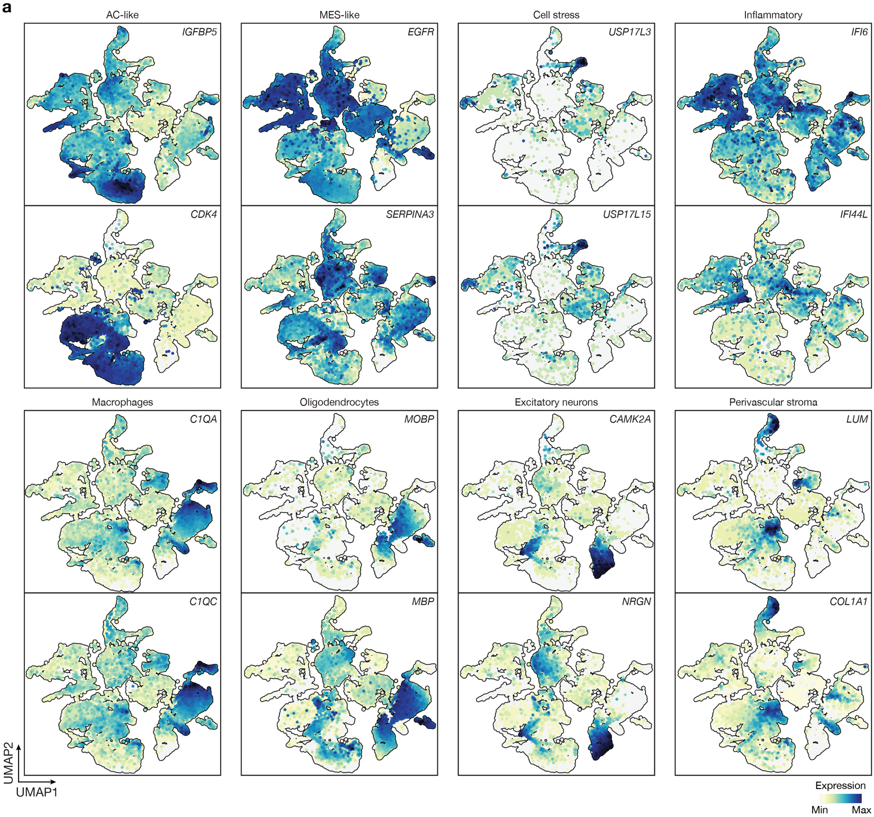
Extended Data Fig. 11. Spatial RNA sequencing of human glioblastomas from NCT04555577. a, Gene expression feature plots showing marker genes for spatial transcriptomes from Fig. 3d.
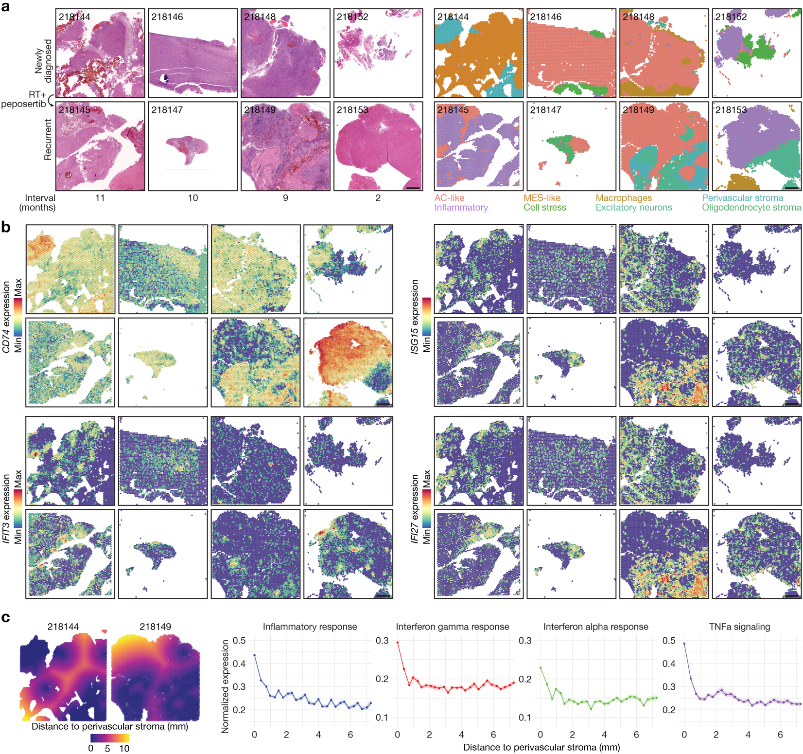Extended Data Fig. 12. Analysis of spatial RNA sequencing of human glioblastomas from NCT04555577. a, H&E histology (left) and spatial transcriptomic projections (right) for 4 patient-matched pairs of newly diagnosed and recurrent glioblastoma samples that were treated with RT and peposertib on NCT04555577 between resections. Scale bars, 1mm. b, Expression of representative inflammatory and interferon response genes across patient-matched spatial transcriptomes. Scale bars, 1mm. c, Spatial projection of all points across RNA capture arrays and their distances to the nearest perivascular border, as defined by the perivascular stroma spatial cluster in a for a pair of newly diagnosed and a recurrent glioblastoma samples with significant perivascular stroma (left). Normalized gene expression of inflammatory response, IFNγ, IFNα, or TNFα signaling modules as a function of distance from the nearest perivascular stroma border (right), aggregated across samples with perivascular stroma. Shaded boundaries represent standard error of the mean. Scale bar, 1mm.
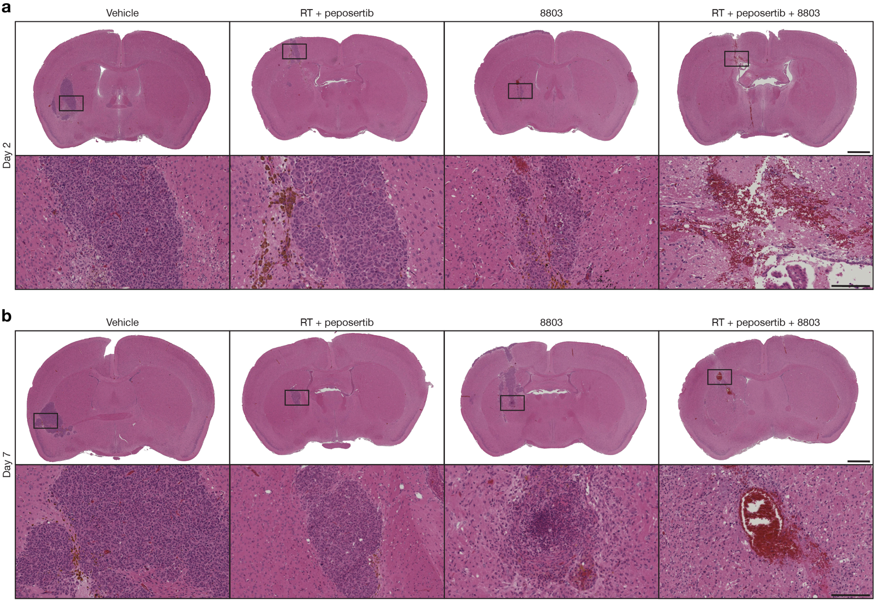Extended Data Fig. 13. Histology of in vivo GBM6 PDXs following treatment with DNA-PKcs inhibition, radiotherapy, and/or STING agonist. a, High and low (insert) H&E histology of GBM6 PDXs after treatment with RT (2Gy x 5 daily fractions) and peposertib (100mg/kg x 5 daily treatments) on days 5-9, STING agonist 8803 (2.5µg by convection enhanced delivery on day 12), or triple therapy with RT + peposertib + 8803. Mice were euthanized for histology 2 days after the last day of treatment. b, as in a but with euthanasia of mice 7 days after the last day of treatment. Images are representative of n=3 mice/condition. Scale bars, 1mm (top) and 100µm (bottom).

