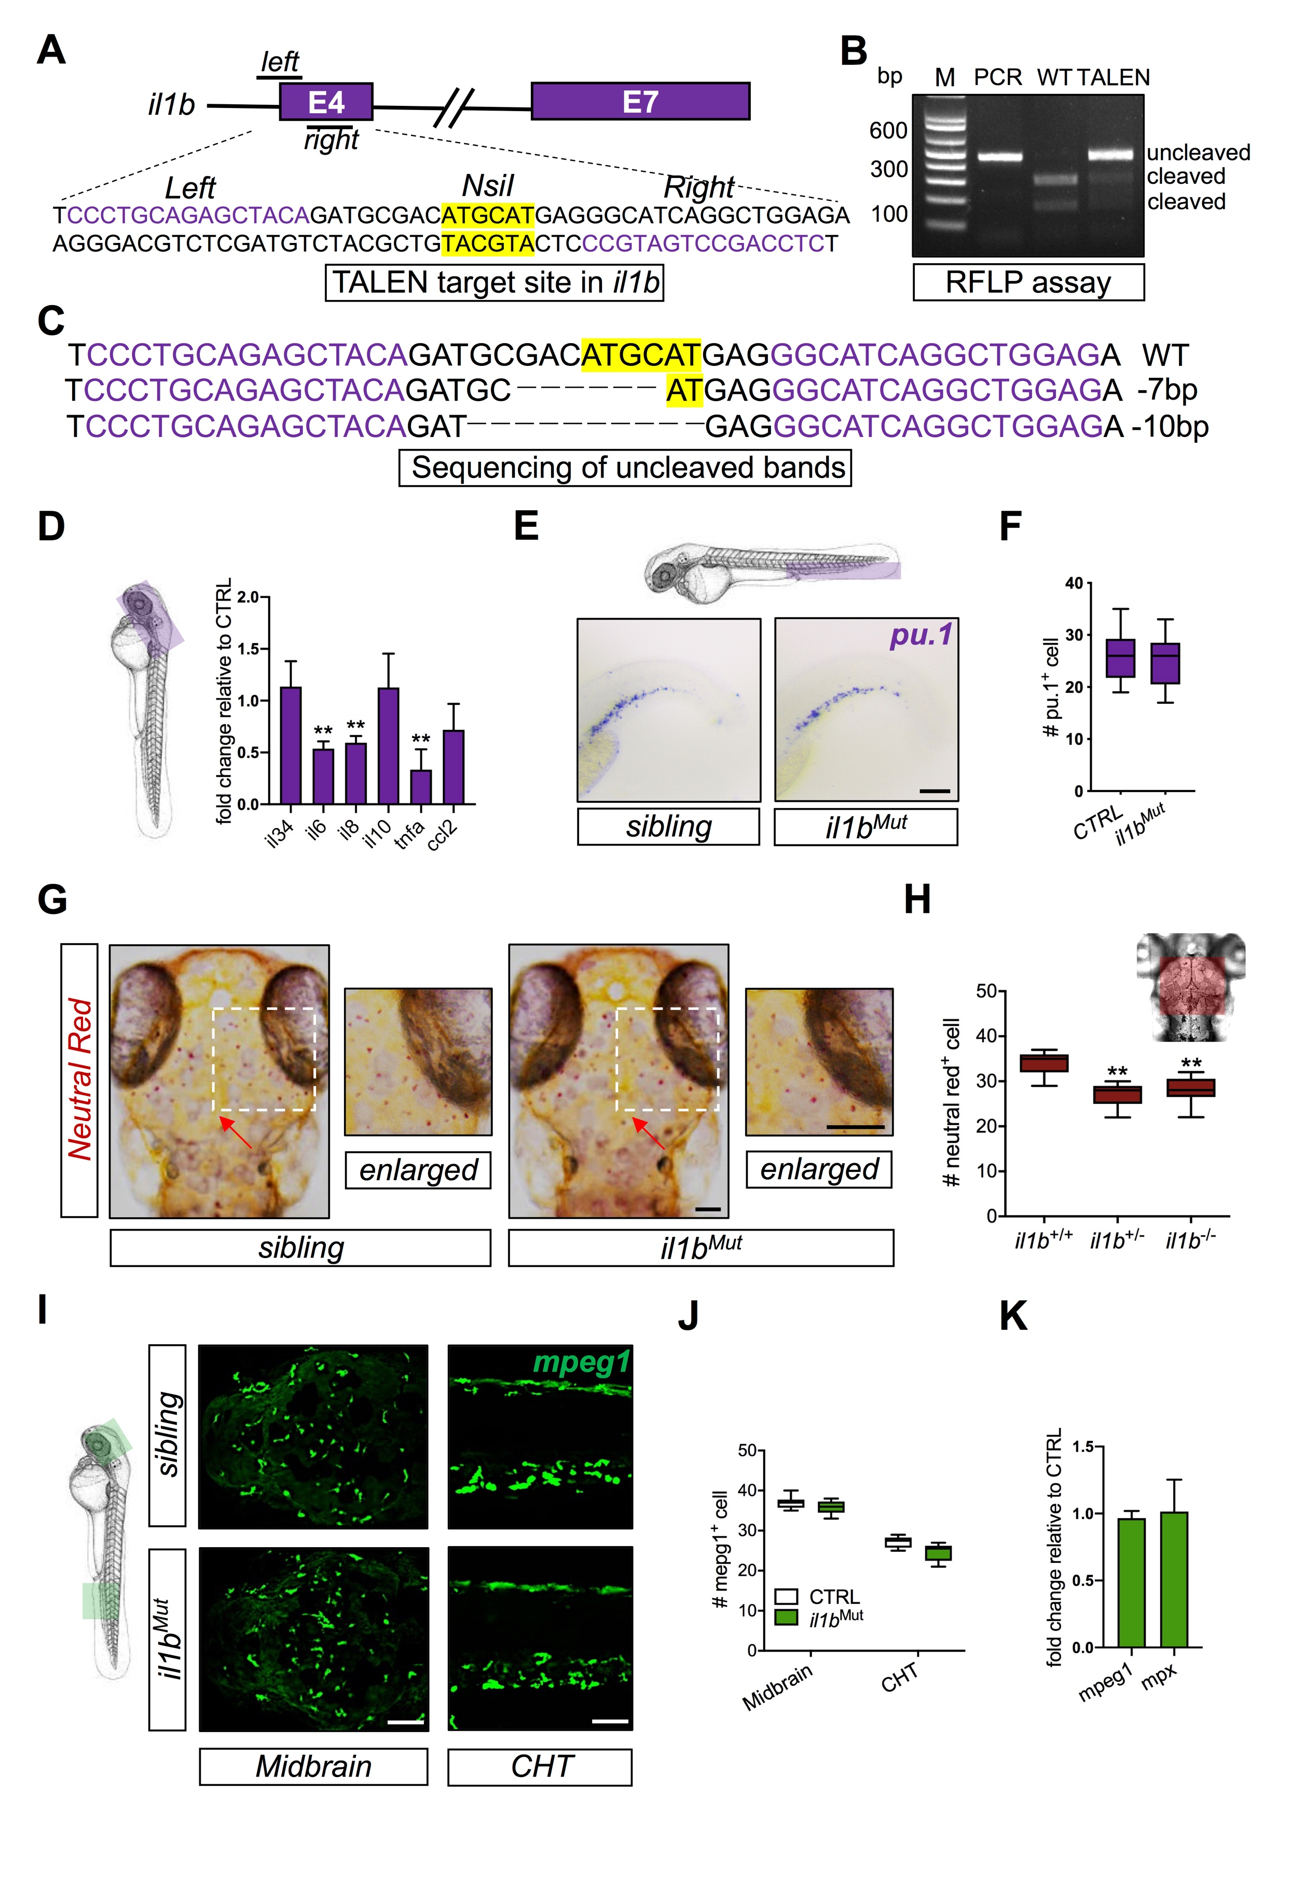
Supplemental Figures
Figure S1. Establishment of il1b mutant zebrafish line by TALEN
(A) Design of TALEN targeting il1b exon (E) 4. (B) Restriction fragment length polymorphism (RFLP) assay served as the genotyping assay. M, marker. PCR, PCR product. WT, wild-type. (C) Sanger sequencing confirmed the deletion mutation in the il1b E4. (D) qPCR results presented mRNA level of various inflammatory cytokines in the region of the head compared to the control (CTRL) (three independent experiments, n = 30 each). **, p < 0.01 compared with CTRL based on unpaired t-test. (E-F) Representive images and the number of pu.1+ cells in CTH of il1b^{Mut} (n = 25) and their siblings (n = 30). Scale bar, 200 µm. (G-H) Representive images and the number of neural red+ lysosomes in macrophages/microglia under il1b^{+/+} (n = 17), il1b^{+/-} (n = 17) and il1b^{-/-} (n = 17). Scale bar, 80 µm , 40 µm (enlarged). **, p < 0.01 compared with il1b^{+/+} based on one-way ANOVA. Red arrow, neutral red⁺ cells. (I-J) Representive images and the number of mpeg1+ cells in the brain and CHT of 3 dpf zebrafish embryos from il1b^{Mut} (n = 6) and its sibling (n = 6). Scale bar, 80 µm (K) qPCR results showed mRNA level of mpeg1 and mpx in the brain compared to the control (three independent experiments, n = 30 each).

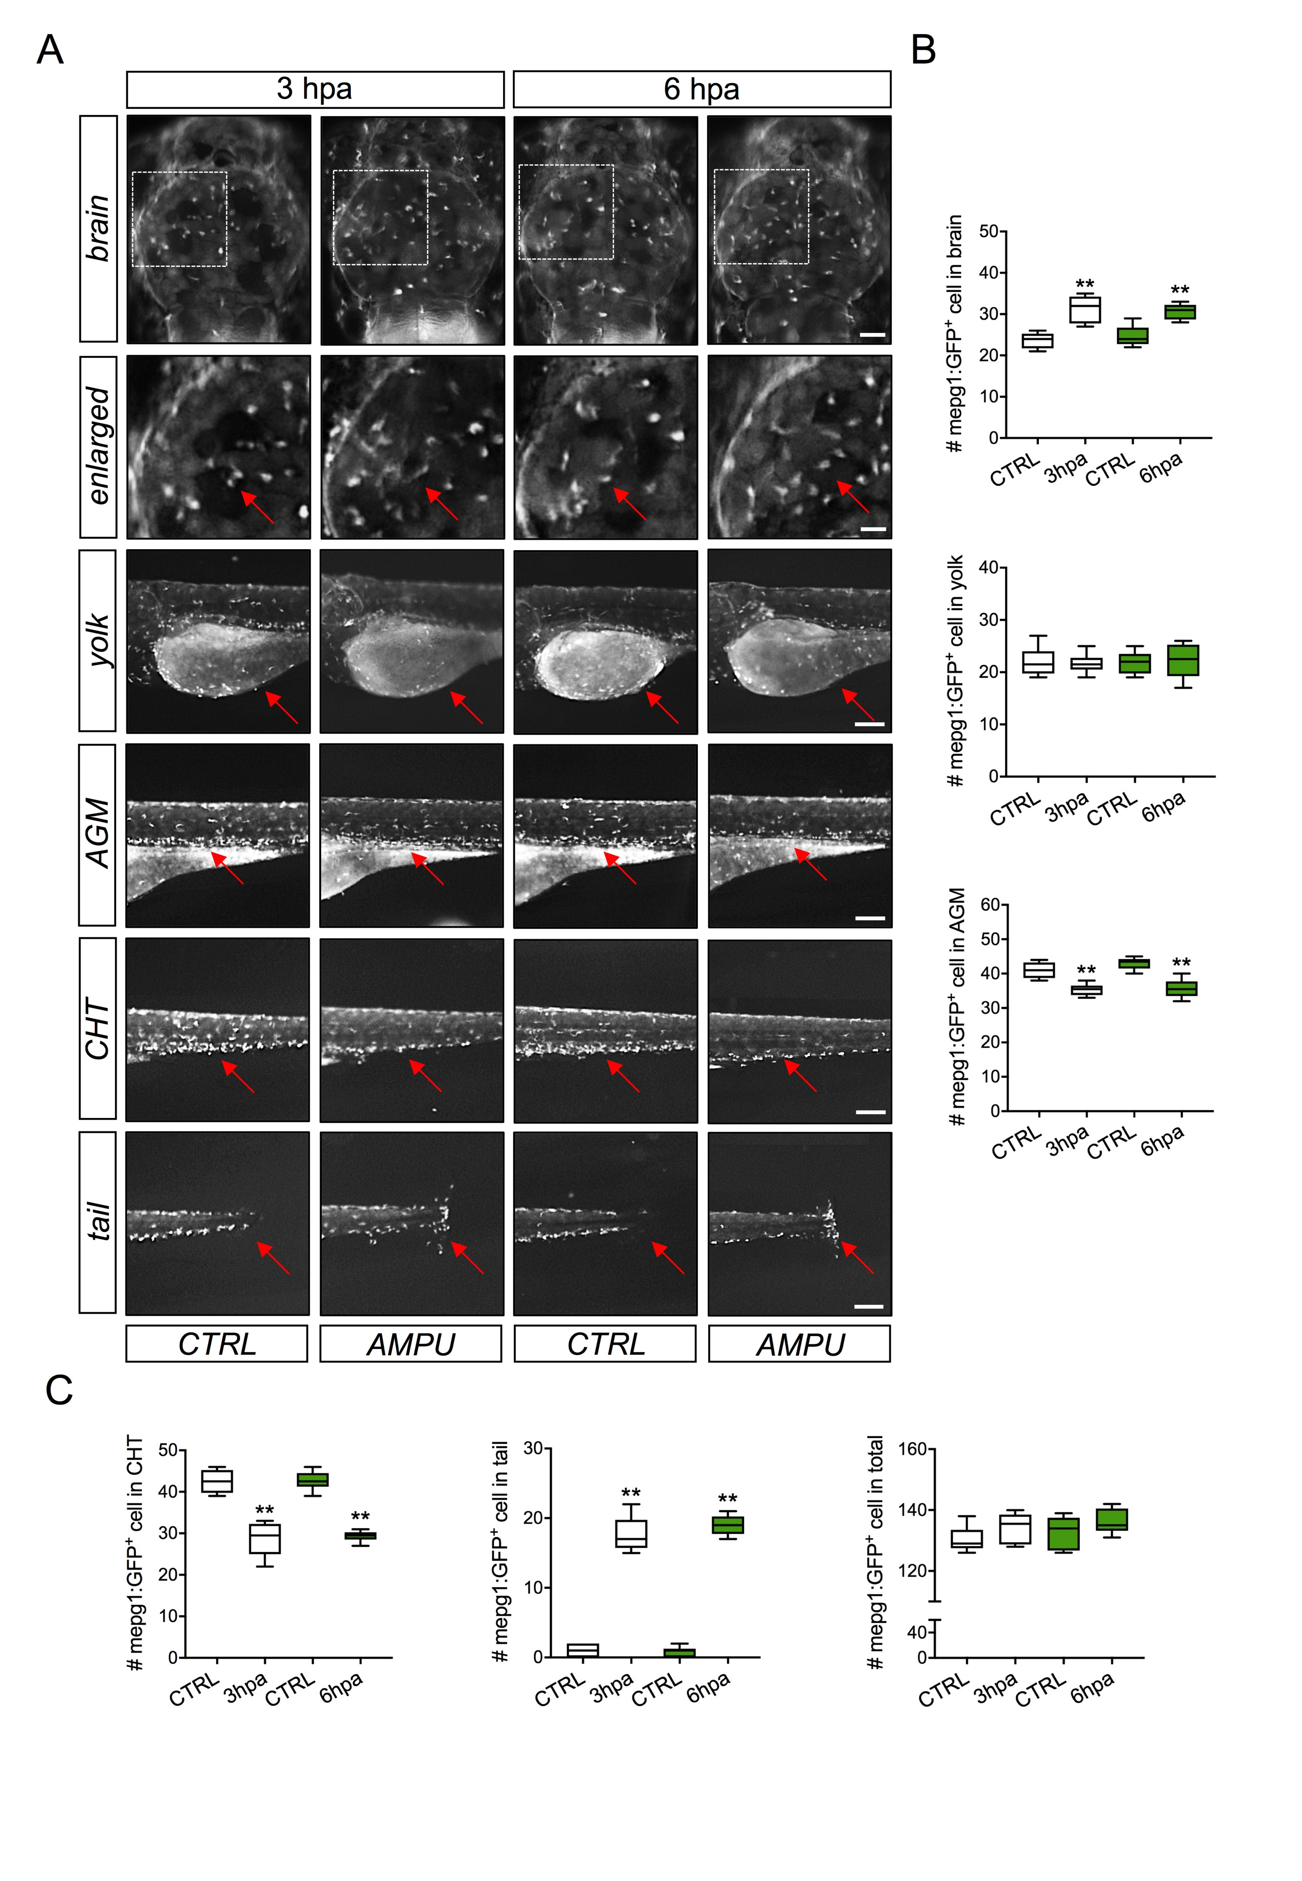
Figure S2. Redistribution of macrophages in response to peripheral tissue injury
(A) Representive image of distribution of mpeg1+ cells in various positions, including the brain, the yolk, aorta-gonad-mesonephros (AGM), CHT and tail/injury site, of zebrafish embryos at 3 and 6 hpa (n = 6 each). Scale bar: 80 μm (Brain), 40 μm (Enlarged), 200 μm (yolk, AGM, CHT and Tail). Red arrow, mpeg1+ cells. (B-C) The number of mpeg1+ cells in in various positions of zebrafish embryos at 3 and 6 hpa. **, p<0.01 compared with CTRL based on unpaired t-test.

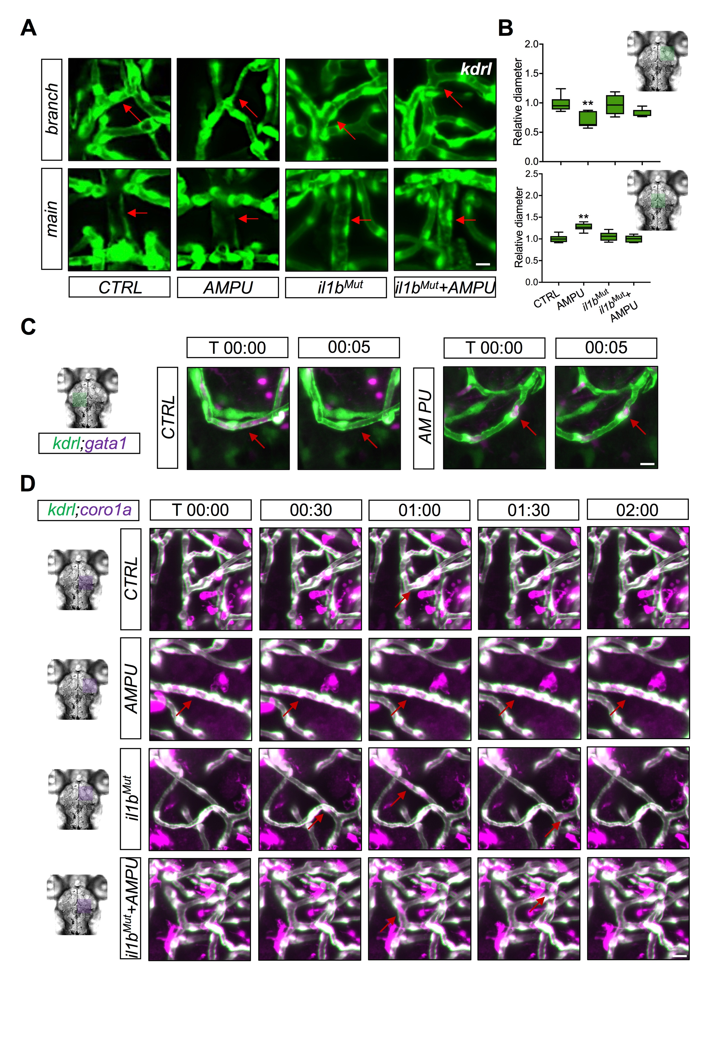
Figure S3. Peripheral tissue injury induced branched cerebral blood vessels narrowing
(A-B) Representive images and the diameter of kdrl+ cerebral blood vessels including main and branch vessel under CTRL (n = 6), AMPU (n = 6), il1b^{Mut} (n = 8) and il1b^{Mut}+AMPU (n = 8). Scale bar, 40 µm. **, p<0.01 compared with CTRL based on two-way ANOVA with Tukey’s HSD. Red arrow, branched or main blood vessel in the brain (C) Representive time-lapse images of kdrl+ cerebral blood vessels and gata1+ erythrocytes under CTRL, AMPU, il1b^{Mut} and il1b^{Mut}+AMPU. T, time. Scale bar, 40 µm. Red arrow, gata⁺ cells. (D) Representive time-lapse images of kdrl+ cerebral blood vessels and coro1a+ macrophages under CTRL, AMPU, il1b^{Mut} and il1b^{Mut}+AMPU. Scale bar, 40 µm. Red arrow, coro1a⁺ cells.

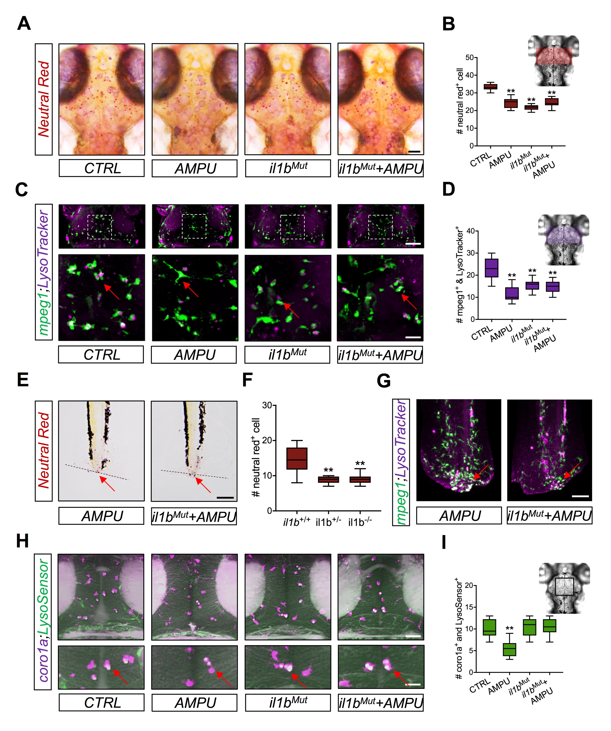
Figure S4. Peripheral tissue injury led to loss of lysosomes in macrophages in the brain
(A-B) Representive images and the number of neural red⁺ lysosome in macrophage/microglia under CTRL (n = 9), AMPU (n = 13), il1b^{Mut} (n = 9) and il1b^{Mut}+AMPU (n = 12). Scale bar, 80 µm. **, p<0.01 compared with CTRL based on two-way ANOVA with Tukey’s HSD. (C-D) Representive images and the number of mpeg1⁺ cells and LysoTracker⁺ lysosome under CTRL (n = 13), AMPU (n = 13), il1b^{Mut} (n = 9) and il1b^{Mut}+AMPU (n = 9). Scale bar, 80 µm (upper) and 40 µm (lower). **, p<0.01 compared with CTRL based on two-way ANOVA with Tukey’s HSD. Red arrow, mpeg1⁺ cells and LysoTracker⁺ cells. (E-F) Representive images and the number of neutral read+ lysosome in macrophages/microglia under AMPU (n = 8) and il1b^{+/-}+AMPU (n = 8) and il1b^{-/-}+AMPU (n = 12). Scale bar, 80 µm. **, p<0.01 compared with CTRL based on one-way ANOVA. Red arrow, neutral read⁺ lysosomes. (G) Representive images of mpeg1+ cells and LysoTracker+ lysosomes in injury site under AMPU and il1b^{Mut}+AMPU. Scale bar, 80 µm. Red arrow, mpeg1⁺ cells and LysoTracker⁺ cells. (H-I) Representive images and the number of coro1a+ cells and LysoSensor+ acidified lysosomes in the brain under CTRL (n = 6), AMPU (n = 6), il1b^{Mut} (n = 6) and il1b^{Mut}+AMPU (n = 6). Scale bar, 80 µm (upper) and 40 µm (lower). **, p < 0.01 compared with CTRL based on two-way ANOVA with Tukey’s HSD. Red arrow, coro1a⁺ cells and LysoSensor⁺ cells.
Supplementary Videos
Video S1. Time-lapse imaging of macrophage/microglia activity in the brain of Tg(kdrl:GFP; coro1a:DsRed) zebrafish embryos from CTRL. Red arrow, active macrophage/microglia.

Video S2. Time-lapse imaging of macrophage/microglia activity in the brain of Tg(kdrl:GFP; coro1a:DsRed) zebrafish embryos from AMPU. Red arrow, active macrophage/microglia.

Video S3. Time-lapse imaging of macrophage/microglia activity in the brain of Tg(kdrl:GFP; coro1a:DsRed) zebrafish embryos from il1b^{Mut}. Red arrow, active macrophage/microglia.

Video S4. Time-lapse imaging of macrophage/microglia activity in the brain of Tg(kdrl:GFP; coro1a:DsRed) zebrafish embryos from il1b^{Mut}+AMPU. Red arrow, active macrophage/microglia.

Video S5. Distribution pattern 1 of active macrophage around the mid-hindbrain boundary of zebrafish embryo. Red arrow, active macrophage/microglia.

Video S6. Distribution pattern 2 of active macrophage within the brain of zebrafish embryo. Red arrow, active macrophage/microglia.

Video S7. Distribution pattern 3 of active macrophage migrating from the peripheral tissue into the hindbrain of zebrafish embryo. Red arrow, active macrophage/microglia.

Supplemental materials and methods
Zebrafish strain
Embryos from Tg(fli1:GFP;gata1:DsRed) zebrafish were also applied in the current study.

Neutral Red, LysoTracker and LysoSensor Staining
Neutral Red at 2.5 µg/ml in E3 medium was applied to stain 3-4 dpf WT or transgenic live zebrafish embryos at 28.5°C for 2-3 hr as previously described (Shiau et al., 2013). After wash and anesthetic treatment, imaging was performed on the Nikon SMZ1270i stereomicroscope. Moreover, LysoTracker Red DND-99 and LysoSensor (Invitrogen) diluted in E3 medium were used to stain 3-4 dpf WT or transgenic live zebrafish embryos at 28.5°C in the dark for 45 min in accordance with the protocol previously described (Sasaki et al., 2017). After wash with E3 medium, stained embryos were anesthetized and imaged using the Zeiss Lightsheet Z.1 Selective Plane Illumination Microscope.

Table 1. List of primers used in the current study
Name | Sequence (5’-3’)
Primers for Genotyping
ZF_il1b_E4_GF | CGACATTTCACATCTGCACCG
ZF_il1b_E4_GR | GTACCTTGGATGACGTTCGC
Primers for qPCR
ZF_il1b_QF | TGGACTTCGCAGCACAAAATG
ZF_il1b_QR | GTTCACTTCACGCTCTTGGATG
ZF_tnfa_QF | TTCACGCTCCATAAGACCCA
ZF_tnfa_QR | CCGTAGGATTCAGAAAAGCG
ZF_il34_QF | ATCGGACCATGCTTTGCCTG
ZF_il34_QR | CCCTACAACAGCAACACGGA
ZF_il6_QF | TGAAGACACTCAGAGACGAGCAGTT
ZF_il6_QR | AGGTTTGAGGAGAGGAGTGCTGAT
ZF_il8_QF | CCTGGCATTTCTGACCATCAT
ZF_il8_QR | GATCTCCTGTCCAGTTGTCAT
ZF_il10_QF | TCAGAGCAGGAGAGTCGAATGCA
ZF_il10_QR | CGATTGGGGTTGTGGAGTGCTT
ZF_ccl2_QF | GTCTGGTGCTCTTCGCTTTC
ZF_ccl2_QR | TGCAGAGAAGATGCGTCGTA
Primers for ISH Probes
ZF_il1b_PF | TGCAATGCACGATTTGCGAT
ZF_il1b_PF | AGAATAAGCAGCACTTGGGGA
ZF_apoeb_PF | CTCCAAACCCAGATGACCCC
ZF_apoeb_PR | GAGAGGTGCGTAGGTTCTCG
ZF_mfap4_PF | TTGGCATAAAACGGAACCGAG
ZF_mfap4_PR | GAGAAGGACGAGTACTGAGCG

References
Sasaki T, Lian S, Khan A, Llop JR, Samuelson A V., Chen W, et al. Autolysosome biogenesis and developmental senescence are regulated by both Spns1 and v-ATPase. Autophagy 2017; 13: 386–403.
Shiau CE, Monk KR, Joo W, Talbot WS. An anti-inflammatory NOD-like receptor is required for microglia development. Cell Rep 2013; 5: 1342–52.

Supplemental uncropped gel
