Supporting Information for
High-Resolution Decadal Spatiotemporal Mapping of Salinity and Water Levels in Louisiana Coastal Wetlands

Jin Ikeda^{a*}, Linoj Vijayan^{b} and Christopher E. Kees^{b,c,d}
Jin Ikeda (*Corresponding author, E-mail: jin.ikeda0401@gmail.com, ORCID: 0000-0002-9364-0888)
Linoj Vijayan (ORCID: 0000-0001-5510-6257)
Christopher E. Kees (ORCID: 0000-0002-7042-6221)

(a) College of Marine Science, University of South Florida, USA.
(b) Coastal Ecosystem Design Studio, Louisiana State University, USA.
(c) Department of Civil and Environmental Engineering, Louisiana State University, USA.
(d) Center for Computation and Technology, Louisiana State University, USA.

Contents of this file

Figures S1 and Videos S1 and S2
Information
- Figure S1 provides supplementary data for the rest of the subbasin output, which cannot be displayed in Figure 9.
- Videos S1 and S2 show the temporal evolution of 12-month moving-averaged salinity and water-level zones from 2008 to 2022, respectively.

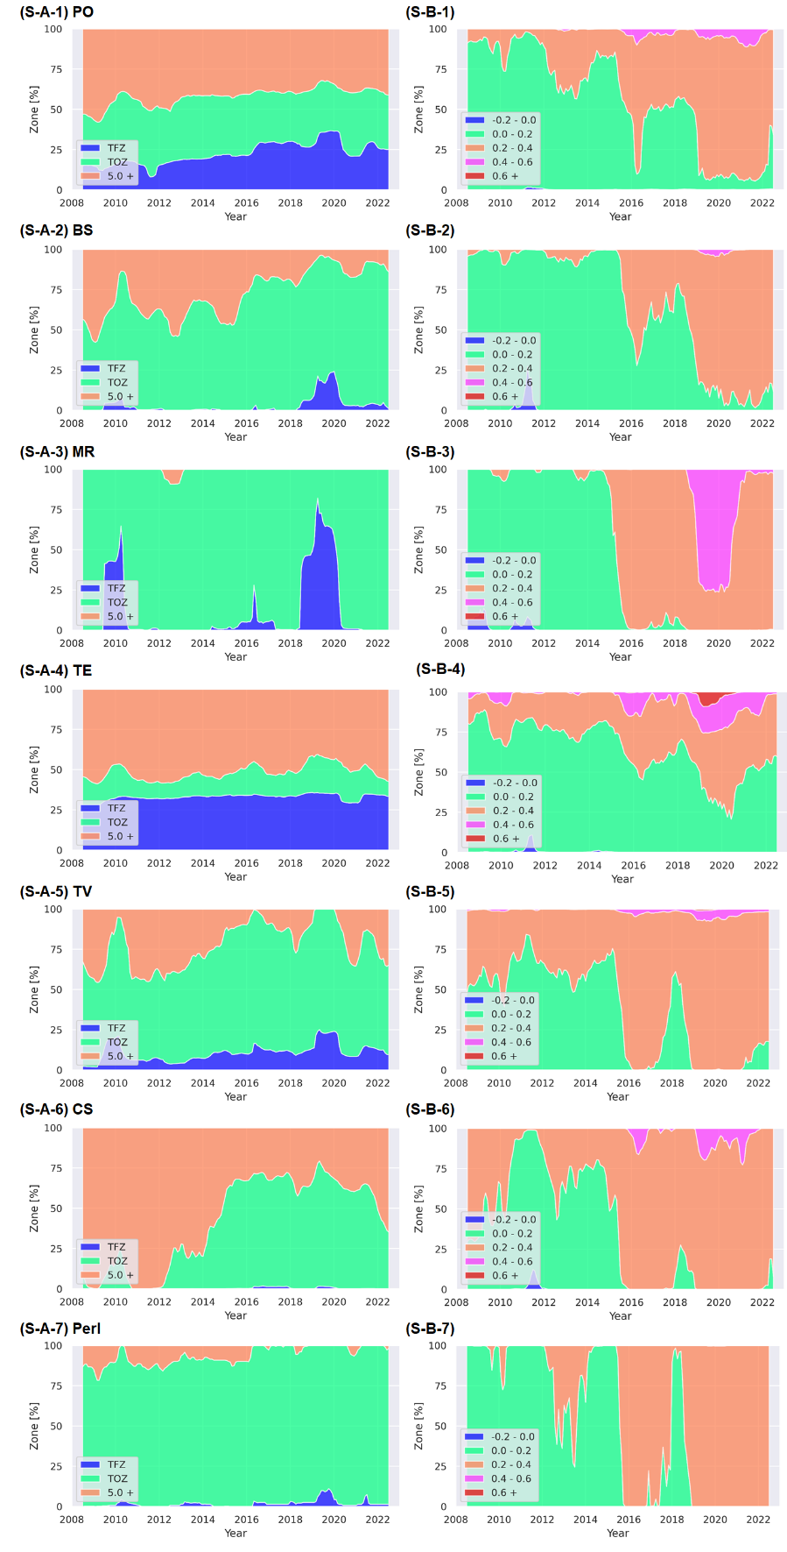
Fig. S1 Moving-average salinity zones: TFZ (0–0.5 ppt), TOZ (0.5–5 ppt), and greater than or equal to 5 ppt zone (a) and water-level zones in NAVD88 (b) based on the IDW interpolation method. The KNN is 4 for salinity and 6 for water levels. Each subfigure represents an individual sub-basin.

