Supplementary Information for

Ionic contrast across a lipid membrane for Debye length extension: towards an ultimate bioelectronics transducer

Authors: Donggeun Lee^{1, 2}, Suho Lee³, Eui-Sang Yu¹, Taikjin Lee¹, Jae Hun Kim¹, Hyun Seok Song¹, Kwan Hyi Lee⁴, Seok Lee¹, Sang-Kook Han², Myung Chul Choi³, Yong-Sang Ryu^{1,*}, and Chulki Kim^{1,*}

¹Sensor System Research Center, Korea Institute of Science and Technology, Seoul 02792, Republic of Korea.
²Department of Electrical &Electronic Engineering, Yonsei University, Seoul 03722, Republic of Korea.
³Department of Bio and Brain Engineering, Korea Advanced Institute of Science and Technology (KAIST), Daejeon 34141, Republic of Korea.
⁴Center for Biomaterials, Korea Institute of Science and Technology, Seoul 02792, Republic of Korea.

*Correspondence to: ysryu82@kist.re.kr; chulki.kim@kist.re.kr

This file contains following information:

1. Device fabrication and measurement setup (Supplementary Figs. S1-3)
2. Lipid preparation and FL measurement
3. Buffer solution exchange (Supplementary Fig. S4)
4. Control experiment with identical ionic conditions across the SLB (Supplementary Figs. S5-6)
5. Minimum molecular mass for the full coverage of the SLB (Eqs. S1-3)
6. Langmuir–Nernst isotherm model considering nonspecific bindings (Eq. S4)
7. Sensing mechanism and analytical models (Eqs. S5-10, Supplementary Fig. S7, Table S1)
8. X-ray reflectivity measurement for electron density fitting (Supplementary Figs. S8-9)
9. Chemical potential calculation using the electron density (Eqs. S11-12, Tables S2)
1. Device fabrication and measurement setup

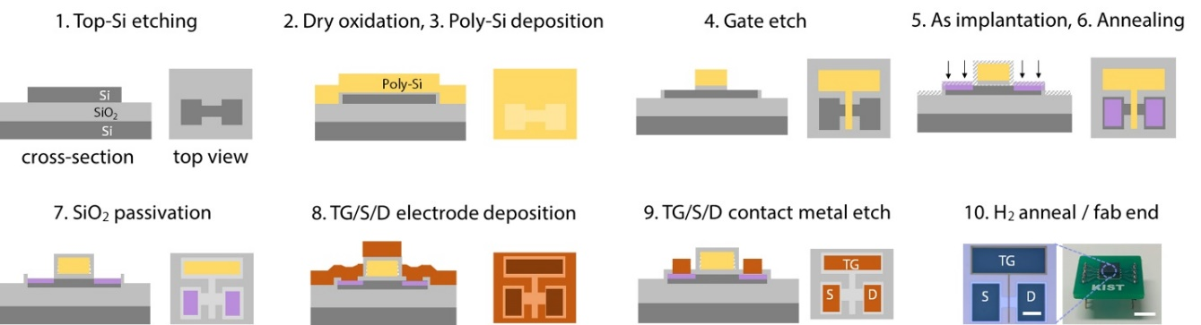
Supplementary Fig. S1. Schematic representation of fabrication of FETs for molecular detection

Extended gate (EG) fabrication: The top gate electrode of the FET is wired to an indium tin
oxide (ITO, thickness: 300 nm and resistivity: 5 Ω/sq) electrode. A 80-nm-thick SiO₂ layer was deposited on the ITO for bonding the reaction chamber to the ITO electrode. The reaction chamber was made of polydimethylsiloxane (PDMS, Sylgard 184 silicon elastomer kit, Dow Corning). The PDMS mixture (base:curing agent = 10:1) was poured into a Petridish and baked for 12 h at 80°C. After curing, an 8-mm diameter and a 5-mm height hole was formed in the PDMS mold using a biopsy punch. Note that the SiO₂ layer plays a bifunctional role here: (1) a surface for forming the supported lipid bilayer (SLB) membrane and (2) serving as a hydrophilic polar silanol (Si-OH) group cross-linked surface for the PDMS chamber via covalent bonding after an oxygen plasma treatment¹.

Importance of disposable EG: The EG reaction chamber is disposable. This measurement configuration for the EG and the remotely packaged FET allows for reliable data acquisition, eliminating any possible contamination or damage to the active current channel upon direct exposure to target analytes in ionic solution. Moreover, direct comparison between measurements is possible because an identical FET transduces signals from the disposable EG. This is important during quantification of analyte concentration.
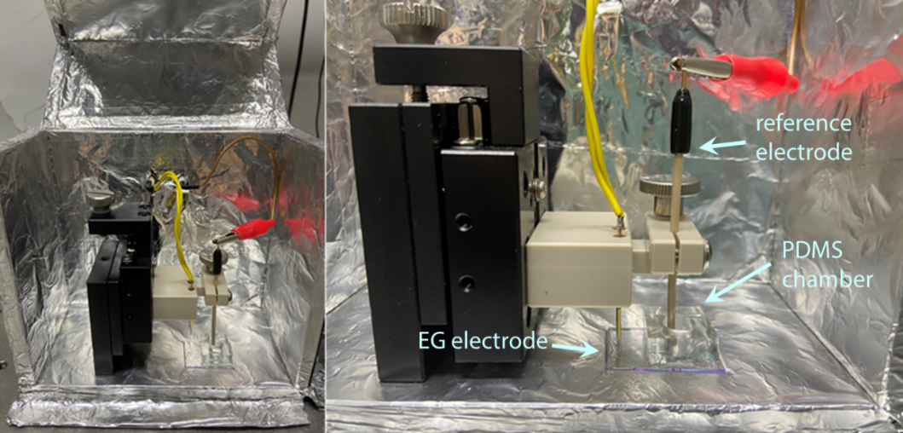
Supplementary Fig. S2. Photograph images of the EG with the reaction chamber placed in a Faraday shielding box

Bias voltage conditions: In our measurements, the variation of the surface potential of SiO₂ of the EG (Δψ) is capacitively coupled to V_{TG}, modulating the I_{D} in the FET. The following transfer curve (fig. S3) was used to convert the obtained I_{D} into V_{TG}. The V_{BG} was adjusted to ensure that the top gate response curve has a maximum slope (dI_{D}/dV_{TG}) when the application of the V_{S} = 1 V and V_{BG} = 13.5 V (Supplementary Fig. S3).

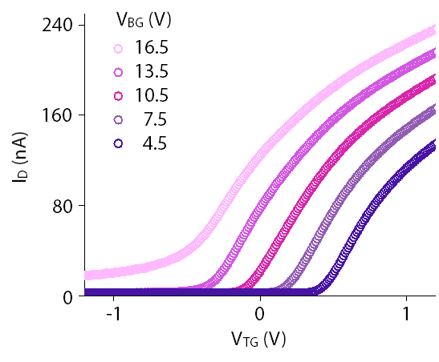
Supplementary Fig. S3. I_{D}-V_{TG} curves at various back gate voltages V_{BG}. (V_{S} = 1 V)
2. Lipid preparation and fluorescence (FL) measurement

FL imaging and mobility test: For the FL imaging, we monitored the SLB using an exposure time of 100 ms and gain 5.8× for every FL micrograph in the SLB coverage experiments. The FL and bright-field (BF) images of particulate materials were monitored using a FL microscopy system (LV100ND, Nikon) and then analyzed using image processing software (ImageJ, National Institutes of Health, USA). For the FRAP test, a 20-μm-circle region of the SLB patch was bleached for 1 min, and time-lapse FL intensities were measured using confocal microscopes (C2 C-ER, Nikon, Japan).

3. Buffer solution exchange

After the SLB (DOPC:B-PE = 95:5) preparation in DIW, half of the solution in the EG reaction chamber (50 μL out of 100 μL) was exchanged with 50 μL of 1× PBS. This process was repeated until the V_{TG} value was saturated (Supplementary Fig. S4). Note that the signal reached a steady state after 10 repeated exchanges of the outer buffer (OB), which is consistent with the expected concentrations (0.992× PBS at the 7th exchange and 0.999× PBS at the 10th exchange (Supplementary Fig. S4).
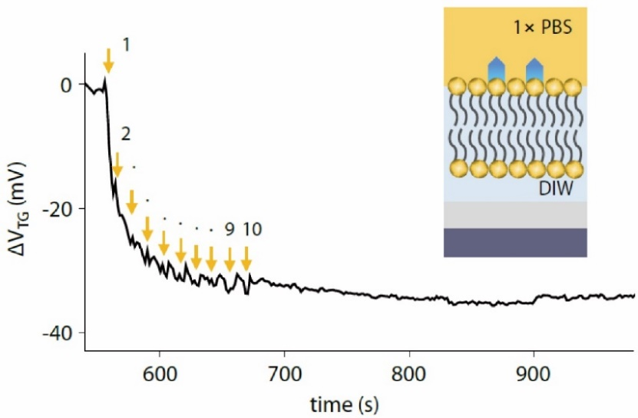
Supplementary Fig. S4. Potential variation of the top gate electrode during the OB exchange process with the ionic contrast across the SLB

4. Control experiment with identical ionic conditions across the SLB

To validate the role of the DIW layer between the SiO₂ surface and the SLB, a negative control experiment was carried out using identical ionic conditions across the SLB. Namely, the SUV was prepared in 1× PBS (0.1 mg/mL) and exposed to the hydrophilic surface of the SiO₂ on the EG. Then, the SLB was surrounded by 1×PBS solution. After SLB formation (marker 2 in Supplementary Fig. S5), we waited for at least 5 min for signal stabilization (Supplementary Fig. S5). No signal change was observed after the 800 pM-avidin injection (marker 3 in Supplementary Fig. S5), in contrast to the recognizable ΔV_{TG} changes (main manuscript Figs. 3a and 3e), after the 800 pM-avidin injection with high ionic contrast across the SLB. This is mainly attributable to the ultra-thin Debye length (approximately 0.74 nm in 1× PBS), which is thinner than the thickness of the IB (1–2 nm).

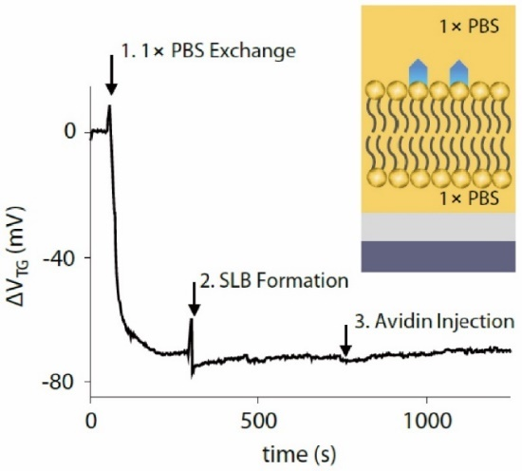
Supplementary Fig. S5. Real-time ΔV_{TG} measurement of the response to biotin–avidin reactions under identical ionic conditions across the SLB

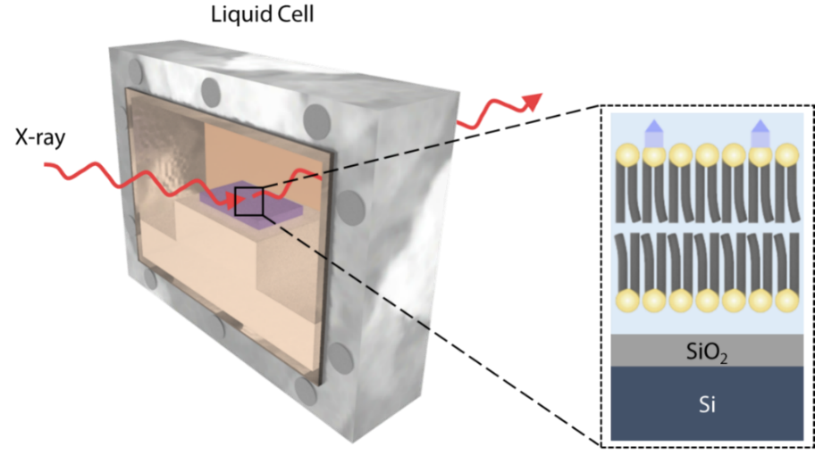
Supplementary Fig. S6. Representation of the liquid cell for X-ray reflectivity measurement and the SLB on a SiO₂ wafer placed in the cell

5. Minimum molecular mass for the full coverage of the SLB

We estimated the required number of lipid molecules to cover the entire surface of the SiO₂ and the inside wall of the reaction chamber A_{EG},
(S1)
where r and h are the diameter and height of the EG chamber, respectively. Considering the head area of DOPC molecules² (A_{SLB} = 72.4 Å²), the required number of DOPC molecules was calculated to be
. (S2)
With an SLB composition of 95/5 = DOPC/B-PE, the averaged mass of the SLB is
. (S3)
This means that full coverage of the EG (the inside PDMS wall and the SiO₂ surface) required at least 0.45 μg of DOPC/B-PE. Considering that the mass of the lipid in solution was 0.1 μg for every drop, the observed saturation after five lipid injections (markers 2 to 6 in main manuscript Fig. 2b) seems reasonable. We confirmed full coverage by casting another drop after signal saturation (marker 7 in the main manuscript Fig. 2b).

6. Langmuir–Nernst isotherm model considering nonspecific bindings

SLB provides complete passivation over the EG; therefore, nonspecific binding of suspended analytes is prohibited. To account for results due to nonspecific binding, we conducted an experiment with the EG functionalized by sulfo-NHS-biotin and compared this with the isotherm analysis of the SLB-FET (main manuscript Fig. 3d). The Langmuir–Nernst isotherm model is described as follows:
(S4)
where K_{eq}, and k_{N} stand for equilibrium constant and nonspecific binding constant, respectively³.
The strong suppression of nonspecific binding in our SLB-FET is described in the main manuscript in Fig. 3d. The measured result (circles in orange in main manuscript Fig. 3d) from our SLB-FET is highly consistent with the conventional Langmuir isotherm model (solid orange line in main manuscript Fig. 3d, k_{N}[A] = 0). Biotin–avidin binding signals measured with the sulfo-NHS-biotin functionalized EG (circles in grey in main manuscript Fig. 3d) exhibited strong agreement with the Langmuir–Nernst isotherm (solid grey line in main manuscript Fig. 3d). From the fitting, k_{N} and K_{eq} were calculated to be 3.685 ± 0.754 mV/μM·m and 54.2 fM, respectively, which was within the reasonable range⁴. Note that our SLB-FET platform allowed for negligence of the second term, whereas protein bindings without SLB should take into account the possibility of nonspecific binding.
7. Sensing mechanism and analytical models

Molecular detection using FETs is based on conductivity changes in response to variance in the gate potential. In our case, using an n-type channel for FET and applying a positive gate voltage leads to accumulation of carriers. When analytes bind to receptors on the SLB, the charge density variation in the SiO₂ layer changes the top gate voltage, and eventually the conductance in the FET. The time-dependent top gate voltage induced by adsorbed molecules is described by Eq. S5,
(S5)
where [AB] is the density of an adsorbed analyte.
In general, the binding kinetics of the receptor when capturing an analyte in solution can be described as follows:
(S6)
where k_{M} is a diffusion-limiting rate constant, k₁ and k₋₁ are association and dissociation rate constants, respectively, and [A]_{s} is the surface concentration of an analyte⁵. We assumed the fast mixing model ([A]_{S} = [A]) to describe our SLB-FET system, because the k₁ in the biotin–avidin reaction (10⁵ to 10⁷ M⁻¹s⁻¹) is two or more orders of magnitude smaller than the k_{M} (~10⁹ M⁻¹s⁻¹) for diffusion limited reactions⁶. In other words, we suppose that the analyte concentration at the surface remains almost the same as in the bulk in the following analysis. With this, the reaction can be described in a simpler fashion by the first order Langmuir equation (Eq. S7a).
(S7a)
Then, the density of the adsorbed analyte is explicitly expressed by Eq. S7b.
(S7b)
By combining Eqs. S5 and S7b, the time-dependent voltage variation is described by Eq. S8,
. (S8)
In our measurements, the target analyte in solution is dropped in the reaction chamber; therefore, this inevitably leads to a sudden increase in the ionic concentration in the outer buffer. Thus, the top gate potential should reflect relaxation behavior via thermal diffusion. We model its transient state towards equilibrium by a resistor–capacitor (RC) circuit model as in Eq. S9.
(S9)
Where the peak voltage V_{p} is the difference between q_{A}[B]_{max}/C_{TG} and the maximum value of ΔV_{TG}(t), τ₁ and τ₂ are RC time constants, and T is an effective duration for the sudden increase in the ionic concentration in the outer buffer.
Finally, the measured signal should be the superposition of these responses described above (Eqs. S8 and S9).
(S10)
Supplementary figure S7 shows the response curve for 100 pM-avidin binding over the SLB (DOPC:B-PE = 95:5), fitted to our suggested theory model. From these fittings, important reaction parameters are obtained. Those parameters are summarized in Table S1.

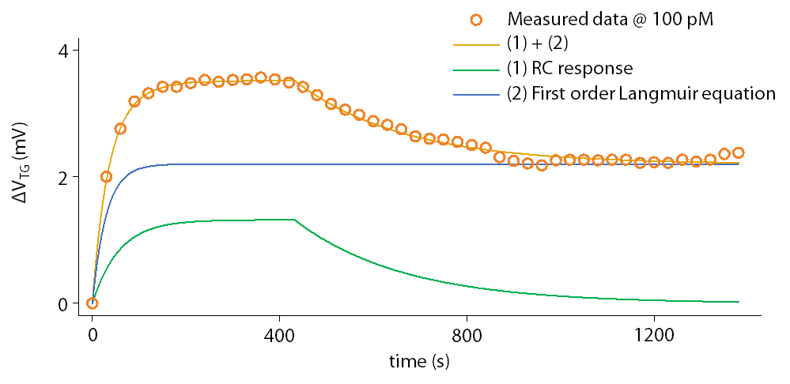
Supplementary Fig. S7. Real-time top gate voltage variation in response to 100 pM-avidin fitted by an RC circuit model and the first order Langmuir equation

Table S1. Fitting parameters in Eq. S10
 | V_{p}  (mV) | τ₁  (sec) | V_{eq}  (V) | k₁  [×10⁷M⁻¹s⁻¹] | k₋₁  [×10⁻²s⁻¹] | τ₂  (sec) | T  (sec)
100 pM | 1.3200 | 29.682 | 0.0022 | 1.6835 | 1.0469 | 231.790 | 432.984
1 nM | 0.7802 | 12.971 | 0.0053 | 1.6642 | 1.0350 | 106.525 | 219.648
5 nM | - | - | 0.0079 | 1.6606 | 1.0311 | - | -
10 nM | - | - | 0.0088 | 1.6227 | 1.0010 | - | -
100 nM | - | - | 0.0089 | 1.7163 | 1.0410 | - | -

8. X-ray reflectivity measurement for electron density fitting
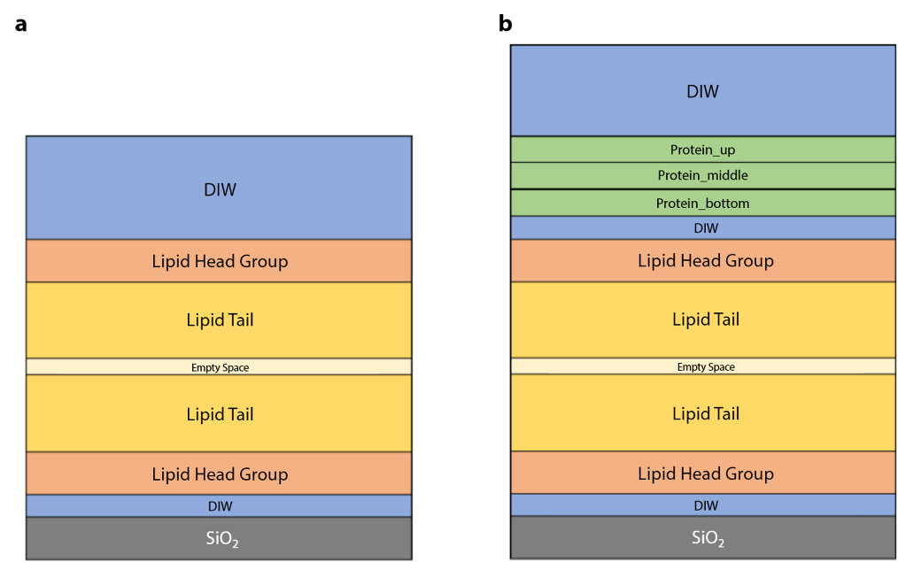
Supplementary Fig. S8. Structure for a slab model. a, the SLB and b, the SLB with a layer of avidin molecules
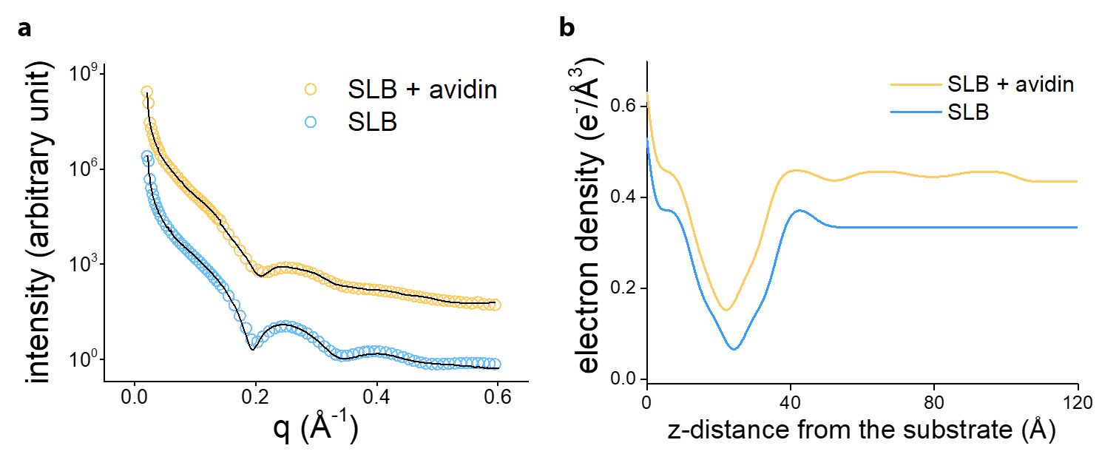
Supplementary Fig. S9. X-ray intensities and electron density profiles of SLB (blue) and SLB with avidin (yellow). a, X-ray reflectivity intensities and their fittings. b, Electron density curves along the z-direction.
As shown in fig. S9a, both measurements of SLB and SLB with avidin were well fitted by the model described above. Slight deviation at high q regime (>0.5 Å⁻¹) is due to the low peak intensity. The electron density plots in fig. S9b clearly exhibit the typical electron density curve of SLB, showing consistency with the literature in terms of the size of the conjugated avidin² (~50 Å).
9. Chemical potential calculation using the electron density

Poisson’s equation (Eq. S11) was applied to calculate electric potential variation due to the redistribution of the charge density in the lipid membrane^{7, 8, 9}.
(S11)
The chemical potential at the SiO₂ surface was calculated by integrating the charge density (Δρ = ρ_{SLB} - ρ_{SLB+avidin}), and multiplied by the area of SLB film (π × R² ≈ 5.027 × 10⁻⁵ m²) assuming in-plane homogeneity.
(S12)
As seen in the main manuscript Fig. 4d, the obtained signal mainly originates from the charge density change in proximity of the SiO₂ surface because the chemical potential is inversely proportional to the distance squared.
Table S2. Electric parameters of FET-SLB circuit components
 | C_{EG} | C_{TG} | C_{BG} | C_{SLB}
Dielectric constant (ε_{r}) | 3.9 | 3.9 | 3.9 | 1.9
Area (m²) | 5.03E-05 | 1.50E-10 | 1.50E-10 | 5.03E-05
thickness (m) | 8.00E-08 | 1.50E-08 | 7.50E-07 | 5.00E-09
Capacitance (F) | 2.17E-08 | 3.45E-13 | 6.91E-15 | 4.36E-06
Voltage (V) | 2.18E-07 | 1.37E-02 | 6.83E-01 | 1.08E-09
References
1. Y. S. Ryu et al., Kinetics of lipid raft formation at lipid monolayer-bilayer junction probed by surface plasmon resonance. Biosens. Bioelectron. 142, 111568 (2019).
2. N. Kucerka, S. Tristram-Nagle, J. F. Nagle, Structure of fully hydrated fluid phase lipid bilayers with monounsaturated chains. J. Membrane Biol. 208, 193-202 (2005).
3. L. Maletinska et al., Human glioblastoma cell lines: Levels of low-density lipoprotein receptor and low-density lipoprotein receptor-related protein. Cancer Res. 60, 2300-2303 (2000).
4. R. A. Kohanski, M. D. Lane, Monovalent avidin affinity columns. Methods Enzymol. 184, 194-200 (1990).
5. X. Duan et al., Quantification of the affinities and kinetics of protein interactions using silicon nanowire biosensors. Nat. Nanotechnol. 7, 401-407 (2012).
6. R. F. Delgadillo et al., Detailed characterization of the solution kinetics and thermodynamics of biotin, biocytin and HABA binding to avidin and streptavidin. PLoS One 14, e0204194–e0204194 (2019).
7. I. D. Mayergoyz, Solution of the nonlinear Poisson equation of semiconductor-device theory. J. Appl. Phys. 59, 195-199 (1986).
8. H. J. Shen et al., Molecular dynamics simulations of ether- and ester-linked phospholipid Bilayers: A comparative study of water models. J. Phys. Chem. B 122, 9399-9408 (2018).
9. K. E. Forsten, R. E. Kozack, D. A. Lauffenburger, S. Subramaniam, Numerical solution of the nonlinear Poisson-Boltzmann equation for a membrane-electrolyte system. J. Phys. Chem. 98, 5580-5586 (1994).

