Supplementary Figures and Tables

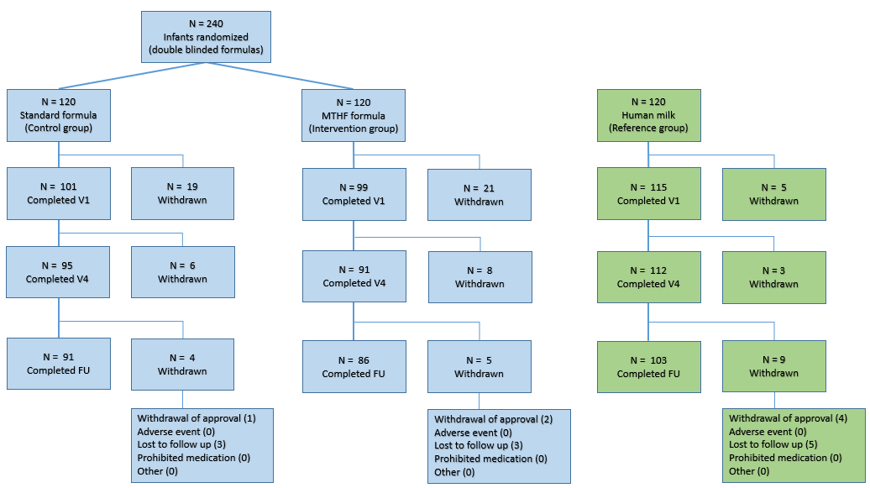
Supplemental Figure 1: Study flow diagram for the mITT.

a)
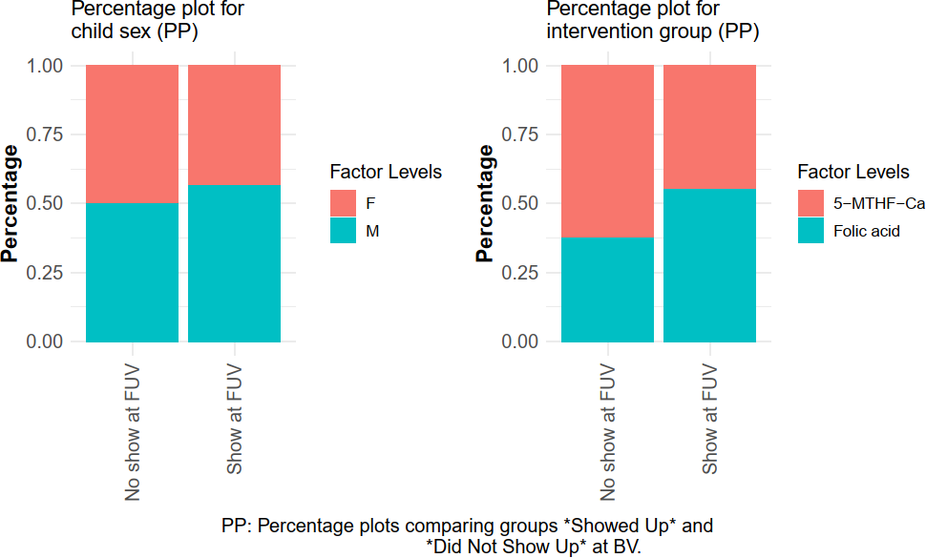
b)
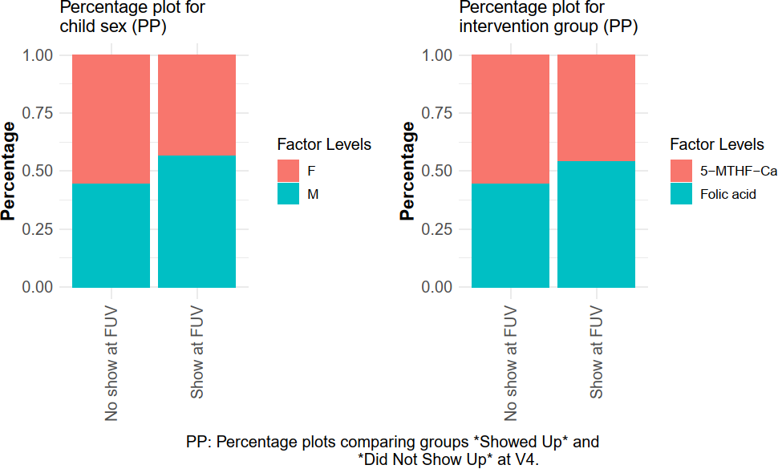
Supplemental Figure 2: Percentage Plots for the per-protocol (PP) population showing the (categorical) variables with respect to the infants that show up at FUV and those that did not show up are compared, considering the observations at baseline visit (BV) a) and at visit 4 (V4) b). On the left, the percentage distribution of sex in the show and no-show groups is shown, on the right their distribution in the intervention (5-MTHF-Ca) and control (Folic acid) groups are depicted, respectively.

Supplemental Table 1: Number of trial participants in mITT population
 | Overall (100%) | 5-MTHF-Ca (31%) | Folic acid (32%) | Reference (37%)
Visit | n | n | n | n
BV | 315 | 99 | 101 | 115
V4 | 298 | 91 | 95 | 112
FUV | 280 | 86 | 91 | 103
Dropouts between V4 and FUV | 18 | 5 | 4 | 9
This table shows the number of infants from the modified intention-to-treat (mITT) population in the three groups (intervention: 5-MTHF-Ca, control: folic acid, reference: breastfed) for three visits that are relevant for the modelling: baseline visit (BV), visit 4 (V4) at 4 months and the follow-up visit (FUV) at 12 months of age.

a) | b) | c)
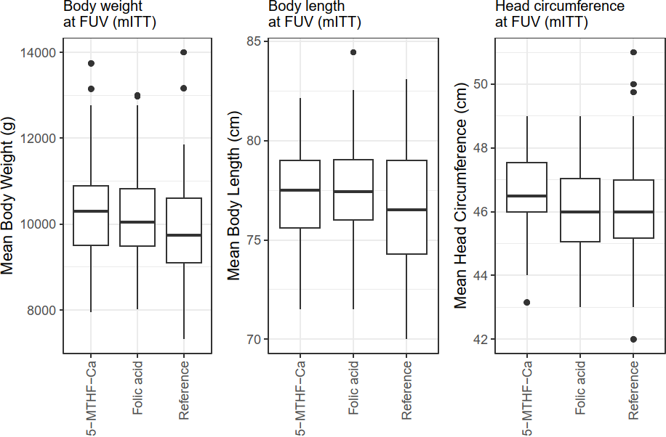
Supplemental Figure 3: Anthropometric measures of infants according to the intervention group (5-MTHF-Ca, n= 86), control group (folic acid, n= 91) and reference group (breastfed, n= 103) at follow-up visit (FUV, age: 12 months) in the modified intention-to-treat (mITT) population (n=280). Presented are box-plots for the mean body weight (in g) a), the mean body length (in cm) b) and the mean head circumference (in cm) c) shown as medians, 25th and 75th percentiles, and maximum and minimum.

Supplemental Table 2: Demographics and anthropometric measures for the mITT population at baseline visit (BV), visit 4 (V4) and follow-up visit (FUV)
BV | 5-MTHF-Ca N = 99 | Folic acid N = 101 | Reference N = 115
Characteristic
Sex
F, n (%) | 43 (43.43%) | 47 (46.53%) | 60 (52.17%)
Birthweight (g) | 3,412 (402); [2,580, 4,290] | 3,488 (396); [2,570, 4,470] | 3,448 (386); [2,500, 4,360]
Age (days) | 21.0 (3.7); [12.0, 27.0] | 19.7 (3.6); [9.0, 27.0] | 19.6 (2.6); [12.0, 26.0]
Body weight (g) | 3,836 (411); [3,000, 4,700] | 3,832 (414); [2,460, 4,920] | 3,907 (429); [2,950, 4,830]
Body length (cm) | 53.80 (1.68); [50.00, 59.00] | 53.99 (2.11); [47.00, 59.00] | 54.03 (1.91); [48.50, 58.00]
Head circumference (cm) | 36.29 (1.00); [34.00, 38.50] | 36.07 (1.16); [33.00, 39.05] | 36.22 (1.09); [33.50, 39.00]
V4 | 5-MTHF-Ca N = 91 | Folic acid N = 95 | Reference N = 112
Sex
F, n (%) | 37 (40.66%) | 44 (46.32%) | 59 (52.68%)
Birthweight (g) | 3,416 (408); [2,580, 4,290] | 3,483 (396); [2,570, 4,470] | 3,453 (379); [2,540, 4,360]
Age (days) | 113.2 (3.6); [100.0, 140.0] | 112.99 (2.64); [108.00, 134.00] | 113.38 (3.06); [107.00, 133.00]
Intervention duration (days) | 92.23 (5.40); [78.00, 118.00] | 93.27 (4.21); [85.00, 110.00] | 93.79 (3.94); [86.00, 109.00]
Body weight (g) | 6,752 (605); [5,330, 8,155] | 6,836 (667); [5,480, 8,735] | 6,647 (681); [5,075, 8,600]
Body length (cm) | 64.12 (1.90); [59.40, 68.00] | 64.48 (2.00); [60.00, 69.50] | 64.20 (2.06); [59.30, 68.55]
Head circumference (cm) | 41.52 (1.08); [39.00, 44.00] | 41.43 (1.30); [38.55, 46.00] | 41.40 (1.23); [38.50, 44.50]
FUV | 5-MTHF-Ca N = 86 | Folic acid N = 91 | Reference N = 103
Sex
F | 35 (40.70%) | 41 (45.05%) | 54 (52.43%)
M | 51 (59.30%) | 50 (54.95%) | 49 (47.57%)
Birthweight (g) | 3,422 (413); [2,580, 4,290] | 3,477 (403); [2,570, 4,470] | 3,453 (388); [2,540, 4,360]
Age (days) | 364.3 (7.9); [316.0, 387.0] | 364.5 (4.6); [357.0, 386.0] | 365.3 (2.9); [359.0, 378.0]
Body weight (g) | 10,273 (1,069); [7,950, 13,745] | 10,198 (1,059); [8,015, 13,000] | 9,869 (1,135); [7,320, 14,000]
Body length (cm) | 77.24 (2.28); [71.50, 82.15] | 77.50 (2.38); [71.50, 84.45] | 76.55 (2.74); [70.00, 83.10]
Head circumference (cm) | 46.47 (1.28); [43.15, 49.00] | 46.26 (1.41); [43.00, 49.00] | 46.26 (1.51); [42.00, 51.00]
This table shows infants from the modified intention-to-treat (mITT) population in the three groups (intervention: 5-MTHF-Ca, control: folic acid, reference: breastfed) for three visits that are relevant for the modelling: baseline visit (BV), visit 4 (V4) and the follow-up visit (FUV). For each of these visits, the sex, birthweight (in g), age (in d), treatment duration (in d), body weight (in g), body length (in cm) and head circumference (in cm) are reported. Continuous variables are reported with the mean, standard deviation (SD), and range [Min, Max]. Count variables (age and treatment duration) are reported with median, SD, and range [Min, Max]. For categorical variables (sex) the proportion of each level (%) in the different groups are shown. N: subject number, F: female, M: male.

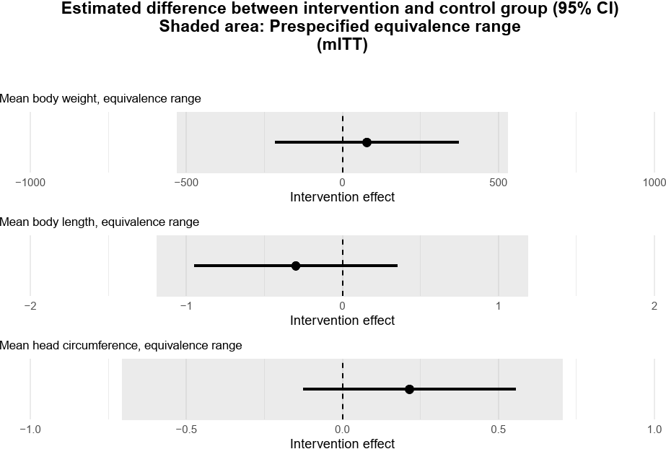
Supplemental Figure 4: Graphical presentation of prespecified equivalence ranges (ER, grey shading) and calculated 95% confidence intervals (95%CI) for (from top to bottom) body weight (78.60 g; 95%CI [-216.09, 373.30]; ER [-529.69, 529.69], p=0.599), body length (-0.30 cm; 95%CI [-0.95, 0.35]; ER [-1.19, 1.19], p=0.367) and head circumference (0.22 cm; 95%CI [-0.13, 0.56]; ER [-0.71, 0.71], p=0.220) at the follow-up visit (FUV) for the modified intention-to-treat (mITT) population. Details of the formal analysis can be found in the Supplementary Statistical Material.
Outcome at FUV were considered equivalent for the infant formula groups if the point estimate for the intervention effect and its 95%CI are contained in the prespecified equivalence range, which is computed as -0.5*SD and +0.5*SD of the outcome for the control (folic acid) group. The control group received 15.2μg folic acid per 100 kcal reconstituted infant formula; the intervention group received an equimolar amount of 15.8 µg 5-MTHF-Ca per 100 kcal starting in the first 28 days of life until 4 months of age.

Supplemental Table 3: Blood safety parameters of the mITT population at FUV
Characteristic | 5-MTHF-Ca N = 86 | Folic acid N = 91 | Reference N = 102
Hemoglobin [g/L] | 121 (9.3);  [93, 150] | 122 (8.2);  [98, 135] | 116 (8.4);  [75, 133]
Proportion within normal range of hemoglobin [105, 135] g/L* | 93.0% | 96.7% | 94.1%
Hematocrit [%] | 0.35 (0.02);  [0.27, 0.40] | 0.35 (0.02);  [0.30, 0.40] | 0.34 (0.02);  [0.21, 0.38]
Proportion within normal range of Hematocrit [0.34, 0.44] % | 66.3% | 75.8% | 53.9%
MCV [fL] | 75.4 (3.9);  [63.0, 83.6] | 75.2 (3.4);  [65.6, 81.9] | 73.8 (4.7);  [56.9, 83.3]
Proportion within normal range of MCV [70, 86] fL * | 91.9% | 94.5% | 83.3%
This table shows hematology markers (mean, standard deviation, range [Min, Max]) for infants from the modified intention-to-treat (mITT) population in the three groups (intervention: 5-MTHF-Ca, control: folic acid, reference: breastfed) at follow-up visit (FUV) at 12 months. With each marker, the respective normal range and the proportion of infants (%) with the marker within the normal range are reported. MCV: mean corpuscular volume, N: number of subjects; * reference range based on (Martin 2006). The infant formula contained either folic acid (15.2 µg/100 kcal) or an equimolar amount of 5-MTHF-Ca (15.8 µg/100 kcal) starting in the first 28 days of life until 4 months of age. Breast fed infants were recruited as a reference group, but were not randomized and did not receive any intervention.

