Supplementary Files

Supplementary Figure 1: Relationship between the Derby Scale of Intrinsic Capacity and the Factor Score Sum from Campbell et al [Campbell 2022].

Supplementary Table 1: The Derby Scale of Intrinsic Capacity (DSIC) scoring system. *Vision is corrected with refractive lens, if appropriate and Hearing is corrected with hearing aids, if appropriate.
 |  | Score
Domains | Items | 0 | 0.5 | 1 | 2 | Total
Locomotion | Short Physical Performance Battery | 0-6 | - | 7-9 | 10-12 | 2
Vitality | Body Mass Index | <18.5 or ³30 | - | 25-29.9 | 18.5-24.9 | 2
Sensory a) | Self-reported Vision* | Poor or registered blind | Fair or Good | Very Good or Excellent | - | 1
Sensory b) | Self-reported Hearing* | Poor | Fair or Good | Very Good or Excellent | - | 1
Psychology | Satisfaction with Life Scale | 0-19 | - | 20-24 | 25-35 | 2
Cognition | Orientation 4 questions (day of the week, day of the month, month, year) and 10 word immediate recall | Orientation <4 correct and 10 word recall 0-4 words | - | Orientation 4 correct and 10 word recall 0-4 words  Or  Orientation <4 correct and 10 word recall ³5 words | Orientation 4 correct and 10 word recall ³5 words | 2

Supplementary Figure 2: Distribution of DSIC scores in the cohort from Wave 4.

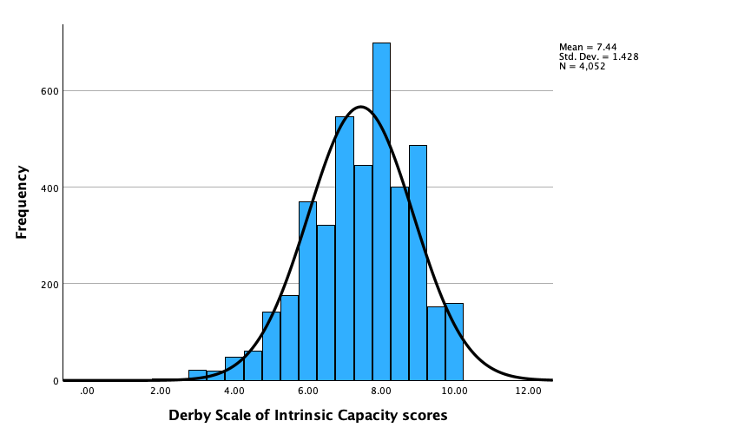

Supplementary Table 2: Covariates No Pain vs Pain baseline
 | No Pain | Pain | OR (95% CI) | p-value
Sex  Male (ref)  Female, n | 1317  1292 | 614  829 | 1.376 (1.209, 1.567) | <0.001
Age*  Mean (SD) |  |  | 1.00 (0.99, 1.01)
Marital status  Married or in civil partnership (ref)  Separated, divorced, or never married | 1881  728 | 1028  415 | 1.043 (0.905, 1.203) | 0.562
Employment  Employed (ref)  Semi retired or retired  Unable to work  Not working | 557  1891  14  147 | 259  1035  37  111 | 1.18 (0.99, 1.39)  5.68 (3.02, 10.70)  1.62 (1.22, 2.16) | 0.054  <0.001  <0.001
Smoking (3251 missing)  No (ref)  Yes | 215  279 | 126  181 | 1.107 (0.829, 1.477) | 0.490
Alcohol  No (ref)  1-4 days drinking in past week  5 or more days drinking in past week | 766  1147  680 | 497  614  325 | 0.825 (0.710, 0.958)  0.737 (0.619, 0.876) | 0.012  <0.001
Education  Degree (ref)  Higher educational non-degree  A level or equivalent  O level or equivalent  No qualification | 509  439  187  849  611 | 198  213  104  477  443 | 1.247 (0.989, 1.573)  1.430 (1.069, 1.912)  1.444 (1.184, 1.762)  1.864 (1.519, 2.287) | 0.062  0.016  <0.001  <0.001
Number of conditions  No long term conditions (ref)  1 or 2 long term conditions  3 or more long term conditions | 1121  1152  304 | 457  598  379 | 1.273 (1.099, 1.475)  3.058 (2.539, 3.683) | 0.001  <0.001
Physical activity levels  High (ref)  Moderate  Low  Sedentary | 663  1468  419  57 | 233  758  396  55 | 1.469 (1.236, 1.747)  2.689 (2.196, 3.294)  2.746 (1.842, 4.094) | <0.001  <0.001  <0.001
*Exp(B) reported from linear regression analysis
Binary logistic regression used in all except for age. Each domain entered as covariate and the reference is the ‘best’ in the category. Interpretation is the odds for having pain. SO e.g. females are 1.38 times more likely than men to have pain compared to no pain.

Supplementary Table 3: Groups of trajectories of pain and associations with health and care outcomes
 | Pain à Pain  N=533 | Pain à No Pain  N=287 | No Pain à Pain  N=380 | No Pain à No Pain, n=1286
Falls  Yes  OR (95% CI) | 34% | 25.1% | 23.4% | 21.7%
Falls  Yes  OR (95% CI) | 0.88 (0.77, 1.01) | 0.90 (0.74, 1.09) | 0.85 (0.72, 1.01) | 0.99 (0.89, 1.11)
Any difficulty with ADL or IADL, Yes  OR (95% CI) | 42.2% | 19.9% | 23.4% | 9.0%
Any difficulty with ADL or IADL, Yes  OR (95% CI) | 0.734 (0.642, 0.839) | 0.77 (0.62, 0.95) | 0.78 (0.66, 0.93) | 0.69 (0.59, 0.79)
Informal help  Yes  OR (95% CI) | 20.3% | 9.1% | 10.3% | 4.0%
Informal help  Yes  OR (95% CI) | 0.72 (0.62, 0.85) | 0.79 (0.59, 1.06) | 0.68 (0.54, 0.85) | 0.69 (0.56, 0.85)
Formal help  Yes  OR (95% CI) | 5.3% | 2.8% | 2.1% | 1.0%
Formal help  Yes  OR (95% CI) | 0.66 (0.50, 0.87) | 0.59 (0.35, 1.00) | 0.55 (0.35, 0.85) | 0.60 (0.40, 0.89)
Unadjusted Binary Logistic Regression of independent variable =baseline IC and dependent variable=adverse outcome, according to pain groups and the proportion of adverse outcome per group. Exp(B) reported as Odds Ratios.

Supplementary Table 4: Structural Equation Modelling values for ADL difficulties.

 | Beta | SE | p-value | Standardised Beta
Number of ADL difficulties
DSIC at wave 6 | -0.07 | 0.02 | <0.001 | -0.12283
Log Pain Severity | 0.485 | 0.129 | <0.001 | 0.131939
Log Age | 0.597 | 0.59 | 0.312 | 0.035509
Number of Comorbidities | 0.051 | 0.016 | 0.001 | 0.111859
DSIC at wave 6
Log Pain Severity | -0.955 | 0.283 | 0.001 | -0.11842
Log Age | -6.494 | 1.279 | <0.001 | -0.17818
Number of Comorbidities | -0.141 | 0.034 | <0.001 | -0.14553
Log Pain Severity
Log Age | 0.028 | 0.159 | 0.859 | 0.00618
Number of Comorbidities | 0.013 | 0.004 | 0.002 | 0.114053

Supplementary Figure 3: Structural Equation Modelling of the effects of age and number of comorbidities on Instrumental Activities of Daily Living difficulties, moderated by pain and intrinsic capacity.

Figures stated on arrows are Standardised Beta. Only significant Standardised Beta values are shown, all p<0.01. Green arrows indicate a positive relationship, and orange arrows indicate an inverse relationship.

