Supplementary Information
Jun Rentschler*, Melda Salhab^{1,}, Bramka Arga Jafino,

Stepwise computational process

The following steps are repeated for each subnational region where data is available.

Merge coastal, pluvial, fluvial flood hazard maps
  - Crop fluvial and pluvial flood rasters to subnational (admin-1) boundary
  - Crop and then virtually warp the coastal flood raster, using a nearest neighbors resampling method, to perfectly match the resolution and extent of the fluvial and pluvial rasters
  - Merge fluvial, pluvial, and coastal rasters using a maximum value method

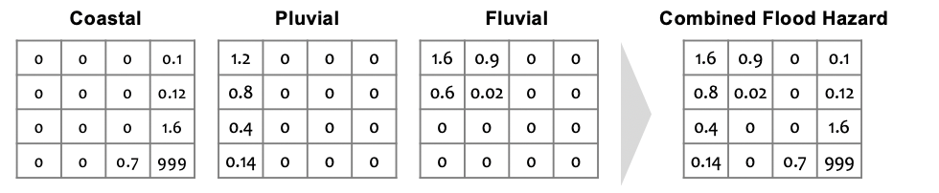

Categorize the flood raster
  - Using the pre-defined flood categories and a category for water bodies, categorize the value of each pixel
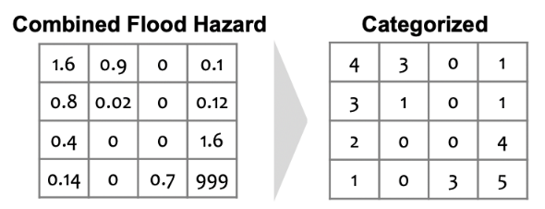

Convert to Boolean integer raster
- Convert the country raster into six different rasters, one for each flood bin
  - Convert each raster for each flood bin to a Boolean (true / false) integer array, where 1 represents the presence of flood risk level in the specific pixel, and 0 represents no presence of flood risk for that pixel

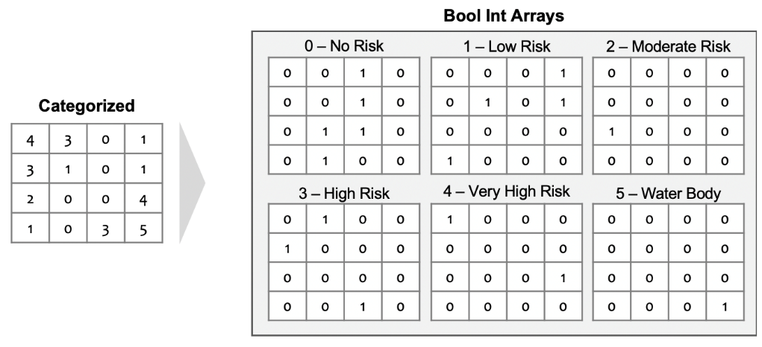

Multiply each flood array by the population array:
- Crop and virtually warp the population raster to perfectly match the flood raster
- For each flood risk array, multiply the array by the population
  - Each flood array pixel is multiplied by the corresponding population array pixel
  - The 1/0 structure allows the resulting array to capture population data for the specific flood risk level

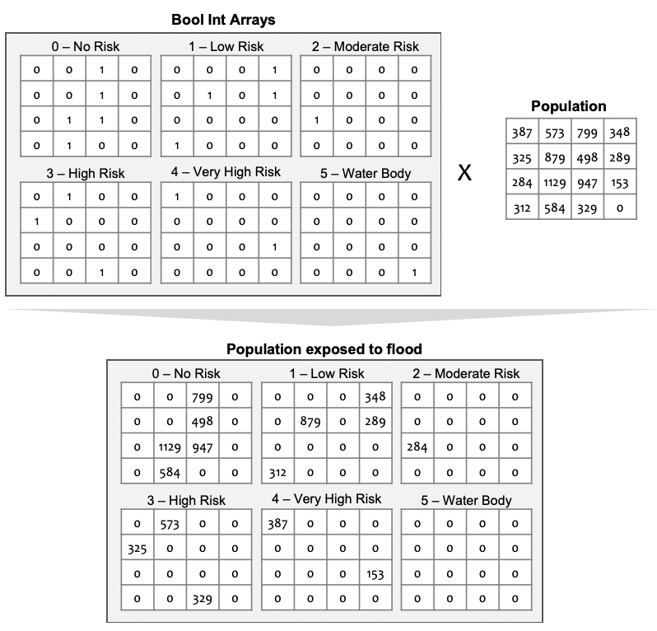
Calculate sums
- For each flood risk array, calculate the total number of people exposed and add the results to the World Bank global administrative map shapefile

Country level summary results

 |  | Total population | Population exposed to high flood risk |  | Population exposed to high flood risk and poor ($1.9 per day) |  | Population exposed to high flood risk and poor ($3.2 per day) |  | Population exposed to high flood risk and poor ($5.5 per day)
 |  | (‘000) | Total  (‘000) | % of population | Total  (‘000) | % of population | Total  (‘000) | % of population | Total  (‘000) | % of population
1 | Afghanistan | 30,296 | 4,501 | 14.9 | 0 | 0.0 | 0 | 0.0 | 0 | 0.0
2 | Albania | 2,797 | 771 | 27.6 | 8 | 0.3 | 50 | 1.8 | 240 | 8.6
3 | Algeria | 44,084 | 4,875 | 11.1 | 16 | 0.0 | 110 | 0.2 | 1,021 | 2.3
4 | Andorra | 113 | 28 | 25.0 | 0 | 0.0 | 0 | 0.0 | 0 | 0.0
5 | Angola | 36,246 | 3,732 | 10.3 | 1,797 | 5.0 | 2,614 | 7.2 | 3,280 | 9.1
6 | Antigua and Barbuda | 93 | 9 | 9.9 | 0 | 0.0 | 0 | 0.0 | 0 | 0.0
7 | Argentina | 44,827 | 7,215 | 16.1 | 0 | 0.0 | 0 | 0.0 | 0 | 0.0
8 | Armenia | 2,773 | 406 | 14.6 | 5 | 0.2 | 37 | 1.3 | 173 | 6.3
9 | Australia | 20,804 | 1,654 | 7.9 | 8 | 0.0 | 13 | 0.1 | 13 | 0.1
10 | Austria | 8,761 | 2,437 | 27.8 | 8 | 0.1 | 10 | 0.1 | 16 | 0.2
11 | Azerbaijan | 8,646 | 1,520 | 17.6 | 0 | 0.0 | 0 | 0.0 | 0 | 0.0
12 | Bahamas | 385 | 81 | 21.1 | 0 | 0.0 | 0 | 0.0 | 0 | 0.0
13 | Bangladesh | 164,109 | 94,424 | 57.5 | 7,504 | 4.6 | 38,612 | 23.5 | 73,349 | 44.7
14 | Barbados | 284 | 20 | 6.9 | 0 | 0.0 | 0 | 0.0 | 0 | 0.0
15 | Belarus | 9,157 | 882 | 9.6 | 0 | 0.0 | 0 | 0.0 | 4 | 0.0
16 | Belgium | 11,580 | 2,070 | 17.9 | 2 | 0.0 | 3 | 0.0 | 5 | 0.0
17 | Belize | 414 | 88 | 21.4 | 10 | 2.4 | 21 | 5.1 | 40 | 9.8
18 | Benin | 12,990 | 1,950 | 15.0 | 899 | 6.9 | 1,433 | 11.0 | 1,772 | 13.6
19 | Bhutan | 813 | 63 | 7.7 | 0 | 0.1 | 5 | 0.6 | 20 | 2.4
20 | Bolivia | 11,832 | 1,875 | 15.8 | 66 | 0.6 | 165 | 1.4 | 381 | 3.2
21 | Bosnia and Herzegovina | 3,324 | 635 | 19.1 | 0 | 0.0 | 2 | 0.0 | 13 | 0.4
22 | Botswana | 2,401 | 294 | 12.2 | 39 | 1.6 | 104 | 4.4 | 176 | 7.3
23 | Brazil | 216,999 | 25,408 | 11.7 | 1,256 | 0.6 | 2,579 | 1.2 | 5,491 | 2.5
24 | Brunei Darussalam | 453 | 115 | 25.4 | 0 | 0.0 | 0 | 0.0 | 0 | 0.0
25 | Bulgaria | 6,892 | 1,184 | 17.2 | 14 | 0.2 | 34 | 0.5 | 85 | 1.2
26 | Burkina Faso | 22,781 | 3,289 | 14.4 | 1,148 | 5.0 | 2,339 | 10.3 | 2,971 | 13.0
27 | Burundi | 11,346 | 1,252 | 11.0 | 974 | 8.6 | 1,153 | 10.2 | 1,224 | 10.8
28 | Cabo Verde | 508 | 27 | 5.3 | 1 | 0.1 | 3 | 0.6 | 10 | 1.9
29 | Cambodia | 19,523 | 7,431 | 38.1 | 0 | 0.0 | 0 | 0.0 | 0 | 0.0
30 | Cameroon | 28,043 | 5,348 | 19.1 | 1,468 | 5.2 | 2,592 | 9.2 | 3,803 | 13.6
31 | Canada | 36,782 | 3,450 | 9.4 | 7 | 0.0 | 17 | 0.0 | 27 | 0.1
32 | Cayman Islands | 73 | 12 | 16.3 | 0 | 0.0 | 0 | 0.0 | 0 | 0.0
33 | Central African Republic | 5,347 | 1,036 | 19.4 | 704 | 13.2 | 867 | 16.2 | 967 | 18.1
34 | Chad | 16,589 | 4,547 | 27.4 | 1,591 | 9.6 | 2,804 | 16.9 | 3,797 | 22.9
35 | Chile | 20,672 | 3,484 | 16.9 | 10 | 0.0 | 22 | 0.1 | 116 | 0.6
36 | China | 1,437,455 | 394,826 | 27.5 | 4,289 | 0.3 | 0 | 0.0 | 0 | 0.0
37 | Colombia | 63,257 | 14,507 | 22.9 | 577 | 0.9 | 1,578 | 2.5 | 3,981 | 6.3
38 | Comoros | 846 | 74 | 8.7 | 11 | 1.4 | 28 | 3.3 | 49 | 5.7
39 | Congo Republic | 3,997 | 1,170 | 29.3 | 686 | 17.2 | 907 | 22.7 | 1,057 | 26.4
40 | Costa Rica | 4,817 | 948 | 19.7 | 16 | 0.3 | 41 | 0.8 | 121 | 2.5
41 | Cote d'Ivoire | 26,537 | 3,484 | 13.1 | 866 | 3.3 | 1,894 | 7.1 | 2,808 | 10.6
42 | Croatia | 4,061 | 1,094 | 26.9 | 6 | 0.1 | 11 | 0.3 | 35 | 0.9
43 | Cuba | 11,114 | 2,026 | 18.2 | 0 | 0.0 | 0 | 0.0 | 0 | 0.0
44 | Cyprus | 1,286 | 145 | 11.3 | 0 | 0.0 | 0 | 0.0 | 0 | 0.0
45 | Czech Republic | 10,816 | 1,500 | 13.9 | 1 | 0.0 | 2 | 0.0 | 5 | 0.1
46 | DR Congo | 114,168 | 15,797 | 13.8 | 11,869 | 10.4 | 14,344 | 12.6 | 15,420 | 13.5
47 | Denmark | 5,888 | 541 | 9.2 | 0 | 0.0 | 0 | 0.0 | 1 | 0.0
48 | Djibouti | 1,153 | 73 | 6.3 | 18 | 1.6 | 34 | 3.0 | 54 | 4.7
49 | Dominica | 69 | 6 | 9.0 | 0 | 0.0 | 0 | 0.0 | 0 | 0.0
50 | Dominican Republic | 12,045 | 1,784 | 14.8 | 8 | 0.1 | 50 | 0.4 | 258 | 2.1
51 | Ecuador | 17,617 | 3,726 | 21.1 | 111 | 0.6 | 319 | 1.8 | 857 | 4.9
52 | Egypt | 96,019 | 38,871 | 40.5 | 1,628 | 1.7 | 12,331 | 12.8 | 29,363 | 30.6
53 | El Salvador | 6,739 | 1,132 | 16.8 | 17 | 0.3 | 94 | 1.4 | 309 | 4.6
54 | Equatorial Guinea | 1,295 | 211 | 16.3 | 0 | 0.0 | 0 | 0.0 | 0 | 0.0
55 | Eritrea | 4,163 | 391 | 9.4 | 0 | 0.0 | 0 | 0.0 | 0 | 0.0
56 | Estonia | 1,391 | 99 | 7.1 | 0 | 0.0 | 0 | 0.0 | 1 | 0.1
57 | Eswatini | 1,096 | 99 | 9.0 | 28 | 2.6 | 51 | 4.7 | 71 | 6.4
58 | Ethiopia | 103,809 | 11,586 | 11.2 | 2,752 | 2.7 | 6,955 | 6.7 | 10,209 | 9.8
59 | Faeroe Islands | 51 | 3 | 6.3 | 0 | 0.0 | 0 | 0.0 | 0 | 0.0
60 | Fiji | 699 | 162 | 23.1 | 0 | 0.1 | 6 | 0.8 | 34 | 4.8
61 | Finland | 5,606 | 612 | 10.9 | 0 | 0.0 | 1 | 0.0 | 1 | 0.0
62 | France | 67,353 | 11,632 | 17.3 | 0 | 0.0 | 2 | 0.0 | 5 | 0.0
63 | Gabon | 2,972 | 579 | 19.5 | 17 | 0.6 | 62 | 2.1 | 186 | 6.3
64 | Gambia | 2,395 | 370 | 15.4 | 40 | 1.6 | 146 | 6.1 | 275 | 11.5
65 | Georgia | 3,728 | 695 | 18.6 | 29 | 0.8 | 104 | 2.8 | 281 | 7.5
66 | Germany | 78,292 | 13,670 | 17.5 | 12 | 0.0 | 33 | 0.0 | 68 | 0.1
67 | Ghana | 32,954 | 4,716 | 14.3 | 583 | 1.8 | 1,364 | 4.1 | 2,564 | 7.8
68 | Greece | 10,221 | 1,314 | 12.9 | 11 | 0.1 | 20 | 0.2 | 57 | 0.6
69 | Grenada | 99 | 9 | 8.8 | 0 | 0.0 | 0 | 0.0 | 0 | 0.0
70 | Guam | 164 | 15 | 9.5 | 0 | 0.0 | 0 | 0.0 | 0 | 0.0
71 | Guatemala | 18,257 | 2,421 | 13.3 | 170 | 0.9 | 502 | 2.7 | 1,068 | 5.8
72 | Guinea | 12,167 | 2,306 | 19.0 | 491 | 4.0 | 1,259 | 10.3 | 1,973 | 16.2
73 | Guinea-Bissau | 1,763 | 301 | 17.1 | 189 | 10.7 | 248 | 14.1 | 278 | 15.8
74 | Guyana | 728 | 276 | 37.9 | 13 | 1.8 | 32 | 4.4 | 71 | 9.7
75 | Haiti | 14,625 | 2,553 | 17.5 | 614 | 4.2 | 1,268 | 8.7 | 2,002 | 13.7
76 | Honduras | 9,449 | 1,801 | 19.1 | 261 | 2.8 | 496 | 5.3 | 861 | 9.1
77 | Hong Kong | 6,032 | 720 | 11.9 | 0 | 0.0 | 0 | 0.0 | 0 | 0.0
78 | Hungary | 9,344 | 1,489 | 15.9 | 7 | 0.1 | 17 | 0.2 | 41 | 0.4
79 | Iceland | 360 | 53 | 14.9 | 0 | 0.0 | 0 | 0.0 | 0 | 0.0
80 | India | 1,405,691 | 389,816 | 27.7 | 65,646 | 4.7 | 222,969 | 15.9 | 334,064 | 23.8
81 | Indonesia | 280,224 | 75,696 | 27.0 | 2,630 | 0.9 | 15,964 | 5.7 | 39,962 | 14.3
82 | Iran | 80,139 | 11,738 | 14.6 | 34 | 0.0 | 313 | 0.4 | 1,653 | 2.1
83 | Iraq | 44,427 | 16,350 | 36.8 | 279 | 0.6 | 2,385 | 5.4 | 8,707 | 19.6
84 | Ireland | 5,482 | 738 | 13.5 | 0 | 0.0 | 3 | 0.1 | 4 | 0.1
85 | Israel | 8,557 | 639 | 7.5 | 1 | 0.0 | 3 | 0.0 | 13 | 0.2
86 | Italy | 61,665 | 8,504 | 13.8 | 92 | 0.1 | 120 | 0.2 | 192 | 0.3
87 | Jamaica | 2,721 | 395 | 14.5 | 7 | 0.3 | 37 | 1.4 | 118 | 4.3
88 | Japan | 125,792 | 36,060 | 28.7 | 270 | 0.2 | 350 | 0.3 | 455 | 0.4
89 | Jordan | 7,138 | 455 | 6.4 | 1 | 0.0 | 13 | 0.2 | 105 | 1.5
90 | Kazakhstan | 18,074 | 3,144 | 17.4 | 1 | 0.0 | 9 | 0.1 | 179 | 1.0
91 | Kenya | 55,137 | 6,566 | 11.9 | 2,369 | 4.3 | 4,339 | 7.9 | 5,714 | 10.4
92 | Kuwait | 3,522 | 301 | 8.5 | 0 | 0.0 | 0 | 0.0 | 0 | 0.0
93 | Kyrgyz Republic | 5,659 | 907 | 16.0 | 4 | 0.1 | 85 | 1.5 | 461 | 8.1
94 | Laos | 7,527 | 2,985 | 39.7 | 218 | 2.9 | 927 | 12.3 | 1,994 | 26.5
95 | Latvia | 2,456 | 554 | 22.6 | 4 | 0.2 | 8 | 0.3 | 17 | 0.7
96 | Lebanon | 9,337 | 872 | 9.3 | 0 | 0.0 | 1 | 0.0 | 16 | 0.2
97 | Lesotho | 1,885 | 151 | 8.0 | 41 | 2.2 | 75 | 4.0 | 111 | 5.9
98 | Liberia | 4,543 | 1,197 | 26.4 | 441 | 9.7 | 833 | 18.3 | 1,090 | 24.0
99 | Libya | 6,921 | 701 | 10.1 | 0 | 0.0 | 0 | 0.0 | 0 | 0.0
100 | Lithuania | 2,748 | 333 | 12.1 | 3 | 0.1 | 5 | 0.2 | 12 | 0.4
101 | Luxembourg | 590 | 69 | 11.7 | 0 | 0.0 | 0 | 0.0 | 1 | 0.1
102 | Macedonia | 2,097 | 397 | 18.9 | 16 | 0.7 | 31 | 1.5 | 72 | 3.4
103 | Madagascar | 27,625 | 5,379 | 19.5 | 3,862 | 14.0 | 4,703 | 17.0 | 5,168 | 18.7
104 | Malawi | 18,470 | 3,057 | 16.5 | 2,212 | 12.0 | 2,776 | 15.0 | 2,976 | 16.1
105 | Malaysia | 34,193 | 8,194 | 24.0 | 1 | 0.0 | 11 | 0.0 | 160 | 0.5
106 | Mali | 23,243 | 5,129 | 22.1 | 2,243 | 9.6 | 3,915 | 16.8 | 4,816 | 20.7
107 | Malta | 424 | 22 | 5.2 | 0 | 0.0 | 0 | 0.0 | 0 | 0.0
108 | Mauritania | 4,448 | 579 | 13.0 | 46 | 1.0 | 171 | 3.9 | 380 | 8.5
109 | Mauritius | 1,277 | 169 | 13.2 | 0 | 0.0 | 2 | 0.2 | 18 | 1.4
110 | Mexico | 140,328 | 24,089 | 17.2 | 408 | 0.3 | 1,533 | 1.1 | 5,434 | 3.9
111 | Micronesia | 59 | 2 | 3.6 | 0 | 0.4 | 1 | 1.3 | 1 | 2.4
112 | Moldova | 3,673 | 496 | 13.5 | 0 | 0.0 | 4 | 0.1 | 60 | 1.6
113 | Monaco | 0 | 0 | 0.0 | 0 | 0.0 | 0 | 0.0 | 0 | 0.0
114 | Mongolia | 3,159 | 458 | 14.5 | 2 | 0.1 | 23 | 0.7 | 120 | 3.8
115 | Montenegro | 603 | 110 | 18.3 | 1 | 0.1 | 6 | 1.0 | 15 | 2.4
116 | Morocco | 35,638 | 3,924 | 11.0 | 27 | 0.1 | 217 | 0.6 | 992 | 2.8
117 | Mozambique | 30,851 | 5,002 | 16.2 | 3,233 | 10.5 | 4,175 | 13.5 | 4,650 | 15.1
118 | Myanmar | 47,823 | 19,104 | 39.9 | 193 | 0.4 | 2,159 | 4.5 | 9,227 | 19.3
119 | Namibia | 2,438 | 423 | 17.3 | 68 | 2.8 | 147 | 6.0 | 241 | 9.9
120 | Nepal | 40,735 | 11,993 | 29.4 | 686 | 1.7 | 4,053 | 9.9 | 8,492 | 20.8
121 | Netherlands | 17,196 | 10,100 | 58.7 | 16 | 0.1 | 26 | 0.2 | 37 | 0.2
122 | New Caledonia | 270 | 46 | 17.0 | 0 | 0.0 | 0 | 0.0 | 0 | 0.0
123 | New Zealand | 4,393 | 623 | 14.2 | 0 | 0.0 | 0 | 0.0 | 0 | 0.0
124 | Nicaragua | 6,881 | 1,147 | 16.7 | 31 | 0.4 | 134 | 1.9 | 373 | 5.4
125 | Niger | 23,865 | 3,350 | 14.0 | 1,393 | 5.8 | 2,496 | 10.5 | 3,098 | 13.0
126 | Nigeria | 216,151 | 38,994 | 18.0 | 15,204 | 7.0 | 26,638 | 12.3 | 34,173 | 15.8
127 | North Korea | 23,224 | 5,735 | 24.7 | 0 | 0.0 | 0 | 0.0 | 0 | 0.0
128 | Norway | 5,223 | 456 | 8.7 | 1 | 0.0 | 1 | 0.0 | 2 | 0.0
129 | Oman | 3,587 | 184 | 5.1 | 0 | 0.0 | 0 | 0.0 | 0 | 0.0
130 | Pakistan | 230,904 | 71,786 | 31.1 | 1,161 | 0.5 | 17,304 | 7.5 | 46,890 | 20.3
131 | Palau | 25 | 2 | 6.1 | 0 | 0.0 | 0 | 0.0 | 0 | 0.0
132 | Panama | 4,058 | 625 | 15.4 | 10 | 0.2 | 31 | 0.8 | 82 | 2.0
133 | Papua New Guinea | 9,145 | 1,374 | 15.0 | 369 | 4.0 | 721 | 7.9 | 1,084 | 11.9
134 | Paraguay | 7,485 | 983 | 13.1 | 15 | 0.2 | 66 | 0.9 | 176 | 2.4
135 | Peru | 35,696 | 3,396 | 9.5 | 157 | 0.4 | 462 | 1.3 | 1,080 | 3.0
136 | Philippines | 105,153 | 30,483 | 29.0 | 1,305 | 1.2 | 7,367 | 7.0 | 17,115 | 16.3
137 | Poland | 39,207 | 5,280 | 13.5 | 17 | 0.0 | 27 | 0.1 | 59 | 0.1
138 | Portugal | 10,118 | 440 | 4.4 | 2 | 0.0 | 3 | 0.0 | 7 | 0.1
139 | Puerto Rico | 3,659 | 429 | 11.7 | 0 | 0.0 | 0 | 0.0 | 0 | 0.0
140 | Romania | 33,822 | 6,548 | 19.4 | 149 | 0.4 | 312 | 0.9 | 656 | 1.9
141 | Russia | 142,717 | 18,394 | 12.9 | 4 | 0.0 | 62 | 0.0 | 692 | 0.5
142 | Rwanda | 13,488 | 1,284 | 9.5 | 679 | 5.0 | 1,001 | 7.4 | 1,164 | 8.6
143 | San Marino | 32 | 2 | 6.5 | 0 | 0.0 | 0 | 0.0 | 0 | 0.0
144 | Sao Tome and Principe | 208 | 26 | 12.4 | 9 | 4.5 | 17 | 8.2 | 22 | 10.8
145 | Saudi Arabia | 36,811 | 2,437 | 6.6 | 0 | 0.0 | 0 | 0.0 | 0 | 0.0
146 | Senegal | 16,174 | 2,376 | 14.7 | 790 | 4.9 | 1,538 | 9.5 | 2,091 | 12.9
147 | Serbia | 6,977 | 1,404 | 20.1 | 1 | 0.0 | 10 | 0.2 | 87 | 1.3
148 | Sierra Leone | 6,782 | 1,296 | 19.1 | 626 | 9.2 | 1,055 | 15.6 | 1,233 | 18.2
149 | Singapore | 4,439 | 577 | 13.0 | 0 | 0.0 | 0 | 0.0 | 0 | 0.0
150 | Slovakia | 5,440 | 1,401 | 25.7 | 17 | 0.3 | 21 | 0.4 | 36 | 0.7
151 | Slovenia | 2,180 | 472 | 21.7 | 0 | 0.0 | 0 | 0.0 | 0 | 0.0
152 | Solomon Islands | 585 | 117 | 20.1 | 29 | 4.9 | 68 | 11.6 | 99 | 16.9
153 | Somalia | 11,002 | 1,831 | 16.6 | 0 | 0.0 | 0 | 0.0 | 0 | 0.0
154 | South Africa | 59,943 | 3,663 | 6.1 | 682 | 1.1 | 1,364 | 2.3 | 2,086 | 3.5
155 | South Korea | 50,972 | 10,351 | 20.3 | 26 | 0.1 | 51 | 0.1 | 103 | 0.2
156 | South Sudan | 16,743 | 5,437 | 32.5 | 4,686 | 28.0 | 5,215 | 31.1 | 5,399 | 32.2
157 | Spain | 51,999 | 5,859 | 11.3 | 38 | 0.1 | 61 | 0.1 | 120 | 0.2
158 | Sri Lanka | 21,387 | 4,140 | 19.4 | 30 | 0.1 | 354 | 1.7 | 1,502 | 7.0
159 | St. Lucia | 169 | 17 | 10.3 | 1 | 0.5 | 2 | 1.0 | 3 | 2.0
160 | Sudan | 42,574 | 8,778 | 20.6 | 1,006 | 2.4 | 3,789 | 8.9 | 6,875 | 16.1
161 | Suriname | 619 | 233 | 37.7 | 45 | 7.3 | 70 | 11.3 | 108 | 17.5
162 | Sweden | 10,064 | 978 | 9.7 | 2 | 0.0 | 2 | 0.0 | 5 | 0.0
163 | Switzerland | 8,693 | 1,660 | 19.1 | 1 | 0.0 | 0 | 0.0 | 1 | 0.0
164 | Syria | 26,550 | 3,548 | 13.4 | 1,603 | 6.0 | 2,730 | 10.3 | 3,294 | 12.4
165 | Tajikistan | 9,381 | 1,671 | 17.8 | 37 | 0.4 | 199 | 2.1 | 665 | 7.1
166 | Tanzania | 54,708 | 7,982 | 14.6 | 3,937 | 7.2 | 6,149 | 11.2 | 7,339 | 13.4
167 | Thailand | 74,946 | 25,431 | 33.9 | 5 | 0.0 | 109 | 0.1 | 1,765 | 2.4
168 | Timor-Leste | 1,322 | 317 | 24.0 | 62 | 4.7 | 198 | 15.0 | 286 | 21.6
169 | Togo | 8,631 | 1,349 | 15.6 | 621 | 7.2 | 978 | 11.3 | 1,211 | 14.0
170 | Tonga | 100 | 11 | 11.4 | 0 | 0.1 | 1 | 0.8 | 3 | 2.9
171 | Trinidad and Tobago | 1,377 | 291 | 21.1 | 1 | 0.1 | 3 | 0.2 | 18 | 1.3
172 | Tunisia | 11,707 | 1,334 | 11.4 | 6 | 0.0 | 62 | 0.5 | 319 | 2.7
173 | Turkey | 79,087 | 11,269 | 14.2 | 5 | 0.0 | 154 | 0.2 | 961 | 1.2
174 | Turkmenistan | 9,850 | 2,419 | 24.6 | 25 | 0.3 | 255 | 2.6 | 804 | 8.2
175 | Turks and Caicos Islands | 43 | 4 | 9.1 | 0 | 0.0 | 0 | 0.0 | 0 | 0.0
176 | Uganda | 42,049 | 5,438 | 12.9 | 2,287 | 5.4 | 3,834 | 9.1 | 4,788 | 11.4
177 | Ukraine | 43,674 | 5,407 | 12.4 | 1 | 0.0 | 19 | 0.0 | 175 | 0.4
178 | United Arab Emirates | 8,967 | 638 | 7.1 | 0 | 0.0 | 0 | 0.0 | 0 | 0.0
179 | United Kingdom | 66,928 | 7,390 | 11.0 | 18 | 0.0 | 30 | 0.0 | 41 | 0.1
180 | United States | 340,766 | 42,590 | 12.5 | 455 | 0.1 | 570 | 0.2 | 783 | 0.2
181 | Uruguay | 3,357 | 226 | 6.7 | 0 | 0.0 | 1 | 0.0 | 7 | 0.2
182 | Uzbekistan | 33,668 | 6,715 | 19.9 | 862 | 2.6 | 2,876 | 8.5 | 5,243 | 15.6
183 | Vanuatu | 272 | 30 | 11.1 | 4 | 1.5 | 12 | 4.5 | 22 | 8.2
184 | Venezuela | 31,718 | 5,843 | 18.4 | 0 | 0.0 | 0 | 0.0 | 0 | 0.0
185 | Vietnam | 98,839 | 45,504 | 46.0 | 465 | 0.5 | 2,133 | 2.2 | 8,843 | 8.9
186 | Yemen | 30,183 | 2,388 | 7.9 | 1,106 | 3.7 | 1,812 | 6.0 | 2,193 | 7.3
187 | Zambia | 18,684 | 2,611 | 14.0 | 1,621 | 8.7 | 2,024 | 10.8 | 2,327 | 12.5
188 | Zimbabwe | 14,360 | 1,426 | 9.9 | 468 | 3.3 | 869 | 6.1 | 1,157 | 8.1

The World Bank, Washington DC, USA
Center for Advanced Spatial Analysis, University College London, London, UK
Deltares, Delft, The Netherlands
Faculty of Technology, Policy, and Management, Delft University of Technology, Delft, The Netherlands

