SUPPLEMENTARY INFORMATION
Microbial communities and nutrient-cycling potential in epilithic biofilms differ between light- and dark-exposed sides of cobbles in a Mediterranean river
David Pineda-Morante¹* · Giulia Gionchetta² · María Argudo¹ · Anna M. Romaní³ · Eugènia Martí¹ · Helena Guasch¹
¹Integrative Freshwater Ecology Group, Centre d’Estudis Avançats de Blanes (CEAB-CSIC), Blanes, Spain
²Institute of Environmental Assessment and Water Research (IDAEA), Spanish Council of Scientific Research (CSIC), Barcelona, Spain
³GRECO, Institute of Aquatic Ecology, University of Girona, Facultat de Ciències, Girona, Spain
*Corresponding author
Email: dpineda@ceab.csic.es

Supplementary Information for:

Supplementary Texts
Text S1. To assess the reliability of PICRUSt2 predictions, we examined Nearest Sequenced Taxon Index (NSTI) values, which quantify the phylogenetic distance between each amplicon sequence variants (ASV) and its closest sequenced reference genome. Because prediction accuracy decreases with increasing NSTI, lower values indicate stronger phylogenetic support for functional inference. Across all ASVs placed in the PICRUSt2 reference tree (n = 22,613), NSTI values exhibited a right-skewed distribution, reflecting the presence of numerous rare taxa with limited genomic representation. ASVs contributing to functional predictions (n = 7,494) showed lower NSTI values (median = 0.076; mean = 0.119; IQR = 0.030–0.173; SD = 0.140) than the full ASV dataset (median = 0.106; mean = 0.216). Importantly, the median NSTI of 0.076 indicates that the majority of predicted ASVs were closely related to sequenced reference genomes. According to Djemiel et al. (2022), NSTI values within this range are consistent with robust functional inference, supporting the reliability of PICRUSt2 predictions in our dataset. ASVs included in functional predictions accounted for approximately 97.6% of total community relative abundance, and 93.5% of the predicted functional signal originated from ASVs with NSTI ≤ 0.2. To further evaluate representativeness, Bray-Curtis dissimilarity matrices were calculated using (i) the complete ASV abundance table and (ii) the subset of ASVs contributing to PICRUSt2 predictions. A Mantel test revealed an almost perfect correlation between the two matrices (Spearman r = 0.9997, p < 0.001), demonstrating that beta-diversity patterns were effectively preserved when analyses were restricted to ASVs with predicted functions.
Supplementary Tables
Table S1. Physiographic localization of the study sites along the Ter River.
Code | Site | Latitude,  N | Longitude,  E | Altitude (m.a.s.l.) | Distance to mouth (km) | Drainage area (km²)
T1 | Setcases | 42°21'26.2" | 2°17'33.7" | 1166 | 190 | 63
T2 | Sant Joan de les Abadesses | 42°13'14.7 | 2°14'26.6" | 714 | 162 | 302
T3 | Ripoll | 42°10'20.0" | 2°11'38.0" | 649 | 153 | 738
T4 | Montesquieu | 42°06'24.0" | 2°12'39.0" | 563 | 142 | 853
T5 | Torelló | 42°03'17.0" | 2°14'39.0" | 503 | 128 | 929
T6 | Manlleu | 41°59'19.8" | 2°16'54.2" | 433 | 112 | 1135
T7 | Roda de Ter | 41°58'55.7" | 2°18'24.3" | 424 | 109 | 1394
T8 | Cellera de Ter | 41°58'07.8" | 2°37'37.2" | 146 | 65 | 1913
T9 | Sant Gregori | 41°58'49.7" | 2°46'00.8" | 75 | 50 | 2080
T10 | Celrà | 42°02'21.9" | 2°51'54.4" | 27 | 37 | 2607
T11 | Sobrànigues | 42°03'34.7" | 2°57'35.0" | 22 | 26 | 2850
T12 | Torroella de Montgrí | 42°01'32.0" | 3°09'07.0" | 2 | 4 | 2950

Table S2. Investigated genes related to microbial phosphorus (P) cycling with their corresponding KO numbers. Genes indicated by an asterisk had a global relative abundance below 0.01% and were not included in the results. For P cycling, the following multi-subunit systems were considered: including the phosphate transporter system (pstSCAB), the ugp transporter system (ugpBAEC), phosphonate transporter systems (phnCDE and phnSVUT), and the C-P lyase complex (phnGHIJKLMNOP).
Gene | Description | KEGG ID
Phosphorus uptake and transport
pstA | Phosphate-specific transport system subunit PstA | K02038
pstB | Phosphate-specific transport system subunit PstB | K02036
pstC | Phosphate-specific transport system subunit PstC | K02037
pstS | Phosphate -specific transport system subunit PstS | K02040
pit | Phosphate inorganic transporter | K03306
phnC | Phosphonate transporter subunit PhnC | K02041
phnD | Phosphonate transporter subunit PhnD | K02044
phnE | Phosphonate transporter subunit PhnE | K02042
ugpA | Glycerol-3-phosphate transporter subunit UgpA | K05814
ugpB | Glycerol-3-phosphate transporter subunit UgpB | K05813
ugpC | Glycerol-3-phosphate transporter subunit UgpC | K05816
ugpE | Glycerol-3-phosphate transporter subunit UgpE | K05815
glpT | Glycerol-3-phosphate transporter | K02445
pgtP* | Phosphoglycerate transporter protein | K11382
phnS | 2-aminoethylphosphonate transport system substrate-binding protein | K11081
phnV | 2-aminoethylphosphonate transport system permease protein | K11082
phnU | 2-aminoethylphosphonate transport system permease protein | K11083
phnT | 2-aminoethylphosphonate transport system ATP-binding protein | K11084
Organic phosphorus mineralization
phoN | Acid phosphatase (class A) | K09474
aphA | Acid phosphatase (class B) | K03788
olpA | Acid phosphatase | K01078
phoA | Alkaline phosphatase A | K01077
phoD | Alkaline phosphatase D | K01113
phoX | Alkaline phosphatase X | K07093
appA | 4-phytase | K01093
phy | 3-phytase | K01083
opd | Phosphotriesterase | K07048
ugpQ | Glycerophosphoryl diester phosphodiesterase (GDP) | K01126
phnA | Phosphonoacetate hydrolase | K06193
phnG | Alpha-D-ribose 1-methylphosphonate 5-triphosphate synthase | K06166
phnH | Alpha-D-ribose 1-methylphosphonate 5-triphosphate synthase | K06165
phnI | Alpha-D-ribose 1-methylphosphonate 5-triphosphate synthase | K06164
phnJ | Alpha-D-ribose 1-methylphosphonate 5-phosphate C-P lyase | K06163
phnK | Alpha-D-ribose 1-methylphosphonate 5-triphosphate synthase | K05781
phnL | Alpha-D-ribose 1-methylphosphonate 5-triphosphate synthase | K05780
phnM | Alpha-D-ribose 1-methylphosphonate 5-triphosphate | K06162
phnN | Ribose 1,5-bisphosphokinase | K05774
phnO | Aminoalkylphosphonate N-acetyltransferase | K09994
phnP | Phosphoribosyl 1,2-cyclic phosphate phosphodiesterase | K06167
phnW | 2-aminoethylphosphonate-pyruvate transaminase (2APT) | K03430
phnX | Phosphonoacetaldehyde hydrolase | K05306
Phosphorus starvation regulation
phoB | Phosphate regulon response regulator (PhoB) | K07657
phoU | PhoR/PhoB inhibitor protein | K02039
phoR | Phosphate regulon sensor histidine kinase (PhoR) | K07636
Inorganic phosphorus solubilization
gcd | Quinoprotein glucose dehydrogenase (PQQGDH) | K00117
ppa | Inorganic pyrophosphatase | K01507
ppx | Exopolyphosphatase | K01524
Table S3. Investigated genes related to microbial nitrogen (N) cycling with their corresponding KO numbers. Genes indicated by an asterisk had a global relative abundance below 0.01% and were not included in the results. For N cycling, the following multi-subunit systems were considered: glutamate synthase (NADPH, gltBD), nitrite reductase (nirBD), cytochrome c nitrite reductase (nrfAH), nitric oxide reductase (norBC), assimilatory nitrate reductase (nasAB), nitrogenase (nifHDK), and ammonia monooxygenase (amoABC).
Gene | Description | KEGG ID
Organic nitrogen synthesis
GLT1* | glutamate synthase (NADH) [EC:1.4.1.14] | K00264
gltB | glutamate synthase (NADPH) large chain [EC:1.4.1.13] | K00265
gltD | glutamate synthase (NADPH) small chain [EC:1.4.1.13] | K00266
gltS | glutamate synthase (ferredoxin) [EC:1.4.7.1] | K00284
glnA | glutamine synthetase [EC:6.3.1.2] | K01915
Organic nitrogen degradation
gudB | Glutamate dehydrogenase [EC:1.4.1.2] | K00260
GLUD1_2 | Glutamate dehydrogenase (NAD(P)+) [EC:1.4.1.3] | K00261
gdhA | Glutamate dehydrogenase (NADP+) [EC:1.4.1.4] | K00262
GDH2 | Glutamate dehydrogenase [EC:1.4.1.2] | K15371
Dissimilatory Nitrate Reduction
nirB | Nitrite reductase (NADH) large subunit | K00362
nirD | Nitrite reductase (NADH) small subunit | K00363
nrfA | Nitrite reductase (cytochrome c-552) | K03385
nrfH | Cytochrome c nitrite reductase small subunit | K15876
Denitrification
norB | Nitric oxide reductase subunit B | K04561
norC | Nitric oxide reductase subunit C | K02305
nosZ | Nitrous-oxide reductase | K00376
Assimilatory Nitrate Reduction
nasA | Assimilatory nitrate reductase catalytic subunit | K00372
nasB | Assimilatory nitrate reductase electron transfer subunit | K00360
narB | Ferredoxin-nitrate reductase | K00367
nirA | Ferredoxin-nitrite reductase | K00366
Nitrogen fixation
anfG* | Nitrogenase delta subunit | K00531
nifD | Nitrogenase molybdenum-iron protein alpha chain | K02586
nifH | Nitrogenase iron protein | K02588
nifK | Nitrogenase molybdenum-iron protein beta chain | K02591
Nitrification
amoA | Ammonia monooxygenase subunit A | K28504
amoB | Hydrazine synthase subunit | K10945
amoC | Hydrazine dehydrogenase | K10946
hao | Methane/ammonia monooxygenase subunit B | K10535

Table S4. Mean and standard deviation of physical and chemical characteristics at each sampling site and date. Variables are: pH, dissolved oxygen (DO), dissolved oxygen saturation (DOsat), water temperature (T), electrical conductivity (EC), concentrations of total phosphorus (TP), total dissolved phosphorus (TDP), dissolved organic phosphorus (DOP), soluble reactive phosphorus (SRP), total dissolved nitrogen (TDN), ammonium (NH₄⁺), nitrite (NO₂–), nitrate (NO₃–), and dissolved organic carbon (DOC). Sampling site codes are defined in Table S1 caption. Sampling date codes: November 2020 (Nov. 2020), March 2021 (Mar. 2021), June-July 2021 (Jun. 2021), and September 2021 (Sep. 2021).
 | pH | DO  (mg L^{–1}) | DOsat (%) | T  (ºC) | EC  (μS cm^{–1}) | TP  (μg P L^{–1}) | TDP  (μg P L^{–1}) | DOP  (μg P L^{–1}) | SRP  (μg P L^{–1}) | TDN  (mg N L^{–1}) | NH₄⁺  (μg N L^{–1}) | NO₂–  (μg N L^{–1}) | NO₃–  (mg N L^{–1}) | DOC  (mg C L^{–1})
T1 | 8.1 ± 0.1 | 9.0 ± 1.0 | 81 ± 8 | 10.8 ± 3.8 | 110 ± 10 | 68.2 ± 15.6 | 31.7 ± 6.2 | 6.5 ± 5.5 | 25.2 ± 11.0 | 0.5 ± 0.1 | 15.2 ± 10.2 | 2.5 ± 1.5 | 0.44 ± 0.10 | 1.5 ± 1.2
T2 | 8.5 ± 0.2 | 10.5 ± 2.9 | 97 ± 22 | 12.8 ± 5.0 | 293 ± 21 | 59.1 ± 18.4 | 26.4 ± 7.8 | 4.2 ± 5.1 | 22.2 ± 12.2 | 0.8 ± 0.3 | 70.9 ± 67.3 | 16.3 ± 8.7 | 0.68 ± 0.28 | 2.0 ± 1.5
T3 | 8.5 ± 0.3 | 10.3 ± 1.7 | 96 ± 8 | 12.9 ± 4.8 | 343 ± 20 | 40.3 ± 14.7 | 17.0 ± 5.9 | 7.1 ± 8.6 | 9.9 ± 3.9 | 0.6 ± 0.2 | 9.7 ± 4.1 | 8.2 ± 3.1 | 0.46 ± 0.10 | 1.7 ± 1.4
T4 | 8.5 ± 0.3 | 10.2 ± 1.5 | 98 ± 7 | 14.0 ± 4.9 | 363 ± 28 | 60.6 ± 32.5 | 25.1 ± 11.3 | 5.3 ± 5.9 | 19.7 ± 13.5 | 0.7 ± 0.2 | 20.9 ± 19.3 | 8.6 ± 6.2 | 0.67 ± 0.21 | 2.7 ± 1.3
T5 | 8.5 ± 0.1 | 10.1 ± 1.9 | 97 ± 10 | 14.5 ± 6.1 | 363 ± 28 | 51.3 ± 18.6 | 19.5 ± 4.8 | 7.5 ± 5.7 | 12.0 ± 7.2 | 0.5 ± 0.1 | 22.2 ± 12.3 | 6.7 ± 2.6 | 0.45 ± 0.06 | 1.9 ± 0.9
T6 | 8.5 ± 0.1 | 10.0 ± 1.4 | 99 ± 7 | 15.8 ± 7.2 | 398 ± 31 | 74.3 ± 13.9 | 26.2 ± 5.7 | 14.7 ± 6.4 | 11.5 ± 4.0 | 1.1 ± 0.3 | 25.5 ± 17.4 | 14.2 ± 2.9 | 0.95 ± 0.31 | 2.9 ± 1.5
T7 | 8.3 ± 0.2 | 9.0 ± 1.7 | 89 ± 9 | 16.0 ± 8.1 | 468 ± 47 | 141.8 ± 47.3 | 48.7 ± 16.2 | 16.1 ± 11.2 | 32.6 ± 5.2 | 1.7 ± 0.7 | 101.7 ± 40.3 | 54.5 ± 36.0 | 1.48 ± 0.70 | 2.8 ± 1.4
T8 | 8.1 ± 0.3 | 9.5 ± 0.8 | 90 ± 6 | 13.4 ± 3.0 | 447 ± 25 | 89.3 ± 19.2 | 38.1 ± 11.3 | 12.7 ± 8.2 | 25.5 ± 7.4 | 2.0 ± 0.5 | 14.6 ± 5.8 | 10.3 ± 3.0 | 1.88 ± 0.57 | 3.1 ± 1.1
T9 | 7.8 ± 0.4 | 9.8 ± 0.7 | 98 ± 8 | 16.0 ± 2.2 | 511 ± 29 | 89.5 ± 11.3 | 40.1 ± 6.2 | 17.6 ± 11.4 | 22.5 ± 11.7 | 2.0 ± 0.4 | 61.6 ± 11.8 | 16.3 ± 2.3 | 1.82 ± 0.37 | 2.9 ± 0.8
T10 | 8.1 ± 0.1 | 8.8 ± 0.8 | 94 ± 9 | 18.5 ± 3.5 | 565 ± 14 | 167.7 ± 19.3 | 68.4 ± 11.1 | 26.2 ± 16.3 | 42.3 ± 25.4 | 2.2 ± 0.4 | 71.3 ± 42.9 | 33.0 ± 8.0 | 2.01 ± 0.40 | 3.5 ± 1.0
T11 | 8.0 ± 0.1 | 8.6 ± 1.0 | 91 ± 8 | 17.9 ± 3.2 | 678 ± 32 | 250.1 ± 47.2 | 117.1 ± 25.4 | 30.7 ± 16.6 | 86.4 ± 28.5 | 2.5 ± 0.3 | 186.0 ± 72.9 | 63.7 ± 14.4 | 2.02 ± 0.26 | 3.0 ± 0.9
T12 | 8.1 ± 0.1 | 8.4 ± 1.5 | 90 ± 9 | 19.6 ± 5.4 | 673 ± 59 | 253.8 ± 67.8 | 112.2 ± 29.4 | 26.0 ± 15.4 | 86.2 ± 37.6 | 2.4 ± 0.4 | 91.6 ± 61.5 | 41.2 ± 20.7 | 2.17 ± 0.27 | 3.0 ± 1.0
Nov. 2020 | 8.2 ± 0.3 | 10.8 ± 1.6 | 101 ± 11 | 12.7 ± 3.3 | 424 ± 172 | 99.9 ± 64.6 | 42.2 ± 25.0 | 19.1 ± 9.3 | 23.1 ± 17.9 | 1.3 ± 1.0 | 50.1 ± 74.7 | 20.5 ± 23.6 | 1.06 ± 0.77 | 2.2 ± 0.9
Mar. 2021 | 8.4 ± 0.4 | 9.9 ± 0.8 | 89 ± 7 | 10.8 ± 2.9 | 456 ± 172 | 95.5 ± 72.3 | 43.7 ± 34.3 | 15.0 ± 14.8 | 28.7 ± 21.8 | 1.5 ± 0.8 | 67.5 ± 73.7 | 25.0 ± 23.3 | 1.37 ± 0.81 | 1.3 ± 0.6
Jun. 2021 | 8.3 ± 0.2 | 7.8 ± 0.6 | 85 ± 6 | 20.1 ± 4.4 | 414 ± 156 | 126.5 ± 86.1 | 51.6 ± 41.6 | 18.1 ± 15.4 | 33.5 ± 30.5 | 1.3 ± 0.7 | 49.3 ± 31.4 | 19.6 ± 13.2 | 1.15 ± 0.70 | 3.1 ± 0.8
Sep. 2021 | 8.1 ± 0.2 | 9.5 ± 0.9 | 98 ± 7 | 17.1 ± 3.7 | 443 ± 148 | 126.7 ± 90.0 | 52.7 ± 41.8 | 6.1 ± 5.7 | 46.7 ± 41.7 | 1.6 ± 0.8 | 63.5 ± 58.5 | 26.7 ± 30.2 | 1.43 ± 0.76 | 3.8 ± 0.7

Table S5. Permutational multivariate analysis of variance (PERMANOVA) results for microbial community composition, and phosphorus (P) and nitrogen (N) functional genes composition based on Bray-Curtis dissimilarities. Three complementary models were used to disentangle spatial, temporal, and cobble side effects on community composition and functional gene composition. Reported values correspond to marginal effects based on 999 permutations; R² indicates the proportion of variance explained by each term, F values represent pseudo-F statistics, and p-values indicate statistical significance. Significant effects (p < 0.05) are shown in bold.
Microbial community composition |  |  |  |  | Microbial P-gene composition |  |  |  | Microbial N-gene composition
Model 1: Site + Time
Term | Df | R² | F | p-value | Df | R² | F | p-value | Df | R² | F | p-value
Site | 11 | 0.317 | 4.10 | 0.001 | 11 | 0.324 | 3.61 | 0.001 | 11 | 0.323 | 3.81 | 0.001
Time | 3 | 0.118 | 5.58 | 0.001 | 3 | 0.087 | 2.89 | 0.001 | 3 | 0.061 | 1.97 | 0.043
Model 2: Site × Time + Cobble side
Term | Df | R² | F | p-value | Df | R² | F | p-value | Df | R² | F | p-value
Site × Time | 33 | 0.335 | 2.29 | 0.001 | 33 | 0.275 | 1.44 | 0.040 | 33 | 0.270 | 1.34 | 0.084
Cobble side | 1 | 0.023 | 5.23 | 0.001 | 1 | 0.051 | 8.75 | 0.001 | 1 | 0.068 | 11.25 | 0.001
Model 3: Cobble side × Site + Cobble side × Time
Term | Df | R² | F | p-value | Df | R² | F | p-value | Df | R² | F | p-value
Cobble side × Site | 11 | 0.059 | 0.65 | 0.999 | 11 | 0.065 | 0.85 | 0.718 | 11 | 0.052 | 0.68 | 0.891
Cobble side × Time | 3 | 0.014 | 0.75 | 0.999 | 3 | 0.022 | 1.04 | 0.413 | 3 | 0.039 | 1.85 | 0.071

Table S6. Spearman rank correlations between predicted phosphorus (P) and nitrogen (N) cycling processes and selected physical and chemical variables in light-side and dark-side biofilms. Correlation coefficients (ρ) and Benjamini-Hochberg (BH) adjusted p-values are shown for each process-variable combination. Significant associations after BH correction (p < 0.05) are indicated in bold. Variable abbreviations are defined in Table S4.
 |  | pH |  | DOsat |  | T |  | SRP |  | DOP |  | DOC |  | NH₄⁺ |  | NO₃–
Side | Process | ρ | p-value | ρ | p-value | ρ | p-value | ρ | p-value | ρ | p-value | ρ | p-value | ρ | p-value | ρ | p-value
Light | P mineralization | 0.000 | 0.998 | -0.040 | 0.812 | -0.237 | 0.223 | -0.194 | 0.285 | -0.107 | 0.538 | -0.457 | 0.018 | -0.196 | 0.285 | -0.421 | 0.030
Light | P uptake | 0.194 | 0.285 | -0.262 | 0.179 | -0.296 | 0.120 | -0.306 | 0.120 | -0.174 | 0.331 | -0.297 | 0.120 | -0.204 | 0.285 | -0.262 | 0.179
Light | P regulation | -0.309 | 0.120 | 0.233 | 0.223 | 0.124 | 0.477 | 0.337 | 0.120 | 0.307 | 0.120 | 0.327 | 0.120 | 0.234 | 0.223 | 0.470 | 0.018
Light | P solubilization | -0.306 | 0.120 | 0.144 | 0.435 | 0.137 | 0.436 | 0.179 | 0.326 | 0.047 | 0.799 | 0.213 | 0.275 | -0.075 | 0.675 | 0.141 | 0.435
Dark | P mineralization | -0.025 | 0.927 | -0.128 | 0.546 | -0.262 | 0.186 | -0.230 | 0.272 | -0.058 | 0.799 | -0.386 | 0.051 | -0.269 | 0.180 | -0.435 | 0.036
Dark | P uptake | 0.159 | 0.510 | -0.278 | 0.171 | -0.359 | 0.061 | -0.221 | 0.276 | -0.034 | 0.904 | -0.363 | 0.061 | -0.143 | 0.512 | -0.082 | 0.717
Dark | P regulation | -0.295 | 0.141 | 0.406 | 0.051 | 0.081 | 0.717 | 0.130 | 0.546 | 0.183 | 0.410 | 0.383 | 0.051 | 0.077 | 0.717 | 0.303 | 0.138
Dark | P solubilization | -0.439 | 0.036 | 0.149 | 0.512 | 0.144 | 0.512 | 0.220 | 0.276 | 0.007 | 0.992 | 0.348 | 0.066 | -0.001 | 0.993 | 0.113 | 0.601
Light | N synthesis | 0.081 | 0.697 | -0.147 | 0.491 | -0.313 | 0.136 | -0.009 | 0.960 | 0.187 | 0.409 | -0.151 | 0.490 | 0.062 | 0.757 | 0.232 | 0.303
Light | N degradation | 0.086 | 0.697 | 0.372 | 0.087 | 0.325 | 0.136 | 0.037 | 0.865 | 0.178 | 0.439 | 0.329 | 0.136 | 0.227 | 0.306 | 0.116 | 0.576
Light | DNRA | 0.121 | 0.570 | 0.112 | 0.585 | -0.171 | 0.443 | -0.275 | 0.220 | -0.377 | 0.087 | -0.283 | 0.205 | -0.325 | 0.136 | -0.568 | 0.001
Light | ANRA | -0.070 | 0.728 | -0.007 | 0.960 | -0.135 | 0.530 | -0.171 | 0.443 | -0.256 | 0.261 | -0.152 | 0.490 | -0.214 | 0.317 | -0.362 | 0.091
Light | Denitrification | 0.221 | 0.306 | 0.018 | 0.938 | -0.120 | 0.570 | 0.034 | 0.867 | 0.071 | 0.728 | 0.081 | 0.697 | 0.210 | 0.317 | 0.249 | 0.265
Light | N fixation | -0.085 | 0.697 | 0.222 | 0.306 | 0.381 | 0.087 | 0.311 | 0.136 | 0.210 | 0.317 | 0.474 | 0.019 | 0.390 | 0.087 | 0.248 | 0.265
Light | Nitrification | -0.045 | 0.834 | 0.314 | 0.136 | 0.160 | 0.472 | 0.145 | 0.491 | 0.259 | 0.261 | 0.122 | 0.570 | 0.231 | 0.303 | 0.160 | 0.472
Dark | N synthesis | 0.001 | 0.997 | -0.143 | 0.588 | -0.228 | 0.274 | -0.009 | 0.994 | 0.102 | 0.718 | -0.126 | 0.674 | 0.001 | 0.997 | 0.259 | 0.220
Dark | N degradation | -0.098 | 0.718 | 0.346 | 0.083 | 0.283 | 0.181 | 0.165 | 0.498 | 0.066 | 0.821 | 0.359 | 0.077 | 0.200 | 0.371 | 0.115 | 0.718
Dark | DNRA | 0.104 | 0.718 | 0.077 | 0.806 | -0.020 | 0.994 | -0.087 | 0.765 | -0.361 | 0.077 | 0.009 | 0.994 | -0.099 | 0.718 | -0.429 | 0.025
Dark | ANRA | -0.067 | 0.821 | -0.172 | 0.478 | -0.238 | 0.266 | -0.148 | 0.582 | 0.008 | 0.994 | -0.237 | 0.266 | -0.215 | 0.315 | -0.245 | 0.260
Dark | Denitrification | 0.278 | 0.181 | 0.008 | 0.994 | -0.183 | 0.436 | 0.017 | 0.994 | -0.108 | 0.718 | -0.056 | 0.843 | 0.110 | 0.718 | 0.230 | 0.274
Dark | N fixation | -0.066 | 0.821 | 0.357 | 0.077 | 0.494 | 0.008 | 0.309 | 0.131 | 0.261 | 0.220 | 0.527 | 0.005 | 0.470 | 0.012 | 0.383 | 0.063
Dark | Nitrification | -0.056 | 0.843 | 0.308 | 0.131 | 0.317 | 0.129 | 0.279 | 0.181 | -0.018 | 0.994 | 0.430 | 0.025 | 0.519 | 0.005 | 0.344 | 0.083

Supplementary Figures
Figure S1. (a) Location of the Ter River catchment (dark gray) within Catalonia (light gray). (b) Map of the Ter River and its drainage catchment showing the twelve sampling sites (orange circles), reservoir locations (white circles), and main tributaries (blue lines). Land-use distribution within the catchment is also shown: forested areas (green), agricultural land (yellow), urban areas (gray), and water bodies (blue). (c) Representative photographs of biofilms from the upper surface of cobbles exposed to light (left) and from the underside of cobbles (right).
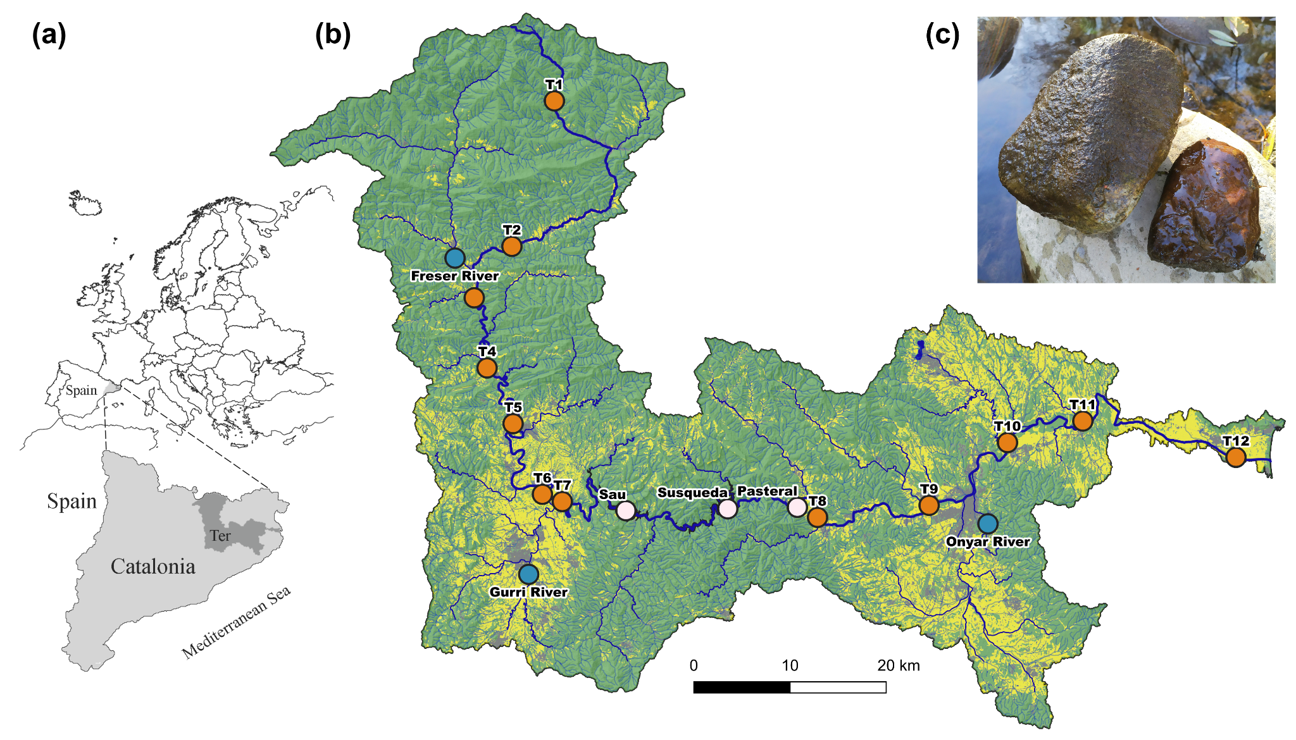

Figure S2. Principal component analysis (PCA) of physical and chemical variables across twelve sampling sites along the Ter River and four sampling dates. Points are colored by site and shaped by sampling date. Variables with strong loadings (|loading| > 0.7) on PC1 included EC, TP, TDP, SRP, TDN, NH₄⁺, NO₂⁻, and NO₃⁻, indicating a gradient associated with conductivity and nutrient concentrations, whereas DO and DOsat loaded strongly on PC2. Sampling site codes and variable abbreviations are provided in Tables S1 and S4, respectively.
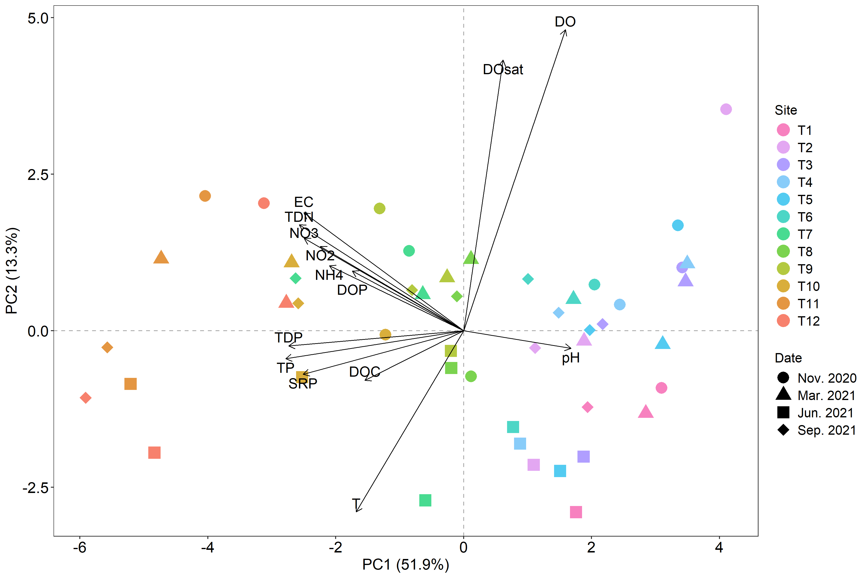
Figure S3. Relative abundance of dominant bacterial phyla along the Ter River and across the four sampling dates for light-side (a) and dark-side biofilms (b). Sites are ordered from headwaters (T1) to river mouth (T12) from left to right. Colors denote the ten most abundant phyla calculated separately for light-side and dark-side biofilms, ordered from highest to lowest mean relative abundance in the legend; all remaining phyla are grouped as “Other”. The dark-side biofilm sample from T8 in September 2021 was excluded from analysis due to insufficient sequencing depth. Sampling site codes are defined in Table S1.
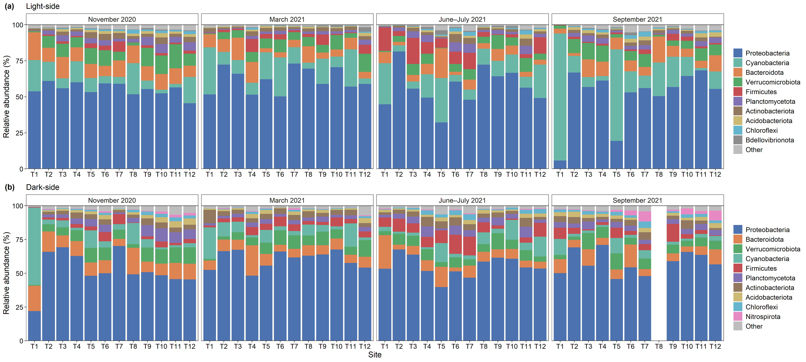
Figure S4. Prevalence patterns of global-core ASVs exhibiting side-specific core status. Heatmaps show the prevalence (%) of ASVs that met the pooled core criterion (relative abundance > 0.0001 in ≥50% of all samples) but fell below the 50% prevalence threshold within one cobble side. The upper panel shows ASVs classified as core in light-side biofilms but not in dark-side biofilms, whereas the lower panel shows ASVs classified as core in dark-side biofilms but not in light-side biofilms. Prevalence was calculated separately for light and dark samples across three detection thresholds (0.0001, 0.0010, and 0.0100 relative abundance). Taxonomic affiliation (Class, Order, Family, and Genus when available) is indicated for each ASV. All ASVs shown were detected on both cobble sides but met the core prevalence threshold in only one cobble side. The complete table of ASVs, including full taxonomic annotation and prevalence statistics, is provided in the Figshare repository associated with this study.
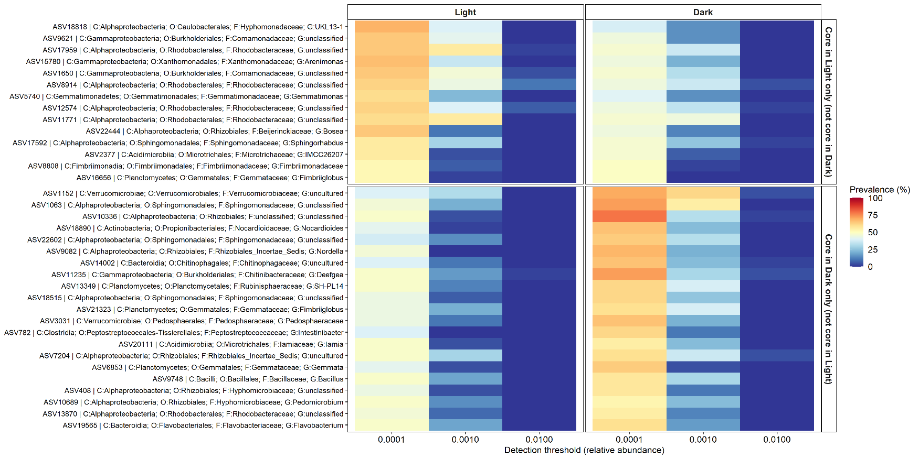
Figure S5. Mean relative abundance of phosphorus- (P, a) and nitrogen- (N, b) cycling functional genes in light-side and dark-side biofilms. Relative abundances (%) are expressed as the proportion of each functional gene (including multi-subunit gene systems) relative to the total predicted KO metagenome generated by PICRUSt2 and were not renormalized within P- or N-cycling gene pools. Accordingly, stacked bars do not sum to 1. Stacked bars representing spatial variation show means across four sampling dates, whereas stacked bars representing temporal variation show means across twelve sites. Bar height reflects the overall contribution of P- or N-cycling genes to the predicted metagenome, while colors denote functional processes, with different shades representing genes within each process. The correspondence between genes and processes is provided in Tables S2 and S3 for P- and N-cycling genes, respectively. Sampling site codes are defined in Table S1.
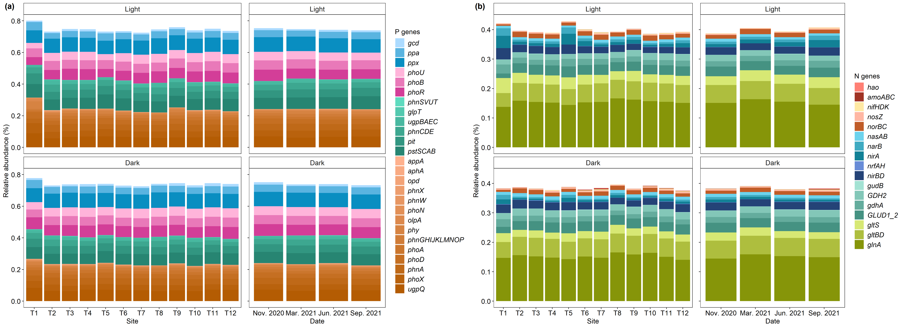
Figure S6. Non-metric multidimensional scaling (NMDS) ordination of microbial potential functional gene composition for phosphorus-(P, a) and nitrogen-(N, b) cycling genes across twelve sampling sites along the Ter River and four sampling dates. NMDS scores are shown in separate panels for each sampling date. Colors denote sampling sites, which are defined in Table S1. Ordinations are based on Bray-Curtis dissimilarities computed from Hellinger-transformed relative abundances of functional genes. Points represent individual samples from the light-side (circles) and dark-side (triangles) biofilms. Sampling site codes are defined in Table S1.
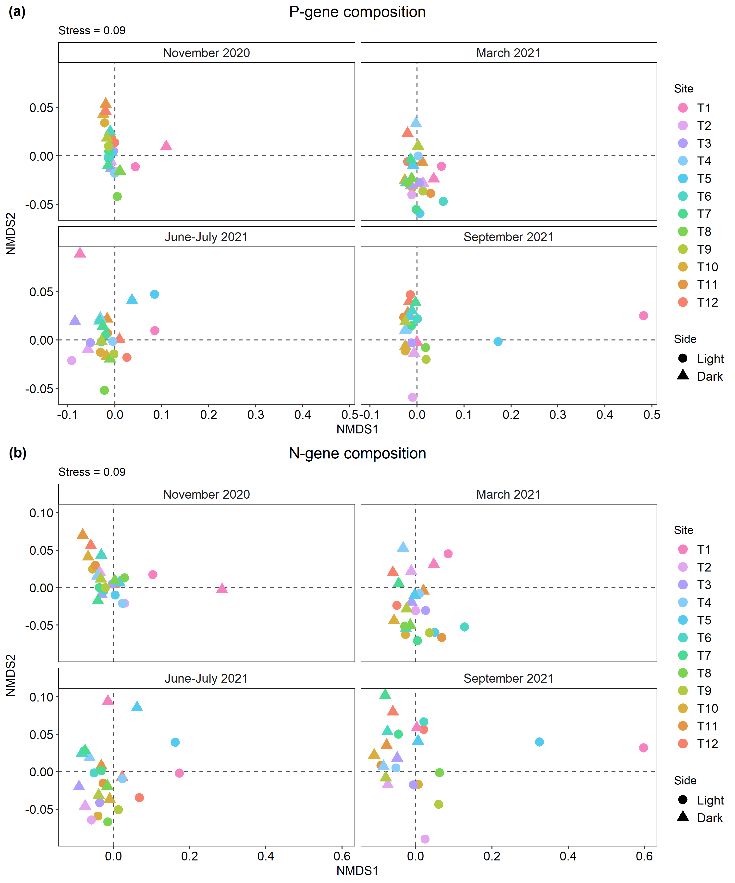
Figure S7. Distance-based redundancy analysis (db-RDA) of microbial community composition (a, d), functional phosphorus (P)-gene composition (b, e), and nitrogen (N)-gene composition (c, f) in relation to physical and chemical variables for light-side (upper panels) and dark-side (lower panels) biofilms. Points represent individual samples, colored by site and shaped by sampling date. Arrows indicate variables that were significant (p < 0.05) in the db-RDA models based on permutation tests (999 permutations) using marginal tests in which each variable was evaluated while controlling for all other variables in the model. Percentages on the axes denote the proportion of constrained (fitted) and total variation explained by each db-RDA axis. Variable abbreviations are provided in Table S4.
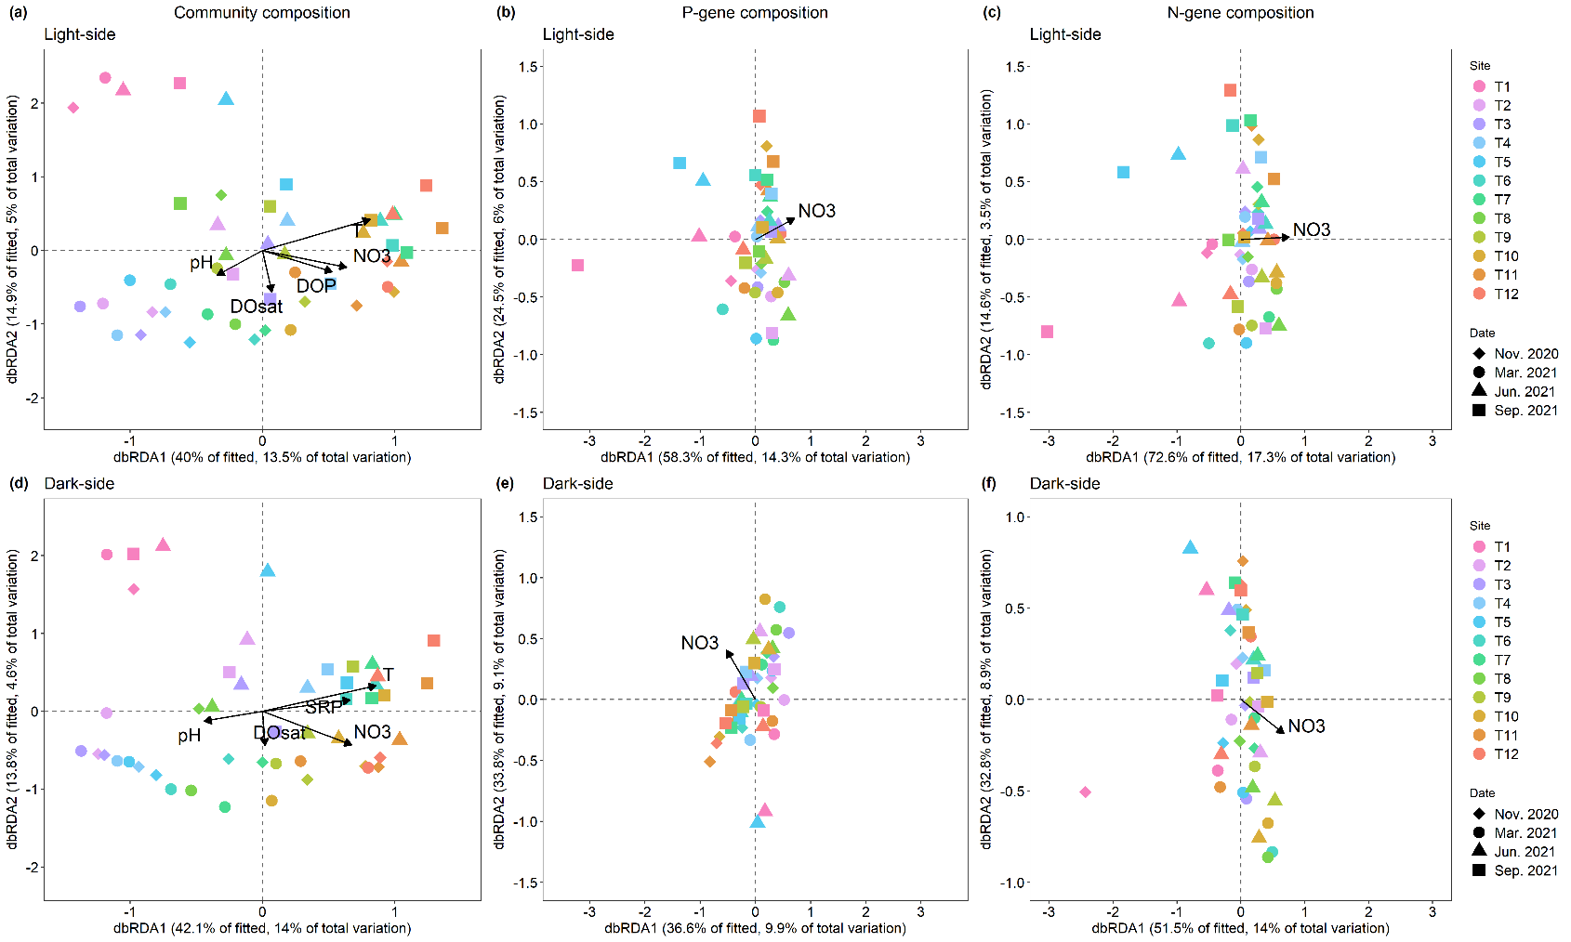

Figure S8. Relationships between taxonomic and functional Bray-Curtis dissimilarities in light- and dark-side biofilms for P-cycling genes (a) and N-cycling genes (b). Points represent pairwise comparisons between samples within each cobble side. Solid lines show multiple regression on distance matrices (MRM) fits describing the relationship between functional and taxonomic dissimilarity, with slopes estimated separately for light- and dark-side biofilms. P-values associated with each MRM model were < 0.001. The p-values shown in each panel correspond to paired permutation tests comparing slopes between light- and dark-side biofilms.
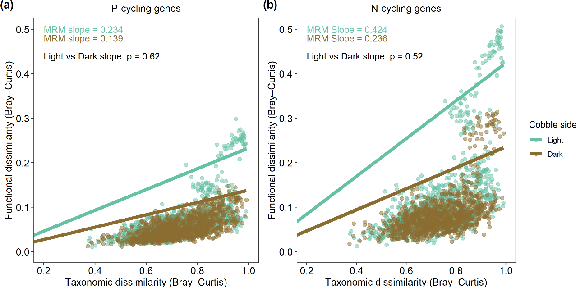
References
Djemiel C, Maron PA, Terrat S, Dequiedt S, Cottin A, Ranjard L (2022) Inferring Microbiota Functions from Taxonomic Genes: a Review. GigaScience 11: giab090. https://doi.org/10.1093/gigascience/giab090

