SUPPLEMENTARY FIGURES/TABLES
Table S1. Log-likelihood change of significant survival predictor models for LSD1 and its prognostic HIF-1 pathway DEGs.

(A) Individual terms in SGH cohort.

SGH cohort
Term | DFS |  |  |  | OS
Term | $$∆{LR}_{X^{2}}$$ | AIC | Logrank  P value | Logrank test | $$∆{LR}_{X^{2}}$$ | AIC | Logrank  P value | Logrank test
CP | Reference | 769.065 | 1.27e-06 | 32.864 | Reference | 536.602 | 1.15e-09 | 47.592
LSD1 IHC score
CP+LSD1 | 0.314 | 703.949 | 7.88e-06 | 31.379 | 1.797 | 504.431 | 1.56e-09 | 49.746
HIF-1 signaling pathway DEGs
CP+VEGFA | 3.637 | 714.725 | 2.47e-07 | 38.913 | 0.748 | 519.013 | 1.12e-09 | 50.453
CP+HIF1A | 1.123 | 719.753 | 2.51e-06 | 33.885 | 0.327 | 519.854 | 1.66e-09 | 49.611
CP+HK2 | 1.024 | 660.350 | 4.38e-06 | 32.666 | 0.008 | 463.802 | 7.41e-09 | 46.433
CP+ANGPT2 | 0.990 | 660.416 | 4.52e-06 | 32.600 | 0.272 | 463.273 | 5.78e-09 | 46.962
CP+ARNT | 0.201 | 721.596 | 5.83e-06 | 32.042 | 0.063 | 520.383 | 2.13e-09 | 49.082
CP+MTOR | 0.065 | 662.267 | 1.05e-05 | 30.749 | 0.021 | 463.776 | 7.33e-09 | 46.458
CP, Clinicopathological parameters (Diagnosis age, tumor grade, tumor size >20mm, lymph node status); AIC, Akaike Information Criterion; DFS, Disease-Free Survival; OS, Overall Survival.

(B) Added prognostic gene terms (LR value > 1) within LSD1 model in SGH cohort.

SGH cohort
Term | DFS |  |  |  | OS
Term | $$∆{LR}_{X^{2}}$$ | AIC | Logrank  P value | Logrank test | $$∆{LR}_{X^{2}}$$ | AIC | Logrank  P value | Logrank test
CP^{LSD1} | Reference | 703.949 | 7.88e-06 | 31.379 | Reference | 504.431 | 1.56e-09 | 49.746
Prognostic HIF-1 signaling pathway DEGs
CP^{LSD1}+VEGFA | 4.380 | 650.518 | 6.87e-07 | 39.091 | 1.078 | 487.371 | 1.01e-09 | 53.329
CP^{LSD1}+HK2 | 0.797 | 599.587 | 2.08e-05 | 31.451 | 0.056 | 435.736 | 1.61e-08 | 47.330
CP^{LSD1}+HIF1A | 0.712 | 657.854 | 1.82e-05 | 31.755 | 0.047 | 489.433 | 2.62e-09 | 51.267
CP^{LSD1}, LSD1 model (Diagnosis age, tumor grade, tumor size >20mm, lymph node status, LSD1 IHC score); AIC, Akaike information criterion

Table S2. Log-likelihood change of significant survival predictor models for LSD1 and its prognostic cell cycle-associated hub genes.

(A) Individual terms in FUSCC cohort.

FUSCC cohort
Term | RFS
Term | $$∆{LR}_{X^{2}}$$ | AIC | Logrank  P value | Logrank  test
CP | Reference | 337.247 | 3.02e-05 | 26.104
LSD1 gene expression
CP+LSD1 | 0.136 | 338.974 | 7.54e-05 | 26.376
Cell cycle-associated hub genes
CP+CDC25C | 0.814 | 337.620 | 4.11e-05 | 27.731
CP+CDC20 | 0.713 | 337.820 | 4.50e-05 | 27.530
CP+MCM7 | 0.597 | 338.053 | 4.99e-05 | 27.298
CP+MAD2L1 | 0.515 | 338.216 | 5.37e-05 | 27.135
CP+CCNE1 | 0.492 | 338.263 | 5.49e-05 | 27.087
CP+PLK1 | 0.379 | 338.488 | 6.07e-05 | 26.863
CP+E2F2 | 0.307 | 338.633 | 6.47e-05 | 26.718
CP+AURKB | 0.200 | 338.847 | 7.12e-05 | 26.504
CP+CCNB1 | 0.175 | 338.897 | 7.28e-05 | 26.454
CP+CCNA2 | 0.174 | 338.898 | 7.29e-05 | 26.452
CP+MYC | 0.159 | 338.929 | 7.39e-05 | 26.421
CP+CDC25A | 0.151 | 338.945 | 7.44e-05 | 26.406
CP+CDK4 | 0.084 | 339.080 | 7.91E-05 | 26.271
CP+ESPL1 | 0.049 | 339.150 | 8.16E-05 | 26.201
CP+MCM4 | 0.035 | 339.176 | 8.25E-05 | 26.175
CP, Clinicopathological parameters (Age at surgery, tumor grade, tumor size >20mm, lymph node status); AIC, Akaike information criterion

(B) Individual terms in METABRIC cohort.

METABRIC cohort
Term | RFS |  |  |  | OS
Term | $$∆{LR}_{X^{2}}$$ | AIC | Logrank  P value | Logrank test | $$∆{LR}_{X^{2}}$$ | AIC | Logrank  P value | Logrank test
CP | Reference | 1255.713 | 6.57e-09 | 43.950 | Reference | 1570.314 | 1.30e-10 | 52.126
LSD1 gene expression
CP+LSD1 | 0.175 | 1257.363 | 2.01e-08 | 44.300 | 0.658 | 1570.998 | 2.73e-10 | 53.442
Cell cycle-associated hub genes
CP+MCM4 | 0.812 | 1256.089 | 1.11e-08 | 45.573 | 0.282 | 1571.750 | 3.89e-10 | 52.690
CP+PLK1 | 0.607 | 1256.498 | 1.34e-08 | 45.165 | 1.107 | 1570.099 | 1.78e-10 | 54.341
CP+MYC | 0.498 | 1256.716 | 1.49e-08 | 44.946 | 0.023 | 1572.268 | 4.97e-10 | 52.172
CP+CDC20 | 0.429 | 1256.854 | 1.59e-08 | 44.808 | 0.393 | 1571.527 | 3.50e-10 | 52.913
CP+CDC25A | 0.348 | 1257.016 | 1.71e-08 | 44.646 | 0.290 | 1571.734 | 3.86e-10 | 52.706
CP+CDC25C | 0.285 | 1257.143 | 1.82e-08 | 44.520 | 0.001 | 1572.312 | 5.08e-10 | 52.128
CP+ESPL1 | 0.280 | 1257.152 | 1.82e-08 | 44.510 | 0.320 | 1571.673 | 3.76e-10 | 52.767
CP+CCNB1 | 0.241 | 1257.231 | 1.89e-08 | 44.432 | 0.064 | 1572.186 | 4.79e-10 | 52.254
CP+E2F2 | 0.117 | 1257.478 | 2.13e-08 | 44.184 | 0.021 | 1572.271 | 4.98e-10 | 52.169
CP+CCNE1 | 0.104 | 1257.504 | 2.15e-08 | 44.158 | 0.175 | 1571.964 | 4.31e-10 | 52.476
CP+CCNA2 | 0.090 | 1257.533 | 2.18e-08 | 44.129 | 0.238 | 1571.838 | 4.06e-10 | 52.602
CP+MAD2L1 | 0.031 | 1257.651 | 2.30e-08 | 44.011 | 0.142 | 1572.030 | 4.44e-10 | 52.410
CP+MCM7 | 0.026 | 1257.660 | 2.31e-08 | 44.002 | 0.101 | 1572.111 | 4.62e-10 | 52.329
CP+CDK4 | 0.005 | 1257.704 | 2.36e-08 | 43.959 | 0.026 | 1572.261 | 4.96e-10 | 52.178
CP+AURKB | 0.002 | 1257.708 | 2.37e-08 | 43.954 | 0.013 | 1572.288 | 5.02e-10 | 52.152
CP, Clinicopathological parameters (Diagnosis age, tumor grade, tumor size >20mm, lymph node status); AIC, Akaike information criterion
(C) Individual terms in TCGA cohort.

TCGA cohort
Term | DFS |  |  |  | OS
Term | $$∆{LR}_{X^{2}}$$ | AIC | Logrank  P value | Logrank test | $$∆{LR}_{X^{2}}$$ | AIC | Logrank  P value | Logrank test
CP | Reference | 64.762 | 0.0186 | 9.998 | Reference | 67.5568 | 0.0009 | 16.3992
LSD1 gene expression
CP+LSD1 | 1.195 | 64.372 | 0.0147 | 12.388 | 1.681 | 66.195 | 0.0006 | 19.761
Cell cycle-associated hub genes
CP+CCNE1 | 1.492 | 63.778 | 0.0114 | 12.982 | 1.282 | 66.993 | 0.0008 | 18.963
CP+E2F2 | 1.213 | 64.337 | 0.0145 | 12.423 | 0.537 | 68.484 | 0.0016 | 17.472
CP+MYC | 1.163 | 64.436 | 0.0151 | 12.324 | 1.124 | 67.309 | 0.0009 | 18.647
CP+MCM7 | 0.840 | 65.082 | 0.0199 | 11.678 | 0.571 | 68.414 | 0.0015 | 17.542
CP+PLK1 | 0.700 | 65.362 | 0.0224 | 11.398 | 1.016 | 67.526 | 0.0010 | 18.430
CP+MAD2L1 | 0.321 | 66.119 | 0.0309 | 10.641 | 0.798 | 67.960 | 0.0012 | 17.996
CP+AURKB | 0.122 | 66.517 | 0.0365 | 10.243 | 0.147 | 69.263 | 0.0022 | 16.693
CP+CDC20 | 0.103 | 66.556 | 0.0371 | 10.204 | 0.015 | 69.527 | 0.0025 | 16.429
CP+CCNA2 | 0.096 | 66.569 | 0.0373 | 10.191 | 0.007 | 69.543 | 0.0025 | 16.413
CP+CDK4 | 0.093 | 66.575 | 0.0374 | 10.185 | 0.026 | 69.506 | 0.0025 | 16.451
CP+MCM4 | 0.070 | 66.621 | 0.0381 | 10.139 | 0.089 | 69.379 | 0.0023 | 16.577
CP+CCNB1 | 0.070 | 66.621 | 0.0382 | 10.139 | 0.006 | 69.544 | 0.0025 | 16.412
CP+ESPL1 | 0.057 | 66.648 | 0.0386 | 10.112 | 0.116 | 69.325 | 0.0023 | 16.631
CP+CDC25A | 0.003 | 66.757 | 0.0404 | 10.003 | 0.009 | 69.538 | 0.0025 | 16.418
CP+CDC25C | 0.000 | 66.762 | 0.0405 | 9.998 | 0.301 | 68.955 | 0.0019 | 17.001
CP, Clinicopathological parameters (Diagnosis age, tumor stage, lymph node status); AIC, Akaike information criterion

(D) Summary table on expression trend and survival outcomes of prognostic cell cycle associated hub genes (LR value > 1).

Prognostic cell cycle-associated hub genes | TNBC cohort
Prognostic cell cycle-associated hub genes | FUSCC  RFS | METABRIC RFS | METABRIC OS | TCGA  DFS | TCGA  OS
PLK1 | High  (P = 0.056) | High  (P = 0.052) | High  (P = 0.064) | High  (P = 0.065) | High  (P = 0.1)
CCNE1 | High  (P = 0.28) | High  (P = 0.3) | High  (P = 0.26) | High  (P = 0.15) | High  (P = 0.41)
E2F2 | High  (P = 0.13) | High  (P = 0.058) | Low  (P = 0.29) | High  (P = 0.025) | High  (P = 0.22)
MYC | High  (P = 0.081) | Low  (P = 0.087) | Low  (P = 0.12) | High  (P = 0.015) | High  (P = 0.036)

Table S3. Details of antibodies used for IHC labelling of TNBC sections.
Antibody | Clone | Dilution | Source | Cellular localisation | Antigen retrieval | Positive control
LSD1 (IHC) | 1B2E5 | 1:25 | ThermoFisher Scientific mAb #41-3300 | Nucleus | H1(20 min) | Lung adenocarcinoma
IHC, Immunohistochemistry; LSD1, Lysine-specific demethylase 1; mAb, Monoclonal antibody.

Figure S1. Colony formation assays demonstrate that LSD1 inhibition (SP2509) significantly inhibits proliferation across different cancer cell lines.
(A) Representative colony formation images of five cancer cell lines (AGS, SW620, OVCAR8, SN12C, and HUCCT1) treated with vehicle control (upper row) or 1.5 µM SP2509 (lower row). Reduced colony density following SP2509 treatment is visually apparent across all cell lines. (B) Quantification of colony formation expressed as relative area of colonies (%) normalized to the vehicle control for each cell line. Grey bars represent vehicle control; red bars represent 1.5 µM SP2509 treatment. Data are presented as mean ± SEM. Asterisks (*) indicate statistically significant reduction in colony area with SP2509 treatment compared to control (p < 0.05). SP2509 treatment significantly suppressed colony formation across all five cell lines.

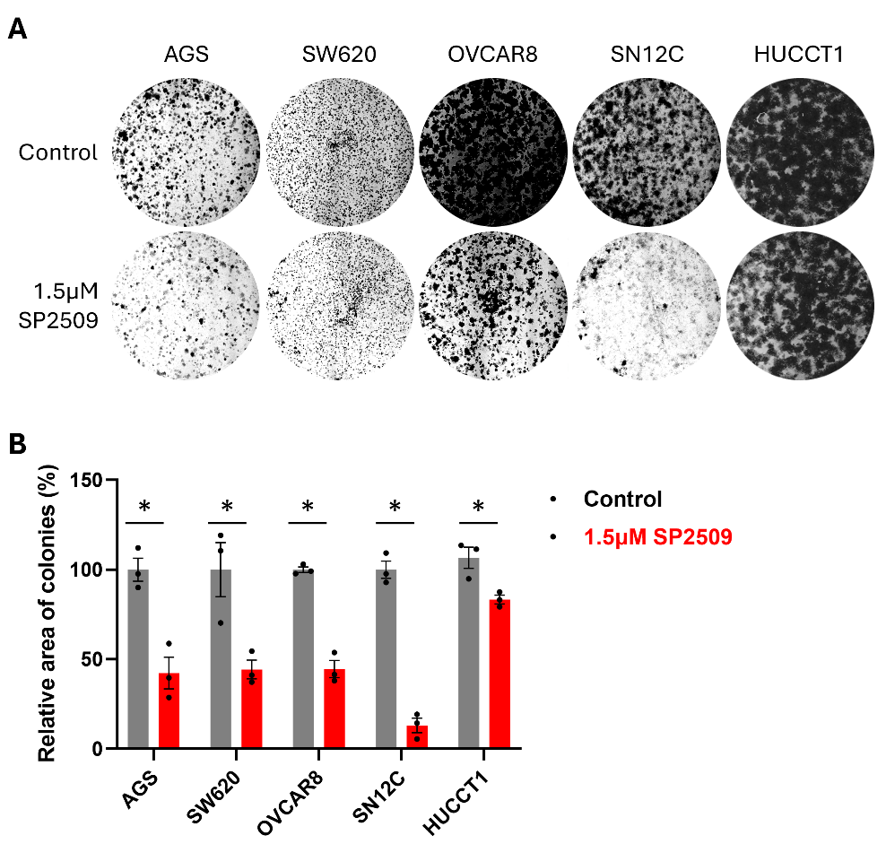

Figure S2. Functional enrichment analysis of genomic regions on 2,807 enriched LSD1 peaks identify hypoxia (Hallmark gene set, left) and primary immunodeficiency (KEGG gene set, right) regulatory pathways.

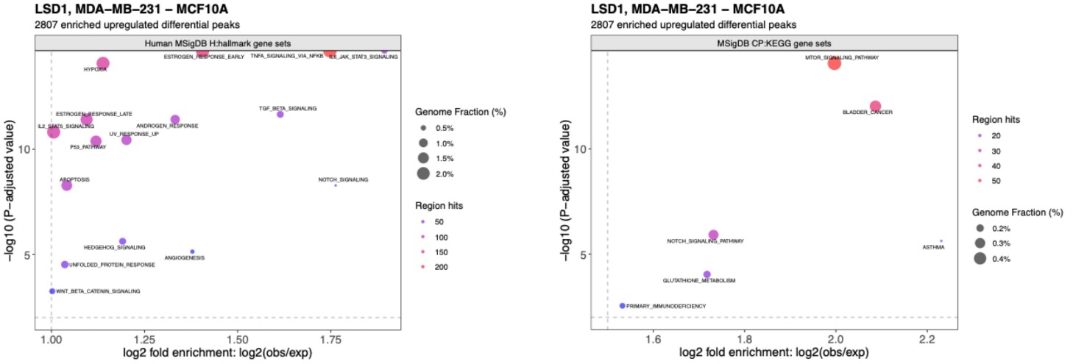

Figure S3. Characteristics of ChIP-seq and RNA-seq samples for human breast epithelial lines.
(A) PCA clustering projection on top two principal components for biological replicates. (B) Bar plot showing the number of identified LSD1 peaks for human breast epithelial lines. (C) Distribution of LSD1-specific peaks relative to genomic regions. (D) Distribution of LSD1 peak distance relative to TSS/promoter regions.
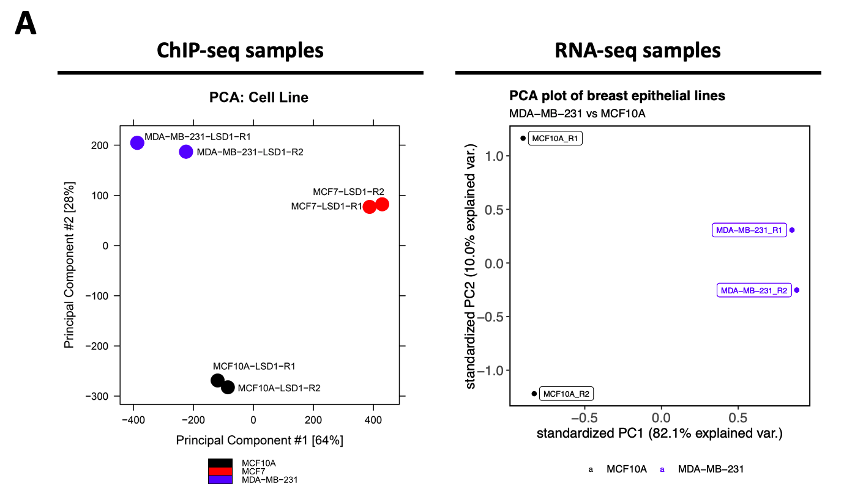
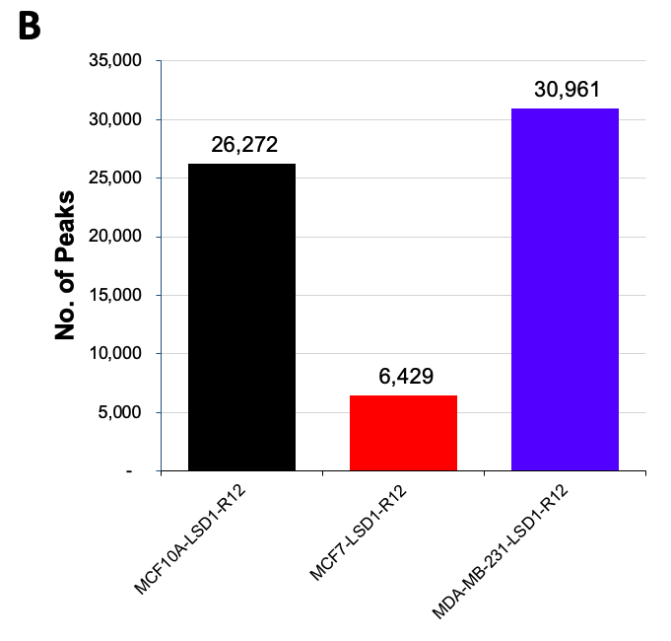
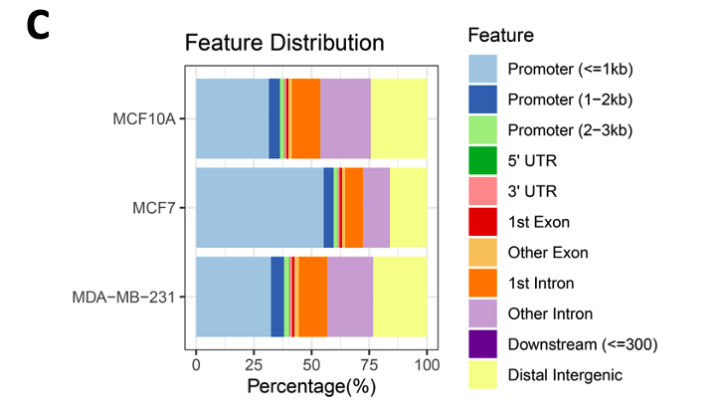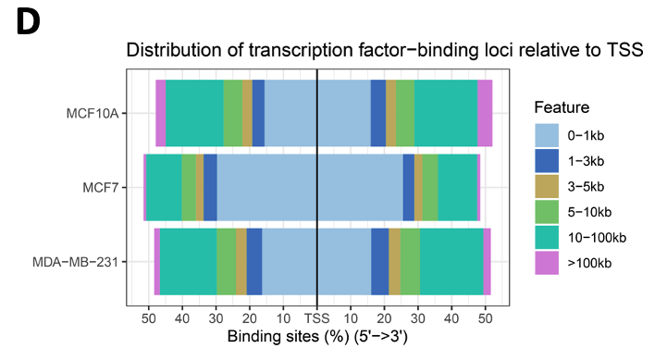

Figure S4. LSD1 tracks on enriched genes supporting cell cycle and hypoxia-associated pathways.
(A) LSD1 tracks on enriched genes mediating "cell cycle"-associated pathways (E2F targets, G2M checkpoint) visualized by Integrative Genomics Viewer. (B) LSD1 tracks on enriched genes supporting "hypoxia"-associated pathways visualized by Integrative Genomics Viewer. For gene schematics above the LSD1 tracks, lines indicate introns, boxes indicate exons, and arrowheads indicate the direction of transcription.

Figure S5. LSD1 inhibition alone or combined with chemotherapy enhances tumoricidal effects in patient-derived TNBC organoids.
(A) Immunofluorescence staining of nuclei (DAPI, blue) and tumor cells (Actin, red) in TNBC patient-derived xenograft organoids (PDXOs).
(B) Quantification of average organoid volume showing enhanced killing following LSD1 inhibition (SP2509, Phenelzine) alone and/or chemotherapy (cisplatin) treatment.

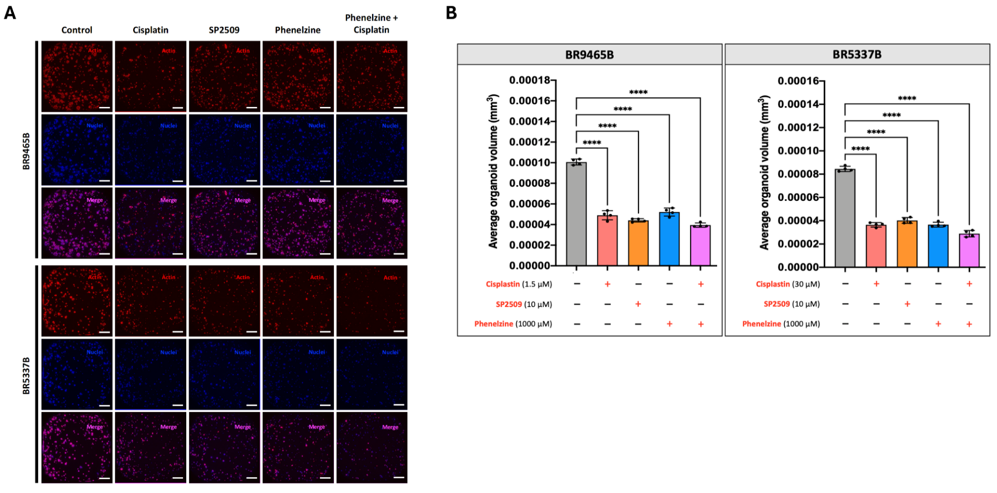

Figure S6. Enrichment of LSD1/KDM1A binding at HIF1A hypoxia-associated enhancer candidates in MDA-MB-231 cells using public ChIP-seq data (A) Proportion of replicated HIF1A hypoxia-associated enhancer candidates overlapping LSD1/KDM1A peaks under two enhancer-background definitions: distal H3K27ac and distal H3K27ac+ATAC (B) Enhancer-matched permutation analysis showing fold enrichment of overlap relative to matched enhancer backgrounds. Among 336 HIF1A hypoxia-associated enhancer candidates within the distal H3K27ac background, 221 overlapped LSD1/KDM1A peaks (65.8%; 77.7-fold enrichment; empirical p = 0.0005). Using the stricter distal H3K27ac+ATAC background, 141 of 232 candidates overlapped LSD1/KDM1A peaks (60.8%; 93.7-fold enrichment; empirical p = 0.0005). These results indicate significant enrichment of public LSD1/KDM1A occupancy at HIF1A-associated distal enhancer candidates.
