Supporting information
Injectable hydrogel coloading photothermal biomimetic nanoparticles combined with zirconium-based MOFs nanoadjuvant for augmenting immunotherapy
Hang Li ¹, Shuohong Tang ¹, Fengqi Sun ¹, Zixuan Wang ¹, Yani Liu ¹, Qi Wang ¹, Xun Wang ¹, Jiaping Zhou ¹, Jianying Chen ², Yihui Liu ², Song Xue ², Fang Wang ², Hao Wang ³and Xin Meng ^{1, 2}*
¹Key Laboratory of Industrial Microbiology, Ministry of Education, College of Biotechnology, Tianjin University of Science and Technology, Tianjin 300457, China.
²Shandong Academy of Pharmaceutical Sciences, Shandong Engineering Research Center of New Sustained and Controlled Release Formulations and Drug Targeted Delivery System, Jinan 250101, Shandong, P.R. China.
³Department of Radiological intervention, Tianjin First Central Hospital, Tianjin 300192, China.
Cell lines
Mouse breast cancer cells 4T1, human breast cancer cells MCF-7, mouse monocyte leukemia macrophages RAW264.7, human hepatocellular carcinoma cells HepG2, mouse fibroblasts L929, and mouse dendritic cells DC2.4 were purchased from Wuhan Procell Biotechnology Co., Ltd. The 4T1-Luc cell line was established by transfecting the Luc plasmid using PEI.
Extraction of 4T1 cancer cell membranes
4T1 cells were cultured and expanded in RPMI 1640 medium supplemented with 10% fetal bovine serum (FBS) and 1% penicillin-streptomycin under standard conditions (37°C, 5% CO₂, saturated humidity). Upon reaching confluence, the cells were digested with trypsin containing 0.25% EDTA. Digestion was terminated after 2 minutes with FBS-containing medium. Following collection, the cells were pelleted by centrifugation and resuspended in PMSF-containing hypotonic lysis buffer, then placed on ice for 15 min to ensure complete lysis. After four freeze-thaw cycles between liquid nitrogen and a 37°C water bath, the lysate was centrifuged at 800 g for 15 min at 4°C. The supernatant was carefully removed and centrifuged at 14,000 g for 2 h at 4°C. The resulting pellet was resuspended in 50 μL of PBS. Protein concentration was determined using the bicinchoninic acid (BCA) assay (Beyotime, Shanghai). The concentration was recorded, and the samples were stored at -80°C, remaining valid for use within 3 months.
RAW264.7 macrophage membrane extraction
RAW264.7 cells were cultured in DMEM containing 200 ng/mL lipopolysaccharide (LPS) and harvested using a cell scraper. M1-polarized RAW264.7 cell membranes were extracted using the method described above for 4T1 cell membranes.
Isolation of BMDM
Sacrifice 6-8 weeks male C57BL/6 mice and carefully separate the femur and tibia from the hind legs. Immerse in 75% ethanol for 3 minutes, then transfer to PBS for washing. Cells were dislodged from the bone marrow cavity using DMEM/F12 medium, collected by centrifugation after ACK red staining, and subsequently induced to differentiate into BMDMs using DMEM/F12 containing G-MCSF under hypoxic conditions.
Calculation of the photothermal conversion efficiency (η) of MPI
The η value of MPI was calculated by monitoring the temperature change of an MPI aqueous solution containing 50 μg mL⁻¹ ICG under near-infrared irradiation at 808 nm (power density 2 W cm⁻²) for 5 minutes, based on the following formula (1):
$\text{η}\text{=}\frac{\text{h}\text{A}\left({\text{T}}_{\text{max}}\text{-}{\text{T}}_{\text{surr}}\right)\text{-}{\text{Q}}_{\text{Dis}}}{\text{I}\left(\text{1-}{\text{10}}^{\text{-}{\text{A}}_{\text{λ}}}\right)}$ (1)
Where h is the heat transfer coefficient, A is the surface area of the container, T_{max} and T_{surr} represent the equilibrium temperature and ambient temperature respectively, Q_{Dis} is the heat loss generated by the container absorbing light, which is negligible in this system as its value is approximately zero; I is the incident laser power; A_{λ} is the absorbance of MPI at a wavelength of 808 nm.
τ_{s} is the sample system time constant, which can be calculated from the linear time data during the cooling phase using the negative natural logarithm of the driving temperature; m_{d} is the mass (1.0 g), and c_{d} is the heat capacity (4.2 J/(g•K)).
${\text{τ}}_{\text{s}}\text{=}\frac{{{\text{c}}_{\text{d}}\text{m}}_{\text{d}}}{\text{h}\text{A}}$ (2)
In vitro hemolysis rate test
Mix rabbit whole blood with PBS at a 1:4 volume ratio and centrifuge at 1500 rpm for 20 minutes. Subsequently, mix the red blood cells with PBS at a 1:9 volume ratio to form a red blood cell suspension. Add different masses of gel (6, 12, 24, and 36 mg) to 1 mL of red blood cell suspension to form the experimental groups. The positive control group was established by adding 1 mL of PBS to 1 mL of red blood cell suspension. The negative control group was established by adding 1 mL of deionized water to 1 mL of red blood cell suspension. After incubating the above samples at 37°C for 1 hour, centrifuge at 3000 rpm for 10 minutes. The in vitro hemolysis rate (HR) was calculated using formula (3) by measuring the absorbance (OD value) at 545 nm wavelength:
$\text{HR(\%)=}\frac{\text{O}{\text{D}}_{\text{sample}}\text{-O}{\text{D}}_{\text{Negative}}}{\text{O}{\text{D}}_{\text{Positive}}\text{-O}{\text{D}}_{\text{Negative}}}\text{×100\% }$ (3)
Swelling and degradation of hydrogels
Hydrogels were immersed in PBS solutions with pH values of 7.4 and 5.8. They were placed in a shaking incubator at 37°C and shaken thoroughly. The mass of the hydrogels was weighed at regular intervals (1, 2, 4, 8, 12, 16, 24, and 32 h). Before each weighing, excess surface moisture was gently blotted with filter paper. Water absorption was calculated using the formula (4):
$\text{Swelling ratio}\left(\text{\%}\right)\text{=}\frac{{\text{W}}_{\text{t}}\text{-}{\text{W}}_{\text{o}}}{{\text{W}}_{\text{o}}}\text{×100\%}$ (4)
Where Wo and Wt were the original weight of the hydrogel and the weight at a specific time, respectively.
Weigh the prepared freeze-dried gel, then place it in PBS containing 1 U/mL hyaluronidase at pH = 5.8 and pH = 7.4. Remove and weigh the freeze-dried gel at each time point (1, 3, 5, 7, 10, 14 days). Calculate the degradation rate of the hydrogel based on mass changes using the formula (5) below:
$\text{Weight loss ratio}\left(\text{\%}\right)\text{=}\frac{{\text{W}}_{\text{o}}\text{-}{\text{W}}_{\text{t}}}{{\text{W}}_{\text{o}}}\text{×}\text{100\%}$ (5)
Where Wo and Wt were the original and time-specific lyophilization weights of the hydrogel, respectively.

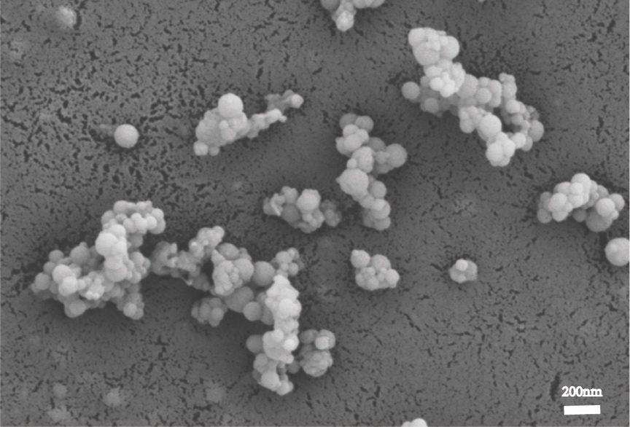
Fig. S1. The scanning electron microscope image of MPI.

Fig. S2. RAW264.7 Macrophage cell membrane extraction polarization verification.

Fig. S3. SDS-PAGE electrophoresis patterns of 4T1 cell membranes, RAW264.7 cell membranes, and hybrid membranes.

Fig. S4. Images of CLSM treated with different fusion methods of M1-type RAW264.7 macrophage cell membranes and 4T1 cell membranes.

Fig. S5. CLSM images of the non-homologous targeting ability of different cells to MPI.

Fig. S6. Morphological changes in RAW264.7 cells under different drug treatment groups. Scale bar: 50 μm

Fig. S7. Heat map of differential gene expression levels in BMDM after cluster analysis.

Fig. S8. Anatomical diagram of the distal tumor.

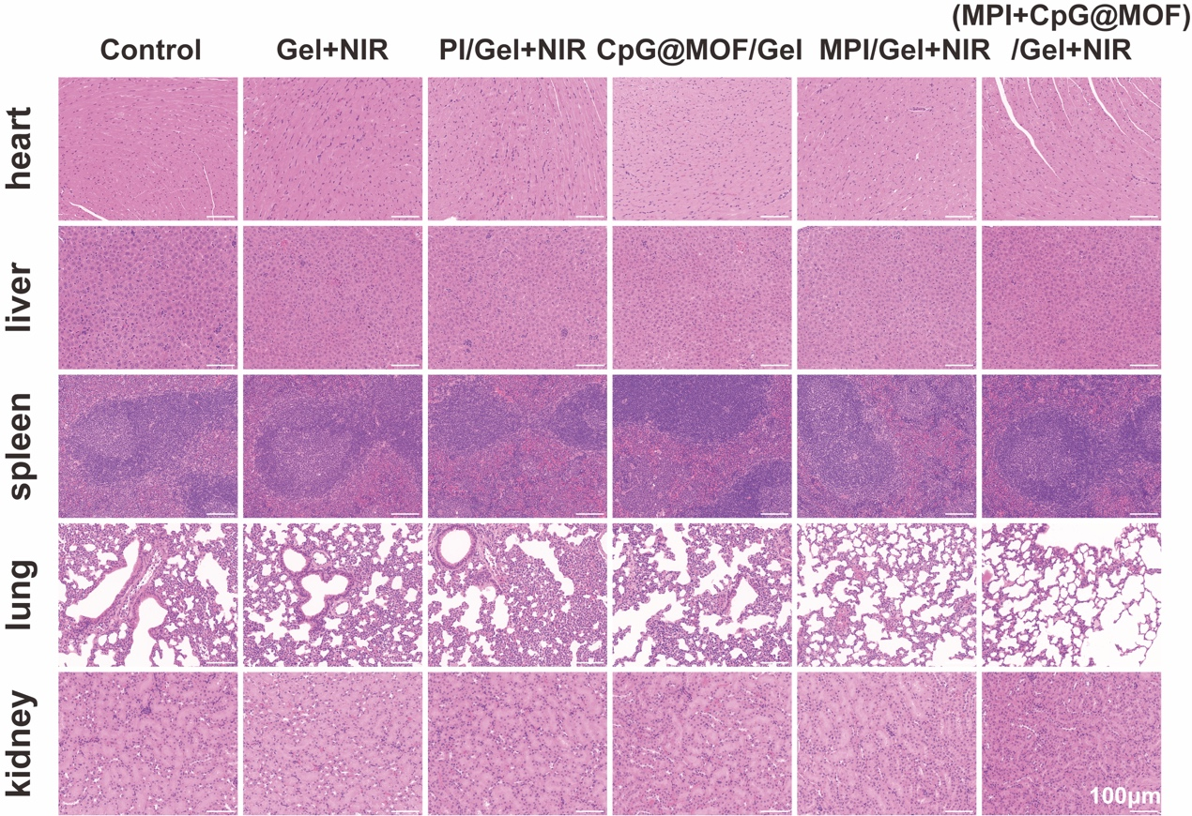
Fig. S9. H&E-stained sections of heart, liver, spleen, lung, and kidney from mice in each experimental group. Scale bar: 100 μm

Fig. S10. Flow cytometry diagram of in situ M2-type tumor-associated macrophages.

Tab. S1. Primers used in qRT-PCR analysis of DC2.4.
 | F-primer | R-primer
Actin-β | GGCTGTATTCCCCTCCATCG | CCAGTTGGTAACAATGCCATGT
TNF-α | GATCGGTCCCCAAAGGGATG | CCACTTGGTGGTTTGTGAGTG
IFN-γ | GAGGTCAACAACCCACAGGT | GGGACAATCTCTTCCCCACC
IL-12P70 | TTGAACTGGCGTTGGAAGCACG | CCACCTGTGAGTTCTTCAAAGGC
IL-1β | TGGACCTTCCAGGATGAGGACA | GTTCATCTCGGAGCCTGTAGTG

