Supplementary Figure S1. Decision curve analysis for the random forest model.
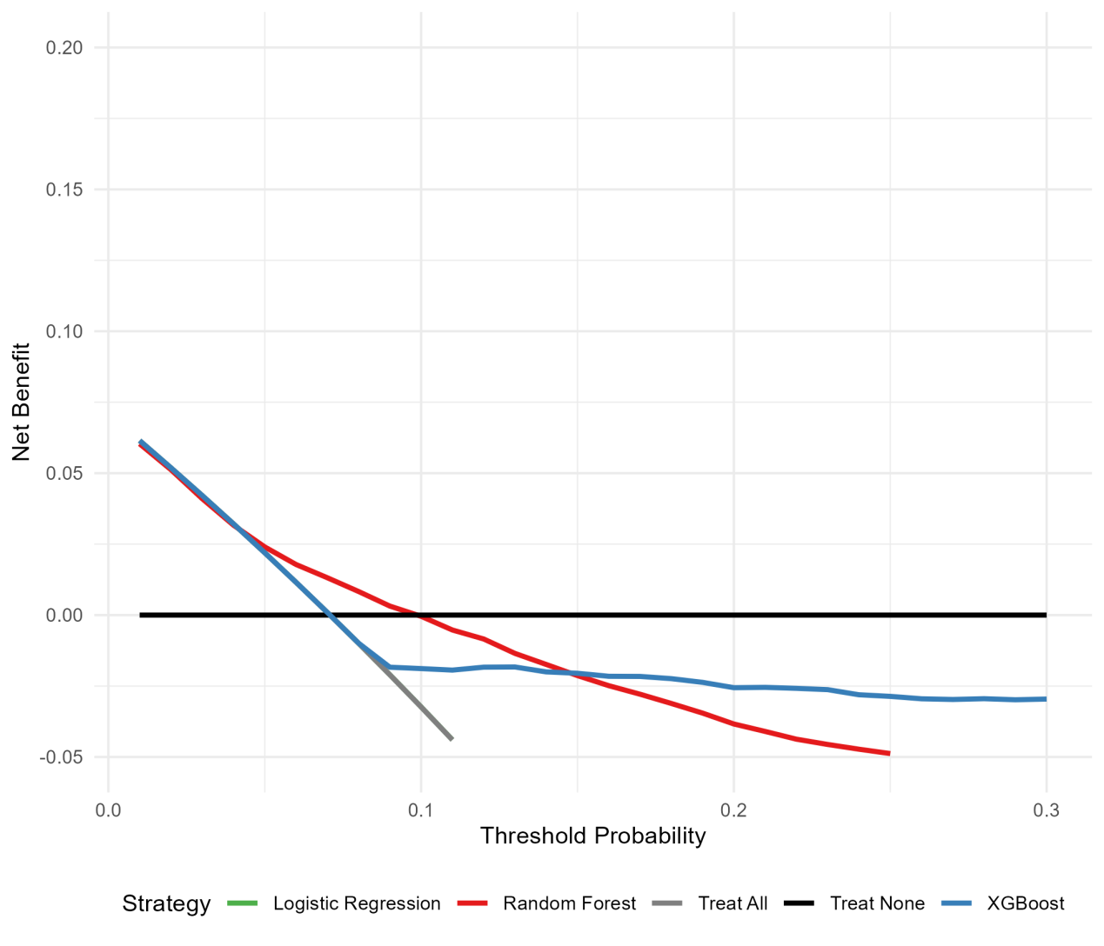
Net benefit is plotted against threshold probability. The “Treat None” line (dashed) represents no intervention. The model curve (solid line) shows net benefit using predicted probabilities. In the threshold range 0.01-0.30, net benefit of the model was consistently ≤0 and did not exceed the “Treat None” strategy.

