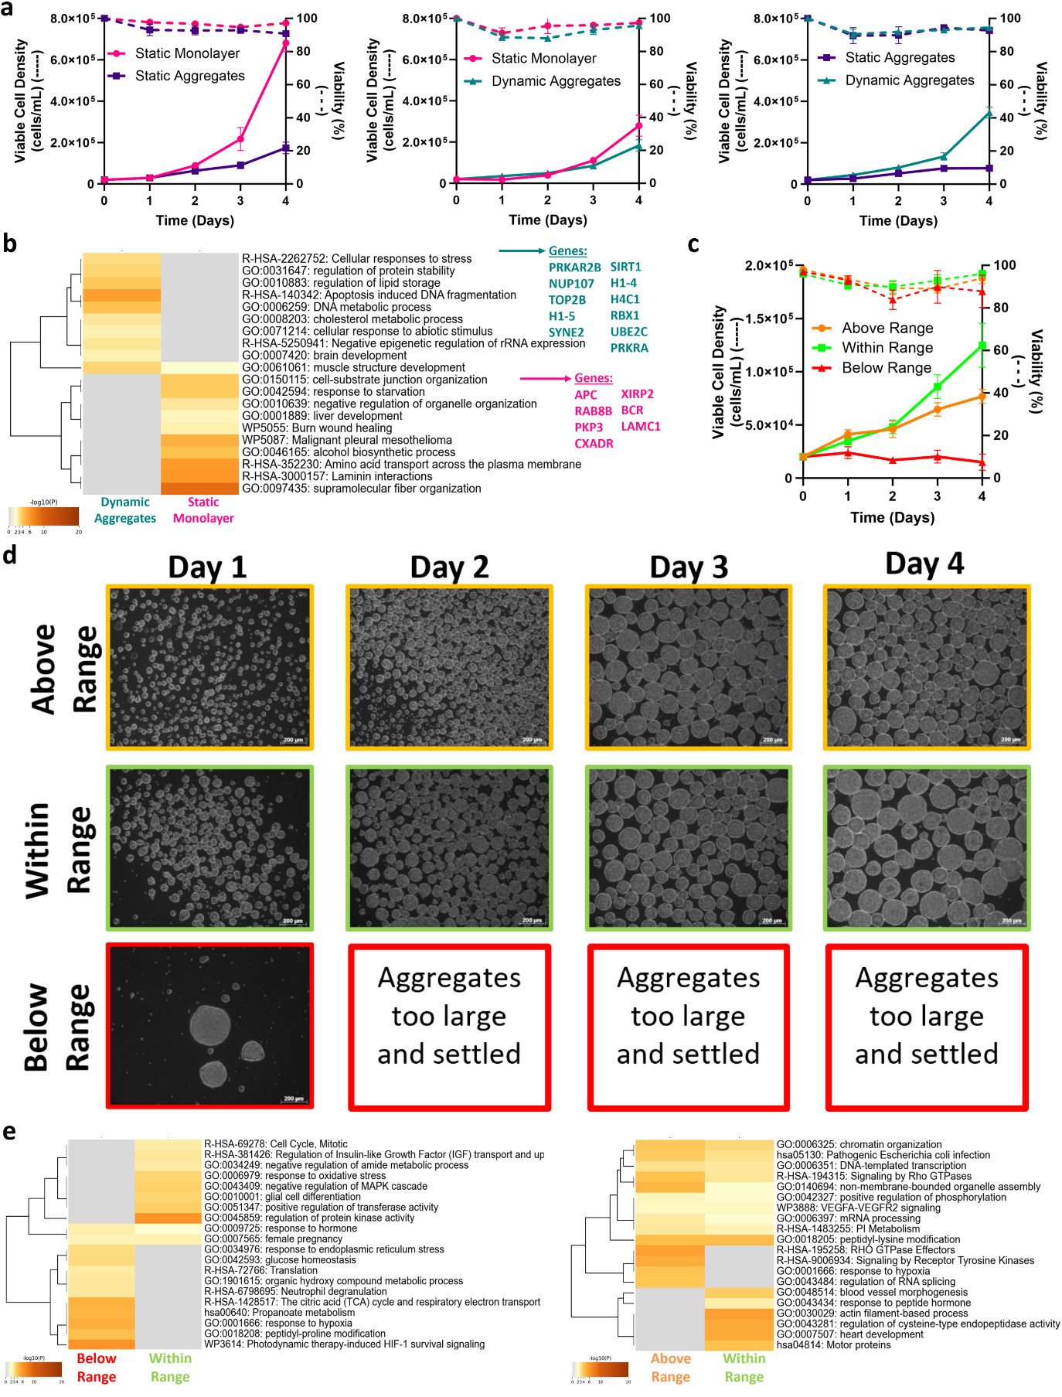
Supplementary Figure 1: Growth kinetics and extended proteomics data. (a) Growth kinetics for comparisons of static monolayer, static aggregates, and dynamic aggregates. (b) Metascape highlighted terms comparing dynamic aggregates with static monolayer. (c) Growth kinetics for dynamic cultures. (d) Morphology under dynamic culture from days 1 to 4. (e) Metascape analysis showing significant terms above and below range relative to within range.
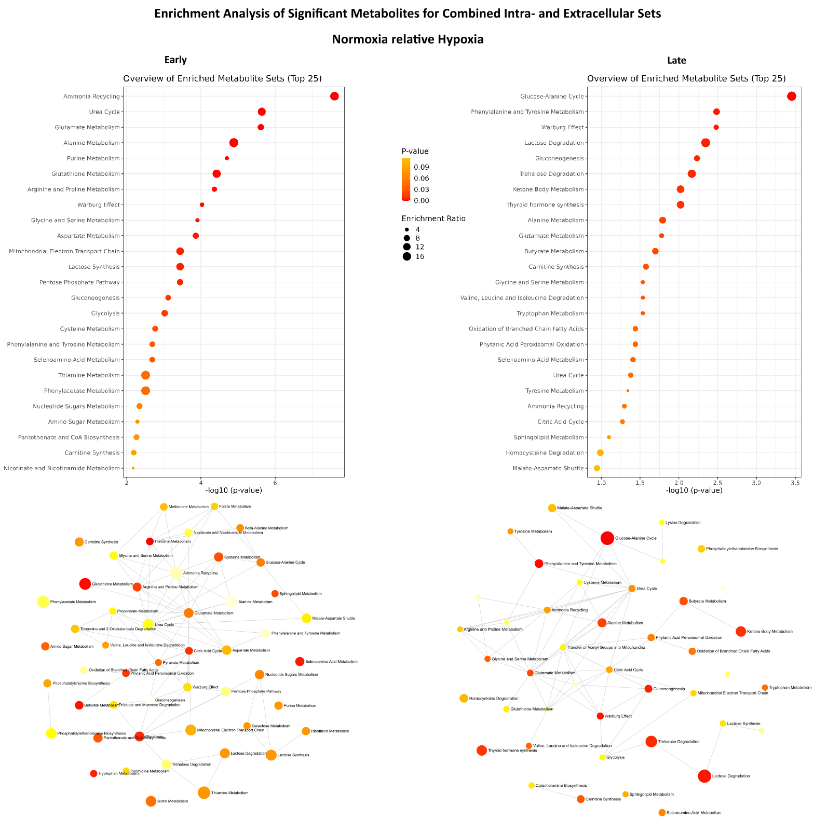

Supplementary Figure 2: Metabolic analysis coupling both intra- and extracellular metabolites meeting differential thresholds.
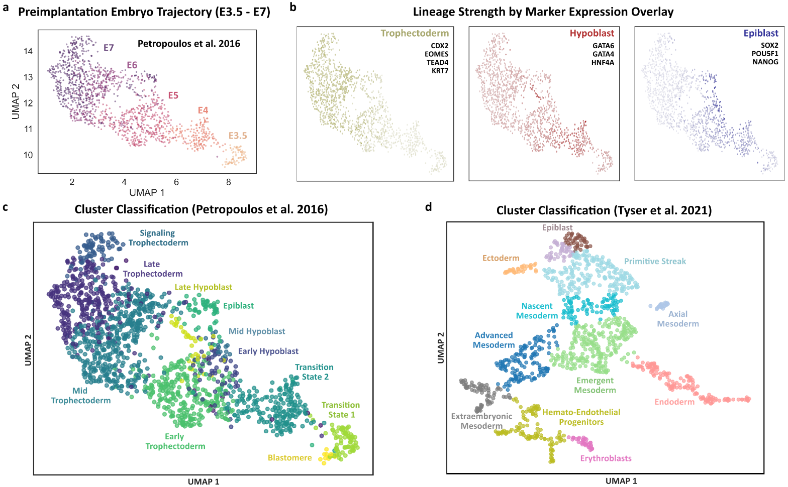

Supplementary Figure 3: Classification of preimplantation and early gastrulating embryo reference datasets. (a) Temporally color-mapped single cell data from Petropoulos et al., 2016. (b) Observation of clusters isolated by overlaying the relative strength of expression across selected markers for trophectoderm, hypoblast, and epiblast. (c) K-means clustering and classification of groups by cell type in the Petropoulos et al. dataset. (d) Classification of early gastrulating cell types in Tyser et al., 2021.

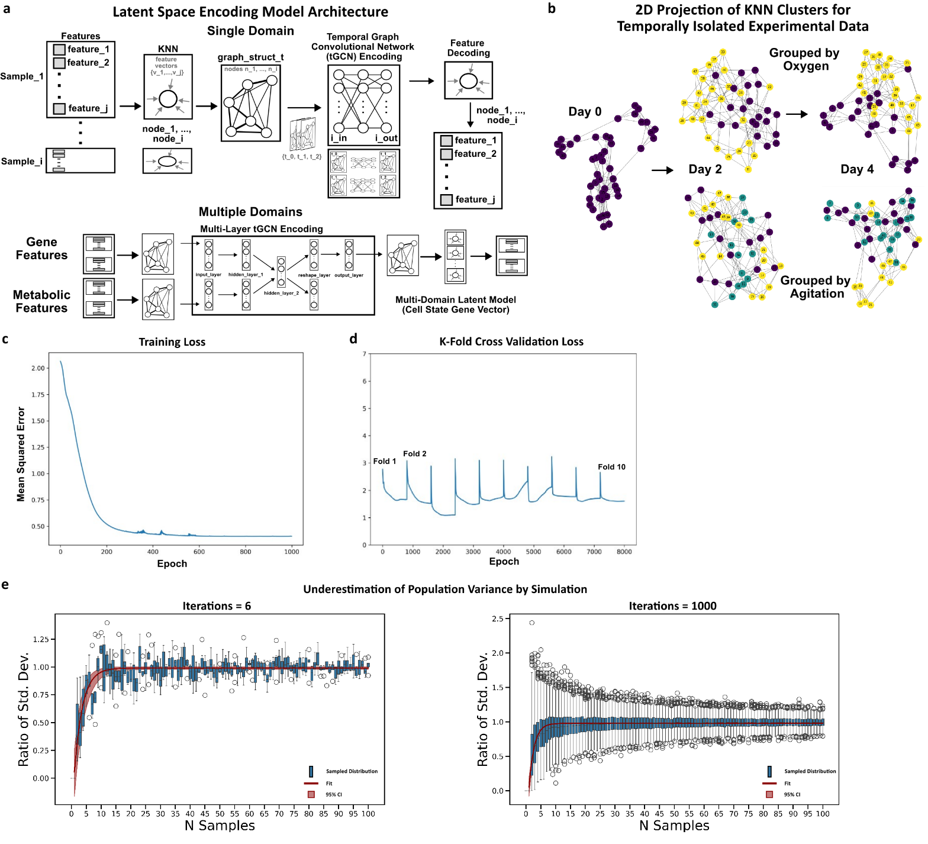

Supplementary Figure 4: Deep learning approach and performance outcomes utilizing a graph structured organization of cell state across omics domains. (a) Temporal graph convolutional network model implementation for single and multiple modality implementations. (b) Two-dimensional visualization of KNN clusters organized into graph representations across conditions and timepoints. (c) Training loss of the multi-domain deep learning architecture (80/20 train-test split). Note that datasets were augmented as described in the methods (n=56). (d) Resultant validation loss across 10 randomized folds.

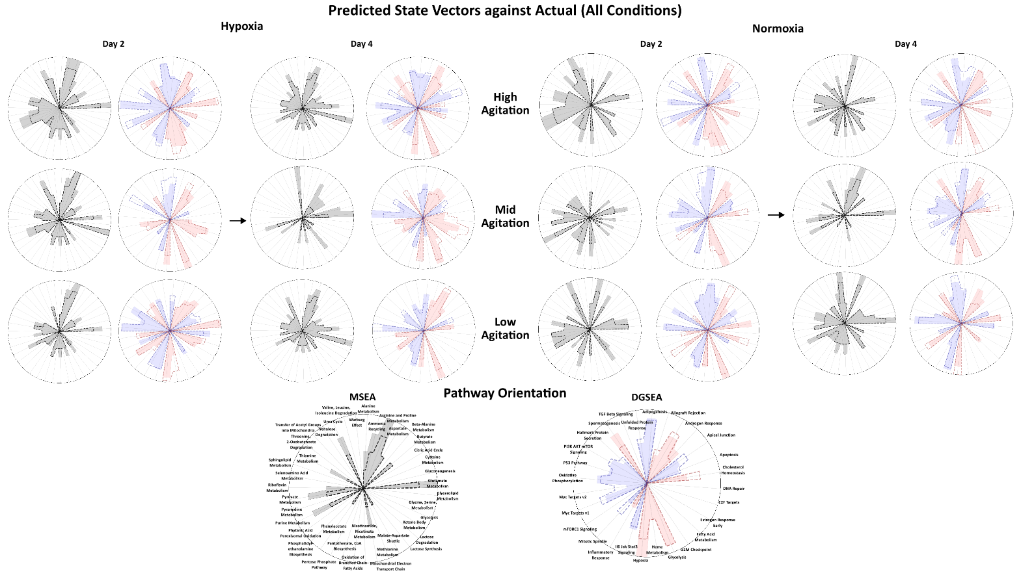
Supplementary Figure 5: Distribution and propagation of predicted outcomes to hallmark signatures across the condition space. (a) Simulation of underrepresentation of variance by sampling distribution size and trial for a normal population distribution with unit variance. (b) Propagation outcomes (DGSEA and DMEA) across the experimental condition space.

