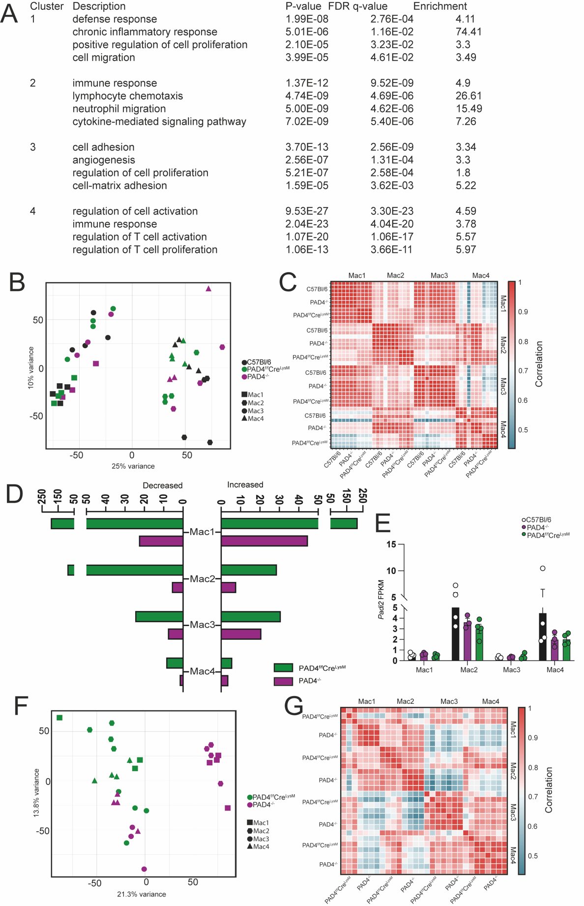

Supplementary Figure 1: A) Pathways enriched in gene clusters 1-4 in Mac1-4 populations sorted from N=4 C57Bl/6 mice. B) PCA plot showing intrasample variance between Mac1-4 populations from N=4 C57Bl/6, N=3 PAD4^{-/-}, and N=4 PAD4^{f/f}Cre^{LysM} mice. C) Pairwise Pearson correlation between FPKM gene expression in synovial macrophage subpopulations from N=4 C57Bl/6, N=3 PAD4^{-/-}, and N=4 PAD4^{f/f}Cre^{LysM} mice. D) Number of significantly different (padj <0.05) expressed genes in PAD4^{-/-} or PAD4^{f/f}Cre^{LysM} compared to C57Bl/6. E) Expression of Padi2 gene in from N=4 C57Bl/6, N=3 PAD4^{-/-}, and N=4 PAD4^{f/f}Cre^{LysM} mice. F) PCA plot showing intrasample variance between Mac1-4 populations from N=4 PAD4^{-/-}, and N=4 PAD4^{f/f}Cre^{LysM} mice during peak STIA (D7). G) Pairwise Pearson correlation between FPKM gene expression in synovial macrophage subpopulations from N=4 PAD4^{-/-}, and N=4 PAD4^{f/f}Cre^{LysM} mice. In both F-G 1 Mac1 and 1 Mac3 replicates were removed due to sequencing error.

