APPENDIX 1: Initial search (up until Dec 2020)

PubMed (n=60)

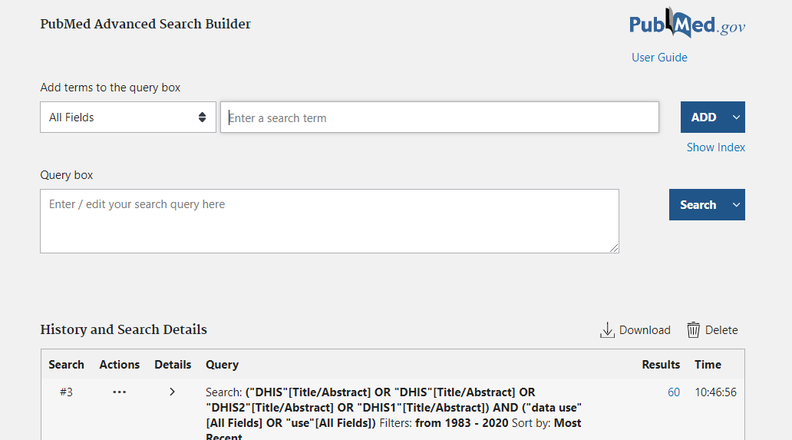

Web of Science (n = 83)
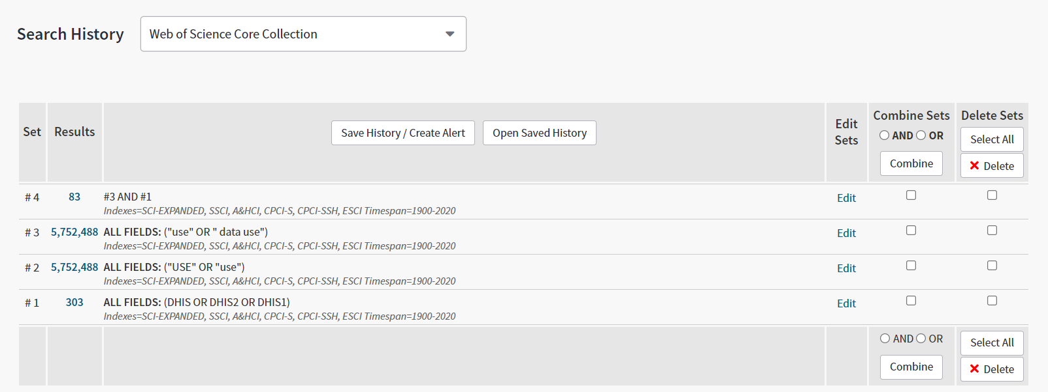

Embase (n=98)

