Table S1. Effect of different IPM modules on coccinellid population, 2020-2021.
IPM Module | Number of Coccinellids/plant  (DAT-Days after transplanting)
IPM Module | 15 | 25 | 35 | 45 | 55 | 65 | Mean
M1 : FPM (Farmers Practice Module) | 0.20  (1.09) | 0.50  (1.22) | 0.60  (1.26) | 0.50  (1.22) | 0.70  (1.30) | 0.80  (1.34) | 0.55  (1.22)
M2: Bio-intensive module | 0.50  (1.22) | 0.70  (1.30) | 0.75  (1.32) | 0.90  (1.37) | 1.00  (1.41) | 0.80  (1.34) | 0.78  (1.34)
M3: Chemi-intensive Module | 0.00  (1.00) | 0.20  (1.09) | 0.20  (1.09) | 0.30  (1.14) | 0.50  (1.22) | 0.50  (1.22) | 0.28  (1.14)
M4 : Adoptable IPM Module | 0.10  (1.04) | 0.20  (1.09) | 0.25  (1.09) | 0.40  (1.18) | 0.60  (1.26) | 0.30  (1.14) | 0.31  (1.14)
Control | 0.50  (1.22) | 0.70  (1.30) | 0.90  (1.11) | 1.40  (1.54) | 1.70  (1.64) | 1.40  (1.54) | 1.10  (1.41)
SEm (±) | 0.004 | 0.006 | 0.007 | 0.007 | 0.009 | 0.009 | 0.007
CD at 5% | 0.012* | 0.020 | 0.023 | 0.023 | 0.028 | 0.028 | 0.022
DAT-Days after transplanting, Figures in parenthesis are square root (√ x+0.5) transformed values.
Table S2. Effect of different IPM modules on coccinellid population, 2021-2022.
IPM Module | Number of Coccinellids/plant  (DAT-Days after transplanting)
IPM Module | 15 | 25 | 35 | 45 | 55 | 65 | Mean
M1 : Farmers Practice Module | 0.4  (1.18) | 0.5  (1.22) | 0.8  (1.34) | 1.0  (1.41) | 0.7  (1.30) | 0.7  (1.30) | 0.68  (1.30)
M2: Bio-intensive module | 0.7  (1.30) | 0.9  (1.37) | 0.8  (1.34) | 1.3  (1.51) | 1.3  (1.51) | 0.9  (1.37) | 0.93  (1.37)
M3: Chemi-intensive Module | 0.3  (1.14) | 0.5  (1.22) | 0.7  (1.30) | 0.6  (1.26) | 0.9  (1.37) | 0.3  (1.14) | 0.55  (1.22)
M4 : Adoptable IPM Module | 0.1  (1.049) | 0.4  (1.18) | 0.5  (1.22) | 0.4  (1.18) | 0.6  (1.26) | 0.4  (1.18) | 0.40  (1.18)
Control | 0.8  (1.34) | 0.7  (1.30) | 1.2  (1.48) | 1.4  (1.54) | 1.9  (1.70) | 1.5  (1.58) | 1.25  (1.51)
SEm (±) | 0.006 | 0.007 | 0.009 | 0.011 | 0.009 | 0.009 | 0.009
CD at 5% | 0.019* | 0.022 | 0.028 | 0.034 | 0.029 | 0.027 | 0.027
DAT-Days after transplanting, Figures in parenthesis are square root (√ x+0.5) transformed values.

Figure S1. Dynamics of spiders and coccinellids under different IPM modules, 2020-2021.

Figure S2. Dynamics of spiders and coccinellids under different IPM modules, 2021-2022.

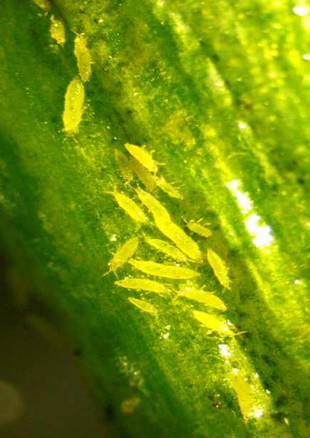
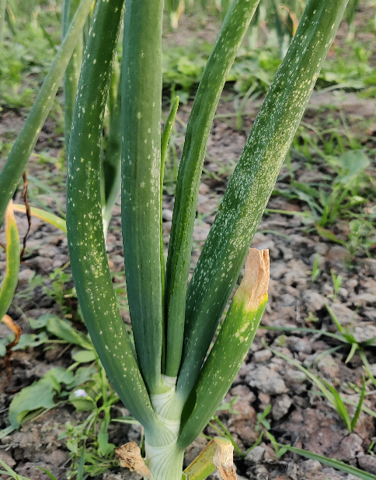

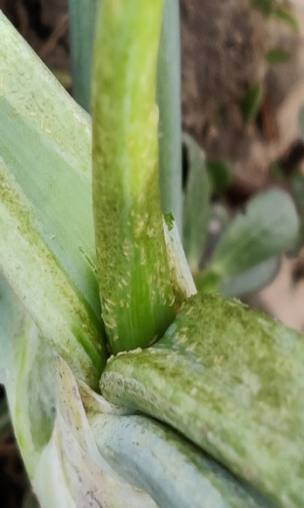
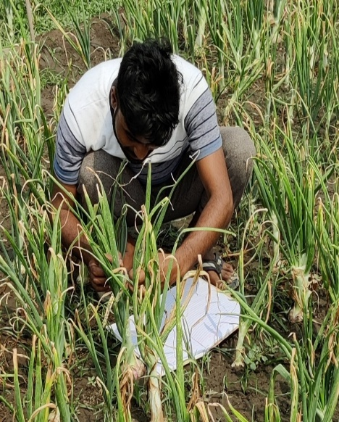
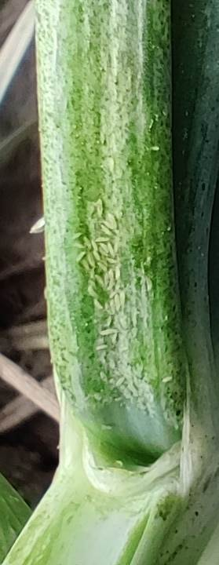
(a). Larvae feeding on leaves (b). Feeding symptoms caused by T. tabaci

(c). Observation (d). T. tabaci infestation
Figure S3. Evaluation of IPM modules: (a) Larvae feeding on leaves; (b) Feeding symptoms caused by T. tabaci; (c) Observation of infestation; (d) T. tabaci infestation.

Figure S4. Different kinds of spiders feeding on T. tabaci: (e-h).

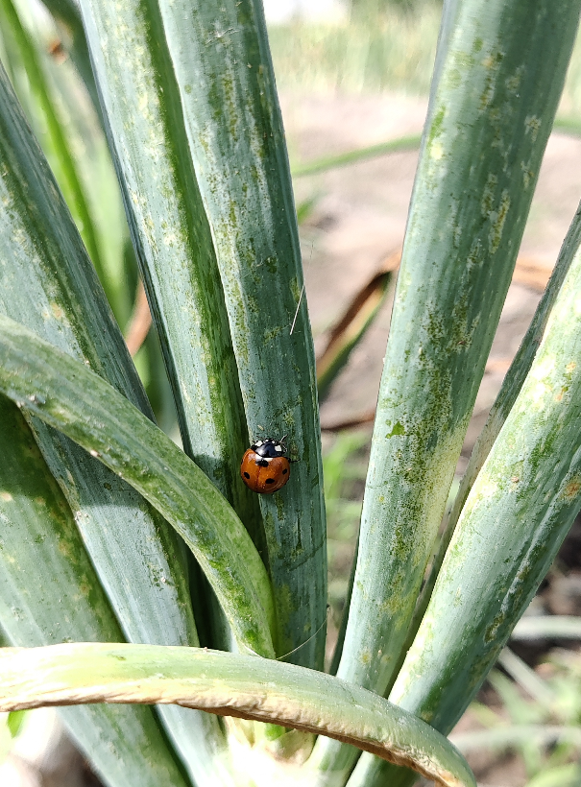
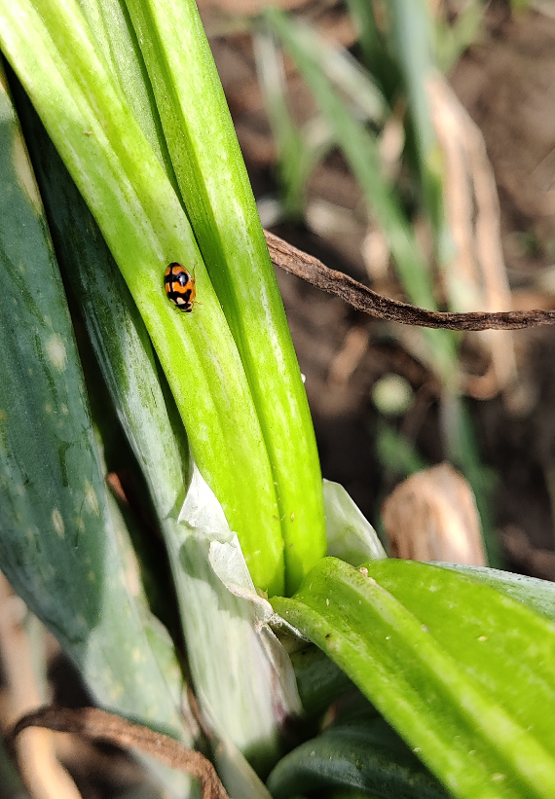

(a). Coccinella septempunctata (b) Coccinella transversalis
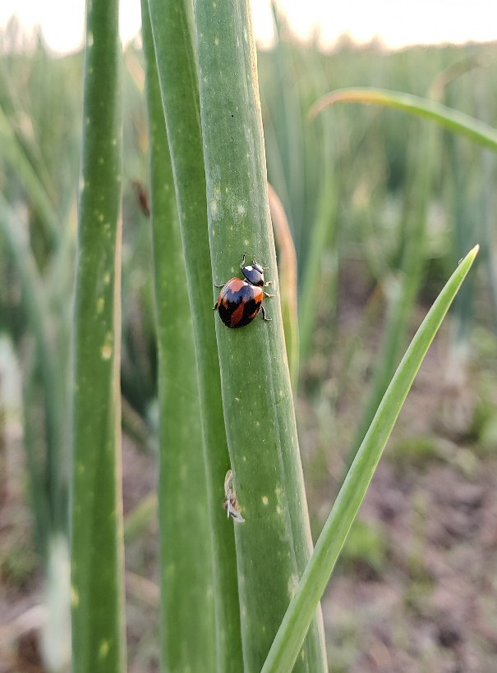

(c) Coccinella septempunctata
Figure S5: Different kinds of Coccineliids feeding on T. tabaci (a-c)

