Supplementary Material
Computational Clinical Validation of Stage-conditioned Synthetic 3D FDG-PET for Alzheimer’s Disease Using Region-wise Metabolic Consistency
Supplementary Table S1. AAL Regions included in aggregation by anatomical lobe.
Anatomical | AAL Regions Included
Frontal | 'Precentral gyrus', 'Superior frontal gyrus, dorsolateral', 'Superior frontal gyrus, medial', 'Superior frontal gyrus, medial orbital', 'Superior frontal gyrus, orbital part', 'Middle frontal gyrus', 'Middle frontal gyrus, orbital part', 'Inferior frontal gyrus, opercular part', 'Inferior frontal gyrus, triangular part', 'Inferior frontal gyrus, orbital part', 'Gyrus rectus', 'Supplementary motor area', 'Rolandic operculum'.
Parietal | 'Postcentral gyrus', 'Superior parietal gyrus', 'Inferior parietal, but supramarginal and angular gyri', 'Supramarginal gyrus', 'Angular gyrus', 'Precuneus'.
Temporal | 'Superior temporal gyrus', 'Middle temporal gyrus', 'Inferior temporal gyrus', 'Heschl gyrus', 'Parahippocampal gyrus', 'Temporal pole: middle temporal gyrus', 'Temporal pole: superior temporal gyrus', 'Mesial temporal lobe'.
Occipital | 'Calcarine fissure and surrounding cortex', 'Cuneus', 'Lingual gyrus', 'Fusiform gyrus', 'Inferior occipital gyrus', 'Middle occipital gyrus', 'Superior occipital gyrus'.
Limbic | 'Anterior cingulate and paracingulate gyri', 'Middle cingulate and paracingulate gyri', 'Posterior cingulate and paracingulate gyri', 'Cingulate and paracingulate gyri', 'Amygdala', 'Hippocampus', 'Insula', 'Olfactory cortex'.
Subcortical | 'Thalamus', 'Caudate nucleus', 'Lenticular nucleus, pallidum', 'Lenticular nucleus, putamen', 'Corpus striatum', 'Basal ganglia'.
Cerebellum | 'Cerebellum', 'Cerebellum_3', 'Cerebellum_4_5', 'Cerebellum_6', 'Cerebellum_7b', 'Cerebellum_8', 'Cerebellum_9', 'Cerebellum_10', 'Cerebellum_Crus1', 'Cerebellum_Crus2', 'Vermis_1_2', 'Vermis_3', 'Vermis_4_5', 'Vermis_6', 'Vermis_7', 'Vermis_8', 'Vermis_9', 'Vermis_10'.

Supplementary Figure S1. Region-wise FDG uptake deviations for Normal Cognition (NC) – Detail panels

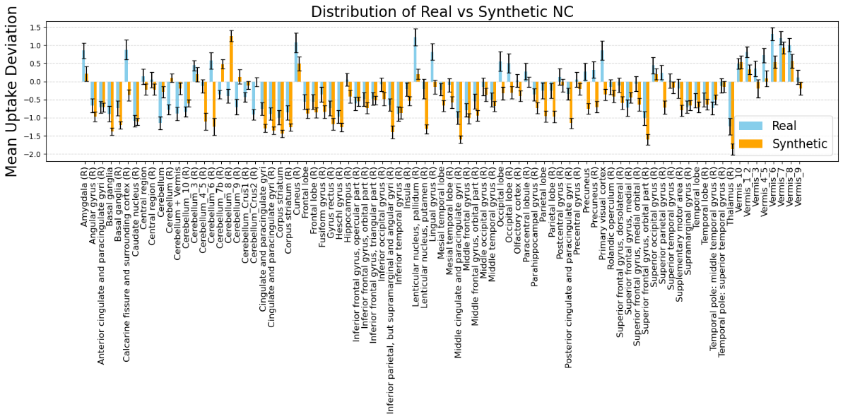

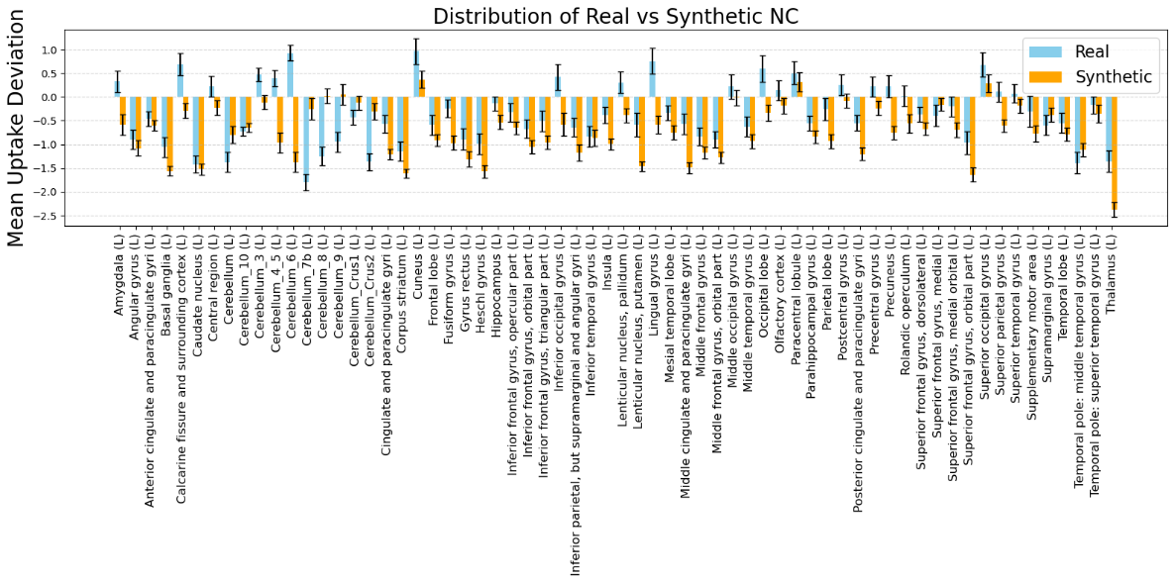
Figure S1. (Top) Right and non-lateralized AAL regions – NC subjects. Bars represent the mean deviation in FDG uptake for each AAL region between real and synthetic PET scans, with error bars showing standard error across subjects. (Bottom). Left AAL regions – NC subjects. Same metrics as above for all left-lateralized AAL regions.

Supplementary Figure S2. Region-wise FDG uptake deviations for Mild Cognitive Impairment (MCI) – Detail panels

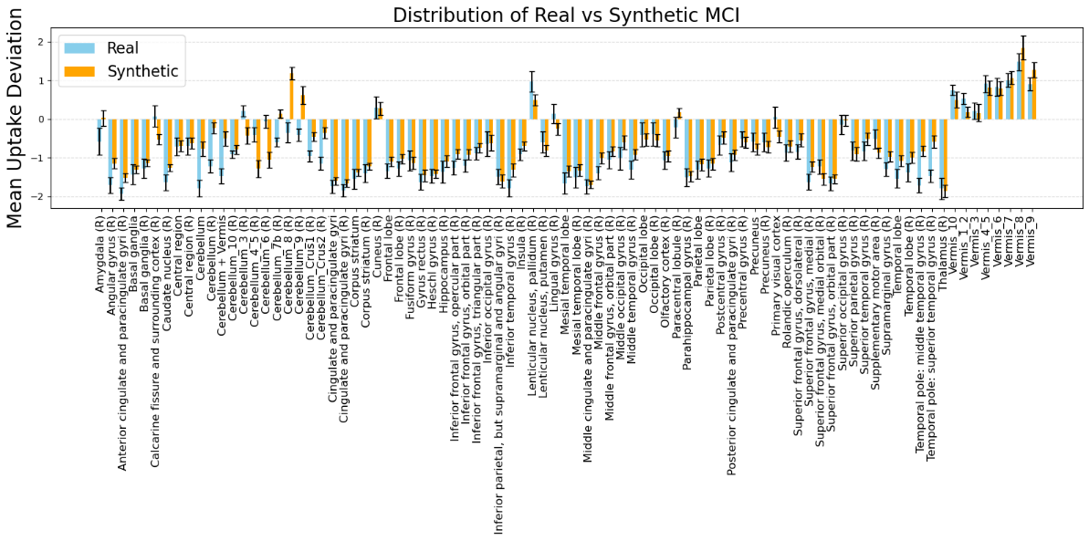

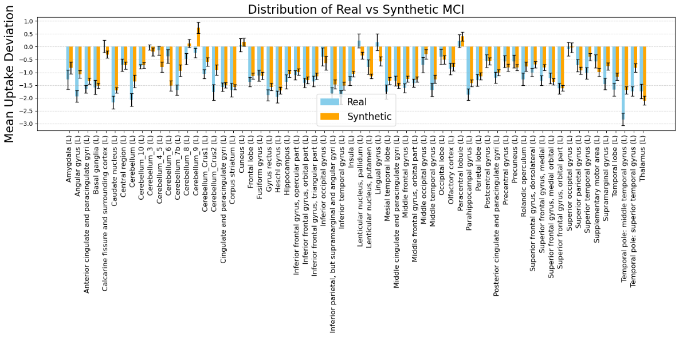
Figure S2. (Top) Right and non-lateralized AAL regions – MCI subjects. Bars represent the mean deviation in FDG uptake for each AAL region between real and synthetic PET scans, with error bars showing standard error across subjects. (Bottom). Left AAL regions – MCI subjects. Same metrics as above for all left-lateralized AAL regions.

Supplementary Figure S3. Region-wise FDG uptake deviations for Alzheimer’s Disease (AD) – Detail panels

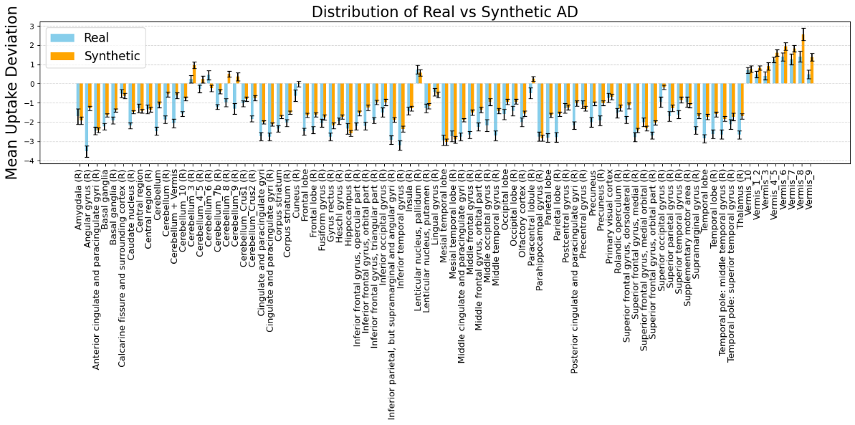

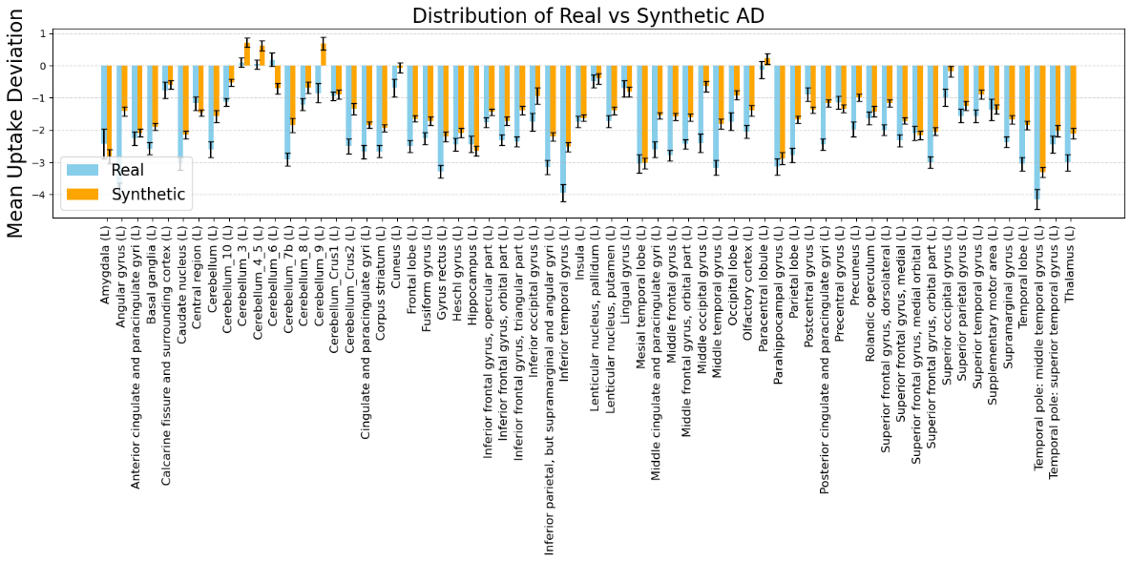
Figure S3. (Top) Right and non-lateralized AAL regions – AD subjects. Bars represent the mean deviation in FDG uptake for each AAL region between real and synthetic PET scans, with error bars showing standard error across subjects. (Bottom). Left AAL regions – AD subjects. Same metrics as above for all left-lateralized AAL regions.

