Materials and methods
CCK-8 assay
Cells were seeded in 96-well plates at a density of 1 × 10³/well and were cultured overnight in a cell incubator. After 24 h, fresh complete medium was replaced in the α-MEM group, and α-MEM+PRF group was replaced with α-MEM+PRF medium. The medium was changed every 3 days. After culturing for 1, 3, 5, 7 days, 10 μl CCK-8 was added to each well. The plate was shaken to mix well, and the cells were incubated in a cell incubator for 1 h. The absorbance was measured at 450 nm wavelength.
Cell fluorescence staining
For showing cell proliferation status more visually, cells were seeded in 24-well plates at a density of 1 × 10⁴/well. Cells were fixed in 4% paraformaldehyde in for 30 min after culturing for 1, 3, 5, 7 days in α-MEM or α-MEM+PRF and incubated with FITC (Sigma, USA) and DAPI (Sigma, USA) respectively dying cytoplasm and nucleus. Cell density was observed by inverted fluorescent microscopy (Olympus, Japan) on different days.
Results
The CCK-8 results showed cell activity increased first and began to decrease at day 5. Compared with α-MEM group, the cell activity of α-MEM+PRF group was higher, and the difference was statistically significant (p<0.05) (Fig Appendix 1). Moreover, the detailed cell morphological parameters were displayed by fluorescence staining (Fig Appendix 2), the numbers of cells in the α-MEM+PRF group were significantly more than that in the α-MEM group at day 1, 3, 5 and 7.
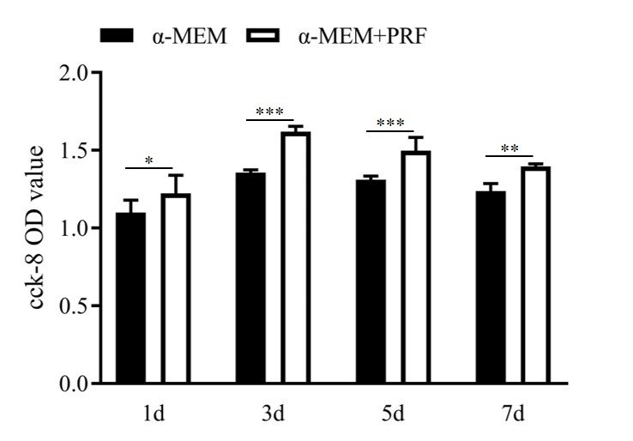
Fig Appendix 1. Cell activity increased first and then decreased. Compared with α-MEM group, the cell activity of α-MEM+PRF group was higher, and the difference was statistically significant (p<0.05). * p<0.05, **p<0.01, ***p<0.001 indicate a significant difference between the groups.

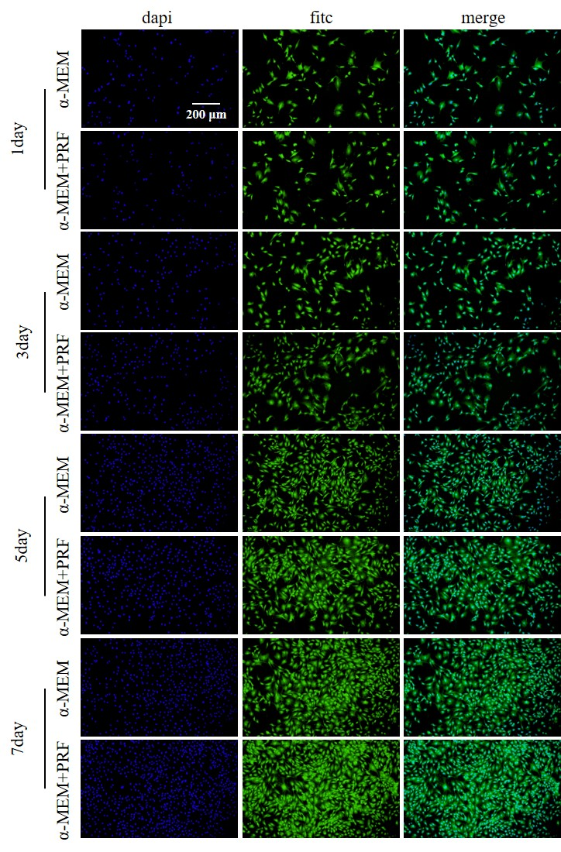
Fig Appendix 2. The numbers of cells in the α-MEM+PRF group were significantly more than that in the α-MEM group at 1, 3, 5 and 7 days.

