Supplementary Materials for
Growth-front complexions deliver stacking faults and Σ2 grain boundaries
Xiaoyuan Ye^{1,2,†}, Huiling Chen^{1,2,†}, Huanhuan Hong³, Xinfu Gu⁴, Lili Zheng^{1,2}, Xinyang Li⁴, Congying Xiang^{1,2}, Fuzhi Dai⁴, Haibin Wang³*, Xiaoyan Song³*, Zhiyang Yu^{1,2}*
¹State Key Laboratory of Chemistry for NBC Hazards Protection, College of Chemistry, Fuzhou University, Fuzhou 350116, P. R. China.
²State Key Laboratory of Photocatalysis on Energy and Environment, College of Chemistry, Fuzhou University, Fuzhou 350116, P. R. China.
³State Key Laboratory of Materials Low-Carbon Recycling, Key Laboratory of Advanced Functional Materials, MOE, College of Materials Science and Engineering, Beijing University of Technology, Beijing 100124, P. R. China.
⁴School of Materials Science and Engineering, University of Science and Technology Beijing, Beijing, 100083, P. R. China.
†These authors contributed equally: Xiaoyuan Ye and Huiling Chen
*Corresponding author. Email: whb@bjut.edu.cn (H.B.W.); xysong@bjut.edu.cn (X.Y.S.); yuzyemlab@fzu.edu.cn (Z.Y.Y.)

The PDF file includes:

Supplementary Figures. 1-10

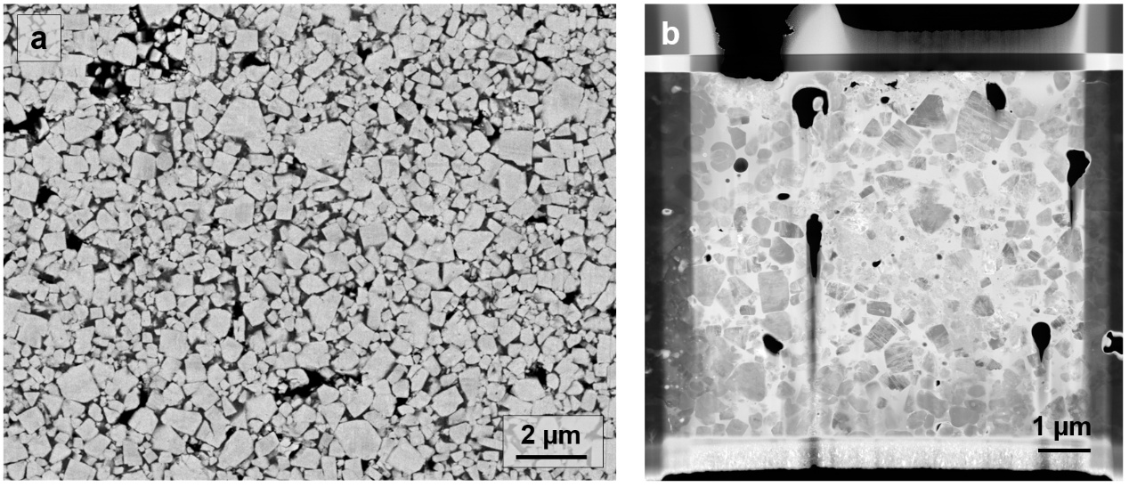

Supplementary Figure 1. Microstructural overview of the WC-Co coating and FIB-prepared lamella. a Scanning electron microscopy (SEM) image of the WC-Co coating, in which WC grains display well-defined morphology and the binder Co phase forms an interconnected network. b Low-magnification TEM image showing a lamella extracted from the central region of (a) by focused ion beam (FIB) milling.

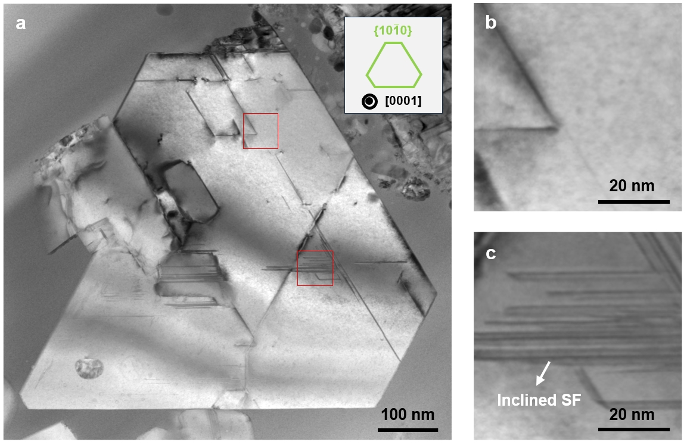

Supplementary Figure 2. Projection geometry of stacking faults in WC near the [0001] zone axis. a Representative WC grain along the [0001] zone axis, exhibiting abundant line contrasts parallel to the prismatic {10$\overline{\text{1}}$0} planes. The inset illustrates the projected morphology, characterized by an ideal truncated triangular shape bounded by {10$\overline{\text{1}}$0} facets (green lines). b-c Enlarged views of the red-boxed region in (a). The stacking-fault traces appear narrow and nearly edge-on in (b), but display a finite width in (c), indicating an inclined fault plane.

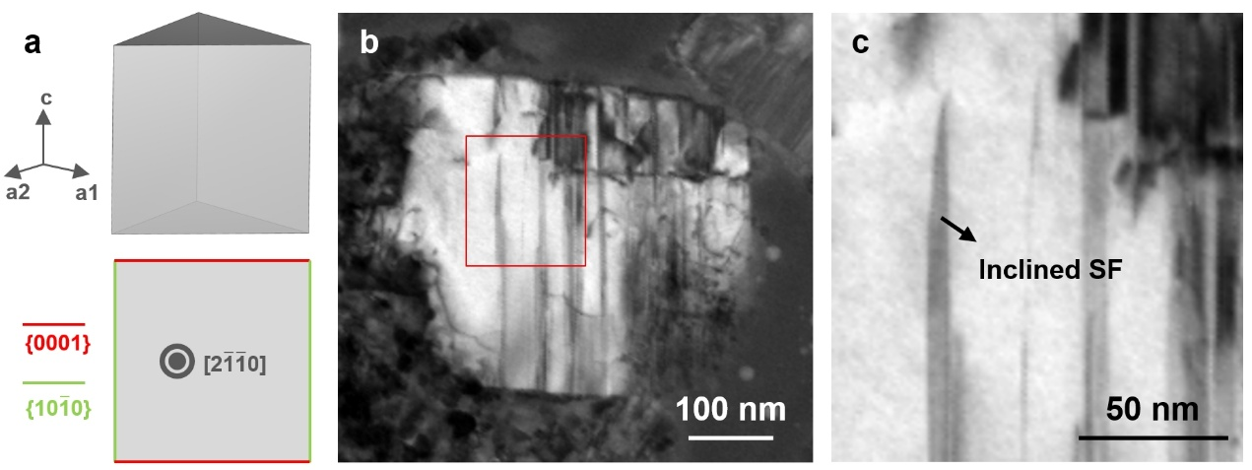

Supplementary Figure 3. Projection geometry of stacking faults in WC along the [2$\overline{\text{1}}\overline{\text{1}}$0] zone axis. a Schematic representation of a WC trigonal prism and its projected outline along the [2$\overline{\text{1}}\overline{\text{1}}$0] zone axis, with {0001} and {10$\overline{\text{1}}$0} facets marked by red and green lines, respectively. b Low-magnification bright-filed (BF) image of a WC grain along the [2$\overline{\text{1}}\overline{\text{1}}$0] zone axis. c Expanded image of the boxed region in (b), in which the dark contrast arises from inclined stacking faults with a finite projected width (black arrows).
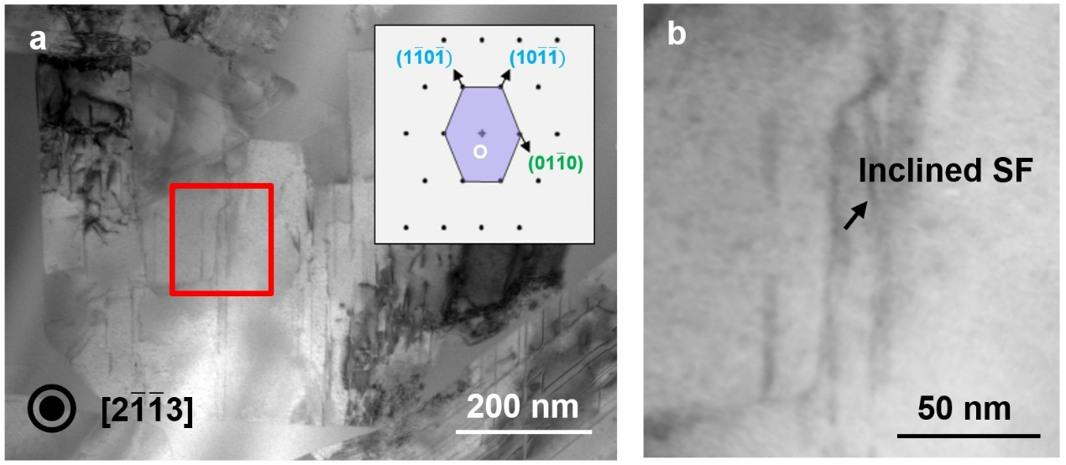

Supplementary Figure 4. Crystallographic imaging of a WC grain revealing inclined stacking faults parallel to the (01$\overline{\text{1}}$0) prismatic plane. a Low-magnification bright-field (BF) image of a WC grain along the [2$\overline{1}\overline{1}$3] zone axis. The inset shows the corresponding simulated diffraction pattern, in which only one (01$\overline{\text{1}}$0) prismatic plane is visible. b Magnified image revealing inclined stacking faults parallel to the prismatic plane.

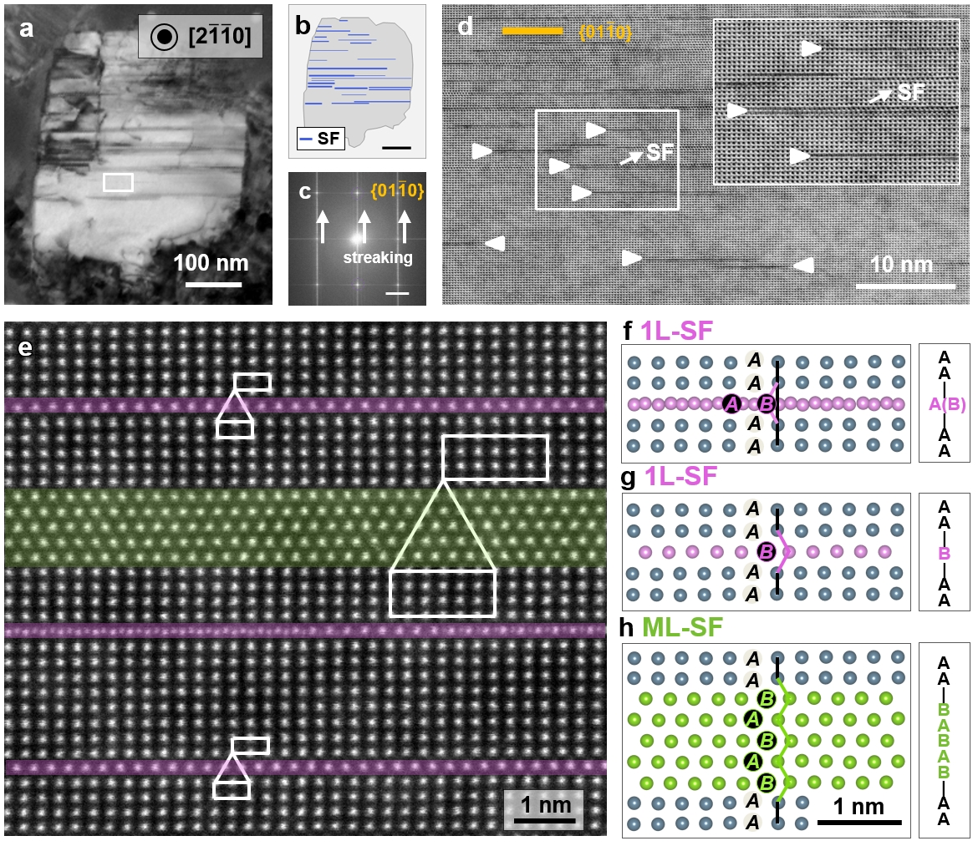

Supplementary Figure 5. Stacking faults in a rapidly-quenched WC grain (viewed along [2$\overline{\text{1}}\overline{\text{1}}$0] axis). a-b Low-magnification BF image and corresponding schematic highlighting intragranular defect traces. c FFT (fast Fourier transform) from an intragranular region, where yellow circles indicate diffraction spots of the (01$\overline{\text{1}}$0) plane. d Magnified view of the boxed region in (a). Stacking-fault traces are marked by arrows; yellow lines indicate the (01$\overline{\text{1}}$0) plane. e Atomic-resolution image showing monolayer (purple) and multilayer (green) stacking faults. f-h Crystallographic models corresponding to the three fault configurations.

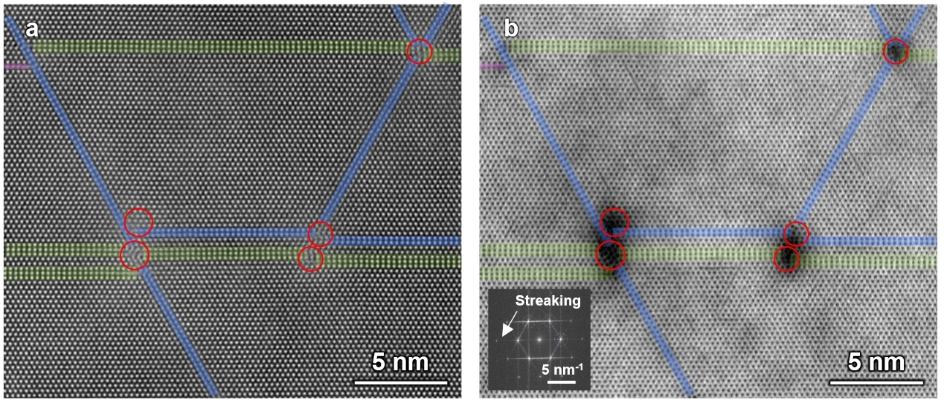

Supplementary Figure 6. Interacting stacking faults in WC and corresponding elongation of diffraction spots in reciprocal space along the [0001] axis. a-b HAADF and BF images of interacting stacking faults within a WC grain. Kinked junctions between stacking faults produce darker diffraction contrast in the BF image. Mono-, double-, and triple-layer faults are highlighted in purple, blue, and green, respectively. The inset in (b) presents the corresponding fast Fourier transform, where the intersecting stacking faults in real space led to pronounced elongation of diffraction spots in reciprocal space.

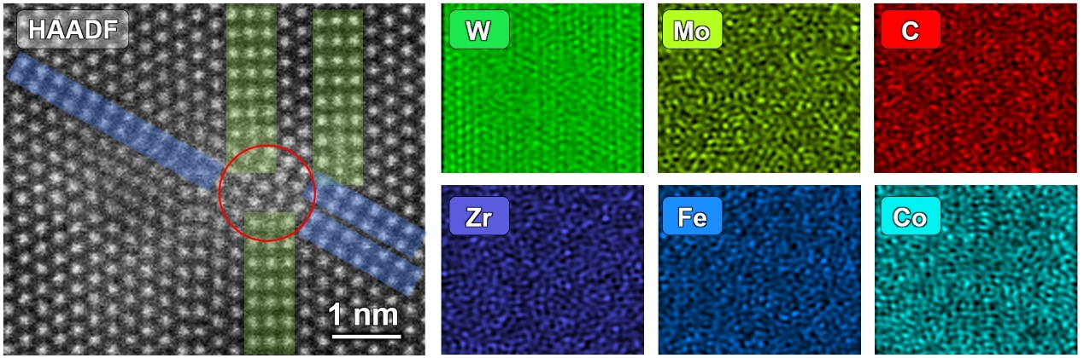

Supplementary Figure 7. HAADF and EDS characterization of a stacking-fault junction along the [0001] axis of WC. HAADF and EDS (energy-dispersive X-ray spectroscopy) images of the stacking-fault junction, where no discernible elemental segregation is observed.

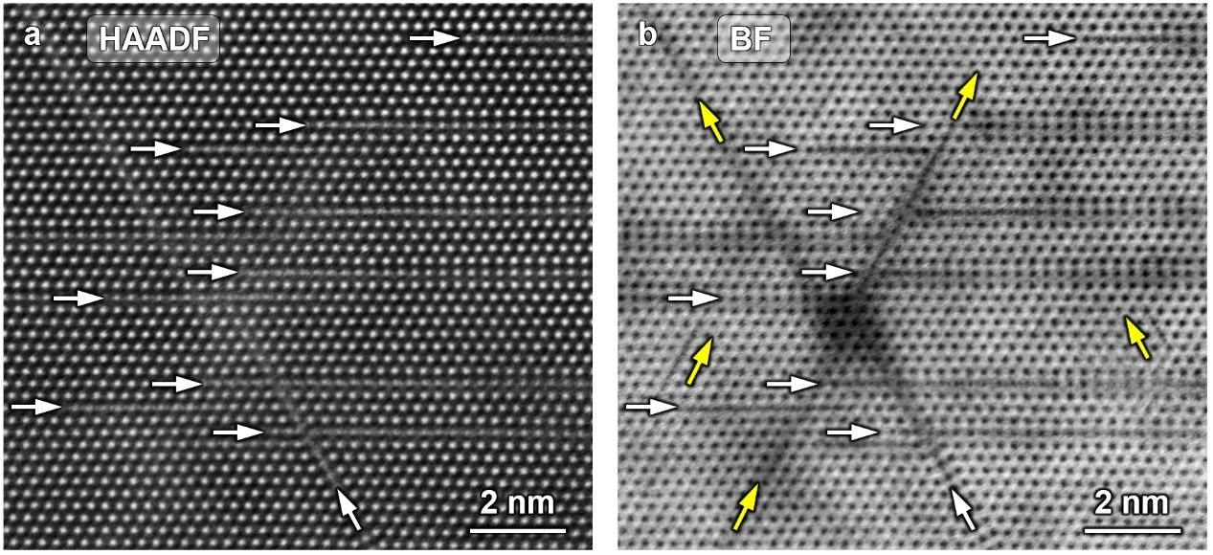

Supplementary Figure 8. Observation of abundant stacking-fault embryos in a WC grain viewed along the [0001] zone axis. a-b HAADF and BF images of a WC grain viewed along the [0001] zone axis, revealing abundant stacking-fault embryos.

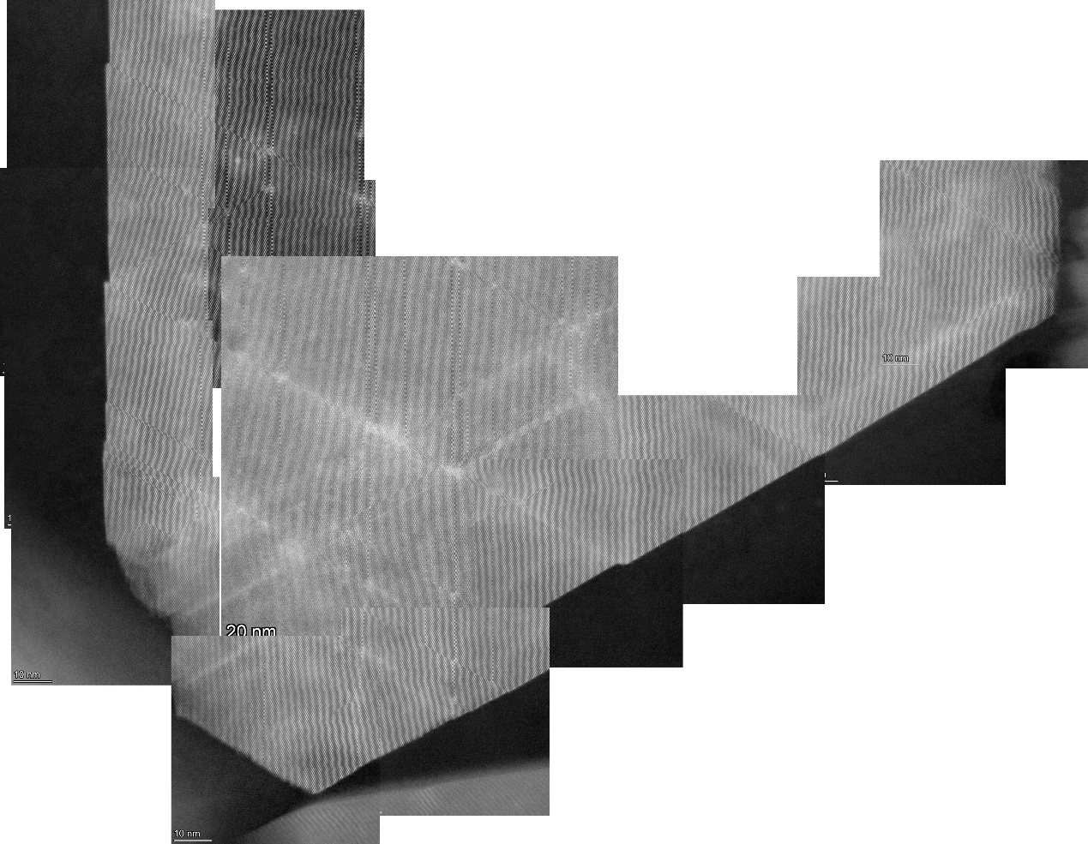

Supplementary Figure 9. Large-area mosaic HAADF images of abundant stacking faults within the WC grain aligned along the [0001] zone axis. Large-area mosaic HAADF (high-angle annular dark-field) imaging revealing abundant stacking faults extending into the grain interior and transforming interconverting across different thicknesses.

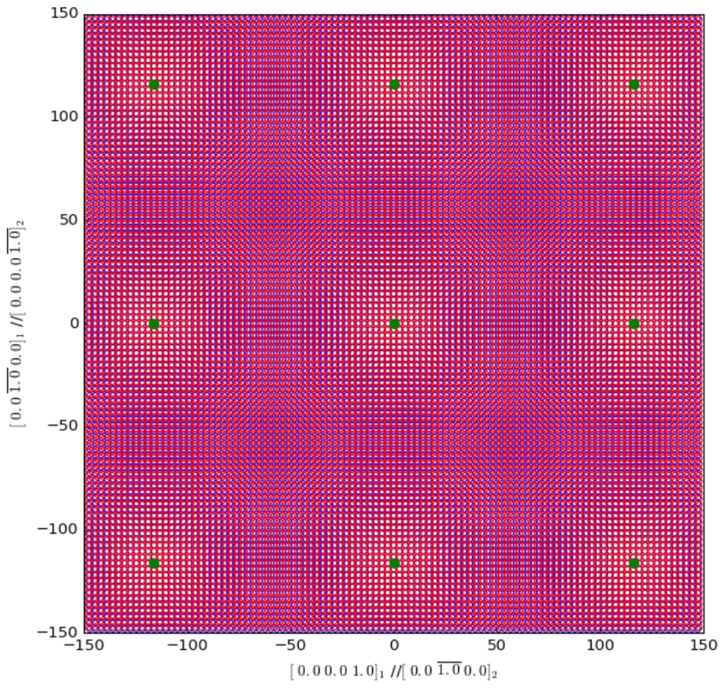

Supplementary Figure 10. Top-view CSL/DSC lattice model of the Σ2 interface. Top-view schematic of the CSL/DSC (displacement shift complete) lattice model, illustrating the periodic alternation of well-matched and poorly matched regions along the Σ2 interface.

