Supplementary Information
Biosensor-assisted growth-coupled selection facilitates the evolution of glycosyltransferase for heparosan biosynthesis in Escherichia coli K5
Abbreviation and formatting note. cAMP-activated global transcriptional regulator (CRP), green fluorescent protein (GFP), optical density at 600 nm (OD600), polymerase chain reaction (PCR), electrophoretic mobility shift assay (EMSA), Gene Ontology (GO), sodium dodecyl sulfate-polyacrylamide gel electrophoresis (SDS-PAGE), reduced nicotinamide adenine dinucleotide (NADH), and whole-genome-evolved K5 (K5-WGE) are defined here for the Supplementary Information. Bacterial Latin binomials are italicized, gene names are italicized, and protein names are presented in roman type. Nomenclature note. Across the main text and Supplementary Tables S5-S6, the standardized construct names are used consistently as follows: pNG, pETDuet-1_Pgnt_gfp; pNT, pETDuet-1_Pgnt_tetA; NCT, pETDuet-1_Pgnt_tetA_P34_CRP; pNTG-CRP, pETDuet-1_Pgnt_tetA_gfp_Pbad_crp; pACYC-NaKfiA/kfiC, pACYC_P34_NaKfiA(mut)_P34_kfiC; K5AC, E. coli K5 ΔkfiA ΔkfiC. In the revised Figure 3 workflow, K5AC denotes the clean chassis used for benchmarking, pNG denotes the Pgnt-only GFP reporter plasmid, and pNTG-CRP denotes the CRP-assisted dual-output selection plasmid. Final Figure 3 method details: pNTG-CRP induction used 2 mg·mL−1 arabinose, induction was synchronized with culture transfer, mixed-population validation used OD600 = 0.01 normalization, and endpoint genotyping was performed by colony PCR followed by Sanger sequencing. CRP-assisted circuit construction denotes additional biosensor-plasmid-borne CRP expression in a CRP-positive K5AC background, not complementation of a CRP-deficient chassis.
Section I. Genome editing, transcriptomic prioritization, and Pgnt characterization
Supplementary Figure S1. Raw PCR gel for ΔkfiA validation.
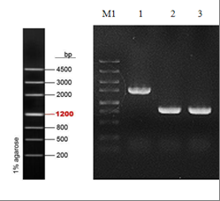
Lane M1, DNA Marker III; lane 1, K5 fragment; lane 2, K5A fragment; lane 3, positive control.

Supplementary Figure S2. K5 versus K5A MA plot.
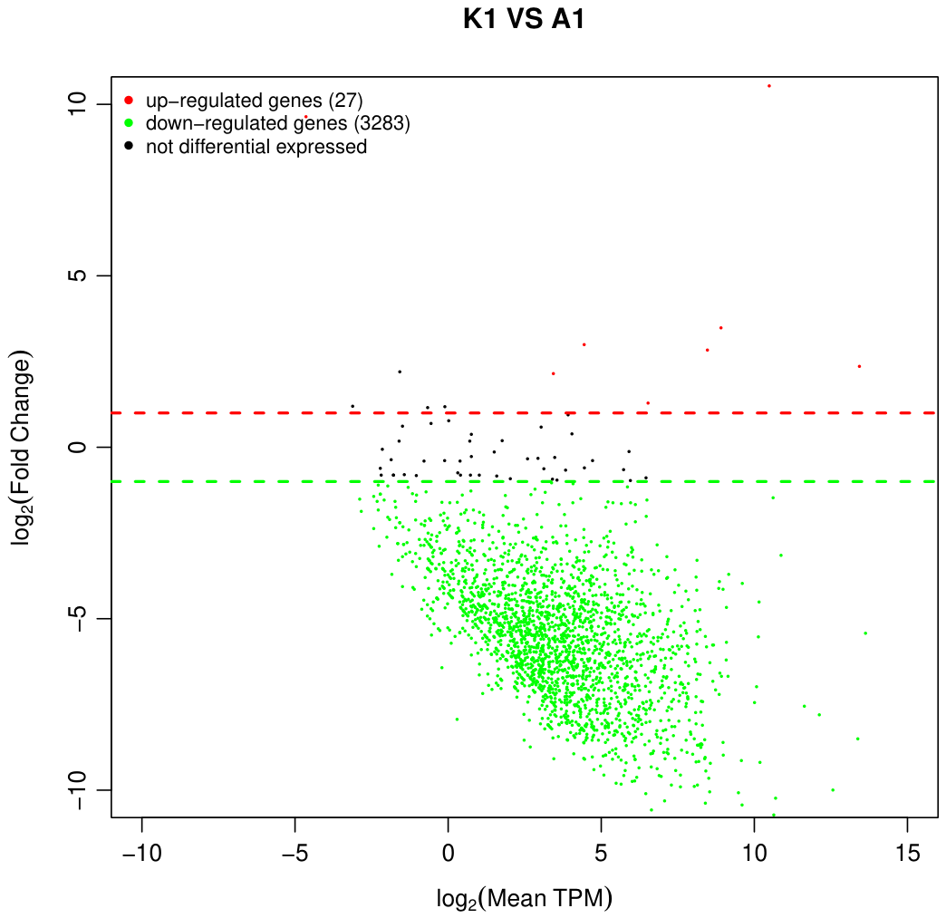
MA plot for K5 versus K5A.

Supplementary Figure S3. K5 versus K5A volcano plot.
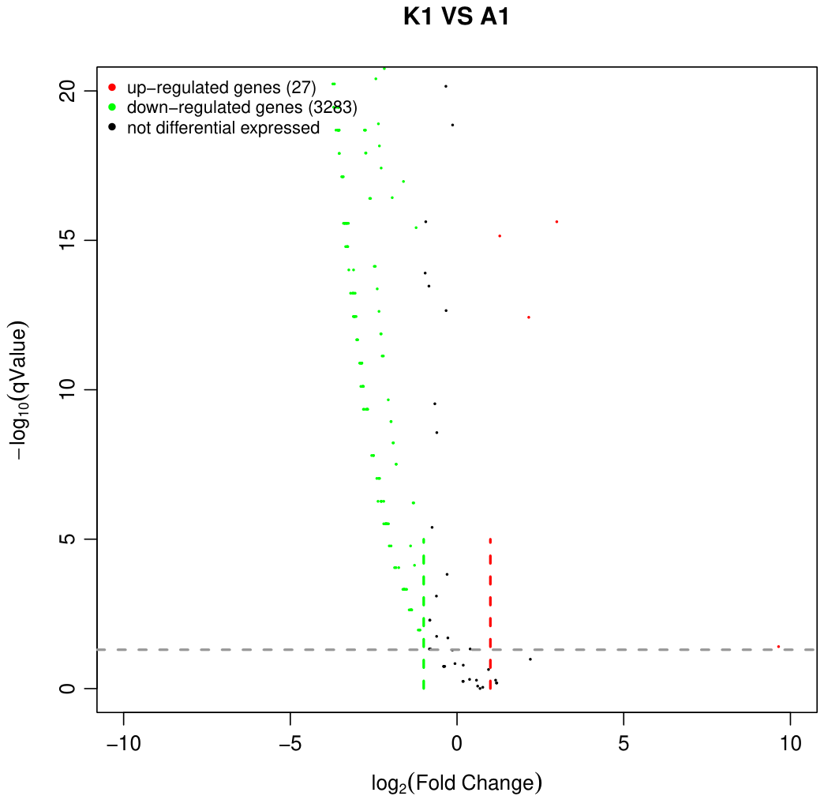
Volcano plot for K5 versus K5A.

Supplementary Figure S4. K5 versus K5A GO enrichment support.
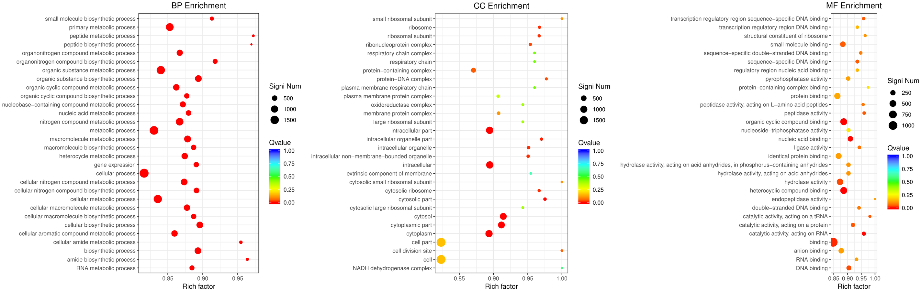
GO enrichment summary for K5 versus K5A.

Supplementary Table S1. Description of COG terms shown in Figure 1D.
COG identifiers and descriptions corresponding to the COG-focused enrichment overview in Figure 1D.
COG ID | Description
COG1216 | Predicted glycosyltransferases
COG3550 | Uncharacterized protein related to capsule biosynthesis enzymes
COG0438 | Glycosyltransferase
COG0463 | Glycosyltransferases involved in cell wall biogenesis
COG0859 | ADP-heptose:LPS heptosyltransferase
COG1087 | UDP-glucose-4-epimerase
COG1088 | dTDP-D-glucose 4,6-dehydratase
COG0794 | Predicted sugar phosphate isomerase involved in capsule formation
COG1442 | Lipopolysaccharide biosynthesis proteins, LPS:glycosyltransferases
COG0707 | UDP-N-acetylglucosamine:LPS N-acetylglucosamine transferase
COG1089 | GDP-D-mannose dehydratase
COG1091 | dTDP
COG1210 | UDP-glucose pyrophosphorylase
COG2943 | Membrane glycosyltransferase
COG3524 | Capsule polysaccharide export protein
COG3563 | Capsule polysaccharide export protein
COG1596 | Periplasmic protein involved in polysaccharide export
COG1898 | dTDP-4-dehydrorhamnose 3,5-epimerase and related enzymes
COG1134 | ABC-type polysaccharide/polyol phosphate transport system, ATPase component
COG1682 | ABC-type polysaccharide/polyol phosphate export system, permease component

Section II. DNA pull-down-based prioritization of Pgnt-associated regulatory candidates and preliminary EMSA support
Supplementary Figure S5. DNA pull-down assay schematic.
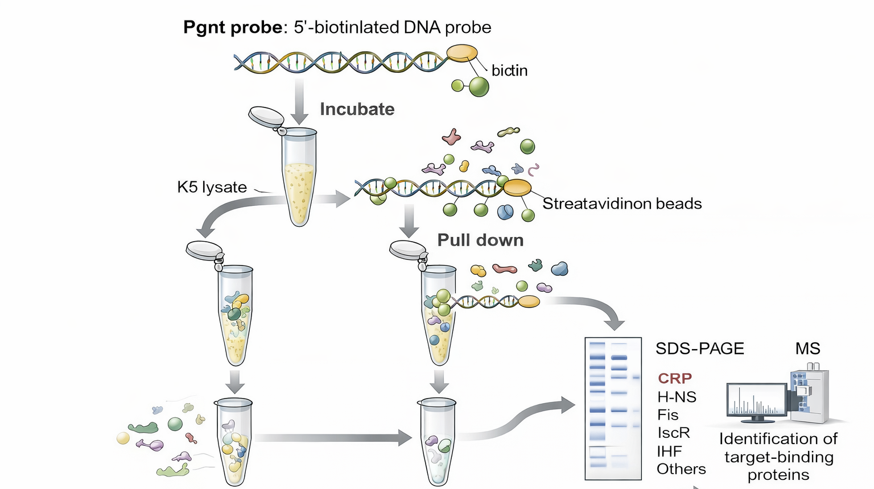
Schematic of the DNA pull-down workflow using a 5'-biotinylated Pgnt DNA probe, Escherichia coli K5 lysate, streptavidin magnetic beads, SDS-PAGE and LC-MS/MS.
Supplementary Figure S6. Pgnt probe agarose gel.
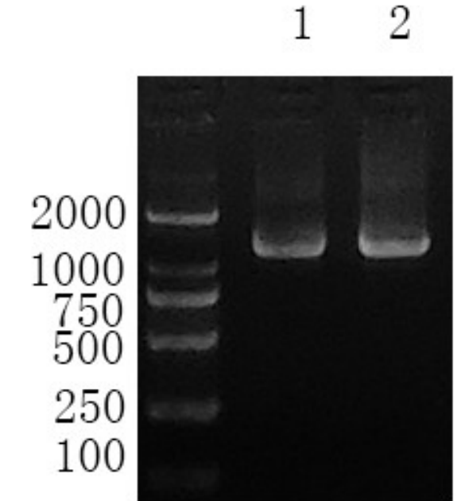
Lane 1, unlabeled Pgnt; lane 2, biotin-labeled Pgnt.

Supplementary Figure S7. Pgnt pull-down workflow support gels.
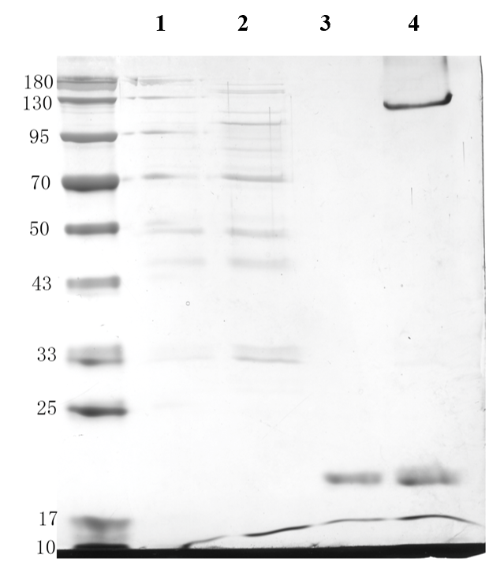
Lane 1, DNA pull-down control group; lane 2, DNA pull-down experimental group; lane 3, magnetic-bead control group; lane 4, magnetic-bead experimental group.

Supplementary Figure S8. GO term distribution of Sample 1-specific proteins.
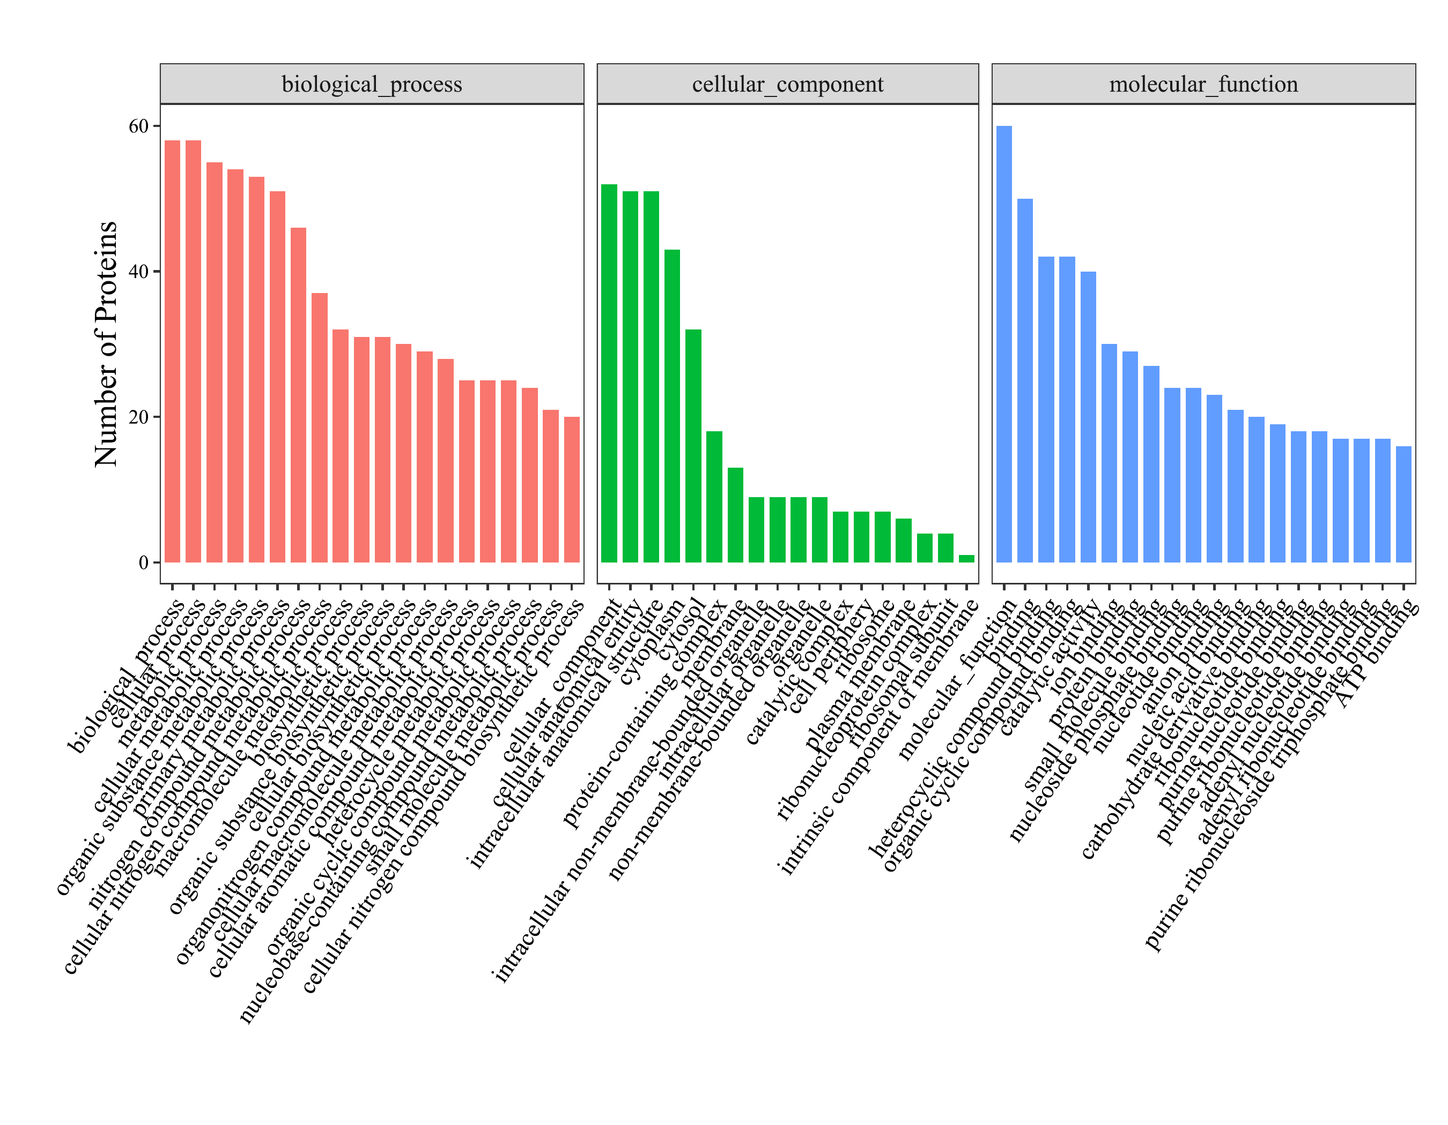
GO-term distribution of Sample 1-specific proteins from the Pgnt-group DNA pull-down analysis.

Supplementary Figure S9. Pgnt-group pathway composition.
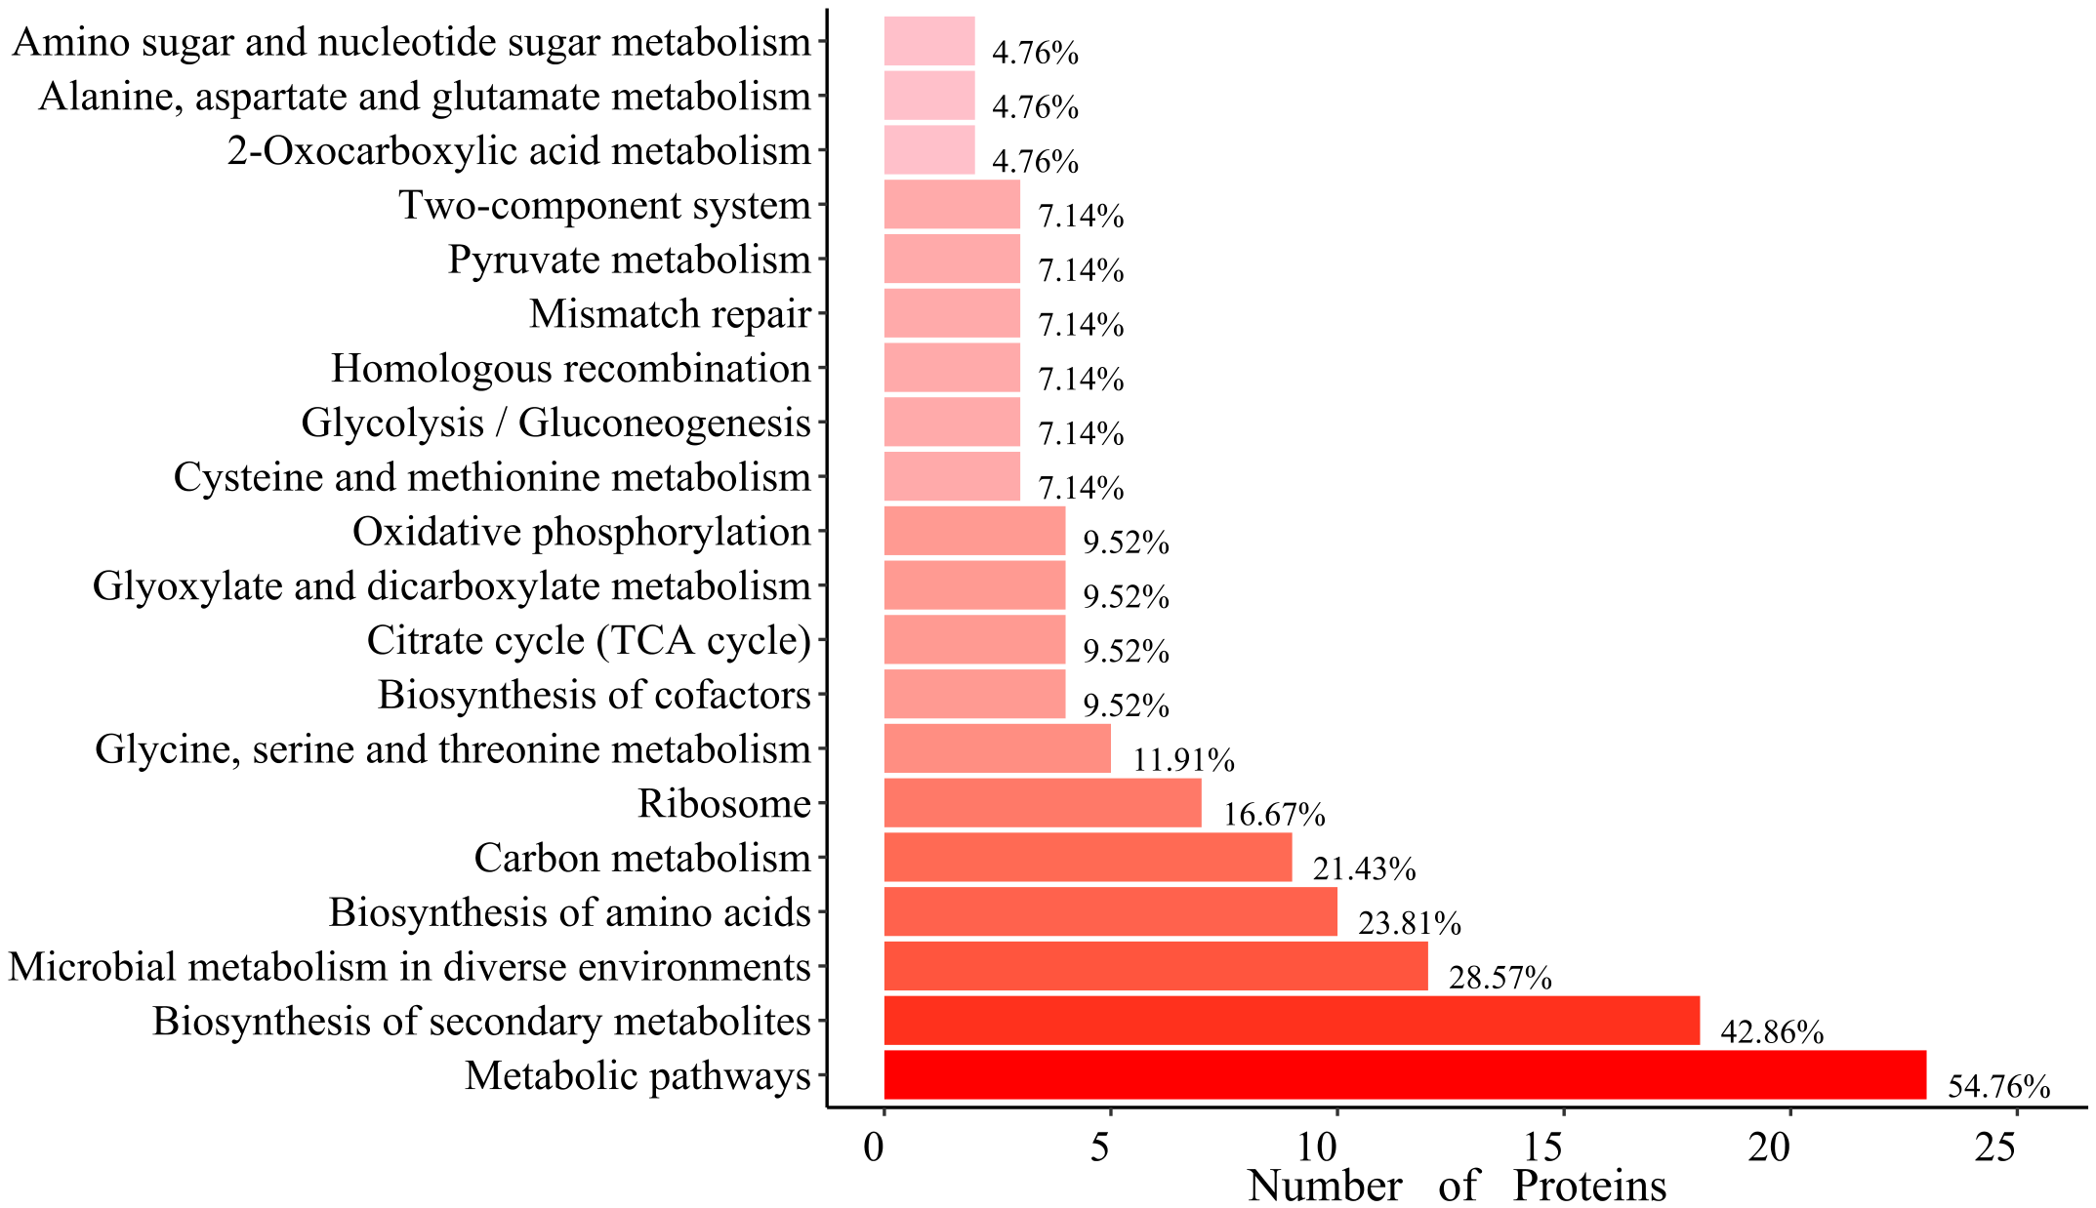
Pathway-composition summary for Sample 1.

Supplementary Figure S10. Pgnt-group protein interaction network.
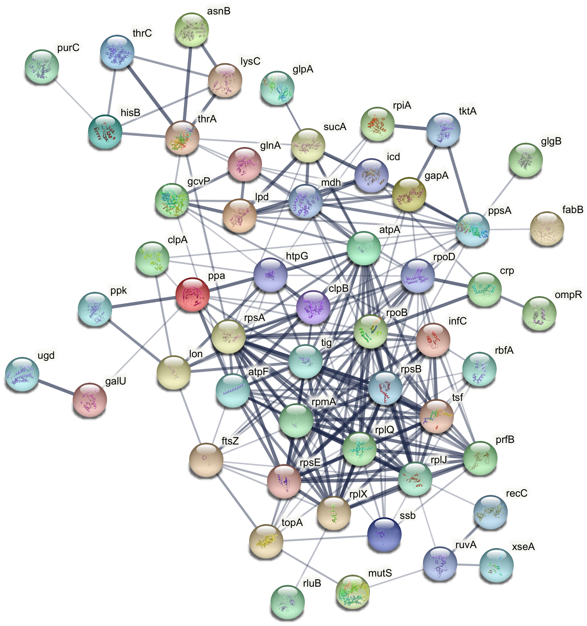
Interaction-network view for Sample 1.

Supplementary Figure S11. Preliminary EMSA analysis of CRP with a Pgnt-derived DNA probe.
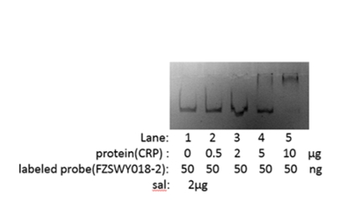
Purified CRP was incubated with the labeled Pgnt-derived probe FZSWY018-2 and analyzed by native gel electrophoresis. Lane 1, probe only; lanes 2-5, probe plus 0.5, 2, 5 and 10 µg CRP, respectively. Each reaction contained 50 ng labeled probe and 2 µg salmon sperm DNA.

Section III. CRP-assisted platform construction and validation
Supplementary Figure S12. Raw PCR gel for ΔkfiC validation.
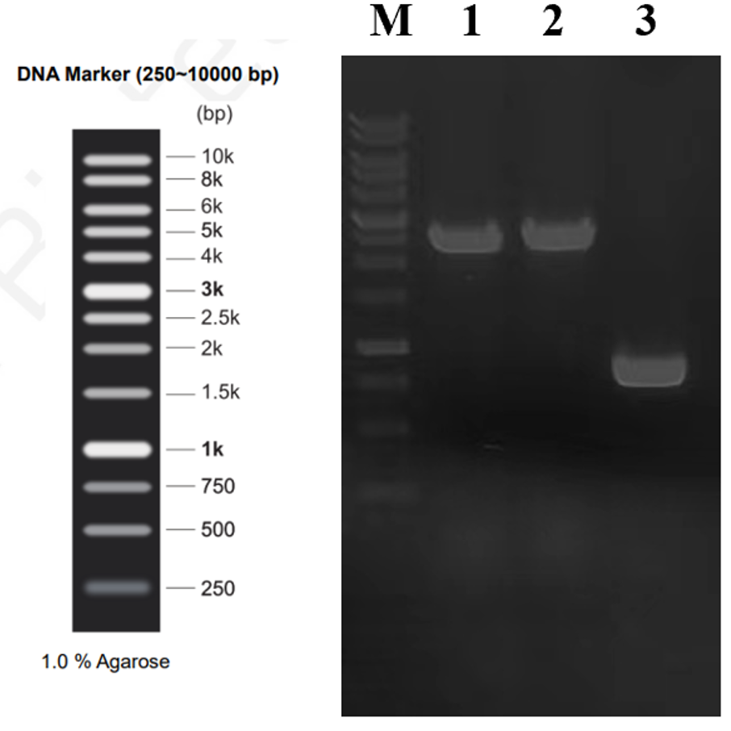
Lane M, DNA marker (250-10000 bp); lane 1, K5 wild-type fragment; lane 2, K5A fragment; lane 3, K5AC fragment.

Supplementary Data S1. NaKfiA benchmark coding-sequence records used for Figure 3 platform validation
This standalone supplementary data item provides the coding-sequence records for the five NaKfiA benchmark variants used to validate the CRP-assisted Pgnt selection platform in Figure 3. Coding sequences are shown in the 5'-to-3' orientation and formatted as FASTA-style records to facilitate direct sequence checking, primer design, and construct verification. Protein-level annotations are limited to the benchmark substitution and mutant codon supplied with the construct records; the corresponding constructs pair each NaKfiA variant with kfiC on the pACYC_P34_NaKfiA(mut)_P34_kfiC plasmid.
Supplementary Data S1A. Summary of NaKfiA benchmark sequence records.
Variant | Benchmark substitution / codon | Source header(s) | CDS length (bp) | Figure 3 use
T108Y | T108Y; mutant codon TAT | NaKfiA_T108Y; NaKfiA_T108Y | 753 | Activity-gradient benchmark variant for circuit validation.
I76V | I76V; mutant codon GTA | pET30a(+)_NaKfiA_I76V; pET30a(+)_NaKfiA_I76V | 753 | Activity-gradient benchmark variant for circuit validation.
E74Y | E74Y; mutant codon TAT | NaKfiA_E74Y; NaKfiA_E74Y | 753 | Activity-gradient benchmark variant for circuit validation.
WT/NaKfiA | Reference NaKfiA sequence | NaKfiA; NaKfiA | 774 | Parental NaKfiA reference in the benchmark panel.
S165K | S165K; mutant codon AAA | NaKfiA_S165K; NaKfiA_S165K | 753 | Highest-activity endpoint benchmark enriched in mixed-population serial passage.
Supplementary Data S1B. FASTA-style coding-sequence records.
T108Y
>T108Y | T108Y; mutant codon TAT | source=NaKfiA_T108Y; NaKfiA_T108Y | length=753 bp
ATGATAATAGCTAATATGGCAACATTTCCCGCTAGGGTAGAAATATGTAAACAAGTGGTTGATAGC
ATCTACAACCAGGTTGACCAAATTAACCTGTGCTTCAACGAGTTTAAGCAGATCCCGAAAGAATAC
GCGAAGTATCACAAACTGAACCCGGTGATTCCGGATACCGACTATAAGGATGTTGGTAAATTTGTG
CACAAAGTTAGCGATAACGACGAGGTGATCCTGATTGACGATGACATCATTTACCCGCGTGACTAT
GTGGAAGTTCTGCGTTACTTCTATAAGAAATACCAACACCTGAACATCATTGTTGGTTATCACGGC
ATCATTTACCCGGATCTGTATGACGGCAGCGTGAGCAGCCGTAAGGTTTTCACCTTTAAACACAGC
CTGAAGCGTCCGCGTGTGGTTAACCAGCTGGGTACCGGCACCGTGTACCTGAAAGGTAGCCAAATG
CCGAGCCTGGAGTATATGAAGGGCAGCCAGAGCTTCGTGGATGTTCGTTTTAGCAAATACATGTTC
GAAAAGGGTATCGGCCTGATCTGCATTCCGCGTGGTGCGGATTGGCAAAAGGAGATCAAACAGGAA
GACAGCATTTTCAACAACTTTACCAGCAAATGGCCGATGCAGGTGATCCAAGAAGTTCAGATCATT
GCGGGCTATAGCAAGCTGCCGTTTAACCTGGTTAAAGAGATTGAATTCAACAAGGACAGCCTGCTG
ATGAGCCAACACCACCACCACCACCAC
I76V
>I76V | I76V; mutant codon GTA | source=pET30a(+)_NaKfiA_I76V; pET30a(+)_NaKfiA_I76V | length=753 bp
ATGATAATAGCTAATATGGCAACATTTCCCGCTAGGGTAGAAATATGTAAACAAGTGGTTGATAGC
ATCTACAACCAGGTTGACCAAATTAACCTGTGCTTCAACGAGTTTAAGCAGATCCCGAAAGAATAC
GCGAAGTATCACAAACTGAACCCGGTGATTCCGGATACCGACTATAAGGATGTTGGTAAATTTGTG
CACAAAGTTAGCGATAACGACGAGGTGGTACTGATTGACGATGACATCATTTACCCGCGTGACTAT
GTGGAAGTTCTGCGTTACTTCTATAAGAAATACCAACACCTGAACATCATTGTTGGTACCCACGGC
ATCATTTACCCGGATCTGTATGACGGCAGCGTGAGCAGCCGTAAGGTTTTCACCTTTAAACACAGC
CTGAAGCGTCCGCGTGTGGTTAACCAGCTGGGTACCGGCACCGTGTACCTGAAAGGTAGCCAAATG
CCGAGCCTGGAGTATATGAAGGGCAGCCAGAGCTTCGTGGATGTTCGTTTTAGCAAATACATGTTC
GAAAAGGGTATCGGCCTGATCTGCATTCCGCGTGGTGCGGATTGGCAAAAGGAGATCAAACAGGAA
GACAGCATTTTCAACAACTTTACCAGCAAATGGCCGATGCAGGTGATCCAAGAAGTTCAGATCATT
GCGGGCTATAGCAAGCTGCCGTTTAACCTGGTTAAAGAGATTGAATTCAACAAGGACAGCCTGCTG
ATGAGCCAACACCACCACCACCACCAC
E74Y
>E74Y | E74Y; mutant codon TAT | source=NaKfiA_E74Y; NaKfiA_E74Y | length=753 bp
ATGATAATAGCTAATATGGCAACATTTCCCGCTAGGGTAGAAATATGTAAACAAGTGGTTGATAGC
ATCTACAACCAGGTTGACCAAATTAACCTGTGCTTCAACGAGTTTAAGCAGATCCCGAAAGAATAC
GCGAAGTATCACAAACTGAACCCGGTGATTCCGGATACCGACTATAAGGATGTTGGTAAATTTGTG
CACAAAGTTAGCGATAACGACTATGTGATCCTGATTGACGATGACATCATTTACCCGCGTGACTAT
GTGGAAGTTCTGCGTTACTTCTATAAGAAATACCAACACCTGAACATCATTGTTGGTACCCACGGC
ATCATTTACCCGGATCTGTATGACGGCAGCGTGAGCAGCCGTAAGGTTTTCACCTTTAAACACAGC
CTGAAGCGTCCGCGTGTGGTTAACCAGCTGGGTACCGGCACCGTGTACCTGAAAGGTAGCCAAATG
CCGAGCCTGGAGTATATGAAGGGCAGCCAGAGCTTCGTGGATGTTCGTTTTAGCAAATACATGTTC
GAAAAGGGTATCGGCCTGATCTGCATTCCGCGTGGTGCGGATTGGCAAAAGGAGATCAAACAGGAA
GACAGCATTTTCAACAACTTTACCAGCAAATGGCCGATGCAGGTGATCCAAGAAGTTCAGATCATT
GCGGGCTATAGCAAGCTGCCGTTTAACCTGGTTAAAGAGATTGAATTCAACAAGGACAGCCTGCTG
ATGAGCCAACACCACCACCACCACCAC
WT/NaKfiA
>WT_NaKfiA | Reference NaKfiA sequence | source=NaKfiA; NaKfiA | length=774 bp
ATGATTATAGCTAATATGGCAACATTTCCCGCGCGTGTTGAGATCTGTAAGCAAGTCGTTGACTCC
ATCTACAATCAGGTGGACCAGATCAACCTGTGCTTCAACGAGTTCAAACAGATTCCGAAGGAGTAC
GCAAAATACCATAAGTTGAACCCGGTTATTCCGGACACCGACTATAAGGACGTGGGCAAATTCGTG
CACAAAGTTTCGGATAATGATGAAGTGATCCTGATTGATGACGACATTATCTACCCGCGCGATTAC
GTCGAGGTGCTGCGTTATTTCTATAAAAAGTACCAGCACCTGAATATTATCGTGGGCACGCATGGT
ATTATCTACCCGGATCTGTATGATGGTTCTGTTTCTAGCCGTAAGGTGTTTACCTTCAAGCACAGC
CTGAAACGTCCGCGCGTTGTTAATCAACTGGGTACTGGTACCGTGTATCTTAAGGGCTCCCAAATG
CCATCTCTGGAATATATGAAAGGTTCCCAGAGCTTCGTGGACGTTCGTTTTAGCAAGTACATGTTT
GAAAAAGGCATCGGCCTGATCTGCATCCCGCGCGGTGCTGATTGGCAGAAAGAAATCAAGCAAGAA
GATAGCATTTTTAACAACTTCACCAGCAAGTGGCCGATGCAGGTCATTCAGGAGGTACAGATTATC
GCGGGTTATAGCAAGTTGCCTTTTAACTTGGTTAAAGAGATTGAATTCAACAAAGACTCCCTCTTA
ATGAGCCAAAAGCTTGCGGCCGCACTCGAGCACCACCACCACCACCAC
S165K
>S165K | S165K; mutant codon AAA | source=NaKfiA_S165K; NaKfiA_S165K | length=753 bp
ATGATAATAGCTAATATGGCAACATTTCCCGCTAGGGTAGAAATATGTAAACAAGTGGTTGATAGC
ATCTACAACCAGGTTGACCAAATTAACCTGTGCTTCAACGAGTTTAAGCAGATCCCGAAAGAATAC
GCGAAGTATCACAAACTGAACCCGGTGATTCCGGATACCGACTATAAGGATGTTGGTAAATTTGTG
CACAAAGTTAGCGATAACGACGAGGTGATCCTGATTGACGATGACATCATTTACCCGCGTGACTAT
GTGGAAGTTCTGCGTTACTTCTATAAGAAATACCAACACCTGAACATCATTGTTGGTACCCACGGC
ATCATTTACCCGGATCTGTATGACGGCAGCGTGAGCAGCCGTAAGGTTTTCACCTTTAAACACAGC
CTGAAGCGTCCGCGTGTGGTTAACCAGCTGGGTACCGGCACCGTGTACCTGAAAGGTAGCCAAATG
CCGAGCCTGGAGTATATGAAGGGCAGCCAGAAATTCGTGGATGTTCGTTTTAGCAAATACATGTTC
GAAAAGGGTATCGGCCTGATCTGCATTCCGCGTGGTGCGGATTGGCAAAAGGAGATCAAACAGGAA
GACAGCATTTTCAACAACTTTACCAGCAAATGGCCGATGCAGGTGATCCAAGAAGTTCAGATCATT
GCGGGCTATAGCAAGCTGCCGTTTAACCTGGTTAAAGAGATTGAATTCAACAAGGACAGCCTGCTG
ATGAGCCAACACCACCACCACCACCAC
Figure 3 source-data synchronization note. The NaKfiA benchmark panel in Figure 3 was evaluated in the K5AC chassis using Pgnt-only and CRP-assisted dual-plasmid configurations. For the CRP-assisted configuration, crp expression was induced with 2 mg·mL−1 arabinose and induction was synchronized with culture transfer. For mixed-population validation, each strain was normalized to OD600 = 0.01 before equal-ratio mixing, and endpoint clones were genotyped by colony PCR using NaKfiA-F (ATGATAATAGCTAATATGGCAACATTTCCCG) and NaKfiA-R (GTGGTGGTGGTGGTGGTGTT), followed by Sanger sequencing. In this context, CRP-assisted denotes plasmid-based reinforcement of the Pgnt module because endogenous CRP was not sufficient to generate a robust plasmid-borne Pgnt reporter/selection output; it does not indicate that K5AC lacks CRP.
Section IV. Growth-coupled evolution of PmHS2 and structural interpretation of validated substitutions
Supplementary Table S2. PmHS2 mutant-library quality summary
Summary of mutation-rate and library-capacity information extracted from the vendor quality-control report for the randomized PmHS2 library.
Parameter | Value
Library type | Randomized and degenerated PmHS2 library
Vector | pACYC_P34_PmHS2
Host used for library cloning/electroporation | SS320 competent cells
Target mutation frequency | 5–8 mutations/kb
Observed mutation frequency | 6.4 mutations/kb
Library quality verification | Sanger sequencing of 22 random colonies
Estimated library capacity | ≥3.8 × 10^7 CFU
Vendor report date | 17 Sep 2023
Supplementary Figure S13. 3D trajectory plot of representative enriched sites.
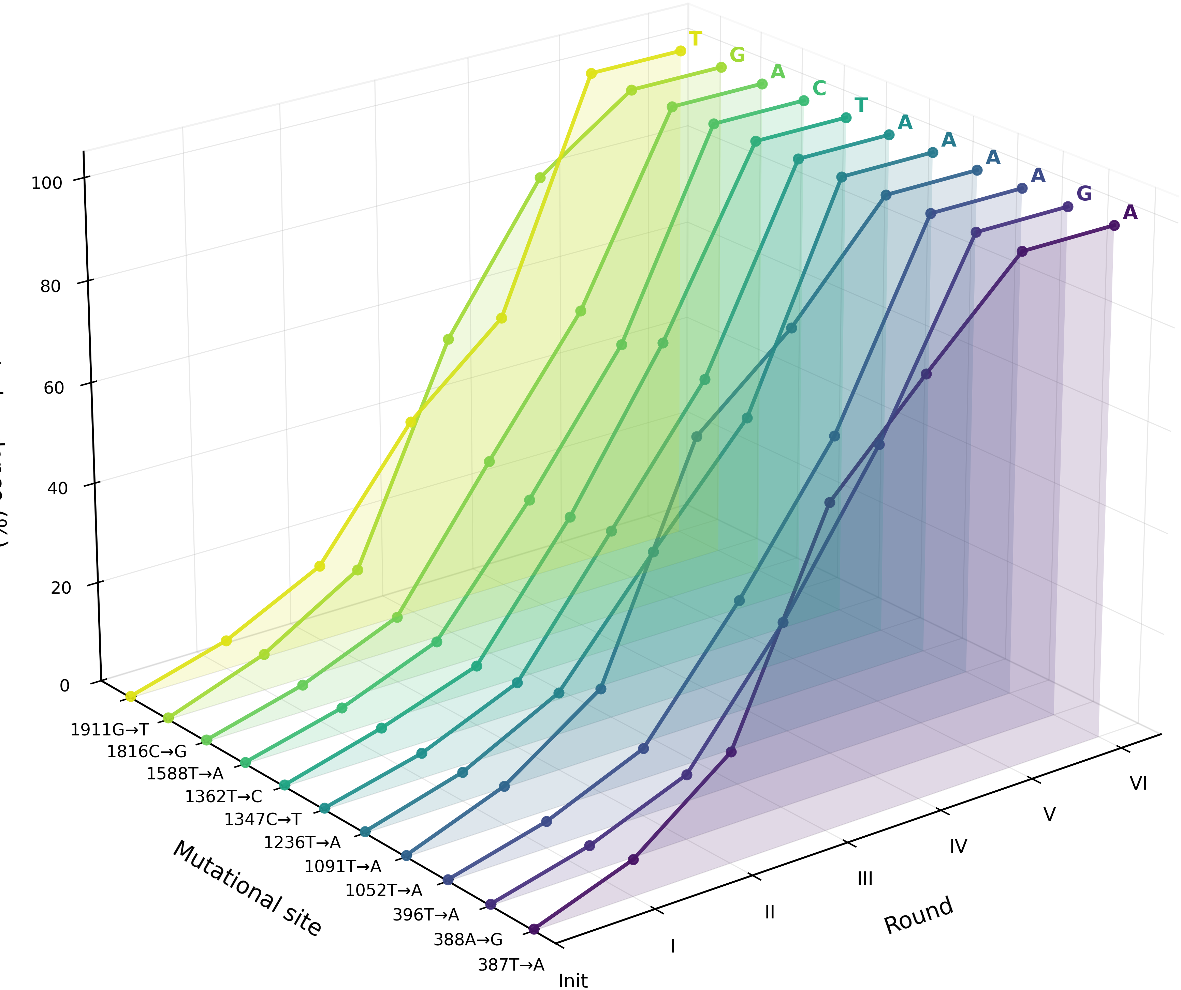
Trajectory plot of representative enriched nucleotide sites.

Supplementary Figure S14. Docking overview and structural mapping of validated PmHS2 substitutions.
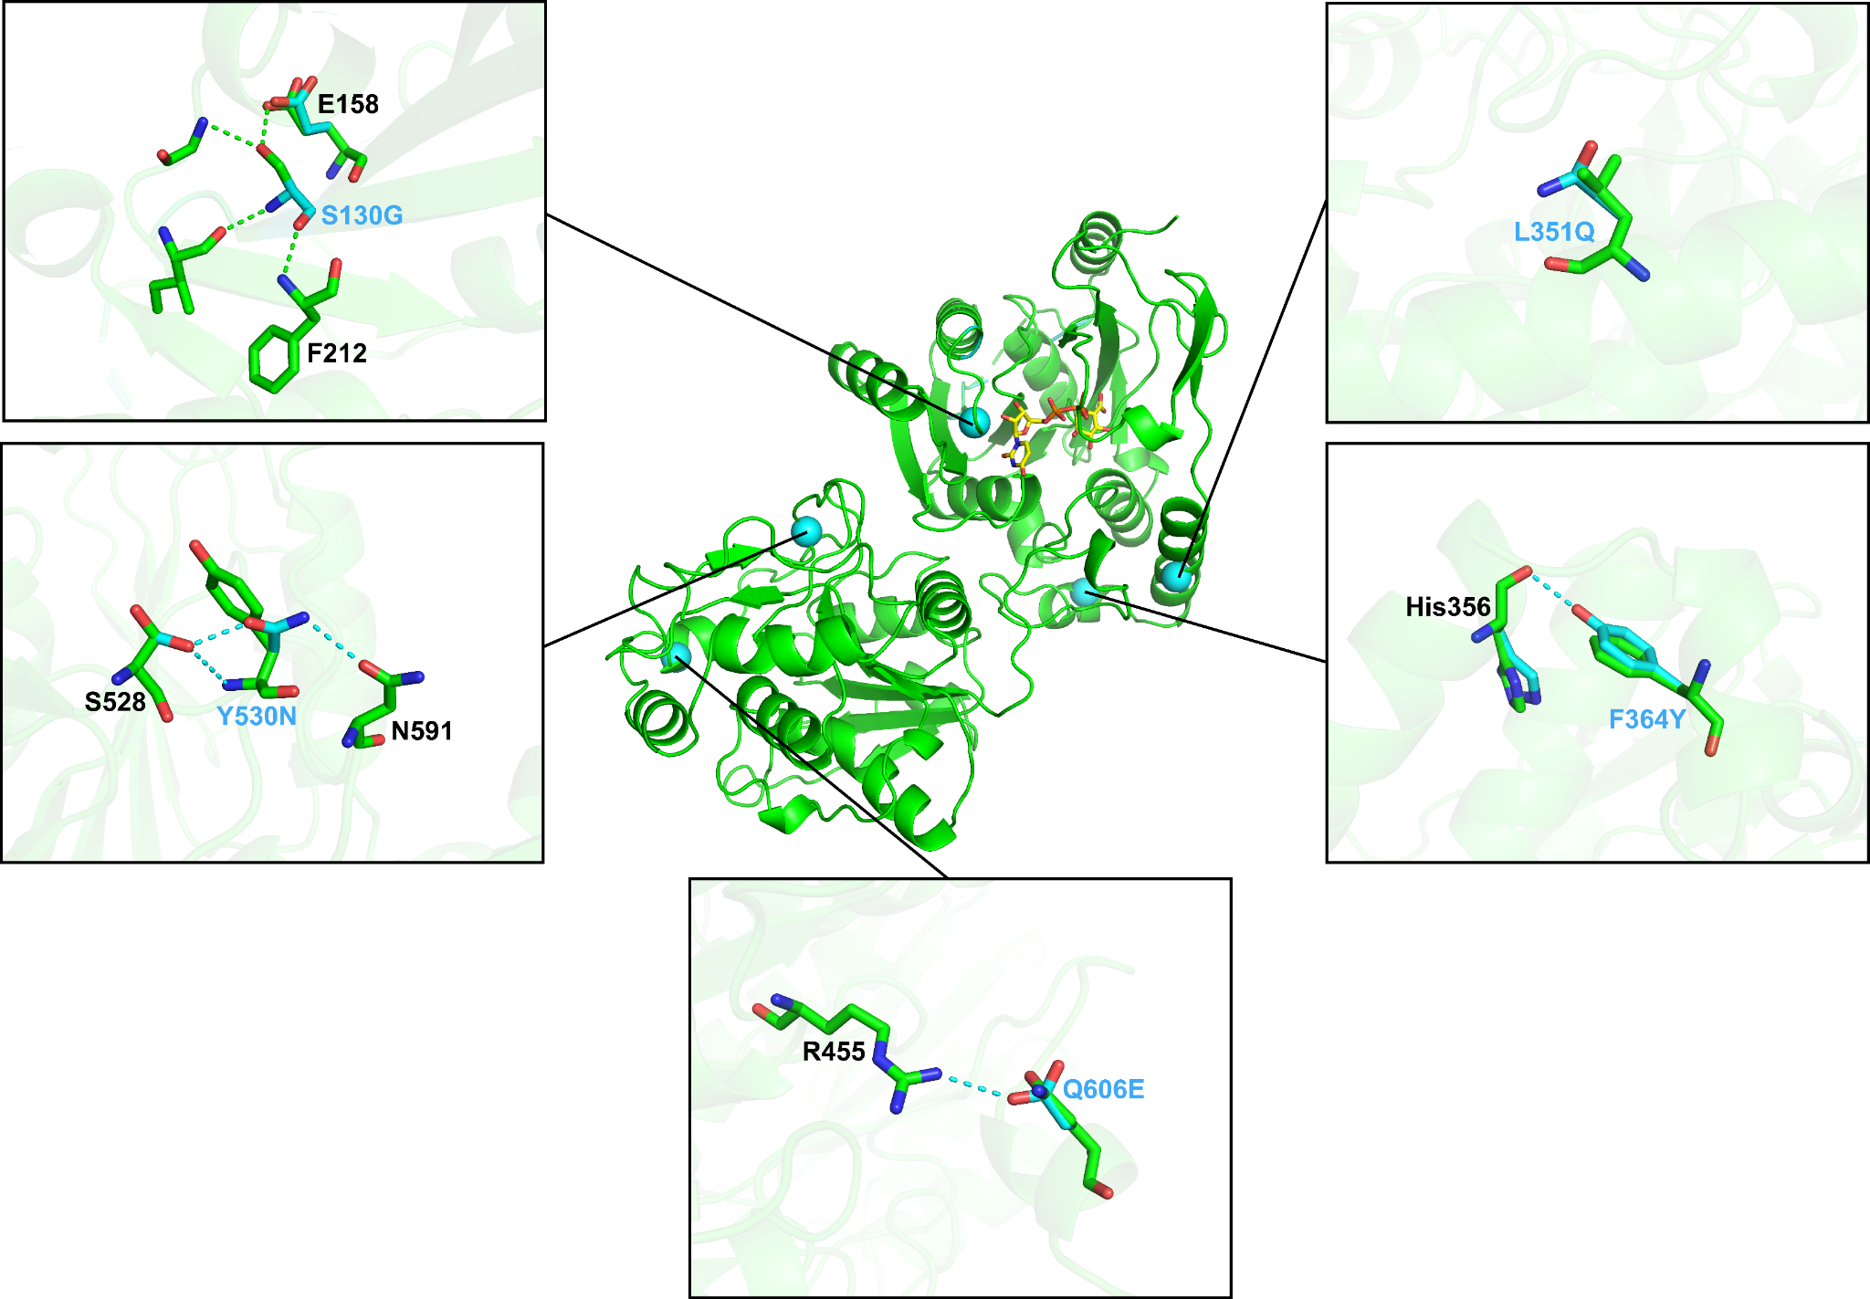
Docking overview for UDP-GlcA and UDP-GlcNAc with chain A of PDB 8VIW, with validated PmHS2 substitutions mapped onto the model. AutoDock Vina v1.2.7 parameters are provided in the Methods.

Supplementary Figure S15. Local structural view of S130G.
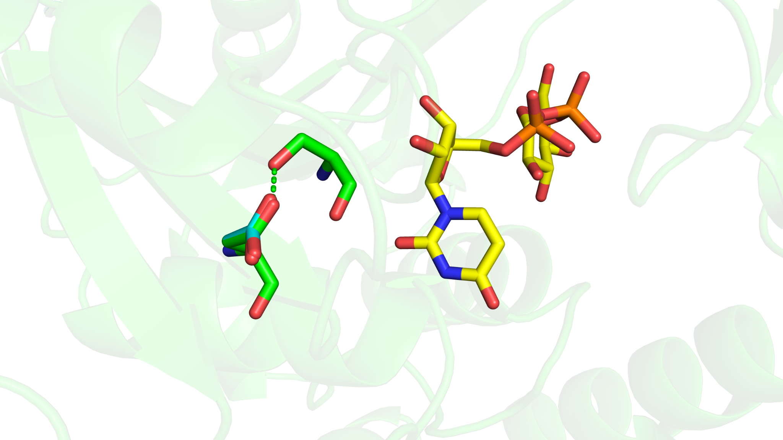
Local structural view of the S130G substitution. FoldX output and local contacts are shown in the panel/source data.

Supplementary Figure S16. Local structural view of L351Q.
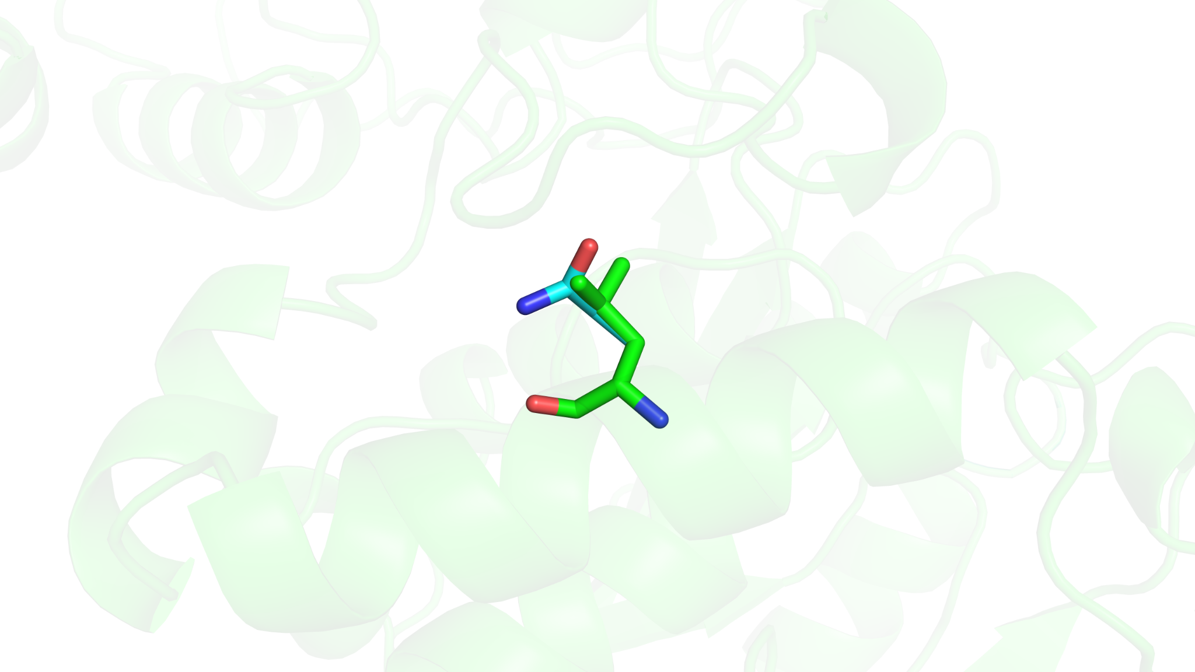
Local structural view of the L351Q substitution. FoldX output and local contacts are shown in the panel/source data.

Supplementary Figure S17. Local structural view of F364Y.
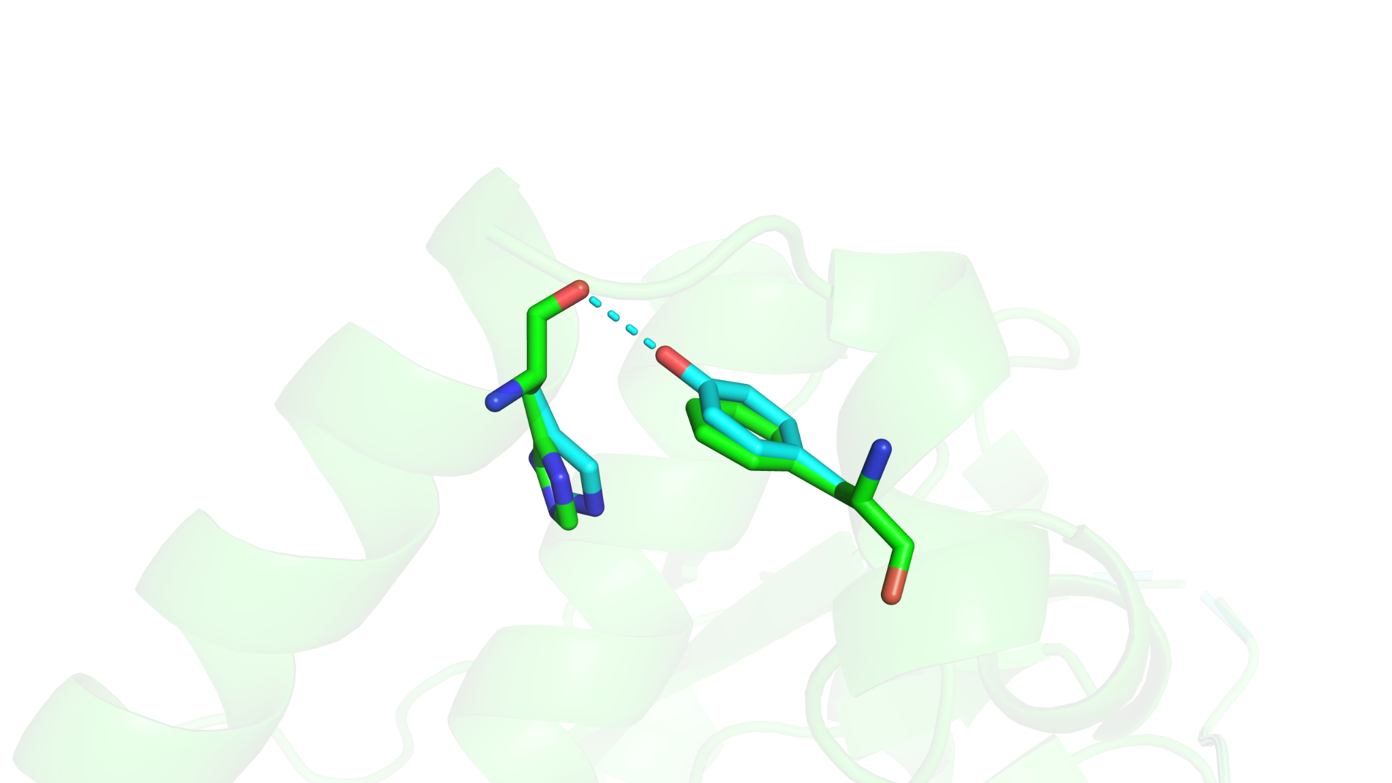
Local structural view of the F364Y substitution. FoldX output and local contacts are shown in the panel/source data.

Supplementary Figure S18. Local structural view of Y530N.
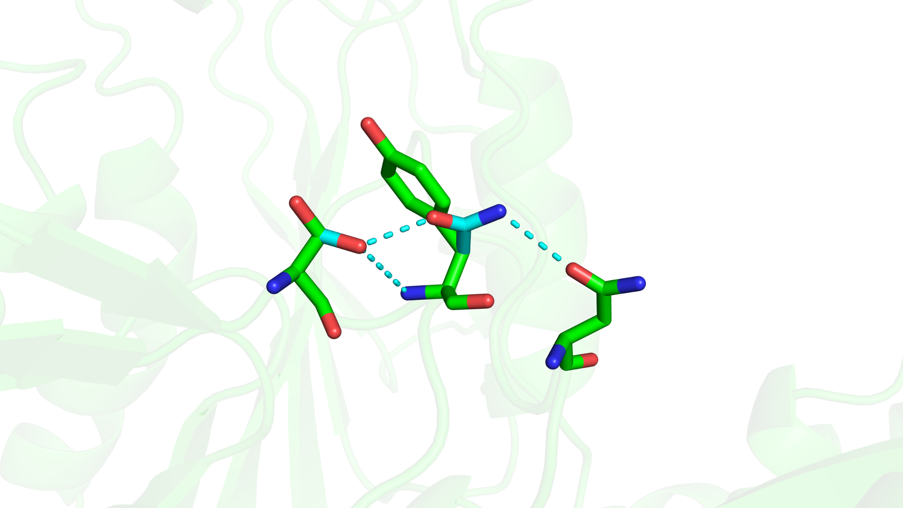
Local structural view of the Y530N substitution. FoldX output and local contacts are shown in the panel/source data.

Supplementary Figure S19. Local structural view of Q606E.
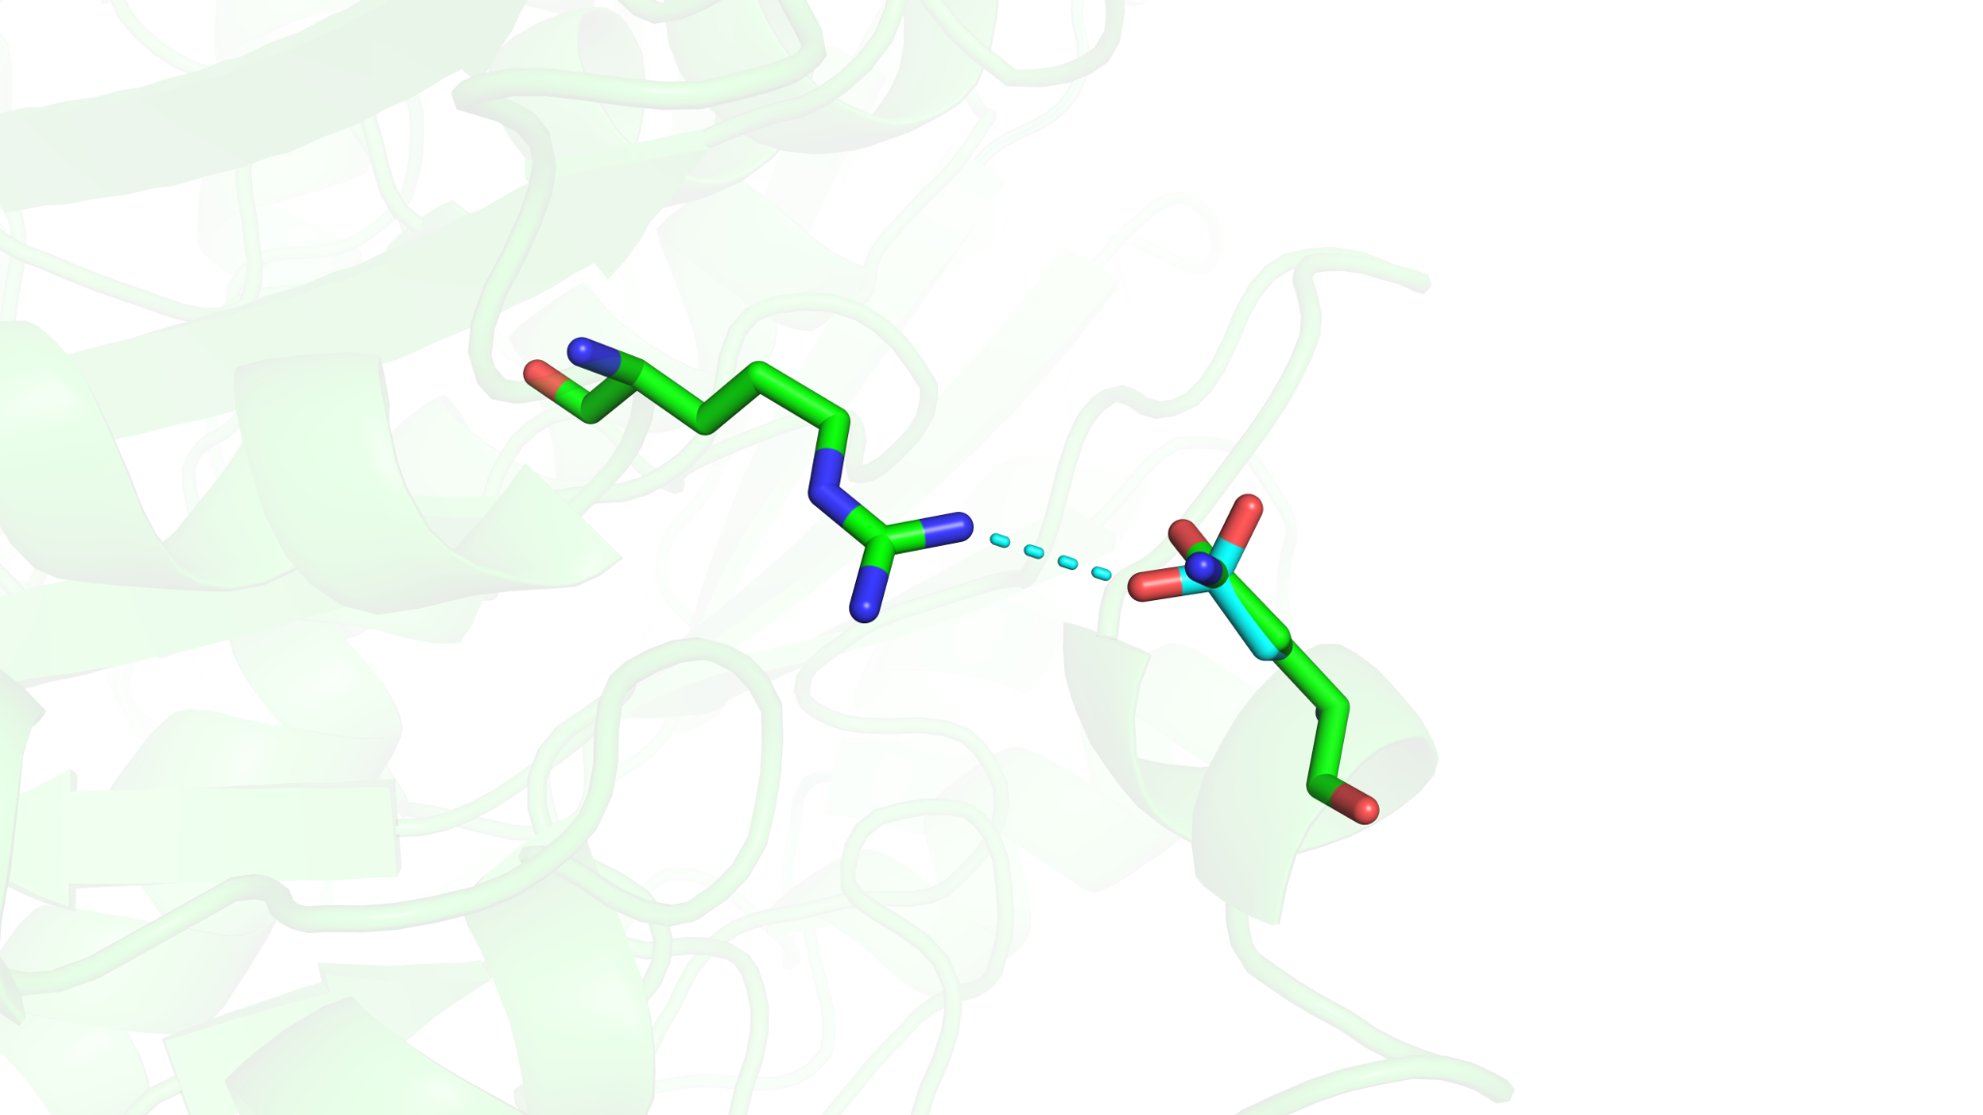
Local structural view of the Q606E substitution. FoldX output and local contacts are shown in the panel/source data.

Section V. kfiA repeat-enrichment outcomes and orthogonal validation
Supplementary Table S3. Mutation-site summary for enriched kfiA variants M1, M2, and M3
Sample | Level | Position(s) | Mutation call(s)
M1 | cDNA | 185, 228, 364, 432, 483, 549, 599, 618, 665, 715, 717 | c.185T>A, c.228A>C, c.364T>C, c.432A>T, c.483T>A, c.549A>T, c.599T>C, c.618A>T, c.665T>A, c.715T>G, c.717A>T
M1 | Protein | 62, 76, 122, 144, 161, 183, 200, 206, 222, 239 | p.V62E, p.V76V, p.S122P, p.T144T, p.D161E, p.I183I, p.M200T, p.T206T, p.I222N, p.*239D
M2 | cDNA | 105, 108, 109, 110, 340, 410, 544, 712 | c.105T>A, c.108G>A, c.109T>A, c.110T>G, c.340A>C, c.410G>C, c.544A>G, c.712G>A
M2 | Protein | 35, 36, 37, 114, 137, 182, 238 | p.N35K, p.E36E, p.F37S, p.I114L, p.R137T, p.M182V, p.G238R
M3 | cDNA | 90, 165, 179, 185, 310, 445, 506, 620 | c.90T>C, c.165A>T, c.179A>T, c.185T>A, c.310T>G, c.445C>T, c.506T>C, c.620T>A
M3 | Protein | 30, 55, 60, 62, 104, 149, 169, 207 | p.I30I, p.P55P, p.K60M, p.V62E, p.C104G, p.L149F, p.V169A, p.F207Y
Tabulated cDNA-level and protein-level mutations identified in the enriched kfiA variants M1, M2, and M3 isolated after repeat enrichment.
Supplementary Figure S20. Schematic of the NADH-coupled assay.
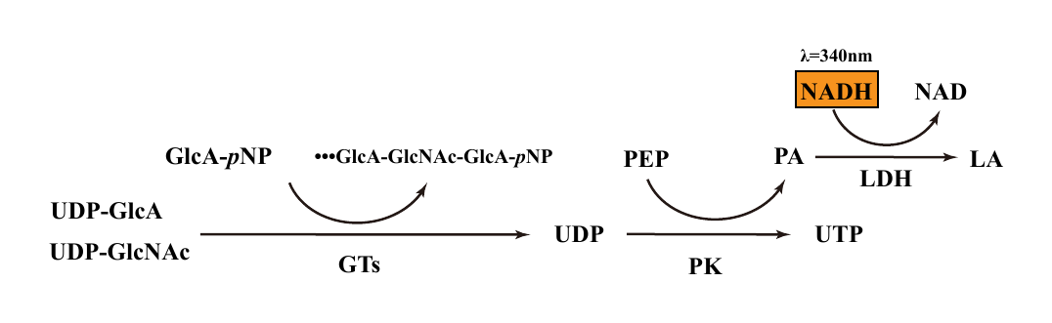
Schematic of the NADH-coupled assay used for coupled-output quantification in Fig. 5D.

Supplementary Figure S21. Raw NADH-coupled kinetic traces for WT and enriched kfiA variants.
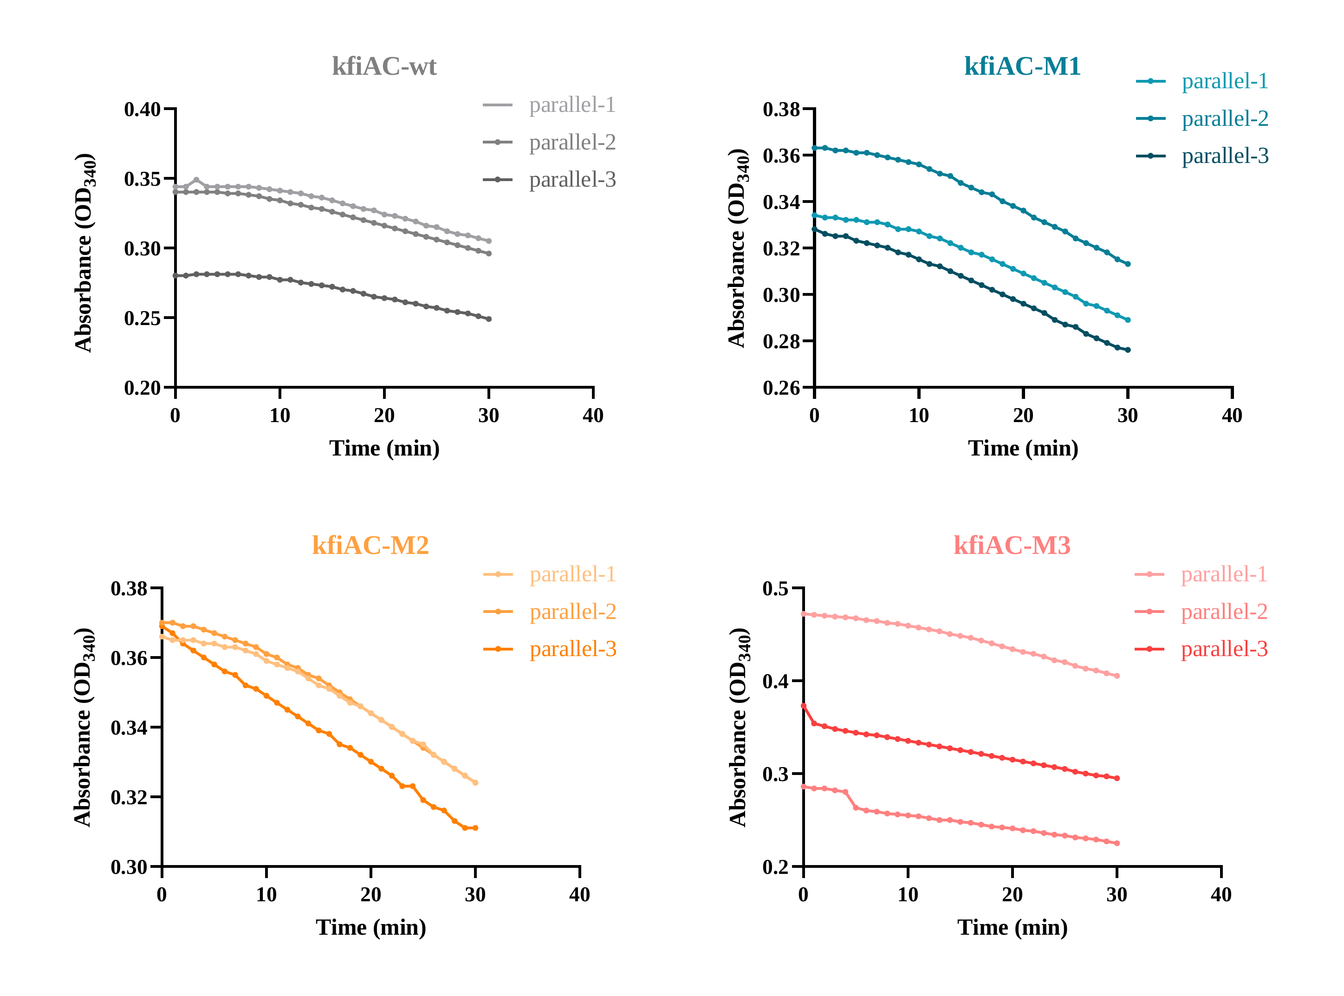
Raw A340 time-course traces used for slope extraction in Fig. 5D. Thin lines indicate biological replicates; thick lines indicate group means.

Section VI. Transcriptomic comparison between K5-WGE and K5
Supplementary Figure S22. K5-WGE gene saturation.
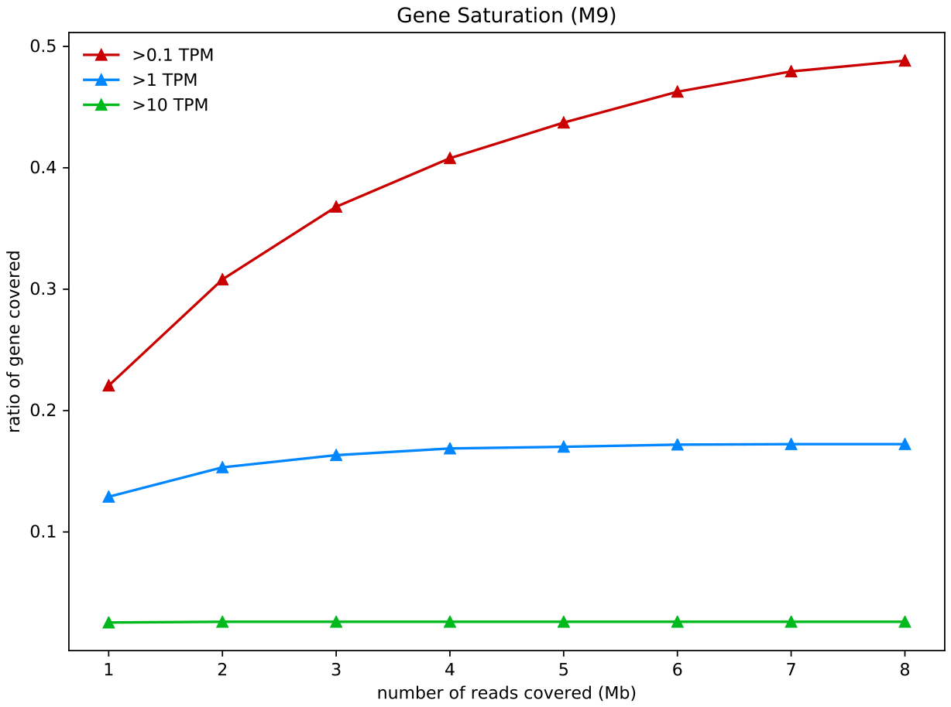
Gene-saturation plot for K5-WGE.

Supplementary Figure S23. K5 gene saturation.
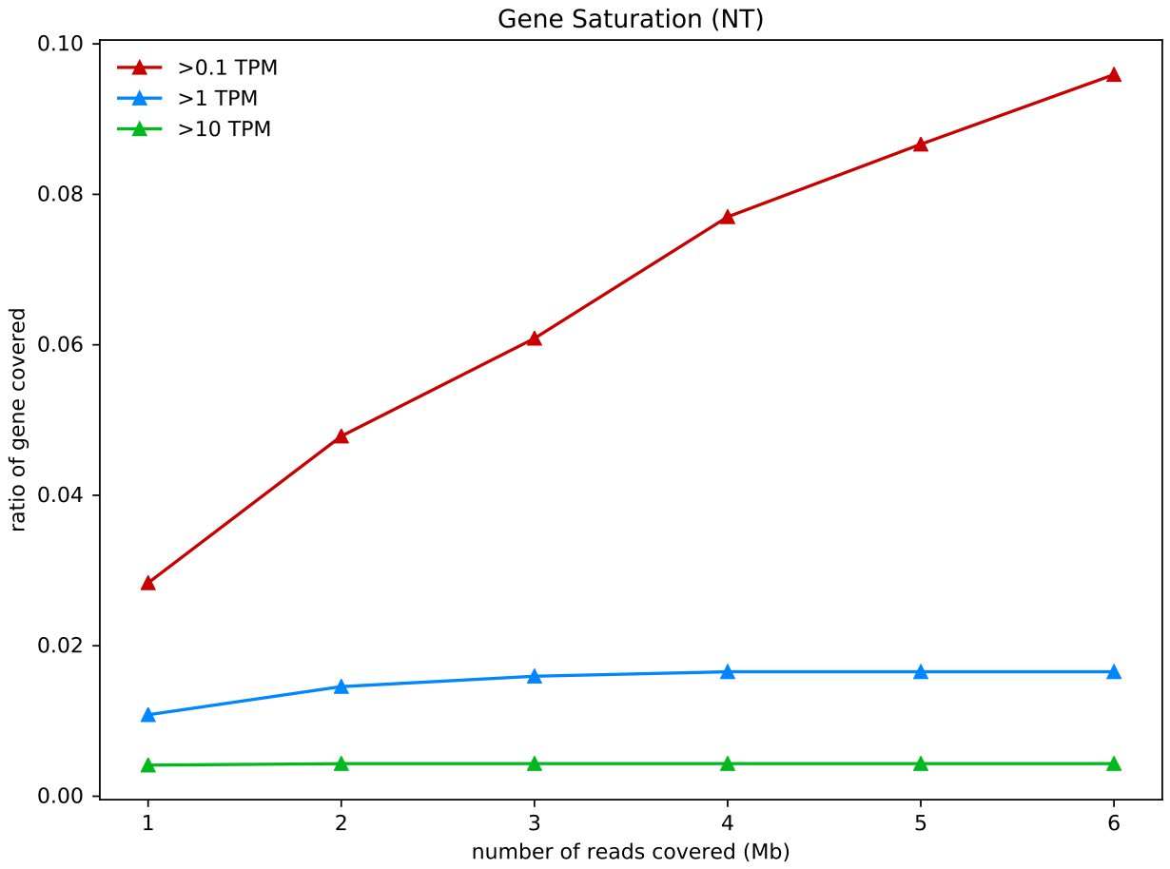
Gene-saturation plot for K5.

Supplementary Figure S24. K5-WGE versus K5 MA plot.
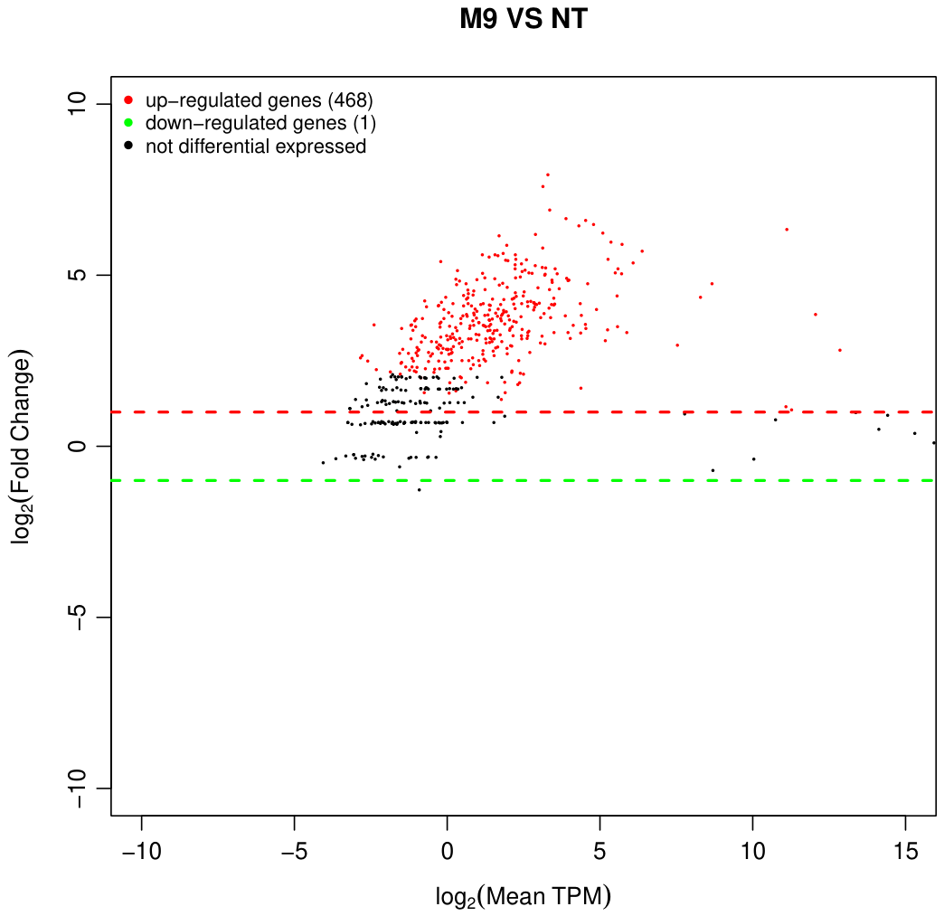
MA plot for K5-WGE versus K5.

Supplementary Figure S25. K5-WGE versus K5 GO enrichment support.
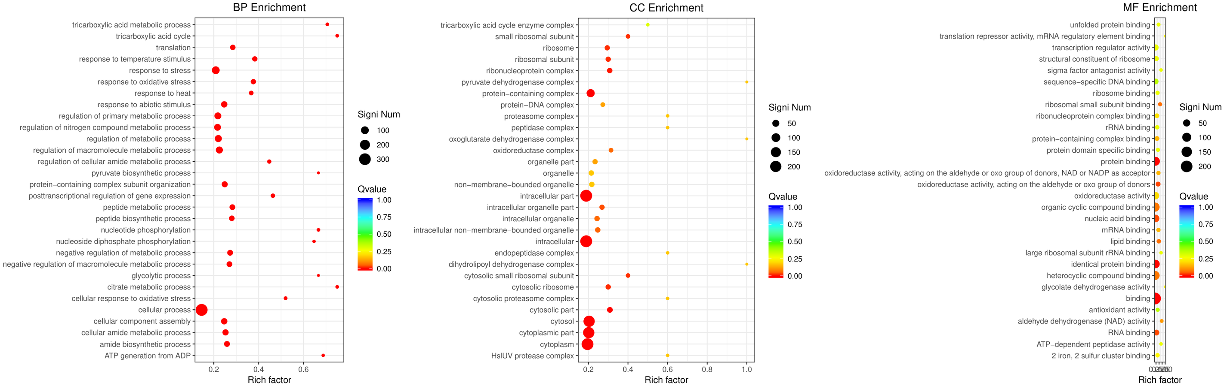
GO enrichment summary for K5-WGE versus K5.

Supplementary Table S4. Sample definitions and naming conventions used across datasets
Item | Definition
K1 | K5
A1 | K5A
Section I transcriptome | Stationary phase, OD600 = 2.10; no biological replicates
M9 | K5-WGE
NT | K5
Section VI transcriptome | Stationary phase, OD600 = 2.1; no biological replicates
Candidate 6 | YihW
Section IV mutation name | S130G

Section VII. Strains and plasmids used in this study
To improve reproducibility and nomenclature consistency, Supplementary Tables S5 and S6 summarize the principal strains and plasmids used in this study. These tables also reflect the revised platform-building logic used in Figure 3: construction of the clean K5AC chassis, Pgnt-only dual-plasmid benchmarking with pNG and pACYC-NaKfiA/kfiC, CRP-assisted fluorescence/growth selection with pNTG-CRP, and mixed-population validation under tetracycline pressure. Here, CRP-assisted selection refers to matching Pgnt with additional CRP supplied from the biosensor plasmid in the otherwise CRP-positive K5AC chassis.
Supplementary Table S5. Strains used in this study
Strain | Relevant genotype / carried construct(s) | Description and experimental use | Source
K5 | Escherichia coli K5 | Parental heparosan-producing strain used as the wild-type reference for pathway characterization, transcriptomic comparison, and selection-circuit evaluation. | This study
K5A | E. coli K5 ΔkfiA | kfiA-deficient chassis generated by CRISPR/Cas9-mediated genome editing; used to define the heparosan-deficient state and to evaluate reporter performance. | This study
K5A/kfiA | K5A carrying pACYC_P34_kfiA | K5A strain carrying pACYC_P34_kfiA, used to restore kfiA expression and support validation experiments. | This study
K5-WGE | Whole-genome-evolved E. coli K5 derivative | Population isolated after coupling the Pgnt-CRP circuit to continuous genome-wide mutagenesis; used to assess host-adaptive outcomes and boundary conditions of the selection strategy. | This study
BL21(DE3) | Escherichia coli BL21(DE3) | Protein-expression host used for recombinant production and biochemical characterization of PmHS2 wild-type and mutant proteins carried on pET-28a(+) constructs. | Commercial
K5AC | E. coli K5 ΔkfiA ΔkfiC | Clean double-knockout chassis generated by additional deletion of kfiC in the K5A background; used for Figure 3 benchmark validation, Pgnt-only and CRP-assisted circuit testing, PmHS2 evolution, and kfiA/kfiC system evolution. | This study
K5AC-NaKfiA benchmark strains | K5AC carrying pNG or pNTG-CRP plus pACYC_P34_NaKfiA(mut)_P34_kfiC | Dual-plasmid benchmark strains carrying wild-type NaKfiA or one of four NaKfiA variants (E74Y, I76V, T108Y, S165K) together with kfiC; used to evaluate Pgnt-only GFP output, CRP-assisted GFP output, tetracycline-coupled growth, and mixed-population serial-passage enrichment. | This study

Supplementary Table S6. Plasmids used in this study
Standardized name | Full designation / backbone | Key genetic element(s) | Primary use in this study | Source
pEcCas | Cas9-expression plasmid | Cas9 nuclease expression cassette for CRISPR/Cas9-mediated editing in E. coli K5. | Genome editing of kfiA or kfiC loci. | Previous study / this study
pEcgRNA-N20-kfiA | gRNA plasmid | Guide RNA targeting kfiA. | CRISPR/Cas9 deletion or editing of kfiA. | This study
pEcgRNA-N20-kfiC | gRNA plasmid | Guide RNA targeting kfiC. | CRISPR/Cas9 deletion or editing of kfiC. | This study
pACYC_EcgRNA_N20-kfiA | pACYC-based gRNA plasmid | Low-copy guide RNA vector targeting kfiA. | Optimized genome editing in E. coli K5 background. | This study
pACYC_EcgRNA_N20-kfiC | pACYC-based gRNA plasmid | Low-copy guide RNA vector targeting kfiC. | Optimized genome editing in E. coli K5 background. | This study
pNG | pETDuet-1_Pgnt_gfp | Pgnt promoter fused upstream of gfp. | Pgnt-only GFP reporter plasmid used with pACYC-NaKfiA/kfiC for Figure 3 dual-plasmid benchmarking. | This study
pNT | pETDuet-1_Pgnt_tetA | Pgnt promoter fused upstream of tetA. | Growth-coupled selection module used to convert Pgnt output into tetracycline resistance. | This study
NCT | pETDuet-1_Pgnt_tetA_P34_CRP | Pgnt-tetA cassette combined with constitutive P34-driven CRP expression. | CRP-assisted sensor-selection circuit used for directed evolution and selection tests. | This study
pNTG-CRP | pETDuet-1_Pgnt_tetA_gfp_Pbad_crp | Pgnt-linked gfp and tetA outputs plus Pbad-crp expression module; crp induction with 2 mg/mL arabinose. | CRP-assisted dual-output reporter/selection plasmid used for Figure 3 fluorescence and tetracycline-growth benchmarking. | This study
pETDuet-1_Pgnt_gfp_Pbad_grcA | TF-screen reporter plasmid | Pgnt-gfp reporter combined with inducible grcA expression. | Candidate transcription-factor screening against Pgnt output. | This study
pETDuet-1_Pgnt_gfp_Pbad_rdgC | TF-screen reporter plasmid | Pgnt-gfp reporter combined with inducible rdgC expression. | Candidate transcription-factor screening against Pgnt output. | This study
pETDuet-1_Pgnt_gfp_Pbad_ompR | TF-screen reporter plasmid | Pgnt-gfp reporter combined with inducible ompR expression. | Candidate transcription-factor screening against Pgnt output. | This study
pETDuet-1_Pgnt_gfp_Pbad_rluB | TF-screen reporter plasmid | Pgnt-gfp reporter combined with inducible rluB expression. | Candidate transcription-factor screening against Pgnt output. | This study
pETDuet-1_Pgnt_gfp_Pbad_rraA | TF-screen reporter plasmid | Pgnt-gfp reporter combined with inducible rraA expression. | Candidate transcription-factor screening against Pgnt output. | This study
pETDuet-1_Pgnt_gfp_Pbad_rbfA | TF-screen reporter plasmid | Pgnt-gfp reporter combined with inducible rbfA expression. | Candidate transcription-factor screening against Pgnt output. | This study
pETDuet-1_Pgnt_gfp_Pbad_crp | TF-screen reporter plasmid | Pgnt-gfp reporter combined with inducible crp expression. | Candidate transcription-factor screening that nominated CRP as the highest-confidence functional modulator of Pgnt output. | This study
pETDuet-1_Pgnt_gfp_Pbad_yihW | TF-screen reporter plasmid | Pgnt-gfp reporter combined with inducible yihW expression. | Candidate transcription-factor screening against Pgnt output. | This study
pETDuet-1_Pgnt_gfp_Pbad_clpB | TF-screen reporter plasmid | Pgnt-gfp reporter combined with inducible clpB expression. | Candidate transcription-factor screening against Pgnt output. | This study
pETDuet-1_Pgnt_gfp_Pbad_rpoD | TF-screen reporter plasmid | Pgnt-gfp reporter combined with inducible rpoD expression. | Candidate transcription-factor screening against Pgnt output. | This study
pPM | pACYC_P34_PmHS2 | Constitutive P34-driven PmHS2 expression cassette on a pACYC backbone. | PmHS2 mutant-library construction and growth-coupled evolution. | This study
pACYC_P34_kfiA_P34_kfiC | kfiA/kfiC library vector | Dual-expression construct carrying kfiA and kfiC under P34 promoters. | Construction and propagation of the heteromeric kfiA mutant library with kfiC maintained as partner subunit. | This study
pSC101_MutD5 | Whole-genome dual-plasmid mutagenesis system | Low-copy mutator plasmid encoding MutD5-mediated error-prone replication functions. | Continuous whole-genome diversification coupled to the selection circuit. | This study
pET-28a(+)_PmHS2-WT | pET-28a(+) | Wild-type PmHS2 coding sequence. | Expression and purification of recombinant PmHS2 reference enzyme in BL21(DE3). | This study
pET-28a(+)_PmHS2-S130G | pET-28a(+) | PmHS2 carrying the S130G substitution. | Expression and biochemical validation of an enriched PmHS2 mutant in BL21(DE3). | This study
pET-28a(+)_PmHS2-L351Q | pET-28a(+) | PmHS2 carrying the L351Q substitution. | Expression and biochemical validation of an enriched PmHS2 mutant in BL21(DE3). | This study
pET-28a(+)_PmHS2-F364Y | pET-28a(+) | PmHS2 carrying the F364Y substitution. | Expression and biochemical validation of an enriched PmHS2 mutant in BL21(DE3). | This study
pET-28a(+)_PmHS2-Y530N | pET-28a(+) | PmHS2 carrying the Y530N substitution. | Expression and biochemical validation of an enriched PmHS2 mutant in BL21(DE3). | This study
pET-28a(+)_PmHS2-Q606E | pET-28a(+) | PmHS2 carrying the Q606E substitution. | Expression and biochemical validation of an enriched PmHS2 mutant in BL21(DE3). | This study
pACYC_P34_Vn_kfiC_P34_kfiA_Vc | BiFC plasmid | VN-tagged kfiC and VC-tagged wild-type kfiA under P34 promoters. | Bimolecular fluorescence complementation (BiFC) analysis of wild-type KfiA-KfiC association. | This study
pACYC_P34_Vn_kfiC_P34_kfiAM1_Vc | BiFC plasmid | VN-tagged kfiC and VC-tagged kfiA M1 variant under P34 promoters. | BiFC analysis of mutant M1 KfiA-KfiC association. | This study
pACYC_P34_Vn_kfiC_P34_kfiAM2_Vc | BiFC plasmid | VN-tagged kfiC and VC-tagged kfiA M2 variant under P34 promoters. | BiFC analysis of mutant M2 KfiA-KfiC association. | This study
pACYC_P34_Vn_kfiC_P34_kfiAM3_Vc | BiFC plasmid | VN-tagged kfiC and VC-tagged kfiA M3 variant under P34 promoters. | BiFC analysis of mutant M3 KfiA-KfiC association. | This study
pACYC-NaKfiA/kfiC | pACYC_P34_NaKfiA(mut)_P34_kfiC | P34-driven NaKfiA variant cassette paired with P34-driven kfiC on a pACYC backbone. | NaKfiA benchmark plasmid used in Figure 3; variants include WT, E74Y, I76V, T108Y and S165K. | This study

