Cystic Fibrosis Restricts Systemic and Local Lipid Fluxes during Lung Infection

Ella Haracic¹, Nicole Reyne^{2,6}, Dylan De Bellis³, Sara J. Fraser-Miller¹, Paul Trim⁴, Alexanda McCarron^{2,6}, Tyren M. Dodgen⁵, Brynley J. Davies¹, Jack K. Waters¹, Bernadette Boog^{2,6}, David Parsons^{2,6}, John Widger⁶, Marten Snel⁴, Shailesh Bihari^{3,7}, Dani-Louise Dixon³, Martin Donnelley^{2,6}* and Bart A. Eijkelkamp¹*.

¹ College of Science and Engineering, Flinders University, Bedford Park, SA, Australia.
² School of Medicine and Robinson Research Institute, College of Health, Adelaide University, Adelaide, South Australia, Australia.
³ College of Medicine and Public Health, Flinders University, Bedford Park, SA, Australia.
⁴ Metabolomics and MS-Imaging Core Facility, South Australian Health and Medical Research Institute, Adelaide, SA, Australia.
⁵ Waters Corporation, Rydalmere, NSW, Australia.
⁶ Women’s and Children’s Hospital, Adelaide, SA, Australia.
⁷ Intensive Care Unit, Flinders Medical Centre, South Australia

Running Title: CF Impedes Lipid Fluxes

* Corresponding authors: Bart Eijkelkamp. College of Science and Engineering, Flinders University, Adelaide, South Australia, 5042, Australia. Phone: +61-8-8201-7779. Email: bart.eijkelkamp@flinders.edu.au. Martin Donnelley. School of Medicine and Robinson Research Institute, College of Health, Adelaide University, Adelaide, South Australia, Australia. martin.donnelley@adelaide.edu.au.
Supplementary Table 1: Fatty acid composition of the 15% lard and 15% fish oil enriched diets.
Calculated Fatty Acid Composition as Fed
 | 15% lard enriched diet | 15% fish oil enriched diet
Saturated Fats C12:0 and less | 0.05% | No data
Myristic Acid 14:0 | 0.23% | 0.44%
Palmitic Acid 16:0 | 3.96% | 2.74%
Stearic Acid 18:0 | 2.57% | 0.76%
Oleic Acid 18:1 | 5.06% | 1.94%
Gadoleic Acid 20:1 | 0.11% | 0.11%
Linoleic Acid 18:2 n6 | 2.17% | 0.48%
a Linolenic Acid 18:3 n3 | 0.30% | 0.06%
Arachidonic Acid 20:4 n6 | No data | 0.24%
EPA 20:5 n3 | No data | 0.86%
DHA 22:6 n3 | No data | 3.75%
Total n3 | 0.30% | 5.23%
Total n6 2.18% | 2.18% | 1.00%
Total Monounsaturated Fats | 5.48% | 3.40%
Total Polyunsaturated Fats | 2.56% | 6.28%
Total Saturated Fats | 6.95% | 4.39%

Supplementary Table 2: Oligonucleide sequences used for qRT-PCR.

 | Sequence (5’ – 3’) | Tm (°C) | Ta (°C) | Product size (bp)
gapdh
Forward | GGGTGTGAACCACGAGAAAT | 63.3 | 63.3 | 156
Reverse | CCACAGTCTTCTGAGTGGCA | 64.8 | 63.3 | 156
fasn
Forward | GGATGGTGGTTTCCTGCTAA | 77.7 | 64.2 | 169
Reverse | GCAGTGCCTTCCTTGAGAAC | 64.2 | 64.2 | 169

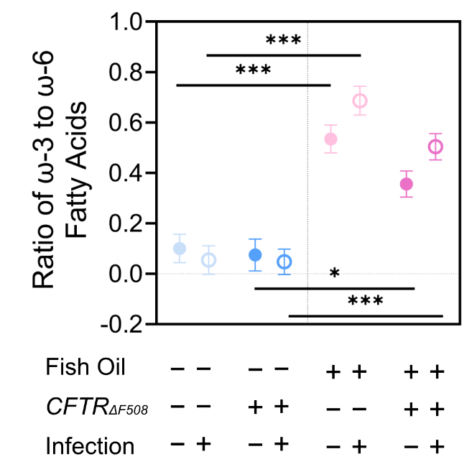

Supplementary Figure 1: The ratio of circulating ω-3:ω-6 fatty acids. The calculated ratio of the absolute abundance of C18:2ω-6 and C20:4ω-6 to C22:6ω-3 in the plasma identified via GC-MS. Results are representative of at least 4 biological replicates. Plots show model-adjusted estimated marginal means (±95% CI). Statistical analyses used factorial linear models with fixed effects of genotype, infection status and diet; p < 0.05, * and p < 0.0005, ***.

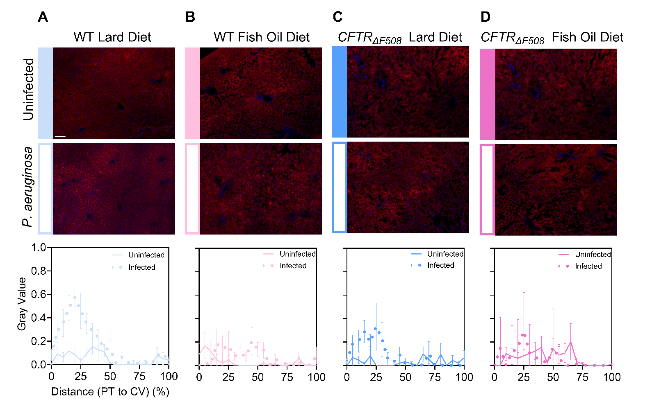
Supplementary Figure 2: Visualisation of hepatic lipid droplets. Nile red and DAPI stained liver tissue (sectioned at 10 µm) for (A) WT animals fed a 15% lard diet, (B) WT animals fed a 15% fish oil diet, (C) CFTR_{ΔF508} animals fed a 15% lard diet and (D) CFTR_{ΔF508} animals fed a 15% fish oil diet. Images were visualised using an Olympus AX70 fluorescent microscope and false coloured using ImageJ (FIJI). The asterisks denote the central vein (scalebar = 100 μm). ImageJ analyses of lipid droplets located from the portal triad to central vein.

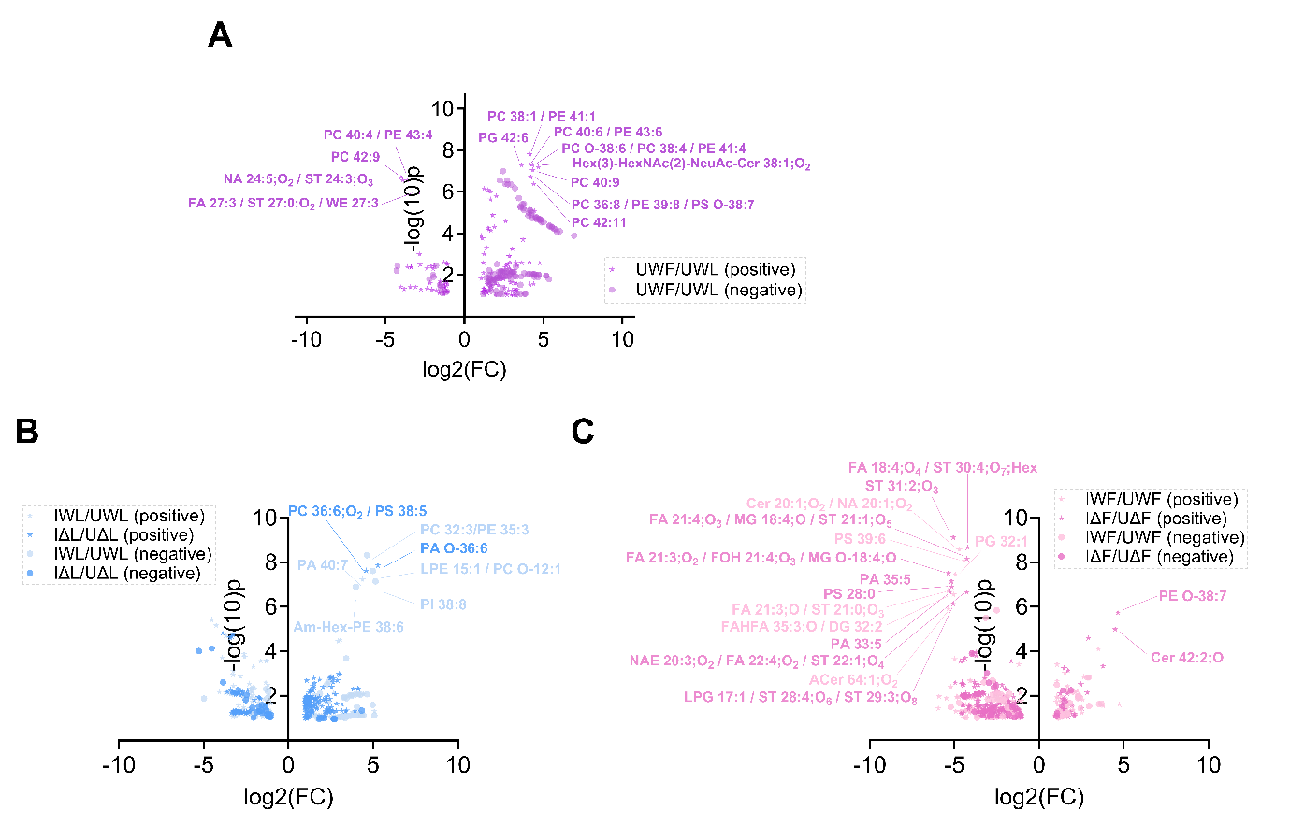

Supplementary Figure 3: The influence of diet and P. aeruginosa infection on the lung lipidome (A) The influence of diet on the lung lipidome in uninfected WT rats. Overlay of ions detected from liquid MALDI-TOF in both positive and negative mode. UWF = uninfected WT rats on fish oil, UWL = uninfected WT rats on lard. (B) The influence of P. aeruginosa infection on the lung lipidome in lard fed WT and CFTR_{ΔF508} rats. Overlay of ions detected from liquid MALDI-TOF in both positive and negative mode. IWL = Infected WT rats on lard, UΔL = uninfected CFTR_{ΔF508} rats on lard, IΔL = infected CFTR_{ΔF508} rats on lard. (C) The influence of P. aeruginosa infection on the lung lipidome in fish oil fed WT and CFTR_{ΔF508} rats. Overlay of ions detected from liquid MALDI-TOF in both positive and negative mode. IWF = Infected WT rats on fish oil, UΔF = uninfected CFTR_{ΔF508} rats on fish oil, IΔF = infected CFTR_{ΔF508} rats on fish oil.

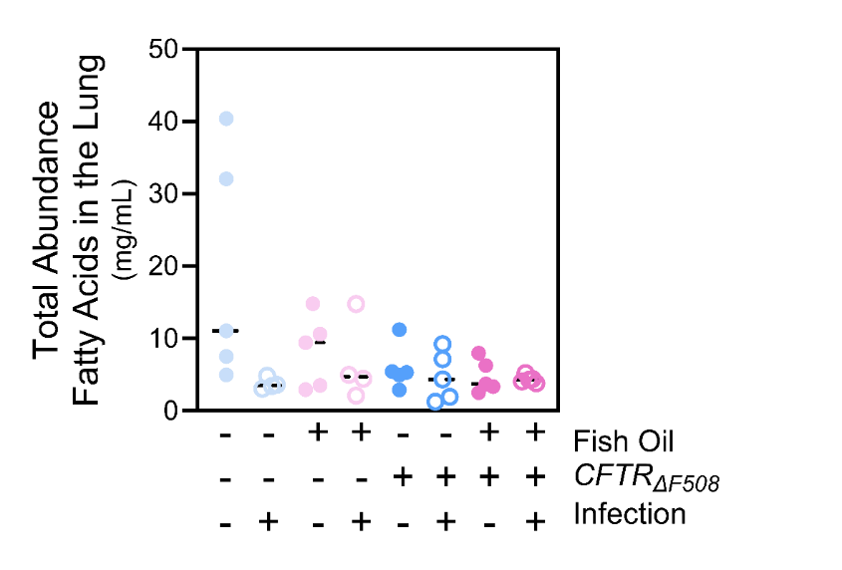
Supplementary Figure 4: Observation of the pulmonary adipocyte heterogenous phenotype in uninfected WT lard rats. The total absolute abundace of pulmonary fatty acids detected by GC-MS. Results are representative of 5 biological replicates except for infected WT rats on the fish oil diet, where there are 4 biological replicates.

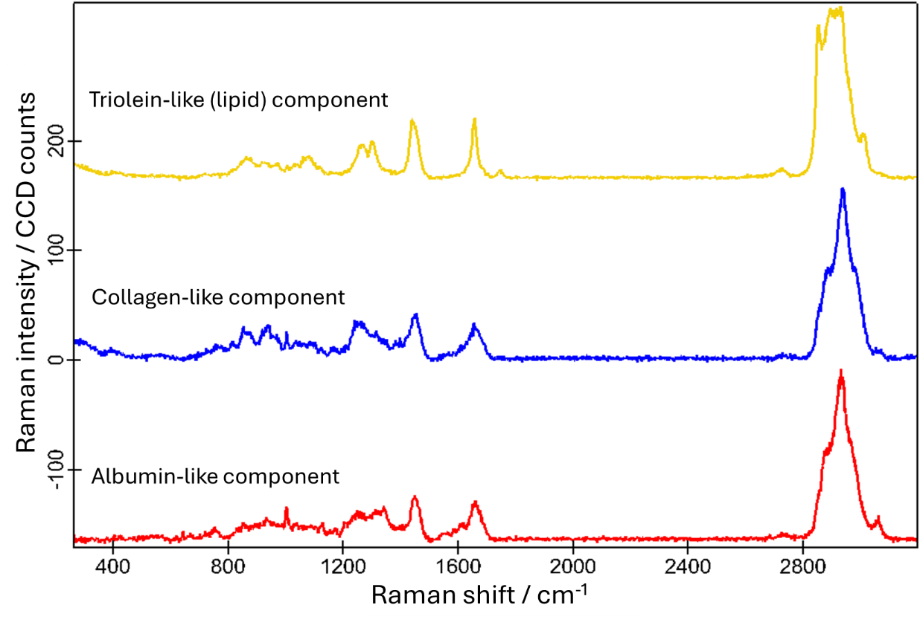
Supplementary Figure 5: The Raman spectral component curves used to generate Raman-based false colour images shown in Figure 4.

