SUPPLEMENTARY MATERIAL
Supplementary methods
The final VCF file, containing SNVs and indels for the 200 trios (600 samples), was loaded into Hail 0.2 (https:// hail.is/; https://github.com/hail-is/hail). Then, multiallelic sites were split into biallelic sites (resulting in 719,209 unique variants).To verify the accuracy of the provided pedigree information, relatedness was assessed between each pair of samples using Hail's ibd() function. The relatedness values were manually checked, and inferred pedigree structures were compared to reported pedigrees to search for discrepancies. Duplicate samples were identified by using an identity value higher than 0.8 (pi-hat > 0.8) and related samples were identified by using an identity value higher than 0.4 (pi-hat > 0.4)²³. No obvious errors in reporting were detected. After filtering the VCF file for the selected coordinates of interest to eliminate off-targets or amplified regions outside the cCREs, low-complexity regions and variants that failed VQSR were excluded. Indels were required to have a variant quality score log odds (VQSLOD) of ≥ -0.6549, while SNVs were required to possess a VQSLOD of ≥ 5.2528.Following these steps, a total of 268,900 unique variants remained.
To ensure the quality of genotypes, various filters were implemented during the genotype quality control process. Initially, we excluded calls with a depth of coverage (DP) < 10 or > 1,000 (as per the distribution of DP values). Moreover, we omitted any call if the GQ was < 25.For homozygous reference calls, genotypes were then filtered if they had < 90% of the read depth supporting the reference allele.Homozygous variant calls underwent filtering for genotypes with < 90% of the read depth supporting the alternate allele or a Phred-scaled likelihood (PL) of being homozygous reference < 25.Heterozygous calls were filtered based on genotypes with < 90% of the read depth supporting either the reference or alternate allele, a PL of being homozygous reference < 25, < 25% of the read depth supporting the alternate allele (i.e., an allele balance (AB) < 0.25), or a probability of the AB (calculated from a binomial distribution centered on 0.5) < 1 x 10⁹.We additionally omitted any heterozygous call in the X or Y non pseudoautosomal (PAR) regions (in a sample that was imputed as male).
Following the implementation of these filters, variants with a call rate < 10% or a Hardy-Weinberg equilibrium (HWE) p-value <1 x 10¹² were excluded. Following the application of these filters and the exclusion of sites that were no longer variants, the dataset comprised 267,157 distinct variants in 200 ASD trios. This dataset was then used as the starting point for the de novo and inherited workflows.

De novo variant detection
De novo variants were identified within the previously described 600-sample dataset.
Variant calling for DNVs utilized the de_novo() function implemented in Hail 0.2. To establish population allele frequencies for all the variants in our dataset, data were sourced from the non-psychiatric subset of gnomAD (https://gnomad.broadinstitute.org/), which includes samples not ascertained for neurological or psychiatric phenotypes (non-neuro subset). Subsequently, these frequencies were utilized as input priors.
Additional criteria for variant calling included the following: (i) homozygous reference genotypes in parents should exhibit no more than 3% of reads supporting the alternate allele, (ii) children's heterozygous calls were required to have a minimum of 30% of reads supporting the alternate allele, and (iii) the ratio of child DP to parental DP needed to be at least 0.3. This procedure resulted in the identification of 11,311 putative de novo variants.
To ensure the quality of de novo variants, we retained variants that were classified as high confidence by Hail or were of medium confidence and represented singletons in the dataset (resulting in the inclusion of 10,383 putative de novo variants). Subsequently, any variant with an allele frequency exceeding 0.1% across the samples in our dataset (of note, any variant yielded such frequency) or in the non-neuro subset of gnomAD was excluded (leading to the exclusion of 9,739 putative de novo variants).
Moreover, samples were excluded if they had more than 5 de novo variants (3 samples excluded with 206, 171 and 101 de novo variants, respectively), based on z-scores ((data value-mean)/ standard deviation) ≥ 3.
Additionally, we filtered out variants that were less than 20 base pairs apart from each other to mitigate the likelihood of false positives (resulting in the exclusion of 2 putative de novo variants).
After applying these filters, the resultant list of high confidence de novo variants included 164 de novo variants from 103 probands.

Rare inherited variation
As with de novo variation, we used the dataset of 600 samples and 267,157 unique variants described above as a starting point to identify high confidence ultra-rare transmitted variants. For this purpose, we employed the pipeline described by Wilfert et al.²² (https://github.com/EichlerLab/ultra_rare_transmitted).
Initially, all sites that were heterozygous and observed only once in the parent population (parental frequency ≤ 2.5×10⁻³) were designated as candidate ultra-rare private variants. Subsequently, only variants which did not violate the rules of Mendelian inheritance were kept, resulting in a total of 84,311 variants. Then, only informative sites were retained, leaving 55,903 variants.
After excluding one outlier family with 2,880 transmitted variants (z-score = 13.19), a final set of 53,023 variants was identified in 199 ASD probands.

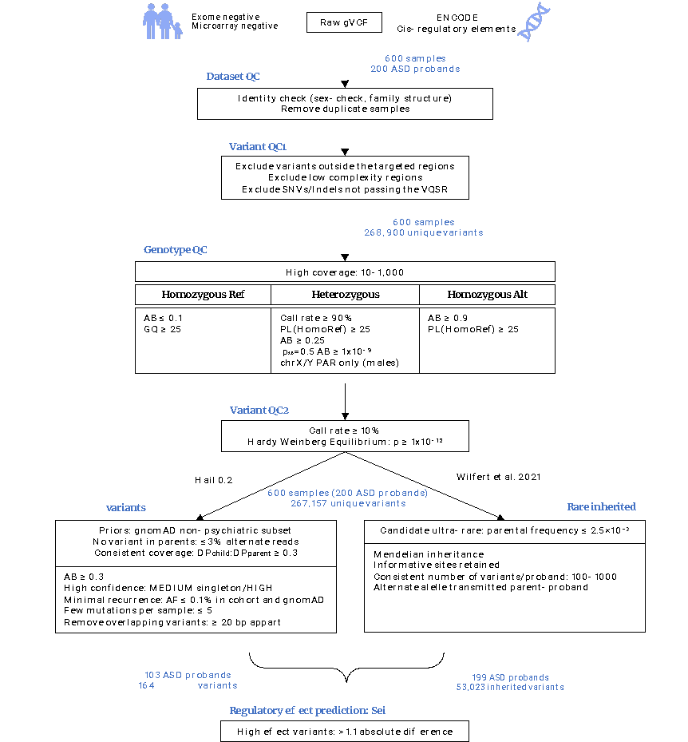

Supplementary Figure 1. Workflow for variant quality control (QC) and filtering . AB, allele balance; AF, allele frequency; bp, base pairs; DP, depth of coverage; GQ, genome quality; PAR, pseudoautosomal regions; PL, phred-scaled likelihood.

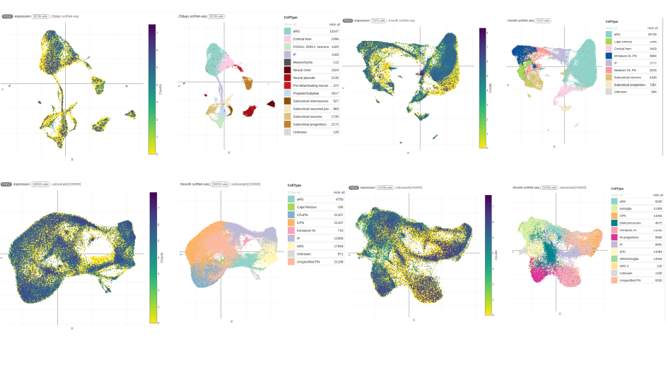
Supplementary Fig 2 POGZ UMAP projections of single-cell transcriptomes across four developmental timepoints (23 days, 1 month, 3 months, and 6 months postnatal). For each timepoint, the left panel shows the distribution of cells colored by gene expression density (purple blue = high, yellow = low), while the right panel displays cells colored by assigned cell type identity. Each point represents an individual cell, with spatial proximity indicating transcriptional similarity. The progressive expansion and refinement of cell type clusters across developmental stages demonstrates dynamic cellular maturation and increasing cellular heterogeneity. N = cells per timepoint. scRNAseq, single-cell RNA sequencing; UMAP, Uniform Manifold Approximation and Projection.
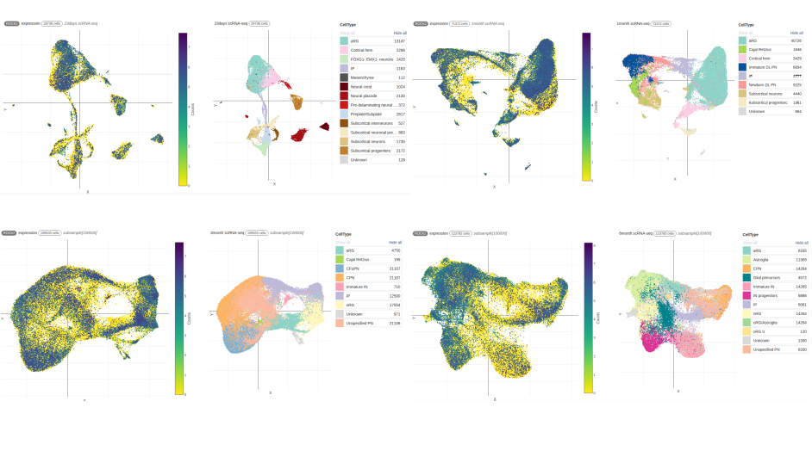
Supplementary Fig 3 ROCK2 UMAP projections of single-cell transcriptomes across four developmental timepoints (23 days, 1 month, 3 months, and 6 months postnatal). For each timepoint, the left panel shows the distribution of cells colored by gene expression density (purple blue = high, yellow = low), while the right panel displays cells colored by assigned cell type identity. Each point represents an individual cell, with spatial proximity indicating transcriptional similarity. The progressive expansion and refinement of cell type clusters across developmental stages demonstrates dynamic cellular maturation and increasing cellular heterogeneity. N = cells per timepoint. scRNAseq, single-cell RNA sequencing; UMAP, Uniform Manifold Approximation and Projection.

