Abstract
In this work, Ti₃C₂T_{x} MXene was identified as efficient nanozyme with area-dependent electrocatalytic activity in oxidation of phenolic compounds, which originated from the strong adsorption effect between the phenolic hydroxyl group and the oxygen atom on the surface of Ti₃C₂T_{x} MXene flake. On the basis of the novel electrocatalytic activity, Ti₃C₂T_{x} MXene was combined with alkaline phosphatase to construct a novel cascading catalytic amplification strategy using 1-naphthyl phosphate (1-NPP) as substrate, thereby realizing efficient electrochemical signal amplification. Taking advantage of the novel cascading catalytic amplification strategy, an electrochemical biosensor was fabricated for BCR/ABL fusion gene detection, which achieved excellent sensitivity with linear range from 0.2 fM to 20 nM and limit of detection down to 0.05 fM. This biosensor provided a promising tool for ultrasensitive fusion gene detection in early diagnosis of chronic myelogenous leukemia and acute lymphocytic leukemia. Moreover, the manageable catalytic activity of MXene broke a path for developing nanozymes, which possessed enormous application potential in not only electrochemical analysis but also the extensive fields including organic synthesis, pollutant disposal and so on.
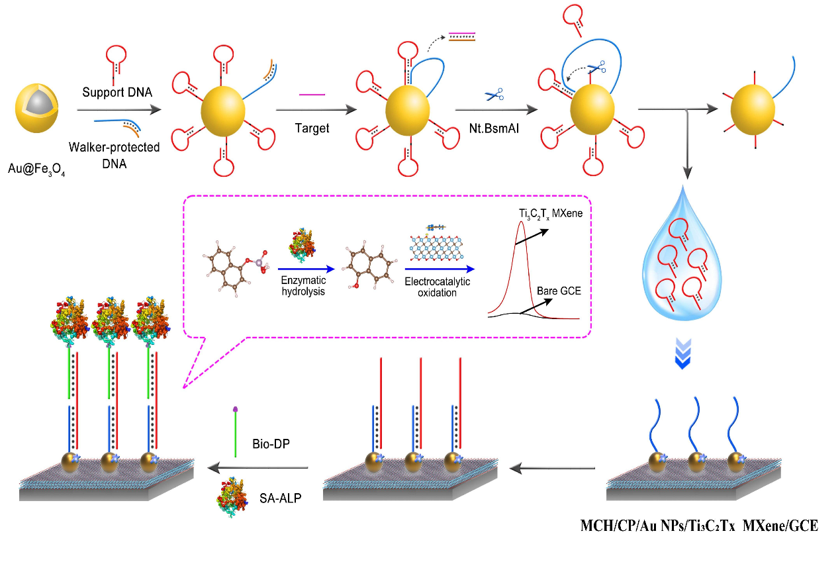
Scheme 1 Schematic illustration for the working principle of the electrochemical biosensor.

