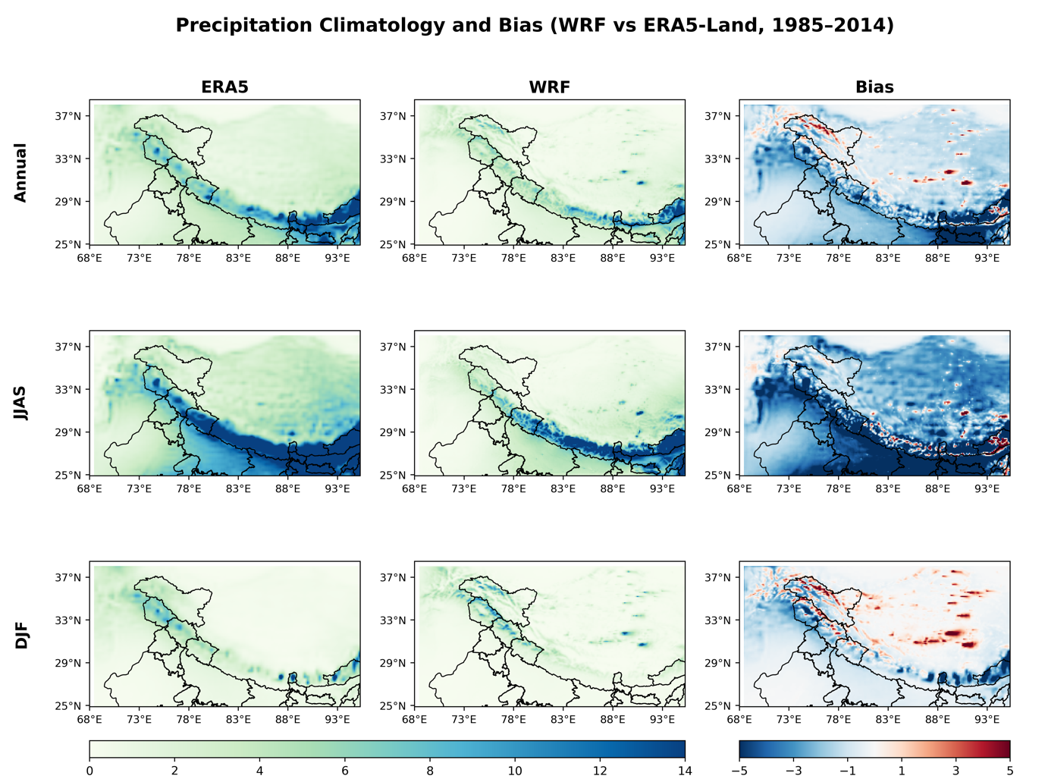
Figure S1. Comparison of precipitation climatology and model bias between ERA5-Land and WRF (D02) over the Himalayan region for the period 1985–2014. Rows represent annual (top), JJAS (monsoon, middle), and DJF (winter, bottom) seasons. Columns show ERA5-Land, WRF, and the corresponding bias (WRF − ERA5-Land). Precipitation is expressed in mm day⁻¹.
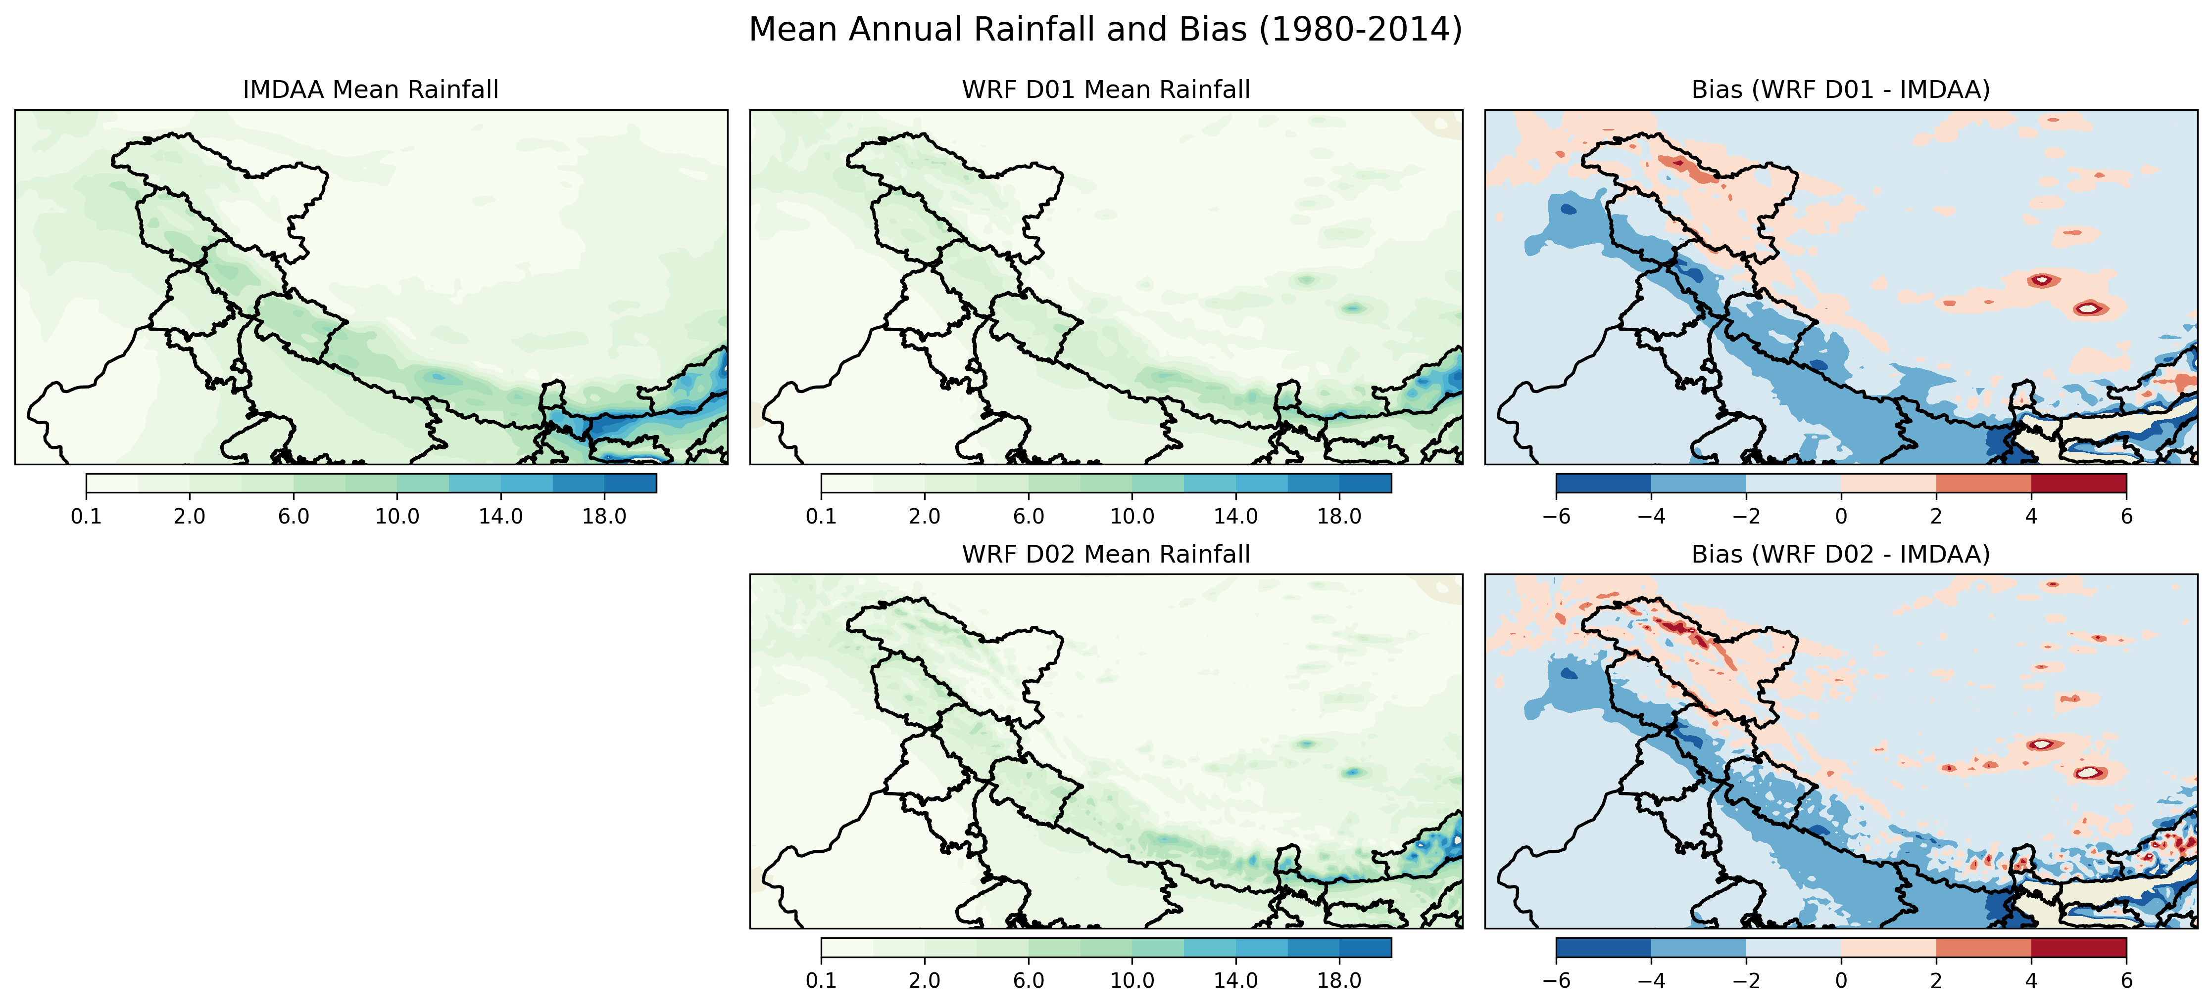
Figure S2. Comparison of annual mean precipitation climatology and model bias between IMDAA and WRF (D02) over the Himalayan region for the period 1985–2014. Panels show IMDAA precipitation, WRF, and the corresponding bias (WRF − IMDAA). Precipitation is expressed in mm/day
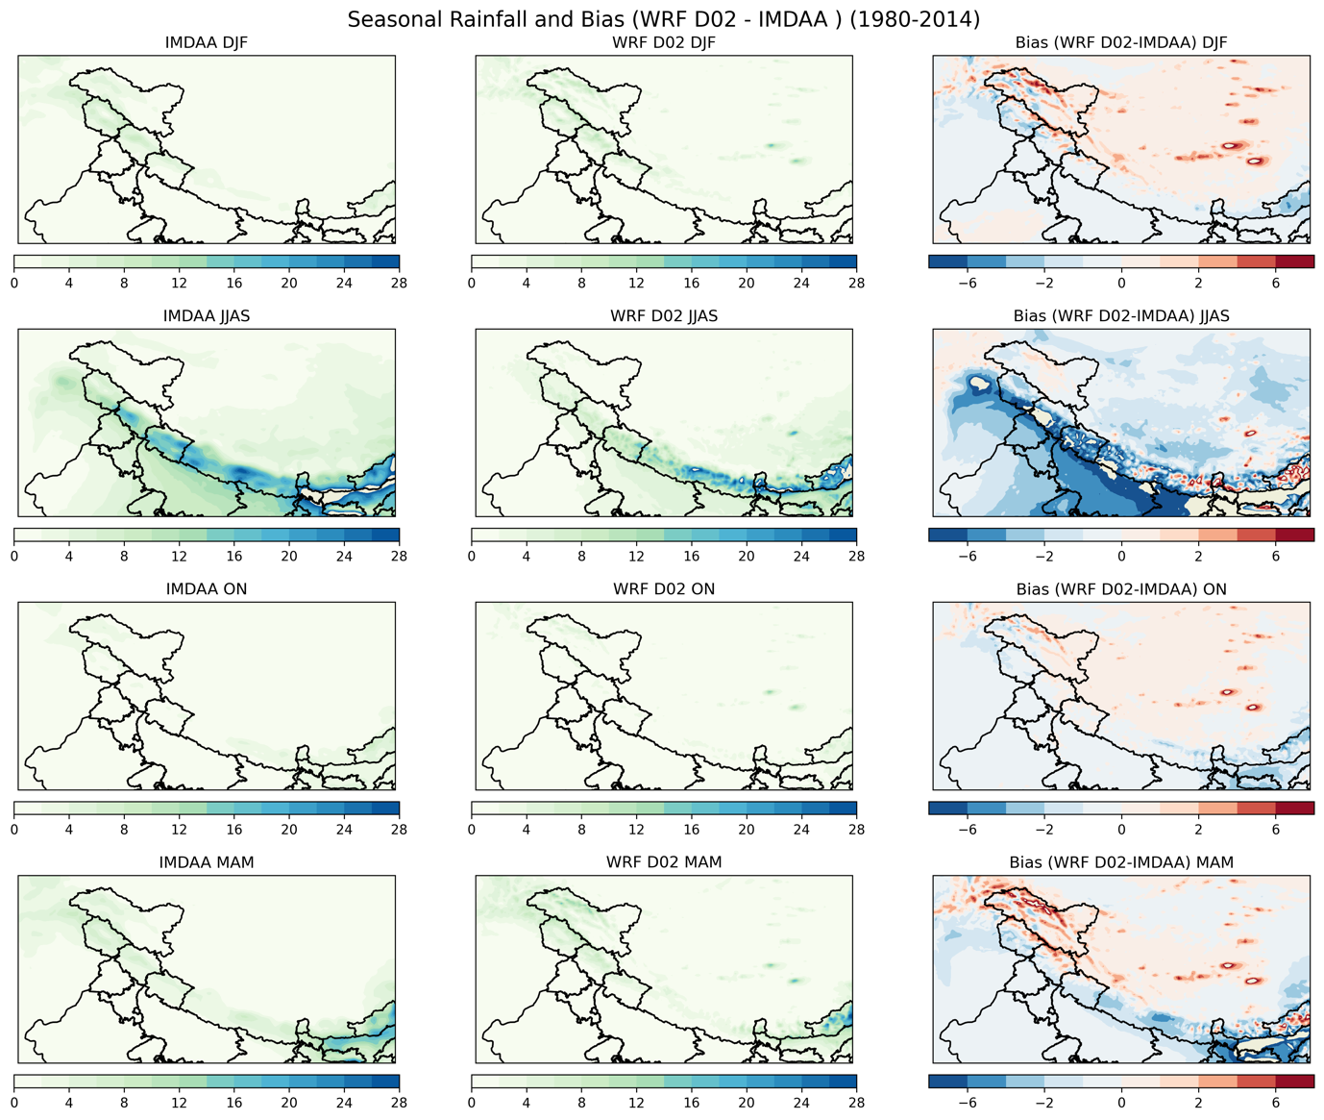
Figure S3. Seasonal precipitation climatology and model bias between IMDAA and WRF (D02) over the Himalayan region for the period 1980–2014. Rows represent DJF (winter), JJAS (monsoon), ON (post-monsoon), and MAM (pre-monsoon) seasons. Columns show IMDAA precipitation, WRF, and the corresponding bias (WRF − IMDAA). Precipitation is expressed in mm day⁻¹.
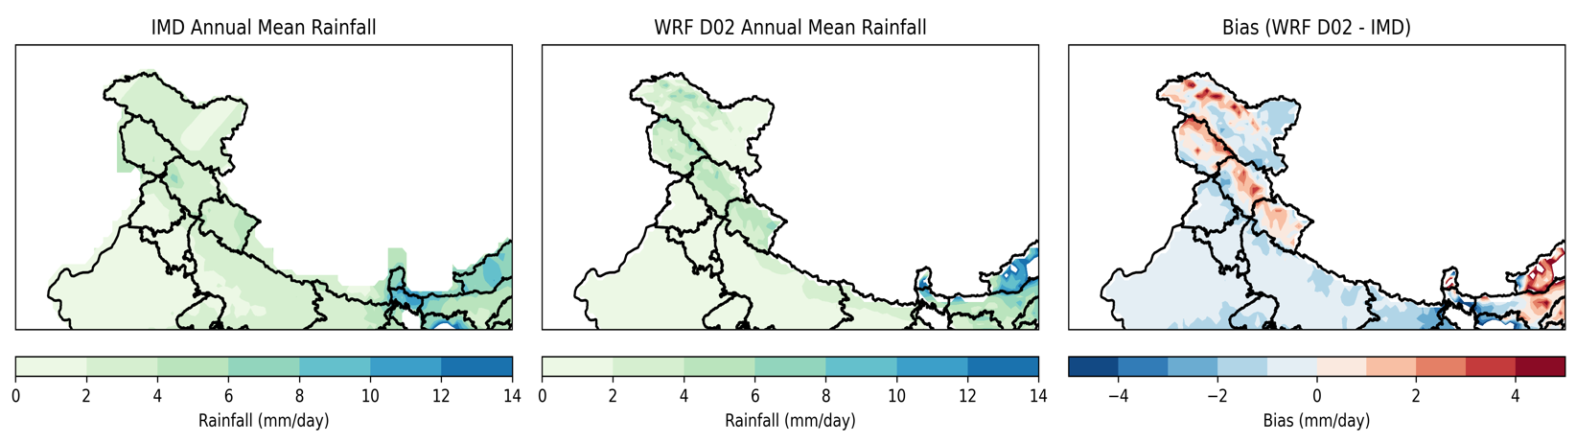
Figure S4. Comparison of annual mean precipitation climatology and model bias between IMD and WRF (D02) over the Himalayan region for the period 1985–2014. Panels show IMD precipitation, WRF, and the corresponding bias (WRF − IMD). Precipitation is expressed in mm day⁻¹.
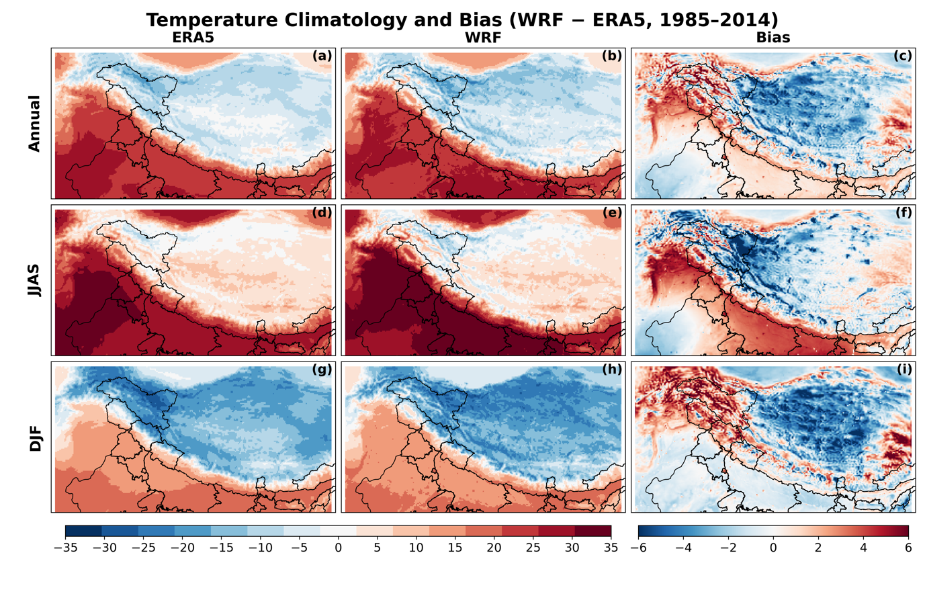
Figure S5. Comparison of temperature climatology and model bias between ERA5 and WRF (D02) over the Himalayan region for the period 1985–2014. Rows represent annual (top), JJAS (monsoon, middle), and DJF (winter, bottom) seasons. Columns show ERA5 temperature, WRF, and the corresponding bias (WRF − ERA5). Temperature is expressed in °C.

