Manuscript supplementary
Table S1: Pairwise comparisons between sites (Dunn’s test with Benjamini–Hochberg adjustment).

Comparison | Z | P.unadj | P.adj
IUI_N - IUI_S | 4E+00 | 7E-05 | 1E-04
IUI_N - JG | -9E-02 | 9E-01 | 9E-01
IUI_S - JG | -4E+00 | 5E-05 | 1E-04

Table S2: Median live coral cover differed among sites.
SITE | n | median_cover | Q1 | Q3
IUI_N | 153 | 0.391 | 0.281 | 0.516
IUI_S | 161 | 0.297 | 0.203 | 0.438
JG | 150 | 0.391 | 0.281 | 0.531

Table S3: Pairwise post hoc comparisons of live coral cover among depths following ART ANOVA.
contrast | df | t.ratio | p.value
DEPTH5 - DEPTH15 | 459 | 1.30 | 6.93E-01
DEPTH5 - DEPTH25 | 459 | -7.64 | 7.72E-13
DEPTH5 - DEPTH35 | 459 | -5.92 | 6.23E-08
DEPTH5 - DEPTH45 | 459 | -7.17 | 2.88E-11
DEPTH15 - DEPTH25 | 459 | -9.17 | 0.00E+00
DEPTH15 - DEPTH35 | 459 | -7.43 | 4.79E-12
DEPTH15 - DEPTH45 | 459 | -8.73 | 0.00E+00
DEPTH25 - DEPTH35 | 459 | 1.82 | 3.64E-01
DEPTH25 - DEPTH45 | 459 | 0.61 | 9.74E-01
DEPTH35 - DEPTH45 | 459 | -1.24 | 7.28E-01

Table S4:Alpha diversity by depth

DEPTH | Metric | mean | se
5 | Richness | 5 | 0.20949259
5 | Shannon | 1.33405271 | 0.04373395
5 | Simpson | 0.67089239 | 0.01551684
15 | Richness | 4.75 | 0.17371462
15 | Shannon | 1.29161818 | 0.04485842
15 | Simpson | 0.64883903 | 0.01855044
25 | Richness | 6.13636364 | 0.20772806
25 | Shannon | 1.46977996 | 0.0402306
25 | Simpson | 0.70131661 | 0.01531776
35 | Richness | 6.06451613 | 0.25483013
35 | Shannon | 1.44917439 | 0.04929891
35 | Simpson | 0.68664772 | 0.0178769
45 | Richness | 5.61052632 | 0.20806512
45 | Shannon | 1.27269213 | 0.06046343
45 | Simpson | 0.59275293 | 0.02673734

Table S5: Results of ART-Anova test for significant differences amongst the photo-physiology parameters data of the five selected corals. Significant P-values are in red.

Species | variable | df | statistic | p.value
Leptoseris | fv_fm | 2 | 25.36 | 6.61E-07
Leptoseris | p | 2 | 9.12 | 9.70E-04
Leptoseris | Pmax | 2 | 6.33 | 1.04E-02
Leptoseris | Sigma | 2 | 0.85 | 4.38E-01
Pocillopora | fv_fm | 2 | 9.25 | 5.69E-04
Pocillopora | p | 2 | 7.57 | 1.78E-03
Pocillopora | Pmax | 2 | 3.70 | 3.40E-02
Pocillopora | Sigma | 2 | 2.78 | 7.52E-02
Porites | fv_fm | 4 | 15.19 | 5.02E-09
Porites | p | 4 | 2.84 | 3.05E-02
Porites | Pmax | 4 | 7.63 | 3.54E-05
Porites | Sigma | 4 | 1.82 | 1.33E-01
Stylophora | fv_fm | 4 | 17.42 | 4.01E-10
Stylophora | p | 4 | 7.22 | 5.67E-05
Stylophora | Pmax | 4 | 31.22 | 2.77E-15
Stylophora | Sigma | 4 | 4.72 | 1.90E-03

Table S6: Pairwise post hoc comparisons of photophysiological parameters among depths following ART ANOVA.

Species | variable | contrast | df | t.ratio | p.value
Leptoseris | fv_fm | DEPTH25 - DEPTH35 | 27.00 | -0.91 | 6.41E-01
Leptoseris | fv_fm | DEPTH25 - DEPTH45 | 26.58 | 5.22 | 5.09E-05
Leptoseris | fv_fm | DEPTH35 - DEPTH45 | 26.95 | 5.87 | 8.83E-06
Leptoseris | p | DEPTH25 - DEPTH35 | 26.76 | -2.58 | 4.07E-02
Leptoseris | p | DEPTH25 - DEPTH45 | 26.21 | 1.27 | 4.24E-01
Leptoseris | p | DEPTH35 - DEPTH45 | 26.60 | 4.26 | 6.49E-04
Leptoseris | Pmax | DEPTH25 - DEPTH35 | 11.65 | 3.56 | 1.06E-02
Leptoseris | Pmax | DEPTH25 - DEPTH45 | 24.68 | 1.59 | 2.69E-01
Leptoseris | Pmax | DEPTH35 - DEPTH45 | 11.87 | -2.83 | 3.82E-02
Pocillopora | fv_fm | DEPTH5 - DEPTH15 | 36.10 | -4.11 | 6.15E-04
Pocillopora | fv_fm | DEPTH5 - DEPTH25 | 36.28 | -0.03 | 9.99E-01
Pocillopora | fv_fm | DEPTH15 - DEPTH25 | 36.34 | 2.82 | 2.09E-02
Pocillopora | p | DEPTH5 - DEPTH15 | 36.26 | -1.90 | 1.54E-01
Pocillopora | p | DEPTH5 - DEPTH25 | 36.66 | 2.68 | 2.86E-02
Pocillopora | p | DEPTH15 - DEPTH25 | 36.80 | 3.87 | 1.21E-03
Pocillopora | Pmax | DEPTH5 - DEPTH15 | 37.38 | 2.51 | 4.24E-02
Pocillopora | Pmax | DEPTH5 - DEPTH25 | 37.90 | 1.75 | 2.02E-01
Pocillopora | Pmax | DEPTH15 - DEPTH25 | 38.00 | -0.08 | 9.97E-01
Porites | fv_fm | DEPTH5 - DEPTH15 | 71.18 | -0.77 | 9.39E-01
Porites | fv_fm | DEPTH5 - DEPTH25 | 71.35 | -2.73 | 5.95E-02
Porites | fv_fm | DEPTH5 - DEPTH35 | 71.03 | -5.35 | 9.89E-06
Porites | fv_fm | DEPTH5 - DEPTH45 | 71.28 | -6.06 | 5.74E-07
Porites | fv_fm | DEPTH15 - DEPTH25 | 71.03 | -2.04 | 2.59E-01
Porites | fv_fm | DEPTH15 - DEPTH35 | 71.27 | -4.74 | 1.01E-04
Porites | fv_fm | DEPTH15 - DEPTH45 | 71.02 | -5.49 | 5.67E-06
Porites | fv_fm | DEPTH25 - DEPTH35 | 71.47 | -2.81 | 4.83E-02
Porites | fv_fm | DEPTH25 - DEPTH45 | 71.03 | -3.41 | 9.22E-03
Porites | fv_fm | DEPTH35 - DEPTH45 | 71.43 | -0.30 | 9.98E-01
Porites | p | DEPTH5 - DEPTH15 | 71.32 | -1.82 | 3.73E-01
Porites | p | DEPTH5 - DEPTH25 | 71.62 | -0.07 | 1.00E+00
Porites | p | DEPTH5 - DEPTH35 | 71.06 | -1.38 | 6.42E-01
Porites | p | DEPTH5 - DEPTH45 | 71.50 | 0.90 | 8.96E-01
Porites | p | DEPTH15 - DEPTH25 | 71.06 | 1.84 | 3.58E-01
Porites | p | DEPTH15 - DEPTH35 | 71.48 | 0.42 | 9.93E-01
Porites | p | DEPTH15 - DEPTH45 | 71.04 | 2.96 | 3.27E-02
Porites | p | DEPTH25 - DEPTH35 | 71.82 | -1.36 | 6.52E-01
Porites | p | DEPTH25 - DEPTH45 | 71.06 | 1.04 | 8.35E-01
Porites | p | DEPTH35 - DEPTH45 | 71.76 | 2.43 | 1.19E-01
Porites | Pmax | DEPTH5 - DEPTH15 | 71.40 | 2.66 | 7.12E-02
Porites | Pmax | DEPTH5 - DEPTH25 | 71.77 | 4.55 | 2.00E-04
Porites | Pmax | DEPTH5 - DEPTH35 | 71.07 | 4.96 | 4.41E-05
Porites | Pmax | DEPTH5 - DEPTH45 | 71.63 | 3.29 | 1.32E-02
Porites | Pmax | DEPTH15 - DEPTH25 | 71.08 | 1.95 | 2.99E-01
Porites | Pmax | DEPTH15 - DEPTH35 | 71.61 | 2.42 | 1.23E-01
Porites | Pmax | DEPTH15 - DEPTH45 | 71.05 | 0.49 | 9.88E-01
Porites | Pmax | DEPTH25 - DEPTH35 | 72.01 | 0.54 | 9.83E-01
Porites | Pmax | DEPTH25 - DEPTH45 | 71.07 | -1.59 | 5.06E-01
Porites | Pmax | DEPTH35 - DEPTH45 | 71.95 | -2.09 | 2.35E-01
Stylophora | fv_fm | DEPTH5 - DEPTH15 | 74.60 | -2.79 | 5.11E-02
Stylophora | fv_fm | DEPTH5 - DEPTH25 | 74.23 | -3.03 | 2.73E-02
Stylophora | fv_fm | DEPTH5 - DEPTH35 | 74.99 | -6.01 | 6.18E-07
Stylophora | fv_fm | DEPTH5 - DEPTH45 | 74.34 | -7.58 | 6.79E-10
Stylophora | fv_fm | DEPTH15 - DEPTH25 | 74.10 | -0.10 | 1.00E+00
Stylophora | fv_fm | DEPTH15 - DEPTH35 | 74.08 | -3.06 | 2.49E-02
Stylophora | fv_fm | DEPTH15 - DEPTH45 | 74.08 | -4.25 | 5.81E-04
Stylophora | fv_fm | DEPTH25 - DEPTH35 | 74.33 | -3.05 | 2.58E-02
Stylophora | fv_fm | DEPTH25 - DEPTH45 | 74.02 | -4.30 | 4.79E-04
Stylophora | fv_fm | DEPTH35 - DEPTH45 | 74.25 | -1.04 | 8.37E-01
Stylophora | p | DEPTH5 - DEPTH15 | 75.93 | -2.59 | 8.20E-02
Stylophora | p | DEPTH5 - DEPTH25 | 75.01 | 2.51 | 9.86E-02
Stylophora | p | DEPTH5 - DEPTH35 | 75.52 | -0.93 | 8.85E-01
Stylophora | p | DEPTH5 - DEPTH45 | 75.39 | 1.53 | 5.47E-01
Stylophora | p | DEPTH15 - DEPTH25 | 74.47 | 4.83 | 6.90E-05
Stylophora | p | DEPTH15 - DEPTH35 | 74.38 | 1.55 | 5.35E-01
Stylophora | p | DEPTH15 - DEPTH45 | 74.35 | 3.96 | 1.54E-03
Stylophora | p | DEPTH25 - DEPTH35 | 75.37 | -3.20 | 1.66E-02
Stylophora | p | DEPTH25 - DEPTH45 | 74.11 | -0.97 | 8.66E-01
Stylophora | p | DEPTH35 - DEPTH45 | 75.06 | 2.33 | 1.48E-01
Stylophora | Pmax | DEPTH5 - DEPTH15 | 75.51 | 3.90 | 1.90E-03
Stylophora | Pmax | DEPTH5 - DEPTH25 | 74.67 | 6.22 | 2.62E-07
Stylophora | Pmax | DEPTH5 - DEPTH35 | 75.99 | 8.21 | 0.00E+00
Stylophora | Pmax | DEPTH5 - DEPTH45 | 74.96 | 10.16 | 0.00E+00
Stylophora | Pmax | DEPTH15 - DEPTH25 | 74.30 | 1.95 | 2.99E-01
Stylophora | Pmax | DEPTH15 - DEPTH35 | 74.24 | 4.14 | 8.29E-04
Stylophora | Pmax | DEPTH15 - DEPTH45 | 74.23 | 5.54 | 4.38E-06
Stylophora | Pmax | DEPTH25 - DEPTH35 | 74.94 | 2.31 | 1.53E-01
Stylophora | Pmax | DEPTH25 - DEPTH45 | 74.07 | 3.69 | 3.82E-03
Stylophora | Pmax | DEPTH35 - DEPTH45 | 74.71 | 1.19 | 7.58E-01
Stylophora | Sigma | DEPTH5 - DEPTH15 | 74.89 | 2.64 | 7.29E-02
Stylophora | Sigma | DEPTH5 - DEPTH25 | 74.36 | 3.37 | 1.01E-02
Stylophora | Sigma | DEPTH5 - DEPTH35 | 75.41 | 3.78 | 2.79E-03
Stylophora | Sigma | DEPTH5 - DEPTH45 | 74.52 | 1.73 | 4.20E-01
Stylophora | Sigma | DEPTH15 - DEPTH25 | 74.16 | 0.56 | 9.81E-01
Stylophora | Sigma | DEPTH15 - DEPTH35 | 74.13 | 1.10 | 8.05E-01
Stylophora | Sigma | DEPTH15 - DEPTH45 | 74.12 | -0.99 | 8.59E-01
Stylophora | Sigma | DEPTH25 - DEPTH35 | 74.51 | 0.58 | 9.78E-01
Stylophora | Sigma | DEPTH25 - DEPTH45 | 74.04 | -1.61 | 4.95E-01
Stylophora | Sigma | DEPTH35 - DEPTH45 | 74.38 | -2.14 | 2.16E-01

Table S7: Results of Linear Decomposition Model (LDM) test for significant differences among the prevalence data of hard corals that are present in >10 samples by depth, and their relative abundance at each depth. Significant P-values are in red.

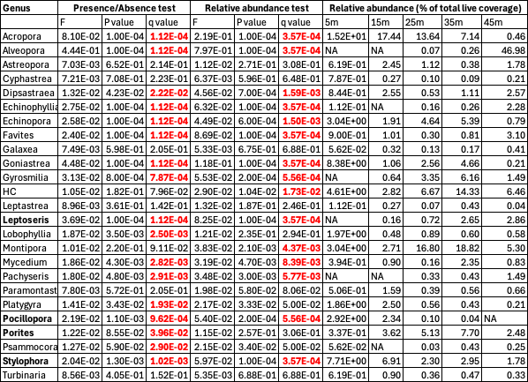

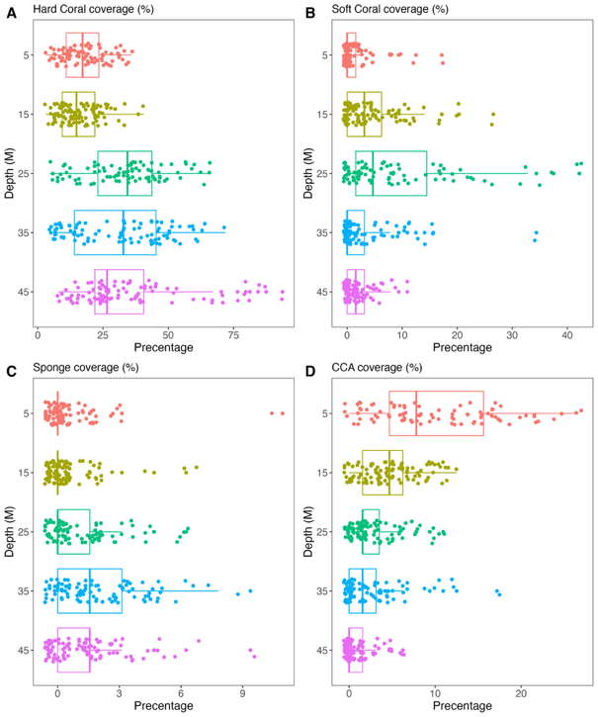
Figure S1 Coverage (%) of A) hard coral, B) soft corals C) sponge and D) CCA coverage at each depth-point, from the total observations across all (29,696 observations). Boxplots are presented. Different letters indicate significant differences as tested by ART-Anova (P<0.05).

Table S7. Results of the ART-Anova test for significant differences among the four live functional groups. Significant P-values are in bold.
Group | Df | F-value | P-value
Hard Coral
DEPTH | 4 | 37.0 | 2.2E-16
Soft Coral
DEPTH | 4 | 23.7 | 2.2E-16
CCA
DEPTH | 4 | 60.2 | 2.2E-16
Sponge
DEPTH | 4 | 19.8 | 4.5E-15

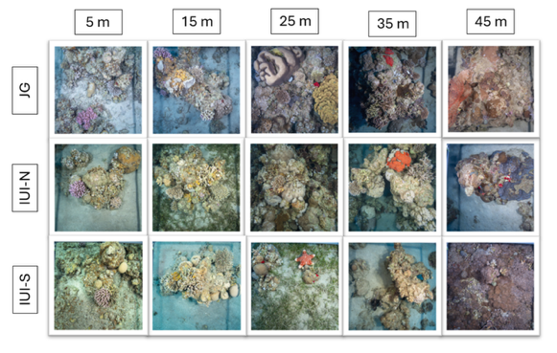
Figure S2:

