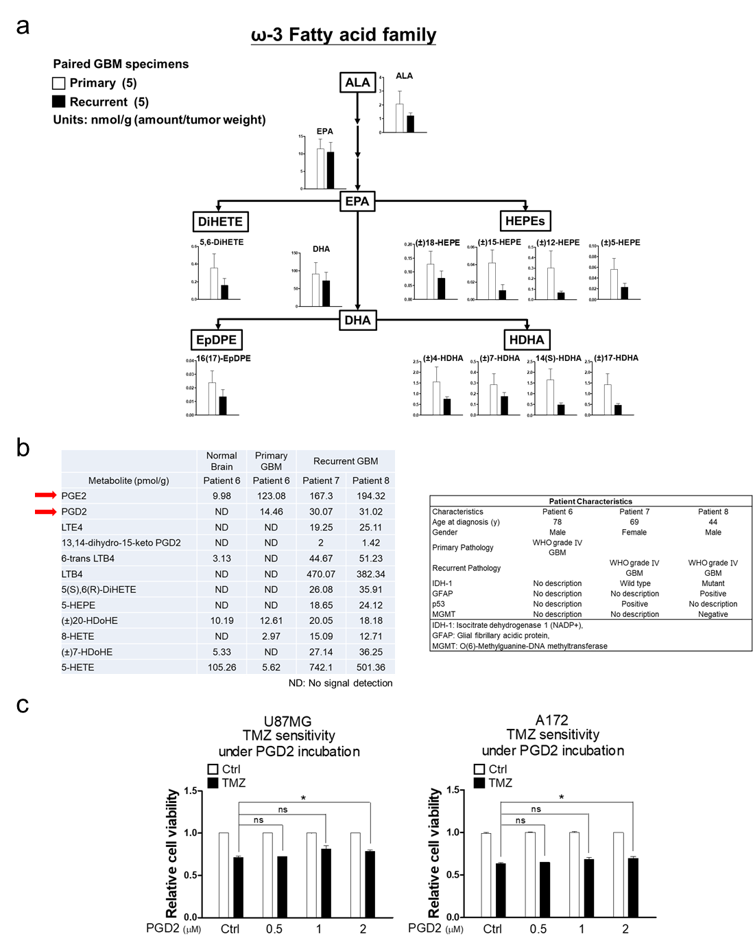
Supplementary Figure 1. The amount of AA-related metabolites in glioblastoma tumors. (a) Targeted ω-3 fatty acid metabolome for paired primary and recurrent glioblastoma specimens from 5 patients determined by UHPLC-QTOF-MS. Data in bar plots were analyzed by two-tailed unpaired Student’s t test. (b) Left pannel: Targeted arachidonate metabolome for normal brain tissue, primary and recurrent glioblastoma specimens determined by UHPLC-QTOF-MS. Right panel: Patients’ characteristics. Red arrows indicate two significantly increased metabolites in recurrent glioblastoma specimans. (c) After treatment with TMZ in the presence of PGD2 for 4 days, cell viability was estimated by MTT assay. Data were analyzed by two-tailed unpaired Student’s t test (n=3).

