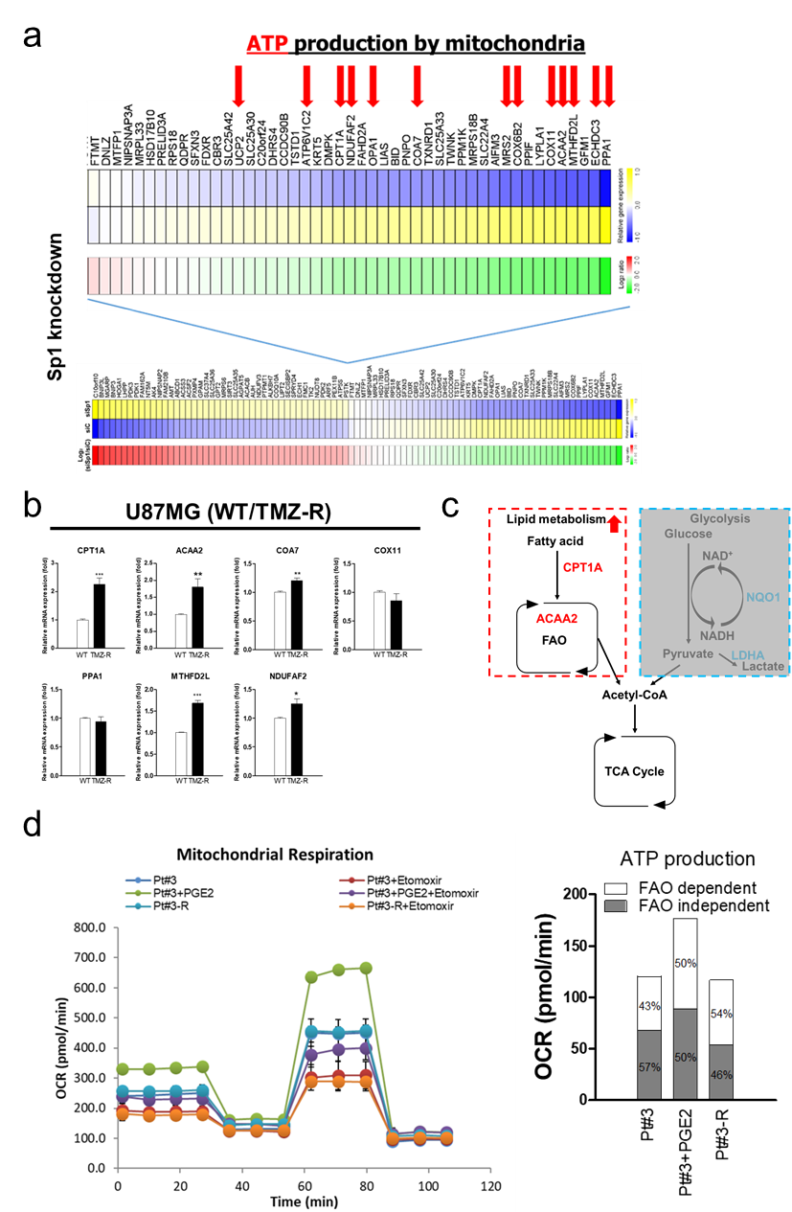
Supplementary Figure 4. The effect of Sp1-regulated PGE2 on FAO. (a) Effect of Sp1 knockdown in U87MG cells on mitochondria-related gene expression. Genes which are essential for ATP production are indicated. (b)The expression of mRNA was measured by real-time PCR. Data were analyzed by two-tailed unpaired Student’s t test (n=3). (c) FAO and glycolysis pathway. (d) The percentage of FAO was measured by the Seahorse XF Mito Stress Test.

