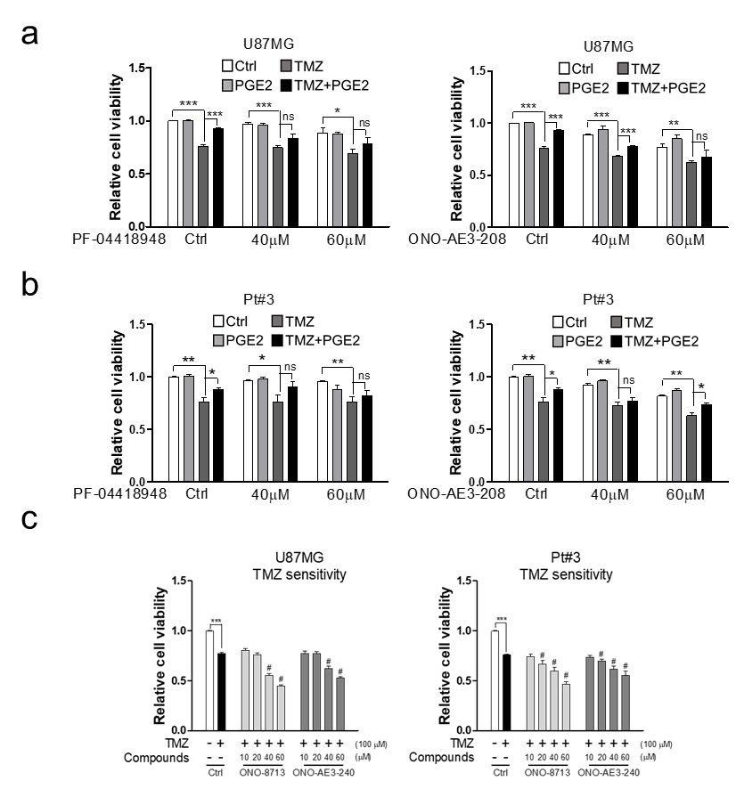
Supplementary Figure 5. The effect of PGE2 receptor antagonists on TMZ sensitivity. (a), (b) U87MG cells were treated with EP2 antagonist PF-04418948 or EP4 antagonist ONO-AE3-208 in the presence of TMZ and PGE2 for 96 h, and cell viability was determined by MTT assay. Data were analyzed by two-tailed unpaired Student’s t test (n=3). (c) U87MG and Pt#3 cells were treated with different compounds in the presence of TMZ for 96 h, and cell viability was determined by MTT assay. Data were analyzed by two-tailed unpaired Student’s t test (n=3). (# means a significant difference with TMZ only).

