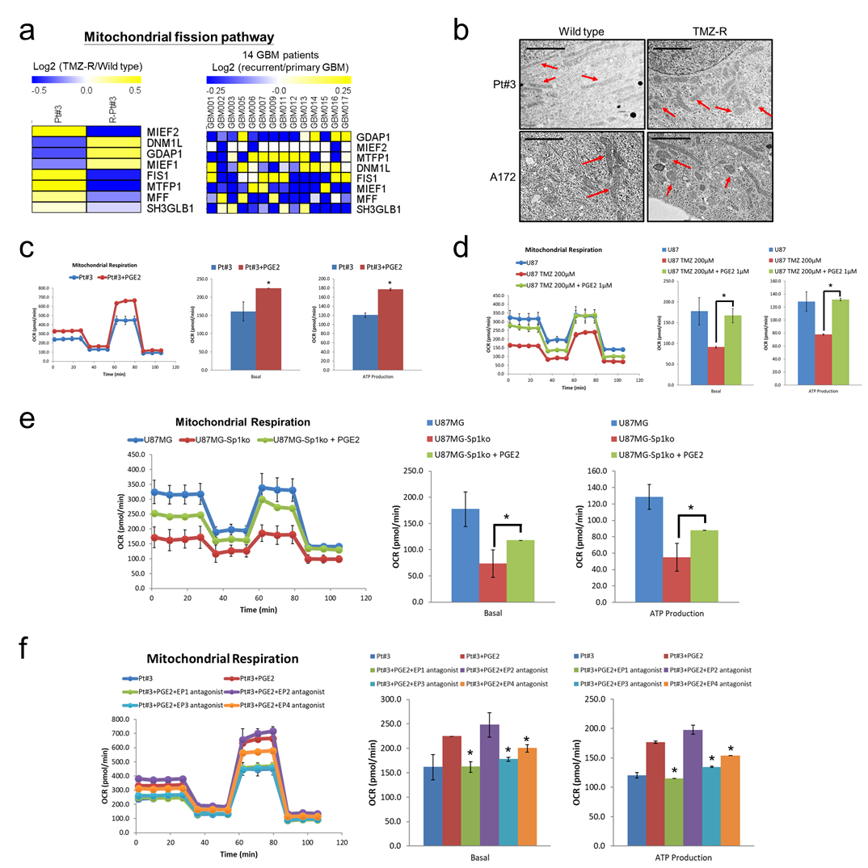
Supplementary Figure 3. The effect of Sp1-regulated PGE2 on mitochondrial activity. (a) RNA expression was analyzed in paired glioblastoma patient-derived cell line and glioblastoma specimens. (b) The images were taken by TEM. The scale bar was 2 μm. (c), (d), (e) After treatment with PGE2 for 4 days, mitochondrial activity was determined by the Seahorse XF Mito Stress test. Data were analyzed by two-tailed unpaired Student’s t test. (f) After treatment with PGE2 in the presence of EP1-EP4 antagonists for 4 days, mitochondrial activity was determined by the Seahorse XF Mito Stress test. Data were analyzed by two-tailed unpaired Student’s t test.

