Machine Learning Models with a Reject Option to Minimize Prediction Error: Application to Optical Properties of Dye Molecules
James Wellnitz¹, Travis Maxfield¹, Matthew Hart¹, Marielle Rath¹, Kathryn Kirchoff¹, Konstantin I. Popov¹*, Alexander Tropsha¹*.
¹UNC Eshelman School of Pharmacy, University of North Carolina, Chapel Hill, NC, USA.
*Email: kpopov@unc.edu; alex_tropsha@unc.edu.

Model | abs-λ_{max} (nm) | emi-λ_{max} (nm) | abs-σ (nm) | emi-σ (nm) | log PLQY | log ε (M⁻¹⋅cm⁻¹)
CasRidge | 38.9 ± 5.4 | 51.45 ± 5.04 | 15.06 ± 1.24 | 21.9 ± 2.7 | 0.61 ± 0.06 | 0.29 ± 0.04
GBT | 36.24 ± 4.0 | 45.88 ± 2.15 | 14.28 ± 0.61 | 19.92 ± 2.1 | 0.57 ± 0.04 | 0.3 ± 0.03
ChemProp | 31.12 ± 3.1 | 39.6 ± 2.8 | 13.38 ± 1.31 | 19.5 ± 0.9 | 0.55 ± 0.04 | 0.29 ± 0.04
Table S1: Mean absolute error (MAE) for the three regression models (rows) using absolute-out cross validation for all six endpoints (columns).

Model | Max Absorbance (nm) | Max Emission (nm) | Bandwidth Absorbance (nm) | Bandwidth Emission (nm) | Log Quantum Yield | Log Extinction Coefficient
Deep4Chem | 31.6 | 32.6 | 14450.87 | 17667.84 | 0.431 | 0.24
CasRidge | 23.74 ± 0.84 | 35.23 ± 1.13 | 12.39 ± 0.77 | 19.84 ± 0.37 | 0.54 ± 0.02 | 0.24 ± 0.02
GBT | 20.14 ± 1.24 | 25.76 ± 0.48 | 10.24 ± 0.89 | 14.76 ± 0.73 | 0.41 ± 0.01 | 0.22 ± 0.02
ChemProp | 19.87 ± 0.67 | 26.01 ± 0.49 | 11.03 ± 0.39 | 15.74 ± 1.14 | 0.44 ± 0.01 | 0.21 ± 0.01
Table S2: Comparison of full coverage models to the deep learning Deep4Chem model from Joung et. al. [REF]. Errors are measured in RMSE and evaluated on random split folds, as outlined in in Joung et. al. bandwidth was converted from wavenumber to wavelength for Deep4Chem. Bolded entries are significantly better than the Deep4Chem results by means of a Students T-Test.

 | Max Absorbance (nm) | Max Emission (nm) | Bandwidth Absorbance (nm) | Bandwidth Emission (nm) | Log Quantum Yield | Log Extinction Coefficient
75% CasRidge | 29.52 ± 3.28 | 44.91 ± 4.28 | 14.15 ± 2.02 | 20.83 ± 3.34 | 0.55 ± 0.04 | 0.26 ± 0.05
75% GBT | 29.94 ± 3.61 | 42.22 ± 2.08 | 13.74 ± 1.2 | 18.61 ± 2.18 | 0.54 ± 0.04 | 0.27 ± 0.04
75% ChemProp | 26.80 ± 3.10 | 37.23 ± 2.63 | 6.80 ± 0.97 | 18.35 ± 0.96 | 0.52 ± 0.03 | 0.27 ± 0.04
50% CasRidge | 25.67 ± 2.26 | 38.98 ± 4.31 | 14.05 ± 3.03 | 20.43 ± 3.73 | 0.49 ± 0.07 | 0.24 ± 0.05
50% GBT | 26.13 ± 2.18 | 38.60 ± 3.10 | 13.35 ± 1.35 | 17.74 ± 2.74 | 0.48 ± 0.04 | 0.25 ± 0.04
50% ChemProp | 24.74 ± 3.45 | 33.99 ± 3.49 | 7.23 ± 1.19 | 17.41 ± 1.12 | 0.47 ± 0.03 | 0.25 ± 0.05
25% CasRidge | 19.46 ± 3.18 | 32.01 ± 4.26 | 10.95 ± 2.01 | 20.9 ± 5.37 | 0.39 ± 0.10 | 0.18 ± 0.02
25% GBT | 21.62 ± 2.11 | 33.49 ± 2.85 | 12.57 ± 1.56 | 16.81 ± 3.16 | 0.42 ± 0.03 | 0.21 ± 0.02
25% ChemProp | 22.42 ± 3.73 | 32.21 ± 4.12 | 7.51 ± 0.95 | 16.06 ± 1.29 | 0.42 ± 0.06 | 0.21 ± 0.03
Table S3: MAE of models utilizing reject option on absolute out validation splits.

Endpoint | Max Absorbance (nm) | Max Emission (nm) | FWHM Absorbance (nm) | FWHM Emission (nm) | Log Quantum Yield | Log Extinction Coefficient
Num unique dyes | 6257 | 6140 | 1543 | 2714 | 5258 | 3730
Num dyes occurrence >1 | 2054 | 2348 | 493 | 936 | 1763 | 1014
Table S4: the number a unique dyes in each of the six datasets and the number of unique dyes in the dataset that occur more than once (in different solvents).

Solvents
O  Water | CS(C)=O  Methylsulfinylmethane | CCO  Ethanol | CCCO  Propanol | CC(C)=O  Acetone | C1COCCO1  Dioxane | CCOCC  Ethoxyethane
ClC(Cl)Cl  Chloroform | C1CCCCC1  Cyclohexane | CO  Methonal | CCCCO  Butanol | Cc1ccccc1  Toluene | ClCCl  Dichloromethane | CN(C)C=O  Dimethylformamide
CC#N  Acetonitrile | CCOC(C)=O  Ethyl Acetate | CC(C)O  Isopropyl Alcohol | c1ccccc1  Benzene | CCCCCC  Hexane | C1CCOC1  Oxolane | CCCCCCC  Heptane
O=P(c1ccccc1)(c1ccccc1)c1ccccc1Oc1ccccc1P(=O)(c1ccccc1)c1ccccc1
1-diphenylphosphoryl-2-(2-diphenylphosphorylphenoxy)benzene
Table S5: SMILES strings of the 22 solvents that occurred more than 100 times used in the curated the dataset. O=P(c1ccccc1)(c1ccccc1)c1ccccc1Oc1ccccc1P(=O)(c1ccccc1)c1ccccc1 was considered a solvent for the purposes of this work

Endpoint | Max Absorbance(nm) | Max Emission (nm) | FWHM Absorbance (nm) | FWHM Emission (nm) | Log Quantum Yield | Log Extinction Coefficient
Total size | 14915 | 15397 | 2363 | 6175 | 11755 | 7437
Training | 8440.6 | 7701.0 | 1439.4 | 3971.8 | 5878.4 | 3726.0
Val Dye Out | 3589.8 | 3324.0 | 602.6 | 1258.6 | 2515.8 | 1631.2
Val Absolute Out | 442.8 | 647.0 | 188.6 | 297.4 | 506.0 | 300.0
Table S6: Number of datapoints in the datasets and model folds generated for each endpoint. Total refers to all datapoints, Training refers to the average size of the five training subsets used for training models. Val Dye Out refers to the average size of dye out validation subsets used for validation. Val Absolute out refers to the average size of absolute out subsets used for validation.

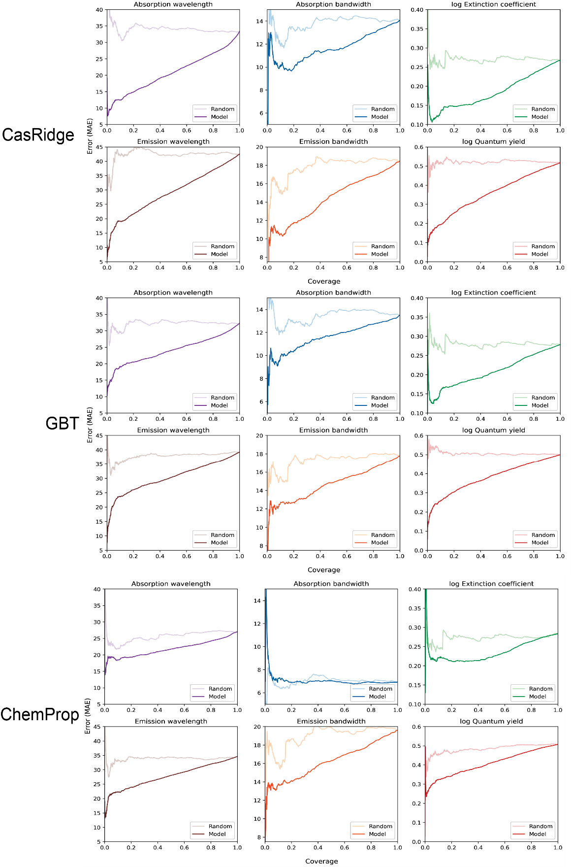
Figure S1: Coverage loss curves for reject option models (solid line) compared to random rejections controls (faded line)

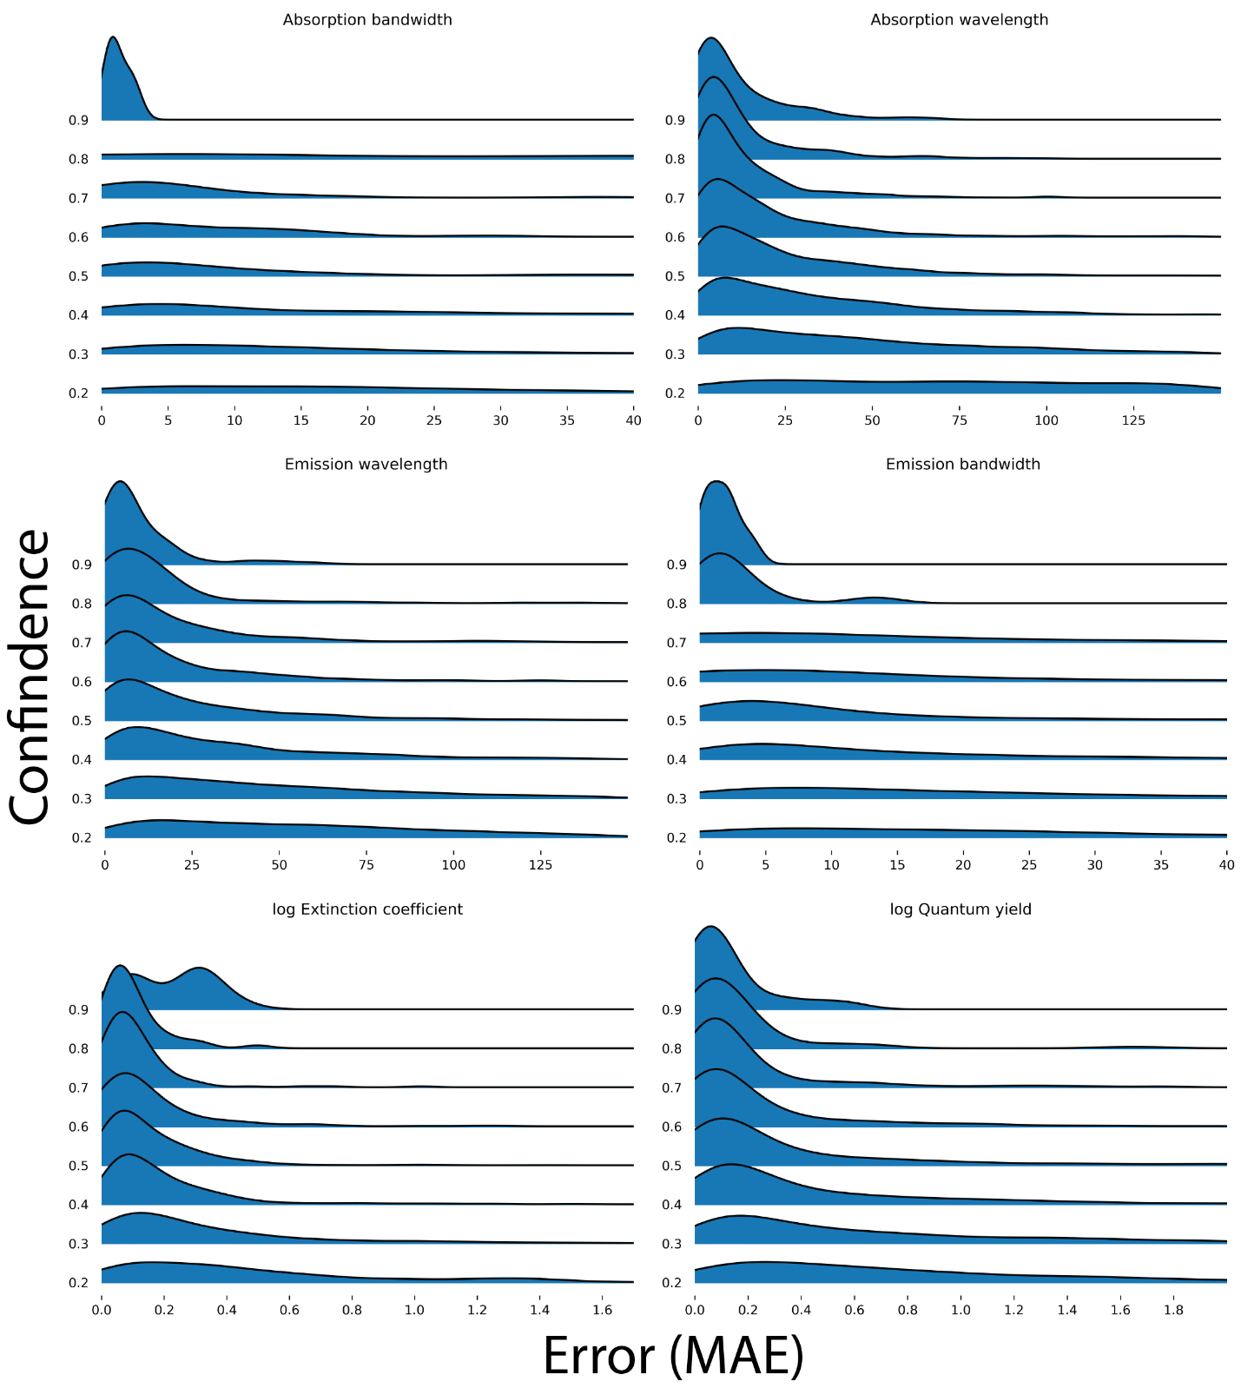
Figure S2: Distributions of MAE across confidence levels. Confidence was binned by groups of 10%, with each density line representing the distribution of errors for that bin of confidence.

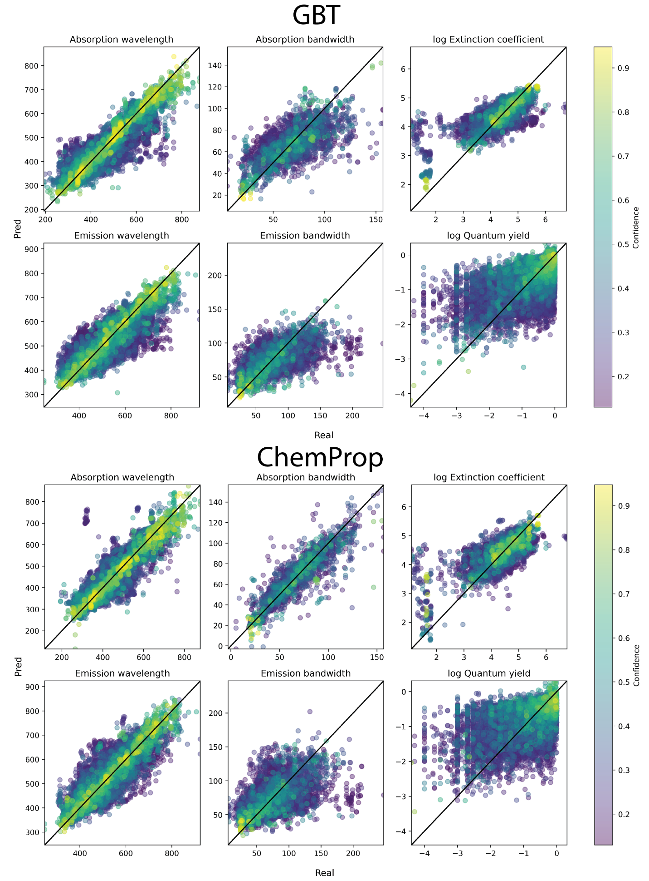
Figure S3: Scatter plot of real and predict values colored by rejection confidence for GBT (top) and ChemProp (bottom) for all 6 endpoints.
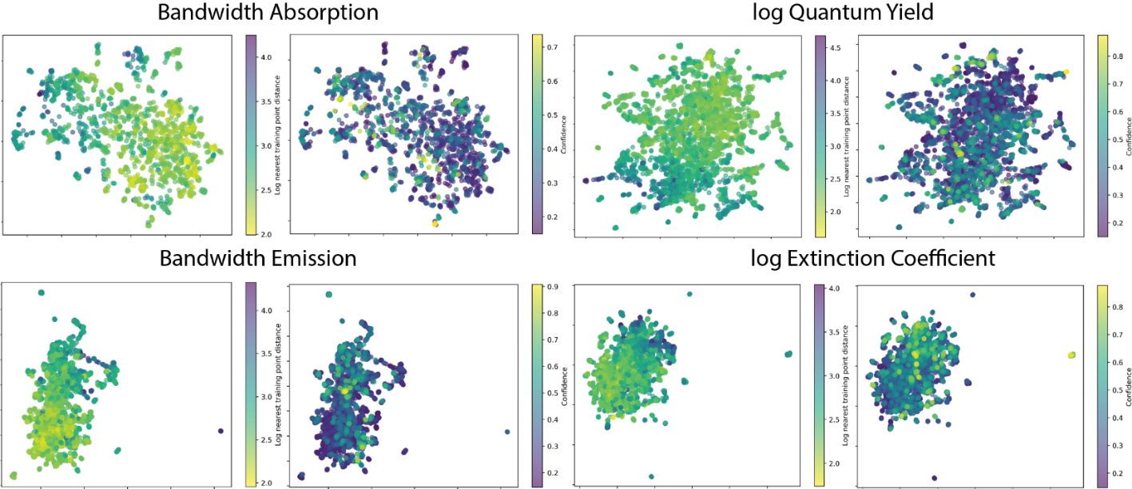
Figure S4: UMap of the chemicals space colored by similarity (left) and rejection confidence (right) for the four endpoints not shown in the main text

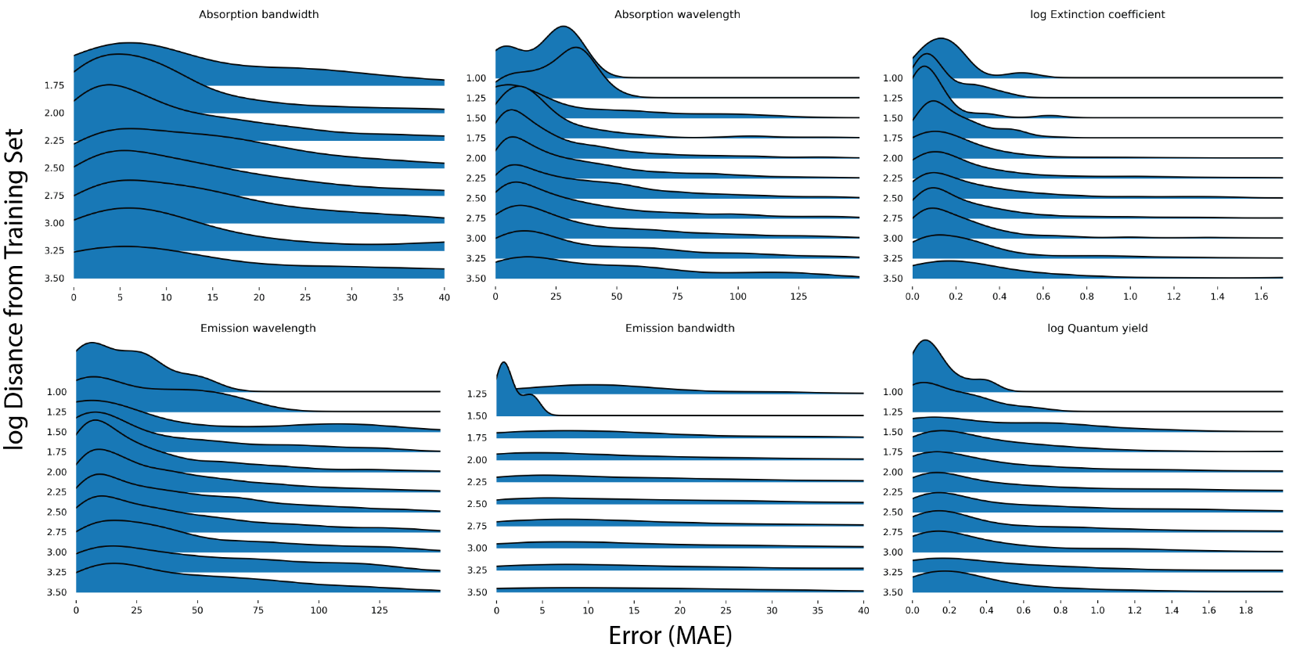
Figure S5: Distributions of error across various similarity levels. Smaller distance means higher similarity. Distance binned by 0.25. Each density line represents the distribution of errors present in that bin.

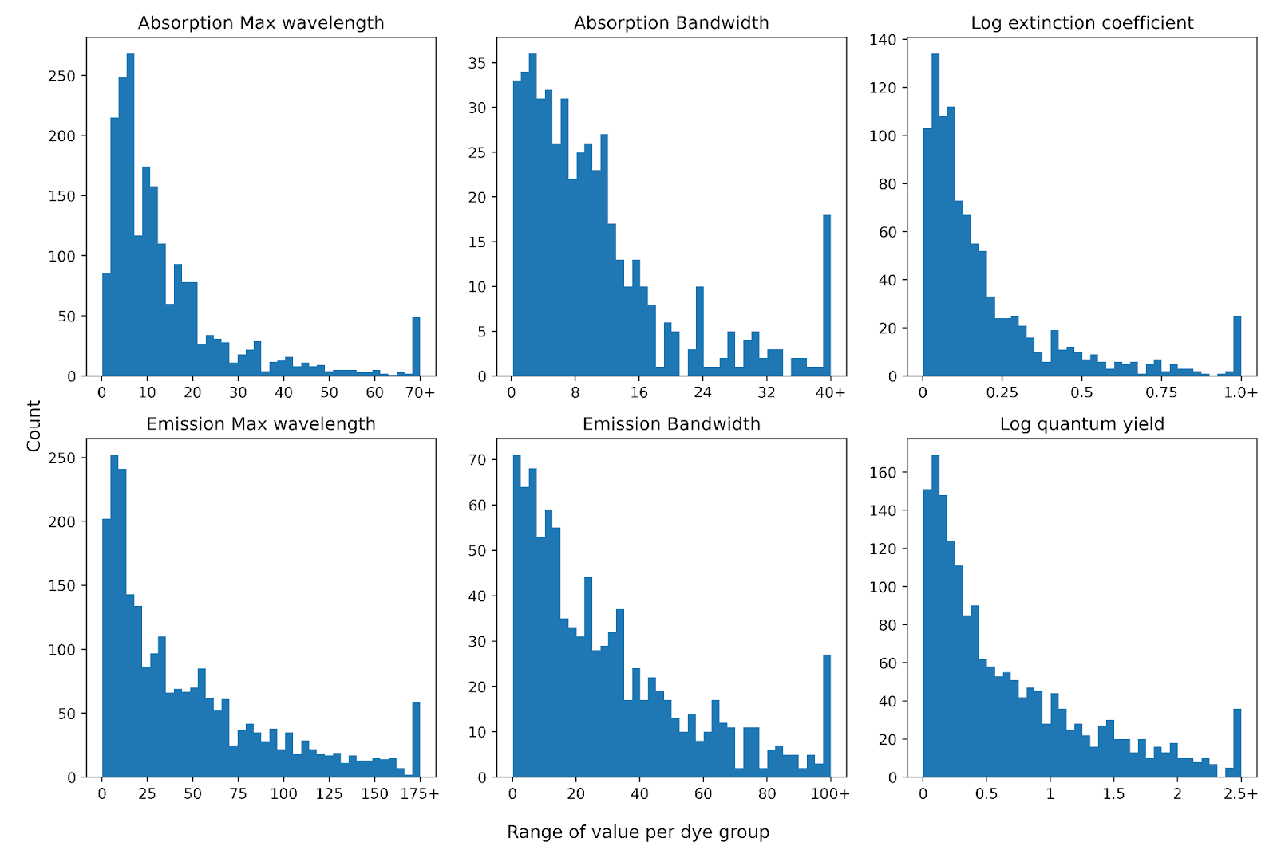
Figure S6: Distribution of the maximum absolute difference in endpoint measurement values across all solvents a given dye was measured in. Dyes that were only measured in a single solvent are not included in the graph.
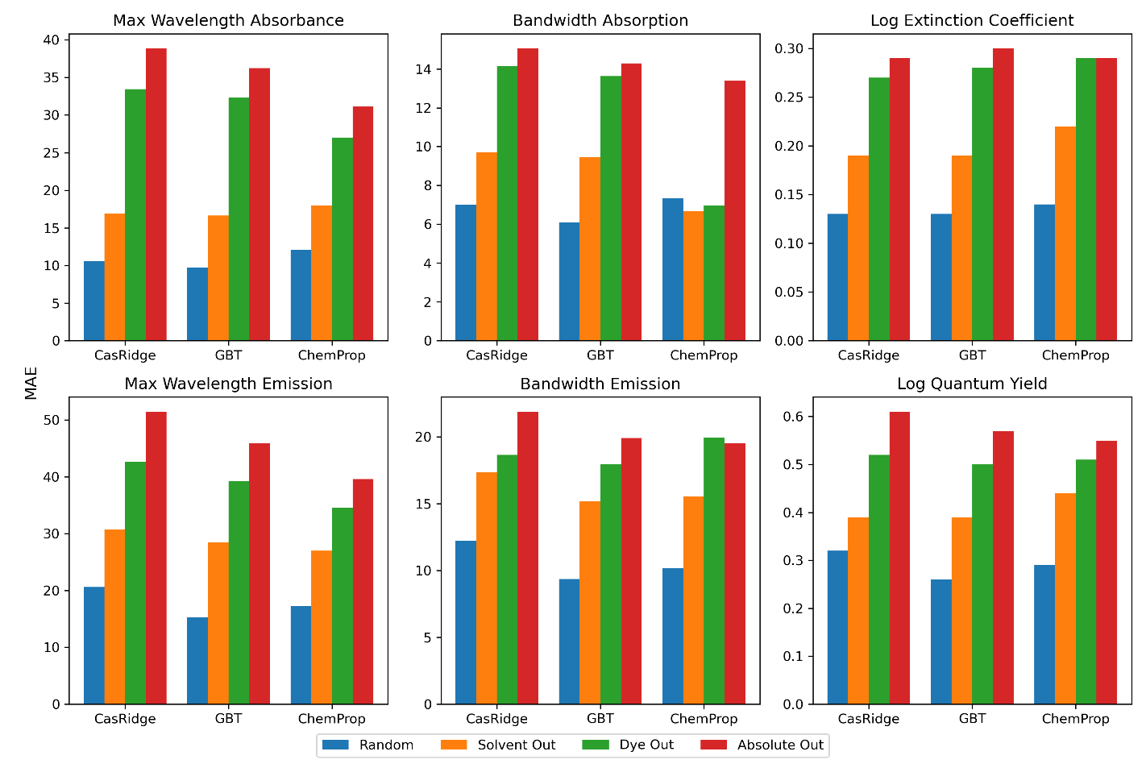Figure S7: Comparison of performance on endpoints for each model across all four validation split methods. For each, Random split validation always performs significantly better than all other validation approaches, with the exception of ChemProp on absorption bandwidth

