Supplementary material 1: Ethical approval certificate

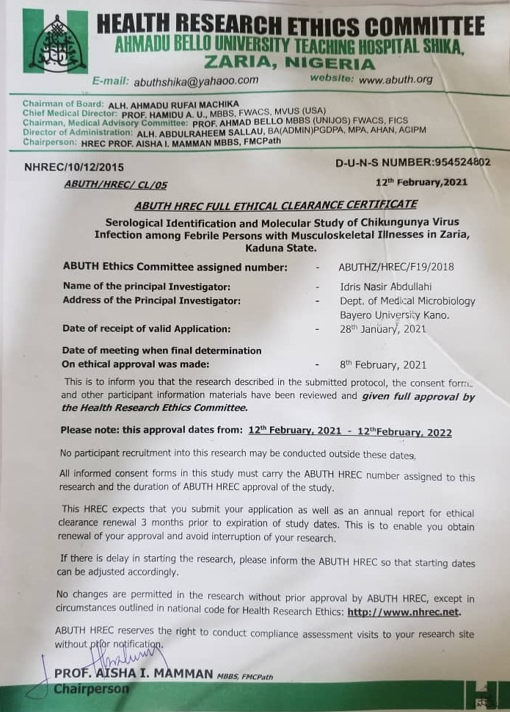

Table S1: Sociodemographic variables of the 250 participants with arthritogenic illness
Category | Total (%)
Sex
Male | 142 (56.8)
Female | 108 (43.2)
Age
20–40 | 124 (49.6)
<20 | 41 (16.4)
>40 | 85 (34)
Residence
Rural | 106 (42.4)
Suburb | 88 (35.2)
Urban | 56 (22.4)
Education level
Non-formal | 47 (18.8)
Primary | 108 (43.2)
Secondary | 80 (32)
Tertiary | 13 (5.2)
Occupation status
Farmer | 41 (16.4)
Driver | 27 (10.8)
Housewife | 74 (29.6)
Civil servant | 65 (26)
Unemployed | 36 (14.4)
Monthly income
<20 USD | 92 (36.8)
20–40 USD | 69 (27.6)
41–80 USD | 47 (18.8)
>80 USD | 17 (6.8)

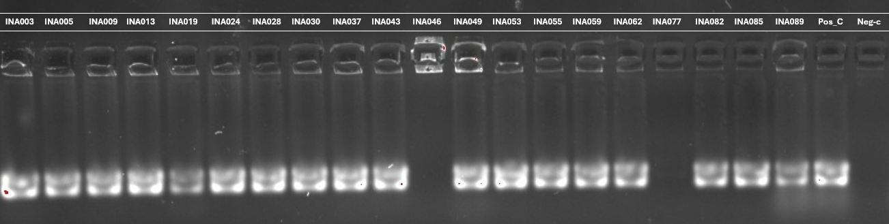
- First run
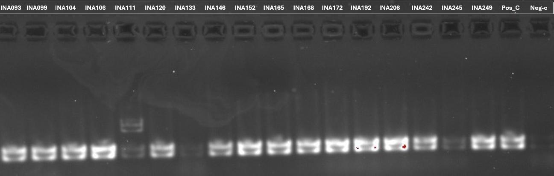
- Second run
The positive control strain used was the CHIKV E1 strain 37997 recombinant protein from HEK293 cells.
Figure S1: Gel pictures of the amplicons from qRT-PCR of the CHIKV targeting E1 gene (208bp) from samples of patients with anti-CHIKV IgM, IgG, IgM+IgG results.
NB:
- The gel pictures were included only to confirm the sizes of the CHIKV E1 gene
- The gel pictures were cropped to make them clearer and eliminate the RT-qPCR we repeated to be sure of the results.

Pictures before labelling and formatting showing edges of the gel
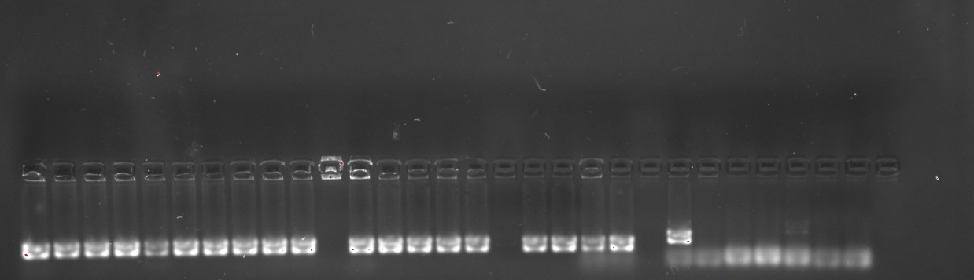
- First run
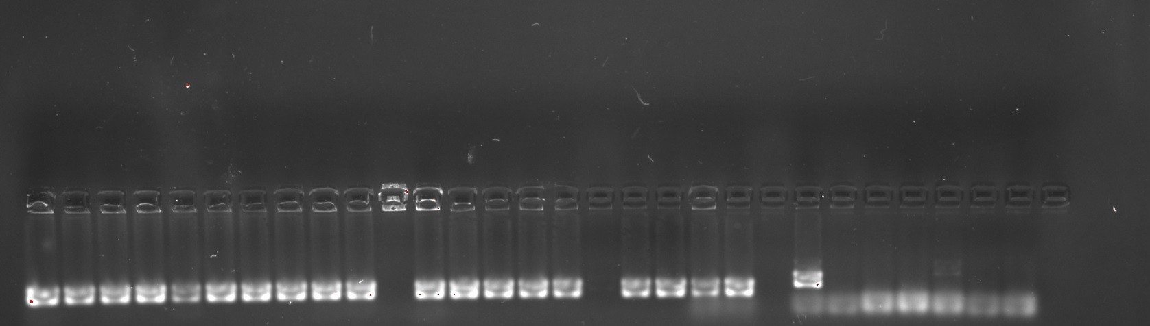

- Second run

